DYNAMIC OF TEMPERATURE AND CONCENTRATION ON OXIDATION REACTION USING REVERSE FLOW REACTOR WITH PERIODIC FEED GAS LIKE SQUARE WAVE FUNCTION: A NUMERICAL APPROACH

Aang Nuryaman^{1, a *}, Rahmad Riyanto^{1,b}, and Subian Saidi^{1,c}

¹ Department of Mathematics, Faculty of Mathematics and Natural Science, Lampung University. Jl. Prof. Soemantri Brojonegoro No. 1 Gedong Meneng Bandarlampung, Indonesia
ªaang.nuryaman@fmipa.unila.ac.id, ^{b}riyantorahmad27@gmail.com, ^{c}subian.saidi@gmail.com

Abstract

Dynamics of oxidation reaction using reverse flow reactor (RFR) are given by a set of convection - diffusion equations that containing the non-linear term corresponding to the reaction rate and provided with certain initial and boundary conditions. In this paper, we investigate the dynamic profiles of temperature and feed concentration on oxidation process using numerical simulation approach. Here we assume the process satisfies 1-D pseudo-homogeneous model and the feed gas form is square wave function. Several different operation parameters have simulated to see the influence towards temperature and feed concentration profile. The results show that period function, small switching time, medium gas velocity and small specific reactor wall surface will make the reactor operated longer.

Keywords: oxidation reaction; reverse flow reactor; switching time

1. Introduction

Climate change induced by global warming is a major issue in the world today. Earlier studies declare that warmth of the earth one of them is result of greenhouse gases (GHG) produced by human activities. Each GHG have a differences effect to global warming. Methane is classified as a GHG, and large volumes of methane in the atmosphere are believed to be a main contributor to climate warming today. Contribution of methane emissions to the greenhouse effect represents 17% of all GHG emissions. Methane has a global warming potential 21 times that of carbon dioxide [1]. Finding efficient methods of reducing methane emissions is stringent.
One of strategy to reduce influence the global warming is by convert CH₄ to CO₂. The stoichiometric reaction of methane combustion can be written as follows:
;

Each one molar CH₄ gas oxidized will realeas heat energy of 802,7 kJ. The removal of methane by combustion thus offers the possibility of a net reduction in GHG potential of 87%. Oxidation of methane concentrations smaller than 1%-v can be conducted over appropriate catalysts, such as Pt or Pd active site [2]. Treatment of low-temperature lean methane emission using a catalytic fixed bed reactor with one-through operation usually requires a preheater to achieve the reaction temperature due to its low adiabatic temperature rise.
The reverse flow operation method applied to the catalytic fixed bed reactor or reverse flow reactor (RFR) is proper method to convert methane to carbon dioxide. RFR has advantages over conventional catalytic fixed bed reactor in terms of the ability to operate auto-thermal.
The behavior of feed gas dynamics inside catalytic reactor during the reaction, kept under review [3-9] to acquire the data needed to design a good and appropriate reactor while the feed gas concentration is constant. This problem is usually described by a set of convection – diffusion equation that containing the nonlinear term corresponding to the reaction rate. Simulation used to learn the behavior of feed gas dynamics along the reactor, especially related to the temperature and concentration during the reaction.
In analytical approach, Nuryaman et.al. [10] studied a singular perturbation problem of methane conversion in steady state under certain assumptions. In another article, Nuryaman and Gunawan [11] reported asymptotic solution of the concentration and temperature variables in a singular perturbation problem in steady state of methane combustion using RFR. Both articles use 1-D pseudo-homogeneous model [3] in constructing the singular perturbation problem.
Dynamic of temperature and concentration at start up condition were reported by Nuryaman [9]. In this paper, we investigate the dynamic profiles of temperature and feed concentration on oxidation process with periodic feed gas like square wave function. The effect of parameter operation in model will be studied.
This paper is organized as follows. In Section 2, data/material and method are described. In Section 3, the results of simulation are presented to interpret the behavior of methane concentration and temperature. The conclusions are written in the last section.

2. Data/Materials and Methods

In this paper, the dynamic behavior profiles of dependent variables were studied using numerical simulation approach. The mathematical model which used in this numerical simulation refers to the 1-D pseudo-homogeneous model that proposed by Khinast []. The governing equations in this model are
Heat balance equation :
Mass balance equation :
with and . The variables and respectively correspond to the temperature (K) and feed concentration (mol/litre) at position and time .
For forward flow, the boundary conditions of mass and heat balances can be written as:
Here and correspond to the temperature and feed concentration entering into reactor and state reactor length. For backward flow, the boundary conditions change on (3) at and on (4) at .
We assumed that the feed gas temperature is constant and its concentration in the form of periodic functions as with and related to high and low frequency on specific time period. For initial condition, , assumed that the reactor has been preheated so reach certain desired temperature, and feed concentration inside reactor, .
On numerical simulation, (1)-(2) discretized using finite difference method that is forward time centered diffusion backward convection. We get the discretized equation is obtained as follows :
where ,, and . and respectively state the number of spatial and time coordinate partitions.

3. Results and discussion.

Using (5) and (6), with boundary conditions (3)-(4) and initial conditions and , then numerical simulation are performed. Temperature and concentration profiles obtained as follows :
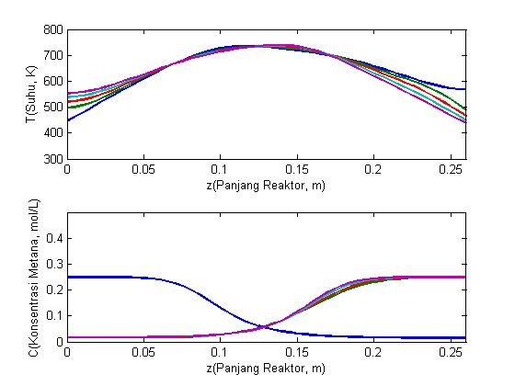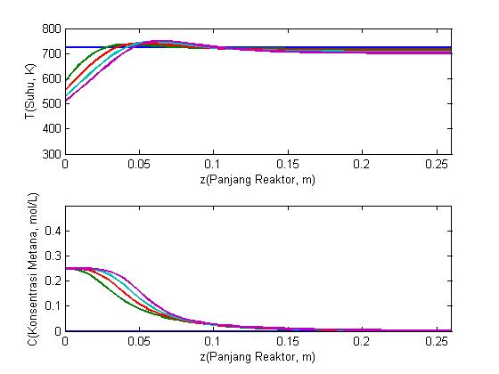
(a)
(b)

Figure 3.1 Dynamic of temperatur and concentration respectively (in the direction of arrow) (a) on first flow and (b) after several reverse, with , , (constant concentration).

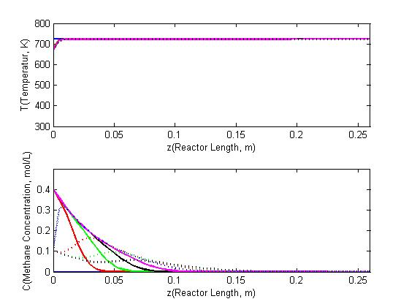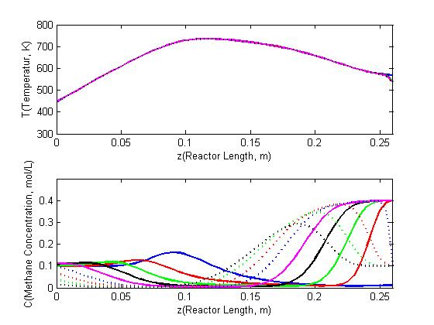
(1a)
(1b)

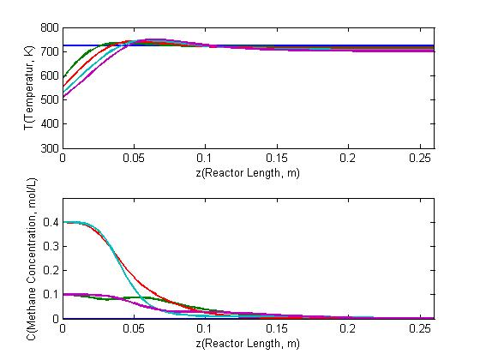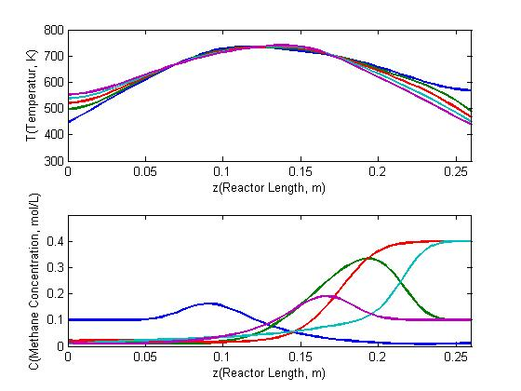
(2a)
(2b)

Figure 3.2 Dynamic of temperatur and concentration respectively (in the direction of arrow) (1a) and (1b) small interval, (2a) and (2b) large interval, with , , .

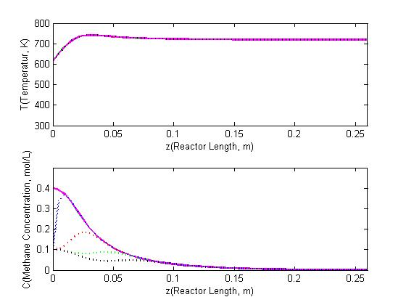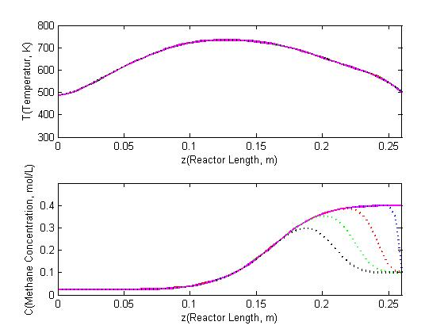
(1a)
(1b)

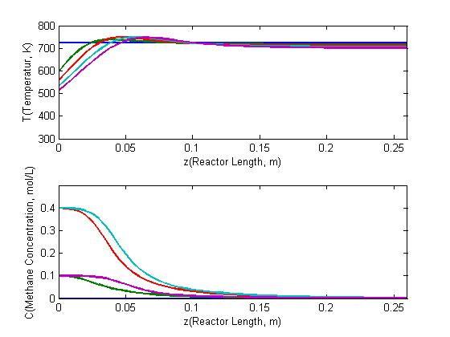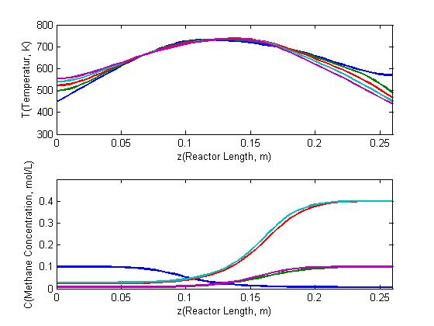
(2a)
(2b)

Figure 3.3 Dynamic of temperatur and concentration respectively (in the direction of arrow) (1a) and (1b) small interval, (2a) and (2b) large interval, with , , .

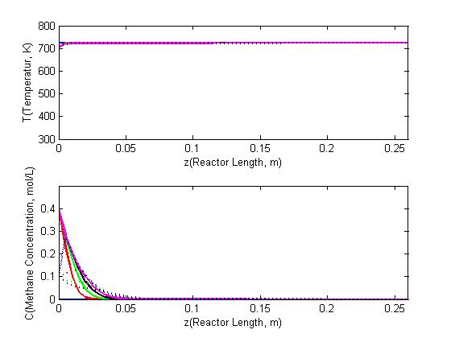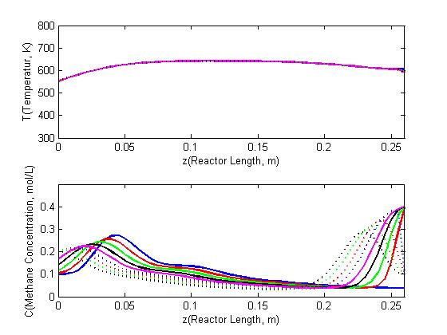
(1a)
(1b)

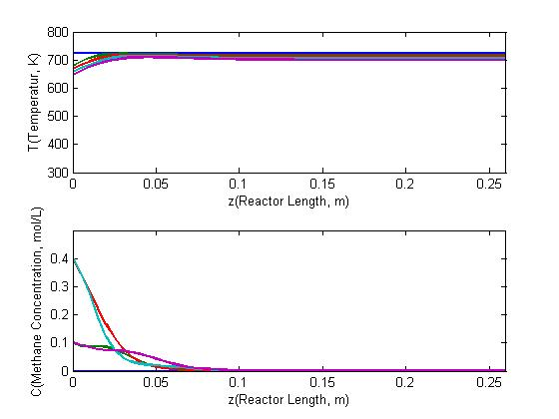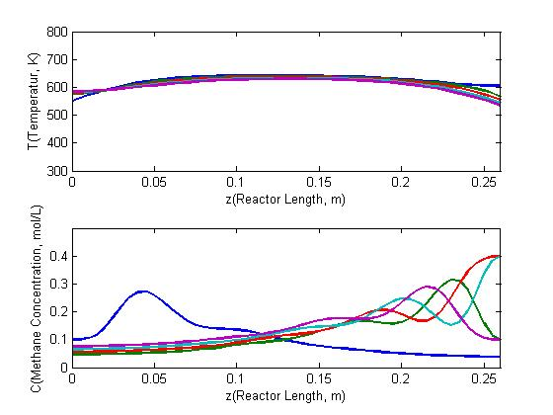
(2a)
(2b)

Figure 3.4 Dynamic of temperatur and concentration respectively (in the direction of arrow) (1a) and (1b) small interval, (2a) and (2b) large interval, with .

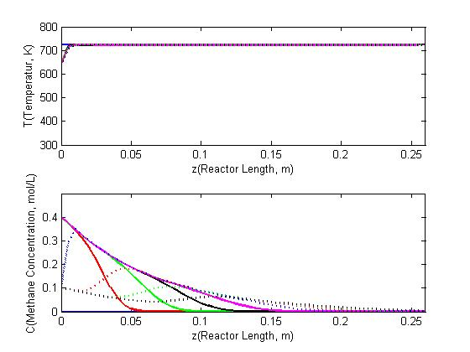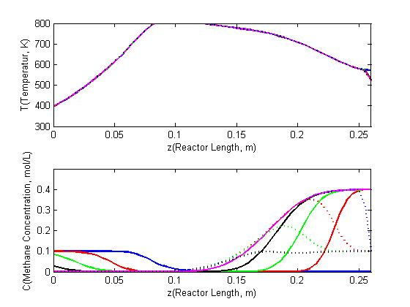
(1a)
(1b)

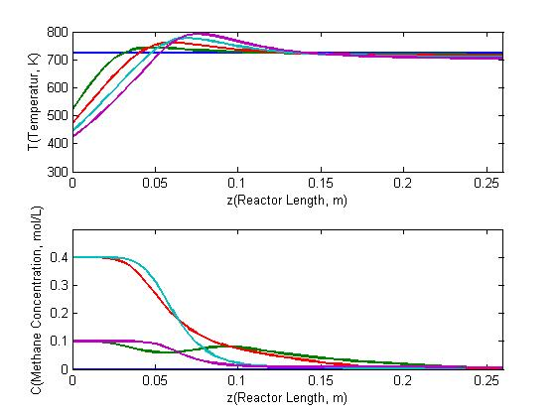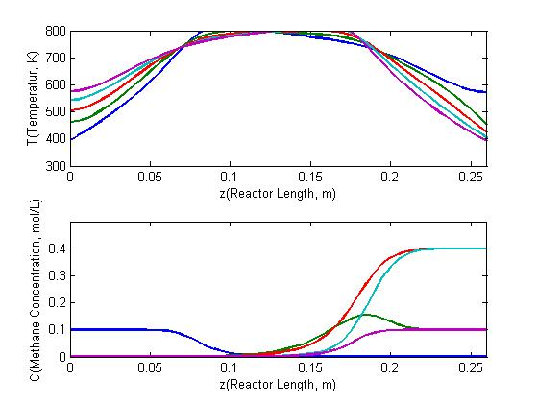
(2a)
(2b)

Figure 3.5 Dynamic of temperatur and concentration respectively (in the direction of arrow) (1a) and (1b) small interval, (2a) and (2b) large interval, with .

In general, between constan and periodik like square wave function qualitatively same on temperature profile. Temperature profile in the end of reactor where feed concentration entering reactor, over time it getting down. it caused by dispersion factor. On reactor position to the right end, the temperature getting up then down again. This profile occurs due to the contribution of heat reaction and cooling. When the feed concentration runs out, then the contribution of heat reaction decreases. In other side the cooling continues, so the temperature getting down. Moreover,with periodic feed concentration like square wave function will have fluctuation because low and high feed concentration that enter the reactor.
While concentration profile for the case of constant feed gas, over time the concentration inside reactor increases, especially near the end of reactor where the concentration entering reactor. It happens because not all feed gas react immediately. But getting to the right, the concentration is getting closer to zero or run out because of reacting. As for the case of periodic feed gas, in general the concentration profile is similar to constant feed gas. The difference lies in the existence of oscillations between high and low concentrations.
Variations in the value of will effect on the visibility of waveform on the concentration profile along the reactor. When is large, the waveform is still visible, heading to the right the period wave is getting smaller. When is small, the waveform becomes invisible because of diffusion.
Variations in the value of will effect to the duration of reactor can operate. The smaller , the temperature profil will drop quickly. This is because the feed gas movement in the reactor is slow, so that only little feed gas reacts. This will cause the reactor to go out quickly. Whereas with the greater , the temperature profile will rise quickly. This is because the feed gas movement in the reactor is fast, so the feed gas reacts a lot. So that the reactor will able to operate longer, but if are too large it can cause the reactor to overheat.

4. Conclusions

The study of oxidation reactions using RFR with periodic feed gas like square wave function has been performed. The temperature profile with square wave function will have fluctuation because low and high feed concentration that enter the reactor. The lower and faster superficial gas velocity is very influence to temperature profile which consequence the duration of reactor can operate.

Acknowledgment

This research was supported by DIPA FMIPA Unila 2017 with grant no. 1028/UN26.21/PN/2017.

References

- Baird and Colin, Environmental chemistry. W.H. Freeman and Company, New York, 1995.
- Becker, E., Carlsson, P.A., Kylhammar, L., Newton, M.A. and Skoglundh, M., In Situ Spectroscopic Investigation of Low-Temperature Oxidation of Methane over Alumina-Supported Platinum during Periodic Operation, The Journal of Physical Chemistry C. v.115(4), pp. 841-1374, 2010.
- Khinast, J., Jeong, Y.O., and Luss, D. Dependence of Cooled Reverse-Flow Reactor Dynamics on Reactor Model. AIChE Journal. v.45(2), pp. 299-309, 1999.
- Solomons, S., Hayes, R.E., Poirier, M. and Sapoundjiev, H. Flow reversal reactor for the catalytic combustion of lean methane mixture. Catalysis Today. v.83, pp 59-69, 2003.
- Gosiewski, K. Effective approach to cyclic steady state in the catalytic reverse-flow combustion of methane. Chemical Engineering Science. v.59, pp. 4095-4101, 2004.
- Litto, R., Hayes, R.E., and Liu, B. Catalytic Combustion for Reduction of Fugitive Methane Emissions From Natural Gas Compressor Stations. Greenhouse Gas Control Technology. v.1(7), pp. 329-336, 2005.
- Ruixiang, L., Yongqi, L., Zhenqiang, G., and Bin, Z. Modeling a Reverse Flow Reactor for Thermal Oxidation of Lean Methane. 3rd International Conference on Bioinformatics and Biomedical Engineering, pp. 1-5, 2009.
- Budhi, Y.W., Effendy, M., Bindar, Y., and Subagjo. Dynamic behavior of reverse flow reactor for lean Methane Combustion. Journal of Engineering and Technological Sciences. v.46(3), pp. 299-317, 2014
- Nuryaman, Aang. Simulasi Numerik Model Matematika Dinamika Reaksi Oksidasi dengan Konsentrasi Gas Umpan Periodik. Prosiding Seminar Nasional Sains Matematika Informatika dan Aplikasinya IV. v.4(4), pp. 139-145, 2016.
- A. Nuryaman, A. Y. Gunawan, K. A. Sidarto, Y. W. Budhi, A Singular Perturbation Problem for Steady State Conversion of Methane Oxidation in a Reverse Flow Reactor, ITB Journal of Science, 44A (3), pp. 275-284, 2012
- A. Nuryaman, and A. Y. Gunawan, A Singular Perturbation Problem in Steady State of Methane combustion using Reverse Flow Reactor, Far East Journal of Mathematical Sciences (FJMS), 102 (9), pp. 2069-2079, 2017.

