INITIATION OF CHILD-FRIENDLY VILLAGE IN EAST LAMPUNG: CURRENT DEVELOPMENT AND CHALLENGES
Rudy
Siti Khoiriah
Utia Meylina
Constitutional Law Department Faculty of Law, University of Lampung
rudy.1981@fh.unila.ac.id
siti.khoiriah@fh.unila.ac.id
utiameylina.umar.fh.unila@gmail.com
Abstract
Indonesia Constitution has provided the constitutional guarantee for children rights. It is guaranteed by Article 28B paragraph (2) of the Constitution provide that every child has the right to live, grow, and develop as well as the right to protection from violence and discrimination. The constitutional provision of the children rights has been supplemented by the ratification of Convention on Rights of the Child by Law No. 23 of 2002. This law mandates that every child have the right to live, grow, develop and participate fairly in accordance with human dignity, as well as protection from violence and discrimination.
In fact, protection mandated in the constitution has been meaningless by the many cases of violence against children, including sexual abuse of children. Government of Indonesia in this regard has already mentioned that violence against child is an extraordinary crime. Therefore, every effort shall be directed to reduction and elimination of violence against children.
In the same time, decentralization policy and local autonomy open opportunity for the involvement of local government to the fights against child violence. This is the case of East Lampung in Lampung Province, which is recently declaring the fight against child violence by the establishment of child friendly village. The establishment of the child friendly village was the respond upon the case of Mistianah, who was violently abused and killed in the one of village in East Lampung.
Within the context, this paper will discuss the current development of the child friendly village in the East Lampung using the socio legal approach. The paper then discusses the challenges that arise while identifying the solution for the massive formulation of another child friendly village in Lampung Province. Finally, this paper might give clue on the cooperation framework among stakeholder since several stakeholders are involved in the developing the child friendly village.

Keywords: Children, rights, law, violence.

INTRODUCTION

Children are a very important nation asset for continuing regeneration in a country, so the child is worth to be protected. The 1945 Constitution as the Constitution of Indonesia has guaranteed the fulfillment of the rights of the children. The guarantee is constitutionally a responsibility for the government to provide for the survival of children protected against violence and discrimination.

Children as the mandate of God to be safeguarded as well as possible. Because of his status which is still in the process of growing, both physically and mentally, so that they needs adult support and assistance, whether directly by their parents or by those who are given the responsibility to take care of them in certain spaces and stages. It is because of this mandate that all nations of the world through the Convention on the Right of the Child (CRC) agree that children should be granted their basic rights and special protection.

But the reality that is found today, indicates that the mandate of the constitution above seems meaningless. Cases of violence - including sexual violence often happen to children. The case that happened, as reported by KPAI that in every year is always increase. In 2016, in just four months (January to April 2016) KPAI recorded 28 cases of physical violence involving children, both as victims and perpetrators, while cases of sexual violence reached 36 cases.

The case that took enough attention was took placed in april 2016 and then the case that happened to Yuyun (14 years), a child from the Village of Kasie Kasubun, Padang Ulak Tanding District, Rejang Lebong, Bengkulu. Yuyun was held captive, abused in turns, and was eventually killed by 14 perpetrators which are in the same age with Yuyun. Not only that, a portrait of violence against children also occurred in Lampung. A case of no less terrible happened to Mistianah, a 10-year-old girl from Labuhan Ratu Village, East Lampung District. Mistianah experienced the same thing as Yuyun; Abused and eventually killed. In addition to the Mistianah case, Child Advocacy Institute (LADA-Damar) Lampung recorded 19 incidents of sexual crimes against children with 49 children during 2016 in Lampung Province.

A bit of the above case indicates that the government at all levels and branches of its power requires more strenuous efforts to realize child protection.

Child-related regulation on its own has experienced a fairly sharp dynamic since cases of violence against children surfaced some time ago. The Government Regulation in Lieu of Law No. 1 of 2016 regarding the Second Amendment to Law Number 23 Year 2002 on Child Protection has been established as law through Act No. 17 of 2016. Through the regulation, the government tries to aggravate criminal sanctions against Sex offender. The auction is essentially aimed at providing a deterrent effect against the perpetrators of sexual crimes so that it is expected to reduce the number of sexual crimes against children.

However, the community does not then release hands and fully surrender child protection efforts to the government. The community still has responsibility for the implementation of child protection. Furthermore, the Child Protection Act describes that community obligations and responsibilities for child protection are carried out through community role activities in the provision of child protection.

It is the mandate of the Child Protection Act, which then makes the author try to participate in the protection of the child, in accordance with the capacity as an academician. Facts on the ground where many sexual crimes cases are encountered in Lampung Province, also makes the authors increasingly feel they have the responsibility to initiate activities that can at least reduce the number of cases that tend to continue to grow. Through the Ipteks bagi Masyarakat Scheme (IbM) funded by Ministry of Research, Technology and Higher Education, the writer then carry out the devotion for IbM society with the title of Initiation of Child-Friendly Village.

DISCUSSION

This section will discuss the design of child-friendly village, the development of child-friendly village that has been initiated in East Lampung district, as well as the challenges faced in implementation of child-friendly village.

DESIGN OF CHIELD-FRIENDLY VILLAGES
Efforts to initiate child-friendly villages begin with an inventory of problems and efforts to generate solutions to the problems found. The inventory, conducted through the Focus Group Discussion (FGD) with the theme "Responding to the Responsibility of the State of Justice of Women and Children at Law Faculty of Lampung University, which was attended by various stakeholders such as Police, Legal Academician, Sociologist, Psychologist, Local Government, NGO, Student Affairs.
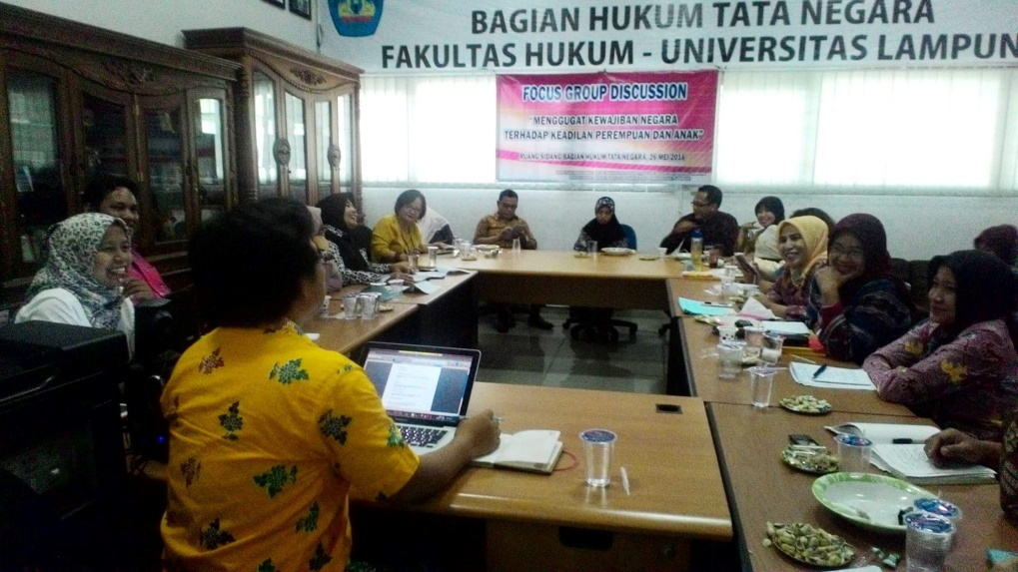

Image 1. FGD with the theme "Responding to the Responsibility of the State of Justice of Women and Children

FGD produced some conclusions, namely the need to raise awareness of parents to educate their children in dealing with other people, especially foreigners. In addition, there is a need for social control houses as a means of creating child-friendly villages.

The implementation of this service takes place in two partner villages in Lampung Timur District, it is Labuhan Ratu VII and Tanjung Inten Village. The first location is the location where the Mistianah case occurred. The selection of this village is done on the consideration that there has been a change of cultural order in the society, so that the community's awareness and social control of the society on child safety is decreasing, which ultimately victimize.

The second location, is one of the villages with a fairly solid economic activity in Purbolinggo District, which is marked by the central market district. Tanjung Inten community profession is quite diverse, ranging from traders, farmers, clerks, freshwater fish farmers, and chicken farmers. The bustle of people in the dynamic economic zone will certainly affect the loosening of controls by parents to their children. This makes the potential for sexual crimes to occur again. Of course, the Mistianah case no one wants to experience it.

The child-friendly village model designs a village that is child-friendly, so children can get a sense of security from the perpetrators of crime. The design requires concepts designed by experts and active participation from local government, village government, and the community.

Personnel involved in child-friendly village initiation in East Lampung, are: First, expert of law and development, with the burden of the task of analyzing the development planning in the village pro to children by taking into account the juridical-normative aspects so that there is no unconstitutionality With existing legislation. Second, Sociolog, with the task of approaching socio-economic and cultural relations at partner sites. Third, psychologists, with the task of counseling and educating partners in order to create child-friendly villages through social control houses. The overall implementers coordinated from start to finish by including formulating independence indicators of partner villages to become independent child-friendly villages.

In addition to personnel with expertise in the field of science above, child-friendly village also involves social activists who can organize the community more flexibly, students who are also an iron stock in implementing community service, as well as local government as a facilitator both morally and materially.

The implementation of child-friendly village initiation is divided into several phases consisting of socialization stage, intervention stage, internalization stage, evaluation stage, and Continuous phase. Details of the stages are:
- Socialization Stage
The socialization stage as the first stage is very important because local partners including children should have a good understanding of the rights of all children. This stage will "broaden" the partner's view of what the child's rights and needs are. This can be done through special activities designed at the beginning of which can be carried out more than once until partners have similar views on child-friendly villages.
- Intervention Stage
After conducting socialization in two partner villages, then initiated child friendly villages which included the construction of a social control house. The main target of child-friendly village intervention is to improve a child-friendly environment in terms of safety, health and recreation, care, and protection.
- Internalization Stage
Following intensive intervention with the relevant stakeholders, internalization of social control houses in the community is upheld so that the community can be self-reliant in the implementation of child-friendly villages.
- Evaluation Stage
Evaluations were conducted to see the partners' ability to organize child-friendly villages on a mandated basis based on measurable indicators.
- Continuous Phase
This final stage is an independent and sustainable child-friendly village stage where villagers and village apparatus can perform the role left by the proposer. Nevertheless, the proposer can keep monitoring and mentoring within a certain period of time.

CURRENT DEVELOPMENT
The initiation of child-friendly village itself has received positive support from the government of East Lampung Regency. The regent of East Lampung launched the village of Labuhan Ratu VII as a child-friendly village Along with 23 other child-friendly villages.

The efforts that have been systematically designed above are carried out by teams with personnel who each have different scientific expertise but are indispensable in efforts to initiate child-friendly villages. It is intended that the implementation of the initiation can cover various aspects, so as to realize the legal ideals that nurture the community.

As mentioned earlier, the initiation of this child-friendly village has the support of local government, in this case the Government of Lampung Timur District. The local government on 19 June 2017 has established 24 child-friendly villages. Regent of East Lampung. The inauguration took place simultaneously with the inauguration of the Regional Children Forum board. The move indicates that local governments are taking positive steps/responses to child friendly village models.
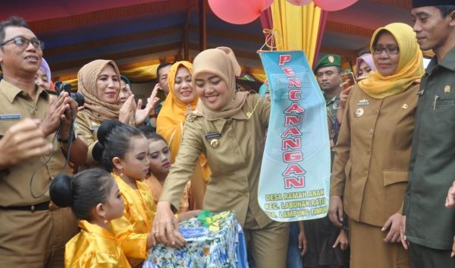
Image 2. Established 24 child-friendly villages

The program that has been running is the collection of children's books and toys. The book collection aims to increase literacy interest and culture literacy to children from an early age. Then, children's toys are also collected with the aim that in addition to reading, children can also use their spare time to play under supervision.

In an effort to collect books and toys, proponents use information dissemination methods in the form of pamphlets printed and scattered at many points on the campus of the University of Lampung and disseminate it through social media. The response from the audience shows a very positive response. Similarly, the Local Government of East Lampung Regency, which supports IbM Initiation of Child-Friendly Village program in the form of bookshelf assistance. This indicates that the initiation carried out through the IbM scheme has deserved attention from various parties.
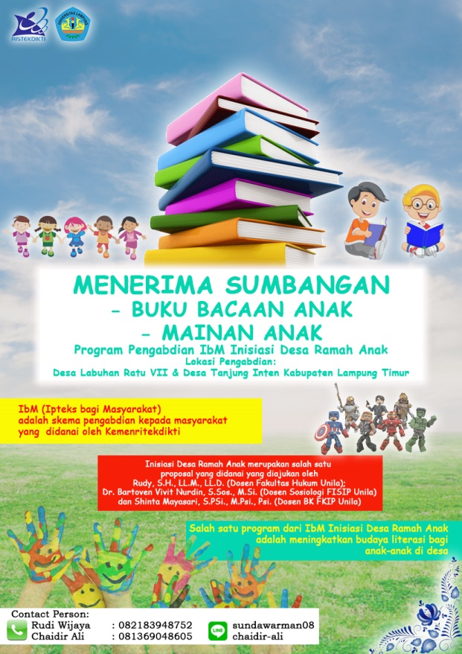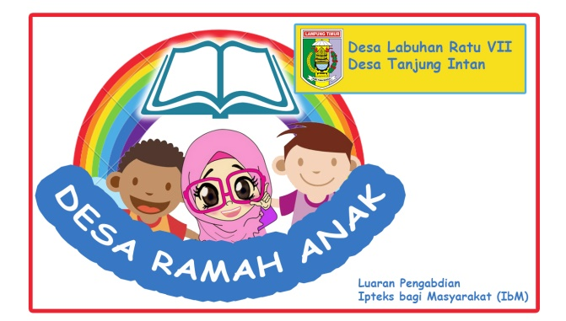
Image 3. Poster and Logo of Initiation of Child-Friendly Village

Children's books and toys are collected, dropped in one place ie in a social control house, which in the execution takes up space in the Village Government Office. It is intended that the inventory and all activities undertaken by the child are monitored and supervised by both IbM executors and by village government officials, as well as facilitate access for the community.

Furthermore, there is still a need to intensify the dissemination of information to the general public with the aim of capturing the public interest to contribute to the initiation of this child-friendly village, whether as volunteers, donors, or to transplant the concept of child-friendly village to other villages. The private sector for example, which can be aimed to increase the number of children's books and toys, among others bookstores and toy stores.
CHALLENGES
The initiation of child-friendly villages, while containing a noble ideal as well as constitutional mandate, in practice remains a challenge that must be overcome. Some of the challenges faced are, among others: First, it requires harmonization and synchronization of related legislation. This is a consequence of changing the development paradigm by reinforcing village autonomy. The Government after passing Law Number 6 Year 2014, incentive to issue regulations of implementation legislation. It is in need of harmonization and synchronization, so that the construction of a clear task between the central government, the provincial government, the district government, and the village government and the community. With the harmonization and synchronization, local government can issue regulation in the form of local regulations on child friendly village. The instrument of the local law product is very important, because it will concern the continuity of child-friendly village in a regulative and technical-operational way.

If local governments, in particular districts, can include child-friendly villages in local legislation programs, child-friendly villages will proceed continuously and minimize budgets due to budgetary factors. That is, local governments need to issue local legal products that also contain the provision of the cost of child protection in APBD.

Secondly, initiation of child-friendly village requires a serious implementation of the local government. It is necessary to ensure that child-friendly village is really going on, not merely ceremonial agenda. With the inclusion of child-friendly village in the area of ​​legal instruments, local governments have the responsibility for a child-friendly village organize as one child protection efforts seriously.

Third, there needs to be a strong stimulus in mobilizing the community in participating in the implementation of child friendly village. This is very important, given the increasingly shifting socio-cultural factors, which put forward the nature of apathy that result in apatisnya society against children. Plus, portraits of Lampung and Lampung Timur provinces still have negative stigma; Areas with high crime and violence levels. In fact, nowadays violence is not only an individual issue or a national issue, but it is a transnational and even global problem.

CONCLUSION
The initiation of child-friendly villages is one of the initiatives initiated to improve the protection of children who preventively try to prevent children from committing crimes against children. This effort is a constitutional mandate of the 1945 Constitution and the Child Protection Act. The challenges faced include: need more harmonization and synchronization of legislation both related to the village and related to child protection, need a serious implementation of the local government. It is necessary to ensure that child-friendly village is really going on, not merely ceremonial agenda and the need for strong stimulus to the community in the partner village so that the community itself feels attached, possessed and moved to continue the child friendly village Has been initiated independently.

REFERENCE

Irma Rumtianing, 2014. Decent City of Children in Perspective of Child Protection. Journal Education and Pancasila Series 27 Number 1 February 2014.
John Dirk Pasalbessy, 2010. The Impact of Violence Against Women And Children And The Solution. Journal Sasi Vol.16. No.3 July - September 2010.
Rudy, 2016. Lack of Law and Sexual Violence. Posted in Lampung Post on May 23, 2017.

Legislation Act
Undang-Undang Dasar 1945
Undang-Undang Nomor 23 Tahun 2002 tentang Perlindungan Anak
Undang-Undang Nomor 35 Tahun 2014 tentang Perubahan Atas Undang-Undang Nomor 23 Tahun 2002 tentang Perlindungan Anak
Undang-Undang Nomor 17 Tahun 2016 tentang Penetapan Peraturan Pemerintah Pengganti Undang-Undang Nomor 1 Tahun 2016 tentang Perubahan Kedua Undang-Undang Nomor 1 Tahun 2016 tentang Perlindungan Anak menjadi Undang-Undang
Peraturan Pemerintah Pengganti Undang-Undang Nomor 1 Tahun 2016 tentang Perubahan Kedua Undang-Undang Nomor 1 Tahun 2016 tentang Perlindungan Anak

Web Page
http://duajurai.co/2016/05/26/hima-htn-pushiban-unila-gelar-fgd-soal-kekerasan-terhadap-anak/
http://www.saibumi.com/artikel-77461-pemkab-lampung-timur-launching-desa-ramah-anak.html
htttp://wartamerdeka.net/bupati-lampung-timur-kukuhkan-24-desa-ramah-anak
http://bangda.kemendagri.go.id/bangda/berita/baca_kontent/1085
http://www.bintang.com/lifestyle/read/2501209/bukan-cuma-yuyun-gadis-10-tahun-ini-juga-diperkosa-dan-dibunuh

Article 28B paragraph 2 expressly have determined that each child has the right to survival, grow, and develop, as well as the right to protection from violence and discrimination
Irma Rumtianing, 2014. Child-friendly City in Perspective of Child Protection. Journal Education and Pancasila Series 27 Number 1 February 2014 Page 8.
http://bangda.kemendagri.go.id/bangda/berita/baca_kontent/1085 diakses pada 29 Juli 2017 pukul 10:46. Wib.
http://www.bintang.com/lifestyle/read/2501209/bukan-cuma-yuyun-gadis-10-tahun-ini-juga-diperkosa-dan-dibunuh accesed on 29 July 2017 at 10:48.
Rudy, 2016. Lack of Law and Sexual Violence. Posted in Lampung Post on May 23, 2017.
Additional criminal subject matter contained in this Perpu is a dead criminal and criminal for life, as well as an additional form of criminal perpetrators of identity, more announcements in the explanation of the Perpu No. 1 Year 2016.
This is in accordance with article 20 of Law No. 23 of 2002 on Child Protection, which specifies that the obligation and responsibility towards the implementation of child protection lies with states, governments, communities, families and the elderly.
http://duajurai.co/2016/05/26/hima-htn-pushiban-unila-gelar-fgd-soal-kekerasan-terhadap-anak/ accesed on 29 juli 2017 at 00:57.
http://www.saibumi.com/artikel-77461-pemkab-lampung-timur-launching-desa-ramah-anak.html accesed on 29 july 2017 at 00:58.
htttp://wartamerdeka.net/bupati-lampung-timur-kukuhkan-24-desa-ramah-anak accessed on 29 July 2017 at 00:58.
John Dirk Pasalbessy, 2010. The Impact of Violence Against Women And Children And The Solution. Journal Sasi Vol.16. No.3 July - September 2010. Page 8.

