The Effect of Diffusion Treatment on the Mechanical Properties of Hot−Dip Aluminum Coating on AISI P20 Steel
M. Badaruddin^{1, a)}, R. Tommy Riza¹⁾, and Zulhanif¹⁾
¹Department of Mechanical Engineering, Engineering Faculty, Universitas Lampung
Jalan Prof. S. Brojonegoro No. 1, Bandar Lampung 35145, Indonesia

^{a)}Corresponding author: mbruddin@eng.unila.ac.id
Abstract. AISI P20 steel was coated by dipping it into a molten Al−7Si (wt.%) bath at 700 °C for 2 minutes. The aluminized steel specimens were subjected to diffusion treatment at 750 °C for 1−49 h. The mechanical properties of aluminized steel were tested with tensile and impact tests. The microstructure and elemental compositions (at.%) of intermetallic compounds formed in the aluminide layer were examined via SEM and EDS. Many pores were generated by phase transformation of τ₅−Fe₂Al₈Si to form the Fe₃(Al,Si)₅ phase as well as the transformation of Fe₃(Al,Si)₅ to form FeAl islands in the outer aluminide layer after diffusion treatment. This formed a stress concentration in the aluminide layer. Therefore, the mechanical properties of aluminized AISI P20 steel decreased with time and temperature.
Introduction
AISI P20 steel is 2.0 wt.% chromium. The other elements include ∼1.5% Mn, ∼0.3% Si, and ∼1.1% Ni (wt.%). This steel can be used at high working temperatures (~500 °C) [1]. Therefore, the AISI P20 steel is a candidate engineering material for heat exchange, boiler pipes, and steam pipelines for use in applications in geothermal power plants and coal-fired steam power plants. However, during high temperature service, the strength of the steel will decrease−either its mechanical strength or its fatigue strength [2]. To improve the high temperature resistance of steel, aluminum coating can cover the surface of the steel. Hot dip aluminizing coating is a simple and inexpensive method to coat materials [3]. The large surface of the steel can be coated by dipping it into a molten Al bath.
The thickness of the intermetallic layer formed on the steel substrate can be controlled by the addition of silicon into a molten aluminum bath [3,4]. The thickness of the aluminide coating on the steel substrate was determined via the formation of an intermetallic compound on the steel substrate via inter-diffusion of solid iron atoms from the steel substrate and liquid aluminum atoms. Thus, intermetallic phases in the aluminide coating increased the hardness [5] and the steel’s mechanical properties [6,7]. However, the phase transformation and accompanying mechanical properties have never been studied as a function of Fe, Al, and Si diffusion to form some intermetallic compounds. Therefore, it is important to study the effect of phase transformation on the AISI P20 steel-armored hot-dip Al coating against changes in mechanical properties.
Experimental procedure
The round tensile and impact specimens were manufactured from an American Iron Steel and Institute (AISI) P20 steel plate that was 25 mm thick according to ASTM E-8M and ASTM E−23, respectively. The end of the specimen was drilled with a diameter 1 mm bit for hanging during the aluminizing. Each specimen was introduced into acetone, ethanol, 10% NaOH solution, and 5% H₃PO₄ solution. Each solution was placed in an ultrasonic cleaner for 1 min. Later, the specimen was covered using the aluminum welding flux and dried in a 150 °C chamber furnace for 3 minutes. It was then removed and placed into a molten Al−7Si (wt.%) bath for 2 minutes. After the aluminizing process, all specimens were washed using HNO₃+H₃PO₄+water solution (1:1:1 volume ratio) to remove the oxide attached on the aluminized specimens.
The diffusion treatments were performed by heating the specimens in a box furnace at 750 °C for 1−49 h and then cooling them in a room temperature. Each test resulted in an average value from test results of the three specimens. Tensile testing used a MTS Landmark 100 kN with a control displacement rate of 1.35 mm/min until the specimen broke. The impact testing used impact test equipment via the Charpy method. The tensile test results and impact test results were plotted using a graphical bar to compare the mechanical properties of the aluminized AISI P20 steel with and without diffusion treatment. The microstructure of the aluminide coating was examined using SEM (FEI Quanta 650), and the chemical composition of aluminide layer (at.%) was analyzed using EDS to study the intermetallic compounds (IMC).
Results and Discussion
Impact Test Results
Figure 1 shows comparative analysis of impact energy values for aluminized steel without diffusion treatment and for the aluminized steel with diffusion treatment. These have the same processing conditions and temperature diffusion (750 °C). An increase in diffusion time thus decreases their impact energy. The aluminized AISI P20 steel without diffusion treatment has the largest impact energy followed by aluminized steel with diffusion treatment at 750 °C and a hold time for 1 h, 4 h, 9 h, and 49 h (Fig. 1).
The lowest impact energy value is seen with aluminized steel with 49 h of diffusion treatment. In addition, the impact energy of the base steel is higher than the aluminized steel with diffusion treatment (Fig. 1). During diffusion treatment at 750 °C for 1−49 h, the inter−diffusion process between the Fe atoms from the steel substrate and the Al atoms from the aluminide coating generated some intermetallic phases in the aluminide layer. Therefore, the inter-diffusion defects formed in the aluminide layer during the diffusion treatment facilitated pore formation [8]. This contributed to the impact energy value reduction in the aluminized steel. On the other hand, the impact energy value for the aluminized steel with diffusion treatment is directly influenced by the duration of the diffusion time.

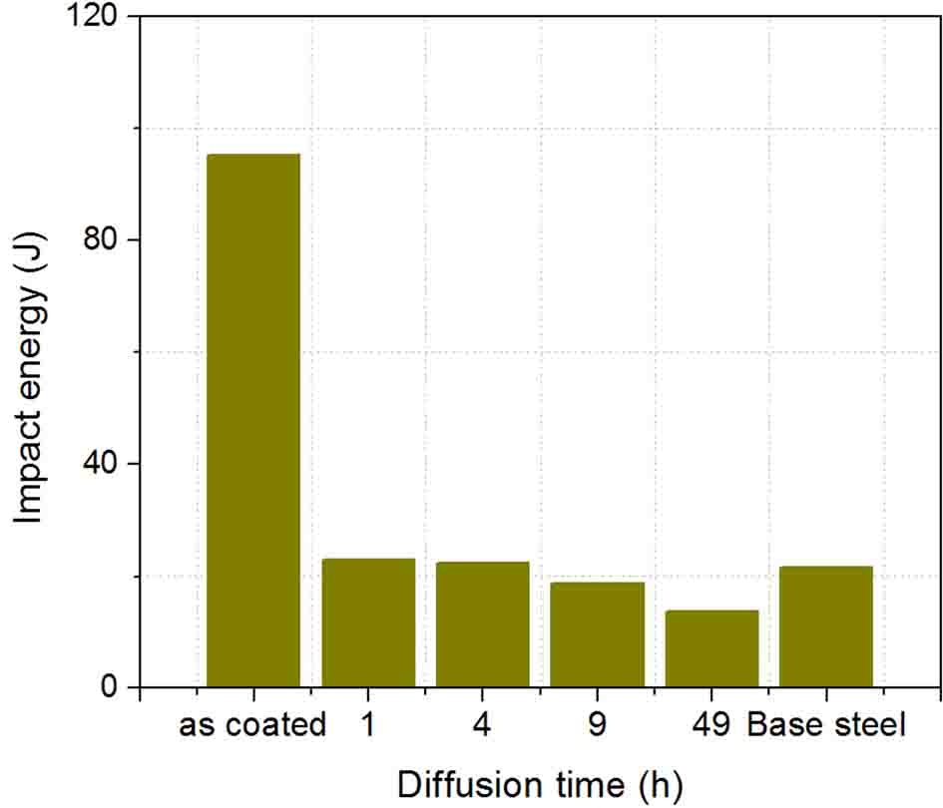
FIGURE 1. The average impact energy of aluminized AISI P20 steel with/without diffusion treatment

Tensile Test Results
Figure 2 shows the bar graph of engineering stress vs. diffusion treatment for the aluminized steel and base steel. The aluminized steel underwent a degradation of mechanical strength, which is undesirable for aluminized steel. The ultimate tensile strength of aluminized samples decrease with increasing diffusion time (Fig. 2), but the ultimate tensile strength of aluminized samples is higher than the base steel. Furthermore, a variation in yield strength is only slightly affected by increasing diffusion time.
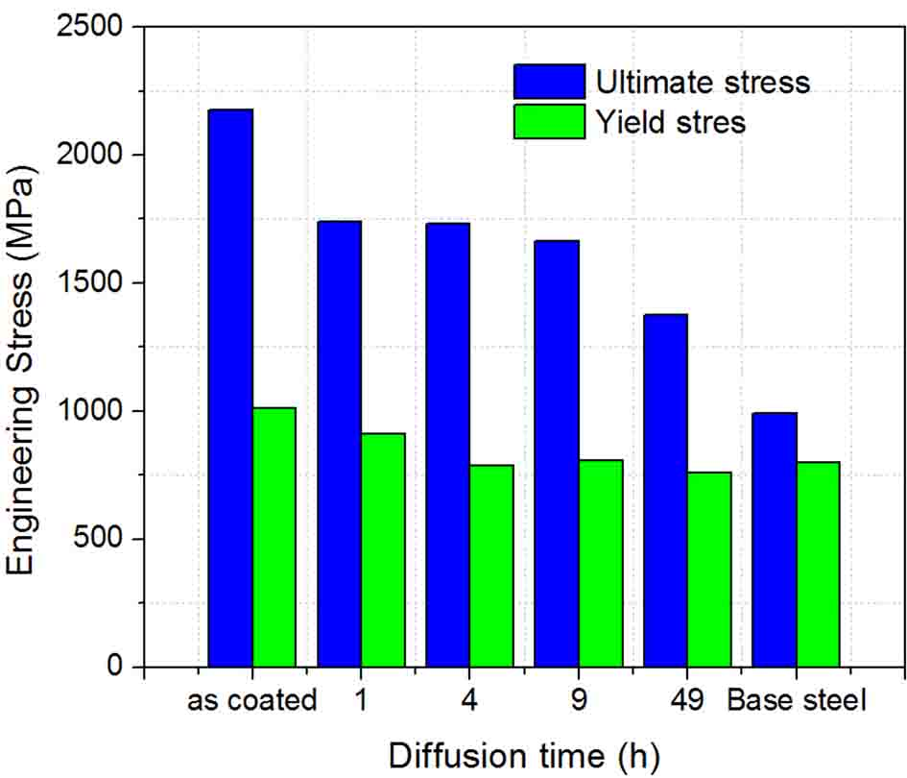
FIGURE 2. The average ultimate stress and yield stress of the aluminized AISI P20 steel after diffusion treatment at 750 °C for 1−49 h

Figure 3 shows the influence of diffusion time on the elongation of aluminized steels. The base steel shows the highest elongation value and aluminized steel shows the higher elongation to fracture for the aluminized steel without diffusion treatment (Fig. 3). Figure 3 shows elongation to fracture for the aluminized steel with and without diffusion treatment and base steel. There is a decrease with increasing diffusion time. In addition, the elongation to fracture for aluminized steel shows a linear trend as the diffusion time increased at 750 °C.

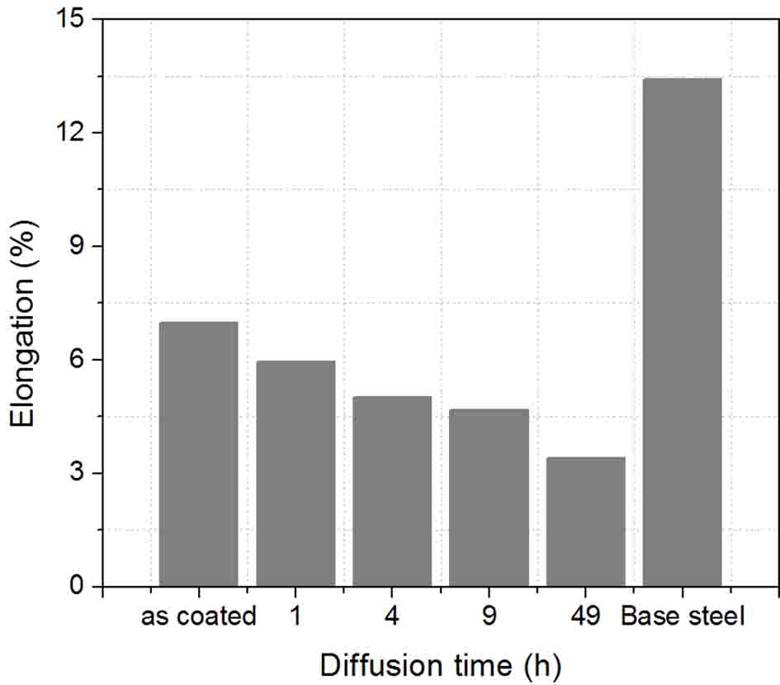
FIGURE 3. The average of elongation values of the aluminide coating on AISI P20 steel after diffusion treatment at 750 °C
Characterization of Phase Constituents
The SEM imaging of the aluminide coating cross−section and the corresponding EDS analysis on AISI P20 steel is shown in Fig. 4. The EDS results corresponding to Fig. 4 are summarized in Table 1. Figure 4a shows the microstructural features of the specimen of aluminized steel (as coated) at 700 °C for 2 min. The coating layer consists of two regions: the Al−Si layer and the intermetallic layer. The chemical compositions of the IMC in regions II are consistent with τ₅−Fe₂Al₈Si, FeAl₃, and Fe₂Al₅ as shown in Table 1. The thicknesses of the aluminum and intermetallic layers are approximately 20 μm and 3.5 μm (consisting of FeAl₃ and Fe₂Al₅ layers), respectively (Fig. 4a). The intermetallic layer has a homogeneous and dense structure toward the steel substrate. No pores or cracks were seen in the aluminide coating.

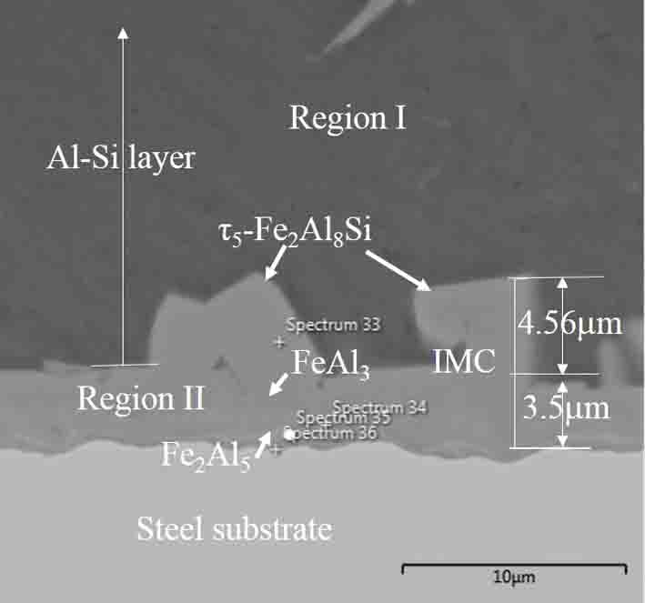 | 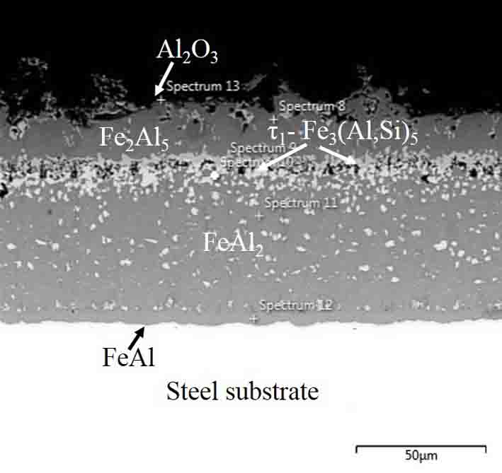
(a) | (b)
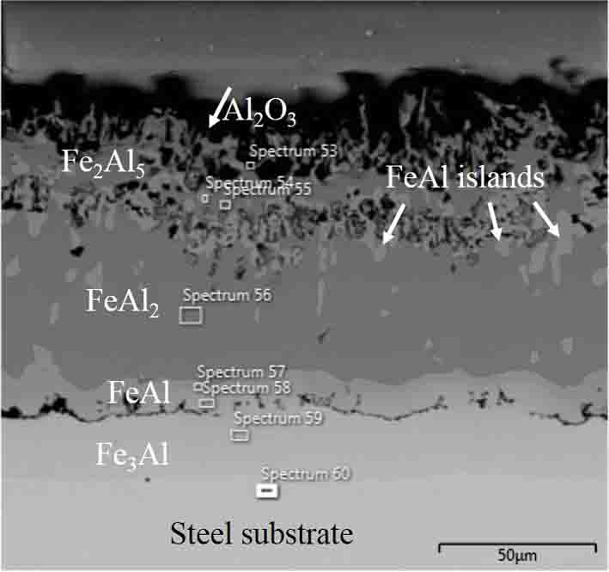
(c)
FIGURE 4. SEM micrographs of aluminide layer: (a) as coated, (b) aluminized steel after 4 h diffusion time, and (c) aluminized steel after 49 h diffusion time at 750 °C. The spectra numbers show the EDS analysis points

SEM (Fig. 4a) and EDS analysis showed that the polyhedral structure on the FeAl₃ layer is τ₅−Fe₂Al₈Si, where the τ₅−Fe₂Al₈Si phase was formed from a monovariant peritectic reaction: L + FeAl₃ ↔ τ₅−Fe₂Al₈Si. This occurred at 620 °C during the cooling process after the steel was dipped into a molten Al−Si bath [9]. Therefore, the polyhedral phase, τ₅−Fe₂Al₈Si, has a composition of 71.5 Al−19.8 Fe−8.70 Si (at.%) growing between Al−Si layer and FeAl₃ layer (Fig. 4a). Confirmation of the EDS results show that Si and Fe with a range of compositions in the τ₅−Fe₂Al₈Si phase are 5.3 to 8.7 at.% and 15.98 to 25.20 at.%, respectively. In contrast, the silicon concentration in FeAl₃ phase has a solubility of about 5.2 at.%. In this study, the EDS analysis result for Si in the aluminide coating is similar to those reported in Ref. [4,9]; the Si concentration is 1.06 to 7.12 at.%. The Fe₂Al₅ layer has a composition of 66.1 Al−27.9 Fe−6.0 Si (at.%). The high solubility of Si in the Fe₂Al₅ phase contributes to the planar structure toward the steel substrate [3,4].
The elemental composition of Al, Fe, and Si in the aluminide coating (in at.%) on the AISI P20 steel was examined by EDS spectrum analysis after diffusion treatment at 750 °C for 4 h and 49 h (Fig. 4b and Fig. 4c). EDS results (Fig. 4b and Fig. 4c) of the intermetallic phases formed in the aluminide layer were confirmed according to previous studies [3,4,9]. The chemical composition of Al, Fe, and Si elements in each aluminide layer are completely shown in Table 1. The formation mechanism of the intermetallic compound was dominated by the inter-diffusion between Fe−atoms in the substrate and Al−atoms in the coating layer during diffusion treatment at 750 °C. After diffusion treatment at 750 °C for 4 h, the polyhedral τ₅−Fe₂Al₈Si between the Al–Si eutectic topcoat and FeAl₃ layer of the as coated specimen disappeared. It was transformed into Fe₂Al₅ and FeAl₂. Moreover, the high content of Si in the τ₅−Fe₂Al₈Si layer rapidly diluted into the Fe−rich region due to the diffusion coupling between internal Al atoms and external Fe atoms to generate the bright τ₁−Fe₃(Al,Si)₅ regions adjacent to the Fe₂Al₅ and FeAl₂ layer in Fig. 4b. In addition, some voids were formed and were dispersed in the outer aluminide layer (Fig. 4b). The volume change induced by the phase transformation contributed to the void formation [8]. The void is called a Kirkendall defect.
TABLE 1. EDS analysis and intermetallic compounds formed in the aluminide layer corresponding
to Fig. 4a, Fig. 4b, and Fig. 4c.
Spectrum | Diffusion time (h) | Chemical composition  (at. %) |  |  |  | Phase
 |  | Al | Fe | Si | O
33 | As-coated | 71.5 | 19.8 | 8.7 | - | τ₅−Fe₂Al₈Si
34 |  | 70.5 | 24.4 | 5.2 | - | FeAl₃
35 |  | 66.1 | 27.9 | 6.0 | - | Fe₂Al₅
36 |  | 61.8 | 34.9 | 3.3 | - | Fe₂Al₅
8 | 4 | 66.7 | 22.8 | 10.5 |  | Fe₂Al₅
9 |  | 55.2 | 26.2 | 18.3 | - | τ₁−Fe₃(Al,Si)₅
10 |  | 45.1 | 36.0 | 18.9 | - | τ₁−Fe₃(Al,Si)₅
11 |  | 70.5 | 29.5 | 10.3 | - | FeAl₂
12 |  | 69.7 | 27.7 | 2.7 | - | Fe₂Al₅
13 |  | 43.8 | 13.9 | 1.67 | 35.9 | Al₂O₃
53 |  | 45.9 | 12.2 | 2.0 | 39.0 | Al₂O₃
54 | 49 | 46.5 | 41.0 | 10.2 | - | FeAl
55 |  | 67.6 | 29.8 | 1.8 | - | Fe₂Al₅
56 |  | 67.7 | 30.1 | 1.4 | - | Fe₂Al₅
57 |  | 54.2 | 38.7 | 5.4 | - | FeAl₂
58 |  | 33.3 | 56.6 | 7.8 | - | FeAl
59 |  | 18.9 | 75.5 | 2.2 | - | Fe₃(Al,Si)
60 |  | 6.4 | 89.2 | 1.0 | - | Fe₃(Al,Si)

As the diffusion time was increased to 49 h at 750 °C, the τ₁−Fe₃(Al,Si)₅ phase transformed to form FeAl islands in the outer aluminide layer, and the FeAl island became proportionally larger in size with respect to the increase in diffusion time as shown in Fig. 4c. The Fe−atoms diffused inward to the Fe₂Al₅ layer with increasing diffusion time. This diluted the aluminum in the Fe₂Al₅ phase, and it transformed into a FeAl₂ layer on the steel substrate (Fig. 4c). In addition, the FeAl layer gradually thickened toward to the steel substrate due many diffused Fe atoms into the FeAl₂ layer over time. The solubility of Si in both the FeAl islands and the continuous FeAl layer was similar in atomic composition: 7.8−10.2% [3,4]. The outer aluminide layer consisted of a thin Al₂O₃ layer for the aluminized steel specimens. This was diffusion-treated at 750 °C for 4 h and 49 h (Table 1).
As mentioned above, some voids will condense out and eventually develop into large pores in the aluminide layer. Thus, the pores formed can be a stress concentration source that can eventually lead to a decrease in the tensile strength and toughness (impact strength) of the aluminized steel during exposure to high temperatures. This finding is similar to Dryepondt and Pint [2] who found that a degradation in the mechanical properties of aluminide coating on both Fe− and Ni−based alloys was attributed to the development of voids at the interdiffusion zone/substrate interface and the presence of brittle phases in the interdiffusion zone. Similarly, there is a decrease in the mechanical properties of aluminized AISI P20 steel after diffusion treatment as shown in Fig. 1 and Fig. 2. However, the tensile strength and highest impact strength values of aluminized steel (as−coated) increased significantly compared to the aluminized sample with diffusion treatment because the intermetallic layer on the steel substrate consisting of FeAl₃ and Fe₂Al₅ layers (Fig. 4a) did not yet contain defects. This is similar to the results reported by Kobayashi and Yakou [5] where the FeAl₃ and Fe₂Al₅ phases have the highest hardness values compared with the FeAl phase. Thus, we suggest that the degradation of mechanical properties of hot-dipped aluminized AISI P20 steel are attributed to void formation induced into the phase transformation during exposure to a high temperature.

CONCLUSIONS
The hot-dip Al−7Si coating increases the mechanical properties of AISI P20 steel. There is good mechanical bonding between the steel substrate and intermetallic layer. This bonding is generated by the reaction between the liquid aluminum atoms and the solid iron atoms, and this is likely responsible for the increase in the tensile strength and impact energy of AISI P20 steel. However, after the diffusion treatment temperature of 750 °C was subjected to the aluminized AISI P20 steel, the tensile and yield strength decreased with increasing diffusion time. The decrease in tensile strength and impact energy of the aluminized P20 steel is influenced directly by phase transformation induced in void formation. Voids condensed into pores concentrate stress in the aluminide coating.
Acknowledgement
This research was financially supported by the Ministry of Research, Technology and Higher Education of Republic of Indonesia via the International Research Collaboration and Scientific Publication grant in 2017 with contract No. 590/UN26.21/KU/2017.
References
- A. Al-Mazrouee and R. K. S. Raman, J. Pres. Vess. Technol. 129, 454−459 (2007).
- S. Dryepondt and B. A. Pint, Surf. Coat. Technol. 205, 1195−1199 (2010).
- C. J. Wang and Mohd. Badaruddin, Surf. Coat. Technol. 205, 1200−1205 (2010).
- W. J. Cheng and C. J. Wang, Mater. Charac. 64, 15−20 (2012).
- S. Kobayashi and T. Yakou, Mater. Sci. Eng. A 338, 44−53 (2002).
- E. Frutos, D. Álvarez, L. Fernandez, and J. L. González-Carrasco, J. Alloys Comp. 617, 646−653 (2014).
- H. Liu, F. Li, W. Shi, S. Swaminathan, Y. He, M. Rohwerder, and L. Li, Surf. Coat. Technol. 206, 3428−3436 (2012).
- Y. Y. Chang, C. C. Tsaur, and J. C. Rock, Surf. Coat. Technol. 200, 6588−6593 (2009).
- T. Maitra, and S. P. Gupta, Mater. Charac. 49, 293−311 (2003).

