BIODIVERSITY OF BIRD SPECIES
(Case Study: In KPHP Gedong Wani Karang Rejo Village Jati Agung Sub District Lampung Selatan District Lampung Province Indonesia)

by
Bainah Sari Dewi¹⁾, Sugeng P. Harianto¹⁾,
A.B. Firdaus²⁾, M.Saipurozi²⁾, B.R. Nababan²⁾, D. Novayanti²⁾ L.N. Aminah²⁾
A.G. Pratiwi ²⁾ F. Rahmandani²⁾

¹⁾ Lecturer of Forestry Department Faculty of Agriculture University of Lampung
²⁾Graduated Student of Forestry in Master Program University of Lampung
Jl. Soemantri Brojonegoro no.1 Bandar Lampung Lampung Indonesia
Email : bainahsariwicaksono12@gmail.com

Abstract

KPHP Gedong Wani is a management system in production forest area by forestry goverment in Lampung Province, Indonesia. GedongWani area also as one of the habitat for biodiversity of bird and this research is the first observation since 2011 - 2016.The research location in KPHP Gedong Wani, Karang Rejo Village, Jati Agung subdistrict, Lampung Selatan district, Lampung Province, Indonesia, June 2016 was conducted to identify and analysis the diversity of birds species.
The methode had been used the concentrated method in three different locations : (1) wetland site, (2) stand of Hevea brasilliensis site, and (3) stand of Gmelina arborea site. The result had been found 7 birds species of 6 families (N=118). The highest diversity (Shannon-Wiener index) was in stand of Hevea brasilliensis area (H’= 1.825), and the lowest was in wetland area (H’= 1,593). The suitable habitat would be important support to food secure for birds as the bioindicator of environment.

Key word : Bird, diversity index, KPHP Gedong Wani, Lampung Province, Indonesia

INTRODUCTION

Ministerial Decree Number SK 68/Menhut-II/2010 dated 28 January 2010 and the Decree of the Minister of Forestry Number. SK 427/Menhut-II/2011 dated 27 July 2011 KPHP Gedong Wani area located in the region of Lampung Selatan District and Lampung Timur District of Lampung Province of ± 30,243 Ha.
UPTD KPHP Gedong Wani mostly consists of two regions administrative districts, 11 subdistricts and 39 villages, up to that location for the existence of rare flora and fauna, but for wild fauna that are not protected such as cobra and birds herons and other bird species that have not been identified (KPHP Gedong Wani, 2014).
The location of the research area of ​​UPTD KPHP Gedong Wani located at four registers Production Forest Area (KHP) are at KHP Way KATIBUNG I Register 5, KHP Way Ketibung II Register 35, KHP Way Tibang 37 and KHP Register Gedong Wani Register 40. The administration area administration of the province of UPTD KPH Gedong Wani most area serve as habitat for many species of wildlife.

Wild animals have a very important role in the interest balance of the ecosystem and one of them are various birds that have a role as agents of first seed dispersers, pollinators of flowers and pest control (Alikodra, 1990), and can use enough space both horizontally and vertically (Wisnubudi, 2009). Birds have high mobility and adaptability spacious (Welty 1982; Dewi dan Harianto, 2009), both in the areas of conservation set by the government as a nature preserve, wildlife reserves and national parks, and outside conservation areas such as plantations, agricultural land, land residents, plantations, forest production and cultivation area. Additionally a bird is a species that has an important role as indicators of biodiversity because birds have properties that support, that life in all terrestrial habitats around the world, sensitive to environmental changes and taxonomy are clear and the geographical spread of its already well known (Sujatnika et al. 1995). Diversity of bird species in one place will be different with another place. Welty (1982) and Parasasmita (2003) states that the presence of birds in a habitat are very closely related to physical factors of the environment such as soil, water, temperature, sunlight and biological factors that include vegetation and other wildlife.

Diversity of birds species were influenced by habitat type. The structure of vegetation and food availability in the habitat are the main factors that affect species diversity in a habitat (Tortosa, 2000). As a component of the habitat of birds, tree can serve as a cover (shelter from the weather and predators, nesting, play the rest and child care) (Setiawan, 2006). Habitat with more diverse vegetation variation will have a diversity of bird species that are higher in comparison to the habitat that has a rare vegetation. Birds sustainability should be maintained with the conservation of birds. Currently data and information about the diversity of birds species in the KPHP Gedong Wani are still limited. Therefore, the study of the diversity of birds species in this area are important to provide accurate scientific information needs for conservation efforts.

METHOD

The research was conducted in KPHP Gedong Wani, Karang Rejo village, Jati Agung subdistrict of Lampung Selatan district, Lampung Province, Indonesia. KPHP Gedong Wani is located in two areas of public administration, the district of Lampung Selatan and Lampung Timur (KPHP Gedong Wani, 2014), which consists of 11 sub district and 39 villages, while the geographical coordinates are located at 105º17'40"E to 105º32'35"E and 05º10'00" Latitude and 05º32' 30" Latitude in June 2016 using concentrated method (Bibby, Jones, and Marsden, 2000). Interview method (Sugiono, 2013) had been done for 30 respondents. Observations were consist of three observation sites : wetlands site, rubber vegetation site and Gmelina arborea vegetation site (Figure 1 and Figure 2).
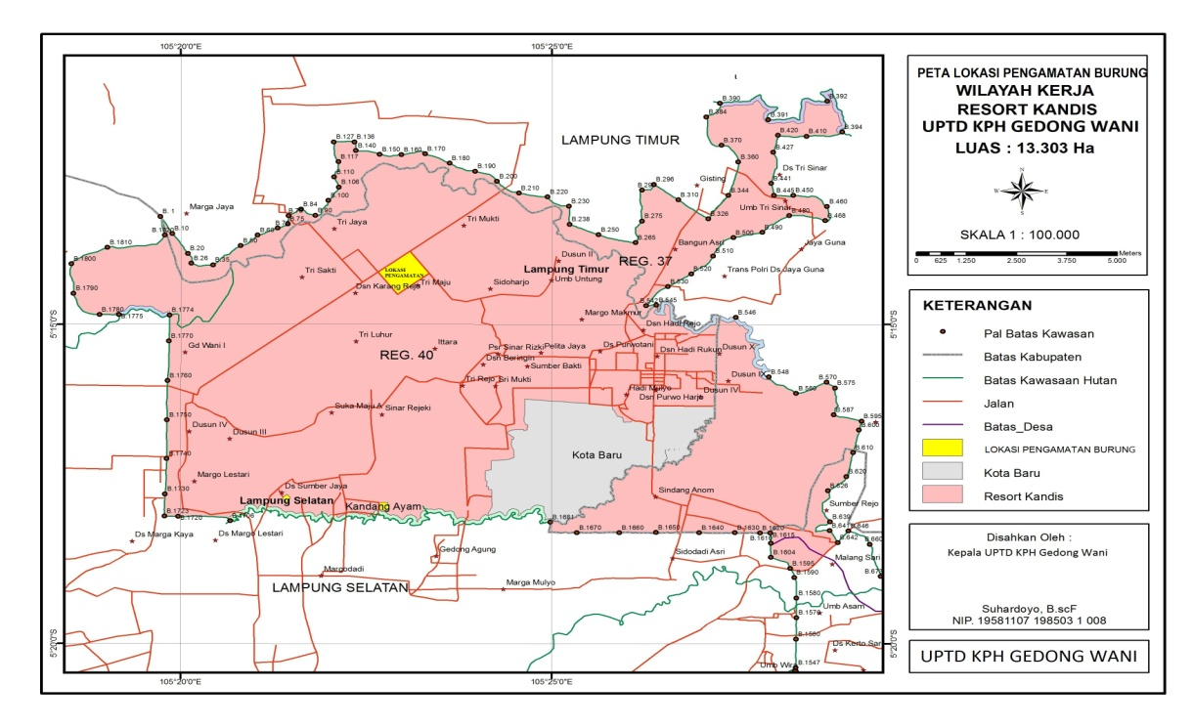
Figure 1. Map of the administrative area of ​​the KPHP Gedong Wani with scale of 1: 100.000
(KPHP GedongWani, 2014).

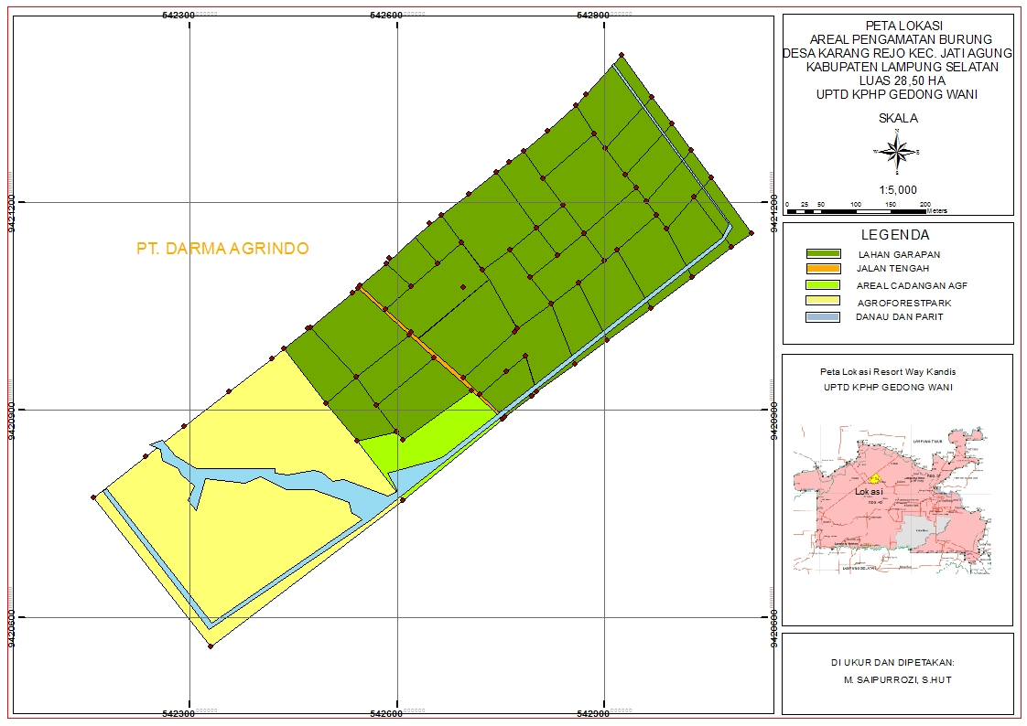
Site 3
Site 2
Site 1
Figure 2. Location Bird in Karang Rejo village, Jati Agung sub district, South of Lampung, Lampung Province, Indonesia by scale 1: 5.000, consist of type of vegetation 1: wetland Vegetation, 2: Rubber Vegetation, 3: Gmelina arborea Vegetation (Saipurozi, 2016).

The consentrated method was done in the morning at 6:00 am to 9:00 am. Bird identification refers to the "Handbook for the Identification of Bird Species in Sumatra, Java, Bali and Kalimantan" (MacKinnon, Philipps, and van Balen, 1998). Diversity of bird species were analyzed using diversity index Shannon-Wienner (Odum, 1971; Fachrul, 2007; Natarino, Dewi and Nurcahyani, 2010; Utama, Dewi, and Darmawan, 2011; Martin, Harianto and Dewi, 2012; Firdaus, Setiawan, and Lestari, 2012; Nababan, Setiawan and Nurcahyani, 2015; and Pamungkas and Dewi, 2015; Pratiwi, Harianto and Dewi, 2015; Triyanah, Harianto and Dewi, 2015), with the following formula: H '= -Σ Pi ln (Pi), where pi = (ni / N). Criteria for the Shannon-Wiener diversity index (H ') are as follows: ≤ 1 (low diversity), 1 <<3 (medium diversity), and ≥ 3 (high diversity).

RESULTS AND DISCUSSION

According to the research, in the three types of vegetation were founded 7 species of birds (N = 118) came from six families (Table 1). The species most commonly found is black nest swiftlet (Collocalia maxima) (n=29). This bird is found in all locations with the largest number of observations on the location of wetlands site. The location allows the mobility of birds is very good. According to MacKinnon et. al. (1998), this bird has a habit of hovering and flying around in the air or flying low over land or water to catch small insects. The result of diversity of birds in KPHP Gedong Wani were showed in Table 1.

Table 1. Species of birds found in KPHP Gedong Wani Lampung Selatan District
Lampung Province Indonesia June 2016
No | Local Name | Scientific Name | Family | Habitat |  |  | Abundance
 |  |  |  | 1 | 2 | 3
1 | Cekakak Sungai | Todirhamplus clhoris | Alcedinidae | 5 | 2 | 2 | 9
2 | Cekakak belukar | Halycon smyrnensis | Alcedinidae | 4 | 2 | 2 | 8
3 | Cucak kutilang | Pycnonotus aurigaster | Pynonotidae | 2 | 7 | 12 | 21
4 | Bentet Kelabu | Lanius schach | Laniidae | 0 | 9 | 5 | 14
5 | Perkutut | Geopelia striata | Columbidae | 0 | 9 | 8 | 17
6 | Bondol Haji | Lonchura maja | Ploceidae | 5 | 0 | 0 | 5
7 | Tekukur | Streptopelia chinensis | Columbidae | 2 | 7 | 6 | 15
8 | Walet sarang hitam | Collocalia maxima | Apodidae | 12 | 9 | 8 | 29
 | Total Individu |  |  | 30 | 45 | 43 | 118
 | Total Species per  Habitat |  |  | 6 | 7 | 7
Habitat Type:
1 = swamp vegetation
2 = Hevea brasilliensis /rubber vegetation
3 = Gmelina arborea vegetation

Families that have species found as the most family Columbidae (Table 1) are doves (Streptopelia chinensis) and Turtledove (Geopelia striata). Turtledoves have a characteristic size +30 cm long and reddish-brown petals.

The tail looks long with thick white edges. Wing feathers darker than body hair, there are distinctive black stripes on the sides of the neck, finely speckled white. Orange iris, black beak, and red feet. Usually in forest habitats, agorforest, plantation, residential, and rice fields. Normally it is live around residential and foraging on the ground. Often sit in pairs on the open road. Distribution in Sumatra, Kalimantan, Java, and Bali (Djausal, Bidayasari. and Ahmad, 2007; Ayat, 2011).
Turtledove has body features small size (21cm) with the dominant color is brown. On the back and side of the neck there are lines thin, gray face. Its habitat is in the forests, plantations (palm / rubber), agroforestry, residential and generally found in the lowlands to an altitude of 900 m. It have a habit in pairs or in small groups, feeding on the ground and often voiced mainly in the afternoon. Distribution in Sumatra, Kalimantan, Java, and Bali (Dewi, Mulyani, and Santosa, 2007;Ayat, 2011).

Collared kingfisher (Todirhamplus clhoris) is included in the family Alcedinidae. This bird has a characteristic size of ± 24 cm, blue and white. Crown, wings, back and tail sparkling blue-green light and there is a black stripe through the eye. Collar and white lower body is clean. Brown iris, half of dark gray, the lower half of a paler, gray legs. Voice "Ciuw ciuw ciuw ciuw ciuw" or "ges-ngek, ges-ngek, ges-ngek". Its habitat is in the forests, agroforestry, plantations and residential and has a habit of hunting large prey, slam-rocking first to perches before eating. Distribution in Sumatra, Kalimantan, Java and Bali (Wibowo, Harianto and Kustanti, 2005; Ayat, 2011).

Cucak finch is a bird belonging to the family Picnonotidae. This bird species is the bird-headed Bulbul cucak that eat fruit even also eat insects. Species of birds chirping aplomb with which many tend to live in trees. Cucak finch bird with a black cap on his head coverts whitish yellow and orange upside-down, chin and upper black stickmen. Collar, coverts, chest, and white stomach.

Long-tailed shrike (Lanius schach) included in the family Laniidae. This bird have a feature size of ± 19 cm, red-backed brick. Part obviously thicker, shorter tail, and eyes bigger than Brown faults (Bentet Coklat). Gray crown and nape; back, wings, and tail are brown with fine black lines, black eye strip width, lower body white, faintly striped brown on the sides of the body (male). Iris brown, blue-pointed black beak, gray legs. His voice was husky, babble screech, sound like Brown faults. Habitats in forests, plantations and open fields up to a height of 900 m above sea level. Have a habit of hunting insects from perches prominently on the edge of the forest. Distribution in Sumatra, Kalimantan, Java and Bali (Ayat, 2011).

Bondol pilgrimage (Lonchura maja) belonging to the family Ploceidae. This bird has feature small (11 cm), brown, white-headed. In juvenile bird brown upper body, lower body and facial dark yellow. Similar with Lonchura ferruginosa.
The difference: more brown, all head and throat is white color. Brown iris, mid-gray blue, pale blue feet. Distribution of this birds in Peninsular Malaysia, Sumatra, Java, Bali and Sulawesi, Thailand and South Vietnam, in the introduction in Japan (Osaka and Okinawa area).
They are easily to found, visit swamp and wetland up to a height of 1,500 meters above sea level. Forming a large group during the paddy harvest season, but distribute in pairs during the breeding season. Behavior generally like bondo (Pipit) (Yayasan Kutilang Indonesia, 2016).
Swallow (Collocalia maxima) belonging to the family Apodidae. It has the characteristics of relatively small size (13cm), dark brown. Coverts graded, from greyish to be the same color as the back. Difficult to distinguish edible-nest swiftlet, but looks fatter and truncated tail fairly straight. Hairy legs, iris brown, beak and black legs. Distribute in all Sunda Besar area. Most breeding near the coast of Sumatra and the islands around it. Swallow bird is the most common in the mountainous areas in chalk Kalimantan. Java is not common in small islands and coastal areas, but common in calk mountains. This bird has eat small insects caught in flight.
Nest of saliva mixed white hair, stick in a calk cave (called "black nest"). Black nest was taken to be sold, but not as expensive as a white nest, because it requires a lot of time to remove the hair and maggot. Issued rattle sound to ekho area. Lays two elongated grain white. Nested seasonally, depending on where it is (Yayasan Kutilang Indonesia, 2016).

Three observation points were found the number of different species of birds. First site of vegetation found 6 species with a total of 30 individual, Second site in the standing vegetation of rubber found 7 species with a total of 45 pieces, Third site in a stand of Gmelina arborea found 7 species with a total of 43 individual.

Figure 3. Histogram of Shannon Wienner diversity index (H') bird observation at three locations in KPHP Gedong Wani, Karang Rejo village, Agung Jati subdistrict, of Lampung Selatan district, Lampung Province, Indonesia, 2016.

The highest diversity index values ​​were found at the site of vegetation rubber (H '= 1,825) with a level of diversity criteria is medium level (1 <H'≤3). The site of the swamp vegetation (H '= 1.372), and the site of vegetation Wareng (H' = 1,788) also have a level of diversity that is medium level (1 <H'≤3). The medium level of diversity is that the site still used as a residence, feeding and breeding ground for bird species. These sites are supported by the vegetation is quite varied as feed for the birds, in contrast to a site that has a low level diversity index. The loss of vegetation caused the loss of food sources for birds, so the site has logged over low diversity index. Diversity of bird species has relation to the balance of the community environment. If the value of diversity index is high, that the indicate the balance of the community is also high. But, if the balance environment is high, it is not necessarily show a high diversity of species in that community (Purnomo, Jamaksari, Revive, Pradityo, and Syafrudin, 2009).
In the study of birds by Utama, Dewi, and Darmawan (2011) was found 43 species with a total of 4101 individuals from 23 families. According Handari, Dewi, and Darmawan (2011) was found a total of 29 species of 14 families and individuals a total of 2642 individuals.

According Rohadi, Dewi, and Darmawan (2011) at the University of Lampung swamp site there are 17 species of birds from 11 families with a total of 1005 individuals. The results of individual birds in Pulau Anak Krakatau Islands Nature Reserve Area, there are 27 species of birds from 18 families and 908 individuals (Martin, Harianto, and Dewi, 2012). According Natarino, Dewi, and Nurcahyani (2010) bird species was found in the area of ​​SHK Lestari Tahura Wan Abdul Rachman covered by 57 species in 23 families.

The number of birds was found in the study site in KPHP Gedong Wani less compared to other bird research that has been done. This is due to the relatively short time observation therefore the researchers was found a few individual and a few species of birds.
In addition to birds , the research sites in KPHP Gedong Wani also found several other species. Figure 4 is a diagram that showed the presence of other species found in KPHP Gedong Wani obtained through interviews with the surrounding communities and employees who works in KPHP Gedong Wani.

butterflies
Figure 4. The species found in KPHP Gedong Wani by interview method June 2016

Another species were found in KPHP Gedong Wani consist of butterflies, grasshoppers, crickets, dragonflies, ants, frog. There are mammals such as chickens, cows, goats, and deer .
Kinds of insects was found, can be used as food for birds . Most of these insects are found around the swamp site and also in agroforestry KPHP Gedong Wani. The existence of these insects are affect the availability population of birds on the sites.

Birds can be an indicator of the presence of the balance ecosystem . In KPHP Gedong Wani there are agroforestry area which is a pilot area of ​​food security where there are paddy field under Gmelina arborea stands . There are also plants fruits, such as longan (Klengkeng) , durian, and papaya. Some plants such fruits into the food security program, because basically the principle of food security programs are the needs of the community. When their primer food such as rice could not be fulfilled due to climate change which causes the rice plant could not grew every season. Birds play a role here as well to spread the seeds of plants of the fruit. The fruit trees are also food for the birds, therefore the cyclus of role of birds as bio indicator of suitable condition of environment have functioned.

CONCLUSION

Based on the results of research in KPHP Gedong Wani in 2016 there are 7 species of birds with the number of 118 individuals belonging from 6 families. Most bird species are the black-nest swiftlet (Collocalia maxima). The highest diversity index values ​​were found at the site of rubber vegetation (H '= 1.825), while the lowest level of diversity index is in the site of wetland (H' = 1.372).

REFFERENCES

Alikodra, H. S. 1990. Pengelolaan Satwa Liar. Fakultas Kehutanan Institut Pertanian Bogor. Bogor

Ayat. A., 2011. Panduan Lapangan Burung Burung Agroforest di Sumatera. World Agroforestry Center. ICRAF Asia Tenggara.

Bibby, C., M. Jones., dan S. Marsden. 2000. Teknik-Teknik Ekspedisi Lapangan : Survei Burung. BirdLife International-Indonesia Programme. Bogor.

Dewi, B. S. dan S. P. Harianto. 2009. Biokonservasi Satwa dan Tumbuhan (Spesies dan Peranannya dalam Hutan) di Pekon Pahmungan Kecamatan Pesisir Tengah Lampung Barat. (Laporan Penelitian). Tidak dipublikasikan. Jurusan Manajemen Hutan Fakultas Pertanian Universitas Lampung. Bandar Lampung.

Dewi. R. S., Mulyani, dan Y. Santosa. 2007. Keanekaragaman Jenis Burung di Beberapa Tipe Habitat Taman Nasional Gunung Ceremai. Media Konservasi. Jurnal Ilmiah Bidang Konservasi Sumber Daya Alam Hayati dan Lingkungan. Volume XII. Nomor III. Diakses tanggal 28 Desember 2014.

Djausal, A., I. Bidayasari. dan M. Ahmad. 2007. Kehidupan Burung di Kampus Unila. Universitas Lampung. Bandar Lampung.

Fachrul, M.F. 2007. Metode Sampling Bioekologi. Bumi Aksara. Jakarta.
Firdaus. A. B., A. Setiawan., dan E. R. Lestari., 2012. Keanekaragaman Spesies Burung di Repong Damar Pekon Pahmungan Kecamatan Pesisir Tengah Krui Kabupaten Lampung Barat. Jurnal Sylva Lestari Vol. 2 No.2, hal 1-6. Universitas Lampung.

Handari, A., B. S. Dewi., dan A. Darmawan. 2011. Keanekaragaman Jenis Burung di Hutan
Produksi Desa Gunung Sangkaran Kecamatan Blambangan Umpu Kabupaten Way Kanan. (Skripsi). Jurusan Kehutanan Fakultas Pertanian Universitas Lampung. Bandar Lampung. Tidak dipublikasikan.

Kesatuan Pengelolaan Hutan Produksi (KPHP) Gedong Wani. 2014. Rencana Pengelolaan Jangka Panjang KPHP Gedong Wani. KPHP Gedong Wani.

Mac kinnon. J., K. Philipps., dan B. Van Balen. 1998. Seri Panduan Lapangan Burung-Burung di Sumatera, Jawa, Bali, dan Kalimantan. LIPI. Bogor.

Martin, F., S. P. Harianto., dan B. S. Dewi. 2012. Keanekaragaman Jenis Burung Di Pulau Anak Krakatau Kawasan Cagar Alam Kepulauan Krakatau. (Skripsi). Jurusan Kehutanan Fakultas Pertanian Universitas Lampung. Bandar Lampung. Tidak dipublikasikan.

Nababan, B. R. R., A. Setiawan, dan N. Nurcahyani. 2015. Keanekaragaman Jenis Burung Di Lahan Basah Way Pegadungan Desa Rajawali Kecamatan Bandar Surabaya Kabupaten Lampung Tengah. Jurnal Sylva Lestari Vol 3 No 1 Hal 71-80. Universitas Lampung.

Natarino, A., B. S. Dewi., dan N. Nurcahyani. 2010. Studi Keanekaragaman Jenis Burung Sebagai Pengembangan Potensi Wisata Birdwatching di Wilayah Kelola Shk Lestari Tahura Wan Abdul Rahman. (Skripsi). Jurusan Kehutanan Fakultas Pertanian Universitas Lampung. Bandar Lampung. Tidak dipublikasikan.

Odum, E.P. 1971. Fundamental of Ecology. Third Edition. W.B Sounders Co. Philadelpia.
Pamungkas. A., dan B. S. Dewi., 2015. Keanekaragaman Jenis Burung Di Kawasan Budidaya Desa Fajar Baru Kecamatan Pagelaran Utara Kabupaten Pringsewu. (Skripsi). Jurusan Kehutanan Fakultas Pertanian Universitas Lampung. Bandar Lampung. Tidak Dipublikasikan.

Partasasmita R. 2003. Ekologi Burung Pemakan Buah dan Peranannya Sebagai Penyebar Biji. Makalah Falsafah Sains-Bogor. IPB.

Pratiwi. A. G., S. P. Harianto., dan B. S. Dewi, 2015. Biodiversitas Burung Di Desa Sungai Luar Kecamatan Menggala Timur Kabupaten Tulang Bawang Provinsi Lampung Indonesia. Seminar Nasional Silvikultur Ke-2, Kongres Masyarakat Silvikultur Indonesia & Musyawarah Forum Perbenihan Tanaman Hutan Nasional. Fakultas Kehutanan Universitas Gajah Mada. Yogyakarta.

Purnomo, H., H. Jamaksari., R. Bangkit., T. Pradityo., D. Syafrudin. 2009. Hubungan Antara Struktur Komunitas Burung Dengan Vegetasi di Taman Nasional Bukit Baka Bukit Raya. (Jurnal). Departemen Konservasi Sumberdaya Hutan dan Ekowisata Fakultas Kehutanan Institut Pertanian Bogor. Bogor.

Rohadi, D., B. S. Dewi., dan A. Darmawan. 2011. Keanekaragaman Jenis Burung di Rawa Universitas Lampung. (Skripsi). Jurusan Kehutanan Fakultas Pertanian Universitas Lampung. Bandar Lampung. Tidak dipublikasikan.

Saipurozi, 2016. Peta KPHP Gedong Wani.Tidak dipublikasikan.

Setiawan. A. 2006. Keanekaragaman Jenis Pohon dan Burung di Beberapa Areal Hutan Kota Bandar Lampung. (Jurnal). Jurnal manajemen Hutan Tropika Vol. XXI No.1 :1-13

Sugiyono. 2013. Metode Penelitian Pendidikan (Pendekatan Kuantitatif, Kualitatif Dan R&D). Alfabeta. Bandung.

Sujatnika, Jepson P, Soehartono TR, Crosby MJ & Mardiastuti A. 1995. Melestarikan Keanekaragaman Hayati: Pendekatan

Triyanah. E., S. P. Harianto., dan B. S. Dewi. 2015. Biodiversitas Burung Di Desa Kibang Pacing Kecamatan Menggala Timur Kabupaten Tulang Bawang Provinsi Lampung Indonesia. Seminar Nasional Silvikultur Ke-2, Kongres Masyarakat Silvikultur Indonesia & Musyawarah Forum Perbenihan Tanaman Hutan Nasional. Fakultas Kehutanan Universitas Gajah Mada. Yogyakarta.

Tortosa FS. 2000. Habitat Selection by Flocking Wintering Common Cranes ( Grus grus ) at Los Pedroches Valley, Spain. Etologia 8: 21

Utama, M. T., B. S. Dewi., dan A. Darmawan. 2011. Keanekaragaman Jenis Burung di Beberapa Tipe Lahan Mangrove Desa Sungai Burung Kecamatan Dente Teladas Kabupaten Tulang Bawang. (Skripsi). Jurusan Kehutanan.Universitas Lampung. Bandar Lampung. Tidak dipublikasikan.

Welty, J.C. 1982. The Life of Birds. Third Edition. Sounders College Publishing. New York.

Wibowo, R.B., S. P. Harianto., dan A. Kustanti. 2005. Keanekaragaman Jenis Burung di Hutan Mangrove Desa Pulau Pahawang Kecamatan Punduh Pedada Kabupaten Lampung Selatan. (Skripsi). Jurusan Manajemen Hutan. Universitas Lampung. Bandar Lampung. Tidak dipublikasikan.

Wisnubudi, G. 2009. Penggunaan Strata Vegetasi Oleh Burung di Kawasan Wisata Taman Nasional gunung Halimun Salak. (Jurnal) VIS NATALIS, Vol 02 No 2, September 2009. Diakses tanggal 29 Juni 2016

Yayasan Kutilang Indonesia. 2016 http://www.kutilang.or.id/ diakses tanggal 23 juni 2016 pukul 11. 15

