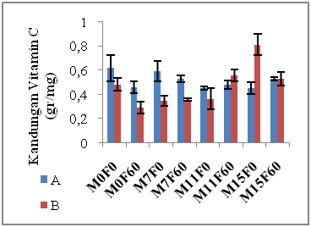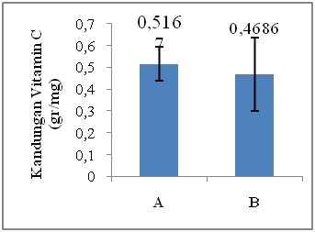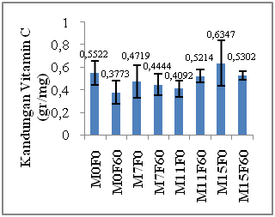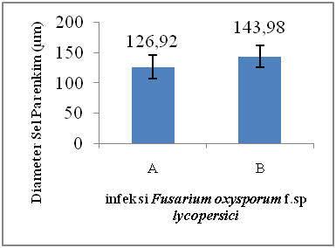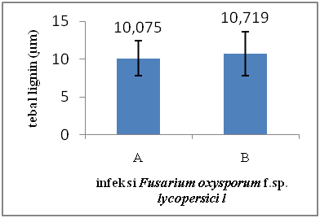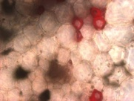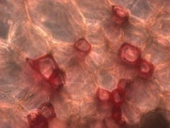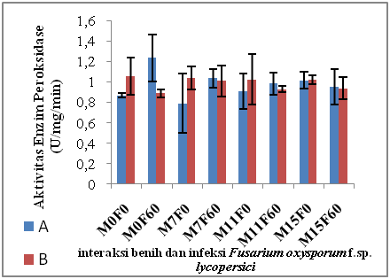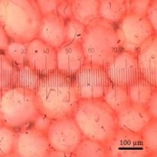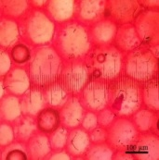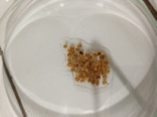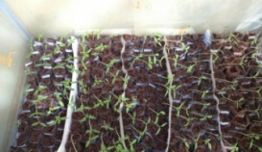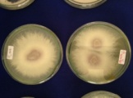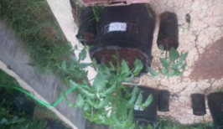

**Nungki, R. Agustrina, B. Irawan, E. Nurcahyani**

**Materials and Methods**

**Introduction**

Activity of peroxydase enzyme

**The Objective of study**

*Fol* infection

Infected F1 tomato seedlings (Fol) show the survival ability to grow from Fol attacks such as parent tuna that can be seen in the presence of:

1. The highest parameter of parenchymal parameters obtained from *Fol*-infected seed (143.98 μm)

2. Treatment of *Fol* infection does not provide any significant difference in lignin thickness of the xylem wall vessels, but the lignin of infected F1

seeds tends to be thicker (0.719 μm).

3. Combination treatment of B & F results in significant differences in peroxidase enzyme activity. The highest peroxidase activity was obtained from

F1 seed (M0F60) infected with *Foll* (M0F0B), 0.1783 U/mg/min.

4. All treatments of F1 seed type (B), Fol infection, and combination of B & F lead to significant differences in vitamin C content. The highest vitamin

C content obtained from the treatment M15F0B

**Conclussion**

Keterangan:

A: withaout *Fol* infection

B: infected with *Fol* for 60 min.

1: The effect of F1 seed type (B)

2: The effect oc *Fol*infection (F)

3: The effect of combination of B & F treat ment

3

3

1

2

2

2

B (60’)

A (0’)

Lignin

**Results**

Parenchyma diameter

vitamin C content

B (60’)

A (0’)

Seedlings

monospora *(Fol) isolation &* suspension *(*107 konidia/sel)

Parameter analysis

Maintenance

Planting

To assess the resistance of F1 tomato plants to Fol infection based on the diameter of parenchyma cells, lignin thickness, peroxidase enzyme activity and vitamin C content

Plants resistant to infectious microorganisms will show an increased activity of peroxidase enzymes, whereas in plants susceptible to infection will show decreased peroxidase enzyme activity (Agrios, 2005). Peroxidase enzymes also act as catalysts in the lignin formation process (Bouizgarne et al., 2006). In the presence of lignin, the plant cell wall becomes thicker so it is difficult dipenetrasi by pathogen (Hopkins et al., 2001). Previous research has shown that 0.2 mT exposure to magnetic fields of tomato seeds can increase the content of peroxidase enzymes and the ability of plants to survive against

*Fusarium* sp.

**FISIOLOGI DAN ANATOMI BATANG TANAMAN TOMAT (*Lycopersicum esculentum* Mill.) F1 YANG DIINFEKSI *Fusarium oxysporum* f.sp. *lycopersici (Fol)***