SOIL CARBON SEQUESTRATION AFTER FIVE YEARS OF NO-TILLAGE
AND BAGASSE MULCHING IN SUGARCANE PLANTATION

M. Utomo¹, A. Niswati¹, S. Yusnaini¹, D. T. Pamungkas¹, N. Diky¹, S. Haryani²,
N. Kaneko³
¹University of Lampung, Jl. Sumantri Brojonegoro, #1, Bandar Lampung, 35145, Indonesia, mutomo2011@gmail.com
²Research and Development Division of PT Gunung Madu Plantations, Lampung 34167, Indonesia, ciciarendy@yahoo.com
³Soil Ecology Research Group, Graduate School of Environment and Information Sciences, Yokohama National University, 79-7 Tokiwadai, Yokohama 240-8501, Japan, kaneko-noburo-sw@ynu.ac.jp
Soil organic C (SOC) play a crucial role in sustaining soil health and mitigating climate change. However, depletion of SOC pools in the tropics is quite high, therefore, it needs to implement best management practices to reduce it. The objective of this study was to determine five years effects of no-tillage system and bagasse mulching on soil carbon storage and sequestration in sugarcane plantation. The experiment was conducted in 2010-2015, at sugarcane plantation in Sumatra, Indonesia. The experiment was a factorial, split plot design, with 5 replications. Soil tillage system as main plot was conventional tillage (CT) and no-tillage (NT), while bagasse mulch as sub-plot was 80 Mg C/ha /year (M1), and with no bagasse mulch (M0). It revealed that after 5 years of tillage and bagasse mulching application, soil C storage under NTM1 was 42,85 Mg C/ha or 45.1% higher (P<0.5) than CTM0. Soil C storage under CTM0 was 29.40 Mg C/ha, the lowest among treatment combinations. Soil C sequestration under NTM1 was the highest among treatments (P<0.05), that was 2.75 Mg C/ha/year, while under CTMO was the lowest (0.24 Mg C/ha/year).

Introduction
Sugarcane (Saccharum officinarum L.) now is globally becoming an important crop for sugar and bioenergy. Indonesia in 2013 was the 8th in sugarcane production and ranked 31st in cane yields countries in the world (Zhao and Li 2015). In fact for more than 50 years, yield decline has become big issue in sugarcane production systems worldwide. The yield decline is because of soil degradation due to decreasing soil organic carbon (SOC) (Dominy et al. 2002; Follett 2001; Maia and Ribeiro 2004; Osher et al. 2003). Furthermore, depletion of SOC will not only induce yield decline, but also induce CO₂ emission (Lal 1997; Utomo et al. 2012; Utomo 2014). For sustainable sugarcane production, therefore, it is suggested to implement best management practices such as no-tillage, crop residue mulching and rotation with cover crop (Dominy et al. 2001).
In the tropics, SOC has important role on enhancing soil health and productivity, but easily depleted by unsustainable soil management (Lal 1997; Lal and Kimble 1997; Utomo 2014). Therefore, the ‘4 per mille Soils for Food Security and Climate’ that was intended to increase global soil organic matter stocks by 4 per 1000 (or 0.4 %) per year (Chambers et al 2016; Lal 2016; Minasny et al 2016) can be used as a reference goal for sustainable sugarcane production. With less soil surface manipulation and mulching, NT is expected to have lower CO₂ emissions, higher soil C sequestration and higher yield than that of CT (Lal 1997; Utomo 2014 ). Due to those reasons, worldwide adoption of NT has expanded rapidly since about 1990, particularly in the United States, Canada, South America, Europe, Asia and Africa (Derpsch et al 2010; Triplett and Dick 2008). In Indonesia as reported by Utomo (2014), food crop farmers had been practiced NT since 1990s due to the fact that it required less cost and labor, yet maintained at least the same crop yield as CT. In a particular sugarcane production, no-tillage and crop residue management have been practiced in Brasil (Cerri et al. 2011), Australia (Page et al. 2013; Stirling 2010); South Africa (Dominy et al. 2001) and US (Judice 2007).
Research of tillage and crop residue effects on C strorage and C sequestration in sugarcane shown different results. Compared to burning sugarcane harvesting system, C sequestration rate at 30-cm depth under unburning harvesting system of sugarcane in Brazil was 1.5 Mg C/ha/year higher (Cerri et al. 2011). Other research in Brazil shown that compared to CT, C storage in NT sandy clay loam Oxisol increased by 2.4 Mg C/ha with C sequestration rate 0.30 Mg C/ha/year (Bayer et al. 2006). However, other research in Queensland shown that the response to either trash retention or tillage management was small (Page et al. 2013). Overall, these reports indicate that most of the agronomic and environmental benefits are achieved when at least 7 Mg/ha of dry straw is maintained on the soil surface of NT (Carvalho et al. 2016).
In Indonesia however, there is a limited information about C storage and C sequestration from NT in sugarcane plantation. The objective of this research was to determine the effect of tillage systems and bagasse mulch on C storage and C sequestration under sugarcane plantation.
Material and Methods
Research site and design
The experimental site was located at sugarcane plantation area (4°40′ S, 105° 13′ E, 45 m above sea level) in Lampung Province, Sumatra, Indonesia (Miura et al. 2013). Schmidt dan Ferguson classifies the climate of this area as B, with temperature and humidity averages are 26.44 ºC 80.4% per year, respectively. The rainfall average was 186.42 mm/ month, with 8.3 months wet season and 2.4 months dry season (Astuti 2011). Based on Soil Taxonomy of US Department of Agriculture, the soil is classified as Hapludults (Soil Survey Staff 2014). The soil has thin top soil with low soil organic matter, and has sub soil with high clay. The research which part of long-term research (2010-2020), was conducted from July 2010 to May 2016 (Fig. 1), on the land that has been previously cultivated intensively for monoculture sugarcane for more than 30 years.
Ratoon 1 Ratoon 2 Ratoon3 Ratoon 1 Ratoon 2 Ratoon 3

2011 2012 2013 2015 2016

- Soil sampling 2014 Soil sampling 2020
Plantcane-1 Plantcane-2
Treatment applications

BBA application
Treatment applications

Figure 1. Time frame and activities of long-term tillage and mulching research in sugarcane plantation, Sumatra, Indonesia
A factorial experiment was arranged in Split Plot Design within Randomized Block Design, with five replications. The main factor was conventional tillage (CT) and no-tillage (NT), while secondary factor was bagasse mulch (M1) and without bagasse mulch (M0). Each plot was 25 m×45 m wide and buffer zone adjacent to the road was 5 m. In first years of plantcane-1 (2010) and plantcane-2 (2014), CT plots were ploughed three times, first to depths of 20 cm using disc plough, second to depth 20-25 cm using disc plough hurrow across the first plow, and third to depth 30-35 cm using moldboard plough. For planting cane seeds, furrow for a depth of 10-15 cm was performed. While for NT treatment plots, no plowing were applied except furrow (10-15 cm depth) for planting cane seeds. Cane seed stem was planted in 2010 using double rows system with distance between rows 90 cm and 130 cm, while in 2014 using single row system with distance between roows 150 cm. Cane seed stems were planted during last of July in 2010 and 2014. Due to herbicides were avoided to any of the treatments, manual weedings were applied. After harvest, harvested sugarcane left to regrowth as ratoons, and there were 3 ratoons per plantcane. Furthermore, for the mulch treatments (M1), bagasse mulch with high rate of 80 Mg/ha was spread on the soil after planting. Bagasse mulch had moisture content 59.7% and C-N ratio 86 (Table 1). Whereas for the no-mulch treatment (M0), no bagasse mulch was applied. Figure 1 shows frame time of field activity from 2010-2015.
Table 1. Chemical properties of bagasse mulch
Sample | Soil Moisture  content (%) | Soil  Organic C (%) | Soil  Organic N (%) | C/N
1 | 67.7 | 42.9 | 0.57 | 75
2 | 57.8 | 44.2 | 0.48 | 92
3 | 53.5 | 43.9 | 0.49 | 90
Average | 59.7 | 43.6 | 0.51 | 86

In this experiment, high rate of organic fertilizers composed of bagasse, blotong (filter cake) and ash (BBA) with C-N ratio 42 was used. BBA with the rate of 80 Mg/ha (wet weight) with ratio of 5:3:1 was applied in all plots only the first year of each plantcane. In CT plot, BBA was spread and mixed during second ploughing, while for NT was left over the land after planting. Meanwhile, inorganic fertilizers (N/P/K with ratio of 120:80:180 kg/ha) were spread in all treatments after planting or ratoons.
Soil sampling and analysis
Soil samples were collected twice on December 2010 (first year of plantcane-1), and on December 2015 (first ratoon on plantcane-2). For soil chemical analysis, composite samples of three sub-samples per plot were taken at 0-20 cm depth and thoroughly mixed. Soil organic carbon (C) and N were analyzed using Walkey and Black and macro Kjeldahl methods respectively, while the soil pH was determined by a 1:2.5 soil:H₂O. Soil temperature (ºC) and soil moisture content (%) at 5-10 cm depth were recorded with a HydroSense soil moisture sensor (Decagon Devices, Pullman, WA, USA). Undisturb core samples for bulk density (BD) measurement were taken at 0-20 cm depth prior to planting in 2010 and in December 2015 (first ratoon, plantcane-2).
The C sequestration estimation in this experiment was modified from those reported by Cerri et al. (2011); Galdos et al. (2009); Khasanaha et al. (2015). The C storage was calculated from soil BD and the carbon concentration as follow: C storage (g/cm²) = (SOC x BD x D)/100, where BD is soil bulk density (g/cm³), D is soil depth (cm), and C is soil organic carbon (%). Soil C storage was then up-scaled into per unit area of estimation (Mg C/ha). Thus, the C sequestration after 5 years of cropping (Mg/ha/year) = (C storage ₂₀₁₅ – C storage ₂₀₁₀)/5 years.
The statistical analyses were performed using the R software version 3.1 (R Development Core Team, 2009). The homoginity and additivity of the data were determined with Bartlett’s test and Tukey test and, respectively.
RESULTS AND DISCUSSION
Soil physical and chemical properties
Soil physical and chemical properties one year after treatment application (2011) were refered to that reported by Miura et al. 2013. There were no differences among treatments in soil pH_{KCl}, soil total C, soil total N, soil moisture, and soil temperature, but soil pH _{H2O} under NT was lower than CT (P< 0.05). After 5 years application (2015) however, the effect of tillage or bagasse mulch treatments on soil properties were more pronounce, but still no interaction effect between treatments (Table 2). Soil moisture and soil temperature under NT were lower than CT (P<0.05), while soil pH under bagasse mulch was higher than no mulch. Soil organic C after 5 years of cropping was strongly affected both by tillage and mulch application (Table 2). The higher SOC under NT and baggasse mulch treatments were mostly because of less soil disturbance and mulch effect (Follet 2001; Lal 1997; Utomo et al. 2012; Utomo 2014). Soil pH between tillage systems was similar, but under M1 was higher than M0. It might be due to the higher SOC with respect to M1 would buffer soil pH. Although not significantly different, BD under M1 tended to be lower than M0, regardless tillage system (Table 2).

Table 2. Soil physical and chemical characteristics five years after treatment (2015)
Treatments | Soil moisture (%) | Soil temperature (ºC) | Soil organic C (%) | Soil pH (H₂O) | Soil bulk density  (g/cm³)
NTM0 | 15.2 + 3.52 | 27.7 + 0.21 | 1.31 + 0.08 | 4.8+ 0.13 | 1.41 + 0.15
NTM1 | 17.6 + 2.66 | 28.6 + 0.59 | 1.60 + 0.20 | 5.1+ 0.02 | 1.35 + 0.22
CTM0 | 20.0 + 4.27 | 29.2 + 0.99 | 0.96 + 0.10 | 4.9+ 0.25 | 1.53 + 0.10
CTM1 | 22.3 + 2.92 | 28.8 + 0.62 | 1.23 + 0.14 | 5.2+ 0.10 | 1.43 + 0.18
Sources of Var. |  | Calculated F
Tillage system (T) | 9.47* | 31.54** | 117.23** | 0.63^{tn} | 2.57^{ns}
Bagasse mulch (M) | 4.51^{ns} | 0.54^{ns} | 43.78** | 12.73* | 1.41^{ns}
TxM | 0.01^{ns} | 4.57^{ns} | 0.05^{ns} | 0.30^{ns} | 0.06^{ns}
Note: CT= Conventional tillage, NT= no-tillage, M1= bagasse mulch and M0= without bagasse mulch; **= highly significant (LSD at 1%), *= significant (LSD at 5%), ns=not significant

Soil carbon storage and sequestration
It revealed that C storages at 0-20 cm depth 5 months after treatments application (2010) were still not significantly differences among treatments (P<0.5) (Fig.2 left). The ranges of C storage were 26.50 Mg C/ha (NTM0) to 29.09 Mg C/ha (NTM1). After 5 years of cropping however, soil C storages under treatments were increased significantly (P<0.5). Any combination with tillage systems, bagasse mulch effect on soil C storage was significant. Soil C storage under CTN0 was the lowest among treatment combinations (29.40 Mg C/ha), while under NTM1 was the highest (42.85 Mg C/ha) (Fig.2 right). These results are in accordance with those reported by Bayer et al. (2006); Galdos et al. (2009). In fact, C storage under CTM1 and NTM0 was not significantly difference.
During 5 years, NTM1 had sequestered as much as 13.76 MgC/ha of carbon, amounting to a carbon sequestration rate of 2.75 Mg C/ha/year (the highest among treatments). In contrast, CTM0 had sequestered only 1.2 Mg C/ha, yielding the lowest carbon sequestration rate of 0.24 Mg C/ha/year (Fig. 3). The higher soil C sequestration of NTM1 than CTM0 was attributed to synergitic effect between no-tillage and bagasse mulch. Due to less soil disturbance and less soil erosion, NT had higher SOC in the soil than CT (Lal 1997; Utomo et al. 2012; Utomo 2014). On the other hand, mineralization of high rate C input from bagasse (80 Mg C/ha/year) contributed a significant addition of soil C.

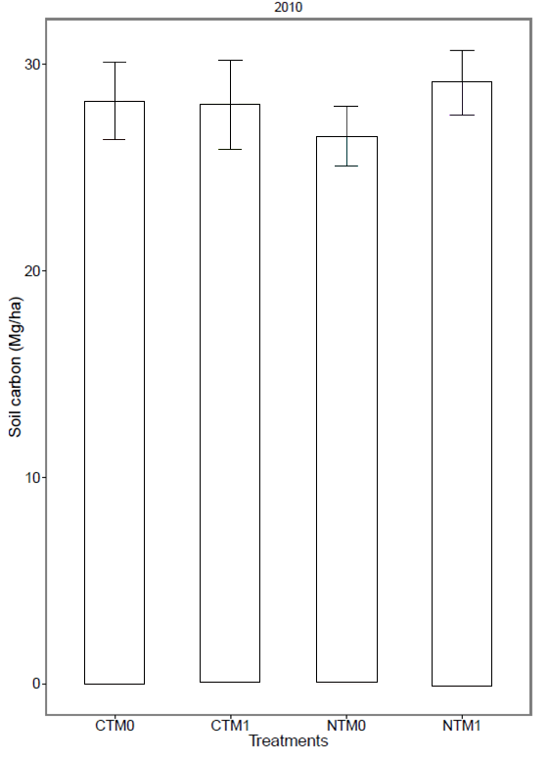
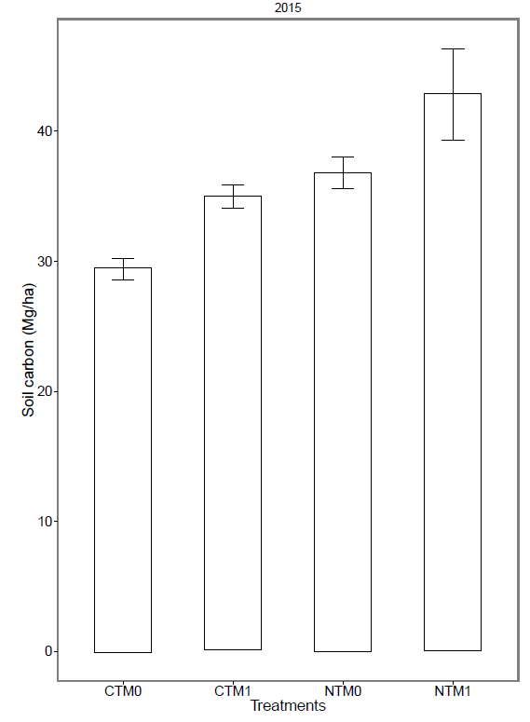

Figure 2. Soil carbon storage under tillage and bagasse mulch treatments (Mg C/ha)
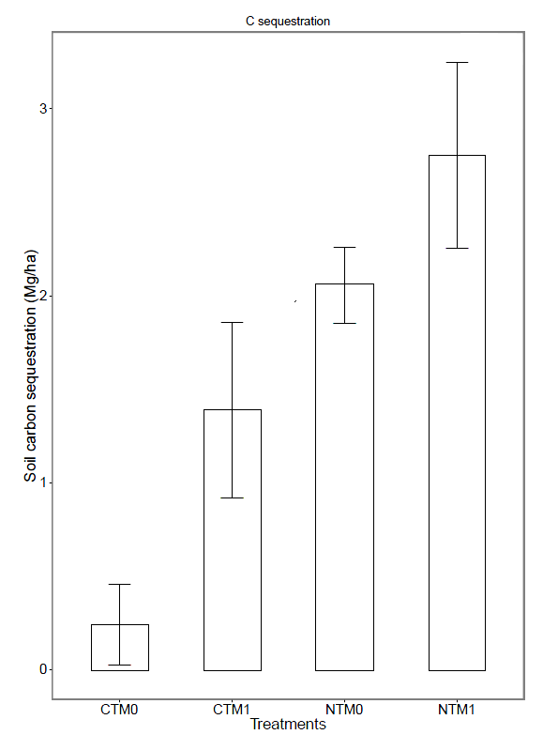

Figure 3. Soil carbon sequestration under tillage and bagasse mulch treatments (Mg C/ha/year)

It was noted that around 70% of bagasse mulch was converted to SOC after 7 months application (data not shown). Because of using high rate of mulch, this soil C sequestration rates under NT-mulch-sugarcane experiment are higher than those under NT-mulch corn-legume in Brazil (Bayer et al. 2006), and in Indonesia (Utomo 2014).

CONCLUSIONS
Any combination with tillage systems, bagasse mulch had significant effect on soil C storage and soil C sequestration. After 5 years of treatments, soil C storage under no-tillage with bagasse mulch was the highest, while under conventional tillage without bagasse mulch was the lowest among treatments. Soil C sequestration under no-tillage with 80 Mg C/ha of bagasse was the highest (2.75 Mg C/ha/year), while conventional tillage without bagasse mulch was the lowest among treatments (0.24 Mg C/ha /year).
The results suggest that no-tillage and high rate of bagasse mulch as best management practices can contribute to soil C sequestrtaion and soil health in sustainable sugarcane production.
REFERENCES
Astuti IY (2011). Pengelolaan tebu (Saccharum officinarum L.) di PT Gula Putih Mataram, Lampung tengah dengan aspek khusus aplikasi blotong pada tanaman tebu lahan kering. Theses (Unpublished).
Bayer C, Martin-Neto L, Mielniczuk J, Pavinato A, Dieckow J 2006. Carbon sequestration in two Brazilian Cerrado soils under no-till. Soil & Tillage Research. 86. pp. 237–245.
Carvalho JLN, Noguerol RC, Menandro LMS,Bordonal RDO,Borges CD, Cantarella H and Franco HCJ (2016). Agronomic and environmental implications of sugarcane straw removal: a major review. GCB Bioenergy. pp. 1-15.
Cerri CC, Galdos MV, Maia SMF, Bernoux M, Feigla BJ, Powlson D and Cerri CEP (2011). Effect of sugarcane harvesting systems on soil carbon stocks in Brazil: an examination of existing data. European Journal of Soil Science. 62. pp. 23–28.
Chambers A, Lal R, Paustian K (2016). Soil carbon sequestration potential of US croplands and grasslands: implementing the 4 per thousand initiative. J. Soil Water Conserv. 71: 68A–74A.
Derpsch R, Friedrich T, Kassam A, Hongwen L (2010). Current status of adoption of no-till farming in the world and some of its main benefits. Int J Agric & Biol Eng. 3 (1). pp. 1-25.
Dominy CS, Haynes RJ; Antwerpen RV (2001). Long-term effects of sugarcane production on soil quality in the south coast and the midlands areas of Kwazulu-Natal. Proc S Afr Sug Technol Ass.75. pp. 222-227.
Dominy, C.S., Haynes, R.J., van Antwerpen, R (2002). Loss of soil organic matter and related soil properties under long-term sugarcane production on two contrasting soils. Biology and Fertility of Soils. 36. pp. 350–356.
Follet RF (2001). Soil management concepts and carbon sequestration zin cropland soil. Soil & Tillage Research. 61. pp. 77-92.
Galdos MV, Cerri CC, Cerri CEP (2009). Soil carbon stocks under burned and unburned sugarcane in Brazil. Geoderma. 153. pp. 347–352.
Judice WE, Griffin JL, Etheredge Jr LM., and Jones CA (2007). Effects of crop residue management and tillage on weed control and sugarcane production. Weed Technolog. 21. pp. 606–611.
Khasanaha N, van Noordwijk M, Ningsih H, Rahayu S (2015). Carbon neutral? No change in mineral soil carbon stock under oil palm plantations derived from forest or non-forest in Indonesia. Agriculture, Ecosystems and Environment. 211. pp. 195–206.
Lal R (1997). Residue management, conservation tillage and soil restoration for mitigating greenhouse effect by CO₂-enrichment. Soil Tillage Res. 43. pp. 81–107.
Lal R and Kimble (1997). Conservation tillage for carbon sequestration . Nutrient Cycling in Agroecosystems 49. pp. 243–253.
Lal R (2016). Beyond COP 21: potential and challenges of the “4 per thousand” initiative. J. Soil Water Conserv. 71: 20A–25A.
Maia JLT, Ribeiro MR (2004). Cultivo contínuo da cana-de-açúcar e modificações químicas de um argissolo amarelo fragipanico. Pesquisa Agropecuária Brasileira 39. pp. 1127–1132.
Minasny D, Malone BP, McBratney AB, Angers DA, Arrouays D, Chambers A, Chaplot V, Chen ZS, Cheng K, Das BS, Field DJ, Gimona A, Hedley CB, Hong SY, Mandal B, Marchant BP, Martin M, McConkey BG, Mulder VL, O'Rourke S, Richer-de-Forges AC, Odeh I, Padarian J, Paustian K, Pan G, Poggio L (2017). Soil carbon 4 per mille. Geoderma. 292 (15). pp 59–86.
Miura T, Niswati A, Swibawa IG, Haryani S, Gunito H, Kaneko N (2013). No tillage and bagasse mulching alter fungal biomass and community structure during decomposition of sugarcane leaf litter in Lampung Province, Sumatra, Indonesia. Soil Biology & Biochemistry. 58. pp. 27-35.16.
Osher, LJ, Matson PA, Amundson R (2003). Effect of land use change on soil carbon in Hawaii. Biogeochemistry. 65. pp. 213–232.
Page KL, Bell M, and Dalal RC 2013. Changes in total soil organic carbon stocks and carbon fractions in sugarcane systems as affected by tillage and trash management in Queensland, Australia. Soil Research. 51. pp. 608–614.
R Development Core Team 2009. A language and environment for statistical computing.
Soil Survey Staff (2014). Keys to Soil Taxonomy. 12th ed. Washington, DC: USDA-Natural Resources Conservation Service. 360p.
Stirling GR, Moody PW, Stirling AM (2010). The impact of an improved sugarcane farming system on chemical, biochemical and biological properties associated with soil health. Applied Soil Ecology. 46. pp. 470–477.
Triplett GB and Dick WA (2008) No-tillage crop production: a revolution in agriculture. Agro J. 100. pp. 153– 156.
Utomo M, Buchari H, Banuwa IS, Fernando LK and Saleh R (2012). Carbon storage and carbon dioxide emission as influenced by long-term conservation tillage and nitrogen fertilization in corn-soybean rotation. J Trop Soils. 17 (1). pp. 75-84.
Utomo M. (2014). Conservation tillage assessment for mitigating greenhouse gas emission in rainfed agro-ecosystems. N. Kaneko et al. (eds.), Sustainable Living with Environmental Risks. pp. 35-44.
Zhao, D and Li YR (2015). Climate change and sugarcane production: potential impact and mitigation strategies. International Journal of Agronomy. 2015. 10p.

