DIVERSIFIED PORTFOLIO FORMATION OF SHARES THROUGH STOCK JAKARTA ISLAMIC INDEX (JII) IN INDONESIA STOCK EXCHANGE
By
Prakarsa Panjinegaraª
ª Department of Management, Economics and Business Faculty of Lampung University, Bandar Lampung
email: prakarsapanjinegara@gmail.com

ABSTRACT
Stock diversification in shaping the investment portfolio is use in order to avoid the risk of investment that the same or similar Relatively, when it is put on the same place by the investor. Jakarta Islamic Index (JII) is one of the indices in Indonesia Stock Exchange the which consists of a set of shares amounted to 30 selected from stocks that have meet the criteria of Islamic Sharia
This study Aimed to see what stocks are included in the JII index in the Indonesia Stock Exchange from January 2012 to December 2016 were eligible to be included into the investment portfolio. Portfolio Viewed performance measurements can be based on the value of Excess Return Portfolio (Alpha) generated. Portfolio performance calculation results Obtained 13 companies listed in the index JII is eligible to be included into the stock portfolio.
Keywords: Return JII, Portfolio, Alpha.

I. Introduction

A. Background Research
Establishment of a portfolio of stocks in anticipation of investment risk in the capital markets is an activity that must be done by the stock investors in order to secure the value of the assets invested. The uncertainty of the result(return)is expected to create the risk that vary according to the type of shares invested.
Ideally, the higher the expected return on investment, the higher the level of risk faced. Conversely the lower the level of the expected results, the lower the level of risk faced. In fact, a lot of investment that is not comparable between the rate of return and risk, so the need for in-depth analysis on the types of investments eligible in the sense of worth between the level of results and the level of risk faced.

Diversify stock in shaping the investment portfolio in order to avoid the risk of investing relatively the same or similar that is introduced into the container's investment portfolio. Diversifying the number of shares in general the principle of world famous stock investing is"Donot Put Your Eggs in OneBasket"that in the literal sense is not to invest fully in only one type of shares alone but should be invested in various kinds of stocks of different types risk so get one that has a minimum risk portfolio with a certain return or a specific risk with maximum return. Diversification should be improved along the marginal benefit exceeds the marginal cost. Statman (1987) stated that the advantage of diversification is to reduce risk. While the fee is the cost of the transaction. Dissent to limit diversification is that the marginal costs rising faster than the marginal benefit from the increase in diversification. Furthermore, Sharpe (1995) argues that diversification can reduce risk, especially the risk of non-market(non-marketrisk).When the value of one share is worse than expected, other stock is likely to be better than expected. In general, the more shares in the portfolio the more likely good luck (good stock) would appear sufficient to offset the bad luck (bad stock). Sharpe further stated that with the increased diversification, the number of non-market risk can be expected to decline, but not proportionately.

Bart (1992) also said that diversification helps investors minimize the risks arising from developments that do not appear from the world economy, the national economy, competition and the management of the company. In an effort to minimize the risks, an investor should diversify by creating a portfolio, where investors are not only investing in a certain company's stock but on some stocks of different companies. With this diversification is expected that investors will gain greater returns compared to only invest in one stock alone. Diversification of risk is crucial for investors, because it can minimize the risks that arise without having to reduce the return you receive.
Jakarta Islmic Index (JII) is one of the indices in Indonesia Stock Exchange which consists of a set of shares amounted to 30 selected from stocks that bersyariah Islam. At the initial launch, stock selection criteria are included in bersyariah involving Syariah Supervisory Board of PT Danareksa Investment Management. However, in line with market developments, the election task was taken over by the Capital Market Supervisory Agency and Financial Institution (Bapepam-LK) in collaboration with the National Sharia Council.

Based on The Figure 1 shows that the movement of the index JII during 2016 tended to increase since the month of January to December. This shows the price of stocks included in the index JII relatively good and improving, but if the stock prices are rising also can improve the performance of the stock, it can be seen from the result of the merger of shares JII into the investment portfolio.

Figure 1. The movement of Jakarta Islamic Index Shares Period 2015-2016
Source:2016 BEI
II. Basic Theory

2.1 Basic Concept

Sharpe (1995) states that risk and return are two characteristics of the investment, therefore it is important to know its origin. Important factors that cause must be identified and evaluated. This is the main task of the security analysis and the results are crucial elements to form a portfolio, revise, evaluate and establish a long-term investment strategy.
The fundamental purpose of the portfolio is to get the optimal allocation among different assets. Portfolio understood as a set combination of assets to be invested and held by investors, both perorarangan and institutions. It could be a combination of real assets such as gold, silver, real assets and financial assets such as securities firms or proof of ownership of shares. In equity markets, the portfolio is associated with the financial asset portfolio is a combination of several stocks so investors can achieve returns optimaland minimize risk (Sumariyah, 1997).

According to Robert Ang (1997) is a collection of portfolio investment instrument established to meet investment objectives. Jones (2000) argued mean a set of securities portfolio where the relatively small number of funds can be invested by buying shares of companies that operate in a variety of industries, in addition to the portfolio will reduce risk. Husnan (2003) describes the portfolio as investment diversification strategy into two or more shares to reduce risk.
A rational investor would choose an efficient portfolio, because it is formed by optimizing the portfolio of one of the two dimensions, ie the return expectedor the return of the portfolio. Efficient portfolio is a portfolio that gives return the greatestexpectations with the level of risk that is certain or a portfolio containing the smallest risk to the level of return expectedgiven (Jogiyanto, 2003). Portfolio said to be efficient if the portfolio lies in the efficient set or efficientfrontier.
Tanjung, Suhadak, Sujana (2011) conducted a fundamental approach in determining the value of shares in the Food and Beverages Sector in Indonesia Stock Exchange. The results showed that the fundamental factor influential in determining the stock assessment.
Karambe, Tandelin (2003) support the use of models Arbitrage Pricing Theory (APT) on the Stock Exchange to explain the returns on stocks or portfolios basil. The study also did test other variables are pre-ranking beta, size and size-pre-beta through the establishment of a portfolio rankings, found that two other variahel are firm size and the ratio of book to market value natal able to explain the yield.
III.RESEARCH METHODS
3.1 Types and Sources of Data
3.1.1 Types of Data
In this study the data types used in the form of secondary data that shares the listing (JII) at the Indonesian Stock Exchange (BEI). JII stocks are shares illiquid market capitalization, has a frequency trading is high, growth prospects and financial condition is quite good, is not volatile and objectively selected by the Stock Exchange and the stock of safe owned for fundamental stock's performance are good, so in terms of risk groups JII stocks have the lowest risk than other stocks. Fluctuating price on the JII stocks tend to be stable group make a return of capital gain is not as high in the group of stocks that experienced significant price fluctuations.

JII stocks are actively traded shares on the Indonesia Stock Exchange (IDX), the data used JII stocks are stock data observation period from January 2012 to December 2016.
3.1.2 Sources of Data
- Price closing price of the shares JII monthly sign of Stock Securities Indonesia (BEI) in January 2012 to December 2016.
- The interest rate on Bank Indonesia SBI report from the period January 2012 to December 2016.
- The market price derived from index index data JII JII where every weekend there in JSX monthly statistics 2012 to 2016

3.2 Population and Sample

Population can be interpreted as a whole element of concern in a study. The population in this study are allcompany publicly traded listed on the Indonesia Stock Exchange in the period from January 2012 to December 2016.
Sampling was done by purposive sampling with certain criteria, among others:
1. Only select stocks that fall into JII for 5 years consecutive observation period between the years 2012-2016.
2. No stocksplit, because there will cause a bias in the calculation of returns.
Based on the above criteria were included in this study sample as many as 14 stocks. The list of companies included JII shown in Table 3.1 below.

Table 3.1 Daftar JII stocks for 2012 to 2016

No. | Code | Issuer Name
1. | AALI | Astra Agro Lestari Tbk
2. | ASII | Astra International Tbk
3. | ASRI | Alam Sutera Realty Tbk
4. | CPIN | Charoen Pokphand Indonesia Tbk
5. | INTP | Indocement
6. | ITMG | Indo Tambang MegahTbk
7. | KLBF | Kalbe Farma Tbk
8. | LPKR | Loppo Karawaci Tbk
9. | LSIP | PP London Sumatra Indonesia Tbk
10. | PTBA | Coal MineBukit Asam Tbk
11. | SMRA | Summarecon Agung Tbk
12. | TLKM | Telekomunikasi Indonesia Tbk
13. | UNTR | United Tractor Tbk
14. | UNVR | Unilever Indonesia Tbk
Source: Results Analysis, 2016

3.3 Techniques of Data analysis
Methods analyst data used in this research is quantitative analysis, which is used to analyze the size of the performance of the portfolio consisting of stocks JII. Steps in analyzing the data obtained from the Indonesian Stock Exchange (BEI) and Bank Indonsesia (BI) to measure the performance of the portfolio is as follows:

3.4.1 Test Assumptions Normality
Test normality assumption is to determine whether the data is normally distributed. To test the assumption of normality can be seen through the test Augmented Dickey Fueller(ADF).

3.4.2 Assessment of shares with Make use of Capital Asset Pricing Model (CAPM)
1. Calculating returns stock
Calculating returns stockeach month during the period estimated an index of individual stock price (IHSI) of each of the issuer company JII anticipation of their corporate actions performed that could affect the share price in calculating stock returns (Samson, 2006), the calculation method with using the formula:
formula:
IHSI_{t} - (IHSI_{t -}1)
R_{i} = + D_{t} ............. .................. (1)
IHSI_{t - 1}
Where:
R_{i} : Return in t
P_{t:} share price(closingprice)in t (in rupiah)
P_{t-1:} stock price(closingprice)in t-1 (in rupiah)
D _{t:} dividend stocks in period t

2. Calculate Return Monthly Market
calculate Return is calculated monthly market by the following equation, assuming the dividend market is not counted or considered zero.
ILQ45_{t} - ILQ45_{t-1}
R_{m} = + D_{t} …………………….…….(2)
ILQ45_{t-1}

Where:
R_{m} = return market
JCI_{t} = Index of market prices of securities in the period of allt
JCI_{t-1}= price of the securities market in the period prior to t
D_{t} = Dividends market period t
3. regressing (R_{i}-R_{f)}and (R_{m}-Rf) for forming CAPM model

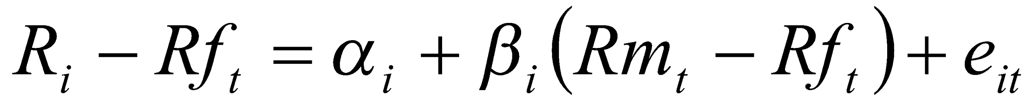 …………………………………...(3)
Description:
= Stock Return
= Risk Free rate of Return
= Returnthe market portfolio

- Determine the equation of Security market line (SML)
E (R) = Rf + [E (Rm) Rf] x βi

- Formation of a portfolio based Excess Return to Beta (ERB)
ERB = (Ri-Rf) / βi ......................................................... (4)

- Determining the amount of cut-off rate (Ci)
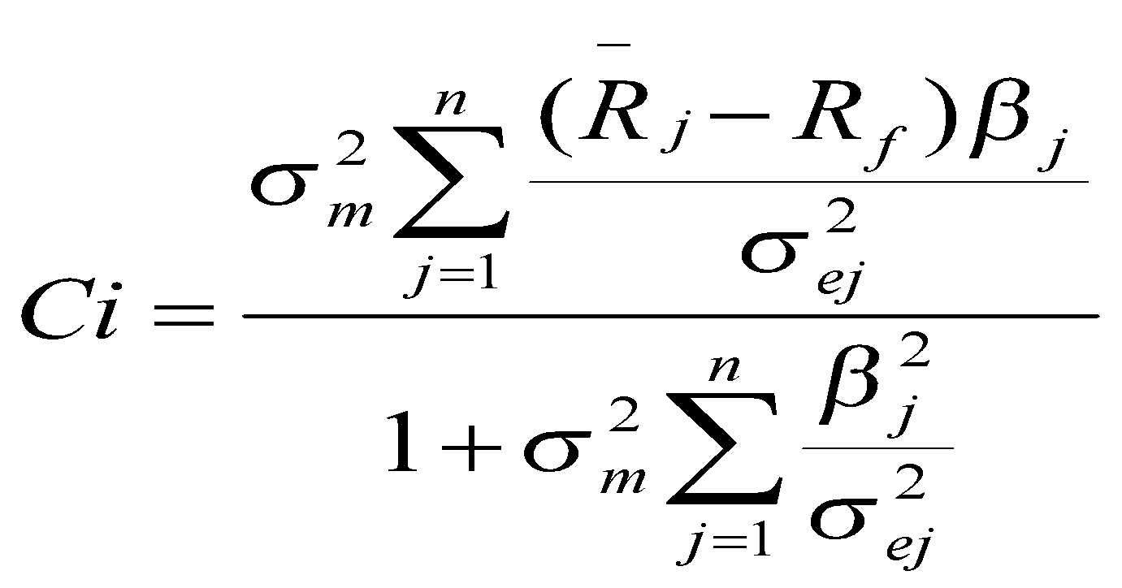

………………………..(5)

- Determine the shares will be included added to the portfolio on the basis of the positive values obtained from the reduction of ERB-Ci

- Doing weighting of each stock is based on based on the weighted average of the value of stock returns

weights Xi = 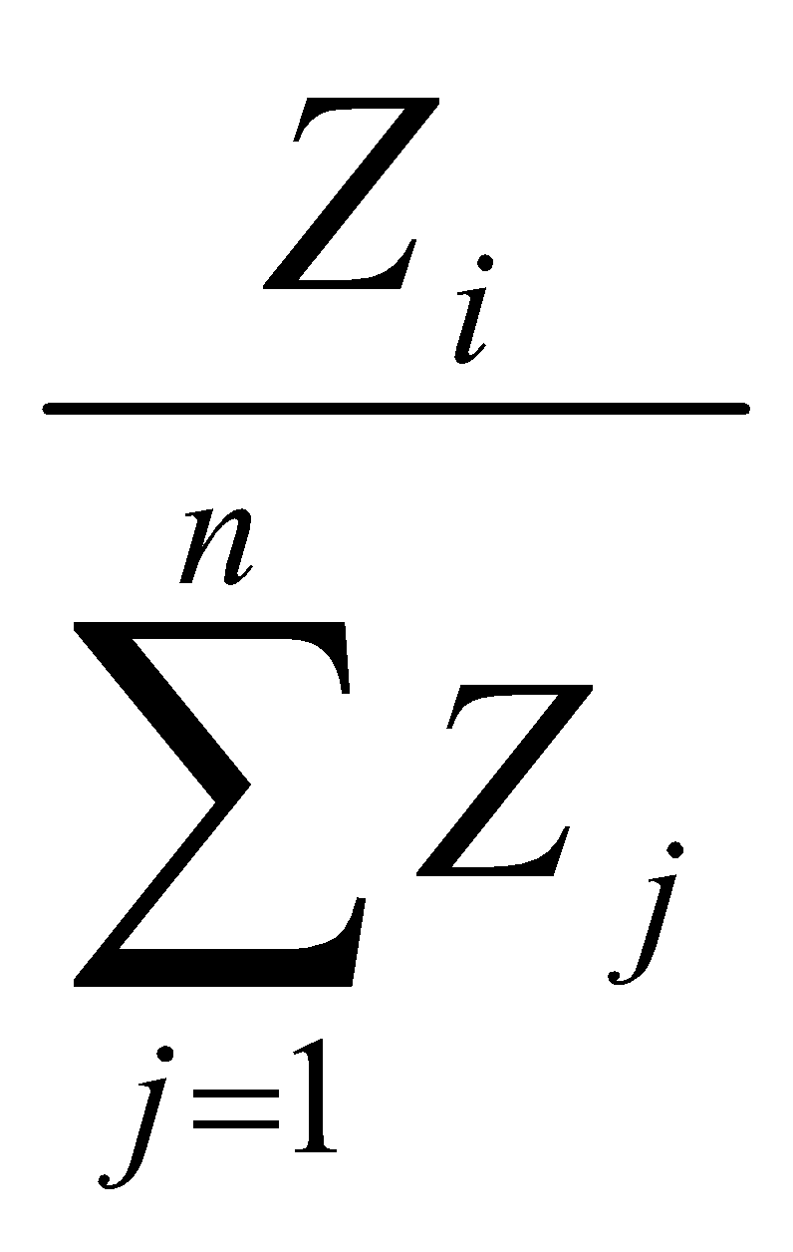 ...................................................... (6)

Where 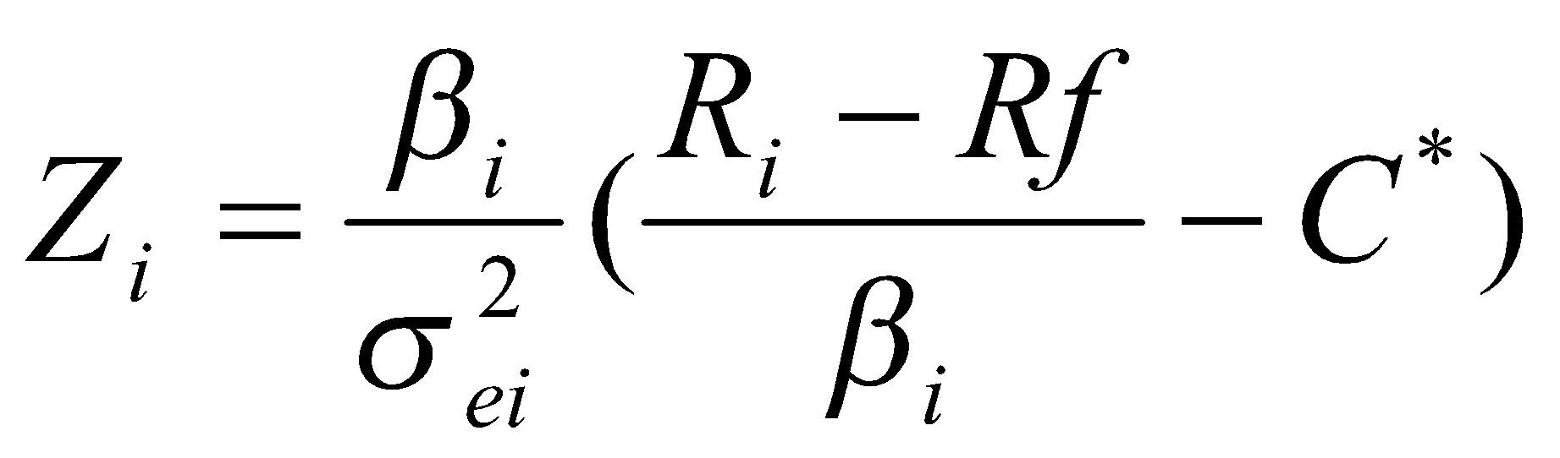....................................... .. (7)

- Perform the formation of the portfolio by type of industry

- Doing per count of portfolio performance based on the Alpha value obtainedwhere:
Α = Rp - (Rf + …………………………(8)

IV RESULTS AND DISCUSSION
4.1. RESULTS
4.1. 1 Stationarity Test of Data
Test results are summarized in Table 4.3 and Table 4.4 show that in the first level (first difference )of all data showed reject the null hypothesis that means the data is stationary.
Table 4.3 Stationary Test Results on Independent Variables
Variables | ADF (Prob.Value)
 | T | Prob.
RMJCI | -7.098816 | 0000
Rf | -4.475039 | 0000
Test Critical Value
1% | -3.519050
5% | -2.900137
10% | -2,587,409
Source: Data processed

while stationary ratings data on the dependent variable in the form of return of the company a total of 14 samples showed results shown in Table 4.4
Table 4.4. Stationary Test Results on Dependent Variables
Dependent Variable | ADF (Prob.Value)
 | T | Prob.
Return AALI | -7.364258 | 0.000
Return ASII | -7.364258 | 0.000
Return ASRI | -6.603556 | 0.000
Return CPIN | -7.515717 | 0.000
Return INTP | -9.636875 | 0.000
Return ITMG | -9.171724 | 0.000
Return KLBF | -9.825932 | 0.000
ReturnLPKR | -8.987258 | 0.000
ReturnLSIP | -9.040722 | 0.000
Return PTBA | -9.325020 | 0.000
Return SMRA | -7.974524 | 0.000
Return TLKM | -7.981079 | 0.000
Return UNTR | -7.761759 | 0.000
Return UNVR | -7.208871 | 0.000
Test Critical Value
1% | -3.519050
5% | -2.900137
10% | -2,587,409
Source: Data processed

4.1.2.Data
4.2.1 Analysis of Stock Return Calculation Model (CAPM)
Before classifying 14 (Fourteen) JII company into a stock portfolio returns a value determined in advance of each stock with CAPM model, in order to get the value of Return, Beta and standard deviation (σ).
Calculation Results of expected return (E (R)), β and σ each company is summarized in Table 4.5.
Table 4.5 Results Calculation of E (R), β and σ 17 issuersLQ45 Year 2012-2016
issuers | Expected Return E(R) | β | σ | Adjusted R-Squared
AALI | 0.005845627 | 0.960513623 | 0.134981 | 0.954
ASII | 0.005845564 | 0.960513623 | 0.134981 | 0.876
ASRI | 0.005061574 | -1.136573413 | 0.134358 | 0.9122
CPIN | 0.006045326 | 1.921177635 | 0.134252 | 0.9092
INTP | 0.005867258 | 1.064837928 | 0.088024 | 0.8854
ITMG | 0.005761448 | 0.555996307 | 0.111109 | 0.7993
KLBF | 0.005819415 | 0.834760652 | 0.126567 | 0.9306
LPKR | -0.005941639 | 1.4225386 | 0.114787 | 0.7766
LSIP | 0.005759885 | 0.548478621 | 0.172575 | 0.9288
PTBA | 0.005861891 | 1.039029749 | 0.109465 | 0.9501
SMRA | 0.006191157 | 2.622482338 | 0.148226 | 0.9327
TLKM | 0.005916429 | 1.301305945 | 0.122664 | 0.6845
UNTR | 0.005823944 | 0.856539163 | 0.081337 | 0.7917
UNVR | 0.00566776 | 0.105446346 | 0.063612 | 0.8076
Source: processed data

4.2. ANALYSIST
To rank the stock used models Excess return to Beta (ERB) using variable stock returns, beta or systematic risk of the stock, the risk-free interest rate (Rf ), And unsystematic risk σ_{(ei}2).
The formation of excess return to beta to see the difference comparison value return of the risk-free interest rate as compared to the value of beta (β).

Furthermore, the calculation of the value of the cut-off rate (efficient frontier value shares) to sort the stocks that deserve to be portfolio, where stocks are above the cut off rate can be added to a portfolio of stocks. Stock assessment results are worthy of a portfolio can be seen in Table 4. 6 below.

Table 4.6. Stocks that enter the portfolio categories and ranked by the difference calculation ERB Cutoff rate
Issuers | Value
 | ERB | Rate Cut off | excess
ASRI | 0.000514 | 5.45071E-05 | 0.000459546
AALI | 0.000208 | 6.52205E-05 | 0.000142786
UNVR | 0.000208 | 6.5759E-05 | 0.000142183
ITMG | 0.000208 | 7.04853E-05 | 0.000137456
INTP | 0.000208 | 9.28449E-05 | 0.000115097
PTBA | 0.000208 | 0.000103322 | 0.00010462
CPIN | 0.000208 | 0.000121258 | 8.66841E-05
TLKM | 0.000208 | 0.000127722 | 8.02194E-05
UNTR | 0.000208 | 0.000134917 | 7.30245E-05
LSIP | 0.000208 | 0.000135434 | 7.2508E-05
SMRA | 0.000208 | 0.000147603 | 6.03389E-05
KLBF | 0.000208 | 0.000149919 | 5.80223E-05
ASII | 0.000208 | 0.00015152 | 5.64214E-05
LPKR | -0.00815 | -0.000489216 | -0.007656413
Source: Data processed

Based on table 4.6 above can be seen there are 1 companies listed from 14 companies that have a negative difference between the value of the Ci ERB reduction(cutoffrate)is LPKR. It shows that the company is not worth entering into the formation of the portfolio, while 13 other listed companies worthy to be put into the equation portfolio.

The next step is to group the 13 companies listed LQ45 into each type of industry, which gained 8 groups of industry as seen in Table 4.7

Table 4.7 grouping 13 companies LQ45 based on the type of industry
Issuer | sectors
AALI | Plantation
LSIP | Plantation
ASII | Automotive
UNVR | Cosmetics
KLBF | Pharmaceuticals
CPIN | Forage
INTP | cement
ITMG | coal mining
PTBA | coal mining
UNTR | Trade large scale
SMRA | Property
ASRI | Property
TLKM | Telecommunications

Assuming that, the companies included in the industry sector the same are identical in the business risks it faces so as not included in the same portfolio, then by grouping the results obtained, formed twelve (12) combined portfolio with 9 (nine) listed therein, among others:
- portfolio 1 consists of companies: AALI, ASII, UNVR, KLBF, CPIN, INTP, ITMG, SMRA, TLKM.
- Portfolio 2 consists of companies: AALI, ASII, UNVR, KLBF, CPIN, INTP, ITMG, ASRI, TLKM.
- Portfolio 3 consists of companies: AALI, ASII, UNVR, KLBF, CPIN, INTP, PTBA, SMRA, TLKM.
- The portfolio consists of 4 companies: AALI, ASII, UNVR, KLBF, CPIN, INTP, PTBA, ASRI, TLKM
- Portfolio 5 consists of companies: AALI, ASII, UNVR, KLBF, CPIN, INTP, UNTR, SMRA, TLKM
- Portfolio 6 consists of companies: AALI, ASII, UNVR, KLBF, CPIN, INTP, UNTR, ASRI, TLKM
- Portfolio 7 consists of the company: LSIP, ASII, UNVR, KLBF, CPIN, INTP, ITMG, SMRA, TLKM.
- Portfolio 8 is composed of companies: LSIP, ASII, UNVR, KLBF, CPIN, INTP, ITMG, ASRI, TLKM.
- portfolio 9consists of companies: LSIP, ASII, UNVR, KLBF, CPIN, INTP, PTBA, SMRA, TLKM.
- Portfolio 10 consists of companies: LSIP, ASII, UNVR, KLBF, CPIN, INTP, PTBA, ASRI, TLKM
- Portfolio 11 consists of companies: LSIP, ASII, UNVR, KLBF, CPIN, INTP, UNTR, SMRA, TLKM
- Portfolio 12 consists of companies: LSIP, ASII, UNVR, KLBF, CPIN, INTP, UNTR, ASRI, TLKM

4.2.3 Portfolio Formation by Weighting Each Of Stock
Each company in the portfolio is weighted to allocate funds invested into a portfolio using X weighted score (Elton & Gruber, 1995) (Table IV.5), so the result:
- Return Portfolio 1 had: Rp1 = 3.070221
- Return Portfolios 2 obtained:Rp2 = 3.008481
- Portfolio Return3 obtained: Rp3 = 3.132182
- Return Portfolio 4 obtained: Rp1 = 3.318139
- return Portfolio 5 obtained: Rp2 = 3.349119
- return Portfolio 6 obtained: Rp3 = 3.146754
- return Portfolio 7 obtained: Rp1 = 3.074231
- return Portfolio 8 obtained: Rp2 = 3.010481
- return Portfolio 9 obtained: Rp3 = 3.162182
- return Portfolio 10 obtained: Rp1 = 3.17022 1
- Return Portfolio 11 obtained: Rp2 = 3.208481
- Return Portfolio 12 obtained: Rp3 = 3.162182

4.2.4. Efficient Portfolio Performance Evaluation by using the value of Alpha (α) CAPM model.
Having obtained the results of portfolio return of each company by using the excess return to beta, followed by a performance calculation porofolio by using the value of α which is the difference between the average return is seen with the return value of the market portfolio with a minimum rate of return is a translation of the CAPM model ,
Model calculations used:
After calculation of α, each portfolio then be evaluated based on the value of α obtained as shown in Table 4.8.

Table 4.8 The calculation of α stock portfolio JII period January 2012-December 2016
No. | Portfolio | Alpha (α)
1 | AALI, ASII, UNVR, KLBF, CPIN, INTP, ITMG, SMRA, TLKM | 0.00945
2 | AALI, ASII, UNVR, KLBF, CPIN, INTP, ITMG, ASRI, TLKM | 0.08324
3 | AALI, ASII, UNVR, KLBF, CPIN, INTP, PTBA, SMRA, TLKM | 0.07103
4 | AALI, ASII, UNVR, KLBF, CPIN, INTP, PTBA, ASRI, TLKM | 0.00007
5 | AALI, ASII , UNVR, KLBF, CPIN, INTP, UNTR, SMRA, TLKM | 0.03086
6 | AALI, ASII, UNVR, KLBF, CPIN, INTP, UNTR, ASRI, TLKM | 0.00687
7 | LSIP, ASII, UNVR, KLBF, CPIN, INTP, ITMG, SMRA , TLKM | 0.00812
8 | LSIP, ASII, UNVR, KLBF, CPIN, INTP, ITMG, ASRI, TLKM | 0.01152
9 | LSIP, ASII, UNVR, KLBF, CPIN, INTP, PTBA, SMRA, TLKM | 0.00058
10 | LSIP, ASII, UNVR, KLBF, CPIN, INTP, PTBA, ASRI, TLKM | 0.0029
11 | LSIP, ASII, UNVR, KLBF, CPIN, INTP, UNTR, SMRA, TLKM | 0.00135
12 | LSIP, ASII, UNVR, KLBF, CPIN, INTP, UNTR, ASRI, TLKM | 0.00659
Source: Data Analysist

Based on calculation, efficient portfolio of some companies obtained the optimal portfolio value obtained at portfolio to 2 that consists of companies: AALI, ASII, UNVR, KLBF, CPIN, INTP, ITMG, ASRI, TLKM with the highest Alpha value of 0.08324. Value shows the performance of the portfolio in the portfolio 2 is better than the performance of other portfolios.

V. CONCLUSIONS AND RECOMMENDATIONS
  - Conclusion

Looking at the results of the discussion and analysis of the data using the Capital Asset Pricing Model (CAPM) shows that the efficient and optimal portfolio in companies included in the index JII since the period January 2012 to December 2016.
According to the research that has been done can be made the following conclusion:
      - the results of the stationary test ADF test shows that the significance of less than 0.01, which means the data variables used in the study with normal distribution.
      - By using the CAPM model and excess return to beta obtained 13 companies listed in the index JII eligible for inclusion in a portfolio of stocks are stocks: AALI, LSIP, ASII, UNVR, KLBF, CPIN, INTP, ITMG, PTBA, SMRA, ASRI, UNTR , TLKM .. As of the 13 stocks are prepared 12 types of portfolios by diversifying the type of industry.
      - The result of the calculation of the performance of the portfolio by using the value of the excess return of portfolio or the value of Alpha (α) acquired portfolio performance 2 consisting of AALI, ASII, UNVR, KLBF, CPIN, INTP, ITMG, ASRI, TLKM performing stock portfolio highest of 3 types of existing portfolios.

  - Suggestions
      - to investors and potential investors who will take the decision to invest in stocks JII should do penganeka diversification (portfolio) investment in order to avoid the risk of failure to achieve the desired results and should choose investment in stocks AALI, ASII, UNVR, KLBF, CPIN, INTP, ITMG, ASRI, TLKM which has the best stock performance based on the calculation Alpha (α).
      - This study uses the CAPM model to determine the Expected Return and Beta with a particular study period. There is room for other researchers to use more complex models and using more variables and span of a longer study in order to obtain better results.

REFERENCES

Ajili, Sonad The Asset Pricing Model and the Three Factor Model of Fama and Frenc, Revisited in The Case of Finance, Yahoo Internet 2002
Ary Gumanti, Tatang and Sriutami, Elegant (2002), "The form of Efficient Market and The test" ,journal of Accounting & Finance Vol. 4, No1, May 2002: 54-68
Elton, Edwin J., and Gruber, Martin J., Modern Portfolio Theory and Investment Analysis. Fifth Edition, USA: John Wiley & Sons, Inc.

Fama, Eugene and Kenneth French (1998), "Value Versus Growth: The International Evidence", Journal ofFinance,53. 1975-1979.

Fama, Eugene, French. (1995), "Size and Book to Market Factors In Earnings and Returns", Journal ofFinance,50, 131-155.

Francis, Jack Clark, Investment: Analysis and Management. Fifth Edition, Singapore: McGraw-Hill Inc.

Haugen, Robert A. (2001), Modern PortfolioTheory,5th Edition, Prentice Hall, New Jersey.

Hartono, Jogiyanto, Prof. Dr., MBA., Ak. 2009. Portfolio Theory and InvestmentAnalysis.Yokyakarta: BPFE Yokyakarta.

Hartono, Jogiyanto, Prof. Dr., MBA., Ak.2005. Efficient MarketInDecision.Jakarta: PT Gramedia Pustaka Utama.

Husnan, Suad. 2003. Fundamentals of Securities Portfolio Theory and Analysis".Yokyakarta: UPP AMPYKPN.

Indarti, Johana. 2003. Return Behavior Analysis and Stock Trading Volume Activity on the Jakarta Stock Exchange (Event Study: Impact of Events Bali Bombing On October 12, 2002 at LQ 45stocks).Master of Management University of Diponegoro, Semarang.

Jones, Charles P. (1998), Investment: Analysis andManagement,John Wiley and Son, California, 6th Edition

Karambe, Edwin., Tandelin. (2003), The Validity Of The CAPM: The Case FromJSX.Journal of Economics and Business Indonesia, XVIII (3). UGM. Yogyakarta

Koetin, EA, the analysis of the Capital Market. Jakarta: Pustaka Sinar Harapan, 1996.
Le Baron, Dean (1983), "Reflections on Market inefficiency", Financial AnalystsJournal,39 (May / June): 16-23.

Levy, Haim S. (1996), Introduction to Investment. South Western Publishing.

Malkiel, Burton (1989), "Efficient Market Hypothesis", in John Eatwell, Murray Milgate, and Peter Newman, editor, The New Palgrave:Finance,New York, Macmillan Press Limited, p. 131.

Megginson, William. L. (1997), Corporate Finance Theory, Addison Wesley, New York.

Miller, Merton (1999), “The History of Finance”, Journal of Portfolio Management, 25 (4): 95-101.

Nazir, Moh. Ph.D. 2002. Metode Penelitian. Darussalam : Ghalia Indonesia.

Putra, Darma. 2009.Analisis Valuasi Saham Pada PT Indofood Sukses Makmur Tbk, PT Gudang Garam Tbk, dan PT Unilever Tbk. Universitas Gunadarma, Jakarta.

Rusdin, Drs., MSi. 2008. Pasar Modal (Teori, Masalah dan Kebijakan dalam Praktik). Jatinangor : Alfabeta Bandung.

Samsul, Mohamad. 2006. Pasar Modal dan Manajemen Portofolio”. Surabaya : Erlangga.

Sartono, R Agus, Manajemen Keuangan. Edisi Ketiga, Yogyakarta:BPFE.1997.

Sukmawati, Dzulkirom, Topowijono. (2013). Analisis Fundamental dengan Pendekatan Price Earning Ratio Untuk Menilai Kewajaran Harga Saham dan Keputusan Investasi. Malang, Univ. Brawijaya

Supranto, J., Statistik: Teori dan Aplikasi. Jilid 2, Edisi Kelima, Jakarta: Penerbit Erlangga. 1998.

Universitas Lampung. 2007. Pedoman Penulisan Karya Ilmiah Universitas Lampung. Bandar Lampung : Penerbit Universitas Lampung.

Van Horne, James C and Jhon Wachawicz Jr, Fundamental of Financial Management, Tenth Edition, New Jersey: Prentice Hall Inc.1998.

Weston J.Fred and Thomas E. Copeland, Management Financial, Ninth Eedition, USA: The Dryden Press, 1992.

Wiyanto. 2002. http://digilib.petra.ac.id/viewer. Uji Efisiensi Pasar Bentuk Lemah pada Saham Industri Rokok di Bursa Efek Jakarta pada periode 1999-2001 ( Metode Peramalan Box-Jenkins dan Runs Test). Petra Cristian University Library. Jakarta
http://www.idx.co.id, http://www.yahoofinance.com
http://www.google.co.id

