CONSERVATION EFFORT of Acanthus ilicifolius
IN LAMPUNG MANGROVE CENTER

Andari Mahardika Putri¹, Bainah Sari Dewi², Rudi Hilmanto³
1. Department of Forestry, Faculty of Agriculture, University of Lampung
2. Chairman of the Centre for research and development of tropical biodeversitas
Jl. Sumantri Brojonegoro No 1 Bandarlampung
Email: andarimahardika03@gmail.com
Phone: 085841443700

ABSTRACT
Jeruju (Acanthus ilicifolius) is naturally herbs that found in area of mangrove forest. Jeruju is also used as an environmental indicator for good maintanance of mangrove forest. This study aims to identify the conservation efforts of Margasari villagers related to the utilization of Jeruju (Acanthus ilicifolius). This research was conducted in March 2017 in Lampung Mangrove Center, Lampung Timur District, Lampung Province, Indonesia. The research methods is questionnaire with 97 female respondents. The result were described that the aspect of Protection, with one activity to protect of leaves Acanthus 47%. Utilization aspects, with five activities : (1) non-timber forest products 100%; (2) utilizing environmental services 85.6%; (3) utilizing plants for food preparations 38.1%; (4) utilizing plants to increase the economy of communities 43.3%; (5) future utilization plant for the next generations 50.5%. The aspect of Preservation, with two activities: (1) Preservation of Acanthus leaves 43.3%; (2) preservation of environmental ecosystem of mangrove forest 74,2%.
Keywords: Conservation, Acanthus ilicifolius, Society, Lampung Mangrove Center.
- INTRODUCTION
Mangrove forests are biodiversity renewable resources with forest constituents comprising trees, shrubs and aquatic biota (Kustanti, 2011). Fisiography Indonesia coastal conditions are very diverse one place to another. Mangroves grow on a flat beach and parallel to the direction of the wind (Samsumarlin et. al, 2015). According to Suhardjono (2012) mangrove as reducer wave energy, including tsunami waves. Mangrove should be existence to preserved as a protected beach area. Destruction of mangrove forest ecosystems was provided a negative impact on the availability of fish resources (Zamdial, 2016). One of the ecological functions of mangrove forests was a habitat variety of mosquitoes including mosquitoes cause malaria (Anopheles sp.). Outbreak of malaria could be increase due to the degradation mangrove forest (Putra et. al, 2015).
The length of coast line reached over 110 km in Lampung Timur District, approx. 70 km is in the Way Kambas National Park, 40 km are in two subdistricts i.e. Labuhan Maringgai and Pasir Sakti (Harianto et. al, 2015).
Margasari village is a coastal village in the Sub-District of Labuhan Maringgai, Lampung Timur District has 100 ha area of mangrove forests in 1995-1996 and in 2012 the increased to 700 ha or grow 85% for 17 years. The increase of mangrove area were occurred due to ground arise and cause of planting done by the surrounding communities of LMC (Lampung Mangrove Center) (Monografi Desa Margasari, 2012), but according to Cesario et. al, (2015) had increased the spacious 117.59 ha since 2010 until 2013, therefore the total area 817.59 ha. One of the shrub of the Mangrove Forests is jeruju (Acanthus ilicifolius). Jeruju is a shrub in coastal areas, river banks, as well as other places of muddy land and brackish watery. The stem is cylindrical, spherical surface slick, lightly browned, long spiked and pointy. A single leaf and short-stemmed. Acanthus ilicifolius is grow in groups and commonly found along the banks of the estuary and lagoon, in the land of marshy and mangrove forests (Valkenberg dan Bunyapraphatsara, 2002).
Women in the village of Margasari were the people who processed foods made from Jeruju (Acanthus ilicifolius). Jeruju also be used as a remedy for ulcers, cancer, arthritis, libido stimulant, asthma, blood cleanser, skin burning, snake bites and intestinal worms (Supriyanto et. al, 2014).
The researcher and students had been researching since 2004 until 2017 (Dewi et. al, 2016) but not available research about the conservation efforts of Jeruju (Acanthus ilicifolius). Therefore it is important to know the efforts of conservation Jeruju (Acanthus ilicifolius) that it was processed as raw material in different types of food produced by the community in the village of Margasari. During this time the ingredients have been processed into food but it is not yet known about conservation efforts Jeruju (Acanthus ilicifolius). Therefore this research need to be done. the purpose of the research is to identify the conservation efforts undertaken Margasari village community associated with the utilization of Jeruju (Acanthus ilicifolius).
- METHOD
Time and Research Site

This research was carried out in March 2017. Location of research was in Lampung Mangrove Centre in Margasari Village, Labuhan Maringgai Subdistrict, Lampung Timur District, Lampung Province, Indonesia as in the description of Figure 1.
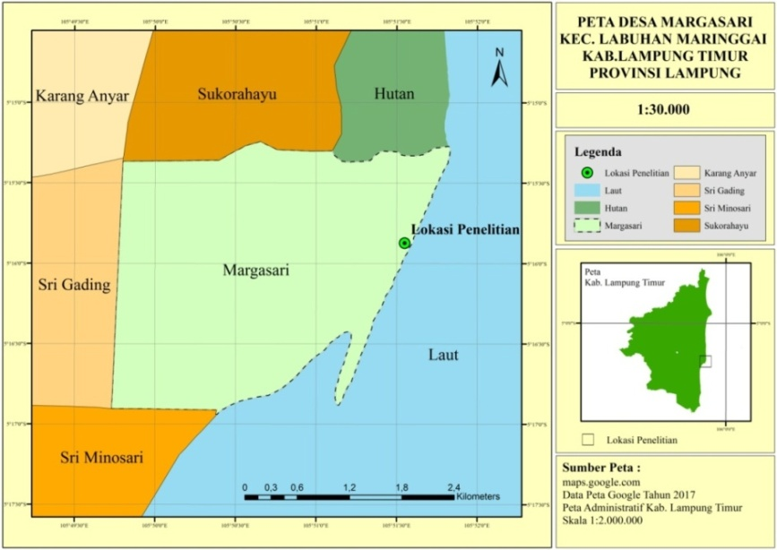
Figure 1. Map of research location in Margasari Village, Labuhan Maringgai Subdistrict, Lampung Timur District Lampung Province, Indonesia with a scale of 1:30,000 on the Research Efforts of conservation Jeruju (Acanthus ilicifolius) March 2017 (Kusuma, 2017).

Objects of Research

Instrument used in this study was a questionnaire, camera, stationery, laptops and GPS (Global Positioning System). The object of this research is the women in four hamlets namely hamlet 1, hamlet 4, hamlet 11 and hamlet 12 of the village of Margasari, Lampung Mangrove Centre, Labuhan Maringgai Subdistrict, Lampung Timur District, Lampung Province, Indonesia.

Methods

The data collected were the primary data and secondary data. Primary data were include data for the women respondent consist of aspects of conservation efforts, the aspects of preservation and the aspects of utilization. Data of distribution of Jeruju (Acanthus ilicifolius) was collected with System Information Geography. Secondary data collected, i.e. books, journals, other literature, geographical location, the physical state of the environment and infrastructure.

Determination of total sample

Samples were taken directly from the village of Margasari i.e. community involved in leaves of jeruju to use the processed into food. The data had been taken objective data (in accordance with the actual reality), representative (representing the actual state), small variansnya, timely and relevant. The sample is a portion of the members of a population selected therefore it is expected to represent the population (Nurhayati, 2008). The number of Women in the villages of Margasari Society as 3,713 inhabitants (Monografi Desa Margasari, 2012) therefore the number of respondents is determined using the formula Slovin (Firdaus, 2012):
n = $\frac{N}{N {(e)}^{2}+1}$

Description:
n = number of samples
N = the number of village women society Margasari is 3.713
e = 10% error Limit
1 = Integer constant
3713 = number of women at Community data village (Monografi Desa Margasari, 2012).
then,

n = 3713
3713 (0.1²)+1

n= 97,37 = 97 respondents

Analyses Data
Data analysis in this research was using qualitative descriptive. Qualitative research is one method to get the truth and belong to scientific research. Qualitative research interprets the correlation of existing factors including the point of view or the ongoing process.
The qualitative research methods were based on the framework of research, a research paradigm, formulation of the problem, the stages of research, research techniques, criteria and engineering inspection data, analysis and interpretation of data (Sudarto, 1995).
The respondent assignment was done by taking a person who has been elected by the researchers.The method was called a purposive sampling technique that mean carefully chosen samples to relevant to the design of the study. Researchers trying to let in the sample there are representatives of all layers of cocial the population so that it can be considered fairly representative (Nasution, 1996).

RESULT AND DISCUSSION
According to Departemen Kehutanan (1990), natural resource conservation biodiversity is resource management and utilization of natural resources biodiversity which follow up wisely to ensure resources with still maintain and enhance the quality and diversity of its value. Conservation of biodiversity and natural resources, the ecosystem were done through aspects: (a) a buffer zone system of protection; (b) Preservation of the diversity of animal and plant species and their ecosystem (c) the Sustainable Utilization of natural resources, the ecosystem and biodiversity.
Margasari Village communities largely have a job as a fisherman. Women in the village of Margasari have a job as housewives, selling fish and make fish salted. Sales results that can increase the economy of the community. Food made from the leaves of jeruju (Acanthus ilicifolius) were processed by women who participate in Kelompok Wanita Cinta Bahari Lampung Timur District i.e. creakers, rempeyek and stick of jeruju . Acording to Ariftia et. al. (2014) the mangrove forests are exploited directly by the society is jeruju leaf (Acanthus ilicifolius) as the basic ingredients to make a number of crackers. Crackers in each month was produced 2,280 kg.
The products of produced using raw materials of the leaf jeruju: cracker, rempeyek, dumplings, pempek and tea (Wahyukinasih et. al, 2014). Irwanto et. al (2015) said that jeruju plant is a plant that contains bioaktif which is able reduce the disease. Antibacterial on jeruju can be classified bacteriostatic and bakteriosidal (Ardiantami et. al, 2015).
Aspect of protection, with one activity that is keeping the leaves jeruju 47%. Aspects of utilization, with five activities, are consist namely (1) non timber forest products 100%; (2) utilize environmental services 85.6%; (3) utilizing plants for processed foods 38.1%; (4) make use of plants to improve the economics of 43.3%; (5) utilization in future 50.5%. Aspects of Preservation, with the two activities, are such as (1) preservation of leaves jeruju 43.3%; (2) preservation of the ecosystem of mangrove forest environment 74.2%. Acording of Febryano et. al, (2015) that local institutional has an important role in rural development because it can mobilize the society to undertake collective action mangrove management sustainably therefore instituted practices that are environmentally friendly. Based on analysis of data conservation efforts can be seen in Table 1.

Table 1. The results of the questionnaire research on the Aspect of utilization of conservation efforts conservation efforts Jeruju (Acanthus ilicifolius) in Lampung Mangrove Centre Margasari Village Labuhan Maringgai Subdistrict Lampung Timur District Lampung Province Indonesia March 2017.

Question Number | 2 | 4 | 5 | 6 | 8
Yes | 97 | 83 | 37 | 42 | 45
No | 0 | 14 | 60 | 55 | 52
% Yes | 100 | 85,6 | 38,1 | 43,3 | 46,4
% No | 0,0 | 14,4 | 61,9 | 56,7 | 53,6
% | 100 | 100 | 100 | 100 | 100

Acording Zulkarnain et. al. (2008) utilization of coastal resources is often done without looking at the balance, preservation, exploited and personal gain, these are causing coastal resources in an endangered and allows a wide range of potential will be degraded and all forms of wealth destroyed therein. Mangrove forest area in the village of Tawiri Maluku Province, seen that the surrounding communities utilize the area with various forms of utilization, good utilization impacting negatively or positively impact (Hiariey, 2009). While in the village of Margasari majority communities do it especially in karenakan Margasari Village communities know how to utilize the results of wood and non wood forest sustainably in addition pemafaatan from forest products, villagers Margasari mangrove seedling planting was also doing that in an effort to pay attention the potential diversity of plant species, particularly women Margasari Village communities did attempt the utilization of Jeruju Leaf (Acanthus ilicifolius) processed into chips , kemplang and rempeyek. Pemafaatan mangrove forest resources in Margasari Village is like the utilization of wood and non-wood, wood is a type of utilization such as fallen twigs and dead for use as fuel. Retrieval of firewood is performed by the community is dried wood found in the mangrove forests and sold at a price of Rp 1,250/belt. Within a year the firewood produced mangrove can reach 180 bunch. The value of the benefits of firewood got by way of multiplying the price/ikat wood with many wood is produced, so that the obtained value of Rp 225,000 per annum (Suzana et. al, 2011). Utilization in the form of non wood such as air, water, fish, crabs and many ecotourism in Margasari Village Community take advantage of, crabs and fish a lot in order to make the sale and for its own consumption, in addition there is also a society which utilizes mangrove forests as places of ecotourism such as fringing mangroves, birdwaching, and read. Mangrove ecosystems in the Coastal sub-district of Labakkang, Mandalle and Segeri also had fisheries resources has been widely exploited by the surrounding community. The utilization of the results of the fisheries in this area are generally still use the traditional technology. The fishermen mostly use the rowboat with the tool in the form of fishing rods, nets, bubu and serok (Mayudin, 2012).
Preservation of plants is done by people in the village of Margasari is the planting of mangrove tree seedlings, but the community in Margasari Village just did not do the seeding and planting nursery, so that if the community wants to do planting then the seeds came from other areas or purchase. Preservation of plants outside the asylum area natural do with keep and breed plants to avoid the danger of extinction (Departemen Kehutanan, 1990).

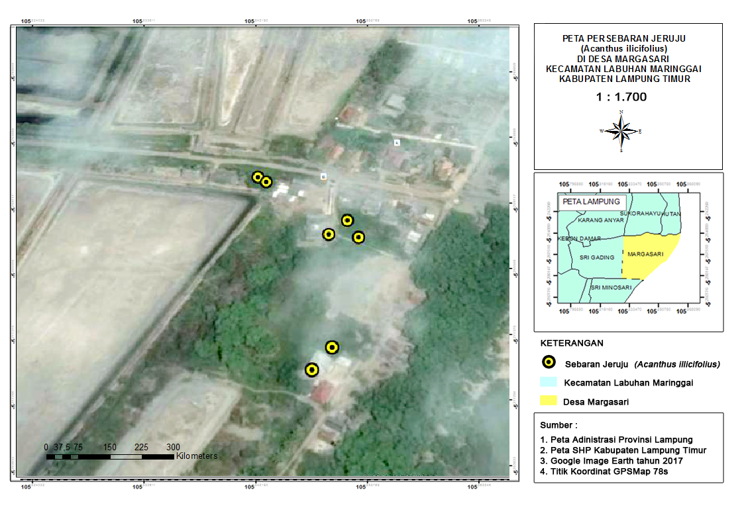
Figure 2. Map of the spread of the tree Jeruju (Acanthus ilicifolius) on the research efforts of Conservation Jeruju (Acanthus ilicifolius) in Lampung Mangrove Centre Margasari Village Labuhan Maringgai Subdistrict Lampung Timur District Lampung Province Indonesia March 2017 (Putri and Putri, 2017).

- CONCLUSION

Conservation efforts in Margasari Village, Labuhan Maringgai Subdistrict, Lampung Timur District, Lampung Province, Indonesia on March were described that the aspect of Protection, with one activity to protect of leaves Acanthus 47%. Utilization aspects, with five activities : (1) non-timber forest products 100%; (2) utilizing environmental services 85.6%; (3) utilizing plants for food preparations 38.1%; (4) utilizing plants to increase the economy of communities 43.3%; (5) future utilization plant for the next generations 50.5%. The aspect of Preservation, with two activities: (1) Preservation of Acanthus leaves 43.3%; (2) preservation of environmental ecosystem of mangrove forest 74,2%.

REFERENCE
Ardiantami, A.S., Sarjito. dan Prayitno, B.S. 2015. pengaruh perendaman berbagai dosis ekstrak daun jeruju terhadap kelulushidupan scylla serrata yang diinfeksi vibrio harveyi. Journal of Aquaculture Management and Technology (4):159-166.
Ariftia, R.I., Qurniati, R. dan Herwanti, S. 2014. Nilai ekonomi total Hutan Mangrove Desa Margasari Kecamatan Labuhan Maringgai Kabupaten Lampung Timur. Jurnal Sylva Lestari. (2): 19-28.

Cesario. E. A. Qurniati. R. dan Yuwono. S. B. 2015. Partisipasi Masyarakat dalam Pelestarian Hutan Mangrove di Desa Margasari Kecamatan Labuhan Maringgai Kabupaten Lampung Timur. Jurnal Sylva Lestari. (3):21-30.

Departemen Kehutanan RI. 1990. UU No. 5 Tahun 1990 Tentang Konservasi Sumber Daya Alam Hayati dan Ekosistemnya. Jakarta.

Dewi. B. S. Hilmanto. R. dan Herison. A. 2016. Lampung Mangrove Center Upaya Riset dan Pengabdia untuk Bangsa. Plantaxia. Yogyakarta.

Febryano. I. G. Suharjito. D. Darusman. D. Kusmana. C. dan Hidayat. A. 2015. Aktor dan Relasi Kekuasaan dalam Pengelolaan Mangrove di Kabupaten Pesawaran Provinsi Lampung Indonesia. Jurnal Analisis Kebijakan Kehutanan.(2): 123-138.

Firdaus A.M. 2012. Metode Penelitian. Jelajah Nusantara. Tangerang.

Harianto. S. P. Dewi. B. S. dan Wicaksono. M. D. 2015. Mangrove Pesisir Lampung Timur Upaya Rehabilitasi dan Perasn serta Masyarakat. Plantaxia. Yogyakarta.

Hiariey, L.S. 2009. Identifikasi Nilai Ekonomi Ekosistem Hutan Mangrove Di Desa Tawiri, Ambon. Jurnal. Organisasi dan Manajemen (1):23-34.

Irwanto, R., Eriyanti, E.E., dan Hendrian, R. 2015. Jeruju (Acanthus ilicifolius): Biji, Perkecambahan dan Potensinya. Prosiding Seminar Nasional Masyarakat Biodiversitas Indonesia. (1): 1011-1018.

Kustanti, A. 2011. Manajemen Hutan Mangrove. IPB Press. Bogor.

Kusuma, A. 2017. Peta Desa Margasari Kecamatan Labuhan Maringgai Kabupaten Lampung Timur. Tidak dipublikasikan.

Mayudin, A. 2012. Kondisi Ekonomi Pasca Konversi Hutan Mangrove Menjadi Lahan Tambak Di Kabupaten Pangkajene Kepulauan Provinsi Sulawesi Selatan. Jurnal Eksos. (8): 90-104.

Monografi Desa Margasari. 2012. Format Potensi, Perkembangan, dan Laporan Profil Desa dan Kelurahan. Provinsi Lampung.
Nasution. 1996.Metode Research. Bumi Aksara. Jakarta.
Nurhayati. 2008. Studi perbandingan metode sampling antarasimple random dengan stratified random. Jurnal Basis Data, ICT Research Center UNAS (1): 18-32.

Putra A.K., Bakri, S. Kurniawan, B. 2015. Peran ekosistem hutan mangrove pada imunitas terhadap malaria: studi di kecamatan labuha maringgai lampung timur. Jurnal Sylva Lestari.(2):67-78.

Putri, A.M. dan Putri, S.M. 2017. Upaya Konservasi Jeruju (Acanthus ilicifolius) di Lampung Mangrove Center Desa Margasari Kecamatan Labuhan Maringgai Kabupaten Lampung Timur.

Samsumarlin. Rachman, I. Toknok, B. 2015. Studi zonasi vegetasi mangrove muara di Desa umbele Kecamatan bumi raya kabupaten morowali Sulawesi tengah. Jurnal Warta Rimba.(2): 148:154.
Sudarto. 1995. Metodologi Penelitian Filsafat.Jakarta. Raja Grafindo Persada.

Suhardjono. 2012. Keanekaragaman tumbuhan vegetasi hutan mangrove di tumbu-tumbu, lampeapi dan wungkolo, pulau wawonii, Sulawesi Tenggara. Jurnal Berita Biologi. (2)221:230.

Supriyanto., Indriyanto., Bintoro. A. 2014. Inventarisasi jenis tumbuhan obat di hutan mangrove Desa Margasari Kecamatan Labuhan Maringgai Lampung Timur. Jurnal Sylva Lestari. (1):67-76.

Suzana, B.O.L.,Timban, J., Kaunang, R., Ahmad, F.2011. Valuasi Ekonomi Sumberdaya Hutan Mangrove Di Desa Palaes Kecamatan Likupang Barat Kabupaten Minahasa Utara. Jurnal ASE. (7): 29-38.

Valkenberg, J.L.C.H,dan Bunyapraphatsara, N. 2002. Plant Resources of South- East Asia No. 20 (2): Medical and Poisoning Plant 2. PROSEA Foundation, Bogor.

Wahyukinasih, M,H., Wulandari, C dan Herwanti S. 2014. Analisis kelayakan usaha berbasis hasil hutan bukan kayu ekosistem mangrove di Desa Margasari lampung timur. Jurnal Sylva Lestari (2): 41-48.
Zamdial. 2016. Analisa struktur komunitas hutan mangrove di Desa pasar sebelah kecamatan kota mukomuko kabupaten mukomuko. Jurnal Enggano.(2):29-37.

Zulkarnain, Agustar, A. dan Febriamansyah. 2008. Kearifan Lokal Dalam Pemanfaatan Dan Pelestarian Sumberdaya Pesisir (Studi Kasus di Desa Panglima Raja Kecamatan Concong Kabupaten Indragiri Hilir Provinsi Riau). Jurnal Agribisnis Kerakyatan. (1): 69-84.

APPENDIX
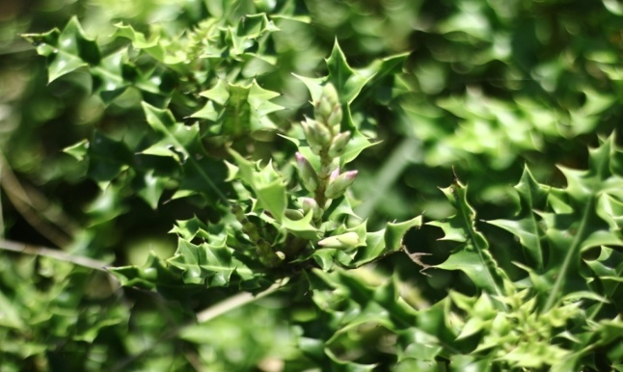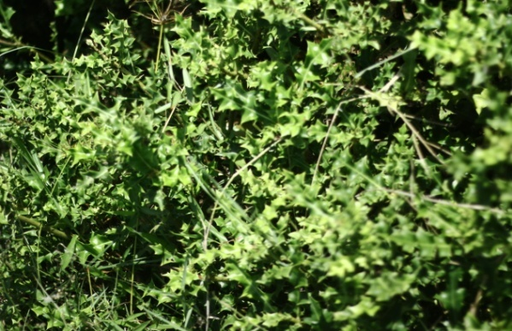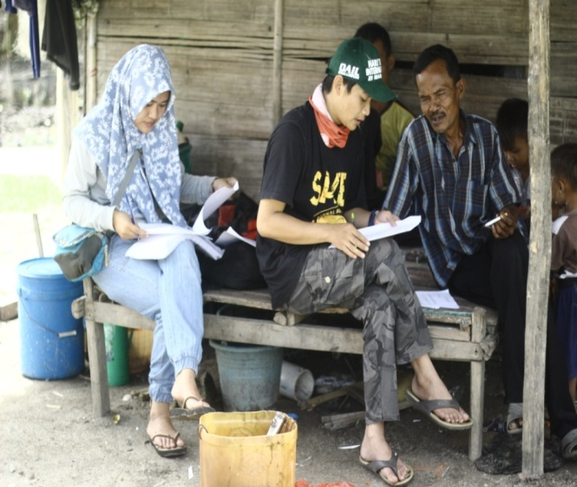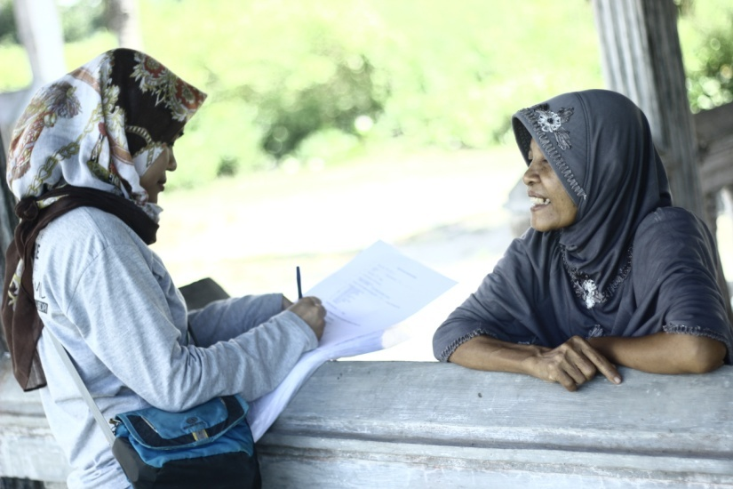
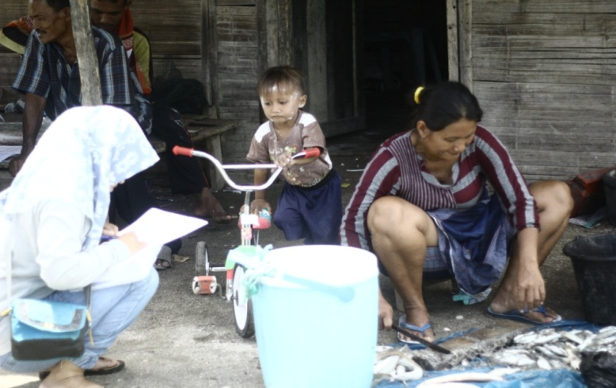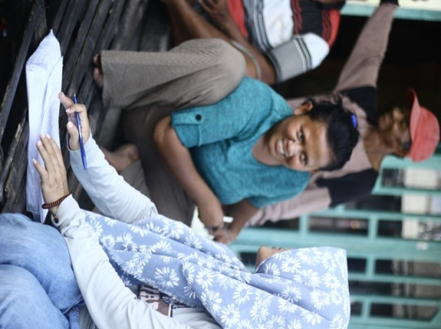
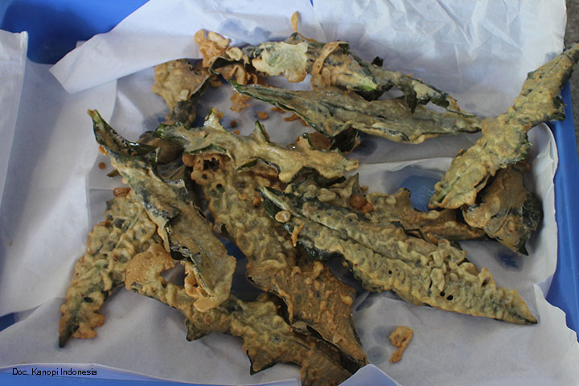
Image Of Research Conservation Effort Of Acanthus Ilicifolius In Lampung Mangrove Center.

