Feeding Behaviour of Sumatran Rhinoceros (Dicerohinus sumatrensis) in Sumatran Rhino Sanctuary Way Kambas National Park
Athaya Talitha S. Awaliah, Bainah Sari Dewi, Gunardi Djoko Winarno, Sugeng P. Harianto, and Norio Tokita
Abstract— Sumatran Rhinoceros (Dicerorhinus sumatrensis) is nocturnal wildlife with complex behaviour. Sumatran Rhinoceros feeding time usually occurs at midnight before morning and in the morning as well. The feeding behavior of Sumatran Rhinoceros will be different in natural habitat and sanctuary. The information about Sumatran Rhinoceros behaviour can support the conservation effort that undertaken. This research aims to analyze the feeding behavior of Sumatran Rhinoceros in Sumatran Rhino Sanctuary. This research was conducted on July 2017 at Sumatran Rhino Sanctuary Way Kambas National Park and the object was one female Sumatran rhinoceros named "Ratu". The Focal Animal Sampling was used to observe Sumatran Rhinoceros feeding behavior. The results showed that the dynamics of feeding activity with the highest percentage occurs in the morning (07.00-10.00 WIB) that is equal to 70% and the proportion of feeding time in a day is 35% of total daily time. The percentage was comparison of total drop-in feeding activity time at amount 1792 minute and total drop-in feeding activity time at amount 419 minute with Ratu’s total daily activity started from 07.00 WIB until 18.00 WIB, in amount of 6359 minute. Drop-in feeding was given twice a day. The drop-in feeding behavior of the Sumatran Rhinoceros is made as natural as possible by minimizing handfeeding like spesificallty put the feed inside the cage and let the rhino eat independently to maintain its natural behavior. Naturally the Sumatran Rhinceros feeding behavior begins by walking to the feed source and sniffing the feed then the Sumatran Rhinoceros will push the trees with their heads or bodies then stepped on with their feet until it fell down, and then they pulling roots, twisting the branches, or breaking branches with mouth.

Keywords— Behaviour, Sumatran Rhinoceros, Feeding, Sumatran Rhino Sanctuary, Way Kambas National Park.

Introduction
S
UMATRAN Rhinoceros was the only rhino species that had two horns and also known as the smallest rhino in the world^{[1]}. This species was critically endangered with the lowest number of population among the other rhino^{[2]}. Its population in natural habitat was estimated approximately 200-300 individual spread in South East Asia^{[3]}. Reliable population estimates for Sumatran rhinoceros have always been difficult to obtain^{[4]}. This uncertain number of Sumatran Rhinoceros population needs to get more concern^{[5]}. The declining of population was caused by lose of habitat because the land forest over function, encroachment, illegal logging and poaching^{[6]}.

The Sumatran rhinoceros is a good example to illustrate the challenges in the conservation of a highly endangered species^{[7]}. Sumatran Rhinoceros was in category critically endangered species^{[8]} and include as Appendice 1 species^{[9]}. Yayasan Badak Indonesia (YABI) was a partner of Forestry Department in order to conserve rhino in Indonesia. YABI had one program named Sumatran Rhino Sanctuary (SRS) that located in Way Kambas National Park^{[10]}. SRS is a rhino sanctuary which managed with semi in-situ program^{[11]} and its made as natural as possible with a little human intervention but still in a intensive supervision. This breeding centre for Sumatran Rhinoceros was established in 1998 as a last-ditch attempt to save the population from extinction ^{[12]}. Sanctuary rhinoceroses in Indonesia also browse freely in 10-hectare enclosures and select additional browse items on their own^{[13]}.

The knowledge about Sumatran Rhinoceros feeding behaviour was an information about its natural behaviour and how to apply it for supporting the conservation effort that will conducted. The success of Sumatran Rhinoceros protection and conservation was determined by manager’s capability that has adequate education about Sumatran Rhinoceros behaviour in order to know what the obstacle in its management^{[14]}. Fewer research about Sumatran Rhinoceros feeding behaviour whether drop-in or in natural habitat made this research necessary. This research aims to analyze how Sumatran Rhinoceros drop-in and natural feeding behaviour in SRS.

Procedure

Time and Location
This research was conducted in July 2017 at Sumatran Rhino Sumatran Way Kambas National Park, Lampung Province, Indonesia. The only site of which we are aware suitable for such a large rainforest enclosure would be Way Kambas National Park^{[15].} SRS has a lowland rainforest ecosystem type. The topography was at altitude of 0-50 m above sea level with a wet tropical climate. Geographically located between 4º59’- 5º05’ LS and 105º42’- 105º48’ BT^{[16]}.

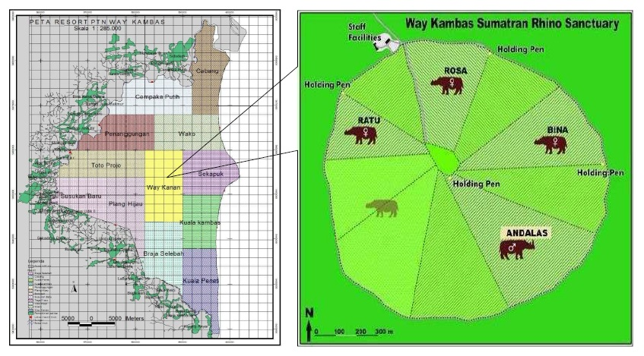
Fig. 1. Research Location at Sumatran Rhino Sanctuary, Way Kambas
National Park with Scale 1:285.000 ^{[17]}

Tools and Object
The tools that used in this research were camera, binocular, watch, stationary, laptop and tallysheets, while the object was one female Sumatran Rhino in SRS named “Ratu”.

Methods
Data about Sumatran Rhino feeding behaviour was obtained by using Focal Animal Sampling method^{[18][19]}. The collected data were primary and secondary data. Primary data was the Sumatran Rhino feeding behaviour and secondary data were books, journals and other literature which could more amplify the results.

Data Analyzing
This research was used the quantitative descriptive techniques. The activity dynamics and time proportion of feeding behaviour was obtained by Focal Animal Sampling equation^{[18][19]} then analyzed quantitatively. The feeding behaviour was analyzed descriptively.
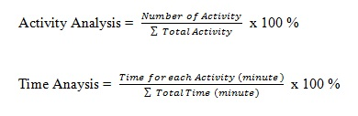

RESULTS AND DISCUSSION
The object was “Ratu” and she was choosen because she can easily adjust stranger presence and she was in parenting period therefore it is not too dangerous to observe. Feeding behaviour is include chewing, swallowing, or inserting any material into the mouth^{[20][21]}. The observation was perfomed for 105 hours observation within 14 days (± 7 hours/ day) and it was separated into two sections which is drop-in feeding behaviour when the rhino inside the cage and natural feeding behaviour when the rhino was released into the forest. Sumatran Rhinoceros behaviour was very complex both in activity dynamics and time proportion. This could be affected by the surrounding enviromental conditions. Ratu’s daily behaviour has different frequency. The activity dynamics was used to know the pattern of activity changes to get the highest frequency of activity in certain hours to represent the trend of Sumatran Rhino activity in general the it is presented in graphic form (Fig 2) as follows.

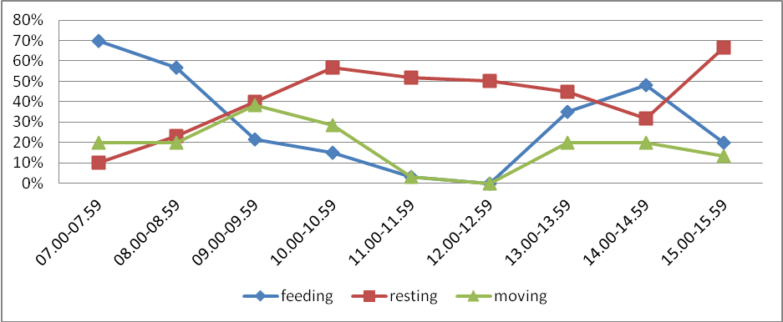
Fig. 2. Ratu’s activity dynamics per hours.
Based on Fig. 1 it could be seen that the activity with the highest percentage in the morning (07.00-10.00 am) was feeding that is 70% at 07.00-07.59 AM and the lowest percentage was moving which is 10% at 07.00-07.59 AM. This happens because it was the time for rhino to get drop-in feed therefore the most dominant behaviour was feeding. Based on other research Sumatran Rhinoceros feeding behaviour in the cage mostly occurs between 07.00-09.00 AM with the average percentage of feeding time 57,5% ^{[22]}. During the day (10.00 AM - 14.00 PM), the behaviour with the highest percentage in the day was resting that is 56,7% at 10.00-10.59 AM and the lowest percentage was moving and feeding at the same amount of 0% at 12.00 AM -12.59 PM. This happens because Sumatran Rhinoceros likes to wallowing during the day to stabilize their body temprature. Usually when the weather is hot, rhino will find the nearest wallow from the cage. During the day, rhino spend more time for wallowing than looking for an extra food in order to keep their body temprature in right. Other research states that at the certain times among 11.00 AM - 13.00 PM Sumatran Rhinoceros had going for wallowing^{[22]}. Activity with the highest percentage in the afternoon (14.00-16.00 PM) was resting that is 66,7% at 15.00-15.59 PM and the lowest percentage was moving in amount 13,3% at 15.00-15.59 PM. This happens because in the afternoon the rhino was given additional drop-in feed around their wallow area, therefore when they were full then they will immediately return to the wallow.
The proportion time of daily activity was the time allocation for each activity based on the total daily time. This data was compared to its total daily time started from 07.00 AM until 16.00 PM. The results were presented in graphical form as follows (Fig. 3)

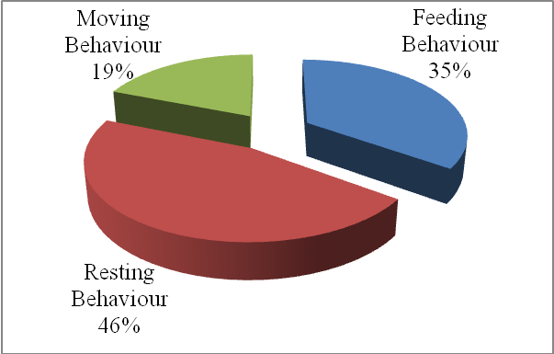
Fig. 3. Ratu’s time proportion per day
Base on the Fig 3 it could be seen that Ratu spent 35% of her total daily time for feeding behaviour. This number was obtained from the comparison of total drop-in feeding time in amount 1792 minutes summed up total natural feeding time in amount 419 minutes with Ratu’s total daily time started from 07.00 AM -16.00 PM in amount 6359 minutes. Rhino spent 49% of their daily time for feeding^{[23]}. This thing was significantly different with this result because the result calculation was obtained based on observation time started at 07.00 AM -16.00 PM while the statement calculation was based on one day observation time. Basically Sumatran Rhinoceros was a nocturnal animal, therefore its feeding behaviour more active at night^{[24].}
Drop-in feeding was made as natural as possible in order to minimize the handfeeding by putting the feed inside the cage and let the rhino eat independently (Fig 4). However, in certain conditions handfeeding can be done, for example when the rhino lacks of appetite the keeper will separates the preffered feed thus the rhino can eat more voraciously.

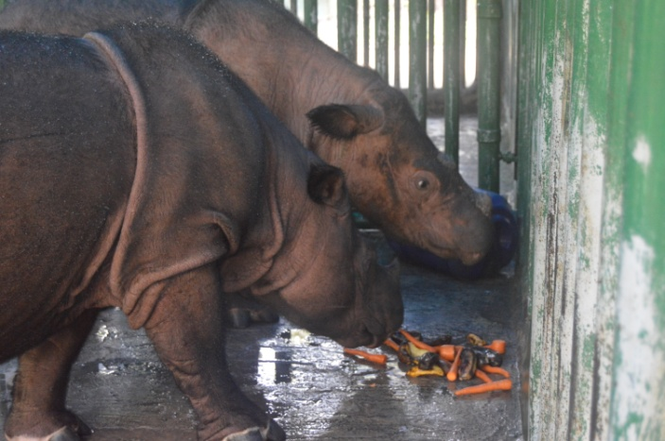
Fig. 4. Ratu and Delilah had drop-in feeding inside the cage.
Before being fed, the rhino will walk near the feed and the stand still while snorting the feed or sometimes rubbing their head or body to the cage. When feeding, the rhino will bite the part of the branch that has lot of leaves and then the rhino will chewing the feed while standing or sometimes with closed eyes. The average of chewing time in a single input was ±31 seconds with the amount of feed chews as much as ±35 times per input. When the rhino full they will walk around the cage and stand still at the center of the cage it difficult to be fed again. Because this species is an obligate browser that requires a large percentage of its diet to consist of fresh, diverse browse species ^{[25]}, it is challenging to maintain in zoos and is less likely to receive a higher plane of nutrition than its wild counterparts browsing in their native forests of Sumatra ^{[26]}. If the feed in the enclosure is incompatible with its natural diet, this might affected the animal behaviour^{[27]}. The drop-in feeding was also given in the afternoon, but the feeding was not done inside the cage but it was given in the forest (Fig 5) The afternoon drop-in feeding place usually close to the wallow area.

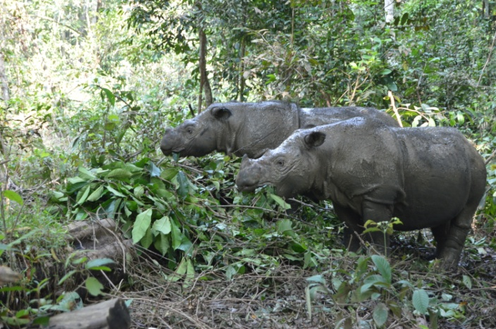
Fig. 5. Ratu and Delilah had afternoon drop-in feeding.
Natural feeding behaviour occurs when the rhino was released to the forest at 10.00 AM, but if the feed necessity were already fulfilled from drop-in feeding, ussualy the rhino will go straight to the wallow area. Natural feeding behaviour begins by walking to the feed source then the rhino will sniffing and snorting the feed source. The rhino will push the trunk of the tree with their body or head (Fig 6) then stepped on it with their legs until it completely fell down. Sumatran Rhinoceros was feeding by push the side of the tree with their chest to lie down the tree then stepped the tree until it fell between their legs^{[22]}. Rhino got their feed by destroying, biting, and bending the tree with their horn, teeth, and legs^{[28]}.

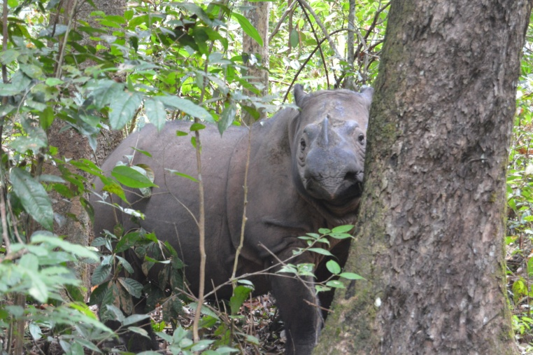
Fig. 6. Ratu pushing the tree with her head.
The rhino also like to eats by stuck out their mouth to reached the hanging roots and then pulling them off (Fig 7). Some literature describe that some plants are being eaten by rhinos by pulled off, especially for the lower plants like lianas and roots^{[29][30].}

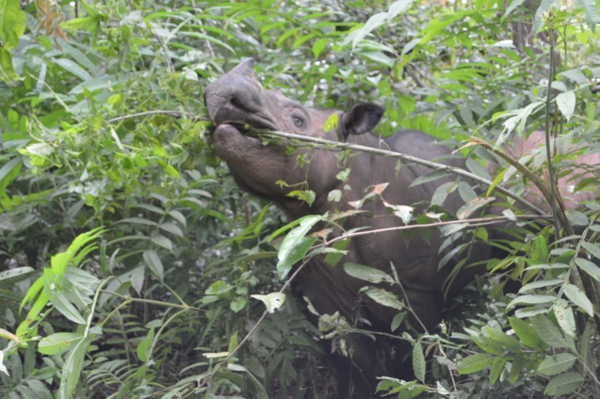
Fig. 7. Ratu trying to reach the roots with her mouth.
Sumatran Rhinoceros also likes saplings and eat them by twisting and biting them to pick up the leaves (Fig 8). The saplings was placed behind the anterior horn then rhino will twisted the saplings which is a typical rhino feeding behaviour^{[1]}. Sumatran Rhinoceros feeding by taken the leaves from its stem, especially in the shoot part ^{[16]}. In one meal, Sumatran Rhinoceros will have as much as eight times picking up leaves before moving to another place.

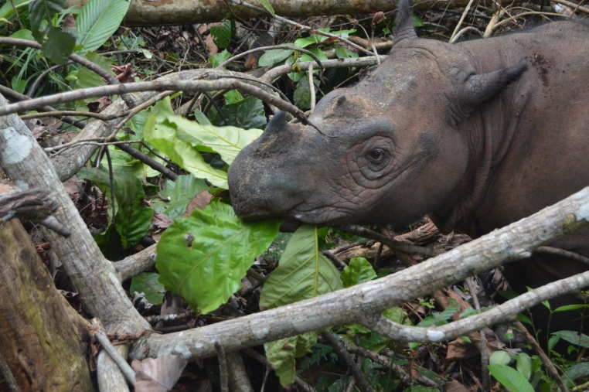
Fig. 8. Ratu’s pushing the tree with her head.

Conclusion
Based on the research, the feeding activity dynamics with the highest percentage occurs in the morning (07.00-10.00 AM) was 70%. Time proportion of Ratu’s feeding behaviour in a day was 35 % of her total daily time. The feeding methods of Sumatran Rhinoceros were by pushing the tree by their head or body and then stepped it with their legs until fell down, pulling off the roots, twisting the branch, and breaking the branch with their mouth.

References
- A.R. Maharani, Sumianto, N. Alim, Apriawan, M. Yunus, A. Mashuri, Sunarwanto, A. Subagyo, dan E. L. Rustiati, “Kajian keberadaan badak sumatera (Dicerorhinus sumatrensis) di Taman Nasional Way Kambas berdasarkan jebakan kamera”, In Prosiding Seminar Nasional Sains & Teknologi V Lembaga Penelitian Universitas Lampung, Bandar Lampung, 19-20 November 2013, pp.1-5 .
- Z. Z. Zahari, Y. Rosnina, H. Wahid, K. C. Yap, and M. R. Jainudeen,. “Reproductive behaviour of captive sumatran rhinoceros (Dicerorhinus sumatrensis)”, Animal Reproduction Science Journal, Vol. 85, pp. 327-335, 2005.
- H. Nicholls, “Sex and the single rhinoceros”, Nature Journal, Vol.485, pp. 566-569, May. 2012.
- R. G. Havmoller, J. Payne, W. Ramono, S. Ellis, K.Yoganand, B. Long, E, Dinerstein, A. C. Williams, R. H. Putra, J. Gawi, K. Talukdar, and N. Burgess, “Will current conservation responses save the critically endangered sumatran rhinoceros Dicerorhinus sumatrensis? “, Oryx Journal, pp. 1-5, August. 2015.
- F. Nardelli, “The last chance for the sumatran rhinoceros?”. Pachyderm Journal, no. 55, pp. 43-53. September. 2014.
- H. R. Sadjudin, M. Syamsudin, dan W. S. Ramono, “Status kritis dua jenis badak di Indonesia”, Al-Kauniyah Jurnal Biologi ,Vol. 6 (1), pp. 73-83, April. 2013.
- P. Kretzschmar, S. Kamer-Schadt, L. Ambu, J. Bender, T. Bohm, M. Ernsing, F. Goritz, R. Hermes, J. Payne, J. Schaffer, S. T. Thayaparan, Z. Z. Zainal, T. B. Hildebrandt, and H. Hofer, ,“The catastrophic decline of sumatran rhino (Dicerorhinus sumatrensis harrisoni) in Sabah: historic exploitation reduced female reproductive performance and population viability”, Global Ecology and Conservation Journal Vol. 6, pp. 257-275, April. 2016.
- International Union for Conservation of Nature and Natural Resource. (2017, May). IUCN red list of threatened species. Available: http://www.iucnredlist.org
- Convention on International Trade in Endangered Species of Wild Fauna and Flora. (2017, May). Appendices I, II, and III. Available: http://www.cites.org
- Yayasan Badak Indonesia. (2017, May). About us. Available http://www.badak.or.id/tentang-kami
- W. Pusparini, P. R. Slevert, T. K. Fuller, T. O Randhir, and N. Andayani, “Rhinos in the parks: an island-wide survey of the last wild population of sumatran rhinoceros”, PLoS ONE Journal, Vol. 10 (9), pp. 1-16. September. 2015.
- A. W. A. Zafir, J. Payne, A. Mohamed, C. F. Law, D. S. K. Sharma, R. A. Amirtharaj, C. Williams, S. Nathan, W. S. Ramono, and G. R. Clements, “Now or never : what will it take to save the sumatran rhinoceros Dicerorhinus sumatrensis from extinction?” Oryx Journal, Vol.45 (2), pp. 225 – 233. 2011.
- D. Candra, R. W. Radcliffe, M. Khan, I. H. Tsu, and D. E. Paglia, “Browse diversity and iron loading in captive sumatran rhinoceroses (Dicerorhinus sumatrensis): a comparison of sanctuary and zoological populations”, Journal of Zoo and Wildlife Medicine ,Vol. 43 (3), pp. 66-73. 2012.
- I. Paripurnawan, dan B.S. Dewi, “Studi perilaku berkubang badak sumatera (Dicerorhinus sumatrensis Fischer, 1814) di Suaka Rhino sumatera Taman Nasional Way Kambas”, Unpublished.
- A. H. Ahmad, J. Payne, and Z. Z. Zainudin, “Preventing the extinction of the sumatran rhinoceros”, Journal of Indonesian Natural History, Vol.1 (2), pp.11-22. 2013
- N. R. Jati, “Alternatif rencana pengembangan ekowisata di Suaka Rhino Sumatera (SRS) Taman Nasional Way Kambas”, Unpublished.
- Suaka Rhino Sumatera. Dokumentasi Peta Lokasi dan Sketsa Kandang. Lampung.
- J. Altman, “Observational study of behavior : sampling methods”. Universitas of Chicago, Chicago, 1973, pp. 227-267.
- D. Suherli, S. P Harianto,dan Y. Widodo, “ Kajian perilaku dan pakan drop-in monyet hitam sulawesi (Macaca nigra) di Taman Agro Wisata Bumi Kedaton”, Jurnal Slyva Lestari,Vol. 4(2), pp. 1-8, April. 2016.
- J. A. A. Pambudi, “ Studi perilaku dan ekologi kukang jawa (Nycticebus javanicus Geoffroy, 1812) di kawasan hutan bodogol. Tesis. Universitas Indonesia”, Unpublished.
- I. Firdilasari, S. P Harianto, dan Y. Widodo, “ Kajian perilaku dan analisis kandungan gizi pakan drop in beruang madu (Helarctos malayanus) di Taman Agro Satwa dan Wisata Bumi Kedaton”, Jurnal Sylva Lestari, Vol. 4 (1), pp. 97-106, Januari. 2016.
- A. Kurniawanto, “ Studi perilaku badak sumatera (Dicerorhinus sumatrensis Fischer, 1814) di Suaka Rhino Sumatera Taman Nasional Way Kambas Lampung”, Unpublished.
- M. Hutchins, and M. D. Kreger, “Rhinoceros behaviour: implications for captive management and conservation”, International Zoo Yearbook Journal, Vol. 40, pp. 150-173, July. 2006.
- H. Arief, “Analisis habitat badak sumatera (Dicerorhinus sumatrensis Fischer 1814) studi kasus: Taman Nasional Way Kambas”, Ph.D. dissertation, Institut Pertanian Bogor, Bogor, 2005.
- E. S. Dierenfeld, R. E. C. Wildman, and S. Romo, “Feed intake, diet utilization, and composition of browses consumed by the sumatran rhino (Dicerorhinus sumatrensis) in a North American Zoo”, Zoo Biology Journal, Vol. 19, pp. 169-180, May. 2000.
- T. L. Roth, P. R. Reinhart, J. S. Romo, D. Candra, A. Suhaery, and M. Stoops, “Sexual Maturation in the Sumatran Rhinoceros (Dicerorhinus sumatrensis)”, Zoo Biology Journal, Vol. 32, pp. 549-555. 2013.
- A. Tiyawati, S. P. Harianto, dan Y. Widodo, “Kajian perilaku dan analisis kandungan gizi pakan drop-in siamang (Hylobates syndactylus) di Taman Agro Satwa dan Wisata Bumi Kedaton”, Jurnal Sylva Lestari, Vol. 4 (1), pp. 107-114, January. 2016.
- A. E. Saputra, “Anatomi otot daerah panggul dan paha badak sumatera (Dicerorhinus sumatrensis)”, Unpublished.
- M. Borner, “A field study of the sumatran rhinoceros (Dicerorhinus sumatrensis), ecology and behaviour conservation situation in Sumatera”, Basel University, Zurich, 1979.
- J. B. Hernowo, R. Lisiawati, S. Ulum, T. Titus, P. Adithya, dan A. Salambessy, “Kajian Terhadap Habitat dan Pakan Badak Sumatera (Dicerorhinus sumatrensis Fischer, 1814) di Suaka Rhino Sumatera di Taman Nasional Way Kambas”, Unpublished.

Manuscript received September 15, 2017. Athaya Talitha Siti Awaliah is with Forestry Departement of Agriculture Faculty University of Lampung (phone: 082159499033; e-mail: athayatalithaa@gmail.com). Bainah Sari Dewi is with Forestry Departement of Agriculture Faculty University of Lampung and The Head of Research and Development Center for Tropical Biodiversity of University of Lampung (e-mail: bainahsariwicaksono12@gmail.com). Gunardi Djoko Winarno is with the Forestry Departement of Agriculture Faculty University of Lampung (e-mail:gundowino@gmail.com). Sugeng P. Harianto is with the Forestry Departement of Agriculture Faculty University of Lampung as a Professor of Forest Resource Conservation Forestry Department of Agriculture Faculty University of Lampung. Norio Tokita is with Nippon Veterinary and Life Science University in Tokyo Japan (e-mail: tokitan@nvlu.ac.jp).

