POTENTIAL STUDY OF METHANOL EXTRACT OF Cyperus kyllingia AS GROWTH INHIBITOR Colletotrichum sp. CAUSES CHILI ANTHRACNOSE
Suskandini R. Dirmawati ¹⁾ and Agustiansyah¹⁾
Faculty of Agriculture, Lampung University
Sumantri Brojonegoro 1 Bandar Lampung Indonesia
Email; suskandini.ratih@fp.unila.ac.id

Abstract – According to Central Bureau of Statistics, the production of chilli in Lampung was decreasing for the last few years because of Chili anthracnose cause Colletotrichum sp. There are several ways to inhibit the growth of Colletotrichum sp. In fact, chemical pesticide is known not effective to inhibit Colltetotrichum growth. Based on those information, the experiment is done to know the effectively methanol extract of Cyperus kyllingia to inhibit Colltetotrichum growth. The experiment consists of several steps: (1) Cyperus kyllingia extraction, (2) To growth Colletotrichum sp on medium Potato Dextrose Agar enriched with extract Cyperus kyllingia for 10 days with concentration variable 0 (control), 100% (P1), 75% (P2), 50% (P3), 20% (P4) and 10% (P5), (3) The measured parameters are colony growth. Statistical analysis result indicates that methanol extract of Cyperus kyllingia significant inhibit the growth colony (P˂0.05). The control is not inhibiting the growth of Colletotrichum sp. in the medium non enrichment with methanol extract of Cyperus kyllingia.

Keywords: Anthracnose, Chili, Cyperus kyllingia.

1.Introduction

The red chili (Capsicum annuum L.) is a horticultural crop commodity that high economic value. Chili contain capsaicin which causes a spicy flavor that can be used as a kitchen spice. According to Prayudi (2010), chili also contain calories, protein, fat, carbohydrates, calcium, vitamin A, and vitamin B1. Based on the projection of the Central Bureau of Statistics (2016), the production of the national chili in 2014 reached 1,074,611 tons and decreased in 2015 with the national chili production to 1,045,200 tons. Various kinds of external factors cause the decrease of chili production, such as pests and plant pathogens.

One of the major diseases of chili is anthracnose. An anthracnose disease in chili plants can cause losses of between 20% and 50% (Rompas, 2001). The pathogenic attack that causes anthracnose disease is the fungus of the Colletotrichum genus. Colletotrichum cause anthracnose diseases, including C. gloeosporioides, C. acutatum, C. dematium and C. capsici. Over 90% of anthracnose diseases are caused by the fungus C. capsici (Gratitude et al., 2007). Figure 1 indicate Symptom of antharanose and C. capsici.

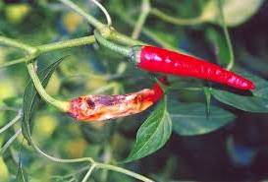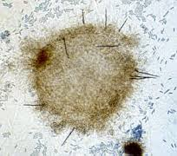
Figure 1. Symptom of antharanose and C. capsici.

In general, anthracnose disease occurs in chili that is old and mature. Synthetic fungicides is used to control anthracnose disease although the use of synthetic fungicides can cause environmental damage, can leave residues on the environment and on the chili fruit, can lead to resistance to pathogenic fungi, to the killing of natural enemies and non-target organisms. To minimalized the impact of synthetic fungicides, it has developed environmentally friendly control by using botanical pesticide.

The recommended disease control in the cultivation system is utilization botanical pesticide. Cyperus kyllingia is a weed which can be found in Indonesia. This weed grows in wide and dry area. Cyperus kyllingia is a weed that is wild plant which far from attention because it doesn’t have economical value. This plant commonly used as botanical pesticide because it has secondary metabolite which consist of saponin, tannin, flavonoid and gallic acid. The secondary metabolite can inhibit fungus such as Colletotrichum sp that causes anthracnose in red chili.

The negative impact for ecology and high cost of synthetic pesticide use, encourage farmers to find alternative control using materials that are cheap, safe and friendly environment.
Botanical pesticide based on plants (ex: Cyperus kyllingia the same genus with Cyperus rotundus but do not have rhizome) have many advantages compared with synthetic pesticides. Botanical ingredients abundant in nature, are easy to make, easy application by farmers and most importantly no negative impact for users, consumers and the environment.

2. Research Methode
Process of extraction Cyperus kyllingia
A small slice 500 g root of Cyperus kyllingia blend until smooth with the 1000 ml of 5 % methanol. Mix the mixture of the roots and methanol using a magnetic shaker for 24 hours. Then filter the liquid mixture with a glass funnel filtered paper. Then evaporate the solvent methanol in the liquid extract using a rotary evaporator at 50 ° C and low pressure 450-550 mmHg vacuum. There is also a way of evaporating naturally to obtain a dry material that turned out after weighed only weighing 2 mg (500 g stolen and root of Cyperus kyllingia mix with 1000 ml methanol and then evaporated by rotary evaporator. Product extraction 2 g extract like a gel).
Preparation of Cyperus kyllingia extract with water and detergent
Mix the mixture of the roots and water to erlenmeyer flask with 1000 ml water and detergent powder 1g / litre. Then immediately formulate this mixture into kaolin.

3. Result
Figure 2 and 3 indicate the effects of Cyperus kyllingia Methanol Extract on
in vitro inhibition to C. capsici

Days Incubation

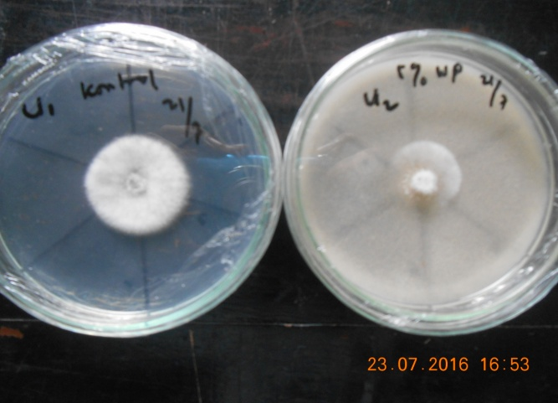
Figure 3. The growth colony of Colletotrichum sp. on medium Potato Dextrose Agar
enriched with extract Cyperus kyllingia for 4 days with concentration 0
(control), ) and 50% .
4. Conclusion
The methanol extract of Cyperus kyllingia inhibit the growth colony C. capsici with various percentage significant (P˂0.05). The control is not inhibiting the growth of Colletotrichum sp in .the medium non enrichment with methanol extract of Cyperus kyllingia. Potential Cyperus kyllingia in WP formulation has phenolic active ingredients of gallic acid.

REFERENCE

Backman P.A & T.B.Brenneman. 1997. Stem rot. In Kokalis Burelle N,
Porter D.M., Rodriguez Kabana, Smith D.H., Subharamanyam P. Compendium of
Peanut Disease. St Paul: APS. p 36-37

Hartman, G.L., J.B.Manandhar, & J.B.Sinclair. 1986. Incidence of Colletotrichum
spp. on soybeans and weeds in Illinois and pathogenicity of Colletotrichum
truncatum. Plant Disease 70:780-782
.
Raid, R.N.& Pennypacker,S.P. 1987. Weeds as hosts for Colletotrichum coccodes.
Plant Disease 71:643-646.

Semangun, H. 1991. Penyakit-Penyakit Tanaman Hortikultura Di Indonesia. Gadjah
Mada University Press : Yogyakarta.

Sembodo, D.R.J. 2010. Gulma dan Pengelolaannya. Graha Ilmu : Yogyakarta.

Wanda T.S, Efri, Titik N.A., & HM. Akin. 2014. Uji Keefektifan Ekstrak Daun
Jarak dan Daun Nimba terhadap Intensitas Penyakit Antraknosa pada Tanaman
Cabai. Jurnal Agrotek Tropika Vol 2. No 3, September 2014.

Wati, I.F., Efri & Tri Maryono. Keefektifan Ekstrak Daun Sirih dan Daun Babadotan
Mengendalikan Penyakit Antraknosa pada Buah Cabai. Jurnal Agrotek Tropika
Vol 2. No.3, September 2014.

Wulandari, A., J. Prasetyo, Efri, & Suskandini RD. 2014. Pengaruh Trichoderma spp
terhadap penyakit Antraknosa pada tanaman cabai varietas Ferosa dan Laris.
Jurnal Agrotek Tropika. Vol 2. No. 3, September 2014

