**THE PROTECTION OF INDIGENOUS PEOPLE’S CONSTITUTIONAL RIGHTS: CASE OF KASEPUHAN CIPTAGELAR**

Rudi Wijayaa, Rudyb

aStudent of Constitutional Department Faculty of Law, Lampung University

E-mail: rudi.wijaya@students.unila.ac.id

bLecture of Constitutional Department Faculty of Law, Lampung University

E-mail: rudy.1981@fh.unila.ac.id

**Abstract**

The Indigenous People’s is a society entity that maintains its ancestral life order, which historically existed before the Unitary State of Indonesia was proclaimed. The Indonesian Constitution has guaranteed the constitutional rights of all citizens, including the indigenous people’s. Article 18B Paragraph (2) of the 1945 Constitution has rescued that it has mandated that the state recognize and respect the traditional rights of indigenous people’s as long as it is alive and in accordance with the development of society and the principle of Republic Indonesia.

In practice, the constitutional rights of indigenous people’s are violated and discriminated against by various parties. However, until now there is no legislation act that explicitly regulates the indigenous people’s and the protection of its rights. To date, the regulation of indigenous people’s is partially regulated in various laws and regulations, which are predominantly in the forestry sector.

One of indigenous people’s which is still alive and developing is Kasepuhan Ciptagelar society in West Java. In fact, the Kasepuhan community themselves often experience discriminatory acts. Thus, the government needs a stronger effort in realizing the indigenous people’s constitutional guarantees in field practice.

This research aims to examine the implementation efforts of indigenous people’s protection in Kasepuhan Ciptagelar, by analyzing the cases that occurred that correlated with existing regulations. In addition, this study also provides some insertion in refining the regulations on indigenous people’s protection.

**Keywords**: Indigenous People’s, Constitutional Rights, Kasepuhan Ciptagelar

**PRELIMINARY**

Indigenous peoples (MHA) are closely related historically, sociologically, and ecologically with the Unitary State of the Republic of Indonesia. As a community entity that existed before the consensus established a country called Indonesia, MHA has existed and is still alive and survive to this day. Activities found in the field show that MHA proved to be a unity that is able to maintain nature and its environment.[1] The ability to preserve this nature will be strongly tied to local wisdom and customary laws run by the MHA. Nature that includes resources in it such as land, forest, river, and all the resources in it have a very strategic position. For MHA, land is not just an economic resource. Soil is an integral part of the whole life of Indigenous peoples. Various custom rituals are performed as a form of MHA spiritual relation with nature, including forests.[2]

The existence of the MHA, however, should not be ignored by the state. Article 1 Paragraph (3) of the 1945 Constitution stipulates that Indonesia is a legal state. It contains the consequences for the state to satisfy the elements of the rule of law, with the most universal element being the enforcement of human rights. This human rights enforcement must be implemented in a non-discriminatory manner, which means that MHA must be guaranteed to uphold its rights.

Constitutionally MHA itself has a guarantee in the Constitution. The warranty can be found in Article 18B Paragraph (2) which reads:

States recognize and respect the unity of Indigenous peoples and their traditional rights as long as they are alive and in accordance with the development of society and the principle of the Unitary State of the Republic of Indonesia, as governed by law.

The article has expressly assigned responsibility to the state to (1) recognize the MHA and its traditional rights; and (2) respect for the MHA and its traditional rights. This Article also at the same time provides a barrier to the recognition and respect for the MHA, ie if the MHA concerned meets the following conditions: (1) is still alive; (2) in accordance with the development of society and the principle of the Unitary State of the Republic of Indonesia.

The above juridical construction faces various obstacles in its implementation effort. Cases that occur indicate that MHA experienced various discriminatory actions from various parties, ranging from communities outside the community MHA and even government officials. This is also exacerbated by the globalization that is put forward the aspects of material profits through the private sector. Often large-scale private companies engaged in industry, such as plantations, forestry, and mining get support from the state.[3] Ultimately such conditions greatly hinder the protection and fulfillment of the constitutional rights of the MHA.

In addition to the problems sourced from outside (external) MHA above, the source of potential other problems arise also from within (internal) MHA itself. If traced from the constitution, the state recognition and respect of an MHA can not be done if the concerned MHA does not meet the specified barrier, especially on the second barrier.

There is a potential conflict between legal norms made by the state and customary law norms prevailing in the community. MHA is in fact always subject to customary law, in turn will experience problems if there is a positive legal norms that must be adhered to simultaneously.

Nonetheless, MHAs are trying to adapt to the contemporary conditions they face. Kasepuhan Ciptagelar, is a community of MHA which recently became a conversation in various media. The fascination with which they are discussed is the effort within their communities to adapt and take on roles in various developmental programs like the general public, but without abandoning customary law. This is in stark contrast to the mainstream stigma of the MHA, which is ancient and closes itself from the times.

This paper seeks to describe the extent to which the MHA in Kasepuhan Ciptagelar make efforts to adjust to the development of the times, especially related to the development of society and the principle of the Unitary State of the Republic of Indonesia, so it can be seen also how the protection of the MHA constitutional rights in Kasepuhan Ciptagelar. The data used in this paper is obtained from literature studies and also observations that have been done by the author in 2015 ago.

DISCUSSION

Empirical Condition Kasepuhan Ciptagelar

Kasepuhan Ciptagelar community is an Indigenous peoples Sunda administratively located in the Sirnaresmi Village, Cisolok, Sukabumi, Jawa Barat province is one of the Kasepuhan incorporated in Indigenous Unity Banten Kidul. Kasepuhan distance Ciptagelar capital district 46 km and from the capital of the province 198 km.[4]

The term Kasepuhan comes from Sundanese, with the basic word sepuh which means old. It shows that Kasepuhan is an old settlement. In the order of the old settlement of Sunda, known 3 (three) types, namely Kabuyutan, Kasepuhan, and Kanoman.[5]

According to hereditary stories, Kasepuhan Ciptagelar people come from Pakuan Pajajaran, the capital of the Sunda Kingdom which according to historical records stood in the 7th century to 16th century AD. According to hereditary stories also, the movement of society from Pakuan Pajajaran to Kasepuhan region is now motivated by the attack launched by the Sultanate of Banten.

Historical records show that it is true that the Sultanate of Banten ever attacked the Kingdom of Sunda.[6] In his last attack, the Sultanate of Banten under the leadership of Maulana Yusuf succeeded in bringing Palangka Sriman Sriwacana, the coronation stone of the Sundanese King. By bringing this stone, the throne can not be passed on by the Sundanese, or in other words the Kingdom of Sunda has lost its sovereignty after the last attack. Remnants of Pakuan Pajajaran who do not want to submit to the Sultanate of Banten is then according to the story of hereditary escape to the south. This is supported by the existence of old villages (kabuyutan and kasepuhan) in the southern region of Banten and West Java, including Kasepuhan Ciptagelar.

As MHA, Kasepuhan Ciptagelar community has an institutional structure of adat. Kasepuhan Ciptagelar led by an Elder who is often called Abah. When viewed from the way to get its power, Kasepuhan Ciptagelar use the form of monarchy, where power is obtained based on lineage. This also applies to positions or other positions under Abah. The institutional structure can be seen in the chart below.

Chart 1 The traditional institutional structure of Kasepuhan Ciptagelar Community [7]

Sesepuh (Abah)

Urusan Kanagaraan

Urusan Syara

Panghulu Adat

Pantun obor

Bengkong Pemeget

Bengkong Istri

Dalang

Sinden

Tukang Kuda

Tukang Bas

Tukang Para

Kemit Leuweung

Paraji

Gandek/Koja

Candoli

Dapur Khusus

Kokolot Lembur

Kokolot Lembur

Incu putu

Abah is the highest customary leader in Kasepuhan. All customary tools within the institutional structure of adat are accountable to Abah. Abah position is obtained from generation to generation, not through election or deliberation, therefore Kasepuhan Ciptagelar government system has the same pattern with monarchy system. Now Abah who holds the power is Abah Ugi Sugriana Rakasiwi, replacing Abah Anom who has died in 2007.

In Kasepuhan Ciptagelar society apply the law that is not written, or which is equal with adat law. Customary law is inherent and run Kasepuhan people with obedience. The continuous implementation of adat law, in addition to being based on the nature of customary law that binds its people internally,[8] also related to the nature of Pajajaran society as the ancestor of Kasepuhan Ciptagelar community that is open, egalitarian, and has a strong social system.[9]

Customary law that prevailed in Kasepuhan Ciptagelar is a legal design that puts the ecological aspect. This is in accordance with the main features of MHA that have a multidimensional relationship with the land and its environment. For MHA, land is not just an economic resource. Soil is an integral part of the whole life of Indigenous peoples. Various custom rituals are performed as a form of MHA spiritual relation with nature.[10]

Despite carrying out customary law in daily life, the Kasepuhan Ciptagelar community did not subsequently reject the reforms that emerged with the times. It makes Kasepuhan Ciptagelar has its own uniqueness compared with other MHA-MHA. If during this MHA is described as a remote community unit[11] even backward, the Kasepuhan Ciptagelar MHA is the opposite of the picture. For the size of MHA, Kasepuhan Ciptagelar indeed has been more advanced. Kasepuhan Ciptagelar even has its own logo that is used to identify and promote themselves to the public.

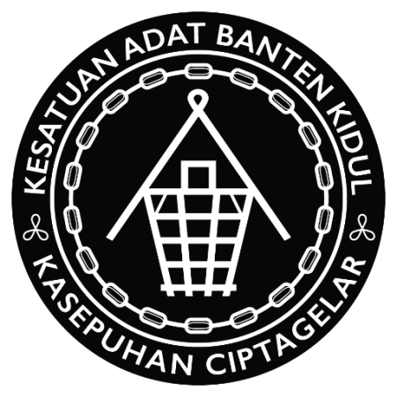

Image 1. Kasepuhan Ciptagelar Logo

The Kasepuhan Ciptagelar community, opening their access to technological progress, continues to use its customary law as a filter. Customary law prevailing in Kasepuhan Ciptagelar itself, puts the agricultural sector as a sector that should not be touched by modern technology.[12] That is, in addition to agriculture, other sectors in MHA Life can be touched by modernization.

The process of entry of modern technology above, can not be separated from the role of traditional leaders in Kasepuhan Ciptagelar, namely Abah. Abah who initiated the use of the river in the Kasepuhan environment to become a source of microhydro energy. In other words, abah as a traditional leader in Kasepuhan Ciptagelar also at the same time become an initiator in the effort of empowering existing resources. This can be seen in the inclusion of electric power in Kasepuhan environment. Electric power is generated by self-powered microhydro power plants.[13] The use of river potential as a source of electricity has been initiated and implemented since the time of Abah Anom, and still continues to this day.

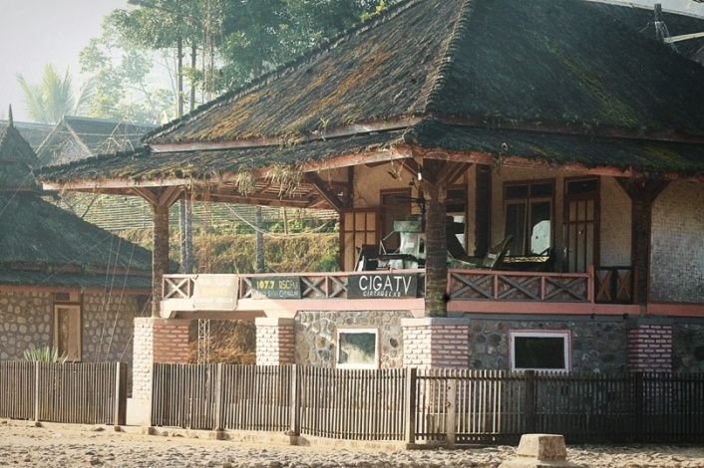It does not stop at the use of river aloes as a power station, a form of modernization that enters the other ciptagelar kasepuhan is the television channel (named CiGa TV) and radio transmitter (named Radio Swara Ciptagelar with UHF number 107.7) specifically kasepuhan area. Content that is broadcast through two electronic media is arranged in such a way that can meet the demand of residents kasepuhan.

Image 2. CIGA TV Operational Sites and Radio Swara Ciptagelar

The inclusion of reforms in the life of society Kasepuhan certainly make people become more creative and capable. The management of these technologies involves members of the Kasepuhan community.

Kasepuhan people are also actively involved in state activities, ranging from ceremonials such as flag-raising ceremonies, to democratic agendas such as elections and general elections. The programs pursued by the government in the Kasepuhan region are also well received by the Kasepuhan community.

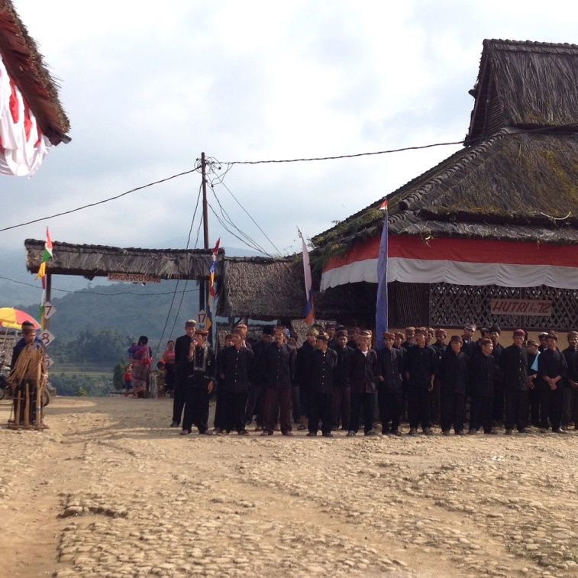

Image 3. The National Flag Raising Ceremony On Proclamation Day

August 17, 2017

The difference is that the Kasepuhan community has one command in choosing their political representatives. In this process Abah has sole authority in determining the voice of the entire Kasepuhan community. If Abah has chosen a name, then it is certain all Kasepuhan people who have the right to vote will choose the same name. Such a system is not something that is seen as harmful to democracy, because as mentioned earlier, for the Kasepuhan community, its customary law is binding without force, so the Kasepuhan people entrust their political choice to their adat leader. In addition, for the people of Kasepuhan Abah is a figure who is considered more capable in determining the choice, so that in addition based on the binding of customary law, Kasepuhan community is also based on the belief that Abah will choose the right people to become representatives of the people who fight for the region.

The existence of these developments, still does not eliminate customs and customary law in Kasepuhan Ciptagelar. The association still shows the nature of the Sundanese indigenous people someah hade ka semah, as well as maintaining the hand of asor as a form of honor to the adat leader. The same can also be found in agricultural systems, building design and cultural order Kasepuhan Ciptagelar society that continues to live until today.

The description of Kasepuhan Ciptagelar above, when associated with Article 18B Paragraph (2) of the 1945 Constitution clearly has been eligible for recognition and respect. First, the MHA still exists and currently has a fairly good existence among other MHAs as well as among the general public. Secondly, there is an effort to adapt itself to the development of society, in the form of promotions to the general public and the upatya adapt to the principle of the Unitary State of the Republic of Indonesia in the form of participation in state activities.

Such recognition and respect, in real terms, need to be set forth in the laws and regulations that provide guarantees for MHA protection. However, until now, the regulation is still partially regulated in various laws and regulations, and it is limited to the sectoral scope, in this case the forestry sector and natural resources. Although the 1945 Constitution states that if the regulation on MHA is regulated in law, not regulated by law, it is now deemed necessary to make the MHA regulation with a special law. It aims to minimize discriminatory actions as often experienced by other MHAs. In addition, regulation with the law will clarify the MHA's constitutional rights fulfillment system in the local legal product mechanism, since the MHA in its realm has different territory with administrative territory as recorded by the government. This has implications for the arrangement being partial and different from each region.

Author's search to date, there is no local legal product in Sukabumi Regency as the area where Kasepuhan Ciptagelar is governing the MHA and its rights. The existing regulation, formed by Lebak Regency[14] which there are also some other Kasepuhan in it. This regulation is closely related to the ciptagelar kasepuhan, since the Kasepuhan customary territory that crosses the administrative boundaries set by the state, so that a small part of the Ciptagelar Kasepuhan territory enters into the administrative area of Lebak Regency.

This can be seen from the attachments of Lebak District Regulation No. 8 of 2015. The first attachment contains a list of names Kasepuhan, in the absence of Kasepuhan Ciptagelar in it. The second attachment, containing a map of the customary territory, with Kasepuhan Ciptagelar contained in it. This shows that there is a complexity to provide a legal umbrella against the MHA. Such conditions will certainly impact on the not maximal effort to fulfill the constitutional rights of MHA Kasepuhan.

Nevertheless, the step of inserting kasepuhan ciptagelar into the map of custom territory in Lebak District Regulation can still be classified in a positive effort as an effort to recognize the existence of MHA. With the entry of Kasepuhan Ciptagelar area on the map of Kasepuhan customary territory in Lebak District, the Government of Lebak District has the responsibility to implement the norms in the regulation to Kasepuhan Ciptagelar region that entered in Lebak Regency area. Although the impact will not be comprehensive, but at least customary mechanisms can still be trusted to state government programs to the entire Kasepuhan region. This relates to the generally communal nature of MHA.[15]

Looking at the Kasepuhan traditional territorial phenomenon that is fragmented and beyond administrative boundaries, it is possible to occur in other MHA areas as well. Such possibilities as soon as possible need to be regulated by the local government that owns the MHA. It is possible to establish cooperation between regions in the form of regulation with regional heads either between districts / cities and between provinces.

The above step is necessary considering the safeguard against MHA will be more effective if implemented by the Local Government. In practice there is no possibility that adat territory is recognized through a Ministerial Decree, but recognition by such determination will certainly not be effective because it does not involve policies implemented in the region.

**Closing**

MHA in Kasepuhan Ciptagelar is an MHA that has made efforts to adjust to the development of society and the principle of Negara Kesatuan Republik Indonesia. In other words, there has been an effort to fulfill the constitutional rights of MHA Kasepuhan Ciptagelar itself. Currently there is a need for protection from outside MHA Kasepuhan Ciptagelar, especially from the government. The government needs to draft a special law on MHA, so that MHA safeguards can be implemented more systemically.

**Referrence**

Alamsyah (2012). *Analysis Kriya Kasepuhan Ciptagelar Sukabumi*. Skripsi Universitas Negeri Yogyakarta.

Reiza D. Dienaputra (2011). *Sunda: History, Culture, and Politic*. Sumedang: Sastra Unpad Press.

Muhsin Z., Mumuh (2008). *Establishment of Priangan Residency* (Paper). Presented in Discussions organized by Program Pascasarjana Fakultas Sastra BKU Ilmu Sejarah, Universitas Padjadjaran, 20 November 2008.

Suganda, Ki Ugis, (2009). *Community of Indigenous Peoples Kasepuhan Ciptagelar: Building a Bargaining Position on Customary Forests*, on Forest for the Future of Customary Forest Management in the Midst of a Changing World. Jakarta: AMAN-DTE.

Rudy (2016). *Hart Primary Rules on Lampung Barat*. Harian Lampung Post 27 Agustus 2016.

Mulyadi, Dedi (2015). *Spirit Budaya*. Purwakarta: Bagian Humas dan Protokol Setda Kabupaten Purwakarta.

Inkuiri Nasional Komisi Nasional Hak Asasi Manusia, 2016. *Rights of Indigenous peoples over its Area in Forest Area.* Jakarta, Komnas HAM.

Sutanandika, 2014. *Hukum Adat Kasepuhan Ciptagelar: Pola Rasionalitas Dina Nanjerkeun Ketahanan Pangan*. Tesis Magister Pendidikan dan Budaya Sunda Universitas Pendidikan Indonesia.

Sembodo, Hertiyo (2011). *Independent Management of Indigenous Peoples Based Mandated PLTMH: Kasepuhan Ciptagelar*. Jurnal M&E Volume 9 Nomor 4 Desember 2011.

**Legislation**

Undang-Undang Republik Indonesia Nomor 20 Tahun 2003 tentang Sistem Pendidikan Nasional

Keputusan Presiden Republik Indonesia Nomor 111 Tahun 1999 tentang Pembinaan Kesejahteraan Sosial Komunitas Adat Terpencil

**Web Page**

<http://www.ciptagelar.info/lokasi/> accesed on August 10, 2017

1. Nature and environment in the local wisdom of the MHA is something that needs to be maintained. This makes the MHA has a strong relationship with nature and its resources. Examples of MHA that until now have existence in maintaining its nature that is Baduy society (more complete in Asep Kurnia and Ahmad Sihabudin, 2010. Time Baduy Talk, Jakarta: Earth Literacy), Community of Kuta Tasikmalaya (more complete in Iman Hilman, 2011, Wisdom Local Indigenous peoples Kampung Kuta in Protecting and Managing the Environment, in Proceedings of International Conference on Sundanese Culture Volume II, Bandung: Rancage Culture Foundation)
2. Inkuiri Nasional Komisi Nasional Hak Asasi Manusia, 2016. *Rights of Indigenous peoples over its Area in Forest Area. Jakarta, Komnas HAM.* Jakarta, Komnas HAM. Page 25
3. Inkuiri Nasional Komisi Hak Asasi Manusia. *Ibid*. Page 58.
4. <http://www.ciptagelar.info/lokasi/>
5. Kabuyutan contains the meaning of the very (most) old settlement, Kasepuhan means old settlements, and Kanoman, meaningful young settlement.
6. The assault occurred during the last three reigns of the Sunda Kingdom, namely the reign of Queen Dewata Buana (1535-1551), the reign of King Nilakendra (1551-1567), and the reign of King Ragamulya (1567-1579), in Mumuh Muhsin Z., *Establishment of Priangan Residency (Paper)*. Page 8.
7. Ki Ugis Suganda, 2009. *Community of Indigenous Peoples Kasepuhan Ciptagelar: Building a Bargaining Position on Customary Forests*,. Jakarta: AMAN-DTE. Page 37.
8. Rudy (2016). *Hart Primary Rules on Lampung Barat*. Lampung Post NewsPaper, August 27, 2016.
9. Dedi Mulyadi (2015). *Spirit Budaya*. Purwakarta: Bagian Humas dan Protokol Setda Kabupaten Purwakarta. Page 10.
10. Inkuiri Nasional Komisi Nasional Hak Asasi Manusia, 2016. *Rights of Indigenous peoples over its Area in Forest Area.* Jakarta, Komnas HAM. Page 25
11. Some legislation uses various terms in the identification of MHA, such as Mayarakat Adat yang terpencil on Undang-Undang Nomor 20 Tahun 2003 tentang Sistem Pendidikan Nasional, and Komunitas Adat Terpencil dalam Keputusan Presiden Nomor 111 Tahun 1999 tentang Pembinaan Kesejahteraan Sosial Komunitas Adat Terpencil.
12. The Kasepuhan Ciptagelar community has a living philosophy that rice that is an agricultural product is the source of life, so that the rice and all its processed products should be treated with the best, and the people believe that what their ancestors have done is the best treatment. Nevertheless, the agricultural system that has been run by the Kasepuhan Ciptagelar community has proved capable of providing a more food stability system than other regions, more fully in Sutanandika, 2014. *Hukum Adat Kasepuhan Ciptagelar: Pola Rasionalitas Dina Nanjerkeun Ketahanan Pangan*. Tesis Magister Pendidikan dan Budaya Sunda Universitas Pendidikan Indonesia.
13. Hertiyo Sembodo, 2011. *Pengelolaan PLTMH Berbasis Kelembagaan Masyarakat Adat Secara Mandiri: Kasepuhan Ciptagelar*. Jurnal M&E Volume 9 Nomor 4 Desember 2011.
14. Peraturan Daerah Kabupaten Lebak Nomor 8 Tahun 2015 tentang Pengakuan, Perlindungan, dan Pemberdayaan Masyarakat Hukum Adat Kasepuhan
15. Communal is defined as the assumption of all MHA members as an integral part of the MHA as a whole, in Yusdianto and Indah Maulidiyah, 2014, Traditional Agencies of Sekal Brak: The Engagement of Indigenous Peoples in the Formation of Pekon Regulations. Bandar Lampung: Justice Publisher. P. 20, in which case, any program or policy that enters into the MHA area, although not by the local government, will remain evenly distributed throughout the MHA