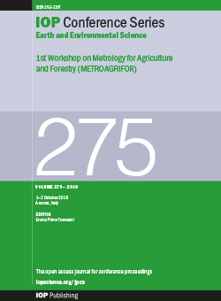
LEMBAR PENGESAHAN

Judul : Utilization of Natural Rubber (Latex) as Raw Material for Flexible Pavement Industry
A E Saputra, A Setiawan , S Bakri , Tugiyono , I Zulkarnain and M Wisman
Penulis : Agus Setiawan
Jurusan : Kehutanan
Fakultas : Pertanian
Publikasi : IOP Conf. Series: Earth and Environmental Science
ISSN : 1755-1307
Link Website : IOP Conference Series: Earth and Environmental Science, Volume 1012, 2022 - IOPscience
Edisi : 1012 (2022) 012082

Bandar Lampung, Mei 2022
Mengetahui,
Ketua Jurusan Kehutanan
Fakultas Pertanian Universitas Lampung Penulis

Dr. Indra Gumay Febryano, S.Hut., M.Si. Dr. Ir. Agus Setiawan, M.Si.
NIP 19740222 200312 1 001 NIP 19590811 198603 1 001

Menyetujui,
Dekan Fakultas Pertanian Ketua LPPM
Universitas Lampung Universitas Lampung

Prof. Dr. Irwan Sukri Banuwa, M.Si. Dr. Ir. Lusmeilia Afriani, D.E.A.
NIP 19611020 198603 1 002 NIP 19650510 199303 2 008

Environmental Change and Issue
012001
THE FOLLOWING ARTICLE ISOPEN ACCESS
Role of Institutional Pattern to Downstream Process of Technological Innovation from Balitbangtan (The Indonesian Agency for Agricultural Research and Development): Jarwo Super Technology in West Java and South Sulawesi
Zulkifli, S Bulkis, I M Fahmid and Rahmadanih
Open abstract, Role of Institutional Pattern to Downstream Process of Technological Innovation from Balitbangtan (The Indonesian Agency for Agricultural Research and Development): Jarwo Super Technology in West Java and South Sulawesi View article, Role of Institutional Pattern to Downstream Process of Technological Innovation from Balitbangtan (The Indonesian Agency for Agricultural Research and Development): Jarwo Super Technology in West Java and South Sulawesi PDF, Role of Institutional Pattern to Downstream Process of Technological Innovation from Balitbangtan (The Indonesian Agency for Agricultural Research and Development): Jarwo Super Technology in West Java and South Sulawesi
012002
THE FOLLOWING ARTICLE ISOPEN ACCESS
Environmental Aspect Beef Cattle on Smallholder Farms
Zairiful, A. A. Candra and N. Irwani
Open abstract, Environmental Aspect Beef Cattle on Smallholder Farms View article, Environmental Aspect Beef Cattle on Smallholder Farms PDF, Environmental Aspect Beef Cattle on Smallholder Farms
012003
THE FOLLOWING ARTICLE ISOPEN ACCESS
Growth and Physiology of Lobster (Panulirus sp) Respond Cutivated in Floating Net Cages with Different Stocking Densities
E Marlina and J Nursandi
Open abstract, Growth and Physiology of Lobster (Panulirus sp) Respond Cutivated in Floating Net Cages with Different Stocking Densities View article, Growth and Physiology of Lobster (Panulirus sp) Respond Cutivated in Floating Net Cages with Different Stocking Densities PDF, Growth and Physiology of Lobster (Panulirus sp) Respond Cutivated in Floating Net Cages with Different Stocking Densities
012004
THE FOLLOWING ARTICLE ISOPEN ACCESS
The Detection of Microbial Contamination on Goat Meat from Traditional Market in Bandar Lampung City
N Riffiandi, G G Maradon and V R Pertiwi
Open abstract, The Detection of Microbial Contamination on Goat Meat from Traditional Market in Bandar Lampung City View article, The Detection of Microbial Contamination on Goat Meat from Traditional Market in Bandar Lampung City PDF, The Detection of Microbial Contamination on Goat Meat from Traditional Market in Bandar Lampung City
012078
THE FOLLOWING ARTICLE ISOPEN ACCESS
The Effect of Type of Vibration to the Quality of Concentrate Latex on the Creaming Process
Maryanti and F Delvitasari
Open abstract, The Effect of Type of Vibration to the Quality of Concentrate Latex on the Creaming Process View article, The Effect of Type of Vibration to the Quality of Concentrate Latex on the Creaming Process PDF, The Effect of Type of Vibration to the Quality of Concentrate Latex on the Creaming Process
012079
THE FOLLOWING ARTICLE ISOPEN ACCESS
Linearity Graph in the Prediction of Granular Active Carbon (GAC) Adsorption Ability
Děvy Cendekia, Dian Ayu Afifah and Windia Hanifah
Open abstract, Linearity Graph in the Prediction of Granular Active Carbon (GAC) Adsorption Ability View article, Linearity Graph in the Prediction of Granular Active Carbon (GAC) Adsorption Ability PDF, Linearity Graph in the Prediction of Granular Active Carbon (GAC) Adsorption Ability
012080
THE FOLLOWING ARTICLE ISOPEN ACCESS
Effectiveness of FOS (Fructo Oligo Saccharide) from Banana Peel on Total Bacterial Count of Rabbit Meat Jerky
SK Syahpura, Zulfahmi and A Syofiana
Open abstract, Effectiveness of FOS (Fructo Oligo Saccharide) from Banana Peel on Total Bacterial Count of Rabbit Meat Jerky View article, Effectiveness of FOS (Fructo Oligo Saccharide) from Banana Peel on Total Bacterial Count of Rabbit Meat Jerky PDF, Effectiveness of FOS (Fructo Oligo Saccharide) from Banana Peel on Total Bacterial Count of Rabbit Meat Jerky
012081
THE FOLLOWING ARTICLE ISOPEN ACCESS
Preliminary Investigation on the Processability of Low-Fat Herbal Cheese Manufactured with the Addition of Moringa, Bidara, and Bay Leaves Extracts
T Setyawardani, J Sumarmono and H Dwiyanti
Open abstract, Preliminary Investigation on the Processability of Low-Fat Herbal Cheese Manufactured with the Addition of Moringa, Bidara, and Bay Leaves Extracts View article, Preliminary Investigation on the Processability of Low-Fat Herbal Cheese Manufactured with the Addition of Moringa, Bidara, and Bay Leaves Extracts PDF, Preliminary Investigation on the Processability of Low-Fat Herbal Cheese Manufactured with the Addition of Moringa, Bidara, and Bay Leaves Extracts
012082
THE FOLLOWING ARTICLE ISOPEN ACCESS
Utilization of Natural Rubber (Latex) as Raw Material for Flexible Pavement Industry
A E Saputra, A Setiawan, S Bakri, Tugiyono, I Zulkarnain and M Wisman
Open abstract, Utilization of Natural Rubber (Latex) as Raw Material for Flexible Pavement Industry View article, Utilization of Natural Rubber (Latex) as Raw Material for Flexible Pavement Industry PDF, Utilization of Natural Rubber (Latex) as Raw Material for Flexible Pavement Industry.

IOP Conference Series: Earth and Environmental Science

PAPER • OPEN ACCESS

Utilization of Natural Rubber (Latex) as Raw Material for Flexible Pavement Industry
To cite this article: A E Saputra et al 2022 IOP Conf. Ser.: Earth Environ. Sci. 1012 012082

View the article online for updates and enhancements.

You may also like
- Research on the performance changes of the binder of the wear layer of open- graded asphalt mixture under different aging methods
Jianjun Tian, Xiao Shi, Hongpo Chen et al.

- Study on Gradation and Performance of Cold Patch Asphalt Mixtures
Li Qiang, Liu Feiyi, Luo Xiao et al.

- The Effect of Technical Natural Rubber Mastication with Wet Process Mixing on the Characteristics of Asphalt-Rubber Blend
Bahruddin, Arya Wiranata and Alfian Malik

This content was downloaded from IP address 103.144.54.29 on 20/04/2022 at 01:18

Utilization of Natural Rubber (Latex) as Raw Material for Flexible Pavement Industry

A E Saputra^{1,2*}, A Setiawan¹, S Bakri¹, Tugiyono¹, I Zulkarnain² and M Wisman² ¹Universitas Lampung, Bandar Lampung, Indonesia
²Politeknik Negeri Lampung, Bandar Lampung, Indonesia

*andyekasaputra@polinela.ac.id, andy.eka21@students.unila.ac.id
Abstract. The rapid development of structures so far needs to be balanced with road construction, but there are many road damages that use asphalt flexible pavements are damaged and changes or deformations in the pavement, this can be caused by the influence of heat, radiation, rainfall, volume or high traffic loads and will be overcome with the addition of natural rubber to reduce the bad things above. The research implemented.at the Road and Bridge Laboratory and the Lampung State Polytechnic Analysis Laboratory for 6 months. The treatment that will be applied in this research is the manufacture of additives with the creaming method in the Analysis Laboratory which finally concentrates latex with variations of 3%, 5% 7 and 9% of the weight of pure asphalt which will be applied with asphalt and aggregate materials. pavement to form a denser bond. Variations in making samples using the FCR (Design Mixed Formula) method or DMF design mix formula, using concentrated latex as an additive and testing using the Marshall Test testing method in road and bridge laboratories so that from the research results obtained for asphalt and latex the treatment has an effect on the value MQ (Marshall Quotient), but the interaction results show that the ANOVA table shows that asphalt, latex and the interaction between asphalt and latex show significant values. Duncan's analysis with an alpha of 0.05 shows that the additives provide significant added value from the MQ (stability / Fatigue) kg/mm value and it is shown that the asphalt mixture with samples A and E after being mixed with additives gives a value according to the applicable standards in the table. requirement 2 for LL (traffic) Weight The min value of MQ 200 and the maximum of MQ 350 lies in a mixture of Type A 3% asphalt content and Type E with 9% asphalt content after adding latex and according to duncan’s analysis of the relationship between Asphalt Content and MQ Value. and for the best result for Flexible Pavement Industry Type A with 3% content can be recommended to be used

Content from this work may be used under the terms of the Creative Commons Attribution 3.0 licence. Any further distribution of this work must maintain attribution to the author(s) and the title of the work, journal citation and DOI.
Published under licence by IOP Publishing Ltd 1

Introduction
The need for the use of asphalt for better quality pavement is increasing with the rapid development of roads. Most of the damage is caused by climate change, high rainfall, radiation and the volume of high traffic loads on the pavement. Repair and improvement of asphalt quality by modifying with the addition of additives is an alternative in improving the quality of road pavement, with the addition of additives it is hoped that there will be an increase in flexibility, deformation resistance, and better durability of pavement material resistance.
Indonesia is one of the largest rubber producers after Thailand, but the use of rubber in Indonesia is less developed. This can be seen from [1] which states that almost 93.3% of natural rubber production in Indonesia is exported to foreign countries and a small part is used domestically. and [2], and rubber production for Lampung province was recorded in 2018 of 159,813 tons per year.[3]
The decline in the price of agricultural commodities, one of which is natural rubber, due to the world economy, has caused rubber farmers to suffer drastic losses, so that the price of processed rubber has decreased. For this, it is necessary to take steps to modify the use of natural rubber in the country to continue to be improved.
So far, asphalt roads in Indonesia do not use additives, concentrated latex, which is a type of natural rubber. Asphalt without additives has many problems in the tropical climate in Indonesia with high temperature differences accompanied by solar radiation and high rainfall resulting in the bond wrapped by asphalt decaying until it is lost so that the pavement material undergoes separation which results in groove deformation on the surface. the road which initially experienced hair cracks, to the destruction of the pavement layer.
Because of this, it is necessary to conduct research on asphalt applications using additives, for example concentrated latex, which is expected to obtain a special formula that has high elasticity, which can increase flexibility, plasticity, high resilience and good reflectivity.
  - Research Purposes
The purpose of this research is to take advantage of the application of natural rubber products in the form of concentrated lactes as asphalt additives to improve the quality of road pavement, so that the workability and flexibility of asphalt quality can be increased.

  - Framework
1. Determination of the type and dosage of concentrated latex and asphalt so that the latex does not clot when mixed with hot liquid asphalt by the method
Creaming with the addition of CMC and NA-Alginate was adjusted to the Mechanical Static Test (MST) on concentrated latex precisely and accurately.
- For asphalt testing using the Marshal Test test method on asphalt pavements with the addition of additives (concentrated latex) and without the addition of additives according to standards, they are analyzed descriptively in the form of tables and graphs by analysts from an economic and environmental perspective.

  - Hypothesis
The proposed hypothesis is to obtain an optimal dose of additive mixture with asphalt which produces road pavement with better quality compared to without additives also according to the applicable standards in Indonesia. [4]

  - Contribution.
The results of this study are expected to provide information and knowledge to users (community, planners, and researchers), as well as increase the economic income of rubber farmers to be able to use rubber as concentrated latex as an additive to asphalt mixtures, can increase the strength value of road pavements, the benefits of There are plenty of concentrated latex available with good quality as an asphalt additive which will eventually increase the income of the state and rubber farmers to compete

at the international level. Besides, this research is expected to be able to develop science and technology, especially construction material technology, especially flexible pavement. Provide input to related parties that the addition of asphalt additives with a certain dose can improve the quality of the road pavement material, it can also be used as an environmentally friendly road construction material.

Methods
  - Place and Time of Implementation
The research was carried out at the Road and Bridge Laboratory and the Lampung State Polytechnic Analysis Laboratory. research for 6 months.
Tools and materials

  - Ingredients
The materials used in this research are:Fresh Rubber as Concentrated Latex, Ammonia, Aquades, CMC (Caroxyl Methyl Cellulose), Na-Alginate, Asphalt Penetration 60/70, Aggregate 1-2, Screening, Ash Rock

  - Tool
The equipment used in the manufacture of concentrated latex additives in the Polylinela Analysis laboratory are as follows:
The minimum shaker has a speed of 225 rpm, Volume Pipette, Analytical Balance, Erlemeyer with a size of 250mL, Measuring Cup, Cup Cup
MST (Mechanical Static Test)
The equipment used in the manufacture of asphalt pavement materials in the Polylinela Road and Bridge laboratory are as followsScales for testing specific gravity and absorption of aggregates, Frying pan for asphalt frying with 1 set of stove and gas, Los Angeles Abrasion Test for aggregate wear test. A set of sieves for sieve analysis test, Asphalt specific gravity test set. Oven for oil and asphalt weight loss test., Penetration test equipment, Asphalt softening point test equipment, Marshall Test Tool, Water Bath for immersing the test object

  - Design Method
This research uses an experimental formula method coupled with the application of concentrated latex additives with asphalt with various additives in percentage to the weight of pure asphalt. 50% - 60% as an additive for inspection of asphalt mixture materials with aggregates, making a design mix, making test objects, carrying out tests using the Marshal Test, and analyzing results.
The initial step is based on making concentrated latex by preparing 250 ml Erlemeyer and adding
0.34 grams of CMC or Na-Algianate with the addition of 8 ml of hot distilled water and adding 150 ml of latex covered in plastic and tied into a shaker at a speed of 225 rpm for 48 hours and allowed to stand for 4 days and tested with MST for optimum KKK analysis. After getting a good formula, it can be mixed with hot liquid asphalt.
The next step is to test the pavement material by starting with the aggregate material consisting of: specific gravity and absorption Screening, specific gravity of rock ash, filter analysis, Los Angeles test followed by asphalt material for testing specific gravity, softening point, penetration test and weight loss until finally the manufacture of a homogeneous mixture of Asphalt Pen 60/70 with Concentrated Latex with
variations of KKK 50% and KKK 60% dry rubber content, continued to make the AC-WC mixture test with 60/70 asphalt to be tested and analyzed using the Marshall Test.

Table 1 Percentage of Asphalt and Concentrated Latex

No Asphalt Application Without Additive Specifications
Asphalt Application with Concentrated Latex Additive

 | AC_WC Bina Marga 2010 | (KKK 50%)
1 | A1 - A3 | A1-A3 + 3%
2 | B1 - B3 | B1-B3 + 5%
3 | C1 - C3 | C1-C3 + 7%
4 | D1 - D3 | D1-D3 + 8%
5 | E1 - E3 | D1 -D3+ 9%

Information :
A1-E3 : Sample name KKK : Dry Rubber Content
3%-9% : Variation % Concentrated Latex AC-WC: Type of flexible pavement used

Concentrated Latex Manufacturing
Making Concentrated Latex Additives Boiling Method Formulation of Design Mixtures
(Design Mix Formula (DMF)

Test results data from material test results: coarse aggregate, fine aggregate, filler including gradation data for each type of aggregate, Adjustment of mixed/combined aggregate gradation, Determination of the combined aggregate grading, Planning of experimental mixtures in the laboratory by determining the type of mixture, large fraction, either analytically or graphically, Determine the approximate asphalt plan (2), Making test objects in the Marshall Test experiment according to SNI 06-2489-1991 [5]and [6], Testing with Marshall equipment according to SNI 06-2489-1991 on density, stability, fatigue (flow), Testing the maximum specific gravity of the mixture at a certain asphalt content in accordance with SNI 03-6757-2002 [7]
Tabel 2. Asphalt Concrete Layer Mix
No | Mixed Properties | LL Weight (2x75 Tumb) |  | LL Weight (2x50 Tumb) |  | LL Weight (2x50 Tumb)
 |  | Min | Maks | Min | Maks | Min | Maks
1 | Stability (kg) | 550 | - | 450 | - | 350
2 | Fatigue (mm) | 2 | 4 | 2 | 4,5 | 2 | 5
3 | Stability/Fatigue (kg/mm) | 200 | 350 | 200 | 2,0 | 200 | 350
4 | Cavities in VIM Mix (%) | 3 | 5 | 3 | 5 | 3 | 5
5 | Cavities in VMA aggregate (%) | In accordance with the Appendix of the Ministry of Public Works, Research and Development Agency for Road Research and Development Center
6 | Immersion index (%) | 75 | - | 75 | - | 75 | -
7 | VFB asphalt filled cavity | 75 | 82 | 75 | 85 | 75 | 85
Source: Asphalt Concrete Layer Implementation Guidelines for Highway Construction

  - Work Procedures
The work procedure in this study was carried out following the flow chart as described in Figures 1 and 2 below.
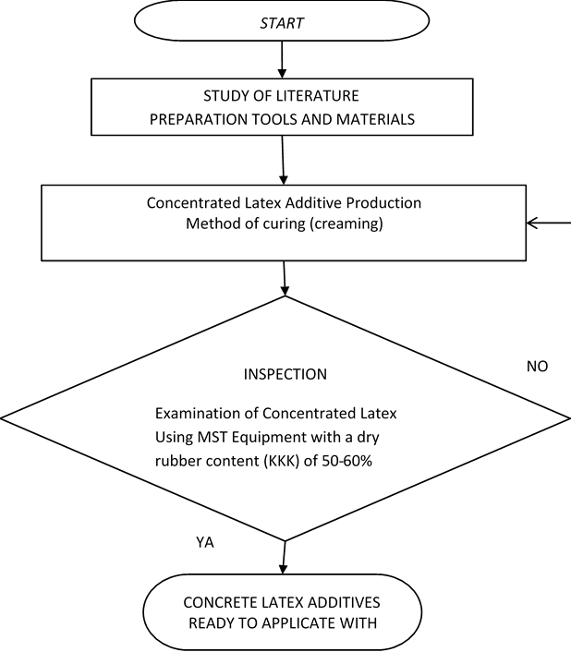
Figure 1. Flowchart of Concentrated Latex Additives in the Lab. Analysis

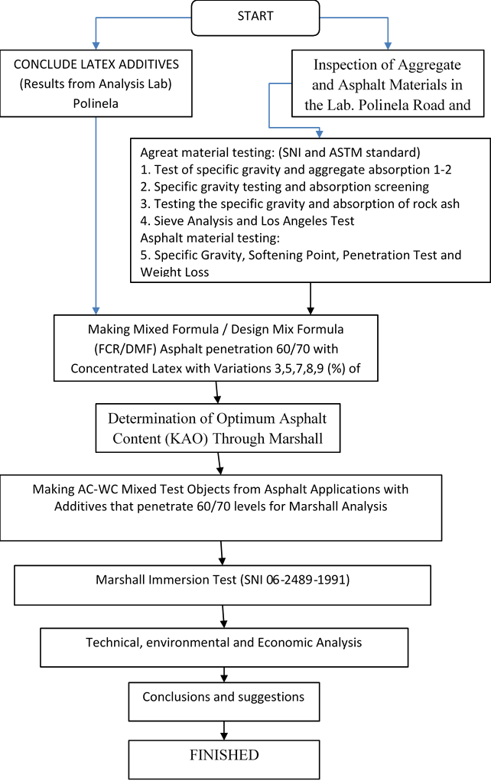

Figure 2. Flowchart of Research Methodology in Roads and Bridges Lab

  - Observation
- Stage 1
Observing the process of making concentrated latex additives with levels of 50-60% Dry Rubber Content (KKK) using the Creaming Method.
- Stage 2
Observing the results of the Concentrated Latex additive mixed with hot liquid asphalt until it looks homogeneous and does not agglomerate with various percentages of 3,5,7, and 9 (%) Concentrated Latex on w/w pure asphalt.
- Stage 3
In the next stage of observation, calculating the optimum content. Analysis of calculating the ideal composition and meeting the specifications. AC-WC Bina Marga 2010 with the formula in equation (2) Marshall analysis was used.
- Stage 4
At this stage the mixture with the DMF design mix formula method can be applied to the manufacture of road pavement samples using Concentrated Latex additives and also compared with asphalt mixtures without additives and tested with the Marshall Test tool in technical,

economic and environmental analysis, according to standards. AC-WC Bina Marga 2010, Then the quality of the product is compared with the standard value of AC-WC Bina Marga 2010 and it is concluded that the product meets the standard or not and the data has been analyzed in the form of tables and graphs.

Results and Discussion
Tabel 3. Marshall Test Results for Latex Additive Mixtures

Cam Aspal | Kadar Aspal | Bj angrgt | Berat benda uji | Isi benda uji | Bj cmpran | Berat isi |  | VIM | VMA | VFB | Stabilitas | FLOW | Hasil Bagi  Marsall (MQ)
 | Cmpr |  | Krng | SSD | Dlm  air |  | Max |  |  |  |  |  | B. alat | Sblm  korek | Stlh  korek
A1 | 3.0 | 2.5 | 1,095.2 | 1,102.7 | 605.0 | 497.7 | 2.5 | 2.2 | 6.4 | 11.9 | 15.4 | 41.4 | 1.0 | 880.0 | 915.2 | 2.8 | 329.2
A2 | 3.0 | 2.5 | 1,090.8 | 1,101.1 | 603.2 | 497.9 | 2.5 | 2.2 | 6.4 | 12.3 | 15.8 | 40.3 | 1.0 | 875.0 | 910.0 | 3.0 | 303.3
A3 | 3.0 | 2.5 | 1,098.0 | 1,097.3 | 598.9 | 498.4 | 2.5 | 2.2 | 6.4 | 11.8 | 15.3 | 41.7 | 1.0 | 903.0 | 939.1 | 2.8 | 334.2
B1 | 5.0 | 2.5 | 1,105.0 | 1,112.0 | 614.0 | 498.0 | 2.5 | 2.2 | 10.7 | 11.1 | 14.7 | 73.0 | 1.0 | 1,345.0 | 1,398.8 | 2.4 | 578.0
B2 | 5.0 | 2.5 | 1,100.0 | 1,109.0 | 613.0 | 496.0 | 2.5 | 2.2 | 10.7 | 11.2 | 14.7 | 72.7 | 1.0 | 1,455.0 | 1,513.2 | 2.7 | 564.6
B3 | 5.0 | 2.5 | 1,106.0 | 1,112.0 | 614.0 | 498.0 | 2.5 | 2.2 | 10.7 | 11.1 | 14.6 | 73.4 | 1.0 | 1,329.0 | 1,382.2 | 2.5 | 544.2
C1 | 7.0 | 2.5 | 1,115.0 | 1,112.0 | 622.0 | 490.0 | 2.5 | 2.3 | 15.4 | 8.9 | 12.5 | 123.0 | 1.0 | 1,195.0 | 1,242.8 | 2.8 | 448.7
C2 | 7.0 | 2.5 | 1,115.0 | 1,125.0 | 626.0 | 499.0 | 2.5 | 2.2 | 15.1 | 10.5 | 14.1 | 107.2 | 1.1 | 1,225.0 | 1,335.3 | 2.8 | 471.8
C3 | 7.0 | 2.5 | 1,119.0 | 1,123.0 | 627.0 | 496.0 | 2.5 | 2.3 | 15.3 | 9.6 | 13.3 | 115.0 | 1.1 | 1,310.0 | 1,427.9 | 4.2 | 343.2
D1 | 8.0 | 2.5 | 1,125.0 | 1,131.0 | 635.0 | 496.0 | 2.5 | 2.3 | 17.5 | 9.2 | 12.8 | 137.0 | 1.1 | 1,155.0 | 1,259.0 | 3.2 | 388.6
D2 | 8.0 | 2.5 | 1,125.0 | 1,130.0 | 639.0 | 491.0 | 2.5 | 2.3 | 17.7 | 8.2 | 11.9 | 148.7 | 1.1 | 1,290.0 | 1,406.1 | 4.9 | 287.5
D3 | 8.0 | 2.5 | 1,124.0 | 1,130.0 | 644.0 | 486.0 | 2.5 | 2.3 | 17.9 | 7.4 | 11.1 | 161.3 | 1.1 | 1,235.0 | 1,346.2 | 3.5 | 381.3
E1 | 9.0 | 2.5 | 1,135.0 | 1,140.0 | 648.0 | 492.0 | 2.5 | 2.3 | 20.1 | 7.6 | 11.3 | 177.4 | 1.0 | 890.0 | 925.6 | 2.8 | 332.9
E2 | 9.0 | 2.5 | 1,135.0 | 1,135.0 | 642.0 | 493.0 | 2.5 | 2.3 | 20.0 | 7.8 | 11.5 | 174.3 | 1.0 | 875.0 | 910.0 | 3.0 | 303.3
E3 | 9.0 | 2.5 | 1,137.0 | 1,141.0 | 648.0 | 493.0 | 2.5 | 2.3 | 20.1 | 7.6 | 11.3 | 177.0 | 1.0 | 900.0 | 936.0 | 2.8 | 333.1

Table 4. Marshall Test Results For Latex Mixtures Without Latex
Cam Aspal | Kadar Aspal | Bj angrgt | Berat benda uji | Isi benda uji | Bj cmpran | Berat isi |  | VIM | VMA | VFB | Stabilitas | FLOW | Hasil Bagi Marsall  (MQ)
 | Cmpr |  | Krng | SSD | Dlm air |  | Max |  |  |  |  |  | B. alat | Sblm korek | Stlh korek
a | D |  | E | F | g | h | J | k | i | l | m | n | o | p |  | q | r
A1 | 3.0 | 2.5 | 1,075.0 | 1,080.0 | 570.0 | 510.0 | 2.5 | 2.1 | 6.1 | 15.6 | 19.0 | 32.2 | 1.0 | 890.0 | 925.6 | 2.0 | 462.8
A2 | 3.0 | 2.5 | 1,075.0 | 1,089.0 | 580.0 | 509.0 | 2.5 | 2.1 | 6.1 | 15.4 | 18.8 | 32.6 | 1.0 | 840.0 | 873.6 | 1.9 | 459.8
A3 | 3.0 | 2.5 | 1,075.0 | 1,086.0 | 585.0 | 501.0 | 2.5 | 2.1 | 6.2 | 14.1 | 17.5 | 35.5 | 1.0 | 780.0 | 811.2 | 2.5 | 324.5
B1 | 5.0 | 2.5 | 1,085.0 | 1,090.0 | 595.0 | 495.0 | 2.5 | 2.2 | 10.6 | 12.2 | 15.7 | 67.3 | 1.0 | 1,020.0 | 1,060.8 | 3.8 | 279.2
B2 | 5.0 | 2.5 | 1,087.0 | 1,085.0 | 600.0 | 485.0 | 2.5 | 2.2 | 10.8 | 10.2 | 13.8 | 78.3 | 1.0 | 1,021.0 | 1,061.8 | 2.5 | 424.7
B3 | 5.0 | 2.5 | 1,086.0 | 1,084.0 | 598.0 | 486.0 | 2.5 | 2.2 | 10.8 | 10.5 | 14.1 | 76.6 | 1.0 | 1,023.0 | 1,063.9 | 2.3 | 462.6
C1 | 7.0 | 2.5 | 1,100.0 | 1,130.0 | 611.0 | 519.0 | 2.5 | 2.1 | 14.3 | 15.1 | 18.5 | 77.4 | 1.0 | 1,150.0 | 1,196.0 | 2.7 | 443.0
C2 | 7.0 | 2.5 | 1,100.0 | 1,106.0 | 612.0 | 494.0 | 2.5 | 2.2 | 15.1 | 10.8 | 14.4 | 104.6 | 1.1 | 1,156.0 | 1,260.0 | 2.8 | 445.2
C3 | 7.0 | 2.5 | 1,085.0 | 1,090.0 | 613.0 | 477.0 | 2.5 | 2.3 | 15.4 | 8.9 | 12.5 | 122.6 | 1.1 | 1,157.0 | 1,261.1 | 2.8 | 450.4
D1 | 8.0 | 2.5 | 1,100.0 | 1,131.0 | 615.0 | 516.0 | 2.5 | 2.1 | 16.5 | 14.6 | 18.0 | 91.3 | 1.1 | 1,184.0 | 1,290.6 | 3.2 | 398.3
D2 | 8.0 | 2.5 | 1,105.0 | 1,138.0 | 616.0 | 522.0 | 2.5 | 2.1 | 16.4 | 15.2 | 18.6 | 87.9 | 1.1 | 1,051.0 | 1,145.6 | 3.2 | 358.0
D3 | 8.0 | 2.5 | 1,106.0 | 1,127.0 | 615.0 | 512.0 | 2.5 | 2.2 | 16.7 | 13.5 | 17.0 | 98.5 | 1.1 | 1,012.0 | 1,103.1 | 3.2 | 344.7
E1 | 9.0 | 2.5 | 1,175.0 | 1,180.0 | 625.0 | 555.0 | 2.5 | 2.1 | 18.4 | 15.2 | 18.6 | 99.0 | 1.0 | 880.0 | 915.2 | 4.7 | 194.7
E2 | 9.0 | 2.5 | 1,174.0 | 1,182.0 | 630.0 | 552.0 | 2.5 | 2.1 | 18.5 | 14.8 | 18.2 | 101.4 | 1.0 | 885.0 | 920.4 | 4.6 | 200.1
E3 | 9.0 | 2.5 | 1,170.0 | 1,185.0 | 620.0 | 565.0 | 2.5 | 2.1 | 18.0 | 17.1 | 20.4 | 88.3 | 1.0 | 885.0 | 920.4 | 4.8 | 191.8

FULL RANDOMY DESIGN_ Two (2) factors The ANOVA Procedure

Class Level Information
Class | Levels | Values
Aspal | 5 | A B C D E
Lateks | 2 | BL SS
Ulangan | 3 | 1 2 3
Information :
BL : Addition of Concentrated Latex
SS: without the addition of Concentrated Latex additives

Number of Observations | 32
Number of Observations | 30

FULL RANDOMY DESIGN_ Two (2) factors The ANOVA Procedure
Dependent Variable: bobotmq

Source | DF | F Value | Pr > F
Model | 9 | 10.94 | <.0001 ***
Aspal | 4 | 16.25 | <.0001 ***
Lateks | 1 | 3.39 | 0.0804 **
aspal*lateks | 4 | 7.53 | 0.0007***
Error | 20
Corrected | 29

The ANOVA table shows that asphalt, latex show *** F = 10,94 ; 16,25 ; 7,53 with p-value = 0,001 (<0,05) significant, and the interaction between asphalt and latex show ** F=3,39 and p-value
= 0,0804 with (<0,1) significant values wand are continued with Duncan's test as shown in the graph be
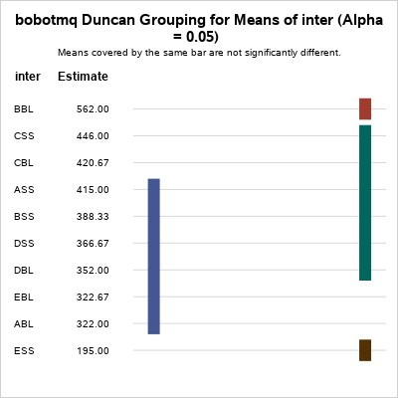

Based on the criteria for Asphalt Concrete Layer requirements and statistically tested Duncan's analysis shows that the additive is very influential in providing significant added value from the MQ (stability / Fatigue) kg/mm value and shows the asphalt mixture with samples A and E before being mixed. the additive provides a value according to the applicable standards in the requirements table 2 for LL (traffic) Weight Min MQ 200 and Maximum MQ 350 values lie in a mixture of Type A 3% asphalt content and Type E 9% asphalt content after adding latex additives,

Conclusion
From the results of the study, it was found that asphalt and latex treatments had an effect on the MQ (Marshall Quotient) value, but the interaction results showed that the ANOVA table showed that asphalt, latex and the interaction between asphalt and latex showed significant values. Duncan's analysis with an alpha of 0.05 shows that the additives provide significant added value from the MQ (stability / Fatigue) kg/mm value and it is shown that the asphalt mixture with samples A and E after being mixed with additives gives a value according to the applicable standards in the table. requirement 2 for LL (traffic) Weight Min MQ 200 and Maximum MQ 350 values lie in a mixture of Type A 3% asphalt content and Type E with 9% asphalt content after adding latex, And for the best result for Flexible Pavement Industry Type A with 3% content can be recommended.

Suggestion
Further research needs to be done so that it can produce maximum interaction and in accordance with the required specifications

References
- Badan Pusat Statistik Lampung 2021 Provinsi Lampung Dalam Angka 2021
- Prastanto H, Cifriadi A eta Ramadhan A 2015 Karakteristik Dan Hasil Uji Marshall Aspal Termodifikasi Dengan Karet Alam Terdepolimerisasi Sebagai Aditif J. Penelit. Karet 33 75
- Habibullah M 2018 STATISTIK KARET INDONESIA 2018 arg S S T Perkebunan (Jakarta: Badan Pusat Statistik)
- Nasional B S 2011 Cara Uji Titik Lembek Aspal dengan Alat Cincin dan Bola (Ring and Ball)
Badan Stand. Nas. 1–17
- Badan Standardisasi Nasional 1991 Metode Pengujian Campuran Aspal dengan Alat Marshall
Sni 06-2489-1991 (Jakarta: Balitbang PU) or 7
- Irfansyah P A, Setyawan A eta Djumari 2017 Karakteristik Marshall Pada Campuran Aspal Beton Menggunakan Daspal Sebagai Bahan Pengikat e-Jurnal Matriks Tek. Sipil 5 947–58
- Pusjatan Balitbang 2002 Metode pengujian berat jenis nyata campuran beraspal dipadatkan menggunakan benda uji kering permukaan jenuh SNI 03-6757-2002 1–6

