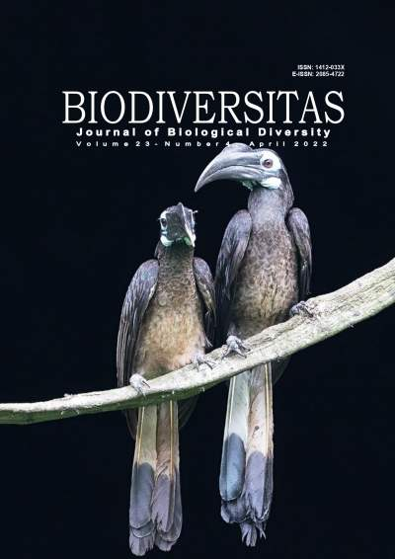
LEMBAR PENGESAHAN

Judul : Short Communication: Assessing the relationship of Sumatran elephant’s movement (Elephas maximus sumatranus) with vegetation intensity in Kotaagung Utara, Lampung Province, Indonesia using NDVI method

Samsul Bakri, Della Tiara Moniq, Agus Setiawan, dan Gunadi Djoko Winarno
Penulis : Agus Setiawan
Jurusan : Kehutanan
Fakultas : Pertanian
Publikasi : Biodiversitas
ISSN : 2085-4722
Link Website : http://biodiversitas.mipa.uns.ac.id/D/D2304.htm
Edisi : Biodiversitas vol. 23 No. 04, April 2022

Bandar Lampung, Mei 2022

Mengetahui,
Ketua Jurusan Kehutanan
Fakultas Pertanian Universitas Lampung Penulis

Dr. Indra Gumay Febryano, S.Hut., M.Si. Dr. Ir. Agus Setiawan, M.Si.
NIP 19740222 200312 1 001 NIP 19590811 198603 1 001

Menyetujui,
Dekan Fakultas Pertanian Ketua LPPM
Universitas Lampung Universitas Lampung

Prof. Dr. Irwan Sukri Banuwa, M.Si. Dr. Ir. Lusmeilia Afriani, D.E.A.
NIP 19611020 198603 1 002 NIP 19650510 199303 2 008

TABLE OF CONTENT
- Cover [PDF]
- Editorial Board & Guidance for Authors [PDF]
- Sustainability status of small-scale fisheries resources in Jakarta Bay, Indonesia after reclamation
ANDI MUHAMMAD YUSLIM PATAWARI, ZUZY ANNA, PURNA HINDAYANI, YAYAT DHAHIYAT, ZAHIDAH HASAN, INTAN ADHI PERDANA PUTRI [PDF]
- Identifying the potential geographic distribution for Castanopsis argentea and C. tungurrut (Fagaceae) in the Sumatra Conservation Area Network, Indonesia
TRY SURYA HARAPAN, NURAINAS, SYAMSUARDI, AHMAD TAUFIQ [PDF]
- The diversity and distribution of Alpinia zerumbet clade in West Malesia
EKA SETIAWAN, MARLINA ARDIYANI, MIFTAHUDIN MIFTAHUDIN, AXEL DALBERG POULSEN, TATIK CHIKMAWATI [PDF]
- Expression of heterosis, heterobeltiosis, and gene action in quantitative characters on soybean (Glycine max)
AYDA KRISNAWATI, MOCHAMMAD MUCHLISH ADIE [PDF]
- Exploration non-symbiotic nitrogen-fixing bacteria from several lakes in East Java, Indonesia
WARDATUN NAFISAH, SITORESMI PRABANINGTYAS, AGUNG WITJORO, RINA TRITURANI SAPTAWATI, ACHMAD RODIANSYAH [PDF]
- Diversity of potassium solving microbes on andisol soil affected by the eruption of Mount Sinabung, North Sumatra, Indonesia
MARIANI SEMBIRING, T. SABRINA [PDF]
- Ecological role and potential extinction of Amorphophallus variabilis in Central Java, Indonesia
BAIQ FARHATUL WAHIDAH, NORMA AFIATI, JUMARI [PDF]
- Deep sea squid in Sulawesi Sea, North Sulawesi Province, Indonesia
SILVESTER BENNY PRATASIK, LAURENTIUS TH X LALAMENTIK, LEFRAND MANOPPO, JOHNNY BUDIMAN [PDF]
- Constructing and expressing acyl-homoserine lactone lactonase (aiiA) gene for enhancing Solanum tuberosum resistance against soft rot disease
ERMA SURYANTI, IMAN RUSMANA, ARIS TRI WAHYUDI, ALINA AKHDIYA, DEDEN SUKMADJAJA [PDF]
- Sumatran tiger identification and phylogenetic analysis based on the CO1 gene: Molecular forensic application
ASHRIFURRAHMAN, SARUEDI SIMAMORA, RUSDIYAN RITONGA, WILSON NOVARINO, DJONG HON TJONG, RIZALDI, SYAIFULLAH, DEWI IMELDA ROESMA [PDF]
- DNA barcoding of freshwater fish in Siberut Island, Mentawai Archipelago, Indonesia
DEWI IMELDA ROESMA, DJONG HON TJONG, MUHAMMAD NAZRI JANRA, DYTA RABBANI AIDIL [PDF]
- Genetic diversity of Central Javanese duck (Indonesia) based on Inter Simple Sequence Repeat markers
R. SUSANTI, AGUSTIN DIAN KARTIKASARI, FITRI ARUM SASI, DYKEN DWI ARLINDA [PDF]
- Half diallel of F1 tomato hybrid and its double cross-compatibility
MUH FARID, MUHAMMAD FUAD ANHSORI, IFAYANTI RIDWAN, NOVATY ENY DUNGGA, IRNA ERMIYANTI [PDF]
- Short Communication: Sustainability of ecological dimension in peatland management in The Giam Siak Kecil Bukit Batu Landscape, Riau, Indonesia
ZULKARNAINI ZULKARNAINI, SUJIANTO SUJIANTO, WAWAN WAWAN [PDF]
- Impact of soil fertilization on arthropod abundance and diversity on soybean agroecosystem
ROSMA HASIBUAN, OLIVIA CINDOWARNI, JAMALAM LUMBANRAJA, FAVORISEN ROSYKING LUMBANRAJA [PDF]
- Interspecific and intraspecific cross-compatibility of Durio kutejensis and hybrid Durio zibethinus x kutejensis
RUDARMONO, NOER RAHMI ARDIARINI, BUDI WALUYO, SUMERU ASHARI [PDF]
- Assessing the economic feasibility of cattle farm agritourism at ex-coal mine lands through the partnership program
FAISOL MUKARROM, EVI GRAVITIANI, PRANOTO PRANOTO, RAVIK KARSIDI [PDF]
- Assessment of macro-faunal diversity of nipa swamp in Bisagu, Aparri, Cagayan, Philippines
JONI MAE B TAGUIAM, GERLIE U BAYANI, FROILAN A PACRIS JR, ROMAR R BANADERO, MARVIN V BALOLOY [PDF]
- Odonatofauna in the freshwater system of Kibalabag, Malaybalay City, Bukidnon, Philippines
DON MARK E GUADALQUIVER, OLGA M NUNEZA, REAGAN JOSEPH T VILLANUEVA [PDF]
- Agroforestry management systems through landscape-life scape integration: A case study in Gowa, Indonesia
DIAN AYU LESTARI HASANNUDIN, DODIK RIDHO NURROCHMAT, METI EKAYANI [PDF]
- Fish behavior based on the effect of variations in oceanographic condition variations in FADs Area of Bone Bay Waters, Sulawesi, Indonesia
ARHAM RUMPA, NAJAMUDDIN, SAFRUDDIN, MUHAMMAD ABDUH IBNU HAJAR [PDF]
- Potential extracts of wedge sea hare (Dolabella auricularia) as immunostimulators in comet fish (Carassius auratus auratus) infected by Aeromonas hydrophila
NURHALISA, INDRIYANI NUR, SURYANI [PDF]
- Visual soil structure quality and its correlation to quantitative soil physical properties of upland rice site in Falcataria moluccana agroforestry system
BAGASTAMA DIPA BRILIAWAN, NURHENI WIJAYANTO, BASUKI WASIS [PDF]
- Bubulcus ibis (cattle egret) conservation with awig-awig (customary law) in Bali, Indonesia
FRANSISCUS XAVERIUS SUDARYANTO, JUNITA HARDINI , LALU ACHMAD TAN TILAR WANGSAJATI SUKMARING KALIH , I WAYAN SUANA [PDF]
- Antimicrobial activity of nudibranch Chromodoris lineolata associated bacteria against skin diseases pathogens from Jepara Coastal Waters, Indonesia
ALDI PRATAMA WIJAYA, AGUS SABDONO, MADA TRIANDALA SIBERO, AGUS TRIANTO, OCKY KARNA RADJASA [PDF]
- Short Communication: Assessing the relationship of Sumatran elephantâ€™s movement (Elephas maximus sumatranus) with vegetation intensity in Kotaagung Utara, Lampung Province, Indonesia using NDVI method
SAMSUL BAKRI, DELLA TIARA MONIK, AGUS SETIAWAN, GUNARDI DJOKO WINARNO [PDF]
- The growth of Paraserianthes falcataria at three different plant ages and soil thickness classes on reclamation sites of post-coal mining areas in East Kalimantan, Indonesia
MULYADI MULYADI, DADDY RUHIYAT, MARLON IVANHOE AIPASSA, SIGIT HARDWINANTO [PDF]
- Diversity report of freshwater gastropods in Buton Island, Indonesia
MUHAMMAD FAJAR PURNAMA, LA ODE MUHAMMAD JUNAIDIN SIRZA, SRI FATMA SARI, SALWIYAH, HASLIANTI, ABDULLAH, SUWARJOYOWIRAYATNO, MUHAMMAD NUR FINDRA, NURHIKMA, AHDIAT AGRIANSYAH, HERLAN HIDAYAT, SYUKUR, KHOIRUL ANWAR [PDF]
- Enzyme production, antibacterial and antifungal activities of actinobacteria isolated from Ficus deltoidea rhizosphere
ISRA JANATININGRUM, YULIN LESTARI [PDF]
- Morpho-anatomical characterization and DNA barcoding of Achillea millefolium L.
MOCHAMMAD ILHAM, SITI RIZQIYATUL MUKARROMAH, GALUH AYU RAKASHIWI, DANI TRI INDRIATI, BRUNI FLARANDA YOKU, PUTUT RAKHMAD PURNAMA, JUNAIRIAH, SEHANAT PRASONGSUK, HERY PURNOBASUKI, DWI KUSUMA WAHYUNI [PDF]
- Diversity and use of medicinal plants for traditional women's health care in Northern Banyumas, Indonesia
WAHYU UTAMININGRUM, NOFRIANTI, DWI HARTANTI [PDF]
- Commercial marine fish species from Weh Island, Indonesia: Checklist, distribution pattern and conservation status
ILHAM ZULFAHMI, MAURIZA APRIANSYAH, AGUNG SETIA BATUBARA, NERI KAUTSARI, KIZAR AHMED SUMON, MOHAMMAD MAHMUDUR RAHMAN, FIRMAN M. NUR [PDF]
- Spatial distribution and temporal patterns of food tree availability of hornbills (Bucerotidae) at Way Canguk Research Station, Bukit Barisan Selatan National Park, Indonesia
RIZKI AKBAR FITRIANSYAH, AGUS SETIAWAN, ELLY LESTARI RUSTIATI, LAJI UTOYO, MARSYA CHRISTYANTI SIBARANI [PDF]
- Variability total phenolic content and antioxidant activity of Curcuma zanthorrhiza and C. aeruginosa cultivated in three different locations in West Java, Indonesia
SURYANI, ASMAUL CHUSNA AL ANSHORY, MARLIN, I MADE ARTIKA, LAKSMI AMBARSARI, WARAS NURCHOLIS [PDF]
- Evaluation of agronomic and fruit quality traits of miraculin transgenic tomato
NONO CARSONO, NIA DESIANA, FERI M. NURRIZQI, IQBAL F. ELFAKHRIANO, ANAS, SANTIKA SARI, KUSUMIYATI, RYO OHSAWA, AYAKO SHIMONO, HIROSHI EZURA [PDF]

 | Home  Content and Archives  Aims and Scope  Editorial Board  Guidance for Authors  Ethical Guidelines  Charges  Membership  Previously Reviewers  Conference Events | Contact Us FAQ Useful links  Editors-PDF  EDITOR-IN-CHIEF:  Sutarno  EDITORIAL MEMBERS:  English Editors: Graham Eagleton (grahameagleton@gmail.com), Suranto (surantouns@gmail.com); Technical Editor & Banking: Artini Pangastuti (pangastuti_tutut@yahoo.co.id), Solichatun (solichatun_s@yahoo.com); Distribution & Marketing: Rita Rakhmawati (oktia@yahoo.com); Webmaster: Ari Pitoyo (aripitoyo@yahoo.co.id)  MANAGING EDITORS:  Ahmad Dwi Setyawan (unsjournals@gmail.com)  EDITORIAL BOARD (COMMUNICATING EDITORS):  Abd Fattah N. Abd Rabou, Islamic University of Gaza, Palestine  Agnieszka B. Najda, University of Life Sciences in Lublin, Lublin, Poland  Ajay Kumar Gautam, Abhilashi University Mandi, Himachal Pradesh, India  Annisa, Padjadjaran University, Sumedang, Indonesia  Alan J. Lymbery, Murdoch University, Perth, Australia  Bambang Hero Saharjo, Institut Pertanian Bogor, Bogor, Indonesia  Daiane H. Nunes, State University of Londrina, Londrina, Brazil  Darlina Md. Naim, University Sains Malaysia, Penang, Malaysia  Ghulam Hassan Dar, Sher-e-Kashmir University of Agricultural Sciences and Technology of Kashmir, Srinagar, India  Hassan Pourbabaei, University of Guilan, Somehsara, Guilan, Iran  Joko Ridho Witono, Center for Plant Conservation-Bogor Botanical Gardens, Indonesian Institute of Sciences, Bogor, Indonesia  Kartika Dewi, Research Center for Biology, Indonesian Institute of Sciences, Cibinong, Bogor, Indonesia  Katsuhiko Kondo, University of Missouri, Columbia, USA  Kusumadewi Sri Yulita, Research Center for Biology, Indonesian Institute of Sciences, Cibinong, Bogor, Indonesia  Livia Wanntorp, Naturhistoriska riksmuseet, Stockholm, Sweden  M. Jayakara Bhandary, Government Arts and Science College, Karwar, Karnataka, India  Mahdi Reyahi-Khoram, Islamic Azad University (Hamadan Branch), Hamadan, Iran  Mahendra Kumar Rai, SGB Amravati University, Maharashtra, India  Mahesh K. Adhikari, Adhikari Niwas, Kathmandu, Nepal  Maria Panitsa, University of Patras, Agrinio, Greece  Mochamad A. Soendjoto, Lambung Mangkurat University, Banjarbaru, Indonesia  Mohamed M.M. Najim, University of Kelaniya, Kelaniya, Sri Lanka  Mohib A. Shah, Nepean Telehealth Technology Centre, Sydney, Australia  Nurhasanah, Mulawarman University, Samarinda, Indonesia  Praptiwi, Research Center for Biology, Indonesian Institute of Sciences, Cibinong, Bogor, Indonesia  Rasool B.Tareen, University of Balochistan, Quetta, Pakistan  Seyed Aliakbar Hedayati, Gorgan University of Agricultural Sciences and Natural Resources, Iran  Seyed Mehdi Talebi, Arak University, Iran  Shahabuddin, Universitas Tadulako, Palu, Indonesia  Shahir Shamsir, Universiti Teknologi Malaysia, Skudai, Malaysia  Shri Kant Tripathi, Mizoram University, Aizawl, India  Sugeng Budiharta, Purwodadi Botanical Gardens, Indonesian Institute of Sciences, Pasuruan, Indonesia  Sugiyarto, Universitas Sebelas Maret, Surakarta, Central Java, Indonesia  Subash C. Santra, University of Kalyani, India  Taufiq Purna Nugraha, Research Center for Biology, Indonesian Institute of Sciences, Cibinong, Bogor, Indonesia  Yosep S. Mau, Nusa Cendana University, Kupang, Indonesia  ISSN 1412-033X | E-ISSN 2085-4722  PUBLISHER: Society for Indonesian Biodiversity  CO-PUBLISHER: Department of Biology, FMNS, Sebelas Maret University Surakarta  FIRST PUBLISHED: 2000  ADDRESS:  Sebelas Maret University  Jl. Ir. Sutami 36A Surakarta 57126. Tel. +62-271-7994097, Tel. & Fax.: +62-271-663375, email: editors@smujo.id  ONLINE: biodiversitas.mipa.uns.ac.id  Download the Editorial Boards.

BIODIVERSITAS | ISSN: 1412-033X
Volume 23, Number 4, April 2022 | E-ISSN: 2085-4722
Pages: 1920-1928 | DOI: 10.13057/biodiv/d230426
Short Communication:
Assessing the relationship of Sumatran elephant’s movement (Elephas maximus sumatranus) with vegetation intensity in Kotaagung Utara, Lampung Province, Indonesia using NDVI method

SAMSUL BAKRI, DELLA TIARA MONIK♥, AGUS SETIAWAN, GUNARDI DJOKO WINARNO
Department of Environmental Science, Postgraduate Program, Universitas Lampung. Jl. Prof. Dr. Sumantri Brojonegoro No. 1, Bandar Lampung 35145, Lampung, Indonesia. Tel./fax. +62-271-783682, ♥email: dellatiaraaa@gmail.com
Manuscript received: 1 March 2022. Revision accepted: 21 March 2022.
Abstract. Bakri S, Monik DT, Setiawan A, Winarno GD. 2022. Short Communication: Assessing the relationship of Sumatran elephant’s movement (Elephas maximus sumatranus) with vegetation intensity in Kotaagung Utara, Lampung Province, Indonesia using NDVI method. Biodiversitas 23: 1920-1928. The Indonesian Elephant Conservation Forum stated that the population of Sumatran elephants (Elephas maximus sumatranus) had decreased dramatically up to 70% in the last 20-30 years due to illegal hunting, land conversion, and encroachment, so the availability of elephant food in the wild is gradually inadequate. With the decline of the elephant population in Indonesia, several parties such as the government, NGO, and the public are beginning to monitor the Sumatran elephant. The monitoring is carried out by observing and studying the movements of elephants using a GPS Collar. The research aims to find out the consistency of elephant movement and its relationship to the availability of feed as indicated by the intensity of vegetation in KPH Kotaagung Utara, Lampung Province, Indonesia. This research used GIS technology (Correlation Citra Landsat 8 OLI and BIG Demnas Data), elephant movement data using GPS Collar in 2020, and land use data by BPKH Lampung. The results showed that the monthly movement pattern of elephants in 2020 was consistently monitored. From January-July, elephants are in the North area, while in August-December are in the South. The intensity of elephant movement in the Mixed Shrub Dryland Agriculture area is higher than in the other areas, at 107 points or about 90% of all the areas in KPH Kotaagung Utara. Meanwhile, in the Dryland and Shrub Agriculture areas, there are 6 points each, or about 5% of all the areas. The vegetation classification in KPH Kotaagung Utara is dense with an NDVI value range of 0.63-0.85. Furthermore, the regression results prove that NDVI and the monthly season affect the movement of elephants with a p-value of <0.001.
Keywords: KPH Kotaagung Utara, NDVI, Sumatran elephant (Elephas maximus sumatranus)
Abbreviations: API: Application Programming Interface; EEC: Earth Engine Computing; GPS: Global Positioning System; H: Hypothesis; IUCN: International Union for Conservation of Nature and Natural Resources; IVI: Important Value Index; KHL: Kawasan Hutan Lindung; KPH: Kesatuan Pengelolaan Hutan; NDVI: Normalized Difference Vegetation Index; NGO: Non-Governmental Organization; NIR: Near Infra-Red; R-Sq: R-Square (Coefficient of Determination); R-Sq (Adj) is the Adjusted R-Square (Coefficient of Determination); SEE: Standard Error of Estimate; WWF: World Wide Fund for Nature

INTRODUCTION
The Sumatran elephant (Elephas maximus sumatranus) is the largest herbivore in Sumatra (Indonesia) with the classification Proboscidea (Imtiyaaz et al. 2021). According to the International Union for Conservation of Nature and Natural Resources (IUCN) 2022, Sumatran elephants are included in the Red List Data Book in the critically endangered category. According to the Directorate of Biodiversity Conservation, Directorate General of Natural Resources and Ecosystem
Conservation, Ministry of Environment and Forestry of the Republic of Indonesia Jakarta (2020), in 2017, the Sumatran elephant population was estimated at 1,694- 2,038 individuals found in 36 habitat pockets and spread over seven provinces, including Aceh, North Sumatra, Riau, Jambi, South Sumatra, Bengkulu and Lampung. The Government Regulation Number P.20/MenLHK/Setjen/ Kum.1/6/2018 about Protected Types of Plants and Animals in Indonesia strengthens the protection of Sumatran elephants, with the second amendment of Regulation of the Minister of Environment and Forestry Number P.106/MenLHK/Setjen/Kum.1/12/2018, however, the conversion of forest functions to agricultural and plantation areas, resulting in depression in elephant’s natural habitats as a refuge, and become one of the factors’s causing the decline of elephants population (Kumar et al. 2020).
In general, Sumatran elephants can be found in stable habitats, such as tropical rainforests in some parts of Indonesia (Moßbrucker et al. 2016). In line with Shaffer et al. (2019), elephants live in groups by traveling long distances out of their roaming area to fulfill their food needs and water, find social partners, and reproduce. The availability of adequate food and water will indirectly affect the activities and behavior of the elephants.
According to Wall et al. (2021), elephants often choose to be in protected areas, with security better than in other areas, aside from the abundance of food and water. However, as time goes by, anthropogenic activities, forest encroachment, and land clearing in protected forest areas are increasing, and the home range and food chain of the elephants that inhabit the rest of the forest are interrupted (Calabrese et al. 2017). These negative activities will destroy the elephant's natural habitat and trigger conflicts between elephants and humans. Thus, monitoring is needed to determine the elephant's roaming area. Analysis of land use maps was carried out using satellite imagery to see the greenery level of plants in the observation area (Prasetyo et al. 2017). Doing mapping and observation is one of the methods used to find out the relation between the roaming area and the wild elephant feed in KPH Kotaagung Utara. The first thing to do is see the intensity of elephant movements based on the land use map. According to Nedd et al. (2021) land use and land cover are important to be understood because such data refer to the purpose and the land function, such as wild animal habitat, land change, and development, as well as the physical appearance of the earth's surface such as bodies of water, rocks, built-up land, and others. Moreover, these appearances are valuable information for nurturing elephant programs that live naturally or domestically (Meytasari et al. 2014). The development of technology nowadays, like GPS (Global Positioning System) and non-invasive molecular technic, helps increase our understanding of observing and studying the wildlife ecology, especially wild elephants (Wong et al. 2018). After that, analyzing the vegetation intensity damage at KPH Kotaagung Utara using the vegetation indexes. Index vegetation is needed to identify pixels covered by the size of vegetation proportion. According to Xue and Su (2017), the vegetation index is obtained from the greenness of vegetation or canopy based on digital signal intensity, or what is known as a fairly simple algorithm. There are many vegetation indexes with different algorithms, one of them is the vegetation index Normalized Difference Vegetation Index (NDVI). NDVI is an index that is often used to calculate the greenery scale, counted by the multispectral information as the normalization ratio between red-bow and closer infra-red this classification can be done with a good technique using remote sensing because of the special vegetation characteristic towards electromagnetic waves (Woźniak et al. 2020). Finally, do the correlation of NDVI value with the presentation of the elephant's move. Based on the background given, this observation aims to see the consistency of the elephant’s movement and the relation with the food supply availability indicated by the vegetation's intensity in KPH Kotaagung Utara, Lampung Province, Indonesia.
MATERIALS AND METHODS

Research location
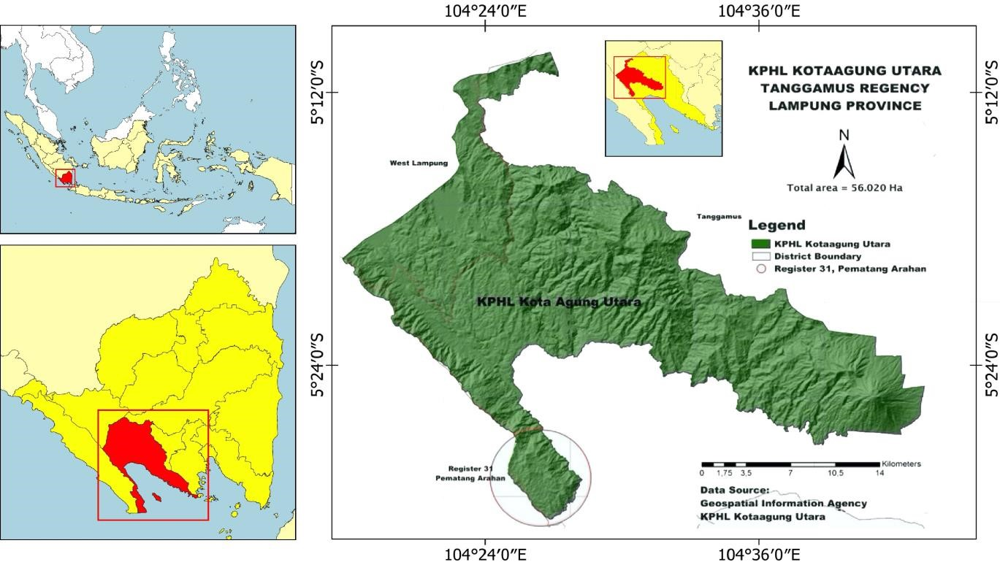
Figure 1. Research location KPH Kotaagung Utara, Tanggamus District, Lampung Province, Indonesia
The research was conducted at a protected area, namely Kawasan Hutan Lindung (KHL), located inside KPH Kotaagung Utara, Tanggamus District, Lampung Province, Indonesia (Figure 1). Data analysis was carried out using a laptop and ArcGIS software in January 2022.

Procedures

Types and data source
The data were collected from secondary data obtained from the internet, newspaper, or journal (Ajayi 2017). The data collected were GPS Collar data in 2020 kindly provided by WWF, land use data in KPH Kotaagung Utara consisting of BPKH data, a constellation of Citra Lansat 8 OLI, and BIG Demnas, as well as NDVI, which were obtained by searching using Google Earth Engine.

Data collecting
Secondary data were obtained from the results of mapping the consistency of the Sumatran elephant roaming area using the GPS Collar (data WWF) in 2020, consisting of land use data, a constellation of Citra Lansat 8 OLI and BIG Demnas data, and NDVI results using Google Earth Engine. Currently, there are 24 elephants in the province of
Tanggamus, which are divided into 2 groups. GPS Collars were installed on each Bunga and Citra elephant group leader. According to Nazaruddin, chairman of the Mahout Forum, the elephant fitted with the GPS Collar is a female elephant aged 25-30 years, may weigh up to 2,500 kg (5511.56 lb.) and stand about 2.19 m (7.1 ft.). The data generated from the GPS Collar is in the form of recording the points of elephant movement per day every year. The data was obtained from WWF and has been granted permission to be processed. The goal of the GPS Collar is to track the movement patterns of animals in great detail (Stabach et al. 2020).

Data analysis

Distribution of coordinate points based on land cover
The elephants wearing GPS Collars were moved across different land covers. The data obtained were then processed and analyzed using the formula:

Normalized Difference Vegetation Index (NDVI) analysis based on Earth Engine Computing (EEC)
Vegetation intensity analysis was carried out by NDVI using the red band and Near Infra-Red (NIR) in remote sensing to determine the vegetation index from the satellite (Shafizadeh-moghadam et al. 2021). Viewing the NDVI value of an area can be done by using Earth Engine Computing. Earth Engine is a platform developed by Google with various open-source data available in the data catalog and ready for analysis in multi-petabyte sizes processed through computing services with highperformance capacities (Gorelick et al. 2017). GEE offers substantial advantages over conventional processing, including easy-to-develop and open algorithms and the ability to do various computing tasks efficiently (Xia et al. 2020). This is because the Application Programming Interface (API) can be accessed through the related website (IDE), allowing for rapid generation of prototypes and visualizations in a large cloud computing chart (Gorelick et al. 2017; Sidhu et al. 2018; Chen et al. 2021) An NDVI score near 1 indicates that the area is becoming denser in terms of vegetation cover; and vice versa, a value near 0 indicates that the area's vegetation is becoming rarer (Pahlefi et al. 2021). Ahmed and Akter (2017) describe the NDVI algorithm as follows:

Where, NDVI is the Normalized Difference Vegetation Index; NIR is the spectral reflectance value in the nearinfrared band; R is the spectral reflectance value in the red band. The vegetation density level is classified into five categories (Table 1): cloud and water, non-vegetation, sparse vegetation, moderate vegetation, and dense vegetation (Sunaryo and Iqmi, 2015; Hardianto et al. 2021). Correlations will be made between the data and data from image processing using NDVI at the same coordinates. Through statistical correlation analysis, data validation will demonstrate the similarity of image processing data to actual conditions. The higher the correlation coefficient, the more comparable the two compared outcomes are.

Multiple linear regression
The main motivation for developing the linear model in this research is to obtain a tool that can be used to accurately predict the proportion of an elephant herd or elephant area density (EAD) using two predictor variables (independent variables) in the form of NDVI data and the distribution of elephant movement variables according to time. While the NDVI variable reflects the environmental and ecological conditions of land use at the observation point in 2020, it shows the movement of elephants according to time (t), where (t) is January to December. To make a comparison between one month and another in influencing EAD, one month must be used as a reference. This means that the predictor variable by month that affects EAD needs to be treated as a dummy variable (Artaya 2019). In this study, December is used as a reference, meaning that in this modeling analysis, December must be given a score of 0. Meanwhile, other months are always compared to December in influencing EAD at every point. Mathematically, this description can be expressed by the postulates of the linear model as follows:

[EAD]_{it} = β₀+ β₁[NDVI]_{it} + β₂[JAN]_{it} + β₃ [FEB]_{it} + β₄[MAR]_{it} + β₅[APR]_{it} + β₆[MAY]_{it} + β₇[JUN]_{it} + β₈[JUL]_{it} + β9[AUG] it + β10[SEP] it + β11[OCT] it + β12[NOV] it + ξ it

In the model, β₀ to β₁₂ are the parameters found using the least-squares deviation method (OLS = Ordinary Least Square) using software, namely Minitab 16. This is an error or deviation originating from various variables that are not considered in the prediction model or errors in the measurement of both EAD and NDVI data. In this regard, the hypothesis tested is:

Hypothesis:
H0: β1 =β2=β3=β4=β5=β6=β7=β8=β9=β10=β11=0 H1: β1≠β2≠β3≠ β4≠β5≠β6≠β7≠ β8≠ β9 ≠β80 ≠β11≠0

Where, H0 means that the EAD Value is not significantly different according to NDVI or according to the month of observation. And then, H1 means that the EAD Value is significantly different according to NDVI or
the month of observation.significantly different according to NDVI or according to the month of observation.

As for variables, symbols in models, units, data sources of variable response, and predictors are presented in Table 2.

Hypothesis testing
Hypothesis testing is a subset of inferential statistics that aims to draw conclusions using data from a population sample. Simultaneously, the F method was conducted to test the independent variable's effect on the dependent variable. To determine if the independent variable had a partial effect on the dependent variable, the t-test was performed. The significance level used in this study was 10%. The coefficient of determination test is intended to determine the percentage or proportion of total variance explained by the dependent variable by the independent variable. Because the equation is multiple regression, the value used is R². Testing the multiple linear regression equation parameters was carried out using Minitab 16.

Table 1. Classification of vegetation density on NDVI value

Classification of vegetation density | NDVI value
Cloud and Water  Non-Vegetation  Sparse | -2.0-0  0-0.21  0.21-0.42
Moderate | 0.42-0.63
Dense | 0.63-0.85
Data Source: Sunaryo and Iqmi (2015); Hardianto et al. (2021)

Table 2. Variables, symbols in models, units and scores, data sources

Variable | Symbol | Data source
Elephant movement  (Elephant Area Density) | [EAD] it | World Wide Fund for Nature
NDVI | [NDVI] it | Interpretation of Landsat Imagery
January | [JAN] it | Research results in 2022
February | [FEB] it | Research results in 2022
March | [MAR] _{it} | Research results in 2022
April | [APR] it | Research results in 2022
May | [MAY] it | Research results in 2022
June | [JUN] it | Research results in 2022
July | [JUL] it | Research results in 2022
August | [AUG] it | Research results in 2022
September | [SEP] _{it} | Research results in 2022
October | [OKT] it | Research results in 2022
November | [NOV] _{it} | Research results in 2022

RESULTS AND DISCUSSIONS

Movement patterns of Sumatran elephants
Wild animal behavior is the movement of animals to fulfill the stimuli in their bodies by utilizing the stimuli obtained from their environment. Movement behavior is carried out to find food, breed, or escape from predators and other disturbances. The behavior of wild animals is determined by two elements: primary and secondary factors (Gill et al. 2019). Primary factors encourage animals to move to meet their physiological demands, such as hunger, thirst, and sexual desire. As a result, it is believed that the distribution of feed, water, and mating is the primary predictor of a place's utilization. Additionally, secondary factors affect how space is used and may include variances in a place's microclimate, terrain conditions, risk of encountering predators, and risk of disease. Animals prioritize time and space, as these factors limit and scale animal behavior patterns (Torres et al. 2017).
In Tanggamus District, 24 Sumatran elephants (Elephas maximus sumatranus) were observed, divided into two groups: the Bunga group (16 elephants) and the Citra group (8 elephants). This is related to Williams et al. (2019), which state that elephants live with matriarchal patterns or large and complex social groups in the wild. Elephants move in a wide-roaming area, thus, they utilize a variety of habitat types, including swamp forest, peat swamp forest, lowland forest, and low montane rainforest (Sukumar 1999).
Elephants, as herbivores, require a greater amount of food than other herbivores due to their big body size. Elephant feed is made from plants, including leaves, fruit, stems, bark, tubers, gums, and roots of various plants. According to Riba'i et al. (2013), in general elephants consume five different plant parts: leaves, stems, fruit, roots, and skin. The quantity and diversity of food sources, which vary considerably between areas, are the primary reasons the wild elephant group in the KPH Kotaagung Utara has such a large roaming area. The findings of this study indicate that the Sumatran Elephant’s movement in the KPH Kotaagung Utara from 2020 tends to be steady. Between January and July, elephants go to the North, whereas between August and December, elephants tend to travel to the Southern area of the KPH Kotaagung Utara (Figure 2).

Coordinate points distribution based on land cover
The movement of each group is influenced by the season and the condition of its habitat resources, especially feed and the available home range. During the dry season, groups of elephants typically wander from highland to lowland forest in search of feed, but during the rainy season, elephants do the opposite. Basically, elephants prefer areas with cold weather and will stop feeding activities when the weather is hot. During the dry season, groups of elephants typically wander from highland to lowland forest in search of food, but during the rainy season, elephants do the opposite. In general, elephants prefer chilly climates and will cease feeding activities in hot weather. This is aligned with Williams's (2009) statement that elephants are warm-blooded animals (thermal cover), which means that in hot situations, the elephant will seek shelter and adjust its body temperature to adapt to its environment. Elephants also avoid sunburn by covering their body in soil or mud to keep cool (Imtiyaaz et al. 2021). Elephant populations will thrive in habitats with a balanced blend of physical and biotic environments. Mineral salts, water availability, and slopes contribute to these physical circumstances. While biological variables in the form of vegetation composition or structure, vegetation profile, and feed availability (Shaffer et al. 2019). Elephants equipped with
GPS collars migrate or travel in a variety of land use and cover types. In KPH Kotaagung Utara, there are 119 elephant coordinates distributed throughout 9 different land uses. Primary Dryland Forest, Secondary Dryland Forest, Settlement, Mining, Dryland Agriculture, Shrub Mixed Dryland Agriculture, Rice Fields, Scrub Bush, and Open Land are the different forms of land use. Elephant activity is more intense in the Mixed Shrub Dryland Agriculture area than in other places, with 107 points accounting for approximately 90% of all areas in KPH Kotaagung Utara. Meanwhile, the Dryland and Scrub Agriculture sectors each have six points or approximately 5% of all areas. This is demonstrated in Table 3 and Figure 3.

Table 3. Distribution of the coordinates of Sumatran elephants fitted with GPS Collars on various types of land use in KPH Kotaagung Utara, Tanggamus District, Lampung Province,
Indonesia

Land use Number of Percentage Wide points (ha)
Primary Dryland Forest | 0 | 0 | 206.3090
Secondary  Dryland Forest | 0 | 0 | 5,641.1765
Settlement | 0 | 0 | 125.9465
Mining | 0 | 0 | 96.2618
Dryland Farming | 6 | 5% | 2,002.1857
Mixed Shrub  Dryland  Agriculture | 107 | 90% | 45,772.5237
Rice Field | 0 | 0% | 851.3812
Shrubs | 6 | 5% | 1,485.7736
Open Land | 0 | 0% | 76.2225
Grand Total | 119 | 100% | 56,257.7808

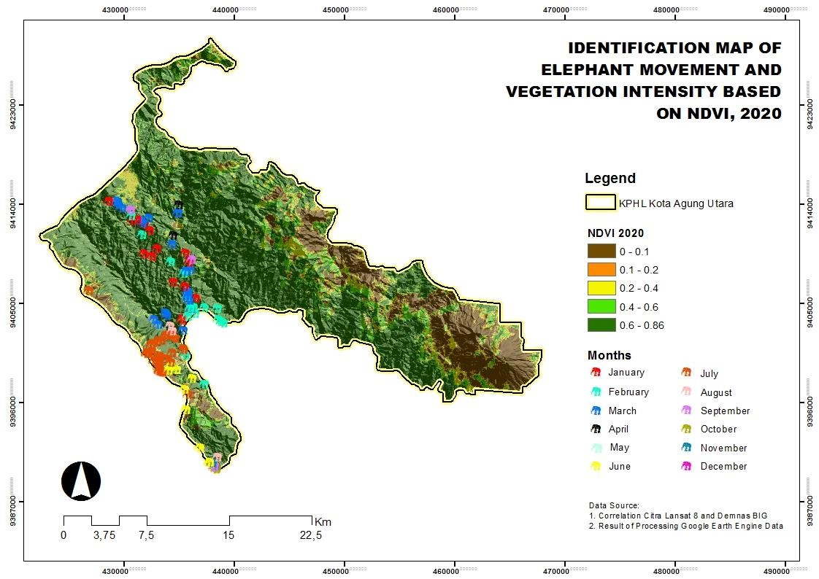
Figure 2. Map of Sumatran elephant movement in KPH Kotaagung Utara, Tanggamus District, Lampung Province, Indonesia for 2020
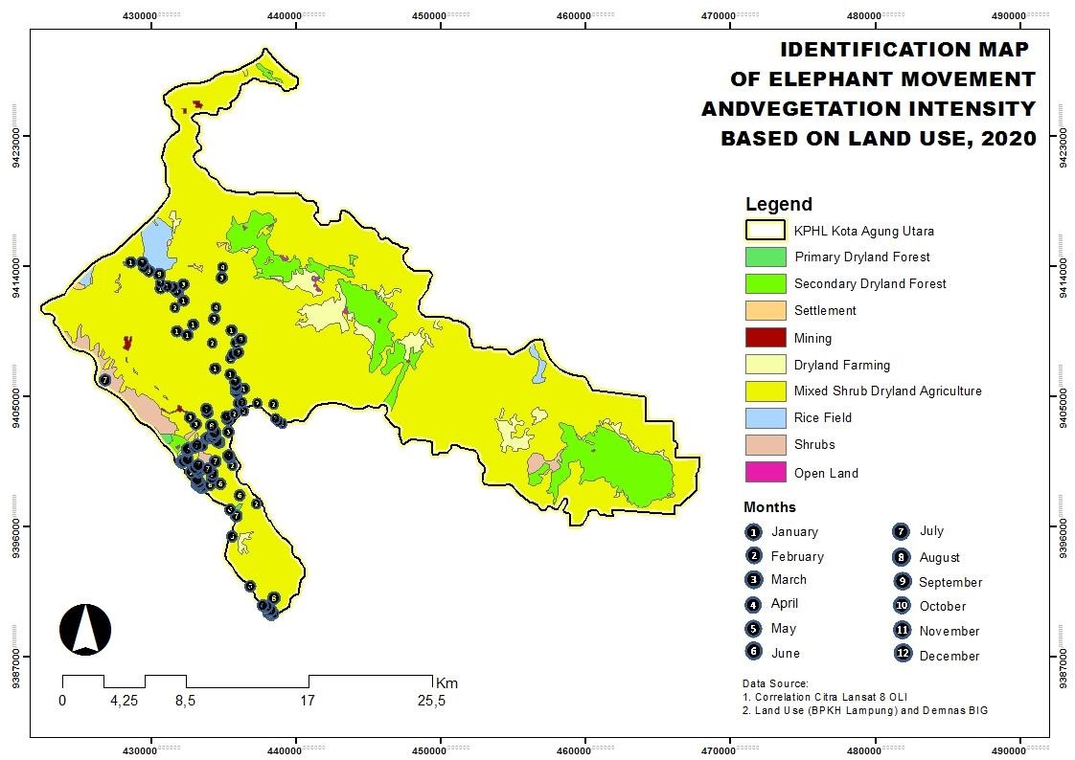
Figure 3. Map of Sumatran elephant movement in KPH Kotaagung Utara Tanggamus District, Lampung Province, Indonesia based

on land use 2020

Based on the elephant’s land uses and roaming, Mixed Shrub Dryland Agriculture receives the most points, 107 out of 119. Due to the predominance of Mixed Shrub Dryland Agriculture usage by elephants in KPH Kotaagung Utara, such area is look like very ideal for Sumatran elephants who live around. The reasons are clear, why they really like those Mixed Shrub Dryland Agriculture. That are because the elephants still found plenty of food, and the ecosystem has a reasonably dense canopy cover, which protects elephants from direct sunburn. The second type of land use that elephant crossed the most is Dryland and Shrub Farm, which received six points out of 119 points. This is reinforced by Putri's research (2021) which states that the vegetation in the northern area is dominated by woody plant species such as harendong trees (Melastoma affine), masi-masian (Mimusops elengi), bendo (Artocarpus elasticus), and cocoa (Theobroma cacao), while the vegetation that dominates the southern area is non-woody plant species, such as reed grass (Saccharum spontaneum), tepus (Phrynium pubinerve), resam fern (Dicranopteris linearis), jerumo manok (Leea indica), Bandotan (Ageratum conyzoides), Kasapan (Clidemia hirta ), reeds (Imperata cylindrica), bone grass (Eleusine indica), teki grass (Cyperus rotundus), and ganyongan (Canna discolor). Additionally, gamal tree (Gliricidia sepium) with an IVI of 111, and dadap (Erythrina variegata) with an IVI of 105 dominated the plant species of dryland agricultural ecosystem type in KPH Kotaagung Utara during the tree phase. The vegetation in an area has a positive influence on the elephant’s habitat, which varies depending on the structure and composition of vegetation that grows in the area (Farhan et al. 2019). Additionally, there was no evidence of Sumatran elephant points in six other types of land cover in the KPH Kotaagung Utara, namely: Settlement, Mining, Primary Dryland Forest, Secondary Dryland Forest, Rice Fields, and Open Land. This is because the land area is so small. Each NDVI's value and area can be viewed in Table 4.
Types of land use in the classification of vegetation density in the form of Non-Vegetation and Sparse, the Sumatran elephant is barely traversed. Apart from having a smaller land area compared to others, elephants are also one of the animals with a high level of sensitivity, making them minimize their activity on human territory. According to Abdullah et al. (2019), elephants can detect sounds in the frequency range from 1-20,000 Hz, with a hearing distance of roughly 10 km. Therefore, increased human activities around elephant habitats, such as mining, agriculture, or urbanization, will generate noise effects that decrease the quality and quantity of elephant habitats, which can impact population decline.

NDVI value based on elephant point distribution
Based on the data analysis, the results of the classification of elephant distribution points with NDVI variations in the KPH Kotaagung Utara for 2020 were classified into Cloud and Water, Non-Vegetation, Sparse Moderate, and Dense, as presented in Table 4. The NDVI value describes the vegetation cover above the ground surface with different brightness values based on the difference in digital number values through a calculation of visible light and near-infrared. The classification can be seen in Figure 4.
According to Figure 4, the vegetation condition in KPH Kotaagung Utara is classified as dense. This is because KPH Kotaagung Utara has a relatively high vegetation density, with an average NDVI of 0.63-0.85 and 107 elephant distribution spots out of a total of 119. This is aligned with studies (Huang et al. 2020) indicating that the theoretical range of the NDVI value is -1 to 1 (the closer to 1, the more vegetation), with values less than 0 representing sea (water) or unoccupied land. The amount of land cover categories also influences the density classification, specifically Secondary Dryland Forest, Primary Dryland Forest, and Mixed Shrub Dryland Agriculture, which dominate in the KPH Kotaagung Utara, covering 51,620.0092 Ha of the total 56,020 Ha. Furthermore, Moderate’s NDVI classification which has 12 elephant distribution points. Meanwhile, the Sparse, Cloud and Water, and Non-Vegetation classifications do not have elephant distribution points. A low NDVI value indicates that the vegetation is experiencing moisture stress, and a higher value indicates a higher density of green vegetation. Furthermore, according to Sugiyanto et al. (2017), elephants will choose fresh grass in the rainy season because it contains carbohydrates and low fiber content (Lignohemicellulose). Meanwhile, elephants prefer leaves containing high protein content in the dry season, like (810% Malvaceae and 10 to 20% Leguminosae). A low NDVI value indicates that the vegetation is under water stress, whereas a high value implies a dense canopy of greenery.

Multiple linear regression T-Test against dependent variables
The T-test, also known as the partial test, was employed to determine the effect of each independent variable of vegetation intensity (NDVI) on the dependent variable of elephant migration in this study (elephant area density). The T-test results on multiple linear regression can be seen in Table 5.

Table 5. Monthly distribution results and Vegetation Intensity (NDVI) on elephant movement (elephant area density) in KPH
Kotaagung Utara, Tanggamus District, Lampung Province, Indonesia

Predictor | Coef | SE coef | T-value | P-value
Constant | 1.688 | 0.118 | 14.27 | 0.000
[NDVI] _{it} | -2.220 | 0.282 | -7.87 | 0.000
[JAN] _{it} | 0.976 | 0.121 | 8.09 | 0.000
[FEB] _{it} [MAR] _{it} | 0.761  0.802 | 0.108  0.099 | 7.07  8.07 | 0.000  0.000
[APR] _{it} | 0.759 | 0.106 | 7.15 | 0.000
[MAY] _{it} | 0.755 | 0.118 | 6.42 | 0.000
[JUN] _{it} | 0.736 | 0.093 | 7.88 | 0.000
[JUL] _{it} | 0.423 | 0.074 | 5.56 | 0.000
[AUG] _{it} | 0.335 | 0.065 | 5.15 | 0.000
[SEP] _{it}  [OCT] _{it}  [NOV] _{it}  S = 0.0726422; | 0.014  0.215  0.201  R- | 0.060  0.731  0.072  Sq = 60.29%; R- | 2.33  2.94  2.76  Sq(adj) = 55.80% | 0.022  0.004  0.007
Note: S is the Standard Error of Estimate (SEE); R-Sq is the RSquare (Coefficient of Determination); R-Sq (Adj) is the Adjusted
Table 4. Value and area of each NDVI classification in KPH Kotaagung Utara, Tanggamus District, Lampung Province, Indonesia for 2020

Classification of vegetation density | NDVI value | Type of land use | Total land use (ha)
Cloud and Water | -2.0-0 | - | -
Non-Vegetation | 0-0.21 | Open Land, Settlement, and Mining | 298.4309
Sparse | 0.21-0.42 | Rice Field | 851.3812
Moderate | 0.42-0.63 | Dryland Farming, and Shrubs | 3,487.9593
Dense | 0.63-0.85 | Secondary Dryland Forest, Primary Dryland Forest, and Mixed Shrub Dryland Agriculture | 51,620.0092

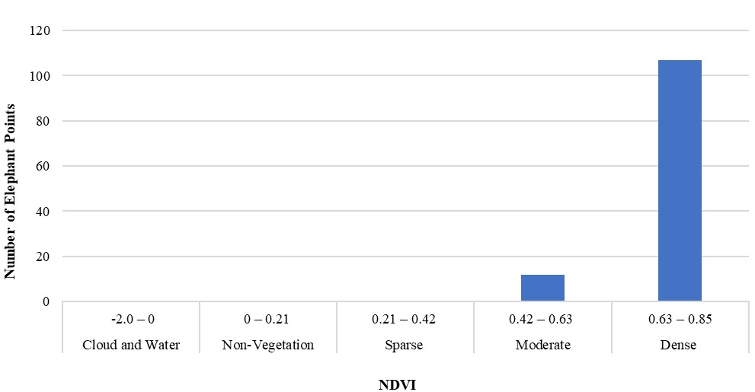

Figure 4. NDVI classification on elephant point distribution in January-December 2020
R-Square (Coefficient of Determination)
The relationship between the dependent variable (EAD) and the independent variable (NDVI and the monthly distibution) in the regression:

EAD = 1.688 - 2.220 NDVI + 0.976 [JAN]_{it} +
0.761 [FEB]_{it} + 0.802 [MAR]_{it} + 0.759 [APR]_{it} +
0.755 [MAY]_{it} + 0.736 [JUN]_{it} + 0.423 [JUL]_{it} +
0.335 [AUG]_{it} + 0.141 [SEP]_{it} + 0.215 [OKT]_{it} +
0.201 [NOV]_{it}

The R-square value, or the resulting determinant coefficient, is 60.29% based on the data processing in Table 3. This value indicates that the diversity of about 60.29% of the vegetation intensity in the KPH Kotaagung Utara affects the presence of elephants. However, the other 39.71% is influenced by other aspects, like salticks. The thing that elephants do to keep their metabolism balanced is by saltlicks (Sitienei et al. 2012). According to Sach et al. (2019), mineral salts such as calcium, magnesium, and potassium contained in the soil or cliffs taken by the elephant’s trunk are deemed helpful for elephants to help strengthen their bones, teeth, and tusks. Other factors that may influence elephant movement, such as the need for safe locations to carry out daily activities: rest, communicating, and dressing up, are elephant behaviors to defend themselves from threats (Setiawan et al. 2021). Additionally, some variables substantially affect elephant mobility (elephant area density) in KPH Kotaagung Utara, specifically monthly seasonal effects in January, February, April, May, June, July, August, October, and November. Sugiyanto et al. (2017) also revealed that elephants have foraging strategies when consuming grass and leave in the dry and wet seasons. Elephants will choose fresh grass in the wet season because it contains carbohydrates and low fiber content (Lignohemicellulose). Meanwhile, elephants prefer leaves containing high protein content in the dry season, like (8-10% Malvaceae and 10 to 20% Leguminosae) (Singh 2019). The T-test and coefficient of the determination indicate that NDVI has a volume of 0.000, which corresponds to a 99% confidence interval. The NDVI coefficient value is -2.220, which means that if the value of vegetation intensity (NDVI) decreases by 1%, it will reduce the movement of elephants by 2.200 from the total movement of elephants in 56,257 hectares of the KPH Kotaagung Utara area. It demonstrates that the high NDVI represents land use and cover in the KPH Kotaagung Utara, which will affect Sumatran elephant distribution. This is consistent with the findings of Lim and Campos-Arceiz (2022), which indicated that the closed-canopy primary rainforest is a marginal habitat for elephants and humans alike and if the forest is harmed, the elephant's habitat will be disrupted. Essentially, grass, shrubs, or denser canopy biophysical characteristics enable satellite sensors to detect their reflectance as cover (Stagakis et al. 2010). However, according to (Hidayati et al. 2018), the vegetation index does not always accurately reflect the field conditions at the NDVI value.
According to this study, the intensity of dense vegetation is directly proportional to the distribution of Sumatran elephant points in KPH Kotaagung Utara. The intensity of elephant movement in the Mixed Shrub Dryland Agriculture area is higher than in the other areas, namely 107 points, or about 90% of all areas in KPH Kotaagung Utara. Meanwhile, in the dry and shrub agriculture areas, there are 6 points each, or about 5% of all the areas. Therefore, the vegetation classification in KPH Kotaagung Utara is categorized as dense with an NDVI value range of 0.63-0.85. Furthermore, the regression results prove that NDVI and the monthly season will affect the movement of elephants with a p-value of <0.001. Thus, the government, non-governmental organizations, and the community can accurately monitor the state of vegetation and elephant movement, thereby minimizing elephanthuman conflicts resulting from land-use changes. Suppose it was determined that the status of the Sumatran elephant's habitat is deteriorating due to encroachment. In that case, it is hoped that specific parties can collaborate to restore the elephant's natural habitat to its original state.

ACKNOWLEDGEMENTS
The author would like to thank the KPH Kotaagung Utara, Lampung, Indonesia and the World Wide Fund for Nature Indonesia Southern Sumatra Program for allowing and assisting in data collection and all who have been involved in the preparation of this study. This study was funded by the World Wide Fund for Nature Indonesia Southern Sumatra Program.

REFERENCES
Abdullah, Shabrina A, Khairil, Saputri M, Syafrianti D, Ala N. 2019. The effect of antrophogenic noise on Sumatran elephant’s anti-predator behavior in the Elephant Conservation Center. J Phys Conf Ser 1460 (1): 012067. DOI: 10.1088/1742-6596/1460/1/012067.
Ahmed KR, Akter S. 2017. Analysis of landcover change in Southwest Bengal delta due to floods by NDVI, NDWI and K-means cluster with Landsat multi- spectral surface reflectance satellite data. Remote
Sens Appl Soc Environ 8 (1): 168-181. DOI:
10.1016/j.rsase.2017.08.010.
Ajayi, OV. 2017. Primary Sources of Data and Secondary Sources of Data. [Dissertation]. Benue State University, Makurdi. [Nigeria]. DOI: 10.13140/RG.2.2.24292.68481.
Artaya IP. 2019. Regresi Linier Berganda Metode Dummy. Qualitative Research Analysis Method. DOI: 10.13140/RG.2.2.30936.75526. [Indonesian]
Calabrese A, Calabrese JM, Songer M, Wegmann M, Hedges S, Rose R, Leimgruber P. 2017. Conservation status of Asian elephants: The influence of habitat and governance. Biodivers Conserv 26 (1): 20672081. DOI: 10.1007/s10531-017-1345-5.
Chen S, Woodcock CE, Bullock ELAP, Service USF, Mountain R. 2021. Remote sensing of environment monitoring temperate forest degradation on google earth engine using landsat time series analysis. Remote Sens Environ 265: 1-10. DOI: 10.1016/j.rse.2021.112648.
Directorate of Biodiversity Conservation, Directorate General of Natural Resources and Ecosystem Conservation, Ministry of Environment and Forestry of the Republic of Indonesia Jakarta. 2020. Sumatran elephants. www.mongabay.co.id/2020/08/12/rusaknya-habitatancaman-utama-kehidupan-gajah-sumatera/. [Indonesian]
Farhan MR, Adawiyah RMK, Aisyah N, Nasrullah M, Triastuti A, Lestari S, Hasriati. 2019. Analisis Vegetasi Tumbuhan di Resort Pattunang- Karaenta Taman Nasional Batimurung Bulusaraung. Universitas Negeri Makassar, Makassar. [Indonesian]
Gill M, Reveron AT, Ramirez AC, Maldonado O, Vandeberg JL, Erausquin GA. 2019. Influence of biological sex on social behavior, individual recogntion, and non-associative learning in the adult gray short-tailed opossum (Monodelphis domestica). Physiol Behav 1 (21): 1-10. DOI: 10.1016/J.Physbeh.2019.112659.
Gorelick N, Hancher M, Dixon M, Ilyushchenko S, Thau D, Moore R. 2017. Remote sensing of environment google earth engine: Planetaryscale geospatial analysis for everyone. Remote Sens Environ 202: 1827. DOI: 10.1016/j.rse.2017.06.031.
Hardianto A, Dewi PU, Feriansyah T, Sari NFS, Rifiana NS. 2021. Pemanfaatan citra lansat 8 dalam mengindentifikasi nilai indeks kerapatan vegetasi (NDVI) tahun 2013 dan 2019 (area studi: Kota
Bandar Lampung). J Geosains dan Remote Sensing (JGRS) 2 (1): 8-
15. DOI: 10.23960/jgrs.2021.v2i1.38. [Indonesian]
Hidayati IN, Suharyadi R, Danoedoro P. 2018. Developing an extraction method of urban built-up area based on remote sensing imagery transformation index. Forum Geografi 32 (1): 1-10. DOI: 10.23917/forgeo.v32i1.5907.
Huang S, Tang H, Hupy JP, Wang Y, Shao G. 2020. A commentary review on the use of normalized difference vegetation index (NDVI) in the era of popular remote sensing. J For Res 1 (32): 1-6. DOI: DOI: 10.1007/s11676-020-01155-1.
Imtiyaaz CD, Syarifuddin A, Triwanto J, Al-Hakım RR. 2021. Analysis of welfare levels, ecology, and animal management in Seblat Elephant Training Center, Bengkulu-Indonesia. J Biotechnol Nat Sci 1 (2): 6474. [Indonesian].
Kumar MA, Vijayakrishnan S, Singh M. 2020. Whose habitat is it anyway? Role of natural and anthropogenic habitats in conservation of charismatic species. Trop Conserv Sci 11 (1): 1-10. DOI: 10.1177/1940082918788451.
Lim T, Campos-Arceiz A. 2022. A review of human-elephant ecological relations in the Malay Peninsula: adaptations for coexistence. MDPI 14 (1): 36-46. DOI: 10.3390/d14010036.
Meytasari P, Bakri S, Herwanti S. 2014. Penyusunan kriteria domestikasi dan evaluasi praktek pengasuhan gajah: Studi di Taman Nasional
Way Kambas Kabupaten Lampung Timur. J Sylva Lestari 2 (2): 78-
88. DOI: 10.23960/jsl2279-88. [Indonesian]
Moßbrucker AM, Imron MA, Pudyatmoko S, Pratje PH, Sumardi. 2016. Modeling the fate of sumatran elephants in Bukit Tigapuluh, Indonesia: Research needs and implications for population management. J Ilmu Kehutanan 10 (1): 5-18. DOI:
10.22146/jik.12622.
Nedd R, Light K, Owens M, James N, Johnson E, Anandhi A. 2021. A synthesis of land use/land cover studies: Definitions, classification systems, meta-studies, challenges and knowledge gaps on a global landscape. MDPI 10 (9): 984-994. DOI: 10.3390/land10090994.
Pahlefi MR, Danoedoro P, Kamal M. 2021. The utilisation of sentinel-2A images and google earth engine for monitoring tropical Savannah grassland. Geocarto Intl 2: 1-15. DOI:
10.1080/10106049.2021.1914749.
Prasetyo NN, Sasmito B, Prasetyo Y. 2017. Analisis perubahan kerapatan hutan menggunakan metode NDVI dan EVI pada citra satelit lansat 8 tahun 2013 dan 2016. J Geodesi UNDIP 6 (3): 21-27. [Indonesian]
Putri AP. 2021. Analisis Ketersediaan jadi Jenis Tumbuhan Pakan dan
Tempat Berlindung Gajah Sumatera (Elephas maximus sumatranus) Pada Daerah Jelajah Gajah di KPHL Kotaagung Utara. [Undergraduate Thesis]. Universitas Lampung, Lampung.
[Indonesian]
Regulation of The Minister of Environment and Forestry of The Republic of Indonesia. 2018. Protected Types of Plants and Animals in
Indonesia. P.20/MenLHK/Setjen/Kum.1/6/2018 and
P.106/MenLHK/Setjen/Kum.1/12/2018. [Indonesian]
Riba’i, Setiawan A, Darmawan A. 2013. Perilaku makan gajah sumatera (Elephas maximus sumatranus) di Pusat Konservasi Gajah Taman
Nasional Way Kambas. Media Konservasi 18 (2): 89-95. [Indonesian]
Sach F, Dierenfeld ES, Evans SCL, Watts MJ, Yon L. 2019. African savanna elephants (Loxodonta africana) as an example of a herbivore making movement choices based on nutritional needs. PeerJ 7: 1-27. DOI: 10.7717/peerj.6260.
Setiawan A, Monik DT, Charles Y, Rustiati EL, Ruciyansah Y, Anwar Z. 2021. An assessment of Sumatran elephant presences (Elephas maximus sumatranus) in Kotaagung Utara (Lampung, Indonesia) as a potential tourism attraction. Biodiversitas 22 (12): 5397-5407. DOI: 10.13057/biodiv/d221222.
Shaffer LJ, Khadka KK, Hoek JVD, Naithani KJ. 2019. Human-elephant conflict: A review of current management strategies and future directions. Front Ecol Evol 1: 1-10. DOI: 10.3389/fevo.2018.00235.
Shafizadeh-Moghadam H, Khazaei M, Alavipanah SK, Weng Q. 2021. Google earth engine for large-scale land use and land cover mapping: An object-based classification approach using spectral, textural and topographical factors. GISci Remote Sens 58 (6): 914-928. DOI:
10.1080/15481603.2021.1947623.
Sidhu N, Pebesma E, Câmara G. 2018. Using google earth engine to detect land cover change : Singapore as a use case. Eur J Remote Sens 51 (1): 486-500. DOI: 10.1080/22797254.2018.1451782.
Singh R. 2019. Potential Roles of Tree Leaves in Ruminant Nutrition. Pashudhan Praharee, India.
Sitienei AJ, Jiwen G, Ngene SM, Paix MJDL, Waweru FK. 2012. Analysis in the concentration, determination and comparison of some mineral elements in the natural salt-licks utilized by elephants: Mt. Elgon National Park Case Study. Open J Adv Mater Res 2: 356-360. 1796-1800. DOI: 10.4028/www.scientific.net/AMR.356-360.1796.
Stabach JA, Cunningham SA, Connette G, Mota JL, Reed D, Byron M, Songer M, Wacher T, Mertes K, Brown JL, Comizzoli P, Newby J, Monfort S, Leimgruber P. 2020. Short-term effects of GPS collars on the activity, behavior, and adrenal response of scimitar-horned oryx
(Oryx dammah). PloS One 15 (2): 1-22. DOI:
10.1371/journal.pone.0221843.
Stagakis S, Markos N, Sykioti O, Kyparissis A. 2010. Monitoring canopy biophysical and biochemical parameters in ecosystem scale using satellite hyperspectral imagery: An application on a Phlomis fruticosa mediterranean ecosystem using multiangular CHRIS/PROBA observations. Remote Sens Environ 1 (114): 977-994.
DOI: 10.1016/j.rse.2009.12.006.
Sugiyanto EEL, Erianto, Prayogo H. 2017. Ketersediaan pakan gajah sumatera [Elephas maximus sumatranus (Temminck, 1847)] di Resort Air Hitam Taman Nasional Tesso Nilo Kabupaten Pelalawan Provinsi Riau. J Hutan Lestari 5 (1): 147-155. DOI: 10.26418/jhl.v5i1.18836. [Indonesian]
Sukumar R. 1999. The Asian Elephant: Ecology and Management. Cambridge University Press, Cambridge, UK.
Sunaryo DK, Iqmi MZ. 2015. Pemanfaatan citra landsat 8 untuk pendeteksian dan mengetahui hubungan kerapatan vegetasi terhadap suhu permukaan. J Spectra 13 (25): 55-72. [Indonesian]
Torres LG, Orben RA, Tolkova I, Thompson DR. 2017. Classification of animal movement behavior through residence in space and time. PloS One 12 (1): 1-18. DOI: 10.1371/journal.pone.0168513.
Wall J, Wittemyer G, Klinkenberg B, LeMay V, Blake S, Strindberg S, Henley M, Vollrath F, Maisels F, Ferwerda J, Hamilton ID. 2021. Human footprint and protected areas shape elephant range across
Africa. Curr Biol 31 (11): 2437-2445. DOI:
10.1016/j.cub.2021.03.042.
Williams E, Carter A, Hall C, Harrison SB. 2019. Social Interactions in Zoo-Housed Elephants: Factors affecting social relationships. Animals (Basel) 9 (10): 747. DOI: 10.3390/ani9100747.
Williams TM. 2009. Heat transfer in elephants: Thermal partitioning based on skin temperature profiles. J Zool 222 (2): 235-245. DOI: 10.1111/j.1469-7998.1990.tb05674.x.
Wong EP, Yon L, Walker SL, Mena AS, Wadey J, Othman N, Saaban S, Arceiz AC. 2018. The elephant who finally crossed the road- Significant life events reflected in faecal hormone metabolites of a wild asian elephant. Gajah 48 (1): 4-11.
Woźniak E, Gabryszewski R, Dziob D. 2020. Remote sensing and electromagnetic wave behaviour to measure vegetation phenology with physics. Phys Educ 55 (4): 1-13. DOI: 10.1088/13616552/ab80ff.
Xia Z, Guo X, Chen R. 2020. Automatic extraction of aquaculture ponds based on Google Earth Engine. Ocean Coast Manag 198: 105348. DOI: 10.1016/j.ocecoaman.2020.105348.
Xue J, Su B. 2017. Significant remote sensing vegetation indices: A review of developments and applications. J Sensors 1 (1): 1-17. DOI:
10.1155/2017/1353691.

