ANALYSIS OF MAKE-UP ARTIST SERVICE E-PROMOTION STRATEGIES THROUGH INSTAGRAM

Oleh
Damayanti
(Ilmu Administrasi Bisnis, Universitas Lampung)
Suprihatin Ali
(Ilmu Administrasi Bisnis, Universitas Lampung)
Mediya Destaia
(Ilmu Administrasi Bisnis, Universitas Lampung)

Abstract

This study aims to analyze the e-promotion strategy carried out by chels.makeupartist through instragam. . The research method that used is qualitative research with content analysis approach model and the main data source in this study is Instagram. The findings in this study are the promotional strategies conducted by chels.makeupartist are social media strategies, especially Instagram. In this social media strategy it contains advertising, publicity and sales promotions for either the services or goods offered. The promotion is done by displaying the portfolio of services that have been done on the Instagram account they have.

RESEARCH BACKGROUND

The rapid information technology influences the marketing process of a business that initially faces to face becomes a screen to face called internet marketing (e-marketing). The internet provides a business opportunity to connect with global internet networks in order to market their products or services more quickly and consumers can see their products and services directly without having to wait long.
Internet users, especially social media are increasing every day which is supported by increasingly innovative cellular telephone providers, so that initially the marketing system was carried out in a conventional way through pamphlets, brochures, magazines and newspapers began to change online. This trend is caused by information about goods and services needed can be obtained easily through internet facilities. In addition, consumers can save time and be more practical in making purchases caused by routines in this digital era.
According to Wikstrom and Wigno in Moriansyah, La (2015), the use of social media as a marketing communication tool not only uses the internet and technology, but must use a communication strategy that is right on target. Marketing communication is the process of disseminating information about companies and products offered to target markets. Marketing communications integrated in dialogue between sellers and buyers that are more personalized, customer-oriented and technology-driven. (Tjiptono and Chandra, 2017).

Instragram users have experienced an increase from the beginning of its appearance, namely from 2010 to 2017. Driven by the Stories feature, signing up via the Web and other update features, Instagram's growth rate is getting faster. It took only four months to add 100 million users since reaching 600 million in December 2016 to April 2017. Meanwhile, it took six months to go from 500 million to 600 million from 21 June 2016 to 15 December 2016 (http: / / indonesiago.digital, 2017). This increase in active Instagram users has made business activists start marketing their products and services to Instagram social media because they can directly upload visual products or services that they will market. The transfer of marketing to social media this one raises a new phenomenon in the marketing communication strategy through the internet in this case social media.
The business of make-up artist services is growing rapidly in line with the development of human routines, so that this business is a lot of business people. (www.tribunnews.com, 2015). Previously it was only done conventionally, namely through mouth to mouth, advertising both on print and radio media, but now the business is starting to use Instagram to market its make-up services to consumers. Instagram is considered as one of the effective new marketing communication media that is considered capable of bridging marketing communications for business owners to consumers. According to Kotler (2010), marketing through online media is in demand because it has several benefits for consumers. This online purchase is convenient, customers do not need to wrestle with traffic, find parking spaces, and walk from store to store and consumers can order goods 24 hours a day from anywhere and anytime. In addition, according to Kotler, online purchases are interactive and immediate, that is, buyers can interact with the seller's site to find information and then place orders. This shows that currently some people are comfortable shopping online because they are easily accessible and not troublesome (Lestari, 2015).
This research focuses on make-up services, because the development of this business is very rapid, marked by the increasing number of make-up business people each year. Based on this, the researchers who are the questions in this study are how is the promotion strategy carried out by Chels Make-Up Artist through Instagram? Based on this question, the researcher then carried out a promotional strategy analysis carried out by the Chels makeup artist in the posting component on Instagram which encouraged interaction between users and followers of the account. Components that are examined in the form of the type of photos / images and videos posted in the account.
METHOD
This study uses a type of qualitative research with a content analysis approach model. Instagram is the main data source for analyzing this research. The account that is the object of this research is the Instagram Chels social media account. makeupartist, who provides makeup artist services in the Lampung area.
The population in this study is a photo uploaded by the Chels.makeupartist account of 3,862 photos posted from December 24, 2014 to August 5, 2018 with followers of 19,900 people. In addition to making observations on the photos posted, the researcher also interviewed the Chels.makeupartist owner to dig deeper into the purpose of the promotional strategy in the photos / images posted.

RESULTS AND DISCUSSION
Profile of Chels.makeupartist Account
Chels.makeupartist was founded by Amanda Malphi, 27 years old, located on Jalan Malabar Wayhalim Permai. This service business was established in late 2014 with an initial capital of Rp.500,000 with the tariff charged for each service issued amounting to Rp.50,000. Amanda started promoting her make-up services via Instagram (IG) on December 24, 2014 under the name "chels.makeupartist" as seen in Figure 1. The reason for using IG in promoting her services, is because she can meet and interact directly with consumers with how to post photos and videos of activities that have been done and abarang ready for sale. The make-steam artist team consists of 12 people selected from the best students from the private courses offered.

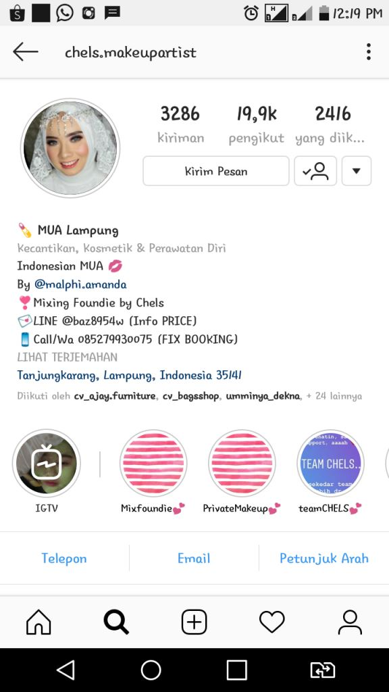

Figure 1. Profile of Chels Make-Up Artist Account on Instagram

Based on the picture 1. it can be seen that there are 19,900 followers of the chels.makeupartist account, the contact person number that can be contacted via WhatsApp (WA) media specifically for booking or booking and LINE for questions about service rates, business owner's account and chels.makeupartist address offline. Initially the make-up services offered were only in the form of party make-up, graduation because the target customers were only the closest friends, but for now the services / goods offered were more diverse, including:
- Make-up party / graduation / farewell at a rate of Rp.230,000.
- Pre-wedding make-up with a tariff of Rp.400,000 only for make-up services, Rp.1,500,000 for make-up and photography services.
- Make-up wedding at a rate of Rp.4,000,000 for Bandar Lampung and added Rp.1,500,000 for areas outside Bandar Lampung.
- Make-up the application at a rate of Rp.350,000.
- Private Course Services of Rp.1,000,000 per one meeting.
- Beauty Class services with a tariff of Rp.300,000 where this beauty class works with outside parties, such as Elf.Organizer (a company engaged in an event organizer) and certain cosmetic products.
- For goods, chels.makeupartist also sells cosmetic products and mix foundations made by the owner of this business. Foaundation mixes are priced at Rp. 350,000 for large jars and Rp. 200,000 for jars.
Chels.Makeupartist Promotion Strategy

The promotion strategy carried out by chels.makeupartist is a social media strategy, namely that social media owned is designed to interact with consumers in a two-way and interactive manner. Social Media is an online media that users can easily participate in, share and create content including blogs, social networks or social networks, wikis, forums and virtual worlds (Hidayatullah, 2016). This social media changes the pattern of information dissemination through internet technology that is social media monologue (from many audiences to many audiences). In interacting with consumers / followers, chels.makeupaartist uses spotlight / highight media, instastory and photo / video posts.

Chels.makeupartist's social media strategy contains (1) advertising (advertising), in the form of information or messages conveyed to followers with the aim of introducing, inviting and persuading followers to use the services offered by MUA, (2) encouraging publicity to influence consumers in image building strategy, branding strategy and expanding marketing, (3) sales promotion. Sales promotions have activities in the form of trade shows, contests, samples, trade incentives and coupons (Simamora, 2007). In this case, Chels.makeupartis conducts sales promotions in the form of portfolio posts from the services of makeup artists, promotions give away, prewedding promotions, promotional activities that work together with one of the smart product brands and event organizers, etc. Through Instagram, chels.makeupartist provides a visual concept that encourages its services to be seen by many people and chels.makeupartist utilizes its portfolio and the beauty of the content in the photos posted which will make its followers decide to use its services.

Chels.makeupaartist uses the media in instragrams, such as highlights, instastories and photo / video posts. There are 38 highlights / hihlight in the chels.makeupartist account consisting of promotions regarding the availability of mixing foundations that are ready for sale, beauty class processes, private make up class activities, make up sales promotion tools, chels team make up artist consisting of 12 people, rules booking make-up services and information about prices that can only be obtained via LINE, make-up service portfolio, address make-up, make-up tutorials, workshops on make up followed by a team of makeup make-up artists. Examples of highlights in the account chels can be seen in Figure. For instastory done by the chels.makeupartist account, usually in the form of customer testimonials, item endorsing, make up demos that are usually in the form of live broadcasts, so that you can be contacted directly by the account followers. The response made by followers is in the form of questions about the use of makeup tools, questions about the products used by chels.makeupartis and praise for the makeup demo.
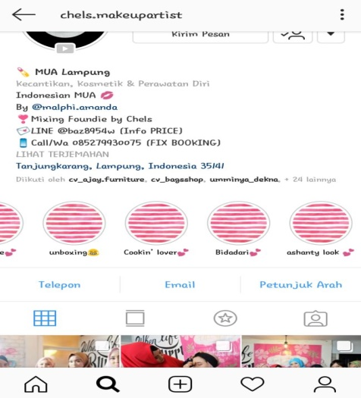

Figure 2. Highlights in the Chels.Makeup artist account
In terms of posts, photos / images posted by chels.makeupartis are 3,286 posts from December 24, 2014 to August 5, 2018 .. Out of the total posts there are 3,228 posts regarding the chels.makeupartist activity, while the remaining 58 posts about endors activities carried out by chels owners .makeupartis. 3,228 posts consisting of:
- Implementation of beauty class activities (9 posts). The post implementation of the activities can be seen in Figure 3.
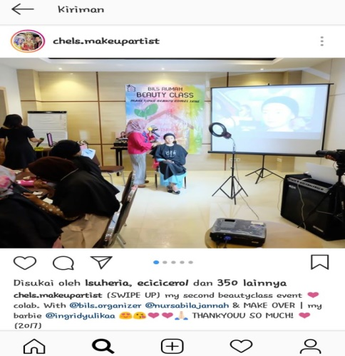

Figure 3. Post Implementation of Beauty Class Activities on the Chels.makeupartist account

- Makeup demo (3 posts). This make up demo collaborates with one of the beauty product brands, namely Ultima II and an event organizer named Instagram account organizer, as seen in Figure 4

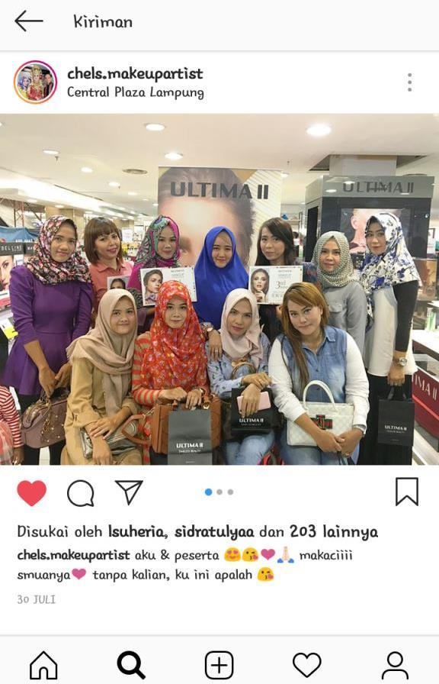

Figure 4. Post Makeup Demo on the Chels.makeupartist account

- Customer Testimonials (123 posts). The purpose of displaying testimonials in posts on this account, so that consumers in this case account followers know that the results of the makeup services performed have given satisfaction to their customers, so in the end teratric followers to use makeup services from chels. An example of a testimony posted by chels.makeupartis can be seen in Figure 5.

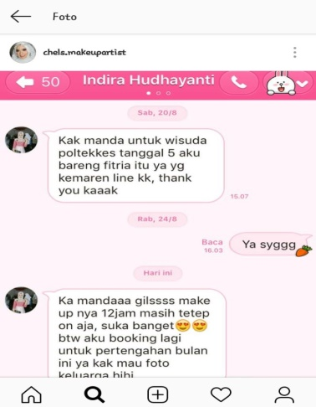
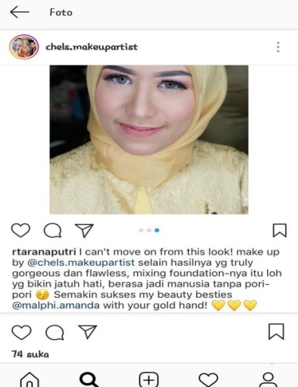
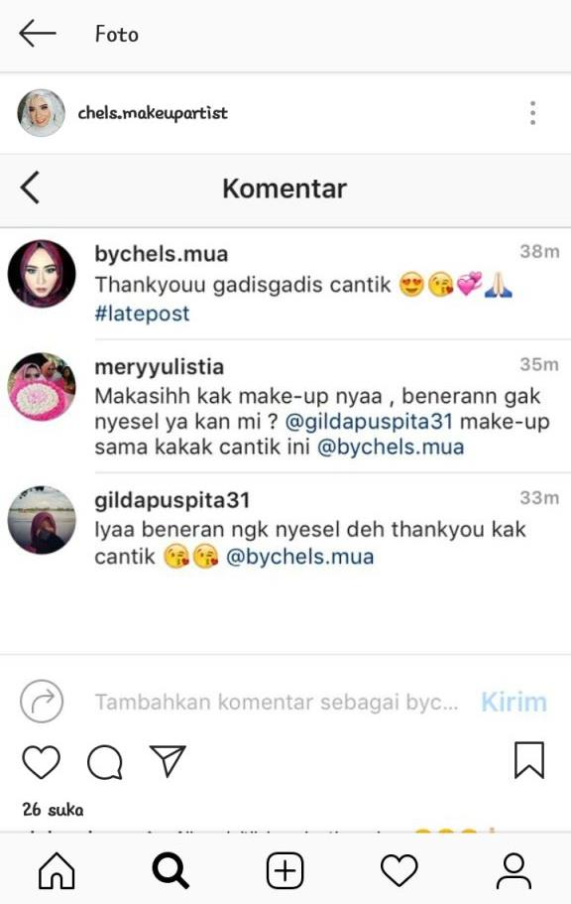

Figure 5. Chels.makeupartist posts about Testimony Consumer, both through
comment column in IG posts, via LINE and consumer personal accounts.

- Portfolio of results of make up services (3,002 posts). The portfolio of make-up services is intentionally displayed in an Instagram account so that followers can see first-hand the results of makeup services and promotions can reach consumers / followers faster and they can directly compare the results of makeup services with other makeup service accounts that post makeup services portfolio. they ... In addition, the purpose of this portfolio also provides an image in the minds of consumers that the results of makeup are very good and can make consumers more beautiful and confident. At first, Chels.makeupartist posted photos before & after consumers that were used up, but even if consumers who protested the results were promoted, now only after make up is displayed, which can be seen in Figure 6.
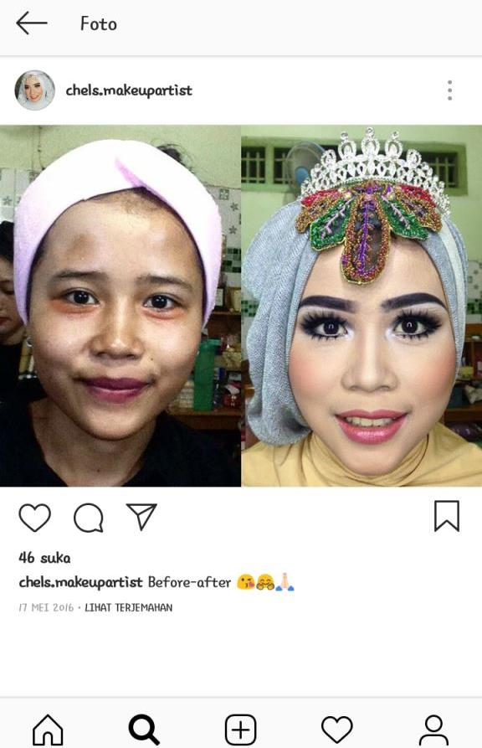

Figure 6. Example of Post Portfolio Results of Chels.makeupartist Makeup Services.

- Advertisements for beauty class (6 posts). The contents of the posting are information about opening the beauty class which is accompanied by the facilities that will be obtained by the beauty class participants, time and place, course prices and sponsors who work together in the implementation of this activity and contact for registrants. Sponsors who have worked together include pixy beauty products, make over, gatsby, grannys nest (venue), etc. as seen in Figure 7.
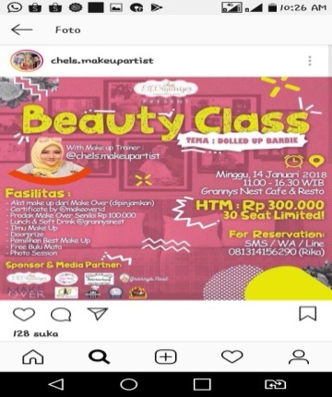
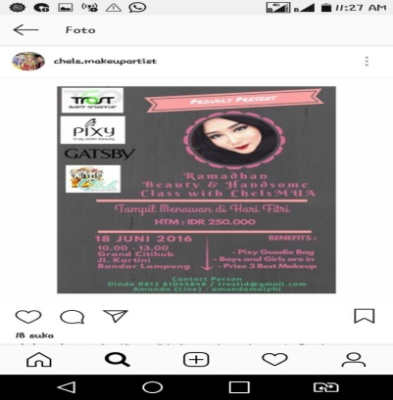

Figure 7. Beauty Class Ad Posts

- Advertisements regarding the opening of the private class make up (2 posts). The posting of the makeup class's private advertisement informs that Chels opened a private makeup class with the time and place caption as shown in Figure 8.
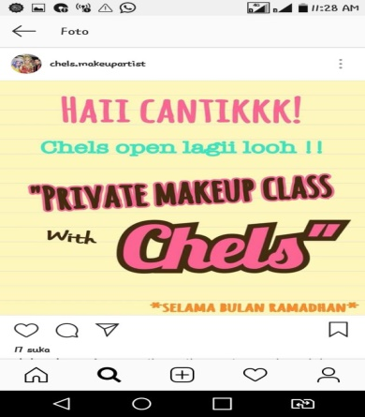
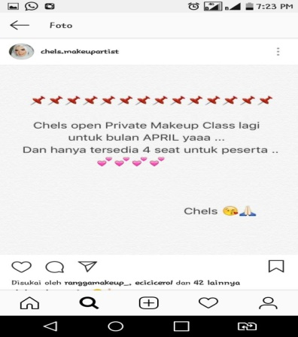

Figure 8. Posts of Makeup Class Private Ads

- Advertise mixing foundation sales (2 posts).

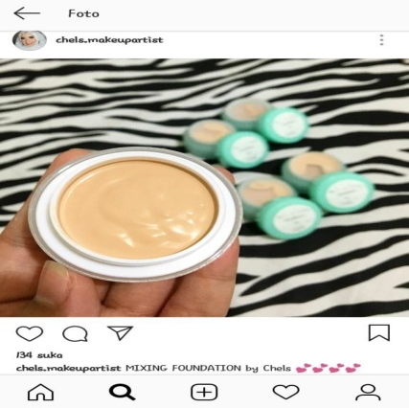

Figure 8. Post Foundation Mix Sales Promotion
- Promosi pre wedding (1 postingan). Promosi Pre wedding bekerja sama dengan One7photo studio yang menawarkan paket pre wedding dengan menabah informasi di dalam captionnya mengenai apa saja fasilitas yang akan didapat dan contact person yang bisa dihubungi jika ingin menggunakan jasa ini, seperti pada Gambar 9.
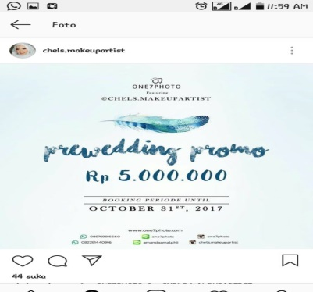

Figure 9. Promotion of Prewedding Chels.Makeupartist who Collaborates With One7photo Studio

- Promotion give away (1 post). Figure 10 shows that Chels.makeupartis promotes give away to consumers by adding captions to the photos posted in the form of information about prizes and requirements that are fulfilled for consumers who want to take part in the promo give away.
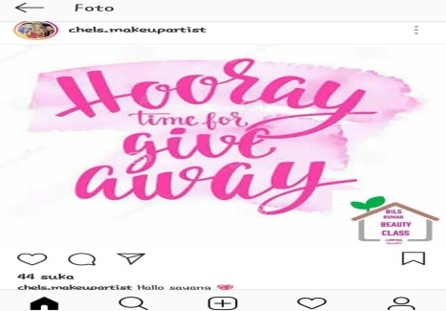

Figure 10. Post Give Away Promo

- Make up equipment and supplies (65 posts). The purpose of posting equipment and make up equipment is for prospective customers to know the quality of the equipment and equipment used by chels.makeupartist. In Figure 11. It can be seen that the makeup products they use are well-known products and have prices that are not cheap, such as make over, NYX, channels and so on.
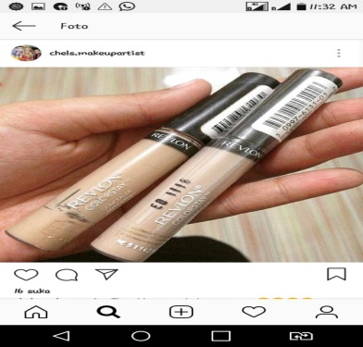
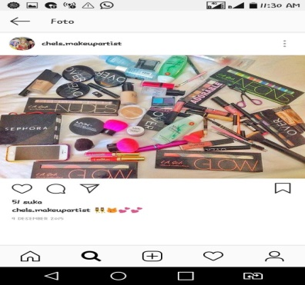

Figure 11. Post make up equipment used by Chels.makeupartistTim chels.makeupartst (6 postingan)
- Publication of Chelsea.makeup artist through print media (1 post).
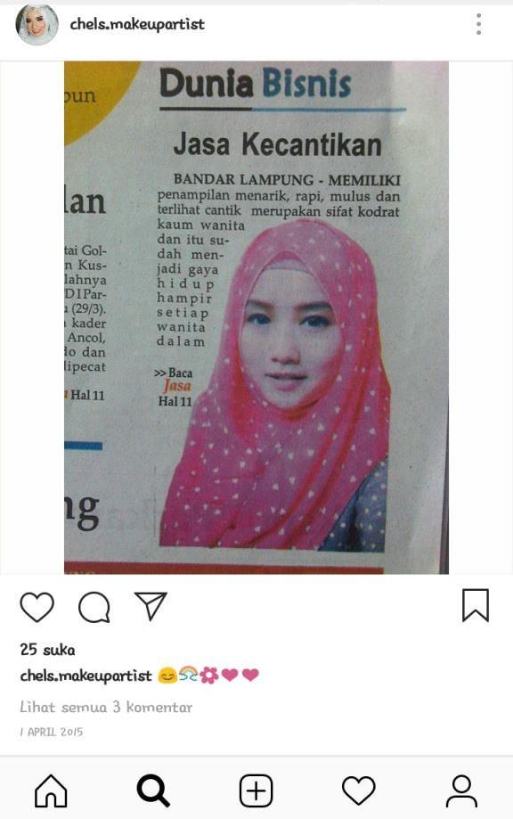

Figure 12. Publication Posts via Print Media on the Chels.makeupartist account

- Schedule of make up services that have been ordered by consumers. (6 posts). This post aims to inform his followers that on that date the makeup services have been in the village, so they cannot add more consumers. In addition, this post will give the image that the Chelsmakeupartist has many customers and if you want to use its services, you have to order from afar.

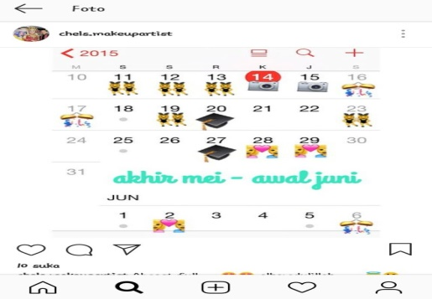

Figure 13. Posts Schedule of make up services that have been ordered by consumers

- Chels.makeupartist's address. the purpose of posting the address chels.makeupartist is to inform the makeup services and private makeup class.

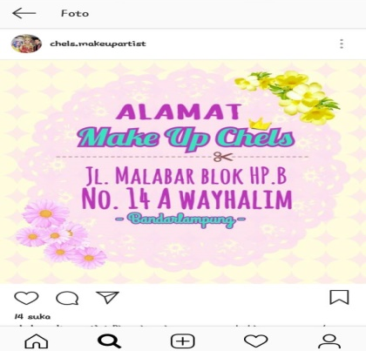

Figure 14. Posting Address Chels.makeupartist
Consumers in responding to every post, both photos and videos of the activities of chels.makeupartis services, do not respond immediately in every post, but they respond through whatsapp, LINE or direct messengers on Instagram. Consumer responses to posts made by Chels are usually in the form of questions about the price of both services and products sold up to booking make up services. In addition, they conduct customer testimonials through direct media such as WA and LINE or post the results of the make up of chels.makeupartist in the personal account of the consumer in question such as the picture ... The interview results revealed that consumers who used the make up service usually gave testimonials and use repeated services. This proves that chels.makeupartist has a promotional strategy that is quite effective in attracting the attention of consumers and providing services that are appropriate to the wishes of consumers.

CONCLUSION

Based on the results of the study, the conclusion of this study is that chels.makeupartist has a promotional strategy in the form of Instagram media utilization, namely (1) through instastory in the form of consumer testimonials, endorsing of products and direct make-up demos, (2) through highlights make up services, make up service booking rules, chels.makeupartist address, beauty class activities and private class make up, make up tutorials and sales of beauty and mixin foundation products, (3) posting photos and videos in the form of a make up service portfolio, conducting beauty class activities, conducting makeup demonstrations, customer testimonials, opening ads for private classes and beauty classes, opening beauty class promotions, mixing foundation sales promotions, giving away promotions, birthday promotions, pre-wedding service promotions. Chels.makeupartist uses Instagram as a medium to promote itself together or personally. Chels.makeupartist promotes by broadcasting his portfolio on their Instagram account.

BIBLIOGRAPHY

Hidayatullah, Nurul. 2016. Promosi Penjualan Melalui Jejaring Sosial (Studi Deskriptif Kualitatif Promosi Penjualan melalui Jejaring Sosial Twitter pada “Coffee House Ulee Kareng”). Jurnal Ilmu Komunikasi Flow. Vol 2, No 18. https://jurnal.usu.ac.id/flow/article/view/12862

Kotler, Philips dan Keller, Kevin Lane. 2010. Manajemen Pemasaran. Erlangga. Jakarta
Moriansyah, La. 2015. Pemasaran Melalui Media Sosial: Antecedents Dan Consequences. Jurnal Penelitian Komunikasi dan Opini Publik Vol. 19 No.3, Desember 2015: 187-196
Simamora, Henry. 2007. Manajeman Pemasaran Internasional, Jilid II, edisi 2. Penenrbit Rineka Cipta. Jakarta.
Tandusan, Chevy F. 2015. Analisis Komparasi Efektivitas Penjualan Sebelum Dan Sesudah Menggunakan Video Marketing Online Talk Fusion Di Manado. Jurnal Riset Bisnis dan Manajemen Vol.3 ,No.2, 2015:141-154.
Survey Pengguna Aktif Instagram, Tahun 2017. http;//indonesiago.digital (2017)
Bisnis Jasa Penatar Rias Panggilan Makin Kinclong. www.tribunnews.com. 18 Mei 2015.

