Intended publication: Biodiversity

Bioconversion of Shrimp Shell Waste by Marine-Derived Actinomycetes to
Glucosamine and Chitooligosaccharides in Solid-State Fermentation

Arik Irawan
Department of Chemistry
Lampung University
collected marine organisms, purified the material and identified compounds

Ni Luh Gede Ratna Juliasih
Department of Chemistry
Lampung University
collected marine organisms and conducted other experiments

John Hendri
Department of Chemistry
Lampung University
designed all of the experiment and wrote the manuscript

*Corresponding author:
Andi Setiawan
Department of Chemistry
Lampung University

*Corresponding author: | ABSTRACT  Actinomycetes secrete various extracellular enzymes involved in the biodegradation of organic compounds including chitin and chitosan biopolymers. This study aims to utilize actinomycetes to convert shrimp shells into chitooligosaccharide (COS) through solid-state fermentation. In this study, three isolates of actinomycetes were selected from the deposit of the Technical Service Unit at the Integrated Laboratory of the Center for Innovation and Technology, Lampung University. Shrimp shell waste was obtained from Lempasing free market, Bandar Lampung. The morphology of actinomycetes was examined microscopically. The ability of actinomycetes to secrete chitinolytic enzymes was tested by the agar diffusion method. Cultivation of actinomycetes on shrimp shell media was carried out by the solid-state fermentation method. The results of morphological observations of the three actinomycetes isolates showed mycelia characteristics in each isolate showing the characteristics of actinomycetes. While the results of the chitinolytic test showed that strain 18D36-A1 showed a clear zone of 2 mm on 1% chitin agar colloidal media. Chromatogram interpretation of culture extract 18D36-A1 showed the formation of glucosamine and COS. Further analysis showed that the COS content tended to decrease after the fermentation process lasted for 6 days. This shows that the process of bioconversion of shrimp shells into glucosamine and COS continues to be small molecules simultaneously. Based on these data, it can be concluded that isolate 18D36-A1 was able to break down shrimp shells into glucosamine and COS. This initial information is very important for determining the design of fermentation using a continuous or batch process.  Keywords: Chitin-oligosaccharides, marine organisms associated actinomycetes, solid-state fermentation, shrimp shell waste,
E-mail: andi.setiawan@fmipa.unila.ac.id

Introduction

Shrimp is the main commodity of Indonesian waters which is the most exported with a production volume of more than 160,000 tons per year (KKP, 2018). The results of processing shrimp for export leave waste in the form of shrimp shells and heads which are usually dumped into the environment and if not handled properly will cause serious environmental problems. At first. the use of shrimp shells is only limited to making crackers, shrimp paste, or animal feed which has low economic value. Currently, shrimp shell is the main source of chitin in nature, chitin derivative compounds have higher economic value such as chitosan, chitooligosaccharides (oligomer), and glucosamine monomer. Chitooligosaccharides itself is an oligomer compound resulting from the degradation of chitin/chitosan. This compound has a higher solubility in water and a lower viscosity when compared to chitin and chitosan. Chitooligosaccharide (COS) has been known to have many benefits in aspects of life, especially its use to improve human health because it has various biological activities such as antimicrobials and antioxidant (Liaqat et al., 2018).

COS can be obtained by chemically breaking down the chitin biopolymer (Jia and Shen, 2002) as well as enzymatic (Olicón-Hernández et al., 2017). However, the use of inorganic acids in the chitin degradation process is very difficult to control and separate, while the use of chitinolytic enzymes produced by microorganisms such as filamentous fungi and actinomycetes on an industrial scale requires high production costs, thus limiting the potential for direct use of enzymes. Taking this into account, this study aims to utilize actinomycetes to convert shrimp shells into chitooligosaccharides through a solid-state fermentation process.

Solid state fermentation (SSF) has been known for a very long time in Indonesia, for example in the manufacture of tempeh (Signorini et al., 2017). Information on the use of actinomycetes that produce chitinolytic enzymes as a micro factory of COS using solid substrate fermentation is considered a revolutionary step that can reduce production costs and is environmentally friendly. Shrimp shell waste as a source of chitin can also be used as a direct substrate in solid substrate fermentation. Chitinase enzymes are produced by actinomycetes in the form of endochitinase and exochitinase, endochitinase breaks down chitin from the deepest part of the glycoside chain turning it into simple oligomers such as acetyl chitobiose, acetyl-chitotriose, and acetyl chitotetraose, while exochitinase acts only at the non-reducing end of the oligomer. break it down into monomers that can enter the bacterial cell so that it can be used in metabolic processes. Endochitinase enzymes both exochitinase work alternately in a certain time span, therefore by controlling the growth time of actinomycetes, it is hoped that chitooligosaccharides will be obtained from the actinomyst fermentation process in shrimp shell waste media by solid state fermentation.

In this study, we demonstrated the ability of actinomycetes 18D36A1 to decompose chitin in shrimp shell waste into glucosamine monomers and chitooligosaccharides oligomers through solid substrate fermentation. This research was divided into several stages, namely maintenance of the isolate, identification of the morphology of the strain isolates, the chitinolytic test of the strain on chitin agar colloid media, fermentation of the substrate using shrimp shell waste media with variations in harvest time, and COS characterization with TLC and HPLC. This preliminary information is very important for determining the design of fermentation using a continuous or batch process.

Material and Methods

Actinomycetes
Actinomycetes isolates were obtained from the deposit of the Technical Service Unit at the Integrated Laboratory of the Center for Innovation and Technology (UPT LTSIT), Lampung University. The isolates were originally isolated from marine organisms on the coast of Banyuwedang, Buleleng, Bali in 2018. Morphological observations were carried out using a microscope, previously all of the actinomycetes culture stocks were scratched on colloidal chitin media so that they were right near the cover slip that had been inserted at an angle of 45° above the media, then incubated for 7 days. (McClenny, 2005). After the incubation period was reached, coverslips containing mycelium from actinomycetes were stained with methylene blue and observed under a Zeiss Axio A1 microscope at 400x magnification.

Chitinolytic Assay
Chitinolytic test was carried out based on the method used by Kuddus et al., (2013). The actinomycetes culture stock was inoculated at one point in the middle of the chitin colloidal media and incubated for 7 days and observed for the formation of a clear zone around the colony. Actinomycetes with the clearest and widest hydrolysis zone will be selected and proceed to the solid substrate fermentation stage using shrimp shell waste media.

Solid State Fermentation and COS extraction
Solid state fermentation refers to the method used by Suresh et al., (2011). Actinomycetes culture stock was inoculated on 0.2 gr colloidal chitin media which had been suspended in 10mL of water and incubated for 7 days. The inoculum was then poured on 10 grams of sterile shrimp shells in a 250 mL Erlenmeyer flask. Harvesting is done periodically on the 0, 3, 6 and 9 days. COS extraction was carried out using 2×25mL distilled water and then concentrated using rotary evaporator under reduced pressure and then was added with absolute EtOH with a ratio 3:7 to precipitate COS. The suspension formed was deposited using a centrifuge with a speed of 6000 rpm for 5 minutes at a temperature of 4°C (Fu et al., 2019). The precipitate was then re-dissolved in distilled water and centrifuged. The obtained filtrate was tested for characterization using thin layer chromatography (TLC), and high performance liquid chromatography(HPLC) methods.

Analysis Bioconvertion od Shrimp shell
For glucosamine and COS analysis, an extract of SFF was subjected to TLC on a Silica gel plate (Merck) and developed in a solvent system composed of n-propanol–water–ammonia (70:30:1, v/v/v) (Liu & Xia, 2006). The TLC plate was stained by spraying 0.1% ninhydrin dissolved in ethanol and the COS on the plate were visualized by keeping the plate in oven at 100 ºC. Bioconvertion product also were analysis by HPLC using a stationary phase of Agilent HC-C18 and a mobile phase of acetonitrile-water 70:30 at a flow rate of 1mL/min at 40oC, and monitored at a wavelength of 210 nm (Purushotham et al., 2012).

Analysis Morphology
Scanning electron microscopy (SEM) was performed to study the mycelium and spore arrangement of isolated actinomycetes by refers Setiawan et al. (2021). Stock cultures of actinomycetes were inoculated into 20 mL of a liquid containing 1% w/v colloidal chitin diluted with artificial seawater (ASW) in a 100 mL Erlenmeyer flask at 32 °C and static. After 7 days, the shrimp shells were put into a petri dish, as much as 1 g, and 1 mL of bacterial inoculum was added and shaken to moisten the shrimp shells. The culture was incubated for 2–6 days at 32 °C and static conditions. After incubation, a small portion of the shrimp shell was cut using an SLEE Disposable Blades microtome to obtain pieces measuring 0.5 cm × 0.5 cm with a thickness of 0.1 cm. The prepared samples were placed on aluminum stubs, which were fixed with carbon adhesive tabs. The top surface of each stub was then coated under vacuum with a gold layer. The gold plating process was complete in 20 min. Gold plated metal stub was observed on SEM with 10 kV electron high voltage, Carl Zeiss EVO MA 10, Oberkochen, Germany.

Results and Discussion

In this study, three strains of actinomycetes 18A13-O1, 18D36-A1, and 18D36-A2 were selected from the isolation of actinomycetes in marine organisms, sponges, and tunicates. The presence of actinomycetes in these two marine biota has previously been reported (Abdelmohsen et al., 2014; Shaala et al., 2016). Microscopic observation of actinomycetes isolates showed different miselium substrate characteristics for each isolate as shown in Figure 1. Isolate 18A13-O1 was obtained from sponge 18A13. Meanwhile, isolates 18D36-A1 and 18D36-A2 were obtained from tunicate 18D36. On microscopic observation, the three Actinomycetes isolates showed different characteristics of the substrate mycelium. Strain 18A13-O1 exhibited characteristic mycelium and elongated spore chains. Strain 18D36-A1 looks like a twig that has a spore chain (Barka et al. 2016), the spore chain is round.

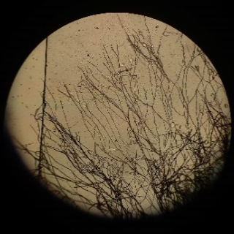 | 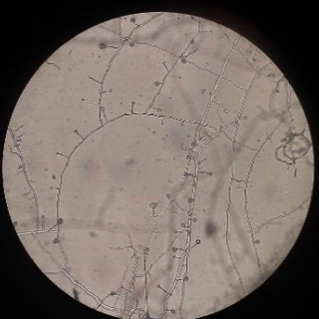 | 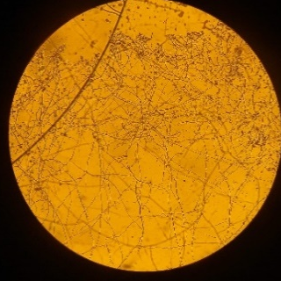
(a) | (b) | (c)
Figure 1. Microscopic image of strain (a) 18A13-O1; (b) 18D36-A1; and (c) 18D36-A2 under a light microscope with a magnification of 400×

Meanwhile, strain 18D36-A2 had denser mycelium branches, but no spore chains were seen in each mycelium branching. The presence of the substrate mycelium is the difference between actinomycetes and filamentous fungi, the mycelium of actinomycetes is able to penetrate into solid substrates while the mycelium of filamentous fungi only decomposes on the surface of the media (Barka et al., 2016). The three actinomycetes isolates used in this study had these characteristics, where the mycelium isolate was observed to enter the colloidal chitin agar medium.

Several previous studies reported that Actinomycetes are decomposing microorganisms and are able to produce chitinase (Tsubjibo et al., 2003) and can utilize chitin as a carbon source (Liaqat et al., 2018). In this study, the results of the chitinolytic test showed the presence of a clear zone in each isolate as shown in Figure 2. This indicates a process of degradation of chitin into simpler molecules by Actinomycetes chitinolytic enzymes (Kuddus et al., 2013). While the clear zone area shows the strength of enzyme activity produced by Actinomycetes to degrade chitin biopolymers (Paulsen et al., 2016). In Figure 2b, it can be seen that isolate 18D36-A1 has a clear zone with a thickness of 2 mm and looks wider than the other two isolates and was selected for further investigation in SSF.

 | 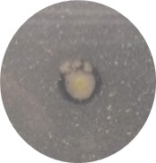
(a) | (b) | (c)
Figure 2. Clear zone on 18A13-O1 chitinolytic test (a); 18D36-A1(b); and 18D36-A2 (c) by point culture on 1% colloidal chitin agar media

Solid-state fermentation (SSF) was carried out in a 500 mL Erlenmeyer flask containing 10 g of shrimp shells each with variations in incubation time of 0, 3, 6, and 9 days. Based on observations, the growth of Actinomycete on the surface of the shrimp shell media was characterized by the formation of mycelia in the air and substrate (William et al., 1967). Figure 3c shows that actinomycetes were able to grow well on shrimp shells, on the third day several mycelium and sporangium tips appeared, and the mycelium spread more and more on the 6th day as shown in Fig. 3d. Until now, information about chitooligosaccharides produced by marine actinomycetes grown on shrimp shells is still very limited (Brzezinska et al., 2010).

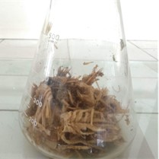 | 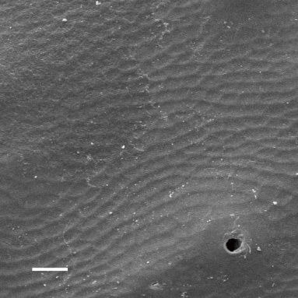
(a) | (b)
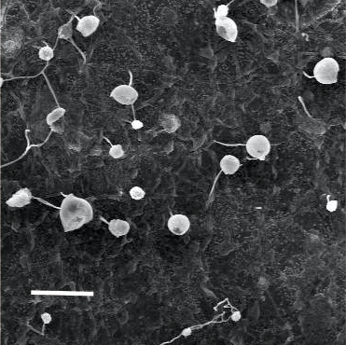 | 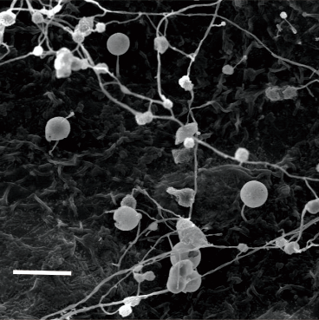
(c) | (d)
Figure 3. (a) Culture of SSF strain 18D36-A1 on shrimp shell waste media; (b) Surface of the initial shrimp shell at with 20-micron scale bar; (c) the surface of the shrimp shell after being overgrown by strain 18D36-A1 on 3 days with 20 micron scale bar ; (d) the surface of the shrimp shell after being overgrown by strain 18D36-A1 on day 6 with 20 micron scale bar.

In the next stage, the results of the shrimp shell bioconversion were analyzed by TLC and HPLC to determine the presence of glucosamine and COS (Wu et al., 2013). The results of the TLC analysis are shown in Figure 4.
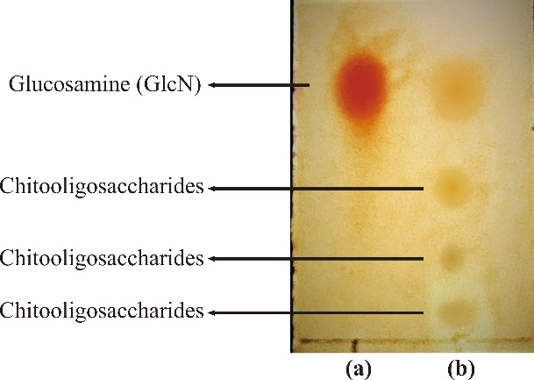
Figure 4. TLC visualization of (a) glucosamine standard; (b) fermentation product extract of 18D36-A1 in shrimp shell medium by solid state fermentation.

The results of TLC visualization using ninhydrin reagent and the composition of the mobile phase isopropyl alcohol: ammonia (25%) with a ratio of 2:1 observed spots of people from standard glucosamine at RF 0.8 as shown in Figure 4a, while the sample of the bioconversion product showed four spots with Rf value 0.8, 0.6. 0.4 and 0.1 depicted in Figure 4b. TLC analysis results indicate that the bioconversion product contains glucosamine and oligosaccharide components. Furthermore, different Rf values ​​also indicate the presence of chitooligosaccharides with different degrees of polymerization, a similar degradation pattern has been reported by Lee et al., (2008).

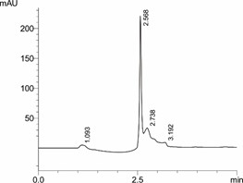 | 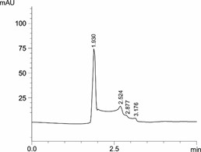 | 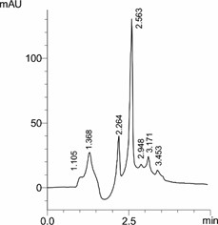
a | b | c
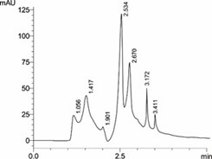 | 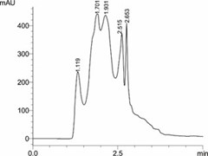
d | e
Figure 5. (a) Chromatogram of glucosamine standard; and incubation time of 18D36-A1 shrimp shell waste medium by SSF in (b) 0 days; (c) 3 days; (d) 6 days ; (e) 9 days .

Further analysis using HPLC can be seen in Figure 5. A sharp peak in the glucosamine standard chromatogram was observed at a retention time (Rt.) of 2.500 minutes (Figure 5a). On 0 day of incubation, when the actinomycetes inoculum was added to the SSF medium, only an unknown peak was observed at Rt. 1,930 as showed in Figure 5b, a minor peak of glucosamine at a Rt. 2.524, and another minor peak at a Rt. 2,877. and 3,176. The results of the analysis on the 3rd day of incubation (Figure 5c.), it was observed an increase in the peak of the glucosamine chromatogram (Rt. = 2,563 minutes) and an increase in the chromatogram peak with a Rt. 3.171 and a new chromatogram peak at a retention time of 3,453 were also observed. On the 6th day of incubation (Figure 5d.), there was no significant change in the peak of the glucosamine chromatogram (2,534 min) but there was an increase in the height of the chromatogram peak at retention times of 2.670, 3.172 and 3.411. On day 9 of incubation (Figure 5e.) there was a significant increase in peak height at the peak of the glucosamine chromatogram (Rt. 2,515 min) and the chromatogram peak at Rt. 2.653.

According to Izume and Ohtakara (1987) who determined the chitooligosaccharide compound using HPLC assisted by an inverted phase column and acetonitrile-water eluent with a ratio of 55:45 showed that the higher the degree of polymerization of a chitooligosaccharide, the higher the retention time of the chromatogram peak. In the sample the formation of a chromatogram peak at a slower retention time compared to glucosamine, namely a peak at a retention time of about 2,600; 3,100; and 3,400 indicated the presence of an oligomer compound of glucosamine in the sample on days 3 and 6 of the incubation period. On day 9 there was a decrease in the production of oligomers with a higher degree of polymerization and more concentrated on monomers and oligomers with a lower degree of polymerization. This indicates that the biodegradation process takes place simultaneously in the decomposition process to form simple molecules. Considering this, further analysis of the chitooligosaccharide derived from shrimp shell waste degradation by strain 18D36-A1 is needed to determine the degree of polymerization with certainty. Continuous SSF culture is also needed to obtain the optimum chitooligosaccharide, namely harvesting on day 6.

Morphological analysis of isolate 18D36-A1 is shown in Figures 5a and 5b. The results showed that isolate 18D36-A1 had spherical spore chains enclosed by a membrane which indicated that the spore chains in this strain were not motile, spore chains with a similar spore shape were also observed in the Streptosporangium oxazolinicum strain isolated by Inahashi. et al., 2011, but what distinguishes it from strain 18D36-A1 is the shape of the spore bag which is perfectly rounded.

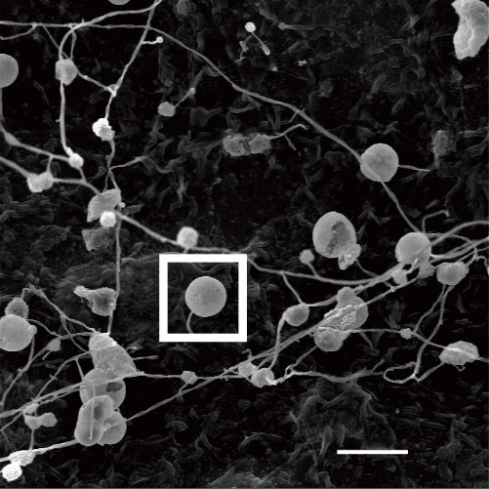 | 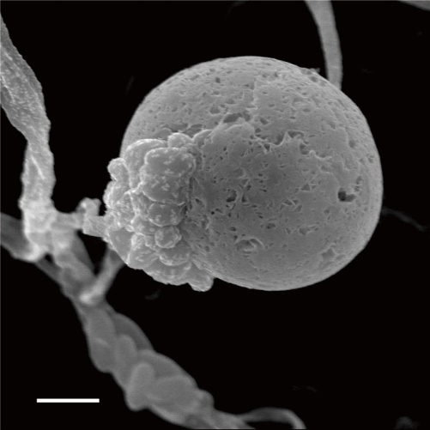
(a) | (b)
Figure 5. SEM image (a) sporangium of strain 18D36-A1 with 20mircron scale bar; (b) 2micron scale bar

Conclusion
The results of this study showed that the actinomycetes of strain 18D36-A1 were able to decompose shrimp shell waste into chitin derivatives in the form of monomers and oligomers through Solid State Fermentation. Morphological analysis using SEM showed that strain 18D36-A1 belongs to the genus Streptosporangium. This initial information is very important for further research related to the optimization of solid fermentation techniques for shrimp shell waste on a larger scale

Acknowledgment
The authors would like to thank to The Deputy of Research Strengthening and Development, The Ministry of Research and Technology/National Agency for Research and Innovation of the Republic of Indonesia, for Basic Research with Grand No. 139/ SP2H/ ADM/ LT/ DRPM/2020. The authors also thank the Technical Service Unit, Integrated Laboratory of Innovation and Technology Center, Lampung University (UPT LTSIT) for providing scanning electron microscopy facilities.

References
- Abdelmohsen UR, Yang C, Horn H, Hajjar D, Ravasi T, & Hentschel U (2014) Actinomycetes from Red Sea sponges: sources for chemical and phylogenetic diversity. Marine drugs. 12(5): 2771-2789.
- Barka EA, Vatsa P, Sanchez L, Gaveau-Vaillant N, Jacquard C, Klenk HP, Clément C, Ouhdouch Y, van Wezel GP (2016) Taxonomy, physiology, and natural products of Actinobacteria. Microbiology and Molecular Biology Reviews. 80(1): 1-43.
- Brzezinska MS, Walczak M, Lalke-Porczyk E, Donderski W (2010) Utilization of shrimp-shell waste as a substrate for the activity of chitinases produced by microorganisms. Polish Journal of Environmental Studies. 19(1).
- Inahashi Y, Matsumoto A, Ōmura S, Takahashi Y (2011) Streptosporangium oxazolinicum sp. nov., a novel endophytic actinomycete producing new antitrypanosomal antibiotics, spoxazomicins. The Journal of antibiotics. 64(4): 297-302.
- Jia Z, Shen D (2002) Effect of reaction temperature and reaction time on the preparation of low-molecular-weight chitosan using phosphoric acid. Carbohydrate Polymers. 49(4): 393-396.
- KKP outlook 2018 https://kkp.go.id/artikel/7962-materi-paparan-refleksi-2018-dan-outlook-2019-kkp accessed October 2021
- Kuddus M, Ahmad IZ (2013) Isolation of novel chitinolytic bacteria and production optimization of extracellular chitinase. Journal of Genetic Engineering and Biotechnology. 11(1): 39-46.
- Lee DX, Xia WS, Zhang JL (2008) Enzymatic preparation of chitooligosaccharides by commercial lipase. Food Chemistry. 111(2): 291-295.
- Liaqat F, Eltem R (2018) Chitooligosaccharides and their biological activities: A comprehensive review. Carbohydrate polymers. 184: 243-259.
- Liu J, Xia W (2006) Purification and characterization of a bifunctional enzyme with chitosanase and cellulase activity from commercial cellulase. Biochemical engineering journal. 30(1): 82-87.
- McClenny N (2005) Laboratory detection and identification of Aspergillus species by microscopic observation and culture: the traditional approach. Medical mycology. 43(Supplement_1). S125-S128.
- Olicón-Hernández DR, Vázquez-Landaverde PA, Cruz-Camarillo R, Rojas-Avelizapa LI (2017) Comparison of chito-oligosaccharide production from three different colloidal chitosans using the endochitonsanolytic system of Bacillus thuringiensis. Preparative Biochemistry and Biotechnology. 47(2): 116-122.
- Paulsen SS, Andersen B, Gram L, Machado H (2016) Biological potential of chitinolytic marine bacteria. Marine drugs. 14(12): 230.
- Setiawan A, Widyastuti W, Irawan A, Wijaya OS, Laila A, Setiawan WA, Juliasih NLGR, Nonaka K, Arai M, Hendri J (2021) Solid state fermentation of shrimp shell waste using pseudonocardia carboxydivorans 18A13O1 to produce bioactive metabolites. Fermentation. 7(4): 247.
- Shaala LA, Youssef DT, Badr JM, Harakeh SM (2016) Bioactive 2 (1H)-pyrazinones and diketopiperazine alkaloids from a tunicate-derived actinomycete Streptomyces sp. Molecules. 21(9): 11
- Signorini C, Carpen A, Coletto L, Borgonovo G, Galanti E, Capraro J, Johnson SK, Duranti M, Scarafoni A (2018) Enhanced vitamin B12 production in an innovative lupin tempeh is due to synergic effects of Rhizopus and Propionibacterium in cofermentation. International journal of food sciences and nutrition. 69(4): 451-457.
- Suresh PV, Sachindra NM, Bhaskar N (2011) Solid state fermentation production of chitin deacetylase by Colletotrichum lindemuthianum ATCC 56676 using different substrates. Journal of food science and technology. 48(3): 349-356.
- Tsujibo H, Kubota T, Yamamoto M, Miyamoto K, Inamori Y (2003) Characterization of chitinase genes from an alkaliphilic actinomycete, Nocardiopsis prasina OPC-131. Applied and environmental microbiology. 69(2): 894-900.
- Williams ST, Davies FL (1967) Use of a scanning electron microscope for the examination of actinomycetes. Microbiology. 48(2): 171-177.
- Wu SJ, Pan SK, Wang HB, Wu JH (2013) Preparation of chitooligosaccharides from cicada slough and their antibacterial activity. International journal of biological macromolecules. 62: 348-351.

