Proportional and Simultaneous Control System Design for Portable Ventilators Based on Internet of Things
Aryanto, Ardian Ulvan, Melvi
Electrical Engineering – Universitas Lampung

email: melvi@eng.unila.ac.id
Abstract. This research is about proportional and simultaneous monitoring of real-time ventilator automation systems based on the Internet of Things. The ventilator has a crucial role in the world of critical health, where its role is a substitute for respiratory function/ventilation for patients with respiratory function disorders. A ventilator is a means of breathing with negative or positive pressure that produces controlled air in the airway so that the patient can maintain ventilation and oxygen administration for a long time. The research method is by adding a breathing sensor per minute to measure the air pressure entering the ventilator, the ESP8266 Module as the controller. The research objective was to combine a simple ventilator system, monitoring with a smartphone in one device (standalone) wirelessly connected without a cable channel. Based on the design of the ventilator breathing apparatus, the tool can be done in real-time continuously for 5 days with breathing per minute onaverage it is 20 breaths per minute (normal human).
Keywords: Ventilator, Monitor, Internet of Things, ESP8266 Module
INTRODUCTION

Coronavirus disease (Covid-19) is an infectious disease caused by the recently discovered coronavirus. Most people who contract COVID-19 will experience mild to moderate symptoms and will recover without special treatment. The virus that causes Covid-19 is mainly transmitted through the droplets that are produced when an infected person coughs, sneezes, or exhales. These droplets are too heavy to stay in the air. Droplets quickly fall and stick to the floor or other surface. A person can be infected by breathing air containing the virus when someone is too close to someone who is already infected with Covid-19. A person can also be infected by touching a contaminated surface and then touching the eyes, nose, or mouth, therefore it spreads very quickly. Amid the Covid-19 pandemic, the availability of medical equipment is very important. One of the medical equipment that is urgently needed for Covid-19 patients with respiratory problems is a ventilator. Unfortunately, the need for ventilators in various Indonesian hospital facilities has not been met because they are relatively expensive and difficult to use [1].
Ventilators have a crucial role for critical health, especially Covid-19 patients, where their role is as a substitute for respiratory/ventilation function for patients with respiratory function disorders. A ventilator is a negative or positive pressure breathing apparatus that produces controlled air in the airway so that the patient can maintain ventilation and provide oxygen for a long time. Where the purpose of the installation of the ventilator is to maintain optimal alveolar ventilation to meet the patient's metabolic needs, correct hypoxemia, and maximize oxygen transport. There are two ways to use mechanical ventilation, namely invasive and non-invasive. Invasive use uses an Endo Tracheal Tube (ETT) tube that is inserted through intubation, where insertion of the ETT tube will suppress the host defense system, causing local trauma and inflammation, thereby increasing the possibility of aspiration of nosocomial pathogens from the oropharynx around the cuff [2-5]. Therefore, the technology that will be implemented is using Node MCU technology with a programming language that is easy to implement and use. The design of the ventilator assist device is expected to help reduce physical contact between Covid-19 patients and medical personnel with the help of a wireless sensor network that is connected to the ventilator.

Methods
A ventilator (mechanical ventilation) is a machine that assists people with respiratory failure. Mechanical ventilation is indicated in patients with respiratory distress, respiratory failure, respiratory arrest (apnea), or hypoxemia that is not alleviated by oxygen treatment. Before real respiratory collapse occurs, the patient should be intubated and mechanically ventilated [6-10]. Inadequate ventilation or oxygenation causes respiratory distress.
As a result, we may use the proportional and simultaneous control for air management and adaptive control by using the change in oxygen concentration as controller inputs. Figure 1 depicts the structure of the oxygen concentration self-adjusting PI control system. The design uses the proportional and simultaneous control parameters in time.
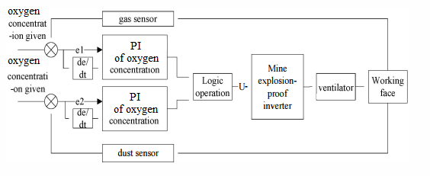
Fig.1. Oxygen of the Proportional and Simultaneous Control

Result and Discussion
The programming algorithm of the ventilator breathing apparatus based on the Internet of Things can be explained from the following communication diagrams and settings:
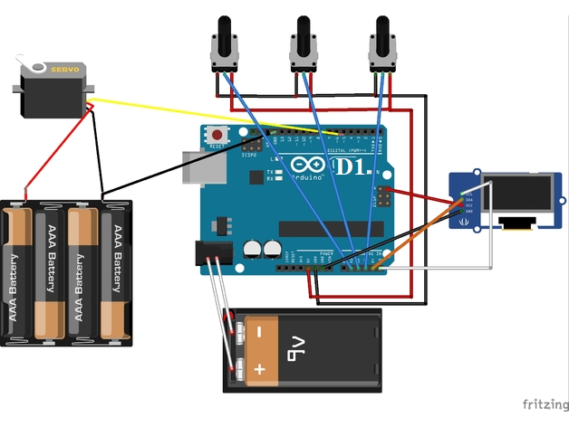
Fig. 2. Communication Diagrams and Settings

The concentration of gas oxygen fluctuates in real-time while underground mining progresses. We conducted an experiment and a MATLAB/SIMULINK simulation of a self-tuning the proportional and simultaneous control system to validate the servo's dependability can be automatically adjusted in response to changes in the explosive oxygen concentration.

A step signal provides the gas concentration in an experiment, and the motor rated speed is 3000r/min, rated voltage is 6v, and p=1. The following is the oxygen concentration data from the experiment:

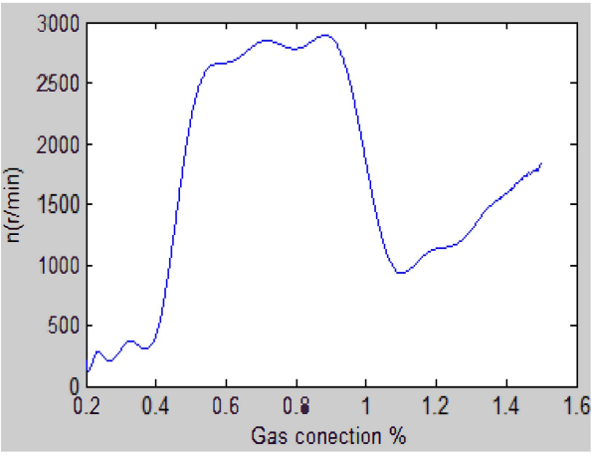

Fig. 3. The Simulation of Servo Changing With the Oxygen

The following are the results of the tool that has been made as a design for a ventilator device based on Internet of Things:

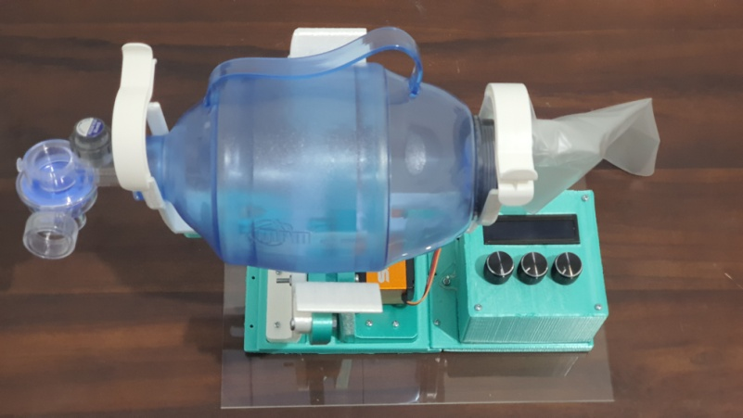
(a)
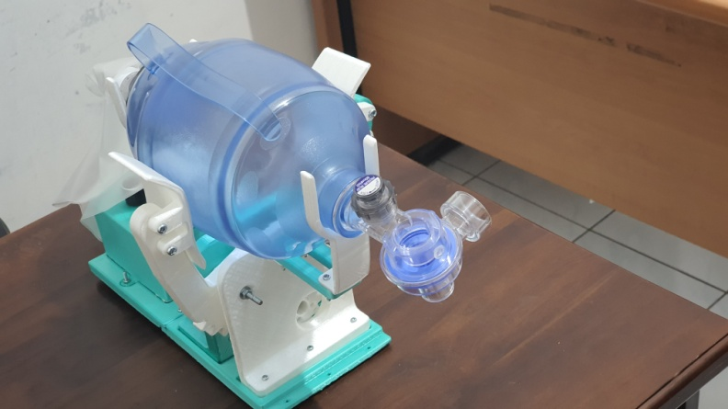
(b)

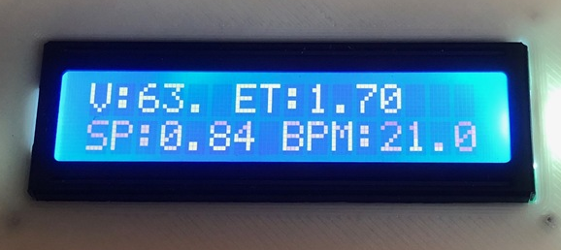
(c)

Figure 4. Ventilator Based on Internet of Things:(a) top view (b) side view (c)display in 16x2 LCD

In this study, it is displayed in real time on the internet network. This study used the IoT cloud server Thingspeak to display breath data per minute. ThingSpeak is an IoT analytics platform service that allows you to aggregate, visualize, and analyze live data streams in the cloud. Here is a chart of breaths per minute that has been done:
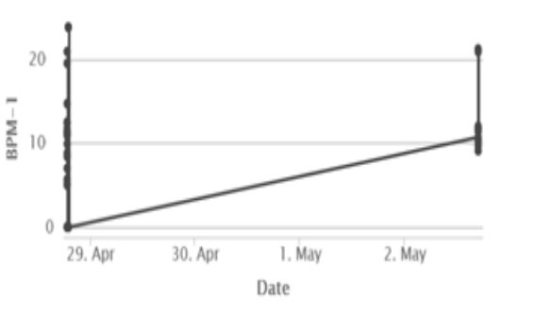

Figure 5 . Breaths per Minute Chart

Conclusion
Ventilator with PI control is presented in this paper, the control method that is used in this paper is adaptive PI control using ratchet tuning algorithm. The results show the adaptive controller that used in this paper can tune the controller adaptively based on the condition to reach the desired target. However steady-state error is still occurred in each simulation, but still tolerable because of a minor error. Adaptive PI fratches tuning is still needed to be improved to have better performance and be easy to use as an adaptive controller. Based on the design of the ventilator breathing apparatus, the tool can be done in real-time continuously for 5 days with breathing per minute on average it is 20 breaths per minute (normal human). The breathing apparatus is expected to help medical personnel reduce direct physical contact with Covid-19 patients with the help of a wireless sensor network that has been created with a simple programming algorithm using the MCU Node which is relatively cheaper when compared to existing conventional ventilators.

Acknowledgments
This research is funded by DIPA BLU Universitas Lampung.

References
- ABBA, A., et al. The novel Mechanical Ventilator Milano for the COVID-19 pandemic. Physics of Fluids, 2021, 33.3: 037122.
- ALI, Saad Mahmood; MAHMOOD, Mohammed Saad; MAHMOOD, Noor Saad. Design of a Low-Cost Ventilator to Support Breathing for Patients with Respiratory Failure Arising from COVID-19. In: IOP Conference Series: Materials Science and Engineering. IOP Publishing, 2021. p. 012143.
- EL-HADJ, Abdellah, et al. Design and simulation of mechanical ventilators. Chaos, Solitons & Fractals, 2021, 150: 111169.
- GIRI, Jayant; KSHIRSAGAR, Niraj; WANJARI, Aishwary. Design and simulation of AI-based low-cost mechanical ventilator: An approach. Materials Today: Proceedings, 2021.
- HASAN, Md Mahmudul, et al. Cost Effective Bluetooth Technology Based Emergency Medical Ventilator for Respiratory Support. In: 2021 International Conference on Automation, Control and Mechatronics for Industry 4.0 (ACMI). IEEE, 2021. p. 1-5.
- PANDEY, Abhishek, et al. An Introduction to Low-Cost Portable Ventilator Design. In: 2021 International Conference on Advance Computing and Innovative Technologies in Engineering (ICACITE). IEEE, 2021. p. 707-710.
- TRUONG, Cong Toai, et al. Model-free volume and pressure cycled control of automatic bag valve mask ventilator. Aims Bioengineering, 2021, 8.3: 192-207.
- TRUONG, Cong Toai, et al. Characteristic of Paddle Squeezing Angle and AMBU Bag Air Volume in Bag Valve Mask Ventilator. arXiv preprint arXiv:2109.08019, 2021.
- WHITE, Luke A., et al. Construction and Performance Testing of a Fast-Assembly COVID-19 (FALCON) Emergency Ventilator in a Model of Normal and Low-Pulmonary Compliance Conditions. Frontiers in physiology, 2021, 12.
- SOJAR, Sakina H., et al. Titration of Parameters in Shared Ventilation With a Portable Ventilator. Respiratory Care, 2021, 66.5: 758-768.

