DESIGNING INTER-ETHNIC COMMUNICATION MODEL IN HOSPITALITY INDUSTRY:
STUDY CASE OF MIGRANTS TOURISM PROVIDERS IN SOUTH LAMPUNG REGENCY
Karomani^{1,} Ida Nurhaida^{2,} Andi Windah^{3*}

¹ University of Lampung
² University of Lampung
³ University of Lampung
*Corresponding author. Email: andi.windah@fisip.unila.ac.id
ABSTRACT

South Lampung Regency is a well-known locus for migration destination. Therefore, it is a melting pot for almost all ethnic cultures in the archipelago. This diversity often brings various potential problems such as inter-ethnic conflicts, which are mostly triggered by the occurrence of miss-communication through miss perception and canalized by prejudice. But it can also be a force that can raise the welfare of the entire community when properly planned, for example through tourism activities. It is then necessary to design public policies in order to increase tourist attraction through the development of competitive advantages in the form of increasing the hospitality attitude of the service providers of tourism activities. In a relatively short time, individual hospitality is relatively easy to feel through verbal communication. Based on that, the research aims to develop a predictive mode of soft intonation performance in oral communication of tourism service providers at the field level as well as a model for predicting communication style based on sociology-demographic background, type or communication model of tourism service providers. The research was done through field survey at 20 tourist destinations in the regency with tourism service providers as respondents. The research found that that (1) The level of softness of the voice intonation of the information service officers: (a) is not better than other tourism service providers. The softness of voice intonation is also significantly influenced by: (b) marital status; by (c) the ethnicity of the father where Lampung, Sunda, Palembang, and Banten are better than Javanese, and (d) is not influenced by the ethnicity of the mother of the service providers. It is also discovered that (2) communication style as a second proxy for hospitality indicators shows that as is the case in voice intonation (a) the communication style of information service office workers is not better than that of service providers. In addition, (b) there is a gender bias in women where the mother's ethnicity has a real influence, especially service providers whose mothers are Padangnese found to be 50 times more argumentative than those whose mothers are Javanese, and (c) conversely whose mothers are Malay Riau found to be 67 times more explanatory.
Keywords: tourism, service providers, ethnic roles, intonation, communication style and hospitality
1. INTRODUCTION
Social distancing or large-scale social restrictions (PSBB) has affected economic performance in all countries. The same condition also has an impact on the economic performance of Lampung Province in general as well as the economy of South Lampung Regency in particular. The level of welfare of this district from the beginning has lagged behind other districts that were later established. According to BPS records [1], the proportion of poor people in South Lampung Regency is 14.86%, ranking 5th out of 15 Regencies/Cities in Lampung Province. However, this district has quite a lot of tourist destinations including nature tourism and is very strategically located as a gateway in and out of Sumatra, it can be designed to accommodate the overflow of tourists from Jakarta and Tangerang Anyer who are already very saturated as well as from abroad. It is estimated that there will be a wave of tourism that will peak soon after the Covid-19 virus pandemic has passed due to the saturation of every citizen during social distancing, regional quarantine, PSBB or those who intentionally self-quarantine in their respective homes.
These competitive advantages and opportunities must be designed for local economic development in order to increase income while reducing poverty. The tourism sector, especially the natural tourism sector, is the only sector that can be used as a leverage factor in regional economic development in various parts of the world. According to Bappenas RI as found in Mukti [2], this sector has very high efficiency in creating jobs as shown by the relatively low investment costs of around USD 6.5 in creating 1 job, while for the non-tourism sector it can reach USD 5,900.This very high efficiency is mainly because the tourism sector can generally rely on natural objects that already exist naturally. River trunks, indentations of bays and estuaries, stretches of beaches and their waving palms, waves crashing, ocean waves, along with fishing activities etc. are natural resources that do not require special investment costs when their products are extracted into a tourism service industry.
Communities in rural areas, which are actually the most important natural tourism service providers, must be prepared properly in order to be able to obtain economic benefits from each tourism activity. Therefore, rural communities in various tourist attractions in South Lampung Regency must also be able to capture the opportunity to obtain great benefits from the potential for tourism waves after the Covid-19 pandemic subsides. These areas include around the Siger Tower, along the coast to Anak Mount Krakatau, Merak Maggot Beach, Natar Hot Springs and around 16 destinations or other tourist objects in this district [1].
In reality, the people of Lampung Province in general and Lampung Regency in particular are a melting pot of various ethnic cultures. Meanwhile, hospitality attitudes are forms of perception that arise in response to a stimulus from the communicator, either in the form of verbal speech, gestures, or in the form of stimulus actions. This means that the stimulus can be relative, whether it is positive, neutral, or negative, especially if it is local from where the ethnic culture originates. Tourism activities at the site level where tourism objects are located, are never separated from the processes of interpersonal communication. It may be that a stimulus that comes from a tourism service provider with a background of a certain ethnic culture is seen by other ethnic cultures as a rude stimulus while in the ethnic culture itself it is normal. The opposite is possible for other ethnic cultures.
Furthermore, this perception will affect prejudice. Prejudice, as a derivative or impact of perception on the other hand, can also be of good, neutral, or bad value. This prejudice will also affect the perceptions and attitudes of tourists both during their stay at tourist sites and in promoting positive or negative impressions about the tourist objects they have visited by mouth promotion in their place of origin. Karomani [3] reported that there was considerable diversity in terms of perceptions and prejudices between the four ethnic cultures. Among other things, the Lampung, Bugis, Batak and Sundanese ethnic cultures 100% perceive that Javanese people as cultural ethnics are "smooth or soft" in greetings and their behavior. The same is the case with Javanese ethnic culture, except for Lampung ethnic culture which is only 90% and Javanese ethnic culture is only 80%, Bugis and Batak ethnic cultures also perceive that ethnic Sundanese culture is "smooth" in nature. The development of positive perceptions and prejudices needs to be prioritized, especially for service providers related to tourism services to achieve excellence with low diversity.
- LITERATURE REVIEW

2.1. Impact of the Covid-19 Pandemic on Local Economic Performance
The projection of Indonesia's economic growth in 2020 which was originally targeted at 5.0% to 5.4% must be lowered to 4.2% to 4.6% percent. The decline in the target was influenced by the case of the Covid-19 pandemic that also hit Indonesia, as revealed by the Governor of Bank Indonesia [4] since the beginning of the epidemic. However, in reality at the end of March 2020, the Minister of Finance lowered Indonesia's economic growth target even more dramatically to 2.3% to -0.48% if this pandemic had not ended by the end of April 2020.
Many academics predicted models stated that pandemic will expire at the end of August or beginning of September 2020. The validation model is quite representative (with level of trust >95%). If the worst case scenario really happens, the implications for each region will be to bear a lot of acute unemployment until the end of the pandemic season. Especially for Lampung Province in general and South Lampung in particular, which is a supplier of migrant workers to industrial-urban areas including Cilegon, Tangerang, DKI, Depok, Bogor, Bekasi, Bandung and even other big cities in Java.
Due to the sluggish economic activity in various urban areas, it is certain that these migrants will return to their respective areas of origin. At the same time, it will have an impact on unemployment and become a heavy burden for the performance of the local economy. From one side, the migrant workers who return home are certainly a burden for South Lampung Regency. But after all, they must be viewed economically as a resource so that they must be stimulated in order to obtain or be able to create jobs. Especially for those who have been laid off or workers in the informal sector who have not been able to suddenly return to urban areas. Moreover, they are actually pioneers . They have been proven to have been able to survive in urban areas facing uncertain situations. According to Curry [5], Mukti [2], as pioneers, these people can be expected to have a strong risk taker spirit. This availability of human resources in South Lampung Regency, should be used to be prepared to become entrepreneurs , namely when the tourism wave peaks following the end of the Covid-19 pandemic. They should be encouraged to start small business as traders in the informal sector, such as souvenirs sellers to culinary traders.

2.2. Tourism Sector as a Leveraging Factor for Local Economic Development
The level of rural welfare has always lags behind the welfare of urban communities. In the Maslowian view, tourism activity is a consumption process that has reached the level to meet psychological needs, not basic needs anymore. This means that urban communities or people from foreign countries are the main consumers. When there is an increase in tourist visits, especially nature tourism, the people in rural areas, where the site of the tourism object is located, will also get the impact of increasing income [6]. This mechanism can be seen as a mechanism for reducing the welfare gap between urban and rural areas.
This mechanism needs to be strengthened so that tourists get excellent service at the site level of the tourism object or supported by the services of the surrounding villages. This will open up opportunities for tourists to spend more time at tourist sites and shop more. Efforts taken to to improve this service are, ( i ) improving the performance of the basic superstructure including security, comfort, hospitality, location cleanliness, etc., (i)i improving infrastructure performance, including electricity supply, internet signal, road and drainage facilities, home stays , cottages etc., ( iii ) provision of consumption needs including restaurants, culinary, etc., (iii) places to shop for various needs including souvenirs and local fruits, (iv) also which is often a variety of traditional attractions or unique ritual events that are not found in other tourist attractions. With the longer tourists stay in tourist attractions, the amount of shopping increases. This means also moving various other economic sectors which at the same time reduces the gap between rural and urban areas.

2.3. Ethnic Culture and Hospitality Attitudes as the Foundation of Tourism Services
Many studies reveal the competitive advantage of the increasingly diverse ethnic culture that has become a tourist attraction [7], including also for halal tourism [8]. In general, these researchers only put forward the premise of the superiority of ethnic culture for tourism development, but did not reveal the multi-ethnic cultural barriers that could become obstacles in efforts to develop collaborative aspects between service providers involved in the tourism sector.
As reported by Karomani [3], the ethnic and cultural diversity that exists in Lampung Province in general and South Lampung Regency in particular can be seen as an inhibiting factor in addition to its attractiveness for hospitality landscape developers , which is an important prerequisite. From the research conducted in Kalianda, District of South Lampung, it was concluded from 4 major ethnic groups in terms of numbers that Lampung, Bugis, Batak and Sundanese generally have the same perception of the typical Javanese as people who are "smooth or gentle" in greeting and in their behavior, "humble. ”, “tolerant”, “honest”, “working hard”, “wise”, “smart” or educated, “simple”, “open”, “generous” and forgiving”. To the ethnic Lampung, ethnic Bugis, Batak, Sundanese and Javanese generally have the same perception that Lampung people are "brave" and "smart" or quite educated.
Aspects of experience such as social closeness, socio-cultural aspects such as religion, and a person's level of education are factors that characterize perceptions and prejudices between Sundanese, Javanese, Lampung, Bugis, and Batak ethnic groups in Bakauheni, South Lampung. There is no inter-ethnic-cultural communication model to predict forms of perception and forms of prejudice based on individual demographics from each ethnic culture [9]. Especially for those who provide tourism services. This model is very useful to be formulated in relation to its usefulness in efforts to improve the performance of service providers in the tourism sector in terms of hospitality (including politeness, gentleness, subtlety) both verbally and in gestures. Furthermore, this model can be used as the basis for the formulation of a qualitative opportunity model of tourist satisfaction based on the demographics of tourists themselves and the ethnic culture of tourism service providers.

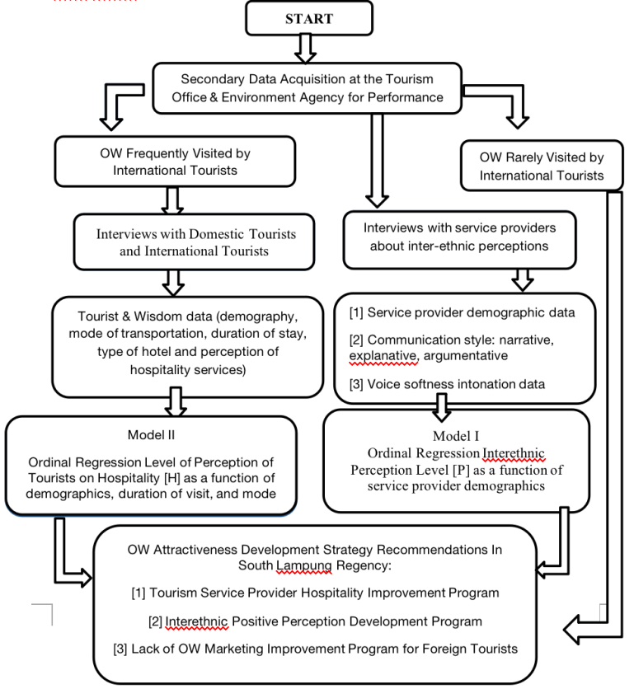
- RESEARCH METHODOLOGY

3.1. Research Procedures
This research consisted of field surveys and data analysis for modeling. Field research carried out at the site level for 20 locations or tourist destinations in South Lampung Regency, including at the Radin Intan II Domestic Airport and public transportation terminals. Respondents of this research included field level tourism service providers. To obtain samples, visits to 20 tourist sites in South Lampung Regency were taken incidentally. The twenty include Tapak Kera Beach, Embe Merak Belantung Beach, Kalianda Marina Beach, Granite Stone Garden, Batu Alif Beach, Cicurug Sarmun Waterfall, Natar Geothermal Way, Kalianda Sulfur Hot Springs, Anak Krakatau, Sebesi Island, Sebuku Island, Mount Rajabasa Camping Sites, Condong Island, Way Kalam Waterfall, Ketang Kalianda Beach, White Sand Beach, Alau-Alau Beach, Kalianda Culinary Bomb Pier, Sebalang Beach, and Siger Tower. However, only tourist objects that have been visited by foreign tourists selected as research locations. This choice is made with regard to the desired data analysis and modeling. Data analysis and modeling carried out at the Multi Media Laboratory, Department of Communication, FISIP, Unila.
The research procedure includes secondary data collection to several agencies in South Lampung Regency SKPD (especially to the Tourism Office and the Environment Agency or the agency in charge of regional planning), field surveys with total sample is at least 60 people, of which at least 15 people are from foreign countries. Interviews with service providers were also conducted to record data on: (i) age, (ii) gender, (iii) education, (iv) length of service in their respective fields, (v) average income, (vi) number of dependents, (vii) the ethnicity of the father and mother, respectively, (viii) domicile and (ix) the answers provided are also in ordinal categories. The interview will also record the way and style of communication, whether flat, explanatory, or argumentative. Likewise, the soft intonation of his voice is an important indicator for the hospitality characteristics of a tourism service provider. The procedures then followed by data analysis, and model development. The entire procedures of this research can be seen from figure 1. below

Figure 1. Research Procedure Diagrammatic

3.2. Proposed Models

3.2.1. The Intonation Model of the Softness of the Voice of the Tour Service Provider
The response variable that will be predicted is the intonation of the softness of the voice [Y_{A}]_{i}, as a proxy for the hospitality of tourism service providers. This model is a function of demographics (age; gender; marital status, length of work, intensity of serving tourists, education level, and ethnic culture. Ordinal Regression model is applied at 90 and 95% confidence levels. Formally, the hypothesis about the model of softness of voice intonation of service providers as a function of 41 predictor variables:
H0: α1= α2= α3= ….= α41 =0 (or not one single research variable has real impact).
H1: α1≠α2≠ α3≠ …. ≠α41 ≠0 (or at least one single variable has real impact).

3.2.2. Storytelling Style Model in Oral Communication
The second model has a motive for formulating a storytelling style model in oral communication as a function of demographic variables, gender, marital status, number of dependents, work experience, intensity of interacting with tourists, types of services, and ethnicity [Y_{B}]_{i.} Response variable on ordinal scale is 0.1 , or 2 each if the perceived response is bad, moderate, or good which describes argumentative, narrative, and explanation storytelling styles, respectively. The form of the hypothesis to be tested can be expressed as follows:
H0: β1= β2= β3= ….= β15412=0 (or not one single research variable has real impact).
H1: β1≠β2≠ β3≠ …. ≠β15 ≠0 (or at least one single variable has real impact).
4. RESULT AND DISCUSSION
There are two models of hospitality from service providers that have been successfully developed through this research. The two models that have been produced include voice intonation [Y_{A}]_{i}, and storytelling style [Y_{B}]_{i} in providing information to tourists.

4.1. Ethnic Voice Intonation Model for Tour Service Providers
The results of the optimization of the prediction model parameters about the softness (intonation) of the voice of the tourism service providers [Y_{-A}], based on father's ethnicity, mother's ethnicity, type of service and length of work, age, gender, number of dependents, marital status, education level, and intensity interact with tourists per week along with the results of the goodness-fit test are presented in Table 1.
As can be checked at the bottom of Table 1., that the resulting P-value = 0.001, which means that this model is very reliable is used to explain that the level of softness of speech of tourism service providers based on 44 predictor variables used. This means that if these 44 variables are used to predict the level of softness of the voice (whether soft, moderate, or not) from 1,000 tourism service providers in this district, there will be 1 wrong prediction result, or only 0.1%. This very low miss prediction rate can justify that this model has a high fit-goodness. In other words, the 44 variables can explain very well the diversity of levels of softness of speech in providing services to tourists. Furthermore, it is necessary to discuss which variables have a real role in determining whether the tone of voice of the tourism service providers will be soft, medium, or not.
4.1.1. Influence of Demographics, Work Experience, and Education
Demographic variables tested for influence include age, gender, education level, marital status, number of dependents, and duration of work. As can be seen in Table 1., it turns out that all demographic variables have no significant effect on the intonation tone of environmental service providers. In the context for the purposes of public policy analysis in the context of empowering tourism service providers, especially in improving communication skills, this demographic variable does not need to be considered. In the context of counseling and training, for example, it is not necessary to design based on these six variables.
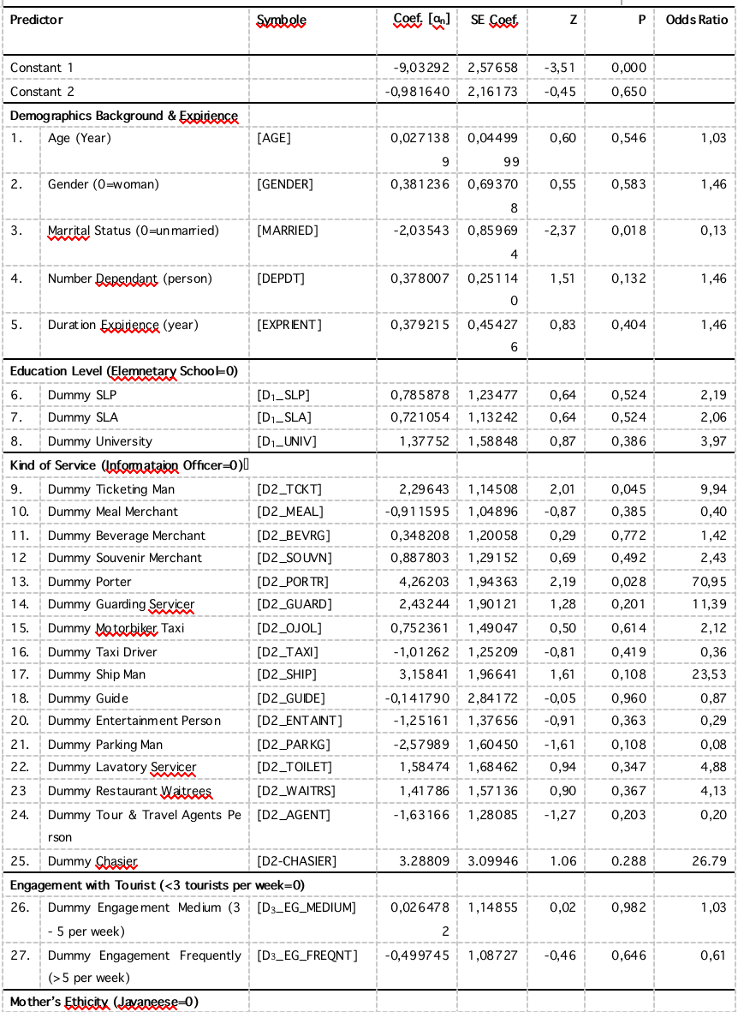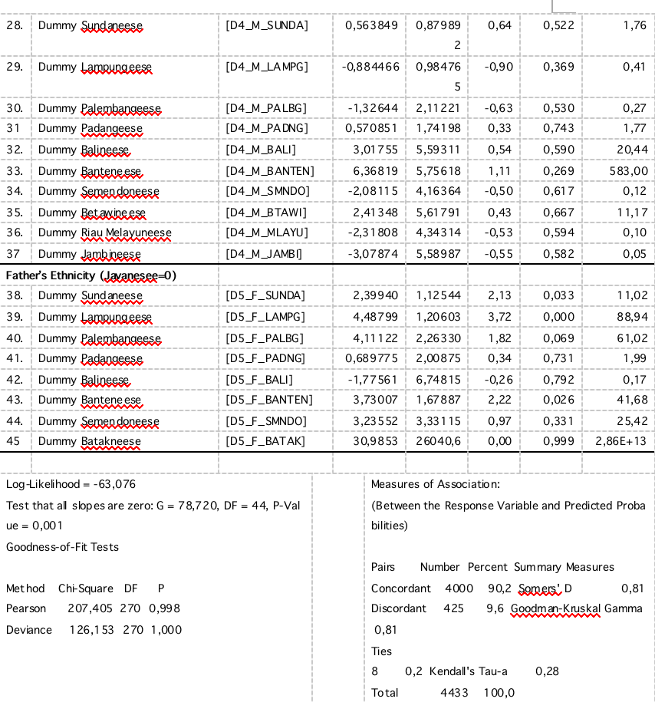Table 1. Results of Optimizing the Parameters of the Softness of Voice Intonation Model in Oral Communicating for Tourism Service Providers in the Scope of South Lampung Regency
4.1.2 The Role of Service Types
It needs to be emphasized here that as a reference are workers in the information service sector (service provider officers). The soft intonation of the information officers was chosen as a reference with the assumption that this unit has been trained, accustomed, and even has a standard operating procedure (SOP). So that it can be seen as the best in carrying out its duties to serve tourists. With this reference, the level of softness of voice intonation [YES] from the 14 types of service providers in the other service sector can be compared.
4.1.3 The Influence of Tourist Service Intensity
The interaction of individual service providers is expected to lead to personality development. In interacting with tourists, each service provider will gradually adapt to make himself a person who is liked by his customers, including in terms of service delivery. Voice intonation is an early clue that tourists can use as an indicator of whether a service provider is friendly and pleasant enough or not. When the intonation of the voice is able to give a friendly impression, then the service provider can use further communication to direct the attractiveness of the merchandise or services he provides in order to open up opportunities for bargaining or negotiations to reach a deal.
However, in this study, it can be revealed that the intensity of interacting in service with tourists has no real effect on the formation of voice intonation, whether low, medium, or high. This means that the intensity of interacting with a number of tourists on average per week (often > 5, moderate 3-5, or low <3) is not important to consider in the analysis of personality development policies of tourism service providers in South Lampung Regency.
4.1.4 Ethnic Influence of Service Providers
According to trait theory, human character is a trait inherited from their parents, not least in the intonation of softness of voice in communication. In this study, what is used as a reference are the service providers of ethnic Javanese descent, both from the father's line and from the mother's line. As can be referred to in Table 1., it turns out that there is a gender bias in the tone of voice in communicating with tourists. In this case, the mother's ethnicity did not make a real difference. On the contrary, from the father's ethnic line, service providers whose fathers are ethnically Lampung, Sundanese, Palembang, and Banten are better than Javanese, meaning that a gender bias phenomenon is found in men. This finding is very important for the development of public policies in fostering the character of tourism service providers based on ecofeminism theory to foster personality, especially in regulating voice intonation when dealing with tourists.
Furthermore, it can be observed that service providers whose fathers are Sundanese, their voice intonation in communicating is 11 times softer than those whose fathers are Javanese, as evidenced by the Odds Ratio = 11.02 with P = 0.033. Likewise for service providers whose fathers are ethnically Lampung, Palembang, and Banten, which are softer than ethnic Javanese at 88.94, 61.02, and 41.68, respectively, with P=0.000, 0.069, and 0.026. This finding is very interesting for further research, because so far there is a view that the Javanese are the softest in verbal communication. The results of this study reject that view at least for ethnicity from the father's side. The soft intonation of the voices of tourism service providers whose fathers are Javanese is not significantly different from those whose fathers are Padang, Balinese, Semendo, or Batak ethnic.

4.2. Prediction Model of the Type of Communication Style of Tourism Service Providers
The results of the optimization of the modeling parameters of the type of style of providing information to tourists [Y-B] are presented in Table 4.2. As with the prediction model for softness of voice intonation, this [Y-B] prediction model can also be well explained by the 14 predictor variables together. At the bottom of Table 2. the results of the goodness fit test of this model are given which gives a P-value = 0.040. The meaning of this finding is that if we use the model to predict the type of style of giving information from 100 respondents of tourism service providers, we will get 4 people (or 4% <5%) who are wrong.
If the acceptability level used is at the 90% level, then this model can be claimed as a good and fit model to explain or predict the type of style of providing information for tourism service providers in the South Lampung Regency. In this regard, it is important to conduct further investigations on individual predictor variables that have a significant effect on the type of style of information provided by these tourism service providers. For this reason, it is necessary to discuss in more detail each of these predictor variables.
4.2.1 Influence of Service Type
In this model, the information officers are used as a reference. The types of styles in providing information are categorized into 3 types, namely argumentative, flat, and explanatory, which are given 0, 1, and 2. The minds of tourists can become uneasy and can even force them to think hard, which means the opposite motivation to travel to enjoy the atmosphere of pleasure in general. As can be checked in Table 2., only souvenir sellers [D5_SOUV] and ferry boatman [D5_SHIP] have a better information style than information officers. Souvenir sellers are almost 7 times more as evidenced by its Odds Ratio = 6.50 with P = 0.048. The boatmen are 52 times better with Odds Ratio=52.22 with P=0.028.
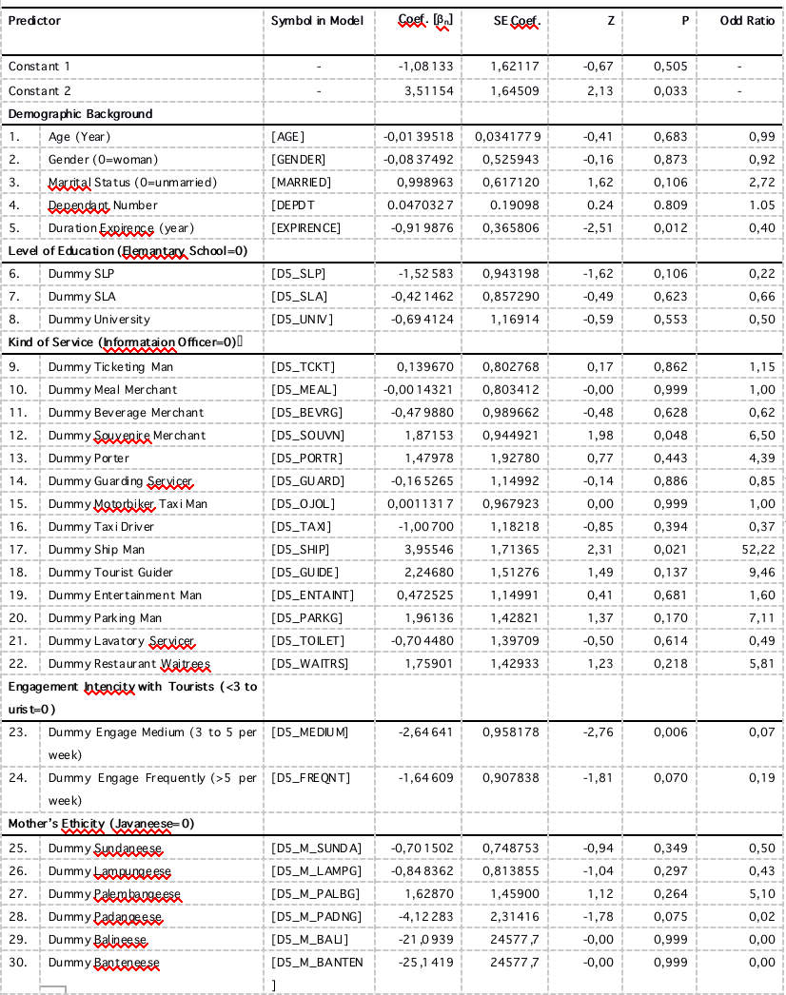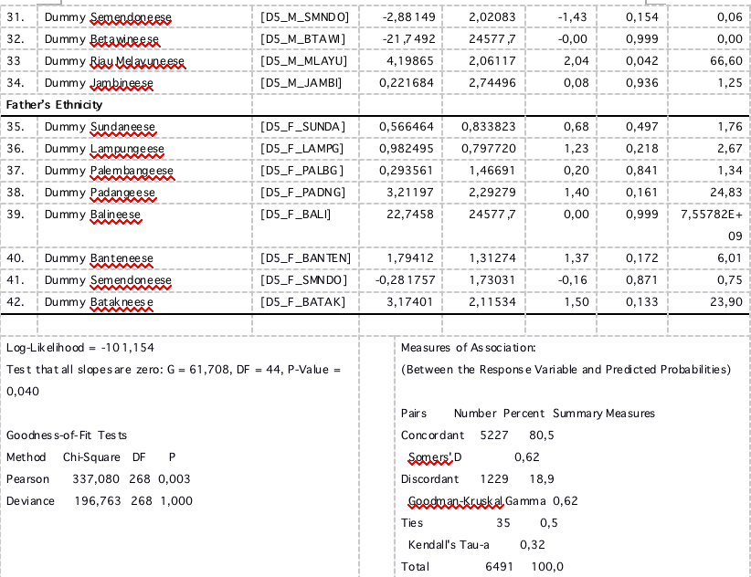Table 2. Communication Style (Argumentative=0, Narrative, and Explanation) for Tourism Service Providers in South Lampung Regency
This finding implies that maybe souvenir sellers are more likely to be faced with situations to always win sympathy from tourists, otherwise it is an opportunity to get orders for goods traded. Likewise with boatmen. The communication style of these two service providers can be a model in the development of community empowerment policies for tourism service providers in South Lampung Regency, especially in the style of delivering information to visitors.
4.2.2 Demographic Influence, Work Experience, and Education
The influence of gender, age, education, marital status, and number of dependents has no real effect on communication style whether it is argumentative, narrative, or explanatory. Therefore, it is also not important to consider in relation to these five variables in designing policies for the empowerment of tourism service providers, especially in developing communication styles to tourists.
4.2.3 The Influence of Tourist Service Intensity
In the study, 3 categories were used, namely the low category if the average interaction was less than 3 tourists, moderate between 3 to 5 tourists per week, and the high category if more than 5 people per week. In this study, the intensity of interacting with tourists had no significant effect. Therefore, this variable also does not need to be considered in relation to these five variables in designing policies for the empowerment of tourism service providers, especially in developing communication styles to tourists.
4.2.4 Influence of Father's Ethnicity Service Provider
As can be referred to in Table 2., it turns out that the influence of the mother's ethnicity from the tourism service providers does not affect their communication style. Therefore, there is no need for consideration in relation to this variable to empower tourism service providers, especially in developing communication styles to tourists. To see this influence, the reference is to tourism service providers whose fathers are Javanese. As can be referred to in Table 2., it turns out that only those whose fathers are of Padang ethnicity have a communication style that is less in line with the motivation of tourists for pleasure compared to those whose fathers are Javanese. This claim can be proven by its Odds Ratio = 0.02 with P = 0.075. It seems that the father of the Ethnic Padang is more accustomed to using a communication style that is rational in nature which uses more argumentative sentence forms than the Ethnic Javanese father. The implication is that the Ethnic Padang style of communication may be more suitable for services for scientific tourists than those whose fathers are Javanese, including groups of conferences, congresses, and other scientific meetings. Meanwhile, the father of Javanese ethnicity may be more suitable for tourists who are solely for pleasure. For this reason, whose father is of Malay ethnicity, the performance of his communication style is far more suitable than that of his Javanese father for services to tourists who do not require much argument, namely tourists whose main motive is for pleasure alone. This claim is proven by the results of the Odds Ratio which is = 66.60 with P = 0.042.
The other ethnic influences of his father are not significantly different from those of service providers whose fathers are Javanese. Thus the policy that is considered important to be carried out for the empowerment of tourism service providers in Lampung Regency is that for scientifically motivated tourist services, the placement of human resources whose fathers are ethnic Padangnese is more recommended. As for the main motive for pleasure, ethnic Malays, Javanese or other ethnicities should be. This kind of policy can be critical, especially for performance-sensitive services such as restaurants and hotels that really need excellent hospitality.
- CONCLUSION
Intonation, softness of voice and communication style of the service providers in 20 tourism objects in the scope of Lampung Province can be concluded: [1] the level of softness of the voice intonation of the information service officers: (a) is not better than other tourism service providers. Apart from that, what is more interesting is that the entrance ticket guards for tourism objects are actually almost 10 times better than the information officers, as shown by the resulting Odds Ratio value. Apart from that, as can be seen from the Odds Ratio value as well, the porters at Radin Inten II Airport, the softness of their voice intonation is the best, almost 71 times that of other tourism service providers. Furthermore, this variable softness of voice intonation is also significantly influenced by: (b) marrital status, by (c) ethnicity of their fathers and (d) not influenced by the Ethnicity of the mother of the service provider. This means that the phenomenon of gender bias is found in men. [2] Communication style as a second proxy for hospitality indicators shows that as is the case in voice intonation (a) the communication style of information service office workers is not better than that of service providers. In addition, from the influence of ethnicity, there is an opposite phenomenon compared to its effect on the softness of voice intonation that (b) there is a gender bias in women where the mother's ethnicity has a real influence.

REFERENCES
[1] | Kabupaten Lampung Selatan Dalam Angka 2019.  https://lampungselatankab.bps.go.id/publication/2019/08/16/f025cfa1494740742e75fd08/kabupaten-lampung-selatan-dalam-angka-2019.html
[2] | Mukti, A.D., S. Bakri, A. Setiawan, dan Lindrianasari. Penggunaan faktor sosial demografi dan sikap kepedulian pada lingkungan sebagai landasan dalam pengembangan jiwa entrepreneurship: Studi di wilayah sub urban Bandar Lampung. Prosiding Seminar Pendidikan Biologi, vol.4, no.1, pp.314-322. 2019.
[3] | Karomani. Itercultural among the local elites in Indonesia (A study in Banten Prtovince. Pertanika Journal of Social & Humanities, vol.25, no.4, pp. 1601-1612. 2017.
[4] | Bank Indonesia. Statistik Ekonomi dan Keuangan Indonesia. 2020.
[5] | Curry, J.G. A closer look at entrepreneurship and attitude toward risk. Thesis Graduate College of Bowling Green State University. 2014.
[6] | Fang, W. T, C.Y. Lien, Y. W. Huang, G. Han, G. S. Shyu, J.Y. Chou, and Eric Ng. Environmental literacy on ecotourism: A study on student knowledge, attitude, and behavioral intentions in China and Taiwan. vol.10, no.1886, pp.1-22. 2018.
[7] | Putri, K. A., A. N. Dewanti, dan M. Muntaha. Penentuan Potensi Wisata Prioritas melalui pendekatan Community-Based Tourism di Desa Wisata Teritip Kota Balikpapan. Journal of Regional and Rural Development Planning, vol.1, no.3, pp.298-306. 2017.
[8] | Jaelani, A., E. Setyawan, dan Nursyamsudin. Religi, budaya dan ekonomi kreatif: Prospek dan pengembangan pariwisata halal di Cirebon. Al-Mustashfa: Jurnal Penelitian Hukum Ekonomi Islam, vol.2, no.2, pp.101-121. 2017.
[9] | Ivankovi, G., S. Jankovi, and M. Perši. Framework for performance measurement in hospitality industry – Case study Slovenia. Ekonomska istraživanja, vol. 23, no.3, pp.12-23. 2010.

