A REVIEW OF ABNORMAL ACCRUAL
AT GOVERNMENT:
A BIBLIOMETRIC STUDY

Describe: this research is a bibliometric analysis study of abnormal accruals in government. The purpose of this study is to classify articles related to abnormal accruals in the financial statements of local governments in various countries and to examine the development of research related to abnormal accruals or the management of local government financial statements. Background Problems: there is still no conclusive and limited theory and empirical evidence about abnormal accruals in the public sector as a non-profit organization. The need to apply accrual accounting in government financial statements to create accountable and relevant financial reports is still in doubt because of abnormal accruals or the practice of managing numbers in local government financial statements. Novelty: conducting a bibliometric study to map research developments related to abnormal accruals so that further research is expected to contribute to science and government policy practitioners. Research Methods: the analysis was carried out using a bibliometric study using the Publish or Perish application and Vos Viewer to map 1000 articles from Google Scholar in the last 20 years (2000-2021). Finding / Results: there are four research groups related to abnormal accruals in government, and the development of theories and variables studied from the year 2000 to the present. Conclusion: Further research is needed to find the reasons and causes for abnormal accrual and the impact of abnormal accrual on the actual performance of the government organization.

Keywords: abnormal accrual accounting, government, financial statement report, bibliometric study

Introduction

Using the accrual accounting system can lead to opportunities to choose policies in the preparation of financial statements that can lead to the management of the numbers presented in financial statements (Pilcher, 2011), referred to as earnings management (if it occurs in a private company). The motivation for managing financial statement figures in the public sector is to meet particular financial objectives set by higher levels of authority [2]–[4]. Abnormal accrual is one form of the government's accrual policy to shift the budget and expenditure to achieve specific government goals in one fiscal year. This method is challenging to detect and use to manipulate accrual accounting policies. [5]. Several abnormal accrual research has been carried out on local governments [1], [2], [4]–[10]. This paper aims to provide a bibliometric analysis of the literature and answer the following questions: 1. To classify articles related to abnormal accruals in local government financial statements in various countries, 2. To examine research developments about abnormal accruals or the management of accounting numbers on local government financial reports.

2. Literatur Review

In applying the accrual accounting method, there are two variables in calculating total accruals: Non-Discretionary Accruals (NDA), which is company conditions, and Discretionary Accruals or Abnormal accruals (AA), which is management policies. These two variables will result in the calculation of Total Accruals. NDA is a variable whose changes are related to economic phenomena and can be explained. At the same time, AA is an error term variable or changes that are not associated with economic phenomena but are the result of policies made by management. AA is accruals arising from transactions made or accounting treatment chosen to manage revenue[5]. AA is a government policy to determine the accounting treatment to be selected, or in other words, to manage accounting numbers. AA is considered to have a patterned relationship with other aspects of the organization (local government), such as total accruals, income, receivables, buildings, property, and equipment. AA's goals in the public sector [5] include: 1) reducing surpluses, appropriating unused, or retaining funding for use in subsequent accounting; 2) increase surplus or unused allocation to create a perception of efficient performance; 3) changing spending information to prevent government or media scrutiny and criticism, and 4) provide funds for expenditures that are available for use in other expenditures. Agency theory by[11] explains the occurrence of information asymmetry that can lead to manipulation practices (abnormal accruals) in local government financial statements.

Methodology and Data Analysis

This research is qualitative research that uses a bibliometric technique in classifying the development of previous research. There are three steps of bibliometric methods: the first step is to use Publish or Perish (PoP) software to find papers or previous research indexed by google scholar related to abnormal accrual accounting in government. The result is 1000 articles written in the last 20 years. Then the second step uses Vos Viewer software to generate findings related to image diagrams based on reports obtained from PoP. The results of this bibliometric technique are three image maps, namely 1. Network visualization map image, 2. Overlay visualization map image, 3. Density map image visualization.

Research Result and Discussion

The following is a network visualization that shows groups or research clusters related to abnormal accruals based on color.
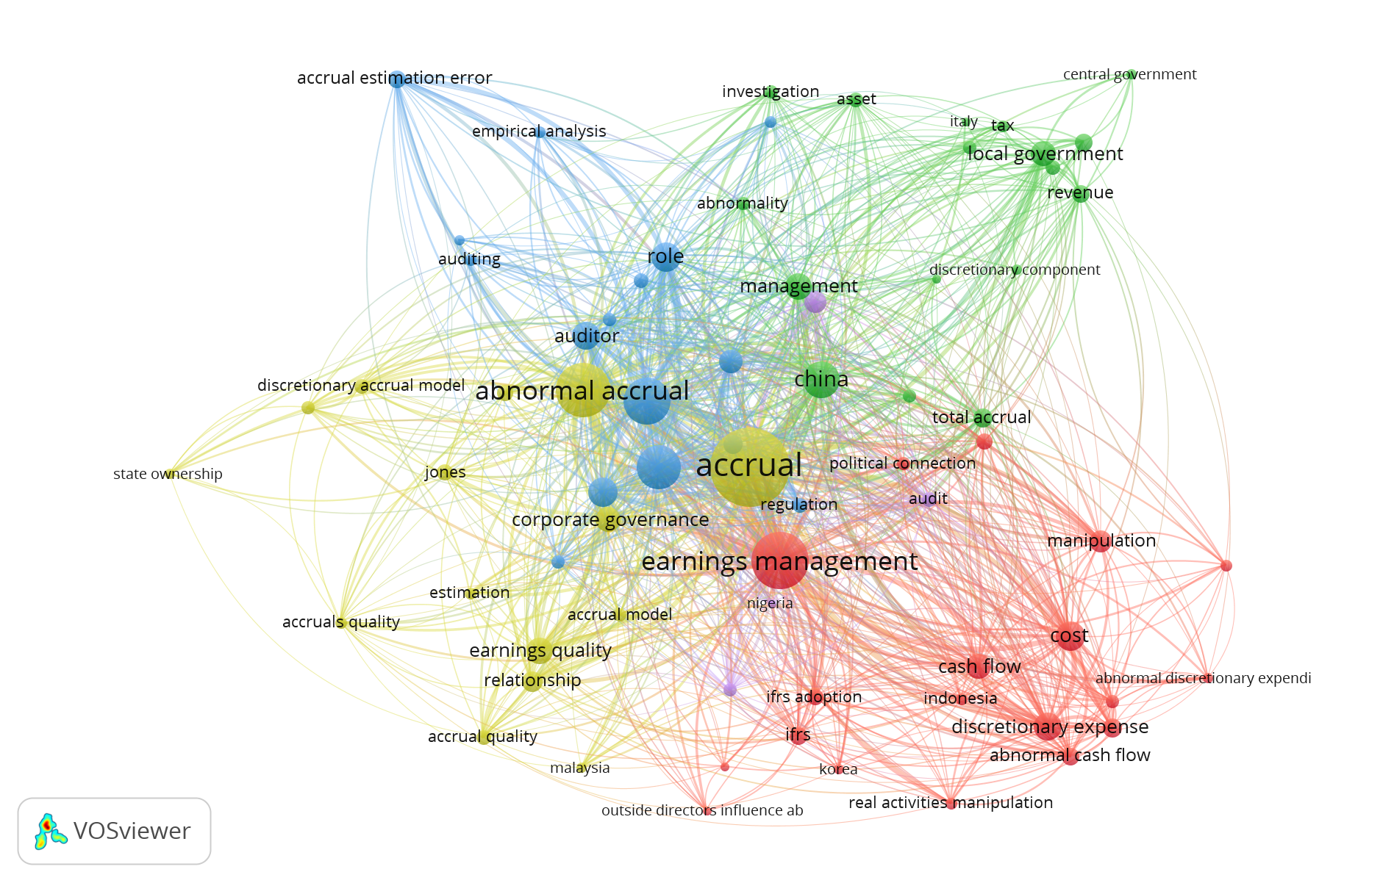

Figure 1. Network Visualization

Based on Figure 1, there are 4 clusters based on color (red, green, blue, light green). Following are explanation for cluster groupings:

Table 1. Research Clusters related to Abnormal Accrual Accounting

CLUSTER | VARIABLE PLAY | SUPPORTING VARIABLE
1(red) | Abnormal | Abnormal cash flow, discretionary, accrual earning management, cash flow, corporate governance, discretionary expenditure, earning management, Indonesia, Korea, manipulation, political connection
2 (green) | Accrual accounting | Accrual accounting, asset, central government, china, discretionary component, local government, investigation, Italy, management, revenue, tax, asset
3(blue) | Discretionary accruals | Abnormal discretionary, accounting, accrual estimation, accrual management, auditing, auditor, discretionary accrual management, discretionary accrual measure, information, performance, practice, quality, regulation, role
4 (light green) | Abnormal accrual | Abnormal accrual, accrual model, accrual quality, corporate governance, earning quality, evaluation, jones model, Malaysia,

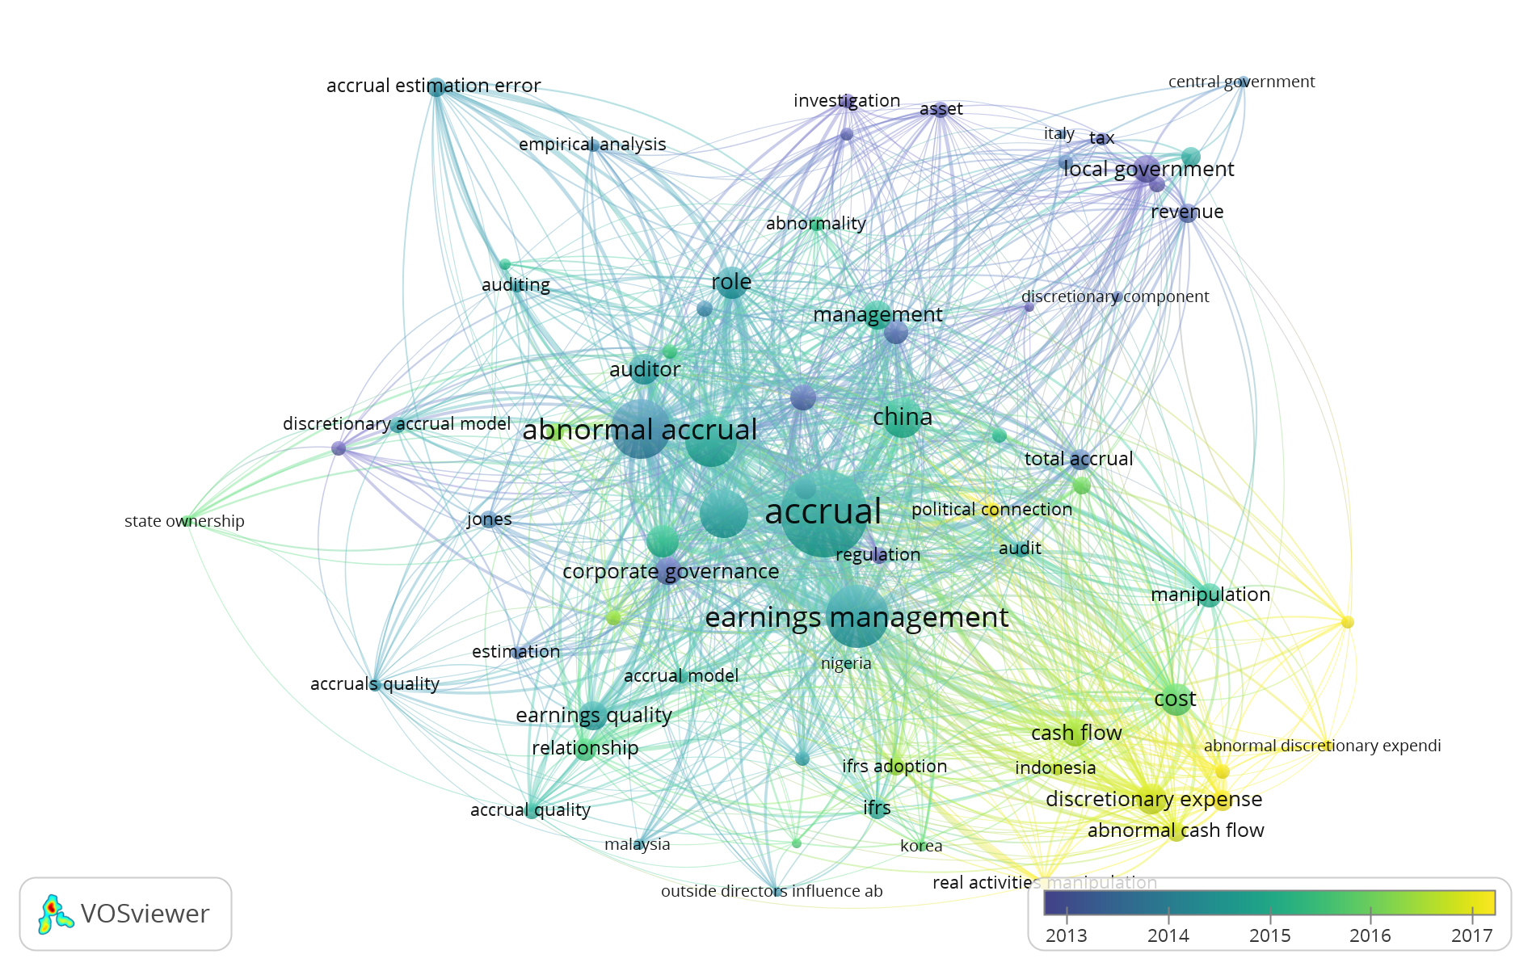
Figure 2. Overlay visualization

Figure 2 is an Overlay visualization that shows the development of research related to abnormal accruals that have been widely carried out from 2010 to the present. A darker color (dark blue) indicates earlier research, while a lighter color (yellow) indicates a more recent study. Research related to abnormal accruals appeared in 2013-2015, initially associated with corporate governance, discretionary accrual model, local government, accrual estimation, revenue, assets, investigation, management, regulation, payment, central government, Italy, Jones model. Furthermore, research related to abnormal accruals from 2015 has developed and is associated with manipulation, cost, earning quality, discretionary expense, Korea, China, Indonesia, Nigeria, Malaysia, political connection, accrual model, audit, cost.

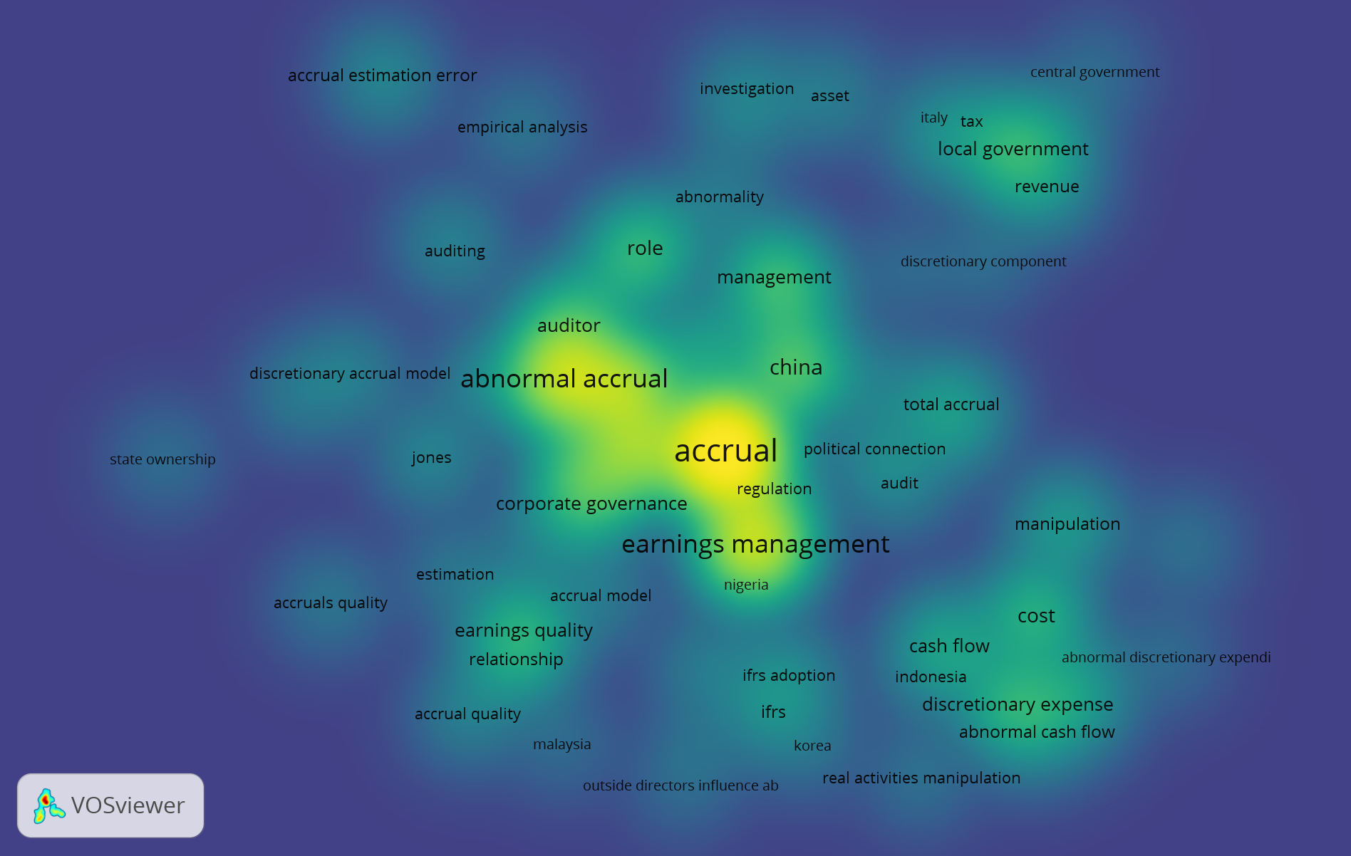

Figure 3. Density Visualization

The density visualization in Figure 3 explains the depth of the discussion. The bright part shows theories that have been used for a longer time or approaches that have been well developed, namely those related to accruals, abnormal accruals, then developed in local government, earning quality, accrual estimation, management, and regulation. Meanwhile, the darker color symbolizes the currently researched theory and has not been widely used or is still being developed, including abnormal or discretionary accruals, manipulation, audits, political connections, discretionary components, accrual quality.
Based on the results of bibliometric studies in the last 20 years, abnormal accrual research on government has developed in many countries and provides empirical evidence of managing accounting numbers in local and central governments. Further research still needs to be set to find out the motivations and causes of this practice and the impact of accrual accounting on the company's actual financial performance. Will applying the accrual basis increase the fairness of the financial statements, or can it even cause deviations (abnormal) gaps that cause information asymmetry, namely not presenting the actual financial statements.

5. Implication and Suggestion for Future Research

Further research needs to be developed and researched qualitatively and quantitatively to establish the theories. The following study can give practitioners such as the government related to better government policies regarding accrual accounting.

6. Reference

[1] R. Pilcher, “Local governmental management of discretionary and specific accruals,” Int. J. Accounting, Audit. Perform. Eval., vol. 7, no. 1/2, pp. 32–60, 2011, [Online]. Available: https://www.inderscienceonline.com/doi/abs/10.1504/IJAAPE.2011.037725.
[2] R. Pilcher and M. Van Der Zahn, “Local Governments, Unexpected Depreciation and Financial Performance Adjustment,” Financ. Account. Manag., vol. 26, no. 3, pp. 299–324, 2010, doi: 10.1111/j.1468-0408.2010.00503.x.
[3] P. Garrone, L. Grilli, and X. Rousseau, “Management Discretion and Political Interference in Municipal Enterprises. Evidence from Italian Utilities,” Local Gov. Stud., vol. 39, no. 4, pp. 514–540, 2013, doi: 10.1080/03003930.2012.726198.
[4] S. Cohen, M. Bisogno, and I. Malkogianni, “Earnings management in local governments: the role of political factors,” J. Appl. Account. Res., vol. 20, no. 3, pp. 331–348, 2019, doi: 10.1108/JAAR-10-2018-0162.
[5] M. J. A. Pellicer, R. Hodges, and C. Marti, “Earnings Management in English Local Governments: Determing factors and instruments,” Financ. Account. Manag., vol. 17463, pp. 1–21, 2016.
[6] O. J. Stalebrink, “an Investigation of Discretionary Accruals and Surplus-Deficit Management: Evidence From Swedish Municipalities,” Financ. Account. Manag., vol. 23, no. 4, pp. 441–458, 2007, doi: 10.1111/j.1468-0408.2007.00437.x.
[7] A. J. Leone and R. L. Van Horn, “How do nonprofit hospitals manage earnings?,” J. Health Econ., vol. 24, no. 4, pp. 815–837, 2005, doi: 10.1016/j.jhealeco.2005.01.006.
[8] A. Ferreira, J. Carvalho, and F. Pinho, “Earnings Management Around Zero: A motivation to local politician signalling competence,” Public Manag. Rev., vol. 15, no. 5, pp. 657–686, 2013, doi: 10.1080/14719037.2012.707679.
[9] R. Martini, R. Agustin, and K. R. Sari, “Accrual Discretion Policy on Excess/Less Budget Financing at the Provincial Level,” TEST Eng. Manag., no. 9925, pp. 9925–9935, 2020, [Online]. Available: https://www.researchgate.net/profile/Rita_Martini3/publication/343809861_Accrual_Discretion_Policy_on_the_ExcessLess_Budget_Financing_at_the_Provincial_Level/links/5f40e39ba6fdcccc43e5b520/Accrual-Discretion-Policy-on-the-Excess-Less-Budget-Financing-at-t.
[10] M. Clémenceau and N. Soguel, “How does depreciations management affect subsequent fiscal performance? The case of the Swiss cantons,” Swiss J. Econ. Stat., vol. 154, no. 1, 2018, doi: 10.1186/s41937-017-0017-4.
[11] C. Jensen and H. Meckling, “THEORY OF THE FIRM : MANAGERIAL BEHAVIOR , AGENCY COSTS AND OWNERSHIP STRUCTURE I . Introduction and summary In this paper WC draw on recent progress in the theory of ( 1 ) property rights , firm . In addition to tying together elements of the theory of e,” vol. 3, pp. 305–360, 1976.

