Geophysical Resistivity Model for Estimation Gold Potential in Pesisir Barat, Lampung
Akroma Hidayatika^{1, a)} Suharno^{2,b)} Rahmi Mulyasari ^{3,c),} Hesti ^{4,d),} Idabagus S Yogi ^{5,e)} Arif P Prabowo^{6,f)}
Author Affiliations
^{1,2,3,4,5} Geophysical Engineering, Faculty of Engineering, Lampung University, Jln. Soemantri Brodjonegoro No. 1 Gedung Meneng Bandar Lampung 35145

Author Emails
- Corresponding author: akroma.hidayatika@eng.unila.ac.id
- suharno.1962@eng.unila.ac.id
- rahmi.mulyasari@eng.unila.ac.id
- hesti.9201@eng.unila.ac.id
- suananda.yogi@eng.unila.ac.id
- ariefputihhhh@gmail.com

Abstract. Gold mineral (Au) is formed due to an increase in the residual solution of magma deposited at high temperature and pressure. This study aims to estimate the potential of gold minerals in some areas of Pesisir Barat Regency based on resistivity geophysical models. Based on geological data, gold minerals in the West Coast are classified as epithermal hydrothermal deposits in the form of low sulfide quartz veins. The results of the subsurface interpretation were identified as a gold mineralization zone associated with the rock in the form of volcanic rock which has a resistivity value of 400Ω.m. The source rock volume has been estimated at 130,000 m³ and ≤133,000 m³. So that the Au mineral content in the study area is estimated at 0.5-2.09 tons.

INTRODUCTION
The research area in Pesisir Barat Regency is suspected to have gold mineral content. Gold mineralization in Pesisir Barat Regency is found in volcanic rocks composed of volcanic breccia, tuff, andesite lava. The gold content of the West Coast area is an epithermal type of hydrothermal gold deposit (in the form of quartz veins), including epithermal low sulphidation (Indarto, et al 2007).
The resistivity geoelectric method is one of the geophysical methods that calculates the ability to conduct electricity from rock layers in the earth. This method works by injecting an electric current into the earth through two current electrodes and measuring the potential difference through two potential electrodes, the result is a potential difference measured at the electrode on the surface. From the measured potential difference, the resistivity variation of each layer under the measurement point can be determined. Obtaining field data in the form of subsurface resistivity values. Based on these data, an inversion calculation is then carried out so that the resistivity variation of a soil layer system is calculated which is associated with the geological structure below the surface.

Regional geology
Pesisir Barat Regency, Lampung Province is located in the regional geology of Kota Agung. The study area is included in the 1:250,000 Scale Regional Geological Map of the City of Agung Sheet (Amin., et al, 1993). The regional rock compositions are, The Hulusimpang Formation of Late Oligocene-Early Miocene age is the oldest rock exposed around the study area. The upper part of this formation is aligned with the lower part of the Seblat Formation which is of Early to Middle Miocene age. The deep breakthrough rock (granite and diorite) of Middle Miocene age broke through the Hulusimpang Formation and the Seblat Formation. The Middle Miocene Lemau Formation is unconformably superimposed on the Seblat Formation. Then, the Lemau Formation was unconformably overlain by the Late Miocene-Pliocene Simpangaur Formation, and deposited in the transition area. The Bintunan Formation is Plio-Plistocene in age which was deposited in fresh to brackish water and local shallow seas, unconformably overlapping the Simpangaur Formation. They are shown in figure 1 below.

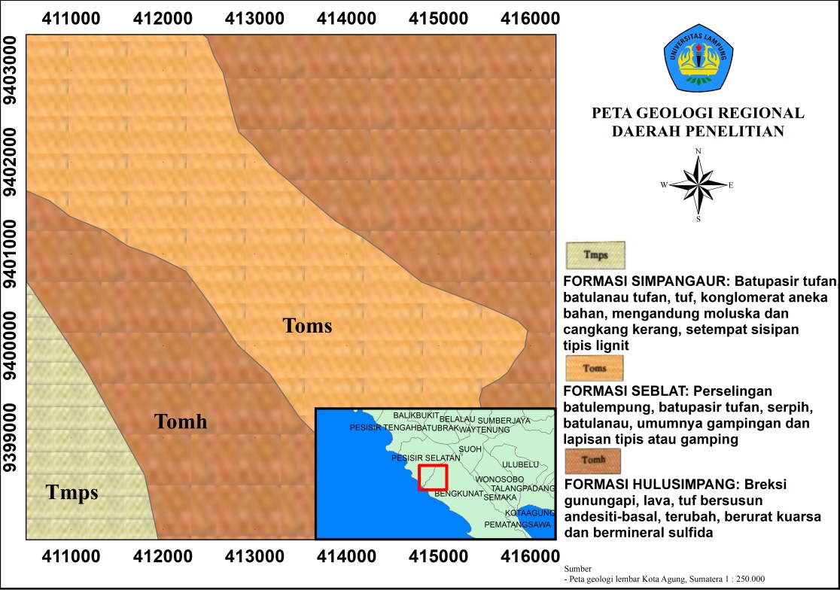

Figure 1. The geological map of the study area (Amin., et al, 1994) has been modified. The research area consists of the Simpangaur Formation, the Seblat Formation and the Hulusimpang Formation

TEORY
The resistivity method basically utilizes electrical conductivity which can be used for various problems in mineral exploration. This method can be used to describe geological structures associated with mineralized zones. The resistivity method is an effective method for determining the position and depth extension of gold-bearing quartz veins (Guo et al 1999). The resistivity model was able to detect the rock response thought to be associated with gold-bearing quartz veins and these results were compared with geological data to infer quartz vein levels. Surveys of surface dipoles have been successfully carried out delineating the main geological structures associated with gold bearing quartz veins (Jong-oh et al 2009). Gold carrier minerals are usually associated with gangue minerals, which are generally quartz, carbonate, tourmaline and small amounts of non-metallic minerals. Below will be presented a table properties of the Gold mineral.
TABLE 1. Gold mineral properties (Diantoro, 2010)
Physical properties | Value
crystal shape | cubucal
color | Yellow gold, white silver, orange, red
melting point | 1064,43 ºC (1948 ºF)
hardness | 2,5 – 3 Mohs scale
density | 19,3 (pure)
resistivity | 2,2 . 10⁻⁸ Ωm
susseptibility | low
ductility | hi
luster | Metallic
According to Lindgren (1933), the factor that controls the concentration of metal minerals (especially gold) in a mineralization process is influenced by the presence, differentiation process. This differentiation process can be caused by crystallization, gravity, liquid separation and assimilation (reaction or dissolution process between magma and wall rocks). This process will form magmatic sulphide and oxide mineral deposits which are usually dispersed. The depositional environment of gold can be classified based on the process of its formation, which can come from hydrothermal processes, metasomatism processes and other surface processes that cause the formation of placer deposits. In this study, the focus is on the target of the subsurface gold environment formed as a result of the hydrothermal process. This relates to controlling structures such as faults, intrusions, wall rocks and so on. The hydrothermal process associated with the controlling structure can form a gold depositional environment in the form of porphyry deposits, high sulphidation epithermal deposits, low sulphidation epithermal deposits, massive sulphide deposits. Differences between low and high sulfide systems (Corbett and Leach, 1998) shown in the following table.

TABLE 2. Differences between low and high sulfide systems (Corbett and Leach, 1998)
Properties | low sulfide | high sulfide
Alteration | Sericite/illite-argillic-propylitic Urate is dominated by quartz ± carbonate | Residual quartz (vughy)-alunite- kaolin minerals-illite minerals- propylitic
Ore Minerals | Pyrite, electrum, gold, galena, sphalerite, chalcopyrite, arsenopyrite | Pyrite, enargite-luzonite, covelite, chalcopyrite, tennantite, gold
Mineral Gangue | Quartz, chalcedony, carbonate, adularia, illite, kaolinite (as overprint), chlorite | Quartz, alunite, kaolinite, dickit, pyrophyllite
Precipitation Form | Dominant veins, generally stockwork with little dissemination and replacement | Dissemination dominance, generally in the form of replacement with little stockwork
Texture | Veins, cavity filling (bands, colloforms, druses), breccias | Replacement of wallrock, breccia and veins
Economical Metal | Au ± Ag, Pb, Zn, Cu, As,  Hg, Te, Sb | Au ± Cu, As, Te

METODOLOGI
Measurements using the geoelectric method of resistivity with the Wenner-Schlumberger configuration in the research area consist of 1 measurement lines, with a track length of 200 m. The electrode for each measurement path is 5 m. The measurement results obtained from the field in the form of resistivity data that are stored automatically on the Ares Resistivity meter tool are then transferred from the tool in the form of a "dat" file to a laptop after it is processed using the Res2Dinv software. From the 2D cross-section it is known that the distribution of resistivity values ​​is influenced by variations in subsurface rocks, then data samples are taken from the 2D cross-section which is considered to represent the subsurface rock structure of the study area. After that, analyze the resistivity value at the point of the geological 3D model. Furthermore, the model is processed using 3D geophysical software, namely rockwork. Based on the point data of the 3D geological model, a 3D-lithology modeling was reconstructed according to the coordinates and elevation of the research area. The selection of 3D geological model points is done based on the pattern of resistivity values ​​that are considered representative of the lithology so that the accuracy of the model to be made is good and makes it easier for interpretation.
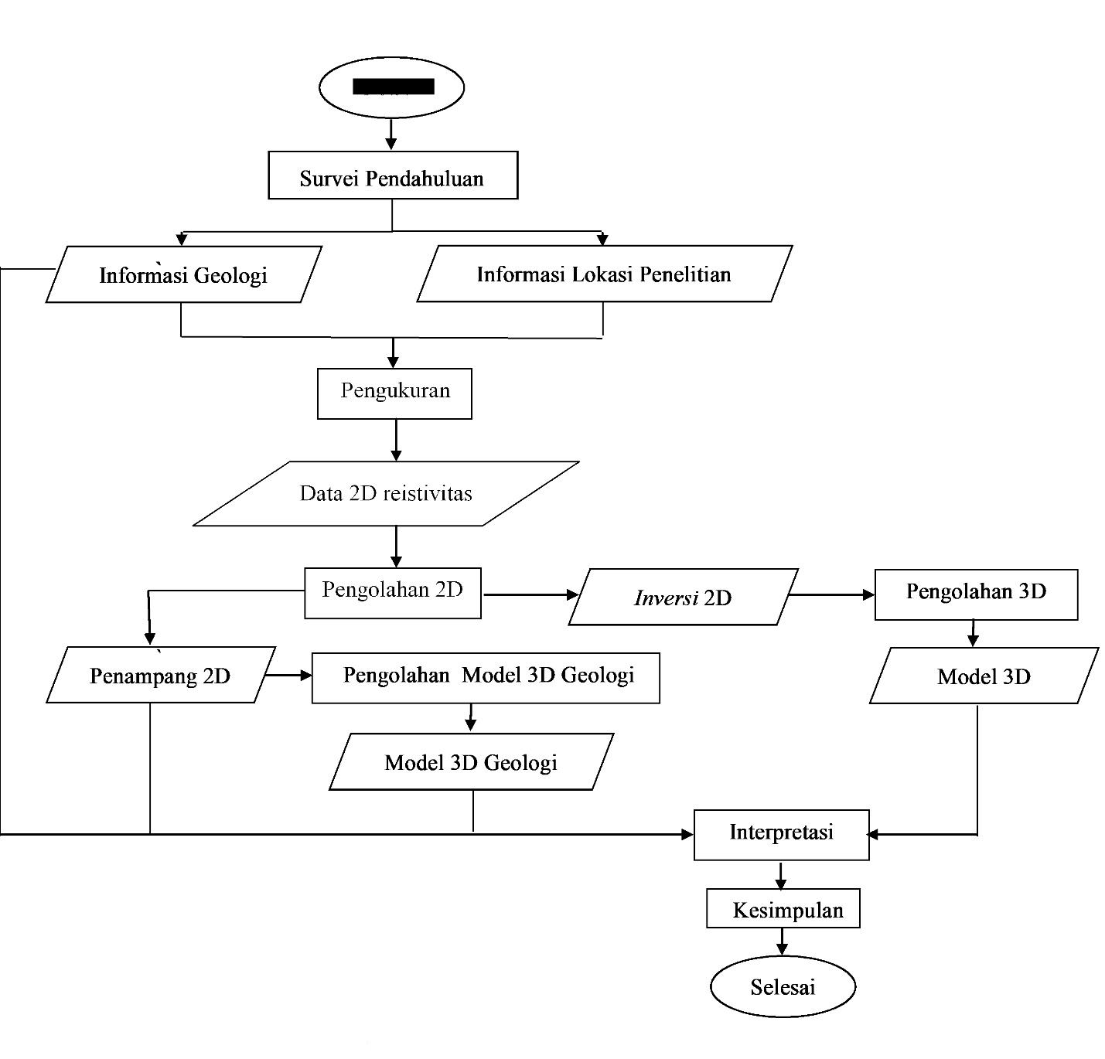
Mulai
Figure 2 . Research flow chart consisting of the stages of literature review until geophysical primary data collection to modeling and estimation of economic mineral reserves

RISULT AND DISSCUSSION
From the 2D cross-section, it is known that the distribution of resistivity values ​​is influenced by variations in subsurface rocks, then sample data is taken from the 2D cross-section which is considered to represent the subsurface rock structure of the study area. After that, analyze the resistivity value at the point of the 3D geological model. o find out the lithology of the rock, the lithological data obtained is estimated at the total depth and elevation to then be compiled and processed using 3D geophysical software, namely rockwork.
Determination of the types of constituent rocks in the geological 3D model is obtained based on the resistivity value indicated by the color image gradation in the 2D modeling results of the inversion and the resistivity value with reference to the resistivity table (Telford, et al 1976). It can be seen from the 3D geological model that there is a gradation of color images which means that there are different lithologies below the surface, for the gray color is indicated andesite lithology, then pink is indicated for clay lithology, then blue is indicated for porphyry granodiorite lithology, then for orange color is indicated. Sandy clay lithology and the green color indicates the dominant soil lithology on the surface.
The same resistivity values ​​can be owned by different rocks, this happens because the resistivity values ​​of the rocks have a range of values ​​that can overlap each other. This research focuses on finding the source rock (volcanic) which is suspected to be associated with gold minerals. The gold content of the research area is a low sulphidation epithermal type hydrothermal gold deposit (in the form of quartz veins), with carrier minerals containing metals and non-metals. Interpretation is done by correlating the results of software data processing in the form of information (resistivity values, depth, thickness) with basic knowledge of rock type resistance aspects, geological information, information on the condition of resident wells (depth and taste) around, knowledge of hydrogeology, referring to rock resistivity tables (Telford, et al 1990) and references related to geothermal research using geoelectric methods that have been carried out.
The 2D resistivity cross section of track 1 obtained a subsurface layer with a stretch of about 200 meters (electrode spacing 5 meters) with a depth of approximately 40 meters. The results of the 2D resistivity cross-section on track 1 using 4 iterations obtained an RMS error of 26.9%. Results of the inversion show (Figure 3) resistivity value is obtained with a relative west-east direction on a topography with a moderate slope having a distribution of resistivity values ​​ranging from 7.75 to d. 2584 .m., shown in blue to purple. This path shows the intrusion pattern of the source rock that extends along the measurement trajectory. The depth of the rock is about 5 meters and is covered by clay (dry) rock and shattered rock that is not compacted, resulting in a high resistivity value. In addition, there are rock contacts with low resistivity values ​​(<100 .m..) at a distance of 105 to 120 meters from the start of the measurement trajectory which is estimated to be a layer of crushed rock and infiltrated by water.

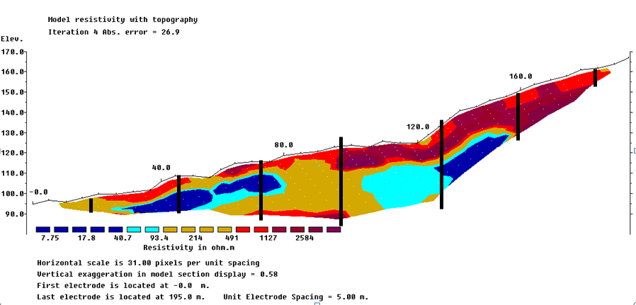
Figure 3 . Resistivity map in research that has been overlapped with topography

So that the estimation of the actual rock structure information is obtained. From the interpretation results by correlating all aspects, the volume value of the source rock (volcanic) is 140,000 m³ and 158,000 m³ and then the estimated potential (Au) based on the results of laboratory tests is 5 g/ton. From the modeling, it is found that the estimated mineral content (Au) in the study area is 0.7 to d. 2.09 tons.

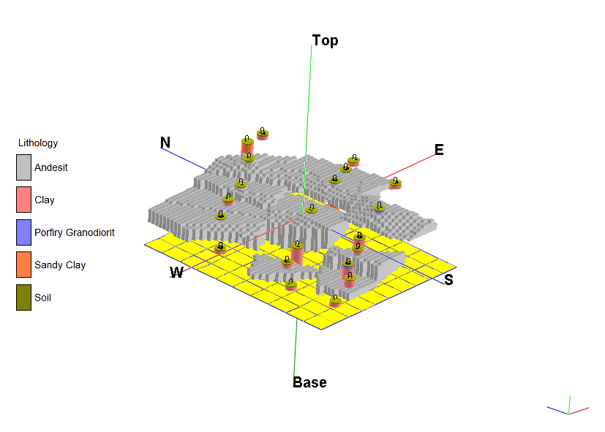
Figure 4 . Reconstruction of 3D geological model of andesite lithology distribution using rockwork so that it is able to estimate the volume of estimated mineral reserves economically

CONCLUSION.
The variation of the resistivity value shows the distribution pattern of the source rock is dominated by a relatively north direction, then in the eastern part there are several distribution blocks of the source rock. Estimation of gold mineral content based on the results of resistivity data modeling, the estimated value of potential reserves at depths of up to 40 m is 0.7 - 2.09 tons

Acknowledgments
Thank you very much to BLU Research Beginner Lecturer UNILA and Department of geophysical engineering, Faculty of Engineering, University of Lampung.

References
- Amin, T.C., Kusnama, Rustandi, E., and Gafoer, S. 1994. Geology of Sheets of Kota Agung, Sumatra, Scale 1:250,000. Geological Research and Development Center. Bandung.
- Guo, W. W., Dentith, M. C., Xu, J. L. dan Ren, F. S. 1999. Geophysical exploration for gold in Gansu Province, China Explor. Geophys. 30 76–82.B. R. Jackson and T. Pitman, U.S. Patent No. 6,345,224 (8 July 2004)
- Indarto, S., Setiawan, I., Zulkarnain, I., Fiqih, F. M. dan Fauzi, A. 2007. Alterasi Dan Mineralisasi Hidrotermal Pada Batuan Volkanik Formasi Hulusimpang Daerah Bengkulu Dan Lampung di Kawasan Sayap Barat Pegunungan Bukit Barisan, Sumatera. Prosiding Seminar Geoleknologi Kontribusi llmu Kebumlan Dalam Pembangunan Berkelanjwan. ISBN. 978-979-799-255-5
- Jong-Oh, P., Young J.Y. dan Hee, J.K. 2009. Electrical Resistivity Surveys for Gold-Bearing Veins in the Yongjang mine. Korea : Nanjing Institute of Geophysical Prospecting
- Telford, W.M., Geldart, L.P., Sheriff, R.E. and Keys, D.A. 1976. Applied Geophysic Edisi 1. Cambridge : Cambridge University Press.

