Land elevation and slope exposition impacts on rubber wood production volume
under agroforestry system

Samsul Bakri^{1,2)}, Christine Wulandari^{1,2*)}, Rusita Jamal³⁾, and Ghina Zhafira⁴⁾

¹Graduate School of Forestry Science, College of Agriculture
²Graduate School of Environmental Science, College of Interdisciplinary
³Department of Forestry, College of Agriculture
⁴Study Program of Forestry, College of Agriculture
Universtitas Lampung, Jalan Sumanteri Brojonegaro #1, Bandar Lampung 35145

Abstract. Nowaday the role of genetic and environment factors on latex production have widely revealed by some researchers, but lack on the wood production wood especially for the effect of land elevation and slope exposition direction against solar beam radiation so need to research. Ordinary Least Square employed at 90% significant level, the respond variable was the volume wood production per tree, [WOOD], whereas the predictor were land elevation in an-100 m above sea level [ELV], land slope expositions that were decomposed into 4 categories with the reference of the compass direction in between 337⁰.30’ to 225.5⁰ follow needle clock’s direction while the three other directions were the westward [WEST], southwest ward [SWST], and northwest ward [NWST]. In order to control the model error we also employed the variables of the air temperature [TEMP] and air humidity. Data collected by surveying to 75 parcels of land belong to HKm member of Mangga Joyo located in Way Kanan Regency. Parameter optimization used Minitab 16. The result suggest, the [WOOD]: (1) will increase significantly around 0.02205(SE=0.01048)m³ for every 100m higher of land elevation, and (2) will decrease significantly around 0.21532(SE=0.07986)m³ which land exposition face to westward than that of eastward. It may be beneficiary for REDD⁺ implementation under Paris Agreement.

- Introduction
1.1 Research Background
Growth and development of plant are controlled by both genetic and environment factors so does the rubber (Hevea brasiliensis). Because of widely used in some industry inputs, the research on effect of booth factors have been conducted exhaustively to increase the latex productivity and quality [1], [2], [3], [4], and so did [5] reported their research on the roles of genetic factor on the latex productivity of some types of clonal resulted from the previous breeding. As for the extensive of research on environmental effect on rubber growth and latex productivity can be referenced the work reported by [6] especially for climate factors (air temperature and rainfall) in relation to land suitability, [7] for soil fertility and management etc. None of these research reveals the roles of the genetic and environmental factors on rubber wood production but on latex productivity.
Having exhaustively endeavour for searching publication about the effect the two factors on rubber wood product, we almost failed to find it. However [8], fortunately, has reported the role of cropping management of leave pruning on rubber stem diameter development. Additionally [9] also have contributed the effect of air humidity and air temperature on stem performance. But both research were employed merely on the rubber seed nursery conditions, that may be give very different effect in case on applying at opened field area with various of environment factors including the terrain of land such as elevation and slope exposition. In relation to this matter, [10] reported that for every moved up a-100 m across the landscape there would be improvement in bean quality indices of a-1000 weight in one hand but worsen the indices of float bean in water soaking in the other hand. Further [10] Bakri et al (2018) also reported that the west ward slopes exposition had no effect significantly on the first indices but on the second indices respectively. We are interesting in revealing the effect of the two terrain land attributes on rubber wood volume production. The two land attributes will determine on resource allocation in agroforestry system during the period of cultivation and latex harvesting as well as in logging wood when the replanting phase will be due. The relationship model of rubber wood production and two variables is very important for some programs of Indonesian Government to reforestation especially for REDD⁺ Scheme under Paris Agreement regime as [11] and [12].
Based on the lesson explained bay [11] it is implied that by applying rubber agroforestry system in reforestation programs under Paris Agreement commitment (REDD⁺ sheme), Indonesia will bring some benefits, i.e it will reaffirm as the leading latex exporter during the period of commitment while enjoy having income from the long CER (certificate emission reduction) lifespan, will also be having the environmental improvement from deforestation and land degradation as well as will provide huge volume of rubber wood as by product of the program when the commitment period ends for next 30 years on. Moreover, the lower stratrume such as food crops, vegetable, aromatic crops, and some silvo-medicines will also remain to contribute community income or at least for supporting subsistence poor consumption. The rubber wood production certainly will, further, bring multiplier effect on the country income through inducing wood processing industry including sawn wood, furniture, veneer, plywood, chemical pulp, fibre pulp, waste paper, paperboard etc. According to [13] Indonesia has been suffering from declining value of total wood products in the net international balance trade from USD 4,519(10⁶) in 2005 to USD 1,136(10⁶) in 2030. These values is equivalent to declining balance trade of wood products from -1.0% to -7.3% in 25 years. Based on the background describe above, we intend to conduct this research that objected to contribute lacking data of the effect of land elevation exposition and slope exposition direction against solar beam radiation on rubber wood production volume.

  - Research Objective
This research was aimed at revealing the impact of the two variables on rubber wood volume production under agroforestry system

- Material and Method
2.1 Research Location
This research took place in December 2019 to January 2020. The research location was at Location Social Forestry of Mangga Mulyo (HKm=Hutan Kemasyarakatan), under Authority of the Forest Management Unit (FMU) of Bukit Punggur, at Way Kanan Regency, Lampung Province_Indonesia. According to [14] the research location is lied in parallel of 04° 42’ 25,95” - 04° 57’ 09,72” S and in meridian of 104° 19’ 07,00” - 104° 32’ 34,00” E. Figure 1 provides the research location. It takes around 7 hours from the Capital City of Bandar Lampung.

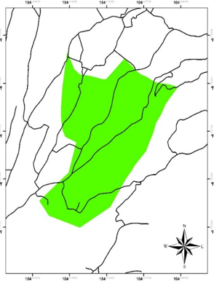 | 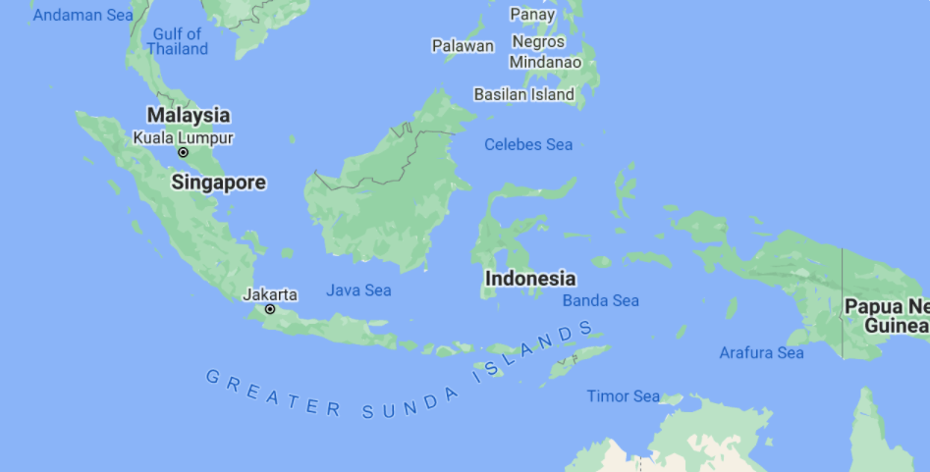
 | 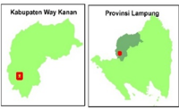
Figure 1. Research Location. Source: After Zhafira et al (2019)

2.2 Equipment
The equipment used were consisted of thermo-hygrometer, altimeter, compass-clinometer, and tape measurement meter (Figure 2).

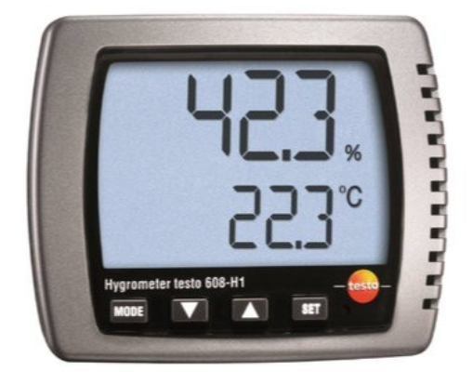  a | 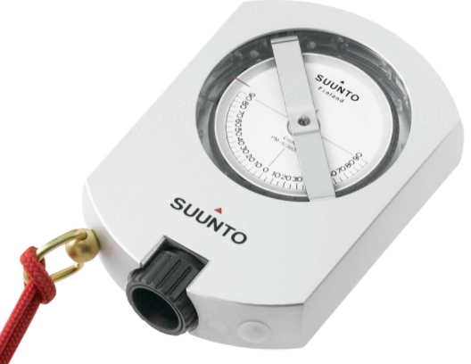  b
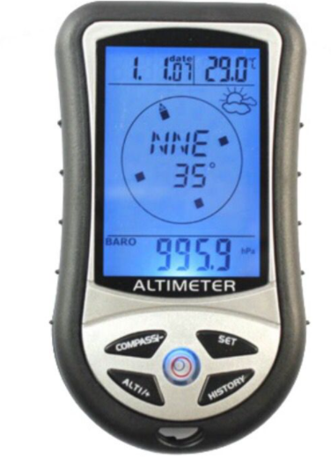  c | 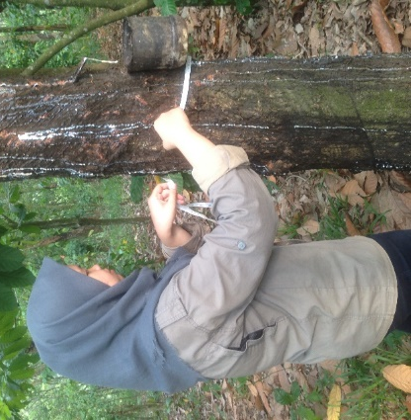  d
Figure 2. Research equipments: [a] Thermo_Hygrometer;
[b] Compas_Clinometer [c] Altimeter]
[d] Tape Measurement

2.3 Model Approach
The ordinary least square postulate model was employed to explain the rubber wood volume production [WOOD] as the respond variable of the land elevation [ELV] and slope exposition direction. The [ELV] measured using altimeter whereas the slope exposition against solar radiation direction. It is important to note that the slopes exposition directions are grouped into fours category. The first category is the slope exposition direction that prominent in accepting the morning solar beam radiation namely the east ward. According to [10] Bakri et al (2018) the east direction is the prominent face in accepting solar beam radiation in relation to photosynthesis for almost tropical crops as coffee robusta (Coffea canephora). So that we established the east ward as the reference for three other categories.
This reference, however, is not perfectly direction to 90º.00’, but we prefer to the compass direction in between 337⁰.30’ and 225º.30’ follows the clock’s needle. It because in the tropical region the solar beam radiation is still reach effectively to land with slope exposition direction wider than the northing or southing direction. Based on this reference we then established the tree others direction of slope exposition i.e. the southwest ward [SWST] = 202º.30’ - 247º.30’; west ward [WST]= 247º.30’ - 292⁰.30’, and north west ward [NWST]= 292º.30’- 337⁰.30’. Figure 3 is the illustration of division for fours slope exposition directions againts solar beam radiation.

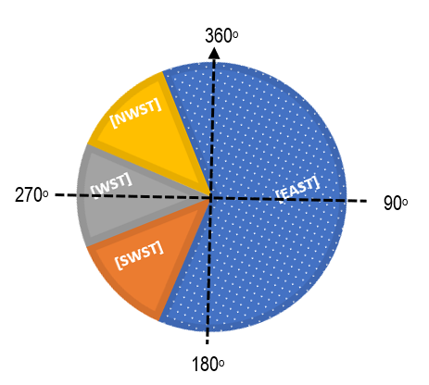
Figure 3. Division of the slop exposition againts
solar beam radiation into 4 categorics

Additionally we further need to control the model error by incorporating the air humidity [RH] and air temperature [TEMP] variables. It was because we aware on one side that booth variable commonly has a significant effect on photosynthesis process that correspond to rubber wood production, but on the other side we did not have booth the long data records, except for one moment during the survey. As for the model can be express in the following.

[WOOD]_{i} = α₀ + α₁[TEMP]_{i} + α₂[RH]_{i} + α₃[ELV]_{i} + α₄[NWEST]_{i}
+ α₅[WEST]_{i} + α₆[SWEST]_{i} + ξ_{i}

2.4 Working Hypothesis

The working hypothesis was constructed as the following:

H₀ : α₁=α₂=α₃=α₄=α₅=α₆=0; There was none of the six variable applied in the model affected significantly on rubber wood production.

H₁ : α₁≠α₂≠α₃≠α₄ ≠α₅≠α₆≠0; There would be at least one variable affect on the rubber wood production.

Where the α₁ to α₆ are the parameter model, ξ_{i} is the error model, and i are the sample numbers (where i=1, 2, 3, …,75). As for the other symbols, accompanied by predictor variables, data acquisition method, unit of measurements, and their data scoring are presented in Table 1.

Table 1. Predictor variables, symbol in model, unit of measurements, data scoring
and their acquisition method

Predictor Variables | Symbol in Model | Measurement Unit | Data Scoring | Data Acquisation
- Air Temperature | [TEMP] | ⁰C | as recorded | Thermo-Hygrometer
- Air Humidity | [RH] | % | as recorded
- Land Elevation | [ELV] | a-100m fold (ASL) | as recoded | Altimeter
Slope Exposition (337º.30’ to 225º.30’as the reference)£= 0
- South West | [S_WST] | Dummy | =1if Southwest, =0 if others
- West | [WEST] | Dummy | =1 if West,  =0 if others | Compass_Clinometer
- North West | [N_WST] | dummy | =1 if Northwest,  =0 if othres
Note: £ follows the clock’s needle

2.5 Testing Hypothesis
In order to conduct on the hypothesis testing we need to collect data both for the respond and predictor variables, through a systematic survey. We drawn randomly 75 from 306 parcel of lands of land belong to HKm member as the sample. For every parcel of land we chose the best 10 of rubber crops then measure the diameter and hight of stem. Besides to measure data for the predictor variables as summarised in Table 1, and so did for scoring data and their unit of measurement. Testing hypothesis conducted by employing Minitab 16.

3. Result and Discussion
Before discussing the model obtained, it was important to explore general information a bout the research area. For this purpose firstly need to reveals the descriptive statistic of data recorded.

3. 1 Descriptive Statistic
For the sake of figuring general information about the data, in this section we need to depict the descriptive statistic as provided in the Table 2, include the average, maximum, minimum, and their standard error (SE). As for the frequency distribution of slope exposition against solar beam radiation is expressed in Figure 3.
The air temperature and air humidity during the survey (Table 2) was normally recorded in the tropical area. These variables are slightly different from [10] i.e 26.1 (SE=1.9)ºC and 71.4 (SE=1.7)% for the average of air temperature and air humidity respectively. The difference may be caused by the differences of range altitude both the area of research i.e from 349m to 1,788m ASL that lies in the parallel in between 05º48' -05º22' LS. The other possibility that made the differences was the time of conducting on of field research etc.

Table 2. Descriptive statistic of tree sample characteristic and land attribute of sampling area

Statistic | Characteristic of Tree Sample |  |  |  | Land Attributes
 | High of (m) | DBH (m) | Wood Volume£ (m³)/tree crop |  | Elevation (100m) ASL | Air Temperature (⁰C) | Air Humidity (%)
- Average | 7.45 | 0.156 | 0.49 |  | 7.07 | 30.50 | 23.56
- Maximum | 12.00 | 0.258 | 0.81 |  | 12.00 | 34.50 | 36.00
- Minimum | 5.00 | 0.051 | 0.16 |  | 5.25 | 26.50 | 16.00
4. SE | 2.15 | 0.048 | 0.15 |  | 1.77 | 1.93 | 5.71
Source: Field survey (2020). Note: £ calculated by the formula = 3.14(DBH)²(tree height) m³.

Figure 3. Data distribution frequency of 4 slopes exposition direction
against solar radiation.

As also can be examine in Table 2. the land elevations are located in between 7.07 to 12.00 hm with the average 5.25 hm above sea level (ASL). These distribution accompanied by respective statistic of their wood production i.e in between 0.49 to 0.81 and the average of 0.16 m³ per tree crop of rubber. In generic view, there is strong positively correlation between the two statistic. And so do to the air temperature and air humidity. These phenomena, however, have not been yet to claimed any causal relationship among these variables until we examined the regression model that involving the land exposition.

3.2 The Goodness Fits of the Model
The results of the goodness fits test of model employed are provided in Table 3 as the following.

Tabel 3. The analysis of variance

Source | DF | SS | MS | F | P
Regression | 6 | 0.62719 | 0.10453 | 6.61 | 0.0004
Residual error | 68 | 1.07469 | 0.10158
Total | 74 | 1.70188
Note: DF=Degrees of Freedom, SS=Sume Square Error, MS=Mean Square Error

Table 3 reflects that there is no proof to accept H_{o.} Then as the consequency we have to accept H₁, that there is at least one predictor variable that affect the [WOOD]. Besides the P=0.0004 achieved also tell us that the model is very good to predict the [WOOD]. With the indicator of P=0.0004 it tell us that in case the model to be utilized for predicting the [WOOD] at any other location of rubber agroforestry, so there will be 4 times miss out from 10,000 times of experiment. So that we can claim that the model is satisfied as the goodness of fits criterion (the F-test).
Having fulfilled the F test, it is interesting in examining the 6 predictor variables which solely have a significant effect on [WOOD]. Table 4 depict the optimized parameters (α₀ to α₆) of the 6 predictor variables applied in modelling. Based on these parameters achieved the significant role of every predictor variables on the [WOOD] can be justified. Besides, based on all these optimized parameters, therefore, model can be expressed as the following:

[WOOD]i = - 0,891 + 0,0367 [TEMP]_{i} + 0,00466 [RH]_{i} + 0,0221 [ELV]_{i}
+ 0,0491 [NWEST]_{i} - 0,215 [WEST]_{i} + 0,0386 [SWEST]_{i}

Table 4. the optimized parameters of the 6 predictor variables applied in modeling
Predictor Variable | Symbol | Coefficient=α_{n} | SE Coef. | T | P
Constant | - | -0.8908=α₀ | 0.4778 | -1.86 | 0.067
Air Temperature (⁰C) | [TEMP] | 0.00667=α₁ | 0.01297 | 2.83 | 0.006
Air Humidity (%) | [RH] | 0.004657=α₂ | 0.004413 | 1.06 | 0.295
Land Elevation (a-100 m fold=hm) | [ELV] | 0.02205 =α₃ | 0.01048 | 2.10 | 0.039
Slope Exposition against solar beam radiation
-Northwest | [NWEST] | 0.04912 =α₄ | 0.05917 | 0.83 | 0.409
-West | [WEST] | -0.21532 =α₅ | 0.07986 | -2.70 | 0.009
-Southwest | [SWEST] | 0.03855 =α₆ | 0.07505 | 0.51 | 0,609
S = 0.125715 R-Sq = 36.9% R-Sq(adj) = 31.3%. Note: the bold letters affect significantly on [WOOD]

  - The Role of Air Temperature and Air Humidity
The role of air temperature, [TEMP], in affecting rubber wood production volume, [WOOD], is positively significant. This claim is proved by it α₁=0.00667m³/ºC. It tells us that, if the others predictors variable are remain constant, there will be an increasement on [WOOD] for every 1ºC [TEMP] rise up. This [WOOD] increasement is very significant in confident level of 99.04% as expressed by P=0.006. It is important to note that this phenomenon can lead us to miss conclusion. We have to realize that data of [TEM] applied in the model was merely one moment during the field survey. The data standing are merely ex-post data and need to ex-ante data to verify the role of [TEMP] on the [WOOD].
As those expressed by P=0.365 (or P>5%), the air humidity [RH] does not any affect on the [WOOD]. But, this conclusion is also based on data temporary data collected during the survey. So that we also need an ex-ante data record in order to justify about this finding.

3.4 The Role of Land Elevation
The role of land elevation, [ELV], has proved a positive impact on the [WOOD] as indicated by the parameter α₃ =0.02205. This parameter tells us that under the others variable retained remain constant, there will be an increasement [WOOD] by 0.02205 m³ per tree crop for every 1 hm land elevation steps up. This effect is significant as connoted by the P=0.039 (3.6% or P<5%) or with the confident level more than 95%. In line with this finding we need to recall the general theory of globe gravitation in connection with the photosyntetic behavior of C3 type as rubber crop [15] that in atmosphere space the partial pressure or saturation of every gas, including CO₂, will reduce gradually following steps up to higher elevation across the landscape. This reducing CO₂ concentration in the air will control directly to the photosynthesis rate of the C3 plants group as those of the rubber crop [15] and [16].
According to [16] the two indicators commonly used in the rate of photosynthesis are Vc_{max} and J_{max}. The first indicator is to measure leaf maximum carboxylation rate and the second one is express the leaf’s ability to transport electrons in the process of producing nicotinamide adenine dinucleotide phosphate or NADP, that is then used to control the carbon reactions. The Vc_{max} determines the leaf’s capacity in carbon fixing and converted into glucose within the dark reactions of the Calvin−Benson cycle. Besides, [18] conducted on an experiment using C3 plant to compare the effect of land elevation on photosynthesis rate with employed the two indicators and concluded that Vc_{max} and J_{max} were approximately 6.5% and 3.5% higher, respectively, in leaves from C3 plants that grown at the high land elevation than those grown at the low altitude, and the ratio of J_{max} to V_{cmax} was 12.7% lower at the low altitude. They argued that in atmosphere space any partial gas pressure will gradually reduces following steps up across the landscape so does the CO₂ pressure or concentration in the air. As a consequence, plants exposed to lower CO₂ partial pressure and lower air temperature have a higher photosynthetic capacity at higher altitude or land elevation.
Additionally, the Vc_{max} determines the leaf’s capacity in carbon fixing and converted into glucose within the dark reactions of the Calvin−Benson cycle. Because the V_{cmax} is an indices of leaf maximum carboxylation rate [15], so the indices also correspond to the glucose formed, the first compound that produced in the photosynthesis process. The compound will, further, undergoes some biochemical processes that converts to more complex ones to build plants tissue including cellulose. As the main component of wood product, cellulose itself is a polysaccharide consisting of a linear chain of several hundred to many thousands of β(1 → 4) chemical bounding chain that links the d-glucose units [18]. At rest that why the [WOOD] more volume significantly for every move up to higher elevation as founded in this research. In contrast [19] reported that the latex production decease following the land elevation steps up across the landscape. It seems any trade off between the wood synthesis and sap production especially in dividing photosynthesis result in rubber tree. Further research is in needing to reveals this interesting phenomenon.

3.5 The Role of Land Slope Exposition
Among the 3 slope exposition against solar beam radiation only does the west ward direction, [WEST], that plays negative role on the [WOOD] as indicated by its parameter α₅= -0.21532. This is meant that under scenario of the other variables are retained to remain constant, there will reduce the [WOOD] around 0.21532 m³ per tree crop for the lands that have slope exposition to west ward direction [WEST]. The effect is significant as connoted by P=0.009 (0.9% or P<1%). As for the lands have slope exposition both to [SWST] and [NWST] there are indifferent on [WOOD] from than that of the east ward direction [EAST].
Slope exposition against solar beam radiation of each parcel of land has effect on the photosynthesis rate as the function intensity of photon energy capturing by chlorophyll cells. The cells, therefore, are the main photon-harvesting component in leaves that closely linked to photosynthesis [15]. The photon energy intensity itself collides the stomata is much depend on the incidence angle of solar beam radiation and related to what time of sun light shining the leave. According to [20] the equinox point area is around the 12.00 o’clock, the time when the sun at the shortest distance to earth surface especially in the tropical region as the research area that located in between the parallel of 04° 42’ 25,95”S and 04° 57’ 09,72” S. The trees that planted on the filed with slope land exposition of the [WEST], therefore, always receives the lowest photon energy for photosynthesis process. The effect is also founded in this research as expressed by the significant reducing [WOOD] around 0.21532 (SE=0,07986) m³ per tree crop (Table 4) then that the [EAST].

- Concluding Remarks
The results suggest that the rubber wood production: (1) will increase significantly around 0.02205 (SE=0.01048) m³ for every 100 m higher of land elevation, and (2) will decrease significantly around -0.21532 (SE=0,07986)m³ which land exposition face to westward than that of eastward direction.

Reference

1. | Darojat, M. R and Sayurandi. 2018. Status klon-klon karet Seri IRR hasil kegiatan pemuliaan Indonesia dan adopsinya di Perkebunan Karet 101 Indonesia. Perspektif, 17(2):101- 116; DOI: http://dx.doi.org/10.21082/psp.v17n2.
2. | Tangonyire, D.F. 2019. Assessing the growth performance of two different hevea brasiliensis clones (irca 41 and gt 1) in the guinea savanna soil in the northern region of ghana. Malaysian Journal of Sustainable Agriculture, 3(2):46-55;  DOI : http://doi.org/10.26480/mjsa.02.2019.46.55.
3. | Junaidi. 2020. Peningkatan produktivitas karet nasional melalui percepatan adopsi inovasi di tingkat petani. Perspektif, 19(1):17- 28;  DOI: http://dx.doi.org/10.21082/psp.v19n1.
4. | Koryati, T and R. Tistama. 2020. Peran paklobutrazol terhadap pertumbuhan tanaman dan fisiologi lateks beberapa klon karet. Jurnal Penelitian Karet, 38(1):49–64. https://doi.org/10.22302/ppk.jpk.v38i1.69.3.
5. | Anna, ICS., Ligia Regina LimaGouvêa2 , MariaAlice Martins3 , Erivaldo José Scaloppi Junior1 , Rogério Soares de Freitas1 & Paulo de SouzaGonçalves2. 2020. Genetic diversity associated with natural rubber quality in elite genotypes of the rubber tree. Scientifict Report, 11: 1081-191. DOI: https://doi.org/10-1038/s41598-020-80110-w.
6. | Hazir, M. H. M.H., R. A. Kadir, E. Gloor, and D. Galbraith. 2020. Effect of agroclimatic variability on landsuitability for cultivating rubber (Hevea brasiliensis) and growth performance assessment in thetropical rain forest climate of Peninsular Malaysia. Climnate Risk Management, 27;  DOI https://doi.org/10.1016/j.crm.2019.100203.
7. | Nguyen, T.T., Truong Tat Do, Richard Harper, Trang Thanh Pham, Tran Vu Khanh Linh, Thai Son Le, Le Bao Thanh, and Nguyen Xuan Giap. 2020. Soil health impacts of rubber farming: the implication of conversion of degraded natural forests into monoculture plantations. Agriculture,10(8):357-370;  DOI: https://doi.org/10.3390/agriculture10080357
8. | Junaidi. 2019. Penghambatan pertumbuhan batang bawah karet melalui metode pemangkasan tajuk. Jurnal Penelitian Karet, 37(2):73 – 184.  DOI : https://doi.org/10.22302/ppk.jpk.v37i2.653.
9. | Oktavia, F, C. T Stevanus, and F. Dessailly. 2020. Optimasi kondisi suhu dan kelembaban serta pengaruh media tanam terhadap keberhasilan aklimatisasi tanaman karet asal embriogenesis somatic. Jurnal Penelitian Karet, 2020, 38 (1):1– 6; DOI: https://doi.org/10.22302/ppk.jpk.v38i1.677
10. | Bakri, S., I. Nurhaida, and A. Setiawan. 2018. Coffee bean physical quality: The effect of climate change adaptation behavior of shifting up cultivation area to a higher elevation. Biodiversitas, 19 (2): 413-420.  DOI: https://10.13057/biodiv/d190208.
11. | Nofyanza, S., M. Moeliono, V.Selviana, B. Dwisatrio, N. Liswanti, A. R. Tamara and M. Komalasari. 2020. Revisiting the REDD+ experience in Indonesia Lessons from national, subnational and local implementation. Info Brief #314 Dec. 2020. DOI: https://10.17528/cifor/007880.
12. | Pramudyanto, A. 2016. Dari Kyoto Protocol 1997 hingga Paris Agreement 2015: dinamika diplomasi perubahan iklim global dan ASEAN menuju 2020. Global, Jurnal Politik Internasional, 18(1): 76-93.  DOI: https://doi.org/10.7454/global.v18i1.119.
13. | Turner, J.A., J. Buongiorno, F. Maplesden, S. Zhu, S. Bates, R. Li. 2015. World Wood Industries Outloook 2005-2030. https://www.researchgate.net/publication.
14. | Bukit Punggur Forest Management Unit. 2014. Rencana Pengelolaan Hutan Jangka Panjang Kesatuan Pengelolaan Hutan Produksi (KPHP) Model Bukit Punggur Kabupaten Way Kanan Provinsi Lampung Tahun 2015– 2024. Way Kanan Regency, Blambangan Umpu_Lampung Province, Indonesia. http://kph.menlhk.go.id/sinpasdok/public/RPHJP/1496031281RPHJP_KPHP_MODEL_BUKIT_PUNGGUR_2015-2024_pdf.pdf.
15. | Roge´rio de Souza No´ia Junior, R.S.N, J. E. M. Pezzopane, J. S. Vinco, T. M. T. Xavier, R. A.Cecılio, J. R. M. Pezzopane. 2018. Characterization of photosynthesis and transpiration in two rubber tree clones exposed to thermal stress. Brazilian Journal of Botany, 41:785-794; https://doi.org/10.1007/s40415-018-0495-3
16. | Qian X., L. Liu, H.Croft, and J. Chen. 2019. C3 plants converge on a universal relationship between leaf maximum carboxylation rate and chlorophyll content. Biogeoscinece. Preprint. Discussion started: 1 July 2019.  DOI: https://doi.org/10.5194/bg-2019-228.
17. | Fan, Y., Z. Zhong, and X. Zhang. 2011. Determination of photosynthetic parameters Vc_{max} and J_{max} for a C3 plant (spring hulless barley) at two altitudes on the Tibetan Plateau. Agricultural and Forest Meteorology, 151(1):1481–1487.  DOI: https://10.1016/j.agrformet.2011.06.004.
18. | Gupta, P. K., S. S. Raghunath, D.V. Prasanna, P. Venkat, V. Shree, C. Chithananthan, S. Choudhary, K. Surender and K. Geetha. 2019. An Update on Overview of Cellulose, Its Structure and Applications.  DOI: https://10.5772/intechopen.84727.
19. | Zhafira, G., C. Wulandari, Rusita, and S Bakri. 2019. Pengaruh ketinggian tempat terhadap produksi getah karet Hutan Kemasyarakatan. Prosiding Seminar Nasional Biologi 4, 2019 Tema PemanfaattanBiodiversitas dan Bioteknologi untuk Pelestarian Lingkungan, Universitas Islam Negeri Sunan Gunung Djati, Bandung 25 April 2019 : 181-185.
20. | Huang, L., L Deng, A. Li, R Gao, L Zhang, W Lei. 2020. Analytical model for solar radiation transmitting the curved transparent surface of solar greenhouse. Journal of Building Engineering, 32:1-13.  DOI: https://doi.org/10.1016/j.jobe.2020.101785.

