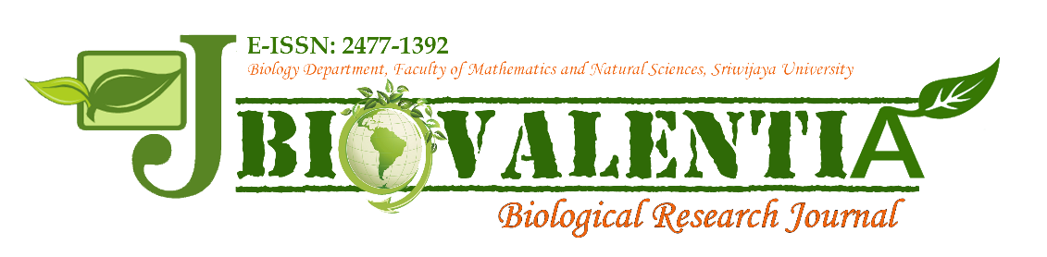
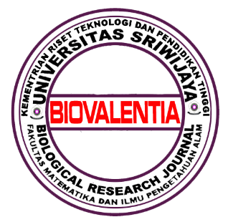

Editorial Office: Biology Department, Faculty of Mathematics and Natural Sciences, Sriwijaya University Palembang-Prabumulih Road KM 32 Indralaya, Ogan Ilir, Sumatera Selatan 30662 Indonesia, Telephone: +62711 580306, Fax: +62711 580056
ISSN Online: 2477-1392
Email: biovalentia@unsri.ac.id l biovalentia@gmail.com
Website: http://biovalentia.mipa.unsri.ac.id

Modification of Atherogenic Diet Cause Atherosclerosis, Increase Total Cholesterol and Showing Hepar Damage in Mice as Alternative Animal Model in Atherosclerosis Research

Dzul Fithria Mumtazah*, Hendri Busman, Gina Dania Pratami, Ahad Putra Dewantara, and Faradhila Amanda

Department of Biology, Faculty of Mathematics & Natural Sciences, Universitas Lampung, Jalan Prof. Soemantri Brodjonegoro No. 1 Gedong Meneng, Lampung, Indonesia.

*Corresponding author
E-mail address: dzul.mumtazah@fmipa.unila.ac.id
Peer review under responsibility of Biology Department Sriwijaya University

Abstract: This study aims to determine the composition of the ideal atherogenic diet to increase the risk of atherosclerosis in the animal model. The research was used 15 male mice, acclimatized for 1-2 weeks to get the susceptible amount of diet to be given. The animal objects are divided into 3 groups; normal diet group (control), 4 weeks atherogenic diet groups, and 8 weeks atherogenic diet groups. The modified atherogenic diet consists of common broiler food, wheat flour, pork oil, quail egg yolks, and water, given 2 times a day of 30 g of food. Water for animal objects is given ad libitum. After 4 weeks and 8 weeks total cholesterol, the formation of foam cells, and hepatocyte degeneration. The results show that the total blood cholesterol of animal models in the group of 8 weeks has the highest level (153,66 ± 6,51), compared to other groups (normal diet and 4 weeks). Animal models show that aortic cross-section formed foam cells in tunica intima and tunica media of endotel, also show the indication of hepar damage by hepatocyte degeneration.
Keywords: modified atherogenic diet, atherosclerosis, foam cell, total cholesterol, mice, hepar damage

Received: …………………….., Accepted: ……………………

INTRODUCTION
Atherosclerosis as a chronic inflammatory disease is a disease caused by abnormalities of lipid metabolism in the body[1]. Atherosclerosis is characterized by the accumulation of lipids and formation of foam cells caused by modified low-density lipoprotein (LDL) uptake. LDL modification takes place as a consequence of lipid oxidation and the catalytic action of a series of enzymes, one of which is secreted phospholipase A2 (sPLA2) [3]. sPLA2 is also a biomarker of the inflammatory process and plays an important role in atherosclerosis [4]. The use of animal models in atherosclerosis research is important as an object to determine the pathogenesis, causes and pathways of the disease. In this case the animals are often used are rodents [5], non-human primates, rabbits, dogs, pigs and other animals [6][7]. Although there are mice as animal models of atherosclerosis, they are not commonly used. Research on atherosclerosis in Indonesia uses a lot of rats that are easier to handle and have a larger heart and aorta size. However, rats (both the Wistar and Sprague-Dawley strains) were more difficult to obtain from mice, the availability is limited and harder to find for many researcher and students. Besides that, the price is more expensive. We strive to formulate an atherogenic diet modification suitable for use in atherosclerosis research using mice as a more affordable, inexpensive, and susceptible animal.

- Materials and Methods
A total of 15 male mice weighing 20-30 grams were acclimatized for one week from the experimental animal farms of the Lampung Veterinary Centre in the laboratory with standard feed and ad libitum water. Mice were divided into three (3) treatment groups, namely the control group, the modified atherogenic diet group for four (4) weeks and the modified atherogenic diet group for eight (8) weeks. The composition of the feed based on an atherogenic diet for each group is described in Table 1.

Table 1. Feed composition of atherogenic base diet in three groups
Composition | Group
 | Control | 4 Weeks | 8 Weeks
Japfa Comfeed Broiler I | 53% | 50% | 50%
Wheat Flour | 24% | 25% | 25%
Pork Oil | 0% | 10% | 10%
Quail Egg Yolks | 0% | 5% | 5%
Water | 24% | 10% | 10%

The control group, 4 weeks group, and 8 weeks group were fed with the composition as listed in Table 1 on an ad libitum basis with a dose of 30 grams per day. The dose of 30 grams per day is determined from the average amount of feed consumed by mice during the acclimatization period. After administration of atherogenic diet modification based feed during the specified time, the animals were sacrificed. The control group was sacrificed After 8 weeks, the 4 weeks group was sacrificed after 4 weeks and the 8 weeks group was sacrificed after 8 weeks. A total of 1 ml of whole blood was taken from the cardiac sinus after terminal sacrifice, besides the aortic arch was also collected from animal models to look for histopathological features of the aorta after several weeks of treatment.
1 ml of blood was used to calculate the total cholesterol, HDL, LDL and triglyceride levels of each experimental animal. These parameters are calculated to determine the atherogenic index. Counting of blood chemistry done at the Regional Health Laboratory Bandar Lampung. Total cholesterol was measured by the CHOD-PAP method, HDL and LDL by the after precipitaiton method, and triglycerides by the GPO-PAP method. The aortic arcus were collected, directly preserved using paraffin and tested histopathologically in the pathology laboratory of the Lampung Veterinary Center.

- Results and Discussion
TOTAL CHOLESTEROL
Cholesterol as part of the composition of the diet of most of our daily generations cannot be denied that it has an important role in the body's metabolism. Not completely bad, cholesterol provides the insulation that supports the work of nerve cells and many other good functions. It is the types of dangerous cholesterol (LDL and triglycerides) whose concentration is higher than good cholesterol (HDL) in the body which is the problem of high metabolic syndrome and its inherited diseases, one of which is atherosclerosis.. The following is an overview of the cholesterol profile of the tested animals after 4 weeks and 8 weeks of treatment. The data below are data on total cholesterol levels in the blood plasma of tested animals. In this data, total cholesterol levels in the 8 week group of treated animals had the highest levels. This could be due to long exposure to a high-fat and highly atherogenic diet in feed.
Table 2. Total cholesterol of animal model collected from blood (mg/dL)
No | Normal Diet | Modification Atherogenic Diet
 |  | 4 Weeks | 8 Weeks
1 | 77 | 182 | 147
2 | 139 | 104 | 154
3 | 101 | 120 | 160
Mean±SD | 105,67  ±31,26 | 135,33  ± 41,20 | 153,66  ±6,51

Mice commonly highly resistant to diet-induced atherogenesis because of HDL level of total plasma cholesterol is almost 70% [8], it causes the differences of total cholesterol of the three groups is not significant. Various studies on how to reduce the concentration of LDL and triglycerides in the blood have been carried out to date, one of which is by using the help of modified animal models to produce model animals that represent diseased organisms that have excess levels of LDL cholesterol and triglycerides and thus develop atherosclerosis on the walls of blood vessels.
ANIMAL WEIGHT
The weight of the animal is considered as an additional contributing factor in the increase in cholesterol levels and its components in the blood. The treatment given is in the form of feeding with different compositions so that it is expected to produce animals with different atherogenic indexes. Overview increase in weight of the test animals can be seen in the following table.
Table 1. Overview increase in animal weight (g) from week to week, the weight of the animals in the control group decreased at the end of treatment
Time | Control | 4 Weeks | 8 Weeks
Week 1 | 33,6 | 33 | 37,6
Week 2 | 36,75 | 35,4 | 36
Week 3 | 39,25 | 35,6 | 39,4
Week 4 | 40 | 35,2 | 37,8
Week 5 | 39,75 |  | 38,2
Week 6 | 40,75 |  | 36,8
Week 7 | 39,25 |  | 38,2
Week 8 | 38,25 |  | 40,4
It shows that the experimental animals have no difficulty eating and have a good appetite related to the given diet.
AORTIC AND HEPAR HISTOPATHOLOGY
In the group of mice with modified diet for eight weeks, microscopic view of the aorta showed the presence of foam cells (arrows) visible on the tunica intima and tunica media (Fig.1).
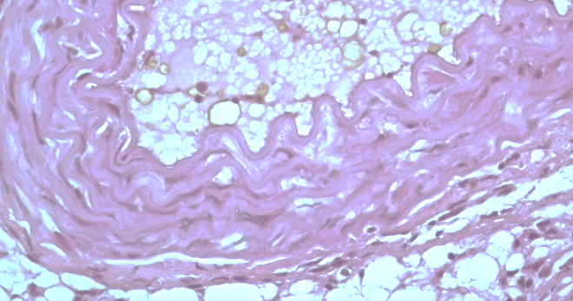
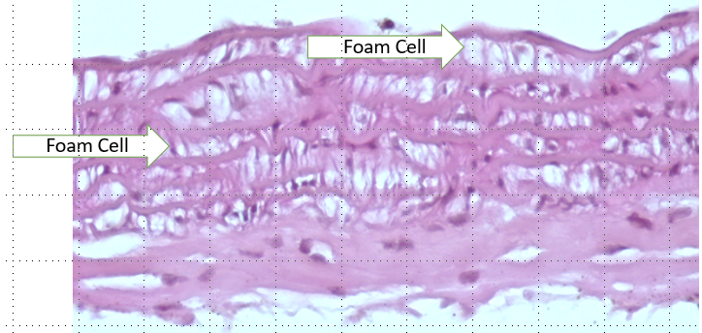
Fig 1. Aortic cross-section showing the formation of foam cells in the tunica intima and media
Apart from aortic histopathology, liver cross section of experimental animals were also observed under a microscope, shows the presence of damage to many hepatocyte cells, which may be due to the early stages of fatty liver cases due to modified diets consumed by mice (Fig.2).
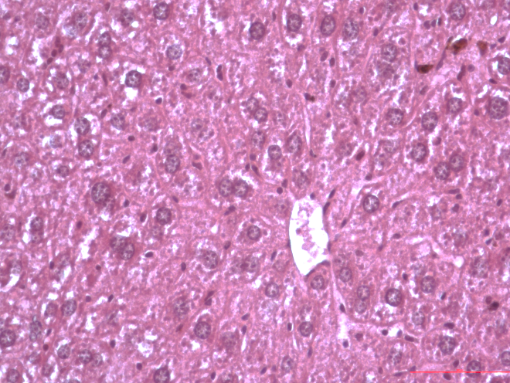
Fig 1. Hepar cross-section showing the tunica intima and media, showing hydropic degeneration and necrosis

CONCLUSION
The modified atherogenic diet consist of 50% common broiler feed , 25% wheat flour, 10% pork oil, 5% quails egg yolks and 10% water could be one of alternatives to induce atherosclerosis, increase total cholesterol and causing hepar damage in mice.

5. conflict of interest
There’s no conflict of interest in this research.

REFERENCES
[1] A. Eisen et al., “Angina and future cardiovascular events in stable patients with coronary artery disease: Insights from the Reduction of Atherothrombosis for Continued Health (REACH) registry,” J. Am. Heart Assoc., vol. 5, no. 10, 2016, doi: 10.1161/JAHA.116.004080.
[3] K. Riches and K. E. Porter, “Lipoprotein(a): Cellular effects and molecular mechanisms,” Cholesterol, vol. 2012. 2012, doi: 10.1155/2012/923289.
[4] A. Santoso, T. Heriansyah, and M. S. Rohman, “Phospholipase A2 is an Inflammatory Predictor in Cardiovascular Diseases: Is there any Spacious Room to Prove the Causation?,” Curr. Cardiol. Rev., vol. 16, no. 1, pp. 3–10, May 2019, doi: 10.2174/1573403x15666190531111932.
[5] S. Murwani, M. Ali, and K. Muliartha, “DIET ATEROGENIK PADA TIKUS PUTIH (Rattus novergicus strain Wistar) SEBAGAI MODEL HEWAN ATEROSKLEROSIS,” J. Kedokt. Brawijaya, vol. 22, no. 1, pp. 6–9, Apr. 2013, doi: 10.21776/ub.jkb.2006.022.01.2.
[6] Y. Lee et al., “Animal models of atherosclerosis (Review),” Biomedical Reports, vol. 6, no. 3. Spandidos Publications, pp. 259–266, Mar. 01, 2017, doi: 10.3892/br.2017.843.
[7] X. Li, Y. Liu, H. Zhang, L. Ren, Q. Li, and N. Li, “Animal models for the atherosclerosis research: A review,” Protein and Cell, vol. 2, no. 3. Higher Education Press, pp. 189–201, 2011, doi: 10.1007/s13238-011-1016-3.
[8] X. Li, Y. Liu, H. Zhang, L. Ren, Q. Li, and N. Li, “Animal models for the atherosclerosis research: a review,” doi: 10.1007/s13238-011-1016-3.

