**GENOTIPE SNP GEN *PLA2G10* T512C DAN T-123/IN1C PADA PENDERITA ANGINA PEKTORIS DI PUSAT JANTUNG NASIONAL HARAPAN KITA**

**JAKARTA, INDONESIA**

**T512C AND T-123/IN1C SNP *PLA2G10* GENOTYPE IN ANGINA PECTORIS PATIENTS AT NATIONAL CARDIOVASCULAR CENTER HARAPAN KITA JAKARTA, INDONESIA**

**Dzul Fithria Mumtazah*1, Erlin Listiyaningsih2, Nastiti Wijayanti3**

*1Jurusan Biologi, FMIPA, Universitas Lampung, Bandarlampung, Indonesia*

*2Stem Cell Facilities and Laboratory of Molecular Biology, Research and Development Division National Cardiovascular Center Harapan Kita, Jakarta, Indonesia*

*3 Laboratorium Fisiologi Hewan, Fakultas Biologi, Universitas Gadjah Mada, Yogyakarta, Indonesia*

*\*dzul.mumtazah@fmipa.unila.ac.id*

**ABSTRACT**

Angina Pectoris is one of the early symptoms which is a marker of severe cardiovascular problems such as coronary heart disease. The *PLA2G10* gene is believed to play a role whether in the atherosclerotic progression that causes plaque deposits which clog the coronary arteries of the heart or otherwise, antiatherogenic. *PLA2G10* polymorphism at SNP ID T512C (rs36072688) and T-123/in1C (rs4003232) play the role in altered the expression level of *PLA2G10* as sPLA2-GX coding gene which cause the rapid plaque progression in some groups of animal model and decrease it in some other.The objection of this research is to determine the genotype of *PLA2G10* gene in angina pectoris patients of National Cardiovascular Center Harapan Kita in order to define if the disease occurs because of the mutation. The research samples are 133 deposit biological materials (peripheral blood mononuclear cell) from National Cardiovascular Center Harapan Kita’s collection, from angina pectoris patients with plaque and non plaque in the coroner. The polymorphism was determined by TaqMan® SNP Genotyping Assay. The result shows that all the samples from angina pectoris patients in National Cardiovascular Harapan Kita have genotype homozigot wildtype (TT) at SNP ID T512C **(**rs36072688) and heterozygot (TC) at T-123/In1C (rs4003232) *PLA2G10* gene and there’s no polymorphism found in two groups of sample.

Key words: pla2g10, snp id, t512c, t-123/in1c, angina pectoris, polymorphism

**ABSTRAK**

Angina pektoris merupakan salah satu gejala awal yang menjadi penanda masalah kardiovaskuler berat seperti penyakit jantung koroner. Sementara gen *PLA2G10* dipercaya memiliki peran, baik dalam progresi aterosklerotik yang menyebabkan deposit plak dan penyumbatan pada arteri koroner, atau justru sebaliknya yaitu antiaterogenik. Polimorfisme *PLA2G10* pada titik SNP T512C (rs36072688) dan T-123/in1C (rs4003232) mampu mengubah level ekspresi gen *PLA2G10*  sebagai gen pengode enzim sPLA2-GX, yang memiliki peranan dalam meningkatkan progresi plak pada beberapa kelompok hewan model dan justru menurunkan proses pembentukan plak pada beberapa kelompok yang lain. Penelitian ini bertujuan untuk mengetahui genotip dari *PLA2G10* pada titik SNP T512C (rs36072688) and T-123/in1C (rs4003232) para penderita angina pektoris dengan plak dan tanpa plak koroner di Pusat Jantung Nasional Harapan Kita untuk kemudian menentukan apakah terjadinya penyakit dikarenakan adanya mutasi. Sampel penelitian adalah bahan biologik tersimpan berupa *peripheral blood mononuclear cell* koleksi Divisi Litbang Rumah Sakit Jantung dan Pembuluh Darah Harapan Kita. Sampel berjumlah 113 yang berasal dari penderita *angina pectoris* dengan dan tanpa plak pada arteri koroner. Penelitian ini menunjukkan bahwa gen *PLA2G10* pada titik SNP T512C **(**rs36072688) memiliki genotip homozigot *wildtype* (TT) dan T-123/In1C (rs4003232) memiliki genotip heterozigot (TC) melalui metode TaqMan® SNP *Genotyping Assay*. Tidak ada polimorfisme yang ditemukan pada kedua grup sampel tersebut.

Kata kunci: pla2g10, snp id, t512c, t-123/in1c, angina pektoris, polimorfiisme

**Pendahuluan**

Angina pectoris, which is characterized by pain in the chest, is a symptom that is mostly triggered by the presence of Coronary Heart Disease (CHD). Coronary heart disease is a disease caused by the buildup of plaque in the coronary arteries which is a product of coronary artery disease (CAD) or atherosclerosis that occurs in the coronary arteries ("Coronary Artery Disease - Coronary Heart Disease | American Heart Association," nd ). Atherosclerosis as a chronic inflammatory disease is a disease caused by abnormalities of lipid metabolism in the body (Poupardin, Srisukontarat, Yunta, & Ranson, 2014) (Li, Shridas, Forrest, Bailey, & Webb, 2010). Atherosclerosis is characterized by the accumulation of lipids and the formation of foam cells caused by modified low-density lipoprotein (LDL) uptake. LDL modification takes place as a consequence of lipid oxidation and the catalytic action of a series of enzymes, one of which is secreted phospholipase A2 (sPLA2) (Riches & Porter, 2012). sPLA2 is also a biomarker of the inflammatory process and plays an important role in atherosclerosis (Santoso, Heriansyah, & Rohman, 2019).

In the 10 types of sPLA2 enzymes present in mammals, sPLA2 Group X (sPLA2-GX) is a phospholipase enzyme that has the highest hydrolysis capacity against phosphatidylcholine (the main phospholipid in cell membranes and LDL) (Bezzine et al., 2000; Karabina et al., 2006), this enzyme has the greatest potential for hydrolysis of mammalian cell membranes in vitro (Bezzine et al., 2000), so its presence is very atherogenic.

In another study using transgenic mice that had been knocked down on the PLA2G10 gene so that this gene was not expressed, the accumulation of collagen that formed atherosclerotic plaques actually increased and the size of the necrotic core in atherosclerotic plaques increased four times compared to controls (PLA2G10 + / +). This shows that PLA2G10 also has potential as antiatherogenic which inhibits plaque formation by up to 50% (Ait-Oufella et al., 2013). Overexpression of sPLA2-GX also significantly reduces the accumulation of triglycerides in adipocytes by 50% (Li et al., 2010) which is an important trigger factor in obesity which also triggers the progression of atherosclerosis.

The discovery of eight-point mutations in the PLA2G10 gene encoding sPLA2-GX by Gora et al. (2009) showed that there was a change in the conformation of the enzyme, especially in vitro R38C polymorphism. Even so, the low number of minor alleles found in the population indicates that these polymorphisms do not have a significant effect in vivo (Guardiola et al., 2015) (Exeter, 2012)*.*

The mutation results in error protein folding of the enzyme which causes sPLA2-GX to be catalytically inactive and rapidly degraded in vitro testing. As stated by Gora et al. (Gora et al., 2009), genetic mutations that are functional can result in changes in protein expression and/or enzymatic activity which have a significant impact on the role of these enzymes in the pathophysiology and the final response of sPLA2-GX in progression. as well as atherosclerosis protection. The SNP point T512C (rs36072688) is located in the 5 'untranslated region of PLA2G10, is located in a region that is believed to be a promoter (putative) and is associated with reduced future cardiovascular risk. Meanwhile, SNP T-123 / in1C which is located at intron number 1 has the potential to interfere with alternative splicing of the RNA to be translated. This allows the mutation to have implications for the expression of the enzyme sPLA2-GX (Gora et al., 2009). This study aims to determine the polymorphisms of the PLA2G10 gene encoding sPLA2-GX at the T512C and T-123 / in1C points, especially in the incidence of angina pectoris.

**Methods**

A total of 133 samples of stored biological material (BBT) in the form of PBMC from patients with cardiovascular disease (CVD) undergoing treatment at the Harapan Kita Heart and Blood Vessel Hospital (RSJPDHK) were divided into two groups, namely the control group without plaque incidence (samples from coronary patients heart disease or CHD), and groups with coronary artery plaque incidence identified on coronary CT. All samples came from Malay race patients, 58 samples were female and 75 samples were male with an age range of 40-80 years. The RSJPDHK R&D collection sample in the form of PBMC comes from the patient's arterial blood sample isolated when each sample arrives. 2 ml of ficoll-hipaque (Sigma) was put into a 15 ml polypropylene tube. The blood sample stored in the EDTA vacutainer tube as much as 2 ml was homogenized by turning it slowly, then mixed with PBS solution in a 1: 1 ratio. The blood was then drawn using a micropipette and flowed slowly over the walls of the 15 ml polypropylene tube which had been filled with Ficoll-Hipaque until two layers were formed. The tube and its contents were then centrifuged at room temperature (25 ° C) at a speed of 1600 rpm for 30 minutes. The formed PBMC ring was slowly removed using a micropipette and placed in a new 15 ml polypropylene tube. PBMC was then washed with 10 ml PBS solution and centrifuged at 2500 rpm at 10 ° C for 5 minutes. After that, the supernatant was removed and the formed cell pellets were washed with 1 ml of PBS solution. 133 samples of stored biological material (BBT) in the form of PBMC from patients with cardiovascular disease (CVD) were undergoing treatment at the Harapan Kita Heart and Blood Vessel Hospital (RSJPDHK) ) were divided into two groups, namely the control group without the incidence of plaque (samples from patients with coronary heart disease or CHD), and the group with the incidence of plaque in the coronary arteries known by coronary CT. All samples came from Malay race patients, 58 samples were female and 75 samples were male with an age range of 40-80 years. The RSJPDHK R&D collection sample in the form of PBMC comes from the patient's arterial blood sample isolated when each sample arrives. 2 ml of ficoll-hipaque (Sigma) was put into a 15 ml polypropylene tube. The blood sample stored in the EDTA vacutainer tube as much as 2 ml was homogenized by turning it slowly, then mixed with PBS solution in a 1: 1 ratio. The blood was then drawn using a micropipette and flowed slowly over the walls of the 15 ml polypropylene tube which had been filled with Ficoll-Hipaque until two layers were formed. The tube and its contents were then centrifuged at room temperature (25 ° C) at a speed of 1600 rpm for 30 minutes. The formed PBMC ring was slowly removed using a micropipette and placed in a new 15 ml polypropylene tube. PBMC was then washed with 10 ml PBS solution and centrifuged at 2500 rpm at 10 ° C for 5 minutes. After that, the supernatant was removed and the formed cell pellets were washed with 1 ml PBS solution.

The DNA of each sample was then extracted from the PBMC using the High Pure PCR Template Preparation (Roche®) kit according to the default protocol. DNA collections were stored at -80 ° Celsius and then tested for polymorphism using the SNP Genotyping Assay method with TaqMan® (Applied Biosystems®) reagent. The two SNP points tested were rs36072688 (T512C) with forward primary 5'_AGCCTGGCCAACATGGT_3 ', and reverse primary 5'_ACCACGCCCGGCTAATTTT_3', while rs4003232 (T123 / in1C) with forward primary 5'GGCTGTAGGGGTAG3 'GGCTGTAG3 SNP testing using the collected DNA samples was carried out according to the built-in protocol of the kit. SNP testing is carried out using the real-time qPCR (Applied Biosystems®) assistance. The results of reading samples with real-time qPCR show the genotype of each sample at the two SNP points tested, directly as shown in Figure 1.

**Result and Discussion**

At the two SNP points studied, there were no polymorphisms in this population. Complete data can be seen in Table 1 below, which shows that all samples with and without plaque at the SNP T512C point have a homozygous wildtype (TT) genotype, and all samples at T123 / in1C have a heterozygous genotype (TC).

In this study, one SNP point was added, namely rs76137801 (C / G) identified by Ensmbl Genome Browser. The mutation at this point is a non-sensory mutation indicating that the PLA2G10 gene sequence is inhibited from full translation, or causes a premature stop codon to appear. The change in nucleotides C to G as predicted by functional mutation identification software (SIFT and PolyPhen) causes changes in the amino acid Arginine to Glycine (R> G) and damages and damages the enzyme protein that should be formed. However, no polymorphisms were found at this SNP point in the sample group.

Table 1. The genotype frequency of the PLA2G10 gene in patients with angina pectoris

|  |  |  |
| --- | --- | --- |
| **Genotip** | **Jumlah Alel Terdeteksi (n=133)** | |
| **T512C**  **rs36072688 (T/C)** | **T123/in1C**  **rs4003232 (T/C)** | |
| **Wildtype** | TT  133 (100%) | TT  0  (0%) | |
| **Heterozigot** | TC  0 (0%) | TC  133 (0%) | |
| **Homozigot Mutan** | CC  0 (0%) | CC  0 (0%) | |

Table 2.The genotype frequency of the PLA2G10 SNP ID gene rs76137801 (C / G) in patients with angina pectoris

|  |  |
| --- | --- |
| **Genotip** | **Jumlah Alel Terdeteksi (n=133)** |
| **Wildtype** | CC  133(100%) |
| **Heterozigot** | CG  0 (0%) |
| **Homozigot** | GG  0 (0%) |

In this population, all genotypes found at rs76137801 were wildtype homozygotes (Table 2), no polymorphisms were found at this point as was the case with the other two SNP points. Gora et al. (2009) found a minor allele frequency (MAF) of 0.32 (9.8% of the mutant population) for T512C and 0.23 (5.7% of the mutant population) for T123 / in1C in a caucasian population in Europe in previous studies. The difference in the race can make the difference in the results of the two studies, SNP T512C and T123 / in1C in the Malay race in this population did not show any polymorphism.

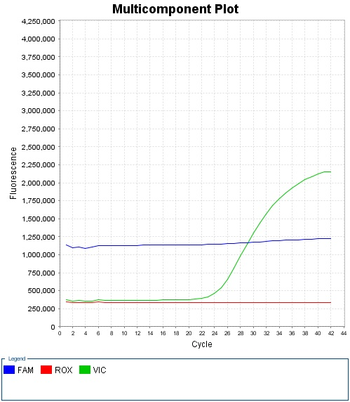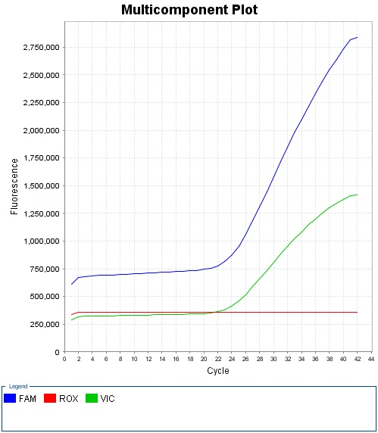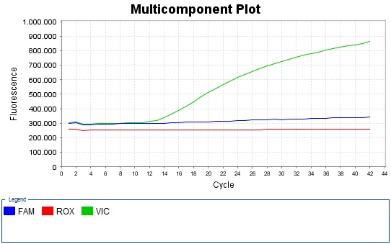

(c)

(b)

(a)

Figure 1.SNP Genotyping Assay curve PLA2G10, (a) rs4003232 sample number one (1) showing heterozygous allele (TC), (b) rs76137801 sample number four (4) showing homozygous wildtype allele (CC), and (c) rs36072688 sample number four (4) showing the wildtype homozygous allele (TT)

In testing polymorphisms, single-nucleotide polymorphism (SNP) is widely used in determining mutation points in certain genes, including PLA2G10. SNPs are variations in DNA sequences that occur in one nucleotide (A, T, C or G) in different genomes among members of a biological species or chromosome pair in humans. This genetic variation underlies differences in a person's susceptibility to disease (Murakami, Irie, & Shimizu, 2015). SNP is the most common genetic variation in humans and occurs once in 100 to 300 base pairs (Musumeci et al., 2010). SNP is also a genetic marker that determines phenotypic changes among individuals (Suh & Vijg, 2005).

The absence of PLA2G10 polymorphisms at the three points studied indicated that angina pectoris patients in both sample groups had normal PLA2G10 gene, without the mutation. This did not prevent this group of patients from developing angina pectoris, although there are limitations to claim that this gene is more atherogenic, this study demonstrates its potential for atherogenic progression. This is because mutations at all three SNP points in the PLA2G10 gene reduce the risk of coronary heart disease in the future. However, in the sample group, this incidence was nil. Polymorphisms at T-512C located at the 5 'end of the PLA2G10 UTR were found to be associated with a reduced future cardiovascular risk during the cohort study conducted by Gora et al. (2009). The SNP that occurs in the putative promoter of PLA2G10 is believed to have implications for the level of protein expression it produces. Meanwhile, SNP T-123 / in1C which is located in intron number 1 (Gora et al., 2009) has the potential to interfere with alternative splicing of the RNA to be translated.

The study conducted by Gora et al. in 2009, showed the presence of eight polymorphism PLA2G10 points (chromosome 16) in a caucasian population in Europe which was then subjected to further genotyping in special cases such as coronary artery disease (CAD) and myocardial infarction (MI). Analysis of protein expression and enzymatic activity with enzyme-linked immunosorbent assay (ELISA) to determine the active secretion produced by PLA2G10 showed that the mutation markedly decreased the total amount of protein produced by cultured COS-7 cells, prevented its efficient secretion, and resulted in no. detected and/or low enzymatic activity of sPLA2-GX.

**Conclusions and Suggestions**

All samples at SNP T512C point are homozygous wildtype (TT) and at SNP point T123 / in1C are heterozygous (TC). No polymorphisms were found at these two points, all samples in the two groups namely plaque and non-plaque had normal genotypes. Future studies can study the location of different SNPs in the PLA2G10 gene and also increase the number of samples.

**Acknowledgement**

We are grateful for the permission from dr. Renan Sukmawan, S.T., Sp.JP (K), Ph.D., MARS., And Dr. dr. Anwar Santoso, SpJP (K), FIHA who has facilitated this thesis research; also to the staff of the Research and Development Division of Harapan Kita Heart and Blood Vessel Hospital Jakarta who have given author permission to be part of the research and facilitate this research at the Molecular Biology Laboratory of the Harapan Kita Research and Development Division.

**References**

Ait-Oufella, H., Herbin, O., Lahoute, C., Coatrieux, C., Loyer, X., Joffre, J., … Mallat, Z. (2013). Group X secreted phospholipase A2 limits the development of atherosclerosis in LDL receptor-null mice. *Arteriosclerosis, Thrombosis, and Vascular Biology*, *33*(3), 466–473. https://doi.org/10.1161/ATVBAHA.112.300309

Bezzine, S., Koduri, R. S., Valentin, E., Murakami, M., Kudo, I., Ghomashchi, F., … Gelb, M. H. (2000). Exogenously added human group X secreted phospholipase A2 but not the group UB, IIA, and V enzymes efficiently release arachidonic acid from adherent mammalian cells. *Journal of Biological Chemistry*, *275*(5), 3179–3191. https://doi.org/10.1074/jbc.275.5.3179

Coronary Artery Disease - Coronary Heart Disease | American Heart Association. (n.d.). Retrieved April 20, 2020, from https://www.heart.org/en/health-topics/consumer-healthcare/what-is-cardiovascular-disease/coronary-artery-disease

Exeter, H. J. (2012). *The genetic architecture of secretory PLA2 (sPLA2) genes and their impact on sPLA2 activity/mass and association with CHD risk.* University College London.

Gora, S., Perret, C., Jemel, I., Nicaud, V., Lambeau, G., Cambien, F., … Karabina, S. A. (2009). Molecular and functional characterization of polymorphisms in the secreted phospholipase A2 group X gene: Relevance to coronary artery disease. *Journal of Molecular Medicine*, *87*(7), 723–733. https://doi.org/10.1007/s00109-009-0483-y

Guardiola, M., Exeter, H. J., Perret, C., Folkersen, L., Van’T Hooft, F., Eriksson, P., … Talmud, P. J. (2015). PLA2G10 Gene Variants, sPLA2 Activity, and Coronary Heart Disease Risk. *Circulation: Cardiovascular Genetics*, *8*(2), 356–362. https://doi.org/10.1161/CIRCGENETICS.114.000633

Karabina, S. A., Brochériou, I., Le Naour, G., Agrapart, M., Durand, H., Gelb, M., … Ninio, E. (2006). Atherogenic properties of LDL particles modified by human group X secreted phospholipase A2 on human endothelial cell function. *FASEB Journal*, *20*(14). https://doi.org/10.1096/fj.06-6018fje

Li, X., Shridas, P., Forrest, K., Bailey, W., & Webb, N. R. (2010). Group X secretory phospholipase a2 negatively regulates adipogenesis in murine models. *FASEB Journal*, *24*(11), 4313–4324. https://doi.org/10.1096/fj.10-154716

Murakami, K., Irie, K., & Shimizu, T. (2015). Diet and Nutrition in Dementia and Cognitive Decline: Potential Role of Vitamin C in the Prevention of Alzheimer’s Disease. In *Diet and Nutrition in Dementia and Cognitive Decline*. https://doi.org/10.1016/B978-0-12-407824-6.00061-6

Musumeci, L., Arthur, J. W., Cheung, F. S. G., Hoque, A., Lippman, S., & Reichardt, J. K. V. (2010). Single Nucleotide Differences (SNDs) in the dbSNP database may lead to errors in genotyping and haplotyping studies. *Human Mutation*, *31*(1), 67–73. https://doi.org/10.1002/humu.21137

Poupardin, R., Srisukontarat, W., Yunta, C., & Ranson, H. (2014). Identification of Carboxylesterase Genes Implicated in Temephos Resistance in the Dengue Vector Aedes aegypti. *PLoS Neglected Tropical Diseases*, *8*(3), e2743. https://doi.org/10.1371/journal.pntd.0002743

Riches, K., & Porter, K. E. (2012). Lipoprotein(a): Cellular effects and molecular mechanisms. *Cholesterol*, Vol. 2012. https://doi.org/10.1155/2012/923289

Santoso, A., Heriansyah, T., & Rohman, M. S. (2019). Phospholipase A2 is an Inflammatory Predictor in Cardiovascular Diseases: Is there any Spacious Room to Prove the Causation? *Current Cardiology Reviews*, *16*(1), 3–10. https://doi.org/10.2174/1573403x15666190531111932

Suh, Y., & Vijg, J. (2005, June 3). SNP discovery in associating genetic variation with human disease phenotypes. *Mutation Research - Fundamental and Molecular Mechanisms of Mutagenesis*, Vol. 573, pp. 41–53. https://doi.org/10.1016/j.mrfmmm.2005.01.005