ANALYSIS OF BUSINESS STRATEGY
WITH CANVAS MODEL BUSINESS (BMC) APPROACH

By:

DR. RR. ERLINA, SE, M.SI.
FACULTY OF ECONOMICS AND BUSINESS, LAMPUNG UNIVERSITY, INDONESIA
erlina.feb62@gmail.com

DR. TOTO GUNARTO, SE, M.SI
FACULTY OF ECONOMICS AND BUSINESS, LAMPUNG UNIVERSITY, INDONESIA
toto.gunarto@yahoo.co.id

FAILA SOFA, SE, M.SM
FACULTY OF ECONOMICS AND BUSINESS, LAMPUNG UNIVERSITY, INDONESIA
faila.shofa@feb. unila.ac.id

ABSTRACT

The increasing competition in the bakery business has made Holland Bakery to be able to maintain its achievements with a business strategy. So a business model is needed as a form of strategy that can be carried out by analysts using the Business Model Canvas, where each building block is also analyzed by the IFE & EFE Matrix, IE Matrix, SWOT Matrix and Blue Ocean Strategy combined with the Business Model Canvas. The results of the IFE matrix analysis resulted in a total score of 2.76, and EFE produced a score of 2.59. The results of the IE Holland Bakery Lampung matrix analysis are in quadrant V, indicating that Holland Bakery Company is currently in a strategic position to maintain and maintain (Hold and Maintain). The appropriate alternative strategy used in this quadrant is the market penetration strategy that Holland Bakery can do by increasing marketing through media strategies in the online or paper and product development form of adding market segments and increasing the variety of Holland Bakery products. Holland Bakery's alternative strategy is to maintain customer loyalty and improve product quality, attract new consumers and retain old consumers, open cooperation with business partners (banks, suppliers, government and store partners) to increase and develop branches in Bandar Lampung, Maximize the use of information media, Internet and social media in creating good relationships with customers, Creating member cards, Providing rewards to the best employees, to maintain employee loyalty in order to create improved service quality and the threat of consumers moving to another bakery, Improve supporting facilities (waiting room, air conditioning, computerized payments and others) and tbsp to attract many new customers.
Keywords: Business Strategy, Business Model Canvas, IFE Matrix, EFE Matrix, IE Matrix, SWOT Matrix, Blue Ocean Strategy, Holland Bakery Lampung

INTRODUCTION
1.1 Research Background
The bakery business in the city of Bandar Lampung is growing due to the increasing consumption of bread in the community. Bread is not only a staple food substitute for rice but also practical to serve and contains nutrients and protein. New companies with modern services are taking advantage of this business opportunity so that they can compete with previous bakeries. Holland Bakery is a fairly senior bakery in Bandar Lampung that strives to continue to develop its products and create the latest innovations while maintaining its own characteristics. Bread products from other companies have a wide variety of products, the same quality, services that are not much different and provide attractive promotions, are one of the things that make consumers switch to these bakery products. Holland Bakery has produced various high-flavored breads with various content variants, cleanliness and quality of taste have always been a priority in production, Holland Bakery's Halal certificate is also an advantage in competing with other bakery products, but in terms of prices offered by products Holland Bakery including companies that provide quite expensive prices. The price offered by Holland Bakery is more expensive than its competitors. Holland Bakery tries to continue to dominate the brand which shows the strong influence of the brand Holland Bakery on consumer satisfaction and loyalty in Bandar Lampung. The following is a picture of competitive market share Holland Bakery's in Bandar Lampung.
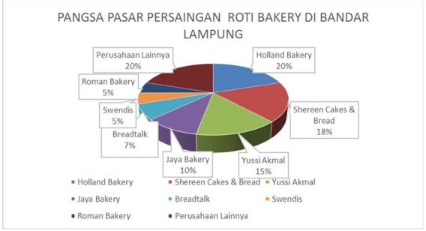

The picture above shows that the bread business in Bandar Lampung has a fairly tight level of competition. Holland Bakery in the market position in Bandar Lampung is at the top of the market followed by Shereen Cake & Bread, and Yussi Akmal. In addition to bakery types, Holland Bakery also has substitute competitors such as J.CO, Dunkin Donut and others.

1.2 The formulation of the problem
Holland Bakery Requires a strategy in facing competition in the bread business in Bandar Lampung. The business model canvas (BMC) is used as a tool to help Holland Bakery see how the business model will be. According to Osterwalder the business model canvas is a business model that is able to simply describe how an organization provides and captures the value of business activities carried out to make money (Osterwalder and Pigneur 2010). Through BMC Holland Bakery, you will see an outline of the business, but every element related to the business will appear complete and detailed. Evaluation of each element will facilitate analysis of what is not right, and in the end the company can take steps to be able to maintain business performance. Based on this, the problem formulations in this study are:
1.2.1 How is the strategy to maintain a suitable business at Holland Bakery in Bandar Lampung with approach business model canvas?

1.3 Research Objectives
The purpose of this study is to determine the design of a new business model as a form of business defense strategy for Holland Bakery Bandar Lampung with approach business model canvas.

LITERATURE REVIEW

2.1 Business Model Canvas
According to Osterwalder and Pigneur (2015) Business Model Canvas (BMC) is one of the strategic tools used to describe a business model and describe the rationale for how organizations create, deliver, and capture value. The canvas business model is depicted through nine basic building blocks that show the logic of how the company intends to make money. These nine blocks cover the four main business areas namely customer, offering, infrastructure and financial feasibility.
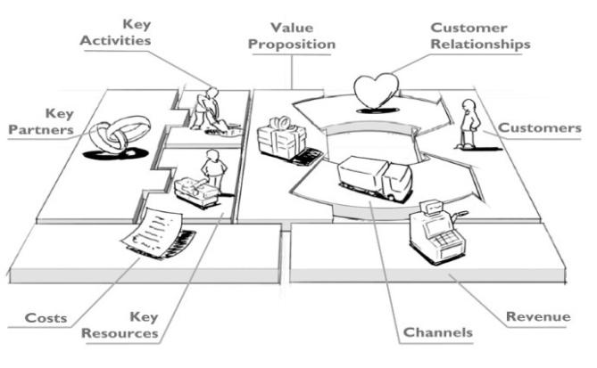
Source: (Osterwalder and Pigneur 2010)
Business Model Canvas
2.2. SWOT Analysis
According to Rangkuti the tool used to compile the company's strategic factors is the SWOT matrix (Rangkuti 2011). This matrix can clearly describe how the external opportunities and threats faced by a company can be adjusted according to its strengths and weaknesses. This matrix can produce four sets of possible strategic alternatives (Rangkuti 2011). The four possible alternative strategies that can be formulated are as follows:
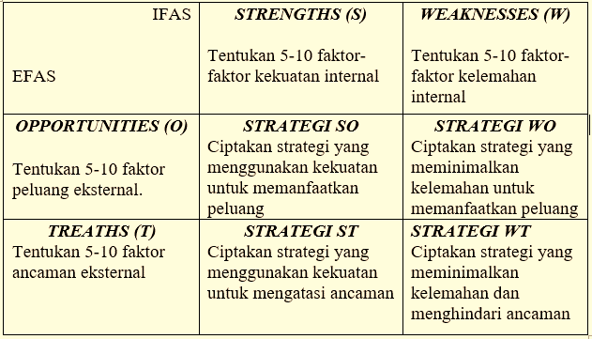
Source: (Rangkuti 2011)
SWOT Matrix Diagram

According to (David 2011), a strength, weakness, opportunity and threat matrix is ​​an important matching tool that helps managers develop four types of strategies: SO Strategy (strength-opportunity), WO Strategy (weakness-opportunity), ST Strategy (strength-threat), and WT Strategy (weakness-threat).

2.3 Blue Ocean Strategy
Blue Ocean Strategy (BOS) is a business strategy that creates new market spaces and does not have competitors (Kim and Mauborgne 2015). In starting the blue ocean strategy, there are several steps that must be taken. Kim and Mouborgne (2015) say the value innovation process is the key to the successful implementation of BOS. This value innovation can be achieved by building a framework for four strategic steps that must be implemented (the four action framework) which deals with four questions, namely:
Eliminate Key: What factors should be eliminated from factors that have been taken for granted by the industry?
Reduce : What factors can be reduced to below industry standards?
Raise : What factors can be raised above the industry standard?
Create : What factors have not been the focus of the industry's offering until it needs to be created?

RESEARCH METHOD

The type of research used is descriptive research, data collection is done by collection techniques with triangulation (combination) of sources, data analysis is inductive / qualitative, and the results of qualitative research emphasize meaning rather than generalization. Analytical tools used in formulating internal factors, strengths and weaknesses, and external opportunities and threats. The next step is to determine the IFE matrix, EFE matrix, IE matrix, SWOT matrix, and Blue Ocean Strategy to determine the Business Model Canvas in the company.

RESULTS AND DISCUSSION

Matrix Analysis of IFE (Internal Factor Evaluation)
Internal Strategy Factor | Weight | Rating | Value Score
Strength (strength)
Holland Bakery brand that is well known | 0.0355 | 4 | 0.1422
High customer loyalty | 0.0355 | 4 | 0.1422
good quality products taste, texture and aroma | 0.0355 | 4 | 0.1422
has variations diverse products | 0.0355 | 4 | 0.1422
Able to sell through an online network system | 0.0355 | 4 | 0.1422
Have professional employees | 0.0355 | 4 | 0.1422 The
logo reflects a modern bakery | 0.0355 | 4 | 0.1422
has a Halal certificate | 0.0355 | 4 | 0.1422
Has a clean and comfortable place | 0.0355 | 4 | 0.1422
has a website and all social media | 0.0355 | 4 | 0.1422
Clean and hygienic equipment and skilled chefs | 0.0355 | 4 | 0.1422
Many branches spread across Bandar Lampung | 0.0355 | 4 | 0.1422
Delivery services via online motorcycle taxis. | 0.0355 | 4 | 0.1422
strategic store location | 0.0355 | 4 | 0.1422
holds Disney character license | 0.0355 | 4 | 0.1422
Sub total | 1 |  | 2.1343
Weakness (Weakness)
average middle to upper class customers | 0.0594 | 1.2 | 0.0713
Bread does not last long | 0.0610 | 1 | 0.0610
There is no unity in the product packaging | 0.0594 | 1.2 | 0.0713
organizational structure is too broad | 0.0563 | 1.6 | 0.0901
the management is quite complicated | 0.0563 | 1.6 | 0.0901
majority of raw materials are not available in country | 0.0579 | 1.4 | 0.0810
Promotion and advertising is not yet complete to communities | 0.0579 | 1.4 | 0.0810
price of products tend to be expensive | 0.0579 | 1.4 | 0.0810
Sub total | 1 |  | 0.6272
Total |  |  | 2.7616

EFE Matrix Analysis (External Factor Evaluation)
External Strategy Factor | Weight | Rating | Value Score
Opportunities (opportunities)
Lampung as a tourism city | 0.0449 | 4 | 0.1797
Consumptive culture of the people of Bandar Lampung | 0.0449 | 4 | 0.1797
population growth in Bandar Lampung | 0.0449 | 4 | 0.1797
consumer knowledge of Holland Bakery products | 0.0486 | 3.8 | 0.1849
outlet increase annually | 0.0598 | 3.2 | 0.1916
changing consumption patterns Rice replaced the consumption of bread | 0.0453 | 4 | 0.1813
Business activities are expanding | 0.0490 | 3.8 | 0.1864
Bread started to become daily necessities | 0.0490 | 3.8 | 0.1864
social media is growing | 0.0453 | 4 | 0.1813
Sub-total |  |  | 1.6514
Threats (threats)
consumer move to another bakery | 0.0815 | 1.6 | 0.1304
competitors start copying product innovations | 0.0815 | 1.6 | 0.1304
Fluctuating consumer tastes | 0.0790 | 1.8 | 0.1422
competitors have lower prices | 0.0790 | 1.8 | 0.1422
supplier or raw material constraints | 0.0848 | 1.4 | 0.1187
Market prices that often fluctuate | 0.0823 | 1.6 | 0.1318
tastes and flavors diverse society | 0.0794 | 1.8 | 0.1429
Sub total |  |  | 0.9390
Total | 1 |  | 2.5905

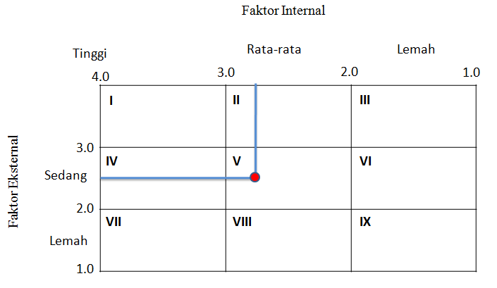

4.1IE matrix analysis Holland Bakery

IFE matrix analysis results yielded a total score of 2.76 for the total score shows that the company's ability to use force to overcome the weaknesses are in the medium level. The results of the EFE matrix analysis resulted in a score of 2.59. The total score indicates that the company can take advantage of opportunities and overcome threats at an average level. The results of the two total scores are then described in the IE (Internal-External) matrix to determine the company's current position.

The result of IE matrix analysis in the Figure above shows that Holland Bakery Lampung is in quadrant V. This shows that Holland Bakery Company is currently in a strategic position to maintain and maintain (Hold and Maintain). Based on the company's position, the appropriate alternative strategies used in this quadrant are market penetration and product development strategies which are the two most commonly used strategies for these types of divisions. The market penetration strategy that Holland Bakery can do is by increasing marketing through media online or paper. Product development strategy in the form of adding market segments and increasing the variety of Holland Bakery products.

4.2 SWOT Matrix Analysis
This matrix can produce four alternative strategies, namely the SO (Strengths-Opportunities) strategy, the ST (Strengths-Threats) strategy, the WO (Weakness-Opportunities) strategy, and the WT (strategy Weakness-Threats) which can be formulated through opportunities. key external, key external threats, key internal strengths, and key internal weaknesses as follows:
1. SO Strategy (Strengths-Opportunities)
SO strategy is a strategy that uses the company's internal strengths to take advantage of external opportunities. The following is the SO strategy that has been analyzed by researchers
a. Maintain customer loyalty and improve product quality, attract new customers and retain old customers.
b. Opening cooperation with business partners (banks, suppliers, government and shop partners) in order to increase and develop branches in Bandar Lampung.
2. WO Strategy (Weakness-Opportunities)
WO strategy aims to improve internal weaknesses by taking advantage of external opportunities.
a. Maximizing the use of information media, internet and social media in creating good relationships with customers.
b. Creating Member Cards
3. ST (Strengths-Threats)
Strategy ST strategy uses company strength to avoid or reduce the influence of external threats.
a. Providing rewards to the best employees, to maintain employee loyalty in order to create an increase in service quality and the threat of consumers moving to another bakery.
4. WT strategy (weakness-threats)
The WT strategy is a defensive tactic aimed at reducing internal weaknesses by avoiding external threats by increasing support facilities (waiting rooms, air conditioning, computerized payments, etc.) and human resources to attract new customers.
4.3 Implementation of Blue Ocean Strategy on the CanvasBusiness Model Holland Bakery
Based on the Blue Ocean Framework, it can be concluded that there are elements in 9 Building Blocks that are recommended to undergo changes.
1. Raise
The block with increased capabilities is the block Key Resource, which is a Vehicle element that is useful as an additional facility for the distribution process to stores to make it faster, factory and shop facilities need to be upgraded again such as shop facilities that use air conditioning in every store, equipped with seats to wait for services so that consumers feel comfortable in the store. Human resources also need to be improved again in order to create satisfying services for consumers.
2. Reduce
The blocks with reduced capability are block cost structures. The most difficult to control cost is the electricity cost. To minimize these costs, Holland bakery must save energy. One way to save energy by turning off unused electrical equipment. You can also replace the equipment with more cost-effective equipment, for example replacing ordinary air conditioners with energy-efficient ones (low watts). Companies can also look for cheaper raw materials, of course, with the many suppliers they have.
3. Create action
This is the most widely applied analysis Blue Ocean of BMC companies, namely the first is social media and the official website on the block channel, which is useful as a tool for promotion as well as direct contact with customers. The company element in a key partnership is a form of cooperation carried out by the company to increase the number of sales. Collaboration with banks can help consumers in the transaction process, collaboration with providers can help companies promote their products via SMS sent through providers that are invited to cooperate and the last is collaboration with mini markets or supermarkets to reach a wider range of consumers.
The customer relationship block in this block, the addition of a member card can help Holland Bakery maintain good relations with consumers and can serve as a promotional media besides that the company can increase other income through the creation of a member card. Adding elements to the block, value proportions namely elements or services delivery order can help and make it easier for consumers to buy products offered by Holland Bakery. The Block key resource also needs to experience additional elements in its human resources, namely the addition of employees in the IT department so that they can manage social media and official websites in order to increase promotion in cyberspace. The addition of IT employees will have an impact on promotional activities online on the block key activities.
4. Eliminate
The only element omitted is leasing the building on block cost structures. Building investment by owning the building itself will be a long-term investment for the company because the company does not need to rent rental fees again every month. In addition, the value of the building will always increase every year so that it can be a promising investment for the company.

Bibliography

David, Fred R. 2011. Prentice Hall Strategic Management: Concepts and Cases (Thirteenth Edition).
Kim, W. Chan, and Renée A. Mauborgne. 2015. Journal of Chemical Information and Modeling Blue Ocean Strategy, Expanded Edition: How to Create Uncontested Market Space and Make the Competition Irrelevant.
Osterwalder, Alexander, and Yves Pigneur. 2010. “Business Model Generation - Canvas.” Wiley.
Rangkuti, F. 2011. SWOT–Balanced Scorecard. PT. Gramedia Pustaka Utama. Jakarta. https://books.google.com/books?hl=id&lr=&id=MaxeDwAAQBAJ&oi=fnd&pg=PP1&dq=SWOT–Balanced+Scorecard+rangkuti&ots=UP_-jvxpxM&sig=_LakKSmbE-uhns7YXzXviwi2ygQ (August 8, 2020).

