Rietveld analysis of geopolymer prepared from amorphous rice husk silica with different thermal treatment
A Riyanto¹, S Sembiring¹, S Husain², R S Karimah¹, I Firdaus¹
¹ Department of Physics, Faculty of Mathematics and Natural Sciences, University of Lampung, Jl. Sumantri Brojonegoro No. 1, Bandar Lampung, Indonesia
² Department of Physics, Lambung Mangkurat University, Banjarmasin, Indonesia

email: agus.riyanto@fmipa.unila.ac.id¹, simon.sembiring@fmipa.unila.ac.id¹, sadanghusain@ulm.ac.id², sofikarimah23@gmail.com¹, iqbal.firdaus@fmipa.unila.ac.id¹

Abstract. The work aims to study the temperature effect on the geopolymer's crystal structure prepared from amorphous silica rice husk. The samples were prepared via the sol-gel method and then subjected to thermal at a temperature of 250-650 ºC. EDS identified the element and compound composition on the surface of the sample. The crystal structure of samples identified by Rietveld refinement of XRD. The sample was dominated by the gibbsite phase at relatively low temperatures (250 ºC). The boehmite phase dominates at a temperature of 350-450 ºC. The amorphous structure of the geopolymer was formed at a temperature of 550-650 ºC. The geopolymer mainly formed from the reaction of boehmite and silica. This study shows a significant effect of temperature on the formation of the geopolymer structure.
Keyword: geopolymer, rice husk, Rietveld analysis, structure
- Introduction
Geopolymer is an inorganic aluminosilicate polymer which formed mainly by polymerization reaction between alumina (Al₂O₃) and silica (SiO₂)[1]. The geopolymer structure consists of [AlO₄] and [SiO₄] tetrahedral linked by sharing all oxygen atoms in a three-dimensional network called polysialate chains[2]. The linkages of [AlO₄] and [SiO₄] tetrahedral require cations such as Na⁺, K⁺, or Li⁺ to balance the negative charge of aluminum elements located in tetrahedral coordination of the network[3]. Geopolymer has an amorphous or semicrystalline structure[4], high specific surface area, and porosity[5]-[7], but the material exhibits excellent mechanical properties[8]-[9]. Previous studies revealed that a geopolymer has an ionic electrical resistivity of about 0.67$×$10⁶ $Ω$.cm at room temperature and frequency of 200 kHz[10], low capacitance[11], low relative permitivity[12], excellent thermal resistance, and good chemical resistance[2]. These properties make it is very suitable for ionic conductor material, which can be applied as an element of a solid-state battery or electrochemical sensor, and so on[10].
Geopolymer is usually produced from the geopolimerization process[13]. Through this process, a geopolymer is prepared by activating raw materials using high concentrated alkaline solutions and followed by curing treatment[14]-[16]. The raw materials commonly used are generally waste materials or natural resources, which primarily containing aluminosilicate compounds such as fly ash[17]-[19], slag[20], clay[21]-[23], kaolin[5], and metakaolin[24]-[25]. This process's advantage is that a geopolymer structure can be obtained by curing treatment at low temperatures under atmospheric pressure. However, the process must be taken a long time[26]-[29]. Furthermore, high purity geopolymer is challenging to obtain because chemical compositions of raw materials are very complex; thus, geopolymer resulting from this process always accompanied by secondary phases such as quartz, albite, mullite, hematite, or maghemite[20]-[21], [30]-[33]. In addition to the geopolymerization process, the sol-gel method can be applied to synthesize a geopolymer. The technique offers homogeneity and prevention of phase segregation during the heating process to obtain high purity geopolymer [10],[12]. For example, Zheng et al. (2009)[34] obtained high purity geopolymer using sol-gel by reacting tetraethoxysilane (TEOS) and aluminum nitrate as starting materials. They reported that the geopolymer obtained from this process shows high purity, although at high-temperature calcination of about 300-800 ºC.
In the context of silicate materials development, including geopolymer, silica is an essential element, and it can be produced from rice husk. This agricultural waste is known to have high purity amorphous silica content of more than 98 %, extracted by a simple method and low-cost[35]-[36]. Several research types applied the acid leaching method to obtain amorphous silica[37]-[38]. This method is based on rice husk amorphous silica solubility, which is very low at pH<10 and increases significantly at pH >10. This characteristic makes the amorphous silica extracted from rice husk by solubilizing under alkaline solution followed by precipitating at a lower pH[39]. Amorphous silica from rice husk has been used to synthesize various materials. In our previous studies, it has been successfully utilized as raw material to produce high purity ceramic materials, such as cordierite[40]-[42], forsterite[43], and sodium ferrosilicate[44].
Previously, we produce geopolymer samples from amorphous rice husk silica and sodium aluminate solutions. We find qualitatively that the phases are dominated by gibbsite, boehmite, and amorphous geopolymer at low, middle, and high temperatures[45]. In this study, we continue the study with the Rietveld analysis to determine the phase qualitatively. This work aims to evaluate the thermal effect of the sample's crystal structure. The samples were subjected to thermal at 250-650 ºC and then characterized by using energy dispersive spectroscopy (EDS) and x-ray diffraction (XRD).

- Materials and methods
The chemicals used in this study consist of gibbsite (Al(OH)₃) and Na(OH) purchased from Merck, HNO₃ (68 %) obtained from Chemical Product, and silica sol extracted from rice husk. This study's types of equipment consist of EDS (JEOL JSM-6360LA) and XRD (Shimadzu XTD-7000 Maxima X).
2.1 Preparation of rice husk silica sol and sodium aluminate sol
Rice husk silica sol was obtained using a method reported in our previous studies[40]-[44]. In the first step, 50 g of rice husk and 500 ml of NaOH (5%) were mixed in a beaker glass followed by boiling for 30 minutes. In the second step, the extract solution was filtered to separate the silica sol from the remaining rice husk. In the last step, the silica sol was cooled at room temperature for 24 hours. Meanwhile, sodium aluminate sol was prepared by dissolving 5 g of gibbsite (Al(OH)₃) into 50 ml of NaOH under magnetic stirring with the rate of 500 rpm for 2 hours to obtain homogeneous sodium silicate sol.
2.2 Geopolymer preparation
Geopolymer preparation was conducted by mixing rice husk silica sol and sodium aluminate sol with a volume ratio of 5:1. The mixture was stirred under a magnetic stirring of 1000 rpm at room temperatures for 5 hours. The mixture's acidity was set by dropwise addition of 5 % HNO₃ solution under stirring until it has a pH of 7. The mixture obtained from this process was filtered until geopolymer gel was obtained. The pre-calcination treatment at 110 ºC was applied to the gel for 7 hours until the solid geopolymer precursor was obtained. The precursor was sieved to get a powder with a maximum particle size of 100 μm. The powder was subjected to a temperature at 250–650 ºC using temperature-programmed with constant heating rate 5 ºC/min and holding time of 3 hours at peak temperature.
2.3 Energy-dispersive spectroscopy (EDS) analysis
The sample was characterized by using EDS (JEOL JSM-6360LA) to evaluate the elementals or compounds on the sample's surface. We analyzed only sample calcined at 250 ºC to characterize because all samples were made in the same composition.
2.4 Rietveld analysis
The samples were characterized by an x-ray diffractometer (Shimadzu XTD-7000 Maxima X) with CuK$α$ radiations with wavelength $λ$ = 0.15418 $Å$. The diffractogram was recorded over the goniometry (2$θ$) ranging from 10º-80º with step size 0.02 and counting time 1 sec/step. The crystal structure analysis was conducted qualitatively using QualX2.0 software[46], and Rietveld refinement analysis by using Rietica software.
- Result and discussion
The EDS spectrum of the geopolymer sample is displayed in Figure 1. The spectrum exhibits the presence of some elements such as sodium (Na), aluminum (Al), silicon (Si), and oxygen (O) with mass percentages of 0.95 %, 18.59 %, 29.73 %, and 50.73 %, respectively. In the form of oxide compounds, the sample is composed of Na₂O, Al₂O₃, and SiO₂. Mass percentages of SiO₂, Al₂O₃, and Na₂O are 63.60 %, 35.13 %, and 1.27 %, respectively. This analysis indicates that several elements or compounds needed to form the geopolymer structure are available in the sample because they are constructed from combining the compounds. The compounds' presence allows the formation of high purity geopolymer because there are no impurity elements or compounds that appear in the sample.

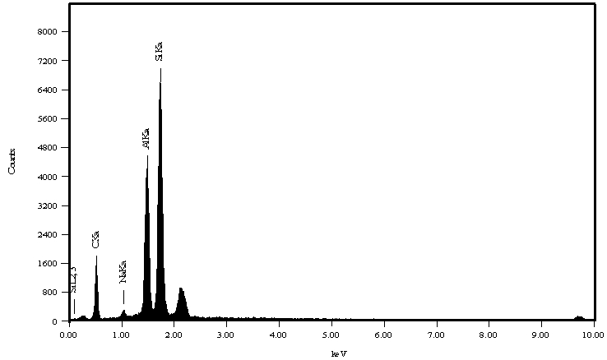
Figure 1. EDS spectrum of geopolymer

Table 1. Rietveld refinement parameters of geopolymer samples
Heating temperature (°C) | $$R_{exp}$$ | $$R_{wp}$$ | $$R_{p}$$ | $$GoF$$
250 | 7.54 | 14.01 | 10.53 | 3.453
350 | 7.75 | 15.00 | 12.23 | 3.746
450 | 7.82 | 12.04 | 9.67 | 2.369
550 | 7.67 | 11.83 | 9.55 | 2.377
650 | 7.79 | 12.83 | 10.35 | 2.710

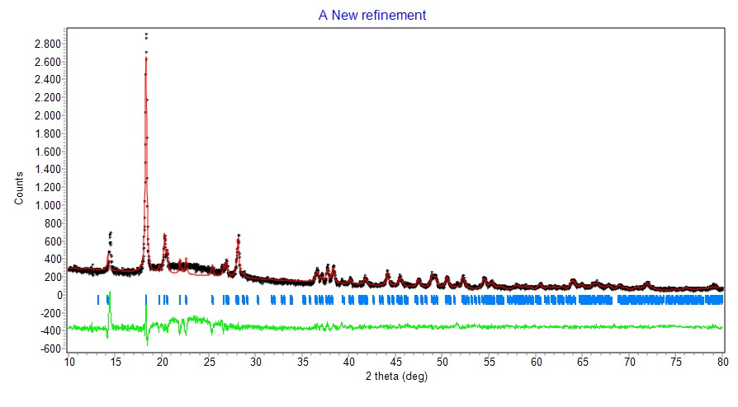
(a)
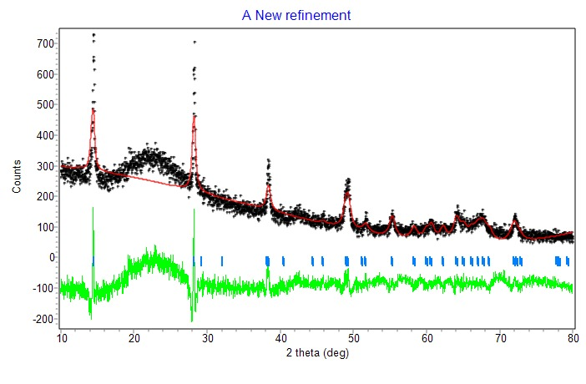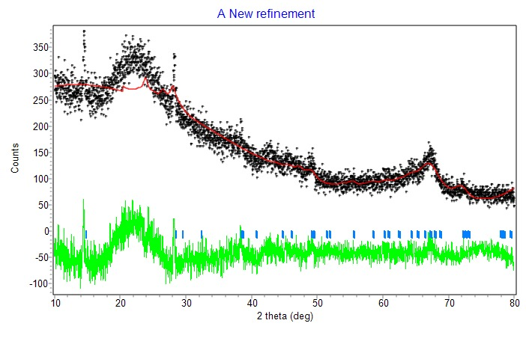
(b)
(c)
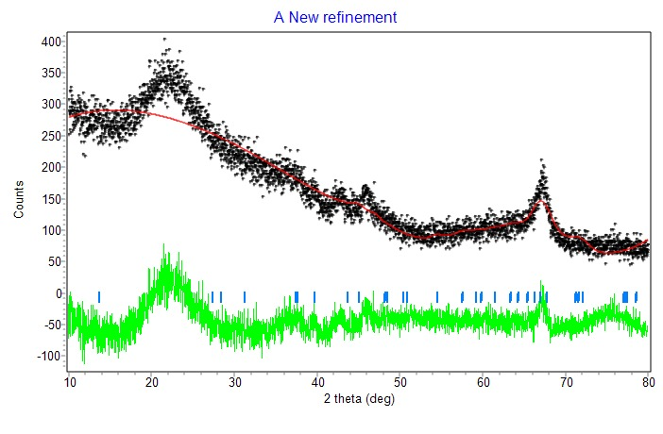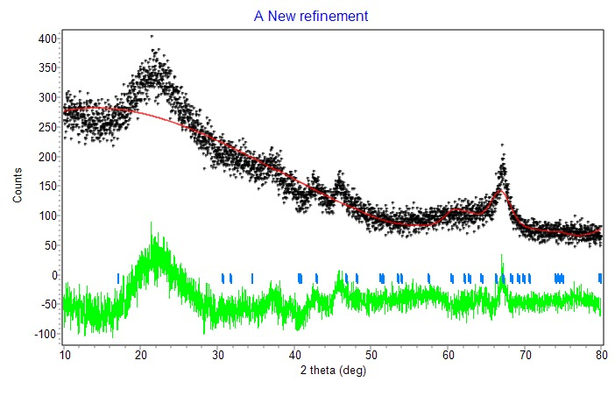
(d)
(e)
Figure 2. Rietveld refinement of XRD pattern of geopolymer which subjected to heat with different temperature, (a) 250 ºC, (b) 350 ºC, (c) 450 ºC, (d) 550 ºC, and (e) 650 ºC

Based on the results of the qualitative analysis using QualX software via search-match, the sample which subjected to thermal at the temperature of 250 ºC match with the database of the gibbsite phase (Al(OH)₃). Samples subjected to thermal at temperatures of 350-450 ºC good agreement with the boehmite (AlOOH) phase database. Meanwhile, the sample subjected to thermal at temperatures of 550-650 ºC was dominated by the amorphous phase, but several peaks match the boehmite phase. This qualitative analysis is used for a qualitative analysis (Rietveld refinement) using the Rietica software. The results of the Rietveld refinement XRD pattern of the samples are depicted in Figure 2. The refinement results include all samples show that the goodness of fit (GoF) value required by Rietveld's analysis, which is less than 4 and R_{wp} less than 20[47]-[48], as shown in Table 1.
The Rietveld refinement of the sample subjected to thermal at 250 ºC (Figure 2(a)) represents the high crystalline structure. Figure 2(a) clearly shows that the sample is the gibbsite based on the refinement results. The refinement confirmed that the sample has a monoclinic structure with space group P21/n. The phase of the sample treated thermally at 350 ºC also exhibits a high crystalline structure (Figure 2(b)), but the phase is different from the sample subjected to thermal at 250 ºC. The refinement results clearly show that it is a boehmite (AlOOH), an orthorhombic structure, and a space group of Amam. Cell parameters for both samples show in Table 2. The phase transformation from gibbsite to boehmite causes significant changes in cell parameters and volume. The gibbsite and boehmite domination in the samples subjected to thermal at 250-350 ºC indicates no polymerization reaction between the raw materials used to produce a geopolymer. The domination of gibbsite and boehmite phases in the temperature range is due to gibbsite, which initially from raw material requires the lower temperature to grow to be a crystal. Otherwise, silica needs a higher temperature to achieve a crystalline state.

Table 2. Cell parameters geopolymer samples
Heating temperature (°C) | Phase | Crystal structure | Space group | a (Å) | b (Å) | c (Å) | Cell volume (Å³)
250 | Gibbsite | Monoclinic | P21/n | 8.6590 | 5.0770 | 9.7030 | 425.42
350 | Boehmite | Orthorhombic | Amam | 3.7000 | 12.2270 | 2.8680 | 129.75
450 | Boehmite | Orthorhombic | Amam | 3.7000 | 12.2270 | 2.8680 | 129.75
550 | Boehmite | Orthorhombic | Amam | 3.7000 | 12.2270 | 2.8680 | 129.75
650 | Boehmite | Orthorhombic | Amam | 3.7000 | 12.2270 | 2.8680 | 129.75

Based on the refinement results, the sample thermally treated at 450 ºC still has the same phase as the sample thermally treated at 350 ºC, i.e., the boehmite phase with orthorhombic structure and Amam's space group with cell parameter as shown in Table 2. Nevertheless, the diffractogram changes, as depicted in Figure 2(c) characterized by a decrease in intensity of the peaks at an angle of 2θ = 14.49º and 28.18º, which are the primary and secondary peaks of the boehmite phase, respectively. Besides, at this angle range, a broad peak is created, which characterizes the amorphous silica phase in the sample. These changes indicate that the sample is beginning to undergo a polymerization process to form a geopolymer structure. Significant changes occurred in the thermally treated samples at 550-650 ºC, as shown in Figures 2(d)-(e). Even though, according to the refinement results, the sample still has a boehmite phase with an orthorhombic structure with a cell parameter as shown in Table 2, the primary and secondary diffraction peaks that characterize this phase have disappeared. Besides, the two samples' diffractograms tend to show that the phase contained therein is amorphous. Based on the previous report, the amorphous phase formation shows a strong indication of geopolymers' formation in both samples[4],[47]. These refinement results show a significant role of temperature in the formation of geopolymer structures. From this study, it is concluded that the geopolymer based on silica of rice husk is formed from the reaction of the boehmite and silica phases under high-temperature conditions.

- Conclussion
This study's results indicate that heat treatment strongly influences the phase and crystal structure of each sample. At a temperature of 250 °C, the sample is a gibbsite phase with a monoclinic structure. It grows to be a boehmite phase with an orthorhombic structure at a temperature of 350-450 °C. Meanwhile, the geopolymer structure is formed in the temperature 550-650 °C.

- References

[1] Davidovits J 1991 J. Thermal. Anal. 37 1633-56
[2] Azimi E A, Mustafa M, Bakri A, Ming L Y, Yong H C, Hussin K, and Aziz I H 2016 Rev. Adv. Mater. Sci 44 273–85
[3] Saravanan G, Jeyasehar C A, Kandasamy S 2013 J. Eng. Sci. Tech. Rev. 6(1) 25–32
[4] Srivastava S and Gadhave R 2015 Orient. J. Chem. 31(4) 2475–80
[5] Steinerova M 2011 Ceram. Silik. 55(4) 362–72
[6] Steins P, Poulesquen A, Frizon F, Diat O, Jestin J, Causse J, Lambertin D, and Rossignol S 2014 J. Appl.Cryst. 47(1) 316–24
[7] Sharma S, Medpelli D, Chen S, and Seo D K 2015 RSC Adv. 5(80) 65454–61
[8] Hamaideh A, Al-qarallah B, Hamdi M R, Ali S, and Mallouh A 2014 J. Water Resource Prot. 6 507–13
[9] Rovnaník P and Šafránková K 2016 Materials 9(7) 1–13
[10] Cui X M, Zheng G J, Han Y.C, Su, F, and Zhou J 2008 J. Power Sources 184 652–56
[11] Kusak I, Lunak M, and Rovnanik P 2016 Procedia Eng. 151 157–61
[12] Cui X M, Liu L P, He Y, Chen J Y, and Zhou J 2011 Mater. Chem. Phys. 130(1-2) 1–4.
[13] Duxson P, Fernández-Jiménez A, Provis J L, Lukey G C, Palomo A, and Van Deventer J S J 2007 J. Mater. Sci. 42(9) 2917–33
[14] Patankar S V, Ghugal Y M, and Jamkar S S 2014 Indian J. Mater. S. 2014 1–6
[15] Abdul Rahim R H, Azizli K A, Man Z, Rahmiati T, and Nuruddin M F 2014 J. Appl. Sci. 14(23) 3381–84
[16] Nath S K, Mukherjee S, Maitra S, and Kumar S 2017 J. Therm. Anal. Calorim 127(3) 1953–61
[17] Škavara F, Duong N A, and Cilova Z Z 2014 Ceram. Silik. 58(1) 12–20.
[18] Onutai S, Jiemsirilers S, Thavorniti P, and Kobayashi T 2015 Constr. Build. Mater. 101 298–308.
[19] Abdullah M M A B, Jamaludin L, Hussin K, Bnhussain M, Ghazali C M R, and Ahmad M I 2012 Int. J. Mol. Sci. 13(12) 4388–95
[20] Allahverdi A, Kani E N, and Yazdanipour M 2011 Ceram. Silik. 55(1) 68–78
[21] Mostafa N Y, Mohsen Q, and El-Maghraby A 2014 Int. J. Min. Met. Mater. 21(6) 609–19
[22] Faheem M M T, Al Bakri A M M, Kamarudin H, Binhussain M, Ruzaidi C M, and Izzat A M 2013 Adv. Mat. Res. 626 878–82
[23] Chen L, Wang Z, Wang Y, and Feng J 2016 Materials 9(767) 1–12
[24] Gao K, Lin K L, Wang D, Hwang C L, Shiu H S, Chang Y M, and Cheng T W 2014 Constr. Build. Mater. 53 503–10
[25] Ferone C, Colangelo F, Roviello G, Asprone D, Menna C, Balsamo A, Prota A, Cioffi R, and Manfredi G 2013 Materials 6(5) 1920–39
[26] Srinivasan K and Sivakumar A. 2013 ISRN Polymer Sci. 2013 1–8
[27] Heah C Y, Kamarudin H, Mustafa Al Bakri A M, Binhussain M, Luqman M, Khairul Nizar I, Ruzaidi C M, and Liew Y M 2011 Phys. Procedia 22 305–11
[28] Li X, Wang Z, and Jiao Z 2013 Materials 6(11) 5069–76
[29] Sivasakthi M, Jeyalakshmi R, Rajamane N P, and Revathi T 2017 Orient. J. Chem 33(3) 2103–10
[30] Mužek M N, Zelić J, and Jozić D 2012 Chem. Biochem. Eng. Q. 26(2) 89–95
[31] Kramar S, and Ducman V 2015 Chem. Ind. Chem. Eng. Q. 21(1) 13–22
[32] Louati S, Baklouti S, and Samet B 2016 Adv. Mater. Sci. Eng. 2016 1–7
[33] Payakaniti P, Pinitsoontorn S, Thongbai P, Amornkitbamrung V, Chindaprasirt P 2017 Const. Build. Mater. 135 164–76
[34] Zheng G, Cui X, Zhang W, and Tong Z 2009 J. Mater. Sci. 44(15) 3991–96
[35] Bakar R A, Yahya R, and Gan S N 2016 Procedia Chem. 19 189–95
[36] Fernandes I J, Calheiro D, Sánchezb F A L, Camachob A L D, Rocha T L A de C R, Moraes C A M, and Sousaa V C de 2017 Mater. Res. 20(2) 512–18
[37] Sousa A M de, Visconte L, Mansur C, and Furtado C 2009 Chem. Chem. Technol. 3(4) 321–26
[38] Yuvakkumar R, Elango V, Rajendran V, and Kannan N 2014 J. Exp. Nanosci. 9(3) 272–81
[39] Kalapathy U, Proctor A, and Shultz J 2000 Bioresour. Technol. 73(3) 257–62
[40] Sembiring S, Simanjuntak W, Situmeang R, and Riyanto A 2016 Ceram. Int. 42(7) 8431–37
[41] Sembiring S, Simanjuntak W, Situmeang R, Riyanto A, and Karo-Karo P 2017 J. Asian. Ceram. Soc. 5(2) 186–92
[42] Sembiring S, Simanjuntak W, Situmeang R, Riyanto A, and Junaidi 2018 Ceram. Silik. 62(2) 163–72
[43] Sembiring S, Riyanto A, Simanjuntak W, and Situmeang R 2017 Orient. J. Chem. 33(4) 1828–36
[44] Riyanto A, Sembiring S, Amalia A R, Astika A, and Marjunus R 2020 J Phys. Conf. Ser. 1572 1-9
[45] Riyanto A, Sembiring S, and Junaidi 2017 Reaktor 17(2) 96-103
[46] Altomare A, Corriero N, Cuocci C, Falcicchio A, Moliterni A, and Rizzi R 2015 J. Appl. Cryst. 48 598-603.
[47] Kisi E H 1994 Mater. Forum 135-55
[48] Wu E, Kisi E H, and Gray A EM 1998 J. Appl. Cryst. 31 363-68

