Growth and Estimation of Potential Carbon Absorption by Transplantation Branching Coral Reefs on Mahitam and Pahawang Islands of Pesawaran Regency, Lampung Province

Endang L Widiastuti ^{1,2}), S K D Dani²), Tugiyono ¹), I G Yudha²), G Nugroho^{1,2}
¹ Faculty of Mathematics and Natural Sciences, University of Lampung,
² Department of Coastal and Marine Management, Multidisciplinary Postgraduate Faculty,
University of Lampung

E-mail: elwidi@yahoo.com

Abstract. This study aims to determine the growth and survival and carbon uptake of transplanted coral reefs in Mahitam and Pahawang Islands. Mahitam Island transplants were carried out using iron media and Pahawang Island using concrete media. Growth and survival measurements for 24 months were carried out 3 times from the start of planting. In addition, measurements of water quality were also carried out at that location. The amount of carbon in coral reefs was measured using spectrophotometry, where samples of coral reefs were dried first then mashed and dissolved using a solution of H₂SO₄ and K₂Cr₂O₇ 1N. The results showed that the branching coral transplanted for 24 months had an average growth of 17.21 cm on Mahitam Island and 19.97 cm on Pahawang Island. The coral survival was higher on Mahitam Island compared to Pahawang Island with a percentage of 92.14 % and 88.24 %. The organic carbon (C) content of the transplanted coral reefs on Mahitam Island was 1.11 % and on Pahawang Island was 1.01 %. In conclusion, the transplanting of branched coral reefs at Mahitam and Pahawang Islands was said to be successful with high growth and viability. As well as the transplanted coral reefs at the research location can store carbon (C).
- Introduction
Coral reefs have an ecological role as a food supply area, a nursery area, a growing area and a protection area for biota that is associated with coral reefs [1]. However, in recent year coral reefs have experienced enormous ecological pressure, there are two main causes of degradation of coral reef ecosystems, namely due to human activities (anthrophogenic causes) and natural causes (natural causes). Damage to coral reef ecosystems has an impact on reduced productivity and the ability of the oceans to carry out their ecological functions. Damage to coral reefs can be reversed by means of artificial rehabilitation, one of which is transplantation. Coral transplantation is an endeavor grafting or cutting of live coral to be grafted elsewhere or in a place where the coral has been damaged.

Coral reefs, as one of the most productive marine ecosystems, absorb CO₂ that enters the sea for the photosynthesis process carried out by zooxantellae and formation of a chalk framework. Zooxantellae requires metabolic products in the form of nutrients and CO₂ from corals for photosynthesis, coupled with sunlight as the main source [2]. [3] stated that reef animals can recycle carbon dioxide, which increases in carbon dioxide in nature can increase global warming. Carbon dioxide (CO₂) enters seawater through a diffusion process or is carried by rainwater and then reacts with calcium and magnesium ions to form calcium carbonate (CaCO₃) and magnesium carbonate (MgCO₃) salts. The uptake or utilization of carbon dioxide (CO₂) in a very large amount for calcification which then results in coral reefs spread vertically and horizontally widely, making coral reefs as a carbon sink [4].

Although some experts claim that the formation process of lime by coral animals actually increases CO₂ and this is still a matter of debate [5]. This contradiction is related to the opinion of other experts who state that the increase of CO in the atmosphere from 320 ppm to 340 ppm actually causes the bleaching of corals almost all over the world [6]. However, the photosynthetic process carried out by these zooxantellae produces oxygen which is then consumed by coral animals, while CO₂ is produced from respiration of coral animals which is the main supply of carbon. This carbon supply not only comes from respiration of coral animals, but also comes from the external environment which is used by coral animals for photosynthesis and calcification [7].

- Methods
  - Coral Reef Sampling
During 24 months, measurements of coral growth and survival were carried out 3 times from the start of the transplant. A total of 5 coral samples cut along ± 4 cm were taken from each shelf / medium of the transplanted coral reef on Mahitam Island (St. 1) and Pahawang Island (St. 2). Each location contains 30 racks / transplant media. The coral samples obtained were then weighed to determine the initial wet weight.

  - Physical and Chemical Leaching of Coral Reef Samples
The coral samples taken were then washed in running water and brushed, then rinsed again using distilled water. After physical washing, samples of coral reefs were immersed in distilled water for 1 night then soaked again with 10% HCl solution for 24 hours. Followed by rinsing again with distilled water which is done repeatedly. Then the coral sample was dried in an oven at 80⁰ C until dry and then weighed to find out the% weight of the sample lost during the chemical washing process.

  - Walkley and Black method of C-Organic designation
The dried coral reefs are crushed using a mortar and pestle until they become a fine powder. Then weigh 0.5 grams of coral reef powder, put in 100 ml Erlenmeyer, then add 5 ml of K₂Cr₂O₇ 1N while shaking then add 7 ml of concentrated H₂SO₄ and shake again until homogeneous, let stand for 30 minutes. After chilling, then dilute with distilled water to the limit and let stand for 24 hours. After 24 hours the sample was filtered before absorbance. Measurement of C-organic levels using a visible spectrophotometer at a wavelength of 561 nm.

  - Data analysis
Observation data of fragment length, growth rate, survival rate and c-organic content were processed using Microsoft Excel software and analyzed descriptively.
    - Calculation of growth and coral growth rate refers to Ricker (1975):

$βL =Lt-L0 P =\frac{Lt-L0}{t}$
Where: βL = increase in length / height of coral fragments, Lt = average length / height of coral fragments after the t-th observation, L0= average length / height of initial coral fragments, P = achievement of coral growth, t = time of observation.

    - The survival of coral reefs refers to Ricker (1975):
$$R = \frac{Nt}{N0} ×100 \%$$
Where: SR = survival rate, Nt = number at the end of the study and N0 = number of individuals at the start of the study.

    - Walkley and Black's Organic C-Contents (Page, 1982):
Organic C content (%) = curve ppm x 100 / mg e.g. x100 ml / 1,000 ml x fk
Where: ppm curve = concentration obtained at the time of measurement on the spectrophotometer, 100 = conversion to%, fk = correction factor for water content {100 / (100-% water content)}

    - Carbon storage refers to (Blue carbon initiative, 2014):
Carbon storage (gC / m²) = [Biomass (g / m²) x organic content (%)] / 100
Where: biomass = dry weight of sample (g) x density / area (m2)

- Results
a
a
a
b
a
  - Total Growth of Coral Reefs
The results showed that at station 1 and station 2 for 24 months there was growth in the transplanted corals. The average growth rate of branching corals at station 1 was 17.21 cm, while at station 2 was 19.97 cm. With an average growth rate of 8.61 cm at station 1 and 9.99 cm at station 2 (Figure 1).

Figure 1. Total growth and growth rate of branching corals transplantation at station 1
(Mahitam Island) and station 2 (Pahawang Island)
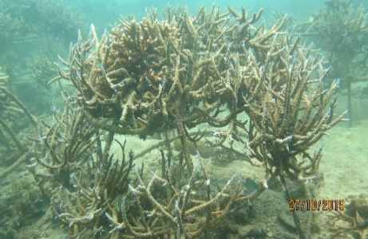  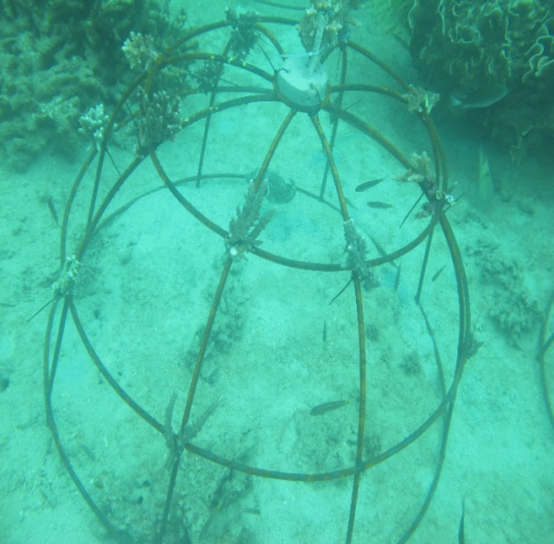 |  | 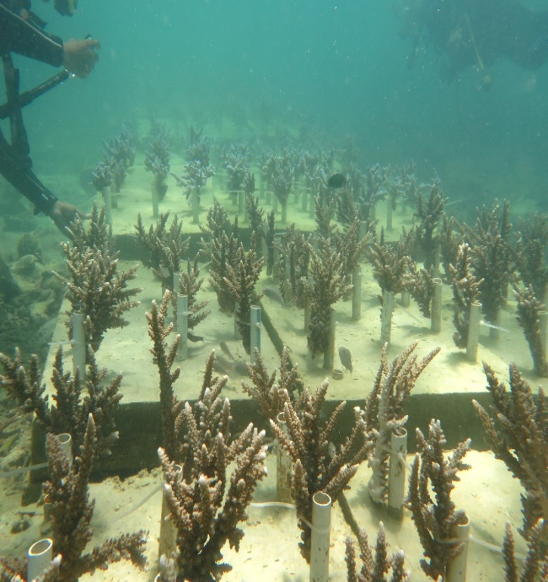  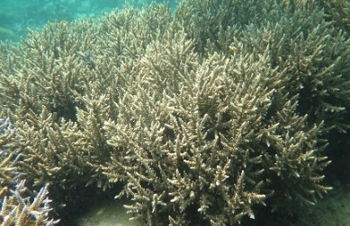
Figure 2. The coral transplants in Mahitam Island |  | Figure 3. The coral transplants in Pahawang Island

  - Coral Reef Survival Rate
Figure 4 this shows that at station 1 and station 2 the survival rates of the transplanted corals until the end of the measurement were 92.14% and 88.24%.

Figure 4. Survival rate of branching corals (St 1 is Mahitam Island, St 2 is Pahawang Island)

  - Condition of Water Parameters
Based on measurements when data collection on environmental conditions at the two research stations (Mahitam and Pahawang Islands) the conditions were in the range of tolerance limits needed for the growth of branching coral reefs (table 1).

Table 1. Average water conditions in Mahitam and Pahawang Islands
Water Parameters | Temperature (° C) | Salinity (‰) | Brightness (m) | DO (ppm) | pH
Early transplant | 29.5 | 32.3 | 8 | 7.25 | 7.0
12th month | 30.0 | 33.2 | 8 | 7.35 | 7.5
24th month | 30.5 | 33.5 | 8 | 7.30 | 7.5
Quality Standard¹⁾ | 28 - 32 | 33 - 34 | > 5 | > 5 | 7.0 - 8.5

¹⁾Decree of the Minister of Environment Number 51 of 2004

  - C-Organic Content and Carbon Storage on Coral Reefs
The transplanted coral reefs in Mahitam Island and Pahawang Island have the element of carbon (C) which can be seen in table 2.

Table 2. Carbon content of coral reefs at station 1 and station 2
Station | Organic C content (in %) |  | Average (%)
 | Deuteronomy 1 | Deuteronomy 2
1 | 1.106 | 1.108 | 1.107
2 | 1.014 | 1.006 | 1.010

Based on carbon storage calculations, transplanted coral reefs at the two study stations had a total carbon storage difference of 0.07 gC / m².

Figure 5. Carbon storage on coral reef at St. 1 (Mahitam Island) and St. 2 (Pahawang Island)
- Discussion
In this study the growth of branching coral reefs on the transplant media on Pahawang Island was higher than that of Mahitam Island (Figure 1). This presumably is because of the initial size of the transplanted coral fragments which was different in each location. Where the initial size of the coral fragments in Pahawang Island ranged from 8 - 10 c, while those on Mahitam Island was between 5 - 7 cm. Other study stated that the coral fragments of Acropora formosa with an initial size of 2 cm had a lower average length growth rate than the coral fragments of Acropora formosa with an initial size of 8 cm [8]. This is also supported by Soong el at which claimed that the longer the fragment size the higher the growth rate [9]. Other factors that influence the success of coral reproduction by fragmentation include the size of the fragments were the type of substrate on which the fragments placed and the type of coral [10].

Although the growth of coral reefs on Pahawang Island was better than Mahitam Island, the survival rate of corals on Mahitam Island was higher than Pahawang Island, namely 92.14% and 88.24% (Figure 4). This could be influenced by several factors including the medium used for transplantation, location of transplantation, and size of coral transplants (Figure 2). Mahitam Island used iron media and Pahawang Island used concrete media. Some of the coral deaths that occurred at this station were caused by stress from a number of transplant colonies due to the attachment of algae or sediment to the transplant media. Naturally corals have the opportunity to recover or become better if supported by better environmental factors and stressor reduction [11]. Based on table 1, water conditions for both locations were within the range of tolerance limits required for the growth of branching coral reefs.

Transplants carried out on Mahitam Island have an area of ​​up to 30 m² and in Pahawang Island the area reaches 45 m². The results of measurements using a spectrophotometer showed that the organic carbon (C) content of the transplanted coral reef at station 1 was greater than station 2 (Table 2), with total carbon storage. 1.6 gC /m² and 1.53 gC /m². The number of organisms that inhabit waters will give changes to the water chemistry in the form of carbon from the respiration and photodegradation processes [12]. Thus, coral reefs associated with zooxanthellae can utilize or absorb carbon as a source of photosynthesis. In addition, transplantation of coral reefs can be an alternative in the process of protecting, preserving and managing marine resource ecosystems.

- Conclusion
Transplantation of branched coral reefs carried out on Mahitam Island and Pahawang Island, Lampung Province for 24 months can be said to be successful because the coral survival reaches >50 %, with an average growth of 17.21 cm on Mahitam Island and 19.97 cm on Pahawang Island. The average value of C-organic content in the transplanted branched coral reefs for 24 months at station 1 was 1.107 % with carbon sequestration of 1.60 gC/m² and at station 2 was 1.010 % with carbon absorption of 1.53 gC /m².

REFERENCE

[1] Sunarto 2008 Penyediaan Energi Karbon dalam simbiosis coral-alga Karya Ilmiah: Fakultas Perikanan dan Ilmu Kelautan Universitas Padjajaran.
[2] Romimohtarto K dan Juwana S 2007 Biologi Laut : Ilmu Pengetahuan Tentang Biota Laut. Penerbit Djambatan. Jakarta.
[3] Ammar M S A, El-Gammal, Nassar M, Belal A, Farag W, El-Mesira G, El-Hadad K, Orabi A, Abdelreheem A dan Shaahan A 2013 Riview: Current Trent in Coral Transplantation an Approuch in Coral Biodiversity. Biodiversitas. 14(5): 43-54.
[4] Silvianita T 2003 Biologi Terumbu Karang. Makalah Training Course Yayasan Terumbu Karang Indonesia (Terangi). Jakarta.
[5] Ware J R, Stephen V, Smith., Marjorie L dan Reaka K 1991 Coral Reef: sources or sink of atmospheric CO₂? Coral Reef 11:127-130.
[6] Veron J E N, Hoegh G, Lenton T M, Obura DO, Pearce P, Sheppard C R C, Spalding M, Stafford M G, dan Rogers A D 2009 The coral reef crisis: The critical importance of <350 ppm CO₂. Elsevier. 58:1428-1436.
[7] Al-Horani F A, Al-Moghrabi S M, Beer D D 2003 Microsensor Stusy of Photosynthesis and Calcification in the Scleractinian Coral, Galaxea facicularis: Active Internal Carboncycle. Experimental Marine Biology and Ecology. 288:1-5.
[8] Hermanto B 2015 Pertumbuhan Fragmen Acropora Formosa pada ukuran yang berbeda dengan metode transplantasi di perairan Selat Lembeh. Platax. 3 :2.
[9] Soong K dan Chen T 2003 Coral Transplantation: Regeneration and Growth of Acropora Fragments in a Nursery. Restoration Ecology. 1: 62-71.
[10] Thamrin 2006 Karang Biologi Reproduksi dan Ekologi. Minamandiri Pres. Pekanbaru.
[11] Luthfi O M., Rahmadita V L dan Setyohadi D 2018 Melihat Kondisi Kesetimbangan Ekologi Terumbu Karang di Pulau Sempu, Malang Menggunakan Pendekatan Luasan Koloni Karang Keras (Scleractinia). Ilmu Lingkungan. 16(1):1-8.
[12] Middelburg J J, Duarte C M dan Gattuso J P 2004 Respiration in coastal benthic communities, in: Respiration in Aquatic Ecosystems Oxford University Press UK Hal 206 – 244.

