eDonation Android Application for Used Goods Donation using Location-based Service
RI A Pribadi¹, A Pambudi², Ardiansyah³
Department of Computer Science, Faculty of Mathematics and Natural Sciences, University of Lampung, Jl. Sumantri Brojonegoro no 1, Bandar Lampung, Indonesia

email: irwan.adipribadi@fmipa.unila.ac.id¹, agungpambudi139@gmail.com², ardiansyah@fmipa.unila.ac.id³

Abstract. Used goods/secondhand can be found anywhere during the buying cycle. Used goods are also can be reused and even still have value. Used goods such as books, clothes, bags, shoes that are still suitable for use, can also be donated to others needy. In the current technological development, many donations have been made online. This can provide donors and social institutions in raising donations. But the donations consist only of money and are not goods. In overcoming this, the eDonation apps can help donors in donating their used goods. This application also helps social institutions in raising broader donations. By utilizing location-based services, donors can find out the location of social institutions in the vicinity, so donors can choose the location of the nearest social institution that receives donations in the form of used goods that are suitable for use.
Keyword: eDonation, Used goods, Location Based Service.
- Introduction
Used goods/secondhand is an English vocabulary which means a goods owned by somebody else before. Nowadays, lot of used or used goods produce new valuable goods even have very high prices. Apart from being marketed, used goods can also be used as a form of donation to parties in need such as used clothes, bags, and books [1].
Generally, the behavior of donating involves several parties, both between individuals as donors and a charity or individuals who are the target of donation (donation target). One of the factors that can influence donation behavior is the similarity in attitudes, characteristics, or personalities. By the same background attitudes, the target and the participants ‘connection’ can be formed [2]. Term of donation, endowment, and funds raising, are very familiar in our lives. Literally, the definition of donation is an effort to give with the aim of charity and helping others needy. All forms of donation are voluntary, thus there is no set amount or hope of getting reward. Along with the advance of technology and changes in behavior of people who yearn for convenience in carrying out activities have made the concept of online donations even easier to accept [3].

Many parties needy have difficulty to find donors. Indeed, it is many times for the donation provided by donors to be less targeted. Information about donors and social institutions who need assistance are often not met. The social institutions do not know where they can seek aid, while the donors do not know how to distribute donations and to whom these donations can be distributed. Mostly, the form of donations is cash, others are in the form of goods, basic needs, and etc. But the important thing is that the aid must be right on target in the sense that the aid reaches the recipient who needs it and the type of aid is in accordance with what is needed. If not, then the aid will be useless and potentially be misused [4].
One technology that can be utilized in donating preloved goods via Android is Location Based Service (LBS) technology that is available in all smartphones today. LBS or location-based services is an information service that utilizes the ability to use location information from mobile devices that can be accessed by mobile devices through mobile telecommunications networks [5]. So that this LBS can be used to determine the location of Donors and Social Institutions.

- Research Methods
- Research Framework
In this research, the system development method used is ‘Waterfall’ which is one of the methods in the System Development Live Cycle (SDLC) which has a characteristic that each phase of Waterfall work must be completed first before proceeding to the next one. The Waterfall method can also assist developers in detailing the software requirements to be built. Furthermore, this model can be a solution in overcoming a problem with logical and sequential steps such as: Requirement Analysis, System Design, Implementation, Testing, Deployment, and Maintenance [6]. Waterfall Method stages can be seen in Figure 1.
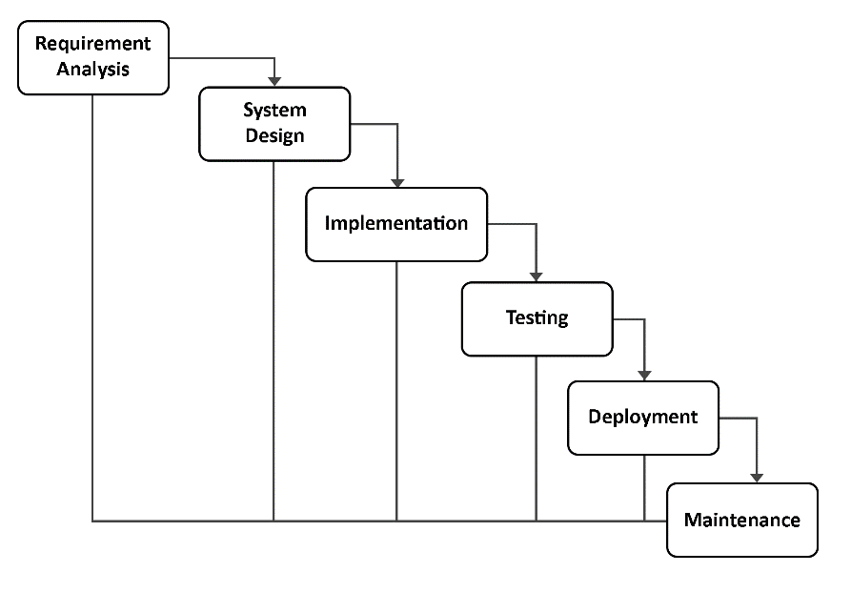
Figure 1. Waterfall method.

- Method of Collecting Data
This stage is the process of formulating and limiting the problem to be researched. The formulation and limitation of the problem is needed in order to guide a better direction for researcher in developing the system so that the research carried out is appropriate and does not go outside the predetermined limits. At this stage, preliminary data collection is performed including preparation of tools and materials to support the application development process. At the data testing can be implemented using two methods, such as through literature review and observation.
- Literature Review
This literature review stage is the collection of data through various literatures such as books, journals, papers or documents related to the research to be performed. This stage aims to obtain concrete data that supports system development.
- Observation
At this stage, the collection of related data in the development of the system. This observation stage is carried out to complete the required data. An analysis is performed on similar apps, like the KitaBisa apps. The apps is analyzed on the menu and available features, then used in the design and development process of the system.

- System Requirements Analysis
In making efforts to solve problems that have been identified, a system is created according to existing needs. Use case diagrams are used to find out what functions are in a system and who is entitled to use these functions [7]. The Use Case Diagram eDonation apps is shown in Figure 2.
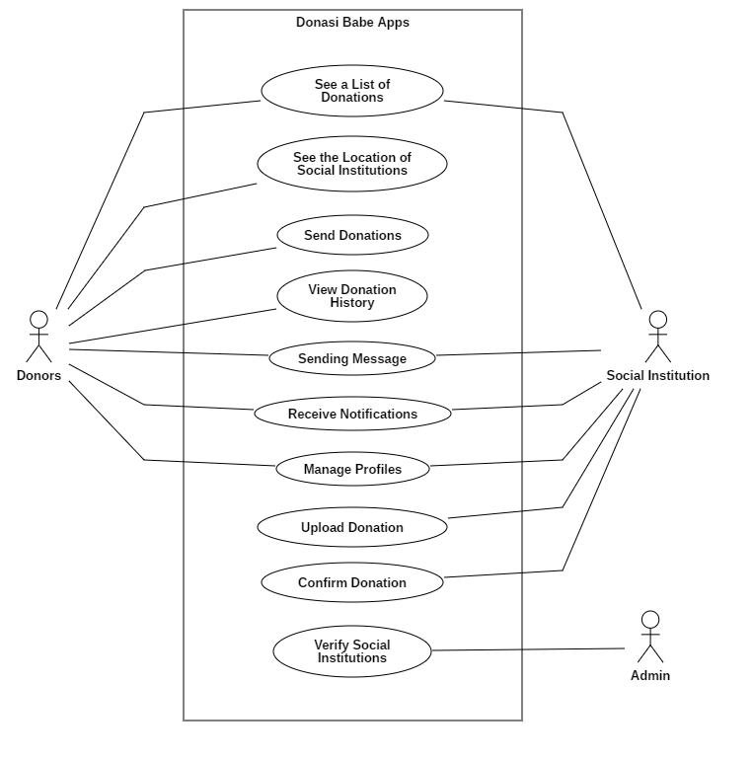
Figure 2. Use Case Diagram.

- Result and Discusiion
- Result
eDonation apps is a system built to ease Donors to find Social Institutions that can receive donations of used goods. This donation apps can also help Social Institutions in raising donations for used goods. This apps have two levels of user, it is a Donatur (donors) and Lembaga Sosial (Social Institutions). The Donatur here is the person who donates used goods that are suitable for use to the targeted Social Institutions. Donors can choose the type of donation that has been uploaded by the Social Institution. Donors can also view or select Social Institutions that are in the vicinity of the Donor locations. Meanwhile, Social Institutions are institutions or organizations that oversee donations in the form of wearable goods. In this system, Social Institutions can read the location, upload the type of donation, and confirm donations.
In its development, this apps are built using the Android framework where program code is written using the IDE Android Studio and Java programming language. In this research used an Acer Aspire 4750 laptop with the Windows 10 operating system to help the system development process. MySQL as database management systems is used to store all user data that is in hosting. The interface designed using Adobe Illustrator software. Furthermore, to test the data processing API (application programming interface) on the server, author used Postman software.

- Discussion
The system implementation is performed after the analysis and design stages have been completed. The results of the system implementation on the eDonation apps are shown in the following pictures.
- Registrasi Menu
The Registrasi (registration) is a menu for create account for new users. On this page, users will be asked to fill in their full name, email, phone number, and password. The registrasi menu display can be seen in Figure 3.
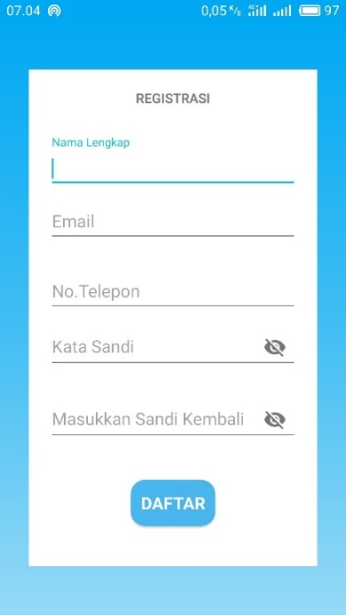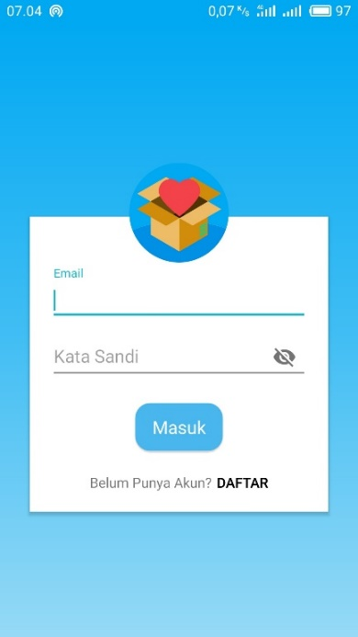
Figure 3. Registrasi Menu Figure 4. Login Menu

- Login Menu
The Login menu is a menu to validate accounts that have been registered by the user. On this page, the user will be asked to enter an email and password that has been successfully registered. If the email and password entered are correct it will move to the home page. However, if the email or password is wrong, the application cannot move to the main page. The login menu display can be seen in Figure 4.

- Beranda Menu
The Beranda (home) is the main display of the apps. There are several sections that are displayed on this page, specifically the latest donation list, Donasi Sekarang Menu (donate now), Cari Lembaga Sosial Menu (look for social institutions), Riwayat Donasi Menu (donation history), Bantuan Menu (help), and Tentang Menu (about). In the latest donation list display, there are only a maximum of five pictures that contain the latest types of donations uploaded by Social Institutions, if you want to see all types of donation lists, users can select the “Lainnya” menu to display all types of donation lists from various Social Institutions. The beranda menu display can be seen in Figure 5.
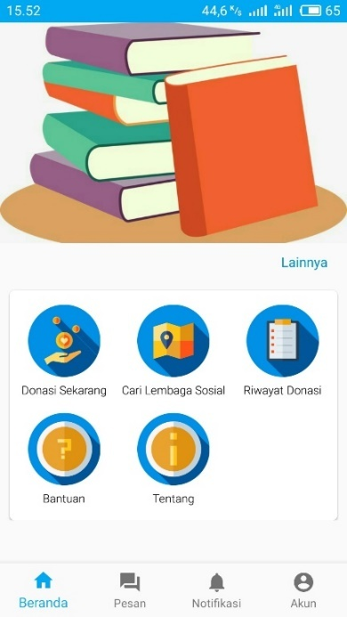
Figure 5. Beranda Menu

- Pesan Menu
The Pesan (message) is a menu for interaction between Donors and Social Institutions so that they can communicate each other or can ask questions about donations in the apps. The Pesan page displays a list of messages from donors or a list of messages from Social Institutions. The pesan menu display can be seen in Figure 6.
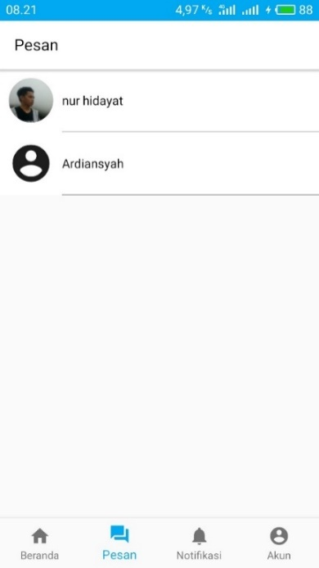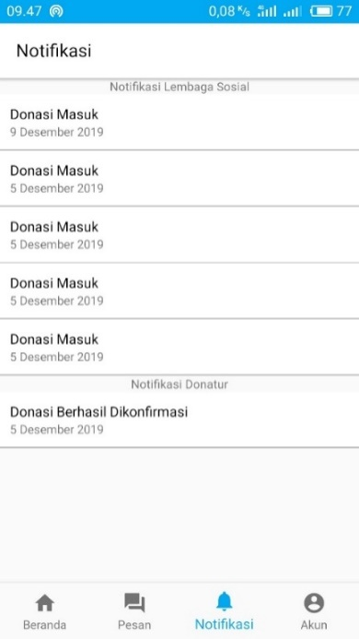
Figure 6. Pesan Menu Figure 7. Notifikasi Menu

- Notifikasi Menu
The Notifikasi (notification) is a menu that displays information related to incoming donations for Social Institutions and also displays information on donation status for Donors. The notifikasi menu display can be seen in Figure 7.

- Profil Donatur Menu
The Profile Donatur (donor’s profile) is a menu that displays information related to the Donor's personal data. This menu contains your name, profile photo, email, phone number, address, date of birth, and gender. On this page there is an edit button that allows you to change the profile of the donor itself. The appearance of the profil donatur menu can be seen in Figure 8.
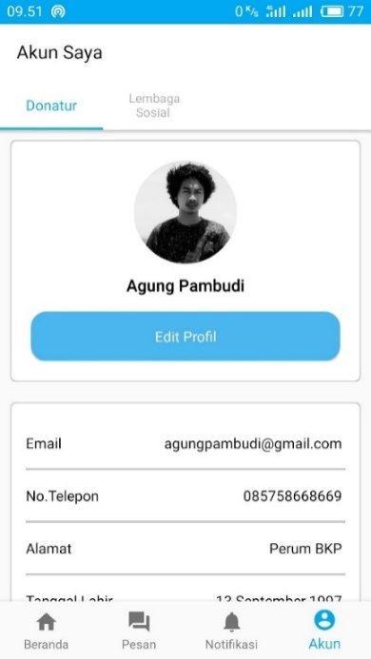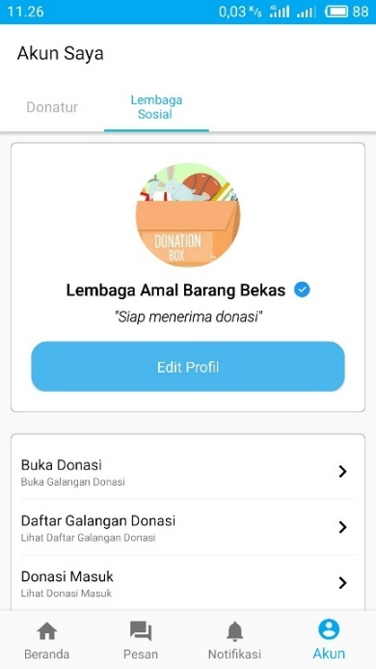
Figure 8. Profil Donatur Menu Figure 9. Profil Lembaga Sosial Menu

- Profil Lembaga Sosial Menu
The Profil Lembaga Sosial (social institutions profile) is a menu for Social Institutions to manage donations from donors and to raise donations. On this page there are several menus including: the buka donasi (open donation) menu, the daftar galangan donasi (donation list) menu, and the donasi masuk (donation received) menu. The display of the Lembaga Sosial profile menu can be seen in Figure 9.

- System Testing
At this phase, system testing has been performed which aims to find errors or deficiencies in the system tested and to find out that the system created has met the criteria in accordance with the system design objectives. The identification of tests implemented include:

Table 1. Test Identification

Test Class | Test Items
Validation | Login
User Data Management | Adding Data User
 | Changing Data User
Display | Apps Displays Donation Data
 | Apps Displays Main Page
 | Apps Displays Message
 | Apps Displays Notifications
 | Apps Displays Account Information

This test was performed on 10 respondents and the test results were obtained based on the test class, including:
1. Validation
Overall, the results of the tests show that the apps successfully validate the user when logging in to the apps.
2. User Data Management
Overall, the results of the test show that the apps have succeeded in adding new Donor user data, Social Institution user data, and Donation List Data from both Donors and Social Institutions. This test also succeeded in changing user data for donors and social institutions.
3. Display
Overall, the results of the tests show that the apps manage to display the user interface well in the various screen resolutions tested. However, in the notification section there are several tests that cannot display notifications when the apps process is closed. Yet, if the apps are running, notifications can be received on all devices. This is due to the limitations of the notification API which can run properly when using the Android Oreo version (API 26) even though the apps is closed or not running. So that testing notifications for versions of Android below Oreo or API level less than 26 does not work properly. To receive message data, donation data, historical data, and account information data can run properly.

- Conclusion
Based on the results of the research conducted, it can be concluded that an eDonation Android-based apps has been successfully built, has succeeded in displaying the locations of various social institutions, is able to display the list of donations from various social institutions making it easier for donors to choose the type of goods to be donated, is able to send messages from Donors to Social Institutions or vice versa, and can receive message notifications, incoming donation notifications, and confirmed donation notifications.
Some suggestions that need to be considered in developing this system are as follows:
- Adding an email verification feature to the user when registering an account
- Calculating the distance between the location of the Donor and the intended Social Institution and
- Adding a donation feature based on the closest location to the donor.

References
[1]. Choiri, E. O. 2018. Tips Menjual Baju Bekas Preloved Agar Cepat Laku. [Online]. Available at https://www.jurnal.id/id/blog/2018-tips-menjual-baju-bekas-preloved-agar-cepat-laku/. Accessed on 20 Nov 2019.
[2]. Liviatan, I., Trope, Y., dan Liberman, N. (2008). Interpersonal similarity as a social distance dimension: Implications for perception of others’ actions. Journal of Experimental SocialPsychology,44(5),1256-1269.doi:10.1016/j.jesp.2008.04.007.
[3]. Fatra, R. 2017. Fenomena Transformasi Praktik Donasi. [Online]. Available at https://www.kompasiana.com/rizkofatra/58b0fbf3379373c31f4e815c/fenomena-transformasi-praktik-donasi. Accessed on 25 Mar 2019.
[4]. Alexandrea, J. dan Handiwidjojo, W. 2016. Program Bantu Sistem Penyaluran Donasi Non Tunai Berbasis Web. Jurnal EKSIS. Vol. 09, No. 02.
[5]. Muludi, K., Febriansyah, F. E., dan Setiawan A. 2016. Aplikasi Pencarian Informasi Sholat Jumat di Kota Bandar Lampung Menggunakan Location Based Service Berbasis Android. Jurnal Komputasi. Vol. 4 No. 2, Lampung.
[6]. Simarmata, J. 2010. Rekayasa Perangkat Lunak. Penerbit Andi, Yogyakarta.
[7]. Sugiarti, Y. 2013. Analisis dan Perancangan UML (Unified Modeling Language) General VB.6. Penerbit Graha Ilmu, Yogyakarta.

