Identification of Temperature and Rainfall Pattern in Bandar Lampung and the 2020 -2049 Projection
Novika Ayu Eko Kusumastuty^{1,2}, Tumiar Katarina Manik², and Paul Benyamin Timotiwu²
¹ Indonesian Agency for Meteorology, Climatology and Geophisics, Pesawaran, Lampung, Indonesia
²Faculty of Agriculture, University of Lampung, Bandar Lampung, Indonesia
E-mail: novikaayu23@gmail.com
Abstract. Climate change is a global phenomenon that is increasingly needed to be discussed. In local scale climate change is expressed often as climate phenomenon such as El-Nino South Oscillation (ENSO), Madden Julian Oscillation (MJO) and Dipole Mode Index (DMI). This condition caused many problems at the local scale especially in urban areas. Major hydrometeorological disasters such as floods and droughts impacted community daily life. Therefore, to deal with those hydrometeorological disasters, cities need to develop mitigation mechanisms based on data and information of future weather conditions. The objection of this study was to analyse historical climatic conditions of Bandar Lampung, Indonesia, and project the future climate up period of 2020-2049 using CMIP5 Representative Concentrations Pathways (RCP) 4.5 and RCP 8.5 models. Observed data was obtained from BMKG (Indonesian Agency for Meteorology, Climatology and Geophysics) stations while projected data obtained from BMKG Climate Change Centre. The results showed there were downward tendency of rainfall both in historical data and the projection and for most of the season except for dry periods; while temperature showed upward tendency consistently. Mitigation actions with reducing greenhouse gas concentrations have impact more on temperature trend than on rainfall distribution.
- Introduction
Climate change is a global phenomenon caused by warming in the global climate system as results of increasing greenhouse gases concentration in the atmosphere. Climate change marked with an increase in global air and sea surface temperature, usually land are warming faster than oceans [5]. Global temperature has increased 0.2°C per decade during the last 30 years and the rate of change per year is greater when the El-Nino phenomenon occurs [3]. Over the next two decades, global temperature increase is projected to be between 0.3°C-0.7°C [7]. In addition, temperature in Lampung has changed due to changes in land use structures. In general, temperatures have increased for downtown areas, oil palm plantations and open areas in coastal areas; the projected temperature rise can be or the temperature is projected to rise to 4°C for these areas. Meanwhile, for rice fields the temperature is relatively stable and constant [11]
Changes in air temperature lead to several changes in other climate elements such as changes in rainfall distributions and seasonal patterns in one region. Changes in both rainfall and temperature can directly have impact on agriculture production [6], especially in crop and yield production [4]. Impact of climate change on agriculture production has been a serious concern [14].The most risk in agriculture sector related to climate change in Indonesia is decreased harvested area and rice production [9].
Indonesian is a region which could severely affected by climate change. The phenomenon of global climate change affects areas of Indonesia that are especially sensitive to climate variability, such as El-Nino South Oscillation (ENSO), Madden Julian Oscillation (MJO) and Dipole Mode Index (DMI). If that high sensitivity area combined with low adaptability, then those areas become vulnerable to climate change. Urban areas referred as one of vulnerable area since they are usually located close to coastal areas, have poor drainage systems and occupied by dense population. Urban areas problems included lack of clean drink water, flooding and rob from sea level rise. In facing those possible conditions, urban areas need environmental management strategies based on valid data and sound climate change analysis. One of the information needed is a historical study of the climate in the area and its future projections to determine adaptation and mitigation actions.
This study in general is a study of air temperature and rainfall trend, while indication of climate change was analyzed with time series methods. Time series could provide information on trends, cycles or shifts pattern around the long-term average. The study continued with climate projection as an effort to obtain description of the future climate in response to changes in greenhouse gases composition in the atmosphere. Several simulation models are available up to year 2100 projection. The projection results depend on the assumed global development scheme. Intergovernmental Panel on Climate Change (IPCC) issued some new scenarios, called Representative Concentration Pathways (RCP 2.6, RCP 4.5, RCP 6.0 and RCP 8.5). Four Representative Concentrations Pathways (RCP) scenarios illustrate the range of greenhouse gas radiation strengths in 2100, from 2.6 to 8.5 W m⁻². The lowest level scenario, the middle level is a stable scenario Representative Concentrations Pathways (RCP) 4.5, and the highest or a scenario without mitigation efforts is Representative Concentrations Pathways (RCP) 8.5 [8]. This type of analysis have been done in India and found that the temperature increased by 2 ° C to 4.8 ° C, using RCP 2.6 and RCP 8.5, respectively, while rainfall was projected to increase by 6%, 10%, 9% and 14%, using RCPs of 2.6, 4.5, 6.0, and 8.5, respectively [2].
The objection of this study was to analyse historical climatic conditions of Bandar Lampung, Indonesia, and project the future climate up period of 2020-2049 using CMIP5 RCP 4.5 and RCP 8.5. RCP 4.5 and RCP 8.5 used to compare between projection scenarios that use mitigation scenarios and those that do not for Bandar Lampung area. The results could be used as bases of mitigation and adaptation strategies.
- Method
  - Research Site
Bandar Lampung, Indonesia (5°39' S, 105°.26' E and 113 m asl)
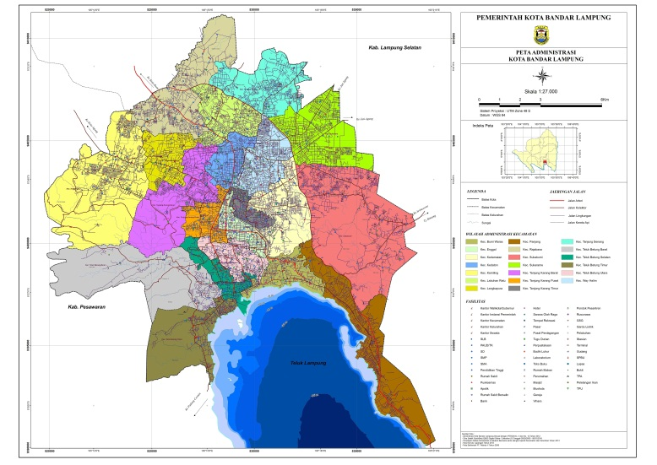
Figure 1. Bandar Lampung administration map

  - Data
This study processed secondary temperature and rainfall data, obtained from the BMKG (Indonesian Agency for Meteorology, Climatology and Geophysics) Pesawaran Lampung, Indonesia. Data was available from 1976 to 2019.
Projections of temperature and rainfall used the GCM-CMIP5 output model with RCP 4.5 and 8.5 scenarios. The data was obtained from the BMKG Climate Change Centre. The data was available in grid form, completed with metafile attributes and was stored in a file with a special netCDF format. Prior to use, the projection data must be corrected with observational data to reduce any bias.
The difference between RCP 4.5 and RCP 8.5 are based on the mitigation scenario used. The RCP 4.5 scenario referred to a scenario of increasing greenhouse gases compensated with a mitigation scenario of reducing greenhouse gas concentrations; whereas the RCP 8.5 scenario based on a scenario of increasing greenhouse gases without a mitigation scenario of reducing greenhouse gas concentrations [12].
  - Method of collecting data
Data from RCP 4.5 and RCP 8.5 scenario models that have been extracted need to be corrected so that the model data has the same values and changes as the observed data. Data correction was done by calculating the difference between the observed data and the model data. The requirement for data correction is that the model data and observational data must have the same period. The calculation of data correction can be done with the following formula [13].
${CH}_{Model_kor}={CH}_{Mod} ×{\frac{\overline{CH}obs}{\overline{CH}mod}}^{}$
(1)
CH_{Model_kor} | = Corrected model of monthly rainfall
CH_{Mod} | = Rainfall model before corrected
CHobs | = Average baseline period of rainfall observational data
CHmod | = Average baseline period of rainfall data model
$$T_{Model_kor}=T_{Mod} +({\overline{T}}_{obs} - {\overline{T}}_{Mod})$$
(2)
T_{Model_kor} | = Corrected model of monthly temperature
T_{Mod} | = Temperature model before corrected
Tobs | = Average baseline period of temperature observational data
Tmod | = Average baseline period of temperature data model
The projection process started with qualitatively matched baseline data with observational data. The appropriate model could be indicated from the uniformity of the baseline model pattern with the composite pattern of observation data. The next step was the validation process; starting with projecting the data using the selected model with the historical data period 1976-2019 and the period 2020-2049 as the predicted results. Validation was done by measuring the level of correlation between predicted and predictors, a model with a strong correlation would be selected.
- Result and Discussion
  - Annual Data Series Analysis and Projections
Time series of rainfall data of Bandar Lampung in 1976-2019 and its projection in 2020-2049 were presented in Figure 1 and 2.
Observed rainfall for the period 1976-2019 showed a decrease with a trend of 14.581 mm per year. These results were linear with the results of the two scenario data which showed a decline for the 2020-2049 periods with a trend of 3.4702 mm from the RCP 4.5 scenario and 1.945 mm from the RCP 8.5 scenario.
Results of the rainfall trend showed a decrease for all observed years including the projection data which showed linear results with the observed data. A significant decrease occurred during the observation period, while the scenario data showed a decrease in rainfall but not as big as the trend of the observation data. RCP 4.5 showed a decrease of 3, 4702 mm per year while RCP 8.5 showed a decrease of 1,945 mm per year. Scenario results were not too significant compared to the observed data because they are only figures and have not been added to the variability and phenomena that usually occur in annual movements. Result of RCP 4.5 was higher than RCP 8.5 for Bandar Lampung because it was only studied for a small area (one city), it was not researched for a wider area so the results may differ from the theory of research for the whole world.

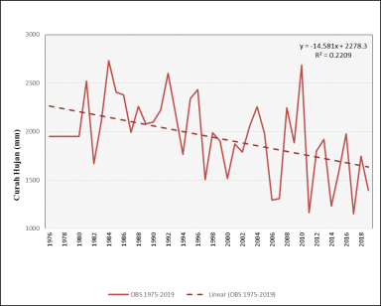 |  | 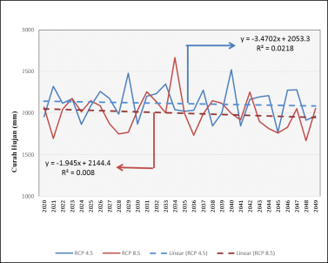
Figure 2. Observed Rainfall of Bandar Lampung in 1976-2019 |  | Figure 3. Projected Rainfall of Bandar Lampung in 2020-2049
Observation temperature of Bandar Lampung in 1976-2019 and its projecting for 2020-2049 period was presented in Figure 3 and 4.

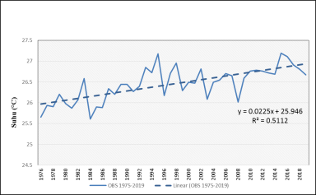 |  | 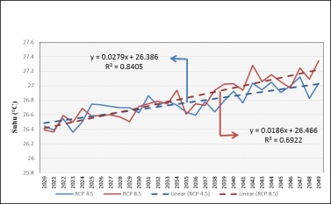
Figure 4. Observed temperature of Bandar Lampung in 1976-2019 |  | Figure 5. Projected temperature of Bandar Lampung in 2020-2049
The temperature in Bandar Lampung city showed an increase in temperature with a trend of 0.0225 ° C per year. The trend of the increase in temperature is linear with the results of the two scenarios used. The scenario data for the 2020-2049 RCP 4.5 periods showed an increase of 0.0279 ° C per year. Meanwhile, based on the RCP 8.5 scenario, it showed an increase with a trend of 0.0186 ° C per year.
The results of temperature trend indicated an increase in temperature for all observed periods of the year. The upward trend was not much different between the observed data and the scenario data.
  - Seasonal Data Series Analysis and Projections
The analysis continued with divide the months in one year into three ’seasons’ which are DJF (December January February), MAM (March, April and May), JJA (June, July and August) and SON (September, October and November). These divisions was attended to find what is the trend in rain season DJF, in transitional season to dry season MAM, in dry season JJA and in transitional season to rainfall season SON.
    - Rainfall
Observed rainfall in terms of seasonal DJF, MAM, JJA and SON for the data 1976-2019 and the projection on period 2020-2049 presented in Figures 5 to 12.

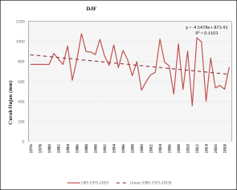 |  | 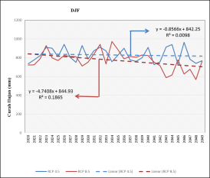
Figure 6. Observed rainfall of Bandar Lampung in December, January and February |  | Figure 7. Projected rainfall of Bandar Lampung in December, January and February
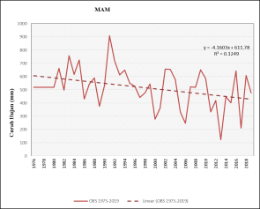 |  | 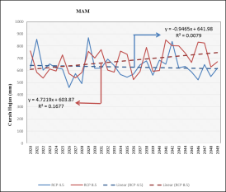
Figure 8. Observed rainfall of Bandar Lampung in March, April and May |  | Figure 9. Projected rainfall of Bandar Lampung in March, April and May
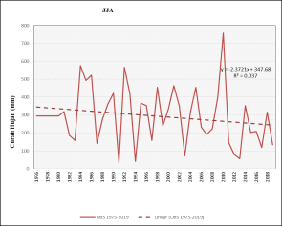 |  | 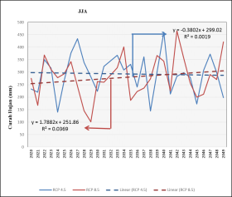
Figure 10. Observed rainfall of Bandar Lampung in June, July and August |  | Figure 11. Projected rainfall of Bandar Lampung in June, July and August
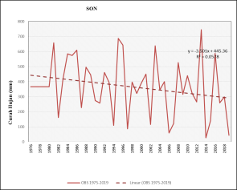 |  | 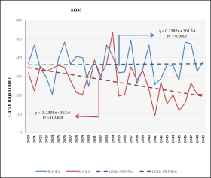
Figure 12. Observed rainfall of Bandar Lampung in September, October and November |  | Figure 13. Projected rainfall of Bandar Lampung in September, October and November
Trend of seasonal rainfall and its projection was presented in Table 1 and 2. Historical seasonal data from 1976-2019 showed a downward trend in rainfall for all periods of the month except for the JJA season. The scenario results showed that for RC 4.5 there were decreases for all months except the SON period while RCP 8.5 results showed that there were decreases in rainfall for the DJF and SON periods and increases in rainfall during the MAM and JJA periods. MAM and JJA are seasonal transition periods for Bandar Lampung, allowing for high fluctuations in that period. The trend of increase and decrease in rainfall per year is greater for RCP 8.5 scenario results for all the periods studied.

Table 1. 1976-2019 Rainfall Seasonal Rainfall Trend

Periods | DJF | MAM | JJA | SON
1976-2019 | -4.5478 | -4.1603 | 2.3721 | -3.501

Table 2. Projection of Seasonal Rainfall Trend

Scenarios | DJF | MAM | JJA | SON
RCP 4.5 | -0.8566 | -0.9465 | -0.3802 | 0.2382
RCP 8.5 | -4.7408 | 4.7219 | 1.7882 | -5.2395

    - Temperature
Observed temperature in seasonal DJF, MAM, JJA and SON for the data 1976-2019 and the projection on period 2020-2049 presented in Figures 13 to 20.

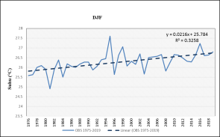 |  | 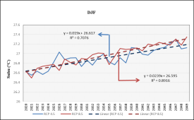
Figure 14. Observed temperature of Bandar Lampung in December, January and February |  | Figure 15. Projected temperature of Bandar Lampung in December, January and February
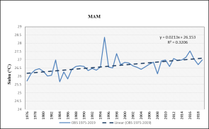 |  | 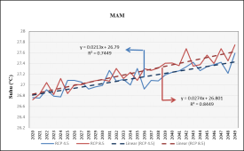
Figure 16. Observed temperature of Bandar Lampung in March, April and May |  | Figure 17. Projected temperature of Bandar Lampung in March, April and May
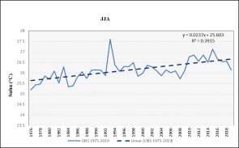 |  | 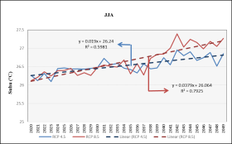
Figure 18. Observed temperature of Bandar Lampung in June, July and August |  | Figure 19. Projected temperature of Bandar Lampung in June, July and August
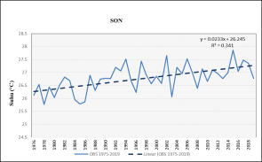 |  | 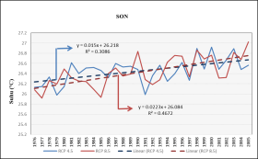
Figure 20. Observed temperature of Bandar Lampung in September, October and November |  | Figure 21. Projected temperature of Bandar Lampung in September, October and November
Trend of seasonal temperature and its projection was presented in Table 3 and 4. Historical seasonal data from 1976-2019 showed an upward trend in temperature for all periods of the month. The scenario results also showed an increase for the two scenarios. Temperature rise trend is greater for RCP 4.5. Movement of the temperature increase trend is greater in the RCP 8.5 scenario.

Table 3. 1976-2019 Seasonal Temperature Trend

Periods | DJF | MAM | JJA | SON
1976-2019 | 0.0216 | 0.0213 | 0.0237 | 0.0233

Table 4. Projection Seasonal Temperature Trend

Scenarios | DJF | MAM | JJA | SON
RCP 4.5 | 0.019 | 0.0213 | 0.019 | 0.015
RCP 8.5 | 0.0239 | 0.0274 | 0.0379 | 0.0223
The rainfall analysis indicated that in the future, based on the projection scenario used, there would be additional rainfall during the dry season and the intensity of rainfall could decrease in the rainy season. It seemed that water will be available all year and this might be appropriable for agriculture productions. However, with a constant upward tendency of temperature, agriculture activities need to be alarmed whether crops water need would be met since high temperature will increase the evapotranspiration rate [10]. High temperature could also ignite forest fire. The temperature increase will affect the sea surface temperature around Bandar Lampung. The existence of a constant increase in temperature will have an effect on the environment and changes in the pattern of human life such as increasing consumption of air conditioning so that the rate of temperature change increases
- Conclusion
Rainfall analysis showed downward tendency of rainfall both in historical data and the projection and for most of the season except for all dry periods; while temperature showed upward tendency consistently.
From the scenario, mitigation of reducing greenhouse gas concentrations did not have a consistent impact on rainfall but impacted on temperature trend. Rainfall distribution and temperature change would be two elements that are interrelated in future changes
- References
[1] BAPPEDA Bandar Lampung. Peta Administrasi Kota Bandar Lampung. https://www.bappedakotabalam.net/peta-wilayah/
[2] Dar M U D, Samanpreet K, Rajan A 2017 Effect of climate change scenarios on yield and water balance components in ricewheat cropping system in Central Punjab, India Journal of Agrometeorology 19 (3) : 226-229 ISSN : 0972-1665
[3] Hansen J, R. Ruedy, Makiko S and Kw L 2006 Global temperature change Proceedings of the National Academy of Sciences DOI: 10.1073/pnas.0606291103
[4] Hatfield JL, K J Boote, B A Kimball, L H Ziska, R C Izaurralde, D Ort, A M Thomson and D Wolfe 2011 Climate Impact on Agriculture : Implications for Crop Production Agronomy Journal DOI: 10.2134/agronj2010.0303
[5] Hayhoe, K., J. Edmonds, R.E. Kopp, A.N. LeGrande, B.M. Sanderson, M.F. Wehner, and D.J. Wuebbles 2017 Climate models, scenarios, and projections. In: Climate Science Special Report: Fourth National Climate Assessment, Volume I [Wuebbles, D.J., D.W. Fahey, K.A. Hibbard, D.J. Dokken, B.C. Stewart, and T.K. Maycock (eds.)]. U.S. Global Change Research Program, Washington, DC, USA, pp. 133-160, doi: 10.7930/J0WH2N54.
[6] IPCC 2007 Switzerland. Synthesis Report. Contribution of Working Groups I, II and III to the Fourth Assessment Report of the Intergovernmental Panel on Climate Change
[7] Khan M I R, Nafees K and Mohd A 2013 Rising temperature in changing environment : A serious threat to plants Climate Change and Environmental Sustainability DOI: 10.5958/j.2320-6411.1.1.004
[8] Nazarenko, L., et al., 2015. Future climate change under RCP emission scenarios with GISS ModelE2. Journal of Advances in Modeling Earth Systems, 7, 244-267. https://doi.org/10.1002/2014MS000403.
[9] Ruminta 2016 Kerentanan Dan Risiko Penurunan Produksi Tanaman Padi Akibat Perubahan Iklim Di Kabupaten Indramayu Jawa Barat Prosiding Seminar Nasional Hasil-Hasil PPM IPB 2016 ISBN : 978-602-8853-29-3
[10] Tjasjono, B 2004 Klimatologi Umum Penerbit ITB
[11] Manik, T K and Syarifah S 2017 Comparative Vulnerability Assessment of Urban Heat Islands in Two Tropical Cities in Indonesia British Journal of Environment & Climate Change 7(2): 119-134, 2017; Article no.BJECC.2017.010 ISSN: 2231–4784
[12] Wayne, G 2013 The Beginner’s Guide to Representative Concentration Pathways. Sceptical Science Version 1.0.
[13] Weiland F C S, L P H van B, J C J Kwadijk and M F P Bierkens 2010 The ability of a GCM-forced hydrological model to reproduce global discharge variability Hydrology and Earth System Sciences, 14 (8), 1595–1621 DOI:10.5194/hess-14-1595-2010
[14] Yan, W., William, G., Jo, Y.K., 2020. Status of Climate Change Adaptation in Northeast Asian Region. Springer Climate,pp 69–96. https://doi.org/10.1007/978-3-319-99347-8_5

