**The patterns of lead and copper levels in the vicinity of heavy metal sources in Lampung, the southern part of Sumatra, Indonesia**

**M R Febriansyah1, L M Septiana1, S Supriatin1 and A K Salam1, 2**

**1**Department of Soil Science, University of Lampung, Bandar Lampung, Indonesia

**2**Corresponding author

E-mail: [axauam@gmail.com](mailto:axauam@gmail.com)

**Abstract.** Heavy metals may easily move through air system and may deposit and accumulate in soil system by water precipitation away from their sources. The objective of this research was to evaluate the soil concentrations of Pb and Cu in the vicinity of several sources of heavy metals in Lampung, the southern part of Sumatra, Indonesia. Soil samples were collected at distances of 0 (Central Points) to 500 m from the presumed centers of heavy metal sources including industrial areas, heavily traffic/rail roads, and residential areas of Panjang Bandar Lampung, Tanjung Bintang and Natar, South Lampung. The results show similar patterns of Pb and Cu distributions along the sampling points. The soil concentrations of Pb and Cu were highest at the central points (0 m) and decreased with distances towards the farthest sampling points of 500 m. The concentrations of Pb and Cu in Panjang were higher than those in Tanjung Bintang and Natar.

1. **Introduction**



Even though some are essentially needed by the living things, heavy metals are toxic at concentrations higher than their allowable levels [1], [2], [3]. However, almost all heavy metals have been silently accumulating in the soil environment in the last decades [4], [5], [6], [7], [8], [9], [10], [11]. Reports show that a great deal of sources of heavy metals have contributed to the accumulated heavy metals in the soil environment, some are at excessive concentrations that may disturb the growth and health of plants, animals, and humans [3], [5], [7], [8], [12].



While a great deal of researchers may have probably solved the problem of heavy metals in the soil environment *in situ* by physical, chemical, and biological engineering [13], [14], [15], [16], [17], [18], [19], their emission into the soil environment must also be understood. Part of heavy metals may move in the soil system by mass flow and diffusion, water percolation and leaching, water runoff and erosion [8], [20], [21], [22], [23]. A significant part may also move through the air system along with fine particle materials exhausted into the atmosphere and may deposit into the soil system by gravitation and water precipitation [5], [7], [8], [24], [25], [26]. Air movement of heavy metals may occur from several potential sources like industrial exhausts, traffic exhausts, and industrial materials like coal [3], [9], [27], [28]. All these processes may cause soil variability in heavy metal concentrations and may give different effects on the living things.

A great deal of research reports on soil heavy metal levels caused by heavy metal movement in the vicinity of heavy metal sources are found in current literature [1], [3], [5], [8], [21], [23]. However, such kind of data is scarce for tropical soils in particular for Lampung and Indonesia. The objective of this research was to evaluate the soil levels of heavy metal concentrations in the vicinity of several presumed heavy metal sources in Lampung Indonesia.

1. **Materials and Methods**

Soil samples were collected from presumed sources of heavy metals in Lampung, the southern part of Sumatra, Indonesia, i.e. the older industrial center of Bandar Lampung (Panjang) and the more recently established industrial area of Lampung (Tanjung Bintang, South Lampung). From each of these areas three different metal source types were evaluated i.e. industrial area, heavily traffic road area, and residential area (figure 1 and 2) that were located approximately 1.0 to 3.5 km apart from each other. One other presumed metal source in Lampung, i.e. coal transportation railroad in Natar, South Lampung (figure 3), was also evaluated. Soil samples were collected at distances of 0, 50, 100, 250, and 500 m from the presumed centers of heavy metal sources (0 m). Distances were determined using Global Positioning System (GPS). The locations of the soil sampling are listed in table 1.

Table 1. Locations of the soil sampling.

|  |  |  |  |  |
| --- | --- | --- | --- | --- |
| Source  Types | Distance (m) | Panjang  Bandar Lampung | Tanjung Bintang  South Lampung | Natar  South Lampung |
| Industry | 0 | 5o 30’52” S 105o 20’ 52” E | 5o 23’ 14” S 105o 22’ 58” E | - |
| 50 | 5o 30’52” S 105o 20’ 55” E | 5o 23’ 14” S 105o 23’ 01” E | - |
| 100 | 5o 30’51” S 105o 20’ 57” E | 5o 23’ 14” S 105o 23’ 05” E | - |
| 250 | - | 5o 23’ 14” S 105o 23’ 14” E | - |
| 500 | - | 5o 23’ 14” S 105o 23’ 28” E | - |
| Heavily Traffic /Rail Road | 0 | 5o 29’26” S 105o 19’ 32” E | 5o 22’ 59” S 105o 23’ 00” E | 5o 20’ 24” S 105o 13’ 15” E |
| 50 | 5o 29’26” S 105o 19’ 34” E | 5o 22’ 59” S 105o 23’ 04” E | 5o 20’ 21” S 105o 13’ 15” E |
| 100 | 5o 29’26” S 105o 19’ 37” E | 5o 22’ 59” S 105o 23’ 07” E | 5o 20’ 17” S 105o 13’ 15” E |
| 250 | 5o 29’27” S 105o 19’ 42” E | 5o 22’ 59” S 105o 23’ 17” E | 5o 20’ 06” S 105o 13’ 15” E |
| 500 | - | 5o 22’ 59” S 105o 23’ 33” E | 5o 19’ 51” S 105o 13’ 15” E |
| Residential Area | 0 | 5o 29’52” S 105o 19’ 50” E | 5o 23’ 57” S 105o 23’ 17” E | - |
| 50 | 5o 29’50” S 105o 19’ 53” E | 5o 23’ 54” S 105o 23’ 19” E | - |
| 100 | 5o 29’49” S 105o 19’ 55” E | 5o 23’ 51” S 105o 23’ 23” E | - |
| 250 | 5o 29’46” S 105o 20’ 01” E | 5o 23’ 54” S 105o 23’ 19” E | - |
| 500 | - | 5o 23’ 45” S 105o 23’ 32” E | - |

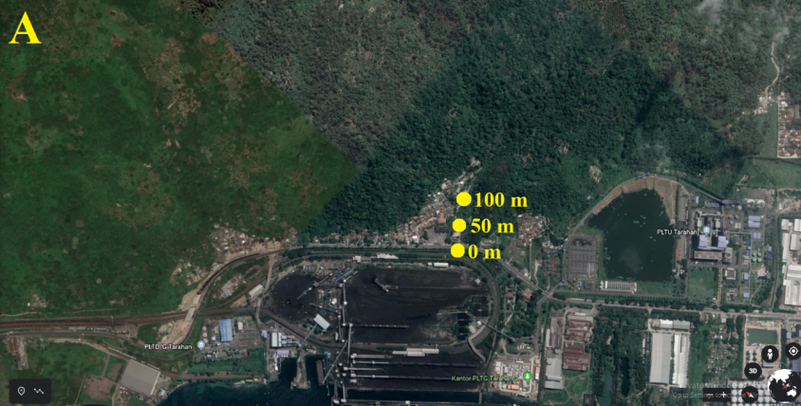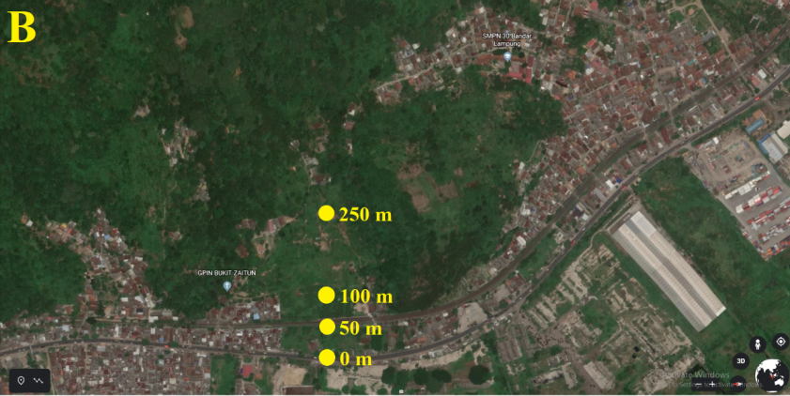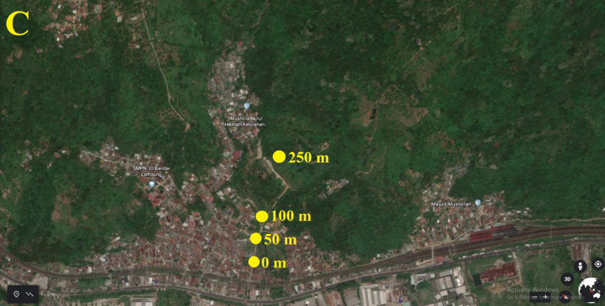

Figure 1. Soil sampling sites in Panjang Bandar Lampung

(A. Industrial Area, B. Heavily Traffic Road, C. Residential Area).

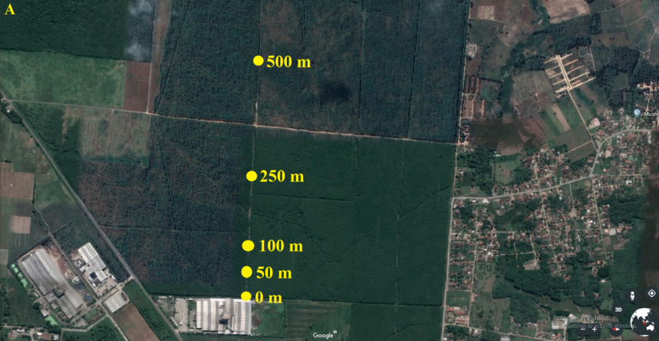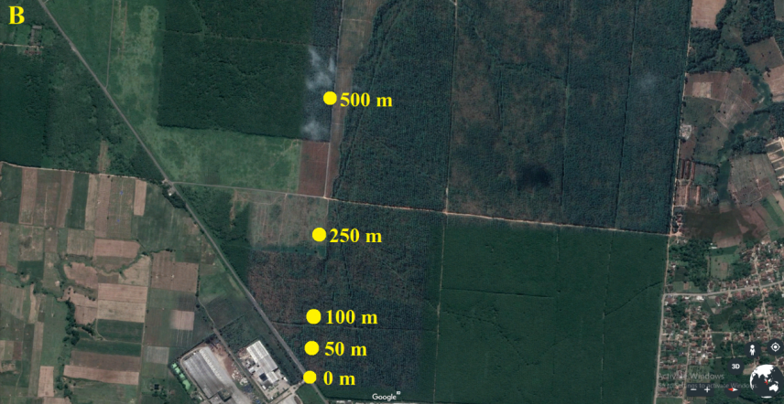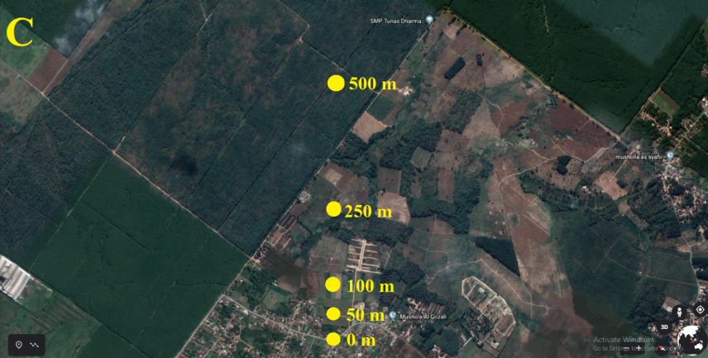

Figure 2. Soil sampling sites in Tanjung Bintang South Lampung

(A. Industrial Area, B. Heavily Traffic Road, C. Residential Area).

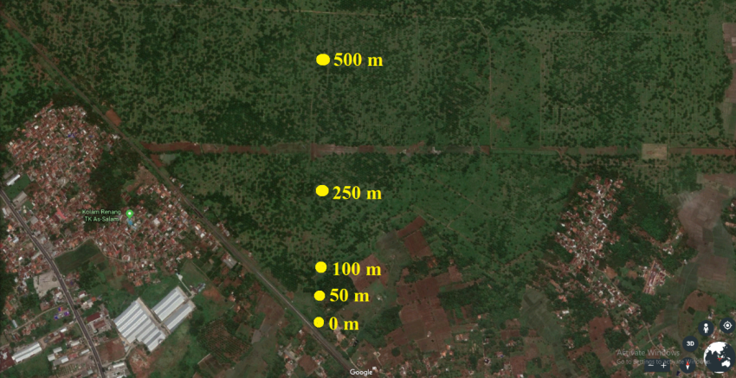

Figure 3. Soil sampling sites in Natar South Lampung (Coal Rail Road).

Soil sample from each location was composite, taken from Ap horizons at 3 sampling points of 10 m apart around each sampling site. Soil samples were air-dried, sieved to 2 mm, and thoroughly mixed before analysis. Heavy metals in soil were extracted by employing 1 *N* HNO3. The concentrations of Pb and Cu after filtration using whatman papers were measured using the iCE 3000 flame atomic absorption spectrophotometer (Flame AAS).

1. **Results and Discussion**

The absolute values of the concentrations of Pb and Cu at the center points (0 m) for each area and each heavy metal source type are listed in table 2. The concentrations of Pb and Cu were shown to be much higher in the industrial area, heavily traffic road, and residential area of Panjang than those in Tanjung Bintang except that Cu in the residential area of Tanjung Bintang was much higher than that in Panjang. The center point of the residential area of Tanjung Bintang was fairly close to a temporary disposal site for residential trashes, causing higher Cu. The higher Pb and Cu concentrations in Panjang are easily understood because the industrial area of Panjang was much older than that of the relatively new established industrial area of Tanjung Bintang. The industrial area of Tanjung Bintang was established recently while that of Panjang was established long time ago. The heavily traffic road of Panjang was also much older and was the main road for transportation from Jakarta to Palembang, while that of Tanjung Bintang was relatively new and not the main road with heavy traffics. In addition, it was very clear in the field that the area of Panjang was bordered by relatively stiff hills to the north (figure 1), that may have hindered the movement of metal movement through air system.

**Table 2. The soil concentrations of Pb and Cu at the center points (0 m).**

|  |  |  |  |
| --- | --- | --- | --- |
|  | Industry | Heavily Traffic/  Rail Road | Residential  Area |
|  | ……………..………mg kg-1 …………….………. | | |
| **Pb** |  |  |  |
| Panjang | 7.31 | 4.34 | 3.59 |
| Tanjung Bintang | 1.61 | 1.87 | 2.74 |
| Natar | - | 2.49 | - |
| **Cu** |  |  |  |
| Panjang | 27.0 | 5.60 | 3.59 |
| Tanjung Bintang | 0.54 | 1.09 | 12.1 |
| Natar | - | 1.19 | - |
|  |  |  |  |

The significant differences between Panjang, Tanjung Bintang and Natar was also consistently shown by two different types of heavy metals sources, i.e industrial area and heavily traffic roads (table 2). For example, the concentrations of Pb and Cu in the industrial area of Panjang were respectively 4.54 times and 50.0 times greater than those in Tanjung Bintang. The concentrations of Pb and Cu in the heavily traffic roads of Panjang were respectively 2.32 times and 5.14 times greater than those in Tanjung Bintang. These observations suggest that the accumulation of Pb and Cu in Panjang were more intense than that in Tanjung Bintang.

The relative concentrations of Pb (PbR) and Cu (CuR) as a function of distances from the center points (0 m) for each area and heavy metal sources are depicted in figure 4 and figure 5, respectively. The PbR or CuR is the ratio of soil Pb or Cu concentration at any sampling distance compared to that at the center points (0 m) as expressed by Equation 1 and Equation 2, where PbR or CuR is the relative concentration of Pb or Cu, Pbi or Cui is the concentration of Pb or Cu at distances i, and Pb0 or Cu0 is the concentration of Pb or Cu at the center point (0 m), and i is distance from the center point, i.e 0, 50, 200, 250, or 500 m.

|  |  |
| --- | --- |
| PbR = | (1) |
| CuR = | (2) |

The PbR for all areas and all heavy metal sources shows a pretty similar pattern, with the highest was at the center points (0 m), and decreased with sampling distances and being the lowest at the farthest points (figure 4). However, there were differences in the magnitude of Pb movements. The PbR at 100 m was only 20% of the center point in Panjang, while that in Tanjung Bintang was 80% of the center point at the same distance, and that at 500 m was about 75%. This observation shows that Pb in Tanjung Bintang moved away freely due to the more level topography (figure 2) while in Panjang the Pb movement was hindered by the bordering stiff hills (figure 1). Therefore, Pb was accumulated more at closer distances from the center point in Panjang. The pattern of Pb distribution in Natar was in general similar to that in Tanjung Bintang due to its similar topography (figure 3).

The movement of Pb from heavily traffic road in Panjang was also similar to that from the industrial area, but Pb moved more freely because hills were located further away from the center point (figure 1). However, the movement of Pb from the heavily traffic road in Tanjung Bintang was similar to that in the industrial area (figure 4). The PbR at 250 m of about 0.90 in Tanjung Bintang was higher than that in Panjang of about 0.40 due to the hindering hills. Therefore more Pb was accumulated in Panjang than that in Tanjung Bintang at the same distances. The patterns of CuR and Cu movement were in general similar to that of Pb (figure 5). The concentration of Cu was highest at the center point (0 m) and decreased with sampling distances.

The concentrations of Pb and Cu in the residential area of Panjang were comparable to those in heavily traffic roads (table 2). However, Pb and Cu were relatively evenly distributed along the soil sampling sites of 50 – 250 m with PbR and CuR 80 to 70% and 85 to 70%, respectively (figure 1 and figure 2). Similarly, Pb in the residential area of Tanjung Bintang was comparable to that in the heavily traffic road (table 2), but it was distributed at lower portion from 70 to 50% (figure 1). Part of Pb moved farther than 250 m (figure 1).

The concentration of Cu in the residential area of Tanjung Bintang was relatively high, about 11 and 22 times much higher than those in the heavily traffic road and industry, respectively (table 2). However, much lower concentrations (< 5%) were found at 50 to 500 m. This phenomenon indicates that the contaminating Cu did not move away from its source.

1. Panjang Bandar Lampung
2. Tanjung Bintang South Lampung
3. Natar South Lampung

Figure 4. The relative concentrations of Pb along the sampling sites in Lampung.

1. Panjang Bandar Lampung
2. Tanjung Bintang South Lampung
3. Natar South Lampung

Figure 5. The relative concentrations of Cu along the sampling sites in Lampung.

1. **Conclusion**

There were similar patterns of Pb and Cu distributions along the sampling points. The soil concentrations of Pb and Cu were highest at the center points (0 m) and decreased with distances towards the farthest sampling points of 500 m. The concentrations of Pb and Cu in Panjang were higher than those in Tanjung Bintang and Natar, indicating that the soil pollution by all heavy metal sources was higher in Panjang.

**References**

[1] Ng C C and Boyce A N 2016 Heavy metals phyto‑assessment in commonly grown vegetables: water spinach (*I . aquatica*) and okra (*A . esculentus)* *Springerplus* **5** 1-9.

[2] Srivastava V, Sarkar A, Singh S, Singh P, De Araujo A S F and Singh R P 2017 Agroecological responses of heavy metal pollution with special emphasis on soil health and plant performances *Frontiers Environ. Sci.*  **5(**64) 1–19

[3] Wuana R A and Okieimen F E 2011 Heavy metals in contaminated soils: a review of sources, chemistry, risks and best available strategies for remediation *ISRN Ecol.* ID 402647 1-20

[4] Sodango T H, Li X, Sha J and Bao Z 2018 Review of the spatial distribution, source and extent of heavy metal pollution of soil in China: impacts and mitigation approaches *J. Health Pollut.* **8**(17) 53-70

[5] Miao X, Hao Y, Zhang F and Zou S 2019 Spatial distribution of heavy metals and their potential sources in the soil of Yellow River Delta: a traditional oil field in China *Environ. Geochem. Health* DOI 10.1007/s10653-018-0234-5

[6] Sharma S, Sharma P and Mehrotra P 2010 Bioaccumulation of heavy metals in *Pisum sativum* L. growing in fly ash amended soil *J. Amer. Sci.* **6**(6) 43–50

[7] Biasioli M, Kralj T, Grčman H, Díaz-Barrientos E, Madrid F and Ajmone-Marsan F 2007 Potentially toxic elements contamination in urban soils *J. Environ. Qual.* **36**(1) 70

[8] Wang M and Zhang H 2018 Accumulation of heavy metals in roadside soil in urban area and the related impacting factors *Int. J. Environ. Res. Public Health* **15***(1064) 1-11*

[9] Jamal Q, Khan K, Munir S and Anees M 2013 Heavy metals accumulation and their toxic effects: review heavy metals accumulation and their toxic effects *J. Bomol. Sci.* **1**(1-2) 27-36

[10] Yunus K, Zuraidah M A and John A 2020 A review on the accumulation of heavy metals in coastal sediment of Peninsular Malaysia *Ecofemininism Climate Change* DOI 10.1108/EFCC-03-2020-0003

[11] Popova E, System S and Popova E 2016 Accumulation of heavy metals in the ‘soil- plant’ system *AIP Conference Proc.* 1772,050006(2006)

[12] Smolders E, Oorts K, Lombi E, Schoeters I, Zrna S and Mclaughlin M J 2012 The availability of copper in soils historically amended with sewage sludge, manure, and compost *J. Environ. Qual.* **7**(66) 506-14

[13] Selvi A, Rajasekar A and Theerthagiri J 2019 Integrated remediation processes toward heavy metal removal/recovery from various environments - a review  *Frontiers Environ. Sci.* **7**(66) 1-15

[14] Ishii Y, Hamano K, Kang D, Idota S and Nishiwaki A 2015 Cadmium phytoremediation potential of Napiergrass cultivated in Kyushu , Japan Article ID 756270

[15] Mazumdar K and Das S 2014 Phytoremediation of Pb , Zn , Fe , and Mg with 25 wetland plant species from a paper mill contaminated site in North East India *Environ Processes* DOI 10.1007/s11356-014-3377-7

[16] Kambhampati M S and Vu V T 2013 Enhanced phytoremediation of copper contaminated soils using chickpea (*Cicer aeritinum* L .) *Bull. Environ. Contam. Toxicol.* **91** 310–313

[17] Hashim M A, Mukhopadhyay S, Narayan J and Sengupta B 2011 Remediation technologies for heavy metal contaminated groundwater *J. Environ. Manag.* **92** 2355-88

[18] A. K. Salam 2000 A four year study on the effects of manipulated soil pH and organic matter contents on availabilities of industrial-waste-origin heavy-metals in tropical soils *J. Trop. Soils* **11** 31–46

[19] Laidlaw W S, Arndt S K, Huynh T and Baker A J M 2012 Phytoextraction of heavy metals by willows growing in biosolids under field conditions *J. Environ. Qual.* **41** 134-143

[20] Duus J, Lekfeldt S, Holm P E, Kjærgaard C and Magid J 2017 Heavy metal leaching as affected by long-time organic waste fertilizer application *J. Environ. Qual.* **46**(4) 871–878

[21] He Z L, Zhang M K, Carvert D V, Stoffella P J, Yang X E and Yu S 2004 Transport of heavy metals in surface runoff from vegetable and citrus fields *Soil Sci. Soc. Am. J.* **68**(5)1662-69

[22] Elbana T A dan Selim H 2010 Cadmium transport in alkaline and acidic soils: miscible displacement experiments *Soil Sci. Soc. Am. J.* **74** 1956-66

[23] Salam A K, Bakrie S and Prihatin F 2005 Depth-wise distribution of extracted Cu and Zn in cultivated field-plots after treatment with a Cu- and Zn-containing waste, lime, and cassava-leaf compost *J. Trop. Soils* **11**(1) 9–14

[24] Mircea M, Silibello C, Calori G, Costa M P, Dirodi G, Radice P, Vitali L and Zanini G 2013 A study of heavy metals pollution in Italy with the atmospheric modelling System of the MINNI project  *E3S Conference 1* **03003** (2013)

[25] Arshad N, Hamzah Z, Wood A K, Saat A and Alias M 2016 Determination of heavy metals concentrations in airborne particulates matter (APM) from Manjung District, Perak, using energy dispersive X-ray fluorescence (EDXRF) spectrometer *AIP Conference Proc.* 1659, 050008 (2015)

[26] Timothy N and Williams E T 2019 Environmental pollution by heavy metal: an overview *Int. J. Environ. Chem.* **3**(2) 72–82

[27] Gaza T and Kugara K 2018 Study of heavy metal air pollution using a Moss (*Grimmia dissimulate*) biomonitoring technique *Universal J. Chem.* **6**(1) 1–13

[28] Salam A K 2017 *Management of Heavy Metals in Tropical Soil Enviroment*, 1st Edition. Bandar Lampung: Global Madani Press 257 p