ISOLATION AND IDENTIFICATION OF ENTOMOPATOGEN FUNGI AS A CANDIDATE OF BIOINSECTICIDE FROM FLIES AND COCKROACHES’ (INSECT VECTOR’S DISEASE)

Emantis Rosa¹, C.N Ekowati², Tundjung T. Handayani³, Endang L. Widiastuti⁴
¹Faculty of Mathematics and Natural Sciences, University of Lampung
e-mail: emantisrosa@gmail.com
²Faculty of Mathematics and Natural Sciences, University of Lampung
e-mail:
³Faculty of Mathematics and Natural Sciences, University of Lampung
e-mail:
⁴Faculty of Mathematics and Natural Sciences, University of Lampung
e-mail: elwidi@yahoo.com

Abstract: Chemical insecticide has been used for many years to eradicate insects as disease vector, in which causing negative effects not only to those of target insects but also to the environment both in the short and long term. Therefore, it is necessary to determine an alternative biological control of this insect by using natural insecticide (bioinsecticide), such as using fungi as entomopathogen. As microorganism, fungi, contain of bioactive compound with their toxicity could kill the target insect from larvae to adults, called entomopathogen fungi. This entomopathogen fungi are presumably eco-friendly and able to produce toxic compound which can kill target insect such as cyclopeptida destruxin A, B, C, D and desmethyldestruxin B. Two of the fungi which known to be entomopathogenic are Metarhizium anisopliae and Beauveria bassiana. Yet, there should be more others, therefore it is necessary to explore and isolate any potential bio-insecticide of entomopatogen fungi for disease vectors such as from flies (Musca domestica) and cockroach (Periplaneta americana). This study found three isolated fungi from flies (L1, L2, L3). They were Geotrichum sp., Penicillium sp., and Aspergillus sp. Three isolated fungi from cockroach (K1, K2, K3) were also found, they were identified as Aspergillus sp., except for K3 Penicillium sp.
Keywords: bioinsecticide, entomopathogen, Aspergillus, Penicillium, Geotrichum
- Introduction
Many cases of vector-borne diseases in the community are transmitted by flies and cockroaches, which act as vectors for parasitic diseases such as ascariasis, diarrhea and dysentery. Chemical insecticides are widely used in controlling such vectors, however, negative externalities emerged from the usage of such insecticides are evident in recent studies, i.e. resistance to vectors, the death of non-target animals, and pollution [1,2]. Therefore, it is necessary to explore the potential of natural materials that are not only effective in eradicating insects that acts as a vector role, but also safe for both health and environment; such as entomopathogenic fungi.
Entomopathogenic fungi which are known to be able killing mosquito larvae are Geotrichum candidum, Beauveria bassiana, Metarhizium anisopliae. These fungi produce destruxin B and beauvaricin compounds which are considered effective in killing larvae (larvicides) [3]. This study by employing Beauveria bassiana against the Orthoptera Order, found that increasing in conidia concentration up to 108 conidia/ml caused 43.33% death [3]. Isolation of entomopathogenic fungi, Metarhizium anisopliae, also indicated able to control flies (Musca domestica L.) (Diptera: Muscidae) [4], while this Metarhizium sp. isolate was also pathogenic to S. litura eggs [5]. Yet, the ability of fungi to kill target insects depends on the enzymatic activity of fungi itself [6]. These enzymes contribute in the process of fungal infection in target insects, starting from spore penetration into the host's body until attacking the insect's digestive tract. The types of fungi that are potential to act as bioinsecticides for insect disease vectors is still limited, therefore, this study thrives to explore the isolation and identification of entomopathogenic fungi originating from flies and cockroaches.

- Methods
This research was conducted in April - November 2018 at the Microbiology Laboratory of the Department of Biology, Faculty of Maths and Sciences, The University of Lampung. The tools and materials used in this study were adjusted to meet the requirement of conducting this study, while the equipment followed the standards of isolation and identification for fungi by the Microbiology Laboratory. This research was conducted through two stages; the isolation stage and the identification stage. Insects used as entomopathogenic fungal agents are originated from Musca domestica (flies) and Periplaneta americana (cockroaches). The identification process was performed, both by macroscopic and microscopic, on the morphology of colony.
Entomopathogen Fungi Isolation
Insects used to determined for entomopathogenic fungi agents were cockroaches and flies. These insects were left to die, then placed in a petri dish covered with a damp sterile filter paper. The petri dishes were left at room temperature (28-30ºC), for 10 days until the insect's body was covered with fungi. The fungi that grows on the insect body were isolated then planted on the PDA medium. Then, they were incubated at room temperature (28-30°C), for 14 days. As fungi started to emerge, they were left to be purified on a sloping medium for identification. Macroscopic and microscopic identifications were carried out by following other studies [7, 8]. The goal from macroscopic identification was to identify colony’s color and shape, while microscopic identification aimed at identifying the hyphal structure, spore’s shape and location, and the presence of special structures (vesicles, stericata, vialid l) following other study [9]. The results of the observations were analyzed descriptively and presented in tables and figures

- Results and Discussion

The study indicated that there were 6 fungi isolates collecting from houses flies and cockroaches. Their characters can be seen in Table 1 for macroscopic characters and Table 2 for microscopic characters.

Tabel 1. Macroscopic morphological characteristics of the colony of fungi isolates from flies and cockroaches

No | Animal sample | Isolate code | Color |  | Shape | Edge
 |  |  | Surface | Base
1 | House flies | L1 | White | Hyaline | Circular | Entire
2 |  | L2 | Green | Hyaline | Circular | Undulate
3 |  | L3 | Yellowish-white | Hyaline | Rhizoid | Filamentous
4 | Cockroaches | K1 | Grayish-green | White | Circular | Undulate
5 |  | K2 | Black | White | Circular | Undulate
6 |  | K3 | White | Hyaline | Myceloid | Filamentous

From the macroscopic characters then identification of entomopathogenic fungi was further investigated as well as their microscopic characters. Macroscopic characteristics of Isolate L1 (Table 1) consisted of colony with white and cotton-like filaments, they also had smooth and even edges. Isolate L1 was consisted of insulated hyaline hyphae which did not have conidiophores. Their isolate colony and morphology of entomopathogenic fungi from flies and cockroaches could be seen in Figure 1.

Tabel 2. Results of the microscopic character identification of entomopathogenic fungi isolates from flies and cockroaches

Isolate | Conidia Structure | Conidiophore | Hypha | Vesicle | Phialide | Foot-cell | Identification
L1 | Short & cylindrical | - | Insulated | - | - | - | Geotrichum sp.
L2 | Globose | Branched off | Insulated | - | single | - | Penicillium sp.
L3 | Globose | Erect | Insulated | Oval | single | Yes | Aspergillus sp.
K1 | Globose | Erect | Insulated | Oval | single | Yes | Aspergillus sp.
K2 | Globose | Erect | Insulated | Oval | single | Yes | Aspergillus sp.
K3 | Globose | Branched off | Insulated | - | single | - | Penicillium sp.

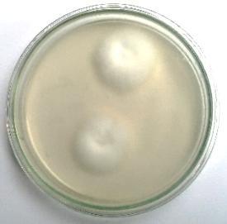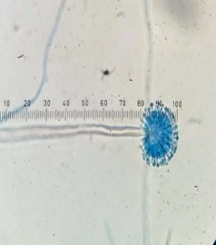 L1
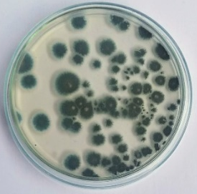 L2, K3
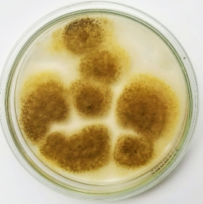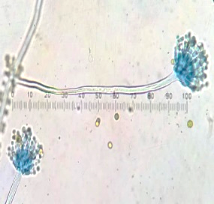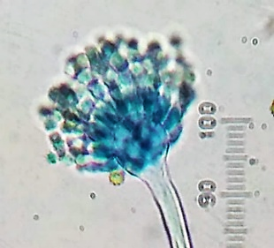 L3, K1 ,K2
Figure 1. Isolate colony and morphology of entomopathogenic fungi from flies and cockroaches
Conidia (arthospores) are short and cylindrical with insulated end that form chain-shaped, and at the size of 5 µm (Figure 1, L1). This morphological characteristic gives well resemblance to the Geotrichum sp. genus.

The colony from L2 and K3 isolates were either green or white, with white edges. The result showed that L2 and K3 have a morphological structure like a brush. The conidia was round-shaped or cylindric-shaped with a diameter of 2.5 µm. It also resembled chain-shaped and was located at the end of a single phialide. The result also revealed branch that support the round-shaped phialide. The conidiophores were branched off. The length of the conidiophores was ranging from 22.5 to 27.5 µm.

Based on the morphological characteristics observed, L2 and K3 isolates had characteristics in accordance with findings by Kurasein [8], in which Penicillium sp. genus was characterized by its feature of hyphae with septa, conidia, sterigma, and conidioconidia (shown in Figure 1). In addition, other characteristics of Penicillium sp. were also noted, such as having branched mycelium, conidioconidia that appear on the surface of the conidia with clustered sterigma, and conidia form chains [9].

Isolates L3, K1 and K2 were characterized by insulated hyphae with a diameter of 7.5 µm. The conidiophore was at length 275 µm, while also having upright and simple structure. On the top of the conidiophore, single phialide was attached to the vesicle. The vesicles were oval-shaped with a diameter of 25x20 µm. Its conidia was 5 µm in length with a round-chain-shaped at the end of pumpkin-shaped phialide (Table 2). This morphological feature resembles to the genus Aspergillus sp (Figure 1, L3, K1, K2).

Microscopically of Aspergillus sp. with a bluish-green round-shaped conidia, while the head of the conidia (vesicle) is clavate or round-shaped, and as its colony grows, it would experience transformation into oval-shaped (columnar) and own conidia stalk (conidiophora) [10]. In addition, according to other study [11], Aspergillus sp. had sterigmata which seemingly cover the upper half part of the vesicles, it also had conidia with a serrated surface.

The size of conidia in Aspergillus might vary due to the differences in gene regulation that determine the establishment of conidia through the conidiation process. Such process leads to the difference in gene expression [12].

The color and time needed for growth of fungi colonies might be affected by several factors; i.e. nutrition, pH, temperature and humidity. Different types of fungi require different nutritions. Therefore, even different types of fungi might be grown in the same media and environmental conditions, it was possible that they would respond differently. Each type of fungi had a different optimum requirement of pH, temperature, and humidity to support its growth, for instance, Aspergillus flavus fungi requires pH of 6, temperature of 25 ℃ and humidity of 90; whereas Penicillium chrysogenum requires pH of 7, temperature of 30 ℃ and humidity of 90 for its growth [13].

- Conclusion
- Three fungi isolates were obtained houseflies, they were L1, L2 and L3 and through macroscopic and microscopic identification they revealed to be Geotrichum sp, Penicillium sp. Aspergillus sp.
- Three fungi isolates also fund from cockroaches, they were K1, K2 and K3, which were identified to be Aspergillus sp. and Penicillium sp.

References
[1] Nejati Jalil., Boostanbakhsh Atefeh. 2012. Cockroaches bacterial infections in wards of hospitals, Home dan city, west of Iran. Asian Pacific Journal of Tropical Disease. Vol. 2: 381-384
[2] Rahman ,M.S dan Soviana ,L.2016. Perbedaan Kerentanan status nyamuk Aedes aegyptiterhadap Malathion di Kabupaten Bantul Yogyakarta Jurnal Kesehatan Masyarakat. Volume 11 no 2.
[3] Dewantara Neil, A. Wibowo N, Felicia J.2017. Efektivitas Beauveria bassiana (Bals.) Vuillemin Sebagai Pengendalian Hama Belalang Kayu (Valanga nigricornis Burm). 1-14. ISSN.
[4] Yunizar, N., Rahmawati.,Kustiati. 2018. Patogenitas Isolat Jamur Entomopatogen Metarhizium anisopliae terhadap Lalat Rumah (Musca domestica L.) (Diptera: Muscidae). Jurnal Protobiont. Vol. 7(3): 77-82.
[5] Trizelia, M.Y. Syahrawati, Dan A. Mardiah. 2011. Patogenisitas Beberapa Isolat Cendawan Entomopatogen Metarhi zium spp. terhadap Telur Spodoptera litura Fabricius (Lepidoptera: Noctuidae). J. Entomol. Indon., 8 (1): 45-54
[6] Halimah, N. Imaningsih W. Mariana. 2018. Karkterisasi Morfologi Jamur Entomopatogen di Hutan Mandiangin Banjarbaru, Kalimantan Selatan. Jurnal Mikologi Indonesia. Vol. 2(1): 39-48
[7] Humber, A.R. 2005. Entomopathogenic Fungal Identification. American Phytopathological Society and Entomological Society of America. Las Vegas, Nevada
[8] Barnett dan B.B. Hunter. 1998. IlustratedGenera of Imperfect Fungi. 4th Edition. Macmillian Publishing Company. New York.
[9] Ganjar, I., Wellyzar Sjamsuridzal dan ariyanti Oetari. 2006. Mikologi Dasar dan Terapan.Yayasan Obor Indonesia. Jakarta.
[10] Kurasein, Riccardo AA Muzzarelli.2009. Chitin. Elsavier.
[11] Fardiaz, S. 1989. Penuntun Praktikum Mikrobiologi Pangan. PAU Pangan dan Gizi IPB. Bogor.
[12] Redig, P. 2005. Mycotic infections in birds I: Aspergillosis. Nort American Veterinary Conference Proceedings, Eastern States Veterinary Association. 1192-1194.
[13] Praja, Ratih Novita., Yudhana, Aditya. 2017. Isolasi dan Identifikasi Aspergillus spp. Pada Paru-Paru Ayam Kampung yang dijual di Pasar Banyuwangi. Jurnal Medik Veteriner. Vol. 1 No. 1 : 6-11.
[14] Hyuk, Jae and Yu. 2010. Regulation of Development in Aspergillus nidulans and Aspergillus fumigatus. Journal of Mycobiology. Vol. 38(4) : 229-237.
[15] Singh, Ward, O.P. 2013. Proteolytic enzymes. In: Young, M.M., Comprehensive Biotechnology: The principles, Applications, and Regulations of Biotechnology in Industry, Agriculture and Medicine. Volume 3. Oxford: Pergamon Press.

