Deep Learning for detection cassava leaf disease
H R Ayu¹, A Surtono¹, and D K Apriyanto¹
¹ Department of Physics, University of Lampung, Soemantri Brodjonegoro street, Bandar Lampung, Indonesia

email: humairoh.ratu@fmipa.unila.ac.id

Abstract. In this research, an intelligent system for detecting cassava leaf disease has been developed by utilizing the MobileNetV2 deep learning model and displaying it using a python graphical user interface (GUI). There are five disease classes used in this study, namely Cassava Bacterial Blight (CBB), Cassava Brown Steak Disease (CBSD), Cassava Green Mite (CGM), and Cassava Mosaic Disease (CMD) and Healthy. The results showed that the overall accuracy of the test data obtained was 65,6%. The GUI application program was made to be operated efficiently for beginners and can be used by cassava farmers in the field.
Keyword: deep learning, cassava leaf, mobilenetv2, GUI
- Introduction
Cassava is a rich plant in protein and vitamins, especially in the leaves [1] also, cassava is also used as a staple substitute for rice. Based on data from the Central Statistics Agency of Bandar Lampung City from 2015-2017, cassava production ranks second with a total production of 5,323.00 tons after rice plants with a total production of 29,583.68 tons. However, cassava production decreased in 2018 by 34.5% compared to the previous year (Central Statistics Agency of Bandar Lampung City, 2019). This is due to the decline in the harvested area that occurs due to disease attacks on cassava plants. Various kinds of diseases on cassava leaves are caused by pests, viruses, bacteria, and fungi [2]. This study focuses on detecting four diseases that are often experienced by cassava leaves, namely Cassava Bacterial Blight (CBB), Cassava Brown Steak Disease (CBSD), Cassava Green Mite (CGM), and Cassava Mosaic Disease (CMD).
Leaves that are attacked by the disease will affect crop yields because leaves are a vital part of the plant, which functions as a place for photosynthesis to take place. The phloem tissue transports the results of photosynthesis to all other parts of the plant. If the plant's leaves are healthy and the photosynthetic process is carried out correctly, then the growth of the stems and tubers is also perfect. However, if the leaves are attacked by disease, and the photosynthetic process is disturbed, the growth of stems and tubers is also disturbed, causing low-quality crop yields. A laboratory test or assistance from a plant expert is usually carried out to detect a disease in cassava leaves. However, to carry out laboratory tests is often constrained by cost issues, as well as an expert cannot detect it on time, so farmers cannot deal with disease problems in cassava leaves quickly and accurately. Therefore, we need an intelligent system that can solve these problems like an expert with an interactive display using python graphical user interface (GUI) software, which aims for easier operation.
Several studies that utilize artificial intelligence have been conducted, such as determining the flavonoid compounds from guava leaf extract using the Adaptive Neural Fuzzy Inference System (ANFIS) [3]. In addition, methods used to detect disease use images such as case-based reasoning [4], the Dempster Shafer method [5], spectral data [6], and image segmentation and soft computing [7]. However, these methods do not carry out the learning process on the dataset, so a method is needed that can carry out the learning process on the dataset and modify the network in order to achieve high accuracy results, the method proposed in this study is the convolutional neural network (CNN). The CNN method has the most significant results in image recognition. This is because the CNN method has the ability to process two-dimensional data/images. Networks on CNN have a special layer called the convolutional layer. In the convolution layer, input in the form of an image will produce a pattern from several parts of the image so that it is easier to classify. Based on this, the CNN method can make the image learning function more efficient to implement.
- Methods
  - The cassava datasets
Images of cassava leaves were obtained from the Kaggle competition, which consists of five classes, namely: Cassava Bacterial Blight (CBB) (466 pictures), Cassava Brown Steak Disease (CBSD) (537 pictures), Cassava Green Mite (CGM) (450 pictures), Cassava Mosaic Disease (CMD) (548 images) and Healthy (316 images) [8]. In conducting experiments, the dataset is divided into three parts, namely 70% training data, 20% validation data, and 10% test data of the total datasets used. An example of a picture of cassava leaves as a dataset for each class is shown in Figure 1. The main symptoms and bacteria that cause disease experienced by cassava leaves include:
CBB is a disease caused by the bacteria Xanthomonas manihotis, generally in humid areas [8]. Initial symptoms of angled lesions, tissue death at the site of infection to shoot death. CBSD is caused by the whitefly virus Bemisia tabaci (Genn). There are two symptoms of leaves, including yellow chlorosis on secondary and tertiary leaf bones [2], the second type of symptom is chlorotic patches. Typical symptoms of this viral infection are the development of dry sepia to brown, foamy, and necrotic sores in the tuber tissue. CGM is caused by the pest Mononychellus tanajoa by eating the undersides of young leaves. This causes chlorosis because chlorophyll is sucked from the cells; as a result, the leaves turn punctate, die, and abscissa. CMD is a disease caused by a virus that belongs to the genus Begomovirus. Symptoms experienced in leaves include a mixture of yellow and white chlorotic patches, which depending on their severity, affect photosynthesis and stunt the plant. This results in a quantitative decrease in yields [8] [2].

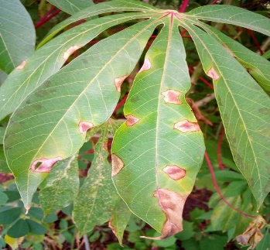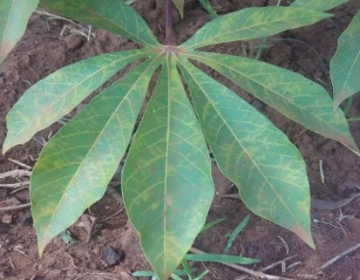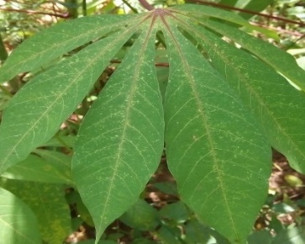
A
C
B
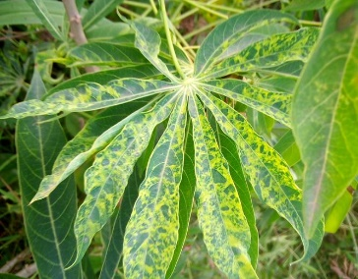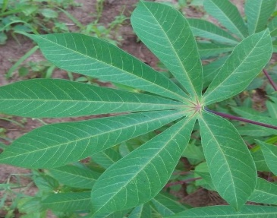
D
E
Figure 1. Example of a picture of cassava leaves that represent each class from the dataset. (A) CBB,
(B) CBSD, (C) CGM, (D) CMD and (E) Healthy
  - Deep learning model: MobileNetV2
MobileNetV2 is a convolutional neural network (CNN) architecture that can be used for object identification, segmentation, and classification [9]. The input size used in this study is 224x224 pixels. The architecture of this model consists of filters which can be separated in-depth and shown in Figure 2. At each location, a matrix multiplication is performed and sums the results onto the feature map. Furthermore, the input feature is divided into two layers, and each layer is further divided into the next layer by combining it with the output feature until the process is complete [10].
The MobileNetV2 model uses an interlayer activation function, which allows the nonlinear layers from the previous layer to be linearized and transferred as input to the next layer. The model continues the training process until it reaches the best level of accuracy. This model is able to outperform existing solutions and is computationally feasible to implement [10].

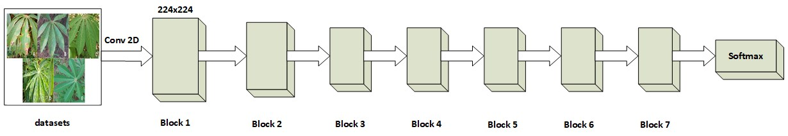
Figure 2. The architecture of the MobileNetV2 model
  - Graphical user interface (GUI)
A software should be user friendly so that it can be operated easily for a beginner. The application program for detecting diseases in cassava leaves is designed to be operated by farmers who have never learned a programming language. The interactive display of the made consists of only two buttons. The first button is the upload button to enter the image of cassava leaves to be detected and the second button is reprocessing, which functions to process the input image using the MobileNetV2 model. The interactive display output is the type of disease detected by the program and the resulting error value.

- Results and Discussion
  - Model performance
The performance of the model used to detect disease in cassava leaf images with the overall accuracy of the data train and validation was 74.5% and 67.3%, respectively. The graph of the level of accuracy and losses in the training and validation process is shown in Figure 3.

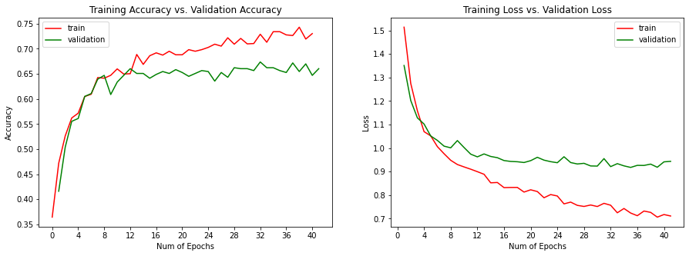
Figure 3. Graph of accuracy and losses in the training and validation process
Many researchers have used the level of accuracy as a factor to determine the performance of the model carried out [11] - [14]. The testing process carried out by the MobileNetV2 model obtained an overall accuracy rate of 65.6%. The average accuracy of the model class performs best in the Healthy class, followed by CBSD, CGM, CMD, and CBB. A detailed analysis of how the model performance changes for various class categories on the cassava leaf test data is presented in the confusion matrices in Figure 4. Diagonal cells show the results detected correctly by the model, namely the proportion of observations that match the basic truth annotations and predictions. The other cells show where the model made the wrong prediction. A high level of confusion occurs in the type of CMD disease, but what is detected is CBSD. This is the same as experienced in a study conducted [15]. The difficulty in distinguishing the two diseases' symptoms is a common problem facing researchers in the field.
The model's ability to detect diseases in cassava leaves resulted in a higher level of accuracy than previous studies that have been conducted [15], with an accuracy rate of 43.2% and 29.4% for image and video data with low severity. These results indicate that the model has worked better than guessing at random. The dataset also has various images, such as stacked leaves, images with too bright light, blurry images, various leaf positions, and different image backgrounds, such as ground, branches, hands, and feet that are too bright. Disturbing so that the model made is worthy of being said to have successfully detected disease in cassava leaves.

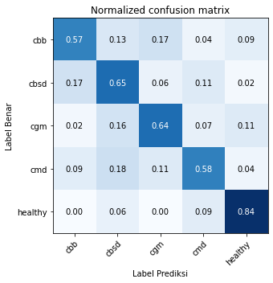
Prediction label
True label

Figure 4. Confusion matrices for cassava leaf image test data
  - Graphical user interface (GUI)
Application programs that have been created can be operated very easily by beginners. The graphical user interface (GUI) design view is shown in Figure. 5.
In the python GUI creation process using source code as follows:

def upload(self):
files_types = "JPG (*.jpg);;BMP(*.bmp);;PNG (*.png);;JPEG (*.jpeg)"
fileName, _=QFileDialog.getOpenFileName(None, 'Upload Image', './',files_types)
self.PATH_IMG = fileName
if fileName:
pixmap = QPixmap(fileName)
self.pixmap = pixmap.scaled(261,191)
QImage = self.pixmap.toImage()
self.image = QImage.copy()
self.ui.label_6.setPixmap(QPixmap.fromImage(self.image))

The source code above is used to run the upload button, the only files that can be uploaded have data types jpg, bmp, png, and jpeg. After the file has been successfully uploaded, an image will appear in the dialog box

Figure 5. GUI application program design view
def reprocessing(self):
self.ui.lineEdit.clear()
self.ui.lineEdit_2.clear()
img = cv2.imread(self.PATH_IMG )
img = cv2.resize(img, (224, 224), interpolation = cv2.INTER_CUBIC)
img = np.reshape(img, (1, 224, 224, 3))
img = img/255.
pred = model.predict(img)
class_num = np.argmax(pred)
probability = np.max(pred)
categories = ['Cassava Bacterial Blight (CBB)', 'Cassava Brown Streak Disease (CBSD)', 'Cassava Green Motle (CGM)', 'Cassava Mosaic Disease (CMD)', 'Healthy']
Jenis_Penyakit = categories[class_num]
Error = (1-probability)*100
self.ui.lineEdit.setText(Jenis_Penyakit )
self.ui.lineEdit_2.setText(str(round(Error,2)) )

While the reprocessing button is used to process the uploaded image using the model: MobileNetV. After the detection process is complete, the results will appear in the form of the type of disease experienced and the error value. The GUI application that was created has successfully run the program to detect diseases in cassava leaves. In the future, this program can be developed for mobile phone applications to be used quickly and accurately.
- Conclusion
The MobileNetV2 model can be used to detect five classes of diseases frequently experienced by cassava leaves. The five classes of diseases are Cassava Bacterial Blight (CBB), Cassava Brown Steak Disease (CBSD), Cassava Green Mite (CGM), and Cassava Mosaic Disease (CMD) and Healthy. The results showed that the test data's overall accuracy rate was 65.6%, this result is superior to the effects of previous studies. This research also creates an interactive display using the python GUI to be operated more easily by farmers.
References

[1] Sambasivam G and Opiyo G D. 2020. A predictive machine learning application in agriculture: Cassava disease detection and classification with imbalanced dataset using convolutional neural networks Egyptian Informatics Journal. Faculty of Computers and Information, Cairo University.
[2] Ramcharan A, Baranowski K ,McCloskey P, Ahmed B, Legg J, and Hughes D P. 2017. Deep learning for image-based cassava disease detection’, Frontiers in Plant Science, 8(October), pp. 1–7.
[3] Ratu Ayu H, Suryono S, Endro Suseno J, and Kurniawati R. 2018. Determination of the ultrasound power effects on flavonoid compounds from Psidium guajava L. using ANFIS. J. Phys. Conf. Ser., vol. 1025, no. 1.
[4] Oyelade O N, and Ezugwu A E. 2020. A case-based reasoning framework for early detection and diagnosis of novel coronavirus. Informatics Med. Unlocked, vol. 20, no. July, p. 100395.
[5] Peñafiel S, Baloian N, Sanson H, and Pino J A. 2020. Applying Dempster–Shafer theory for developing a flexible, accurate and interpretable classifier, Expert Syst. Appl., vol. 148.
[6] Owomugisha G, Melchert F, Mwebaze E, Quinn J A, and Biehl M. 2018. Machine learning for diagnosis of disease in plants using spectral data. World Congr. Comput. Sci. Comput. Eng. Appl. Comput. CSCE 2018 - Proc. 2018 Int. Conf. Artif. Intell. ICAI 2018, pp. 9–15, 2018.
[7] Singh V, and Misra A K. 2017. Detection of plant leaf diseases using image segmentation and soft computing techniques. Inf. Process. Agric., vol. 4, no. 1, pp. 41–49.
[8] Mwebaze E, Gebru T, Frome A, Nsumba S, and Tusubira J. 2019. iCassava 2019 Fine-Grained Visual Categorization Challenge.
[9] Toğaçar M, Ergen B, and Cömert Z. 2020. COVID-19 detection using deep learning models to exploit Social Mimic Optimization and structured chest X-ray images using fuzzy color and stacking approaches. Comput. Biol. Med., vol. 121, no. March.
[10] Jadon A, Varshney A, and Ansari M S. 2020. Low-Complexity High-Performance Deep Learning Model for Real-Time Low-Cost Embedded Fire Detection Systems. Procedia Comput. Sci., vol. 171, no. 2019, pp. 418–426.
[11] Sharma P, Berwal Y P S, and Ghai W. 2019. Performance analysis of deep learning CNN models for disease detection in plants using image segmentation,” Inf. Process. Agric., no. xxxx, pp. 1–9.
[12] Khan S, Javed M H, Ahmed E, Shah S A A, and Ali S U. 2019. Facial recognition using convolutional neural networks and implementation on smart glasses. 2019 Int. Conf. Inf. Sci. Commun. Technol. ICISCT 2019, pp. 1–6.
[13] Zhang W, Jin L, Song E, and Xu X. 2019. Removal of impulse noise in color images based on convolutional neural network. Appl. Soft Comput. J., vol. 82, p. 105558.
[14] Mohanty S P, Hughes D P, and Salathé M. 2016. Using Deep Learning for Image-Based Plant Disease Detection. vol. 7, no. September, pp. 1–10.
[15] Ramcharan A, McCloskey P, Baranowski K, Mbilinyi N, Mrisho L, Ndalahwa M, Legg J, and Hughes D P. 2019. A mobile-based deep learning model for cassava disease diagnosis. Front. Plant Sci., vol. 10, no. March, pp. 1–8.

Acknowledgement
The author would like to thank The University of Lampung for providing financial support for the implementation of this research through research grant with contract numbers 1485/UN26.21/PN/2020.

