LANGUAGE LEARNING STRATEGIES BASED ON GENDER
By Farida Ariyani

WORD COUNT | 2240 | TIME SUBMITTED | 05-JUL-2018 03:39PM
 |  | PAPER ID | 38549233

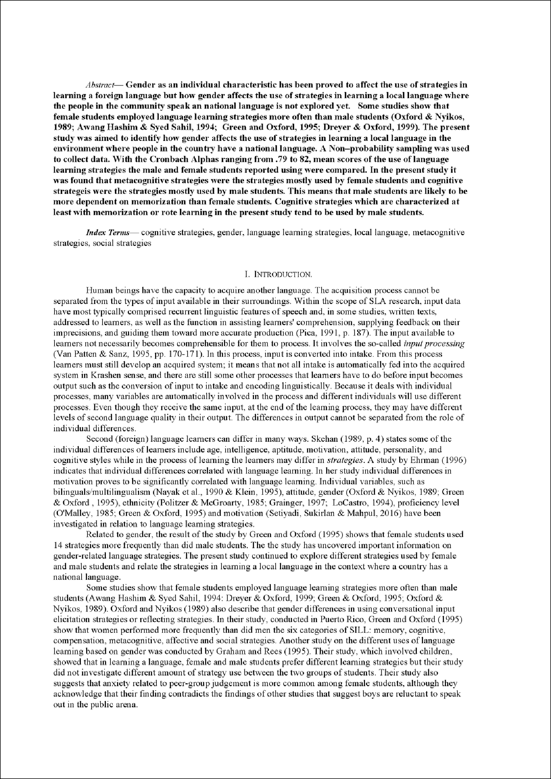

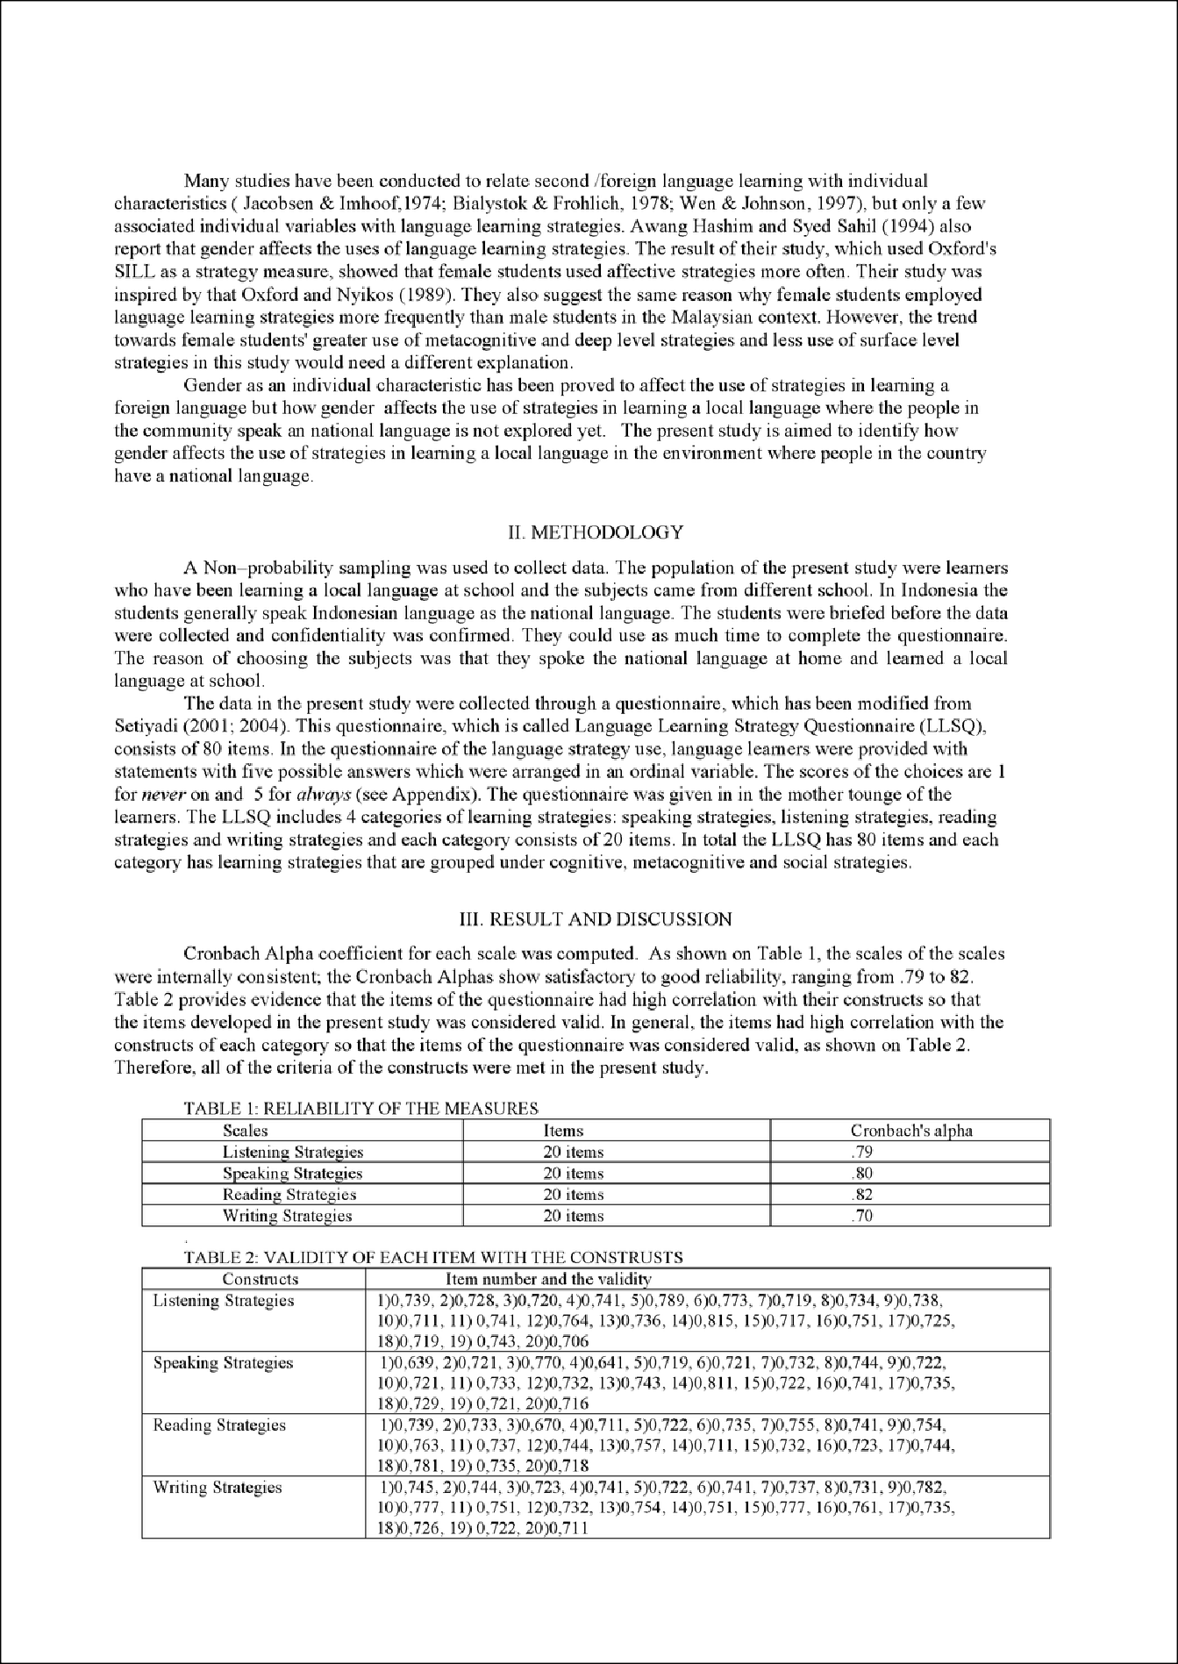

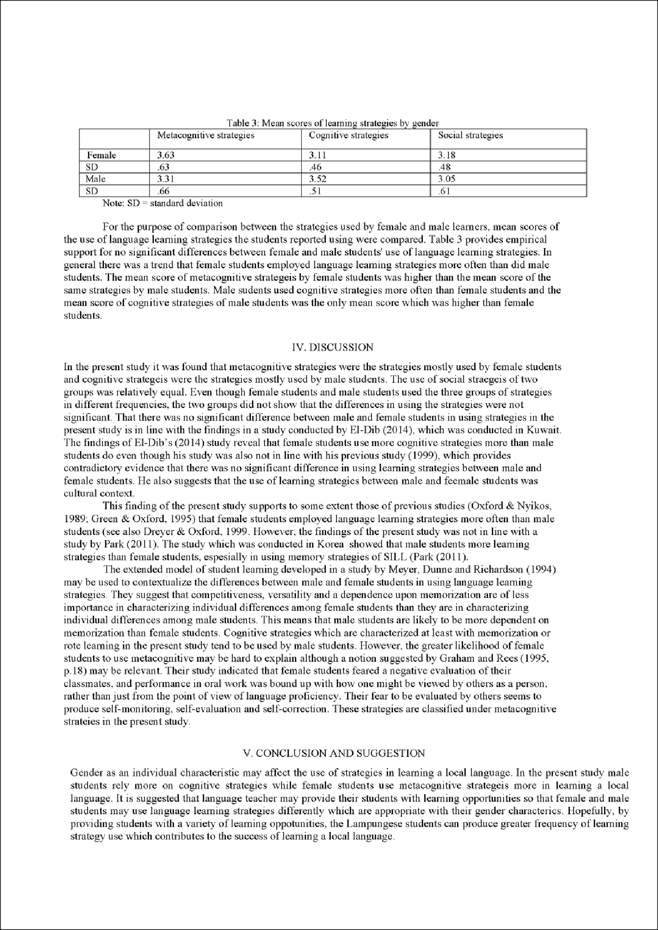

Learning a Local Language at School in Indonesian Setting
ORIGINALITY REPORT

14%
SIMILARIT Y INDEX

PRIMARY SOURCES

1 ccsenet.org
Int ernet

2 Suzanne Graham. "Gender differences in language learning: the question of control", Language Learning Journal, 3/1995
Crossref

3 Teresa Pica. "INPUT AS A THEORETICAL AND
RESEARCH CONSTRUCT. From Corder's Original
70 words — 3%

53 words — 2%

46 words — 2%

Definition to Current Views", IRAL - International Review of Applied Linguistics in Language Teaching, 1991
Crossref

4 J. H. F. Meyer. "A gender comparison of contextualised study behaviour in higher education", Higher Education, 06/1994
Crossref

5 Maram George McMullen. "Using language learning strategies to improve the writing skills of Saudi EFL students: Will it really work?", System, 2009
Crossref

6 Khosravi, Maryam. "A Study of Language Learning Strategies Used by EFL Learners in Iran: Exploring Proficiency Effect on English Language Learning
38 words — 2%

36 words — 2%

23 words — 1%

Strategies", Theory and Practice in Language Studies, 2012.
Crossref

7 Setiyadi, Ag. Bambang. "Skill-based Categories: An Alternative of Language Learning Strategy
16 words — 1%

Measurement", Journal of Language Teaching and Research,

2014.
Crossref

8 Chen, Mei-Ling. "Age Differences in the Use of Language Learning Strategies", English Language Teaching, 2014.
Crossref

9 Setiyadi, Ag. Bambang, Muhammad Sukirlan, and . Mahpul. "How Successful Learners Employ Learning

16 words — 1%

14 words — 1%

Strategies in an EFL Setting in the Indonesian Context", English Language Teaching, 2016.
Crossref

10
Mervat Abou Baker El-Dib. "Language Learning Strategies in Kuwait: Links to Gender, Language
13 words — 1%

Level, and Culture in a Hybrid Context", Foreign Language Annals, 03/2004
Crossref

11
Abdolmehdi Riazi. "Language Learning Strategy Use: Perceptions of Female Arab English Majors", Foreign Language Annals, 10/2007
Crossref
12 words — 1%

12
www.lib.umd.edu
Int ernet
8 words — < 1%

EXCLUDE QUOTES ON EXCLUDE BIBLIOGRAPHY ON
EXCLUDE MATCHES OFF

