Abstract. Urban village as a historic village has a high physical, social and cultural values that needs to be preserved. Kampung Negeri Olok Gading has been designated as a cultural and historical village by the Government of Bandar Lampung City, however it is constrainted by the development of the surrounding area. The purposes of this study are: (1) to know the pattern and variety of activities within the village as a creative village embryo; (2) to know the physical condition, functional condition and environmental condition of the kampung; (3) to formulate the physical arrangement strategy in transforming Kampung Negeri Olok Gading become Urban Creative Village. This research uses descriptive analysis methodology through empirical study to existing condition. Through empirical tracking of the physical elements of the area, it is known that there are significant changes to the condition of the urban village such as: the changing of land use and building, the changing of the building and the environment. The main strategy that can be applied to transform Kampung into the creative village is the integrated conservation of the area which include physical, social and cultural aspects.

Spatial Identifications and Strategies toward Creative Village

in Bandarlampung City
Citra Persada ^{1*}, Nandang ^{2,} and Agung Cahyo Nugroho ³
^{1,2,3}Department of Architecture, Faculty of Engineering, University of Lampung, Indonesia
*Corresponding author email: citra.persada@eng.unila.ac.id
Key Words: conservation, kampung, creative, traditional, Negeri Olok Gading

- INTRODUCTION

The urban village is a high-density residential area and tends to be marginalized by the city's development. Urban village tend to have solid characteristics, grow organically, and differentiate to some clustering with rules/norms of each. This character is getting more unique when it has historic, which became the cultural source and the beginning of city growth [1].
Based on formed typology and morphology, Bandar Lampung is a city which grows organically. The hilly area, which is near to the beach and surrounded by several rivers, became the forming factor of the city's structure which was originally separated between the coastal city (Teluk Betung and its surroundings) and the hilly city (Tanjung Karang Pusat and its surroundings). This natural condition that causes the structure of Bandar Lampung City is formed in such a way, beginning with a clustered growth pattern to adjust with its natural setting for settlements.
One of the cluster of the settlements is Kampung Negeri Olok Gading in Teluk Betung. This village is an old cluster settlement that still exist and survive the rapid growth of Bandar Lampung City. Kelurahan Negeri Olok Gading is
designed as one of the cultural heritage areas, based on Bandar Lampung City’s Local Regulation No. 10/2011 on Urban Spatial Plan of Bandar Lampung City Year 2011-2030, and become one of cultural and historic tourist destination [2] in Bandar Lampung. Nevertheless, as in the conditions of the kampung culture in general, the urban growth is one of the treat to the integrity of the village. The location around the village has grown into a modern settlement with comfortable supporting facilities.
Empowering the village culture or historic village can be created by making the village become creative village called Kampung Kreatif (Creative Village). Creative village means empowering aspects of human being. This empowerment can be done through preservation of cultural activities, preservation of physical entities (buildings and spaces), excellent products and uniqueness of its natural aspects [3]. The result is the village has interesting potential attraction for urban tourism. Creative Village/City is intended to empower the uniqueness of the village/city into a high selling point that can eventually become a unique identity of the city and the improvement of the community's economy [4].
The main problems for achieving Kampung Kreatif are related to basic infrastructure/facilities and community activities. Adequate facilities become an absolute prerequisite to transform Kampung Negeri Olok Gading into Kampung Kreatif. The facilities will have direct correlation with the activity as well as the creation of the proposed activity as part of the featured attraction. Attractions needed to strengthen the role of the village as a cultural/traditional village in urban areas, as a part of urban tourism [5]. Based on these problems, the purpose of this study are: (1) to know the pattern and various activities in the village as a creative village embryo; (2) to know the existing of visual physical condition, functional condition and environmental condition of Kampung Negeri Olok Gading; (3) to formulate physical arrangement strategy to transform Kampung Negeri Olok Gading become Urban Creative Village.
The scope of research area is Kampung Negeri Olok Gading Teluk Betung Kota Bandar Lampung. The reason for choosing the study area is based on cultural considerations and historical/traditional value of the kampung and the village position which is located in the rapidly growing urban development area, which poses a threat to the sustainability of the village.

- METHODOLOGY

This research uses descriptive analysis methodology through empirical study to the existing condition. The analysis is done by giving the description of the existing kampung along with the existing activities which then analyzed. The resulting output is a conclusion about the spatial pattern formed as well as the recommendation of the arrangement.
The Survey or data collection includes the following activities:
- Secondary Data Collection
Data required in this activity include literature studies on regulations, standards and spatial theory related.
- Primary Data Collection
- Spatial observation. This empirical observation method using townscape analysis method [6] aims to determine the characteristics, assess the performance and mapping spatial space and physical elements, which is useful to determine potential spaces and elements in the village to be developed. This method is done by recording the condition of the village through visualization/drawing by determining the observation points in each space of movement/path, open space and intersection (node), or landmark building in order to find the specific elements of space and give a strong perception to the observer [7].
- Observation of activities and facilities. Observations conducted in parallel is the observation of their activities and facilities available within the village. From this observation, we will be able to know the activities that occur as well as facilities available as a benchmark in analyzing the needs in achieving ideal conditions as a creative village.
- Institutional data. Institutional analysis is conducted to determine the extent to which the roles of each stakeholder (government, NGO, practitioners and community) in developing the village become a creative village.
The next stage is the analysis of primary and secondary data obtained and used as the basis of the design and processing spatial Negeri Olok Gading village. The steps are:
- Identifying and analyzing the plans and policies of the Bandar Lampung City related to urban creative village.
- Analysis of the village map and block plan, which aims to determine the structure of the existing space within the village and also to see the connection between solid elements with its void elements (figure-ground).
- Activity analysis by mapping the pattern of activities, types and variety of activities occurring within the village, which may lead to a needs analysis of the required facilities.

- RESULTS AND DISCUSSION

Negeri Olok Gading District is designated as one of the cultural heritage areas based on the Local Regulation of Bandar Lampung City No. 10/2011 on Urban Spatial Plan of Bandar Lampung City Year 2011-2030. This determination will certainly provide further consequences of continuous promotion and management issues, so that the existence of this village can survive in relation to shape the figure of the region and support the tourism sector of Lampung.
- History and Conditions of Kampung
Olok Gading cultural village is a traditional village of Balak Saibatin clan of Bandar Lampung. Based on historical studies [8], Balak clan came from Buay Runjung in Bengkunat, West Lampung, united into one clan into Telukbetung clan. According to the Tambo script of Balak clan, which stated that in Betung Bay there is a village called Olok Gading Village which was founded by Ibrahim Gelar Pangeran Pemuka who moved from Bengkunat to establish a customary territory in Teluk Betung. The move to Teluk Betung was marked by the establishment of Kampung Negeri and Lamban Balak in Betung Bay coastal in 1618 AD namely Lamban Balak Custom House located in Kampung Negeri.
There was a significant change in this village after the big eruption of Mount Krakatau in 1883 AD. It affected the condition of the village become flooded for a long period of time and uninhabitable (Tambo Balak Clan Script). In the early 1900s after the big disaster, the village is still dormant and has not been reorganized. In 1929, Dutch government inaugurated the formation of the clan as the integral part of the colonial government structure and became the lowest official government of the Netherlands which contained in Staatsblad 1929 No 362. The Dutch government through Teloek Betoeng residency, Mr. Gele Aaron at that time to carry out the formation of clans by collecting the paksi and tiguh – one unity of indigenous type in Lampung - Semarga Teluk Betung to carry out the agreement in determining the leadership of the Marga and territorial boundaries of indigenous peoples Teluk Betung Clan. In the discussion, the balancer agreed on the Pangeran Pokok Queen as the chairman of the confederation of balances that exist in Teluk Betung and Tanjung Karang.

- Geographical Conditions

Lamban Dalom Kebandaran Marga Balak Lampung Pesisir is located in Kelurahan Negeri Olok Gading, Teluk Betung Barat district, Bandar Lampung city. Kelurahan Negeri Olok Gading is the first one in Bandar Lampung. The borders are: Regency of Belau in the north, Regency of Bakung in the south, Regency of Sukarame II in the west and Regency of Kuripan in the east. The width of Olok Gading is 109 Ha with a plateau and the average height of about 100 meters above sea level.
- Analysis Of Physical Condition Of The Kampung
Kampung Negeri Olok Gading is an area traversed by a secondary collector road of the city that connects the downtown area to the west of the city. Spatially, this village is located on the west side of Bandar Lampung City and becomes a dense cluster of settlements on the western side of the city, after Citra Garden Housing is formed. The Citra Garden housing cluster encourages the land use change from housing area into trade and services area gradually. This is clearly apparent along Jalan Dr Setiabudi , from the Jalan WR Supratman node to the Citra Garden housing complex. In this road segment there are also educational facilities, namely SDN I Olok Gading and kelurahan office. For the part of the region inside, it is still dominated by the function of relatively dense housing. This high density occurs in LK I, which is a pre-formed area rather than the area in LK II.
- Path of Circulation and Accessibility
The circulation is closely related to changes in land use or building function. This occurs mainly in the main circulation path of the area, in this case Jalan Dr Setiabudi . This road is the main circulation path of the region that formed and became significant as the entrance gate to the area and Citra Garden housing. Jalan Dr. Setiabudi has a road width dimension of approximately 7 m, with sidewalks on the right and left of the road and with a width of approximately 1 m. This sidewalk is set up on a regional drainage channel. As the phenomenon that occurs in urban areas in Indonesia, the sidewalk is also used to conduct informal trading activities such as street vendors and tire patches, as well as store expansion in front of it. The sidewalk is not continuous and cut off after near the public cemetery to the roundabout of Citra Garden housing gate. The path within the village consists of two kinds of local roads that can be passed by vehicles and alleys. For the village area that entered in LK I Olok Gading, there are some alley/hallway, especially in dense settlements behind and beside Lamban Balak. As for the access, the road can be passed by vehicles/cars formed around Lamban Balak.
- Building and Village Patterns
The condition of the building structure in the Kampung Negeri Olok Gading area is relatively well-organized, with varying building density. Buildings in LK I have higher densities than LK II. This indicates that LK I was a pre-existing settlement arrangement compared to LK II. However, there is an old cluster of settlements administratively in Kuripan urban village, southern of Lamban Balak. It can be concluded that Negeri Olok Gading should not be seen as its current administrative territorial but must be seen from the history and typology of the same environment, so that the handling of culture-related areas and tourism can be more comprehensive (Figure 1).
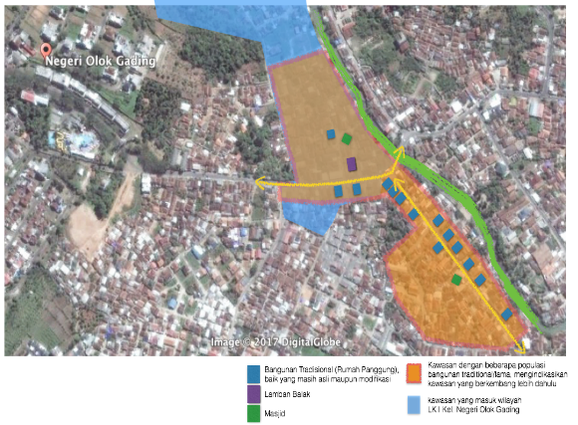

FIGURE 1. The existing traditional building distribution patterns. Source: Google Map, 2017 edited
The traditional building typology called rumah panggung (stage building) spread not only in Kelurahan Negeri Olok Gading, but also in Kuripan Village along Jalan Dr Setiabudi. Therefore, it can be indicated that the initial growth of the village starts from Lamban and constantly leads to the South, parallel to the Way Kuripan river . This refers to the typology of the traditional cluster of Lampung settlements that are always close to the river as a means of transportation and public utilities.
According to Syarief (2017) [9], the initial typology of traditional Lampung settlements is preceded by Pekon Undok in Kenali with a circular village typology surrounding the open space in the middle and oriented on Mount Pesagi. Referring to the typology of rural development in Kenali, the development of the village structure leads to the East-West axis. Eastern part is the position of the establishment of Lamban Balak, which philosophically rises sunlight should not be blocked by other buildings because it is a symbol of life. While at the western end lay graves (ponds) and places of sacrifice as a symbol of death [9].
Hypothetical pattern of village setting in Negeri Olok Gading refers to the explanation above. In the diagram below, it can be explained that Lamban Balak Negeri Olok Gading is located on the East side adjacent to the river. While on the west side there is a tomb meaning to indicate that the typology of the settlement is identical or similar to what was conveyed by previous studies of Syarief. The study was then hypothesized in Kampung Negeri Olok Gading in accordance with the following Figure 2.
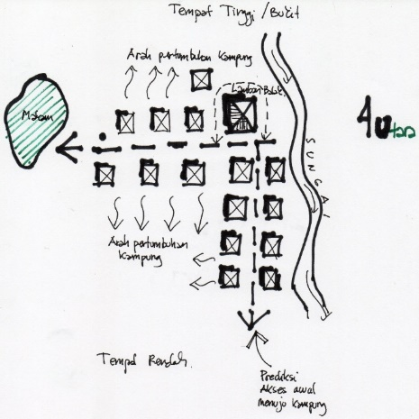

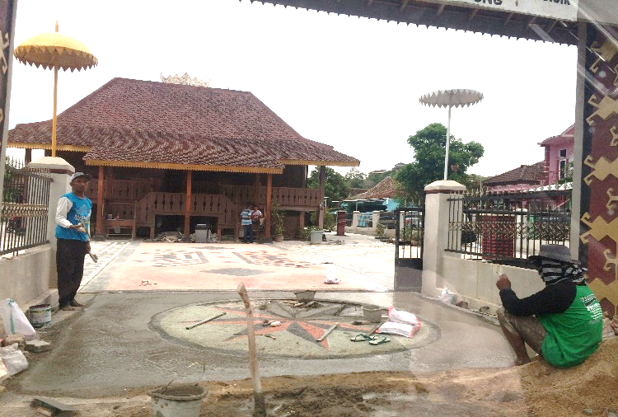

FIGURE 2. (a) he analysis of former conditions of the village development. (b) Lamban Balak at Negeri Olok Gading Source: Analysis, 2017

Another fact that there are many old buildings lie along the Jalan Dr Setiabudi corridor adjacent to the river and then head west. It can be inferred or predicted that access to this village in the early formation was from the South, due to the presence of rivers that restricted access to villages from the East side before the bridge. The subsequent assumption is that the development of the village leads to the South for the East-West oriented building side, combined with growth to the West side of the river-oriented Lamban Balak (Figure 2 and 3).
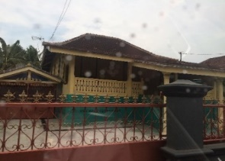
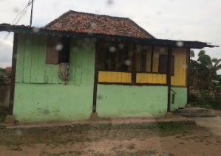
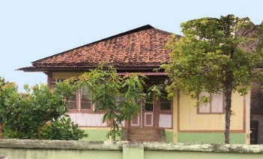

(a) (b)

(c) (d)

(e) (f)

FIGURE 3. (a), (b), (c) Several traditional houses remaining around Lamban Balak. (d), (e), (f) Some traditional houses are still left and modified (around Dr Setia Budi street) Kuripan sub-district, South Side of Lamban Balak . Source: survey, 2017

The change process of architectural form of Lampung indigenous house into modern houses is caused by society in general assumed that traditional house architecture form is already ancient and out of date [8]. They prefer to rebuild their traditional houses into houses with modern architecture not only because of the advancement of the times (in the form of people's mindset), but also because of the condition of old house materials that begin to decay while the material is increasingly rare, especially wood. Furthermore, it is said that the society is considering the construction of modern houses are better and the architectural form of traditional house is not in accordance with the times. In addition, to changes in the architectural forms of traditional house buildings, there is also a fading of the values contained in the ornaments and spatial custom homes. This is due to the lack of awareness and the interest of the community to preserve the cultural values ​​of Lampung, thus causing changes in the traditional architectural features of traditional houses and the waning of cultural values ​​as well as the function of the ornament and spatial.

- Open Spaces and Green Features
There is no open space (square) in this area, except open space in the form of public cemetery area. Open space typologies [10], have been replaced by linear open space in front of the building/sluggish as a multifunctional (communal) space when there are events/ceremonies/traditional ceremonies. This condition will certainly be contradictory to the current conditions, where the linear open space in front of Lamban has become a public open space for the circulation path of vehicles and accessibility to other areas. In terms of green layout, there is no crop arrangement in the public area of both planted plants and potted plants. Green stance is formed within each building's building, except on LK II which becomes Citra Garden housing cluster, which has a better green plan.
- Social
The majority of the population in Negeri Olok Gading is still dominated by Lampung Ethnic. The insistence of economic factors caused by the process of transferring the status of ownership of buildings and changed its shape so that many houses with original Lampung ornaments converted into ordinary house, beside of the high cost of maintaining the structure of the traditional house/building. The other problem is that there is low interest of the next generation to learn the original art of Lampung culture. This problem caused by a change of mindset affected by the globalization/international style paradigm, which considers everything that comes from the outside is the best, and tends to ignore its local wisdom.
- Economic
The economic condition is influenced by the development of the area around it. One of the most significant is the emergence of Citra Garden housing with its supporting functions, which encourage the growth of the economy and affect the existing land use and buildings. The daily needs of the people are filled by the shops / shops within the area, also served by the trading functions that exist around the village area, such as Cimeng Market and the existing trading functions in Citra Garden Housing. The economic condition indicates that the economy of the villagers is caused trade and services sector. The rest is that citizens meet their economic needs from working as private employees or laborers / workers.
- Culture/Art and Customs
The establishment of Kampung Negeri Olok Gading area as a cultural heritage area by the City Government of Bandar Lampung in its spatial policy was, without a doubt, based on the existence of customs and arts of kampung cultures that still exist. The indigenous people of Lampung in this village are still carrying out the customs/traditions that have been done since the time of their predecessors through various customary events which was organized in Lamban Balak. Some traditional arts are also preserved such as dance, pencak silat art, pantun berbalas art and so on.
- Olok Gading Toward Creative Village
Conservation is the main strategy for creating Kampong Olok Gading to be a creative village, with several sub-strategies, which are preservation, adaptive re-use and renewal and rehabilitation of existing building. In achieving the ideal goals and ideal physical conditions of the village, the process of setting up the village into the creative village requires three stages of actions, i.e:

Table 1. The Three Stage of Actions

Phase
First | Second | Third
maintain the existence of historical buildings that become the embryo of development and landmark of the village. Actions :  - protecting the building from damage,  - providing new functions or dual functions in accordance with the demands of regional development | Encourage the formation and inclusion of new functions (cultural, social and economic) related to the revitalization of the area. Action :  - covering functions that accommodate changes in the accessibility system of the area  - increased access to the village to be able to play a role and benefit from the revitalization | Establish elements of outdoor space (street furniture) in open spaces of the area (private road spaces and private spaces). This element is useful to support the establishment of unique characteristics of the village by giving a specific feel of the place. These elements can consist of:  - street lamps,  - pedestrian,  - tub plants,  - waste bins,  - paving pattern/ pavement,  - pavement material, and  - vegetation of plants

- CONCLUSION

Negeri Olok Gading Village as a cultural/historical village still have important and potential factors for cultural and tourism activities. The existence of the main landmark of Lamban Balak and several other traditional buildings can be the main capital in shaping the village atmosphere as a cultural/historical village. This is reinforced by the existence of the customs value system of Lampung that is applied by the society as well as the cultural arts values that are also still maintained.
The aspect of regional development becomes a serious threat to the decline of function and the role of kampung as a cultural village. Increased accessibility of high areas along with the growth of new functions such as Citra Garden housing becomes a challenge for the integrity of the village in maintaining identity. Therefore, the involvement of stakeholders (city government, privat sectors and communities) in the institutional and management is required.
The remaining physical and non-physical cultural resources need to be arranged immediately. With regard to physical cultural resources, the strategy that can be applied in the arrangement of this village is Conservation Strategy, with sub-strategy is on Preservation, Rehabilitation and Adaptive Use. These strategies applied not only for Kampung Negeri Olok Gading administratively, but broader area including Kuripan Area in the south.
The intervention is not only touches on the established area, but also involving the greenbelt/riverside area of the Way Kuripan River. This is solely to increase the tourism potential of the village as well as provide precedent in managing such areas.

REFERENCES
[1] Adhisakti, Laretna T, "A Study on the Conservation Planning of Yogyakarta Historic-tourist City Based on Urban Space Heritage Conception", Thesis, Kyoto : Kyoto University, 1997.
[2] Ashworth, GJ, JE Turnbridge, The Tourist Historic City, New York : John Wiley & Sons, 1990.
[3] Garnham, Harry Launce, Maintaining The Spirit of Place, Mesa Arizona : PDA Publisher, 1985
[4] Landry, Charles, Bianchini, Franco, The Creative City, London : Demos, 1998
[5] Page, Stephen, Urban Tourism, New York : Routledge, 1995
[6] Cullen, Gordon, The Concise Townscape, New York : Van Nostrand Reinhold, 1961
[7] Lynch, Kevin, The Image of the City, Massachusetts : MIT Press, 1960
[8] Saputra, Dhani K, "Perubahan Arsitektur Bangunan Rumah Adat Lampung (Studi terhadap Rumah Adat Saibatin Marga Balak Kelurahan Negeri Olok Gading Teluk Betung Barat Bandar Lampung", Thesis, Bandar Lampung : FISIP Unila, 2017
[9] Syarif, Rislan, Pengaruh Warisan Budaya Perahu pada Arsitektur Tradisional di Lampung, Bandar Lampung : Aura, 2017
[10] Krier, Rob, Urban Space. London : Academic Edition, 1979.

