Torrefaction Upgrading of Palm Oil Empty Fruit Bunches BIOMASS PELLETs for Gasification FEEDSTOCK by Using COMB (Counter Flow Multi-Baffle) REACTOR

Dewi Agustina IRYANI^{1,6}, Agus HARYANTO^{2,6}, Wahyu HIDAYAT^{3,6}, AMRUL^{4,6}, Mareli TALAMBANUA^{2,6}, Udin HASANUDIN^{5,6}, Sihyun LEE⁷

¹Department of Chemical Engineering, Faculty of Engineering, University of Lampung, Indonesia
²Department of Agricultural Engineering, Faculty of Agriculture, University of Lampung, Indonesia
³Department of Forestry, Faculty of Agriculture, University of Lampung, Indonesia
⁴Department of Mechanical Engineering, Faculty of Engineering, University of Lampung, Indonesia
⁵Department of Agro-industrial Technology, Faculty of Agriculture, University of Lampung, Indonesia
⁶ Research and Development Center for Tropical Biomass,University of Lampung, Indonesia
⁷Climate Change Research Division, Korea Institute Energy Research, Republic of Korea

Abstract
The paper is focused on upgrading of Palm oil empty fruit bunches (EFB) pellets by using rapid torrefaction process. This study aims to evaluate the effects of torrefaction on the main energy properties of EFB pellets. The torrefaction process was conducted on range temperature of 250-350 ˚C by using COMB (Counter Flow Multy-Baffle) Reactor with 3 minutes of residence time. The properties of raw pellets and torrefied pellets such as the caloric value, energy density, ash content and mineral compositions, fixed carbon, volatile materials, lignin, holocellulose, extractives, and water immersion of pellets were analyzed in order to study the effect of torrefaction process on the pellets properties changes. The analytical results showed that the initiating heating value and carbon content of raw EFB pellet are 15.82MJ/kg, and 47 .24 % increased up to 16.20 MJ/kg. 17.90 MJ/kg, 47.70 and 62,06 wt%d.b, subsecquentially for brown and black pellets. In case of moisture content, the initial EFB pellets has 9.21% decreased up to 8.97, and 7.80 %, subsecquentially for brown and black pellets. The obtained results revealed significant differences for all of main physical and energy properties of pellets. The torrefaction is able to upgrade the EFB pellets which having higher caloric value, carbon content, and lower water adsorption.. Therefore, the torrefied EFB pellets are potential to apply as a solid fuel for gasification feedstock or others thermal applications.

Key words: Pellet biomass, Palm oil solid waste, Torrefaction, Biomass pellets, Solid biofuel

INTRODUCTION

The production of palm oil in the world is dominated by Indonesia and Malaysia, with the account for around 85 to 90 percent of total global palm oil production. Indonesia is the largest producer and exporter of palm oil worldwide. Palm oil production in Indonesia has increased dramatically over the past decade. The data Indonesian Palm Oil Association (Gapki) stated that Indonesia would able produce 40 million tons of crude palm oil per year starting from 2020.
Production of crude palm oil consist of several stages from the sterilization of the palm oil fresh fruit bunces (FFB) to the digestion, threshing and clarification of the oil cooking. In palm oil industry, to produce 1 ton of crude palm oil required five tonnes of FFB (1). Alongside palm oil production, the industry also produce several different form of waste as well, such as liquid palm oil mill effluent (POME), empty fruit bunches (EFB), mesocarp fibres, shell, and kernel. Presently, the solid waste such as fibres and shell are used as boiler fuel to produce high pressure steam for turbines in power generation of energy in palm oil mill. While, another solid waste such as EFB and shell are not being utilized.
In the palm oil mill with plantation, EFB mainly utilized as mulch or compost for palm oil plantation. The EFB which placed around the young palms is able to control weeds, prevent erosion and maintain the soil moisture [2]. However, in the mill with no plantation, the EFB is untilized properly. Whereas, in the palm oil mill, the utilization of EFB as a source of energy is avoided due to hydrophilic nature, high moisture content and low bulk density, low calorific value. Moreover, the EFB also contains high alkali metal especially potassium and silica (3).
Therefore, in order to improve the fuel properties of EFB, the combination of pelletization and torrefaction were performed in order to alleviate the issues. Torrefaction is also known as mild form of pyrolysis that is carried out at temperatures range between 200 °C and 300 °C in a non-oxidising environment (4,5,6). The purpose of torrefaction is for drying and partial devolatization of biomass without affecting the energy content. Torrefaction is able to changes the properties to provide a better fuel quality for combustion and gasification applications (6). In this study, the effects of torrefaction on the main energy and the properties of the EFB pellets such as the caloric value, ash content and mineral compositions, fixed carbon, volatile materials, lignin, holocellulose, extractives, and water immersion of pellets were evaluate. In addition, torrefaction process was conducted on the temperature range of 250-300 ˚C by using COMB (Counter Flow Multy-Baffle) Reactor with 3 minutes of residence time.

MATERIALS AND METHODS

2.1 Material
Palm oil (Elaeis guineensis) empty fruit bunch (EFB) pellets from one of pellet producer which is located in Tebing Tinggi, south Sumatra (Toba Hijau Sinergy Corp.) was used for torrefaction feedstock. Prior torrefaction and drying by using COMB Reactor, the samples are characterized by using several analyst methods such as the caloric value, carbon content, energy density, ash content and mineral compositions, fixed carbon, volatile materials, lignin, holocellulose, extractives, and water immersion of pellets. The calorific value of pellets were analyzed using a Parr bomb calorimeter according to ASTM D240. The functional groups of feedstock and products were analyzed by using a Fourier Transform Infrared (FT-IR) spectrophotometer model Perkin Elmer 2000. All of characterization method were conducted in order to understand the effect of torrefaction treatment into the material. Therefore, the raw and the torrefied pellet were dried at 105°C until constant weight.

2.2. Methods
2.2.1. Torrefaction Process
The experiment on the EFB pellets torrefaction was mainly focusing on the determination of process parameters to produce torrefied pellet (black pellet) with optimum yield. Prior the torrefaction experiment, EFB pellets were sieved to separate find dusts and sorted/grouped based on pellet size, particularly its length. The sample of pellets was then torrefied in several experiment attempts, at least 5 runs for each biomass pellets were conducted prior to a successful black pellet production. The target temperature applied during torrefaction of pellets biomass was ± 300°C with a column difference between column-in and colum-top was ± 50°C. While, the other process parameters such as column pressure (flow rate), and feedstock feeding rate was varying depend on the feedstock characteristics such as pellet size, weight, and density. Prior to torrefaction process, feeding test was performed to determine the feedstock feeding rate during the torrefaction.

2.2.2. Characterization of Pellets
The moisture content of samples was determined through the air-dry and oven dry weights measurement using an analytical balance (Sartorius AZ6101,Göttingen, Germany) with a sensitivity of 0.01 g. The density of samples were evaluated by measuring their air-dry weight and volume. The composition of raw and torrefied pellets were determined following the method adapted from Datta, et al. (1981) with some modification. Before analyzing the composition of the EFB pellets as the raw material, a sample was extracted using ethyl alcohol to determine the wax content using a soxhlet extractor over 8 h at 80 °C. 150 mg of the de-waxed sample was then dried and treated with 1.5 ml of 72 wt% H₂SO₄ at 30 °C for 1 h. 42 ml of water was added to the treated sample and hydrolyzed for 1 h in an autoclave at 121°C. The hydrolyzed sample was cooled, and then filtered and washed several times with hot water. The residue was noted as a Klason lignin (i.e. acid insoluble solid residue) and was dried at 105°C overnight. The composition of polysaccharide such as hemicellulose and cellulose were determined by using the method which adapted from Datta (1981).
The raw and torrefied pellets were further characterized by several methods. Proximate analysis was performed following ASTM standard E-870-06. The ash content was determined by measuring the weight of sample before and after heating a 1.0 g sample at 575°C for 5 h. The EAS Vario EL cube CHN elemental analyzer was used to measure the elemental composition of the solid products. The caloric value or energy content was determined by using Milne Bomb Calorimeter CAL2K ECO.In addition, for the purpose to identify the chemical structure and functional groups of the raw and torrefied pellets, the Fourier transforms infrared (FTIR) spectrometer (100 Perkin Elmer, MID IR spectrometer) was also performed by using the KBr disk technique (1 mg of sample/100 mg of KBr). The samples were recorded in the range of400 - 4,000 cm−¹.

RESULTS AND DISCUSSION

The Appearance of torrefaction feedstock and products
Figure 1 shows the alteration colors of pellets before and after the torrefaction. The samples are denoted; a – Raw (un-torrefied) EFB pellets; b – Brown torrefied pellets; c – Black torrefied. The alteration color of torrefied EFB pellets from brown to black is mainly attributed to chemical compositions of biomass changes [8] .
 | 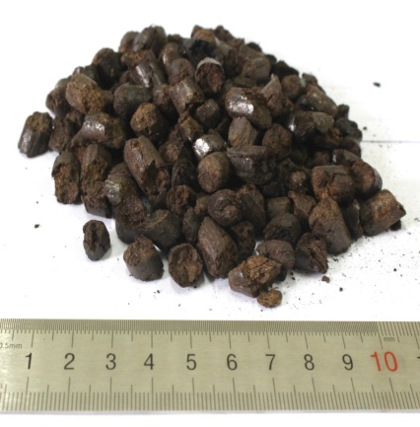 | 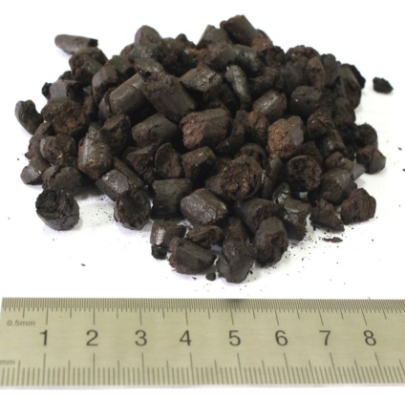
a. un-torrefied pellets | b. Brown Pellets | c. Black Pellets
Fig.1 The apperance of raw and torrefied samples of EFB pellets

Ultimate and Proximate Properties
Table 1 presents the results of the ultimate and proximate values of raw EFB pellets and torrefied. The content of carbon (C) of the torrefied pellets was enhanced by 1.3 times higher than raw EFB pellets, while oxygen (O) and hydrogen (H) content were drastiscally decreases. The reduction of H and O content leads to the dehydration and deoxigenation reactions occurred during the treatment, thus significantly enhancing the heating value (HV) of the torrefied products. The values of atomic H/C and O/C ratios in raw sample were 0.14 and 0.96, respectively. After the torrefaction, the values were changed into 0.12–1.10 and 0.95–0.49, respectively. This result implies that the H/C and O/C values decreased due to the deoxygenation, dehydration and carbonization reactions occurred during the processes. The reaction occurs due to the oxygen-containing functional groups with high activity, moreover low activation energy were easy to crack or recombine to release the CO and CO₂ (9). Moreover, as it was state in the previous paper (6) that the solid fuel with low O/C ratios produce the higher gasification efficiencies than fuels with high O/C ratio. Furthermore, the biofuels with highly oxygenated are not perfect fuels for gasifiers from an exergetic point of view. Therefore, the modification of the properties of biomass are more attractive than gasifying these biomass as fuel directly (6).

Tab. 1 Ultimate and proximate properties of raw and torrified EFB pellets (% d.b)
Pellets Sample | C | H | N | O (diff) | MC | VM | FC | AC | HV
 |  |  |  |  |  |  |  |  | (MJ/kg)
Raw | 47.24 | 6.63 | 0.82 | 45.32 | 7.89 | 83.34 | 15.11 | 9.0 | 15.82
Brown | 47.70 | 6.35 | 0.99 | 45.54 | 6.18 | 82.73 | 12.05 | 11.0 | 16.20
Black | 62.06 | 5.76 | 0.63 | 30.96 | 5.87 | 81.36 | 10.84 | 13.0 | 17.90
d.b dry basis, diff. difference, VM volatile matter, FC fixed carbon, AC ash content, HV heating value

Chemical Composition Analysis Results of EFB Pellets
The chemical compositional changes were measured by gravimetric quantification of each component, as indicated in Tab. 2. The fraction of each component in the raw and torrefied samples is presented based on 100 g of the initial biomass. The result shows those hemicelluloses fractions are more easily degraded by thermal treatment compared with cellulose and lignin. The hemicellulose was easier to be decomposed than other polymers due to its branched structure and lower degree of polymerization (10). Differ with hemicellulose, the cellulose has a greater thermal stability due to their structure which is consist of a long glucose polymer without branches, linked by strong β-(1,4)-glycoside bonds. In case of lignin, the analytical result shows that, the content of lignin tends to increase after the torrefaction. The lignin content increased due to char, re-polymerization products, condensation reactions, and saccharide decomposition products of hemicellulose attached on the surface of the solid material which then leads the dark solid color. This result is in line with the previous research (8) which was stated that the alteration of biomass color after torrefaction is related to the degradation of hemicellulose during the process.
Tab. 2 Chemicals composition of pellets (% d.b)
No | Sample | Hemicellulose | Cellulose | Lignin | others
1 | Raw EFB Pellets | 26 | 35 | 17 | 22
2 | Brown Pellets | 17 | 35 | 21 | 27
3 | Black Pellets | 15 | 35 | 31 | 19

Fourier Transforms Infra Red (FTIR) Results Analysis
The FTIR spectroscopy was used to investigate the change of chemical structure before and after the torrefaction. The spectral data provides a simple characteristic comparison between the raw and the torrefied pellets. All of the peaks were confirmed with literature data (10-11). The FTIR spectral data showed a peak around 3300 cm⁻¹ that is attributed to an –OH group. Comparing the FTIR spectra of the raw and torrefied pellets, the –OH group peak tend to decreased after the treatment. This result is in line with the data of MC presented in Tab. 1. This result indicates that the hydrogen-bonded –OH groups of hemicellulose of wood was gradually degraded. The peak changes were most apparent in black pellets. The peak in the range of 2928–2940 cm⁻¹ is attributed to the aliphatic CH_{n} groups and also weakens indicating fragmentation and decomposition of the polymer chains. The peak in the range of 1720–1740 cm⁻¹ represents C=O stretching vibrations of un-conjugated ketone, carbonyls, ester groups; and C=O of acetyl group in xylan (hemicellulose) become weaker after the torrefaction.

The peak of the C–O–C aryl–alkyl ether linkages was detected around 1247 cm⁻¹. The peak of the β-glycosidic linkages between glucose in cellulose was observed in the range of 874–897 cm⁻¹. The peaks around 1608, 1500, and 1408 cm⁻¹ correspond to the C=C linkages of aromatic groups in the lignin. The peaks around 1608 and 1408 cm⁻¹suggest that lignin in the feed material was almost stable during the torrefaction and remained in the torrefied product.

=CO
-CH
-OH
Fig 2. FTIR spectra of raw and torrefied Pellets

Hygroscopic property of EFB pellets

Sample of pellets | Before imersion | 5 min | 30 min | 1 h | 2 h | 12 h
Raw | 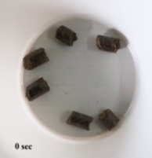 | 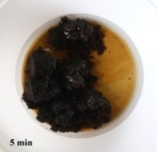 | 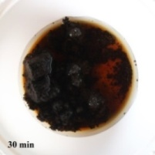 | 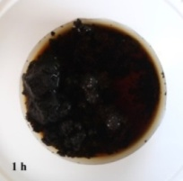 | 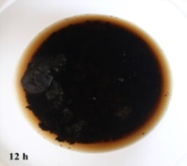 | 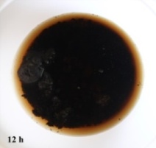
Brown | 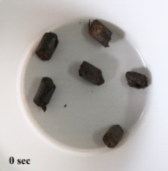 | 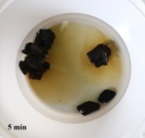 | 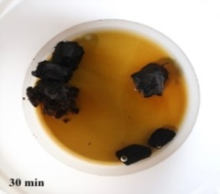 | 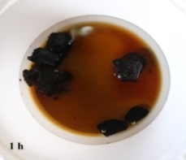 | 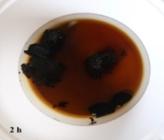 | 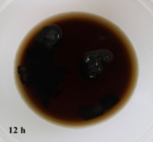
Black | 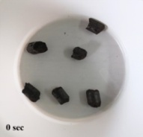 | 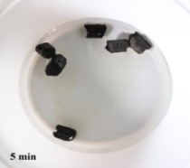 | 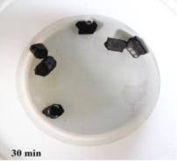 | 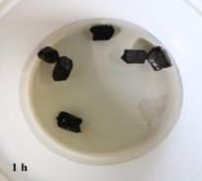 | 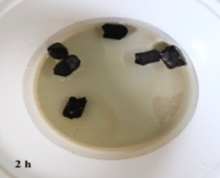 | 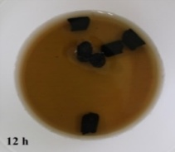
Fig. 3 Water absorption test of the raw and torrefied pellets.

The hygroscopic property of biomass pellets was tested by water absorption test (Fig. 3). The water immersion test which was conducted for 5 min, 30 min, 1 h, 2 h, and 12 h showed that the raw pellets fully disintegrated after 30 min. The Black pellets showed no significant disintegration even after 12 h test which is an advantage for long period storage of pellets.The results showed that the hygroscopic property of the raw pellets altered from hydrophilic into hydrophobic after torrefaction. The hydrophobic property of the torrefied pellet is one of their main advantage because moisture uptake by torrefied pellets is almost negligible even under severe storage conditions. It is generally known that the uptake of water by raw biomass is due to the presence of OH groups. Torrefaction produces a hydrophobic product by destroying -OH groups and causing the biomass to lose the capacity to form hydrogen bonds (11). Due to these chemical rearrangement reactions, non-polar unsaturated structures are formed, which preserve the biomass for a long time without biological degradation, similar to coal (6, 9).

The mineral Compositions Comparison of Raw and Torrefied Pellets
Tab. 3 presented the comparison of the mineral compositions of raw and torrefied pellets. The minerals compositions were analyzed using the X-ray fluorescence (XRF) analysis. The results confirmed the presence of K₂O, CaO, SiO₂, Al₂O₃ and Fe₂O₃ in the sample the result shows that the torrefaction can be slightly reduced the mineral content such as SiO₂, P₂O, CaO and K₂O.
Tab. 3 The mineral composition of raw and torrefied pellets
Element | Unit | Raw | Brown Pellet | Black Pellet
MgO | % | 1.21 | 1.35 | 1.44
Al₂O₃ | % | 0 | 10.06 | 10,36
SiO₂ | % | 10.45 | 0 | 0
P₂O₅ | % | 2,457 | 1,292 | 0
SO₃ | % | 3.57 | 2,418 | 2.34
Cl | % | 6.60 | 6.62 | 5.97
K₂O | % | 51.58 | 44.25 | 46.19
CaO | % | 17.71 | 14,87 | 14.83
TiO₂ | % | 0.19 | 1.03 | 1.03
Cr₂O₃ | % | 0.31 | 0.48 | 0.68
MnO | % | 0.35 | 0.83 | 0,869
Fe₂O₃ | % | 5.08 | 15.94 | 15.76
ZnO | % | 0.733 | 0.19 | 0.18
Rb₂O | % | 0.22 | 0.45 | 0.500

CONCLUSIONS
The torrefied pellets or the black pellets of EFB was succesfully produced with good main energy properties. The results showed the reduction of moisture content after the torrefaction of biomass pellets. The improvement in the hygroscopic behaviour was also observed, showing a more hydrophobic product after torrefaction. The heating value of pellets remarkably increased after the torrefaction with COMB. The results proposed that torrefaction by using COMB technology could produce friable, hydrophobic, and energy-rich fuel which ideal for gasification feedstock.

ACKNOWLEDGMENT
This study was supported by the Indonesian Oil Palm Estate Fund (BPDPKS) organize Palm Oil Grant Research Program 2019.

REFERENCES

- Hambali, E. and Rivai M. (2017). The Potential of Palm Oil Waste Biomass in Indonesia in 2020 and 2030. IOP Conf. Series: Earth and Environmental Science 65 012050, 1-10.
- Oviasogie, P.O., Aisueni, N.O., Brown, G. E. (2010). Oil Palm Composted Biomass: A Review of the Preparation, Utilization, Handling and Storage. African Journal of Agricultural Research 5(13), 1553-1571.
- Stemann, J., Erlach, B., Ziegler, F. (2013). Hydrothermal carbonisation of empty palm oil fruit bunches: Laboratory trials, plant simulation, carbon avoidance, and economic feasibility, Waste and Biomass Valorization 4(3), 441–454.
- Nyakuma B.B, Ahmad, A. Johari, A, Abdullah, A.T., Oladokun, O. (2015). Torrefaction of Pelletized Oil Palm Empty Fruit Bunches, Proceeding of The 21st International Symposium on Alcohol Fuels – 21st ISAF, Gwangju, Korea.
- Uemura, Y., Omar, W.N., Tsutsui, T., Yusup S.B. (1011) Torrefaction of Oil Palm Wastes, Fuel 90, 2585–2591.
- Prins. M.J, Ptasinski, K.J., Jansen F.J.J.G. (2006). More efficient biomass gasification via torrefaction, Energy 31, 3458–3470.
7. Datta, R. (1981). Acidogenic Fermentation of Lignocellulose-Acid Yield and Conversion Of Components, Biotech. and Bioeng. 23(9): 2167-2170.
8. Salca, E. A., Kobori, H., Inagaki, T., Kojima, Y., and Suzuki, S. (2016). Effect of heat treatment on colour changes of black alder and beech veneers. J. Wood Sci. 62(4): 297-304.
9. Chen Q., Zhou J.S., Liu B., Mei Q.F., Luo Z.Y. (2011). Influence of Torrefaction Tretreatment on Biomass Gasification Technology, Energy Science & Technology 56(14), 1449–1456.
10. Iryani, D.A., Kumagai, S., Nonaka, M., Sasaki, K., Hirajima, T. (2017). Characterization and production of solid biofuel from sugarcane bagasse by hydrothermal carbonization. Waste Biomass Valor. 8:1941–1951.
11. Pastorova, I., P.W. Arisz, and J.J. Boon. (1993) Preservation of d-glucose oligosaccharides in cellulose chars. Carbohydrate Research. 248:151–165.

Corresponding author:
Dr. Eng. Dewi Agustina Iryani, Department of Chemical Engineering, Faculty of Engineering, University of Lampung, Indonesia phone: +6281293638980, e-mail: dewi.agustina@eng.unila.ac.id

