Exploring Teacher's PCK Improvement: The Opportunity and Challenging of Integrated STEM Learning Approach for Non-STEM Majors
P. Raja^{1*}, Abdurrahman², and B. Setiadi³

^{1,3} Language Education, FKIP Universitas Lampung,
Jl. Prof. Dr. Sumantri Brojonegoro No. 1 Bandar Lampung, Lampung, Indonesia.

² Science Education, FKIP Universitas Lampung,
Jl. Prof. Dr. Sumantri Brojonegoro No. 1 Bandar Lampung, Lampung, Indonesia.

Email: Abdurrahman.1968@fkip.unila.ac.id
Abstract. The urgency of developing pedagogical content knowledge (PCK) had been investigated in many studies. This was in line with the emerging trend of STEM learning approaches recently. However, only a few studies have reported perceptions of non-STEM teacher’s perception towards their PCK that were associated with the implementation of an integrated STEM-based approach. This study was aimed to explore non STEM teacher’s PCK improvement that was related to the integrated STEM learning approach. We used explanatory mixed method design to collect the data, then the data were analyzed using qualitative descriptive technique. Results indicated that teachers’ PCK improvement reached the satisfying expectation. Their PCK were increased in STEM dimension even though they were actually from non-STEM majors. However, this study only revealed that teachers' beliefs about PCK were related to the STEM approach. Further research should have reached the form of PCK actualization that can be shown by the teacher.
- Introduction

Teaching and learning process requires a teacher to emphasize understanding of students about the content or material being taught, the teacher must also master the concepts of effective and professional teaching methods while also demanding to master the concepts of the participant's personality. A teacher's knowledge of the variables described was known as pedagogical content knowledge (PCK). PCK was defined as a teachers' understanding of how to transform their content knowledge into a pedagogically strong but adaptive form to the knowledge, level of understanding, and learning difficulties presented by each student varies [1,2]. Despite the different definitions, many research had identified two core PCK indicators, they were knowledge about student understanding and knowledge of learning strategies [3]. PCK was an essential variable for teachers in applying teaching approaches that are in harmony with the principles underlying the ongoing education movement.
In response to the challenges of 21st century learning, STEM was emerging as an approach that promises great potential for the development of nature and education [4]. The STEMinist project had previously been enacted in Australia, Indonesia and [5]. In fact, research by [6] has provided some detailed work plans designed to guide all stakeholders involved in the pilot project. That work was dedicated to teachers and teaching organizations who are willing to involve students in STEM education. STEM was not only an important dimension for student’s learning [7, 8], but also important for the development of teacher PCK. Teachers must develop their PCK based on the latest trend issues. Research of [9] developed and tested their own strategies for assessing the pedagogical content knowledge (PCK) of novice and experienced STEM teachers. Many studies had widely identified adaptive teaching in STEM that leads to the development of teacher PCK [10, 11,12], however, there has been no research that reveals about PCK related to the experience of STEM teachers with non-STEM disciplines. Although some have identified STEM experiences by non-STEM major teachers [13], the research did not lead to the development of the teacher's PCK. Therefore, researchers are interested in exploring the non-STEM teacher PCK that exists in STEM practice, using not a single tool but several methods.
- Method
The design of this study was an explanatory mixed method design with a survey and depth interview approach. We used questionnaire of PCK improvement and interview protocol. We used web-based surveys [14] with a multidimensional scale to desribe teacher and practitioner perceptions about STEM education and careers dimension [15, 16, 17, 18]. The data were analysed using qualitative descriptive technique. The survey instrument consisted of 8 statements with the type of response that were strongly agree, agree, disagree, and disagree. The survey respondents were 163 professional non-STEM major teachers in Lampung, Indonesia with S-1 and S-2 educational backgrounds from different science disciplines. The survey and interview carried out after finishing their engagement in STEM approach workshop and its implementation during two month. Our samples come from the fields of Economics, English, Sociology, Citizenship, Geography, Religion, Sports, History, Lampung Language, Cultural Arts, Lampung Language, Indonesian Language, Music and Entrepreneurship. The respondents were detailed in Figure 1 and Figure 2.

Figure 1. Respondent based on gender

Figure 2. Percentage of teacher’s teaching experience

- Result and discussion
The results of the teacher's self-assessment test on improving PCK related to their knowledge and experience applying STEM are discussed in eight observable aspect. The first aspect was represented the teacher's knowledge of STEM-integrated learning strategies that were designed to obtain effective learning. The results was presented in Figure 3.

Figure 3. Improvement of teacher's knowledge of STEM-integrated learning strategies

The second aspect was presented the teacher's knowledge of subject matter and curriculum 2013, which features integrated STEM subject matter. The results was presented in Figure 4.
Figure 4. Percentage of teacher's knowledge of subject matter

Then, the third aspect was presented the teacher's knowledge about personal orientation (ideals) as a professional teacher to teach integrated STEM material. The results was presented in Figure 5.

Figure 5. Percentage of teacher's knowledge of personal orientation as a professional teacher to teach integrated STEM material

The forth aspect was presented the teacher's knowledge of Higher Order Thinking Skill (HOTS) assessment in the context of STEM education. The results was presented in Figure 6.

Figure 5. Percentage of teacher's knowledge of HOTS assessment in the context of STEM education

The fifth aspect was presented the teacher's knowledge of students' understanding of the subject mastery including their alternative conceptions of careers in the STEM field. The results was shown in Figure 7.
Figure 7. Percentage of teacher's knowledge of students' understanding of the subject mastery including their alternative conceptions of careers in the STEM field

The sixth aspect was presented the teacher's knowledge about my orientation as a professional teacher towards learning with the STEM approach (subject matter knowledge, beliefs about the importance of the material, and how to learn it). The results was shown in Figure 8.

Figure 8. Percentage of teacher's knowledge about my orientation as a professional teacher towards learning with the STEM approach

The seventh aspect was presented the teacher's knowledge of the efficacy (values) of teachers for teaching STEM integrated subject matter. The results was shown in Figure 9.
Figure 9. Percentage of teacher's knowledge of the efficacy (values) of teachers for teaching STEM integrated subject matter

The last aspect was presented whether STEM Education encourages teacher’s emotional attributes as a well-oriented teacher. The results was shown in Figure 10.

Figure 10. Percentage of teacher's perception whether STEM Education encourages teacher’s emotional attributes as a well-oriented teacher

Based on Figure 3 to 10, we can see the tendency of increasing non-STEM teacher PCK in a positive direction. Overall, the percentage of all aspects measured is in the criteria of ‘increase’ and only a few in the criteria ‘excellent’. However, this result was a good seeing that non-STEM teachers already had a good awareness of STEM integrated learning. Development of teacher PCK-STEM which contains pedagogical meaning that involves interaction between teacher and students. Therefore, teachers still need professional scaffold from advanced and experienced peer in promoting their work and carreer [19, 20] argues that the focus of our understanding of teacher work is the interaction between learning and teaching and vice versa learning and teaching. Teachers with good PCK, including their views on the STEM approach, always try to focus on how students learn with the teacher as a reliable facilitator [12]

Furthermore, as noted in Figure 5, 85.28% of the respondents (n = 139) indicated that their awareness in orientation teaching practice in STEM approach increased in line with their understanding about STEM terminology and goals. However, further investigation results show that there is sufficient anxiety in integrating technology and engineering in STEM learning practices, especially teachers whose backgrounds are not STEM majors. The following sample is a response from interview result of the History teacher related to this condition.

“Right now, I have just been in direct contact with what the STEM approach is, I want to learn more about STEM. I haven't really thought about how to integrate technology and engineering into historical concepts. I am a teacher in social science sometimes still confused by uniting multidisciplinary views such as STEM in such integrated learning”.

Beside, as noted in Figure 10, 83.44% of the respondents (n = 136) indicated that STEM have impacted in their professional awareness and fully implemented PCK. The following transcript response from English teacher who have implemented stem learning approach in Her Caption Text Class can be seen below.

“I use a bit of technology and I truly enjoy during STEM learning process. I engage student to use computer application and to create the theme with valued text caption which related to environment issues. Students become familiar with the daily math such as statistical expression in representing number and mean of students who gave like and comments toward quality of caption text that was uploaded in a social media. Right now, I feel more comfortable and optimistic about STEM education”.

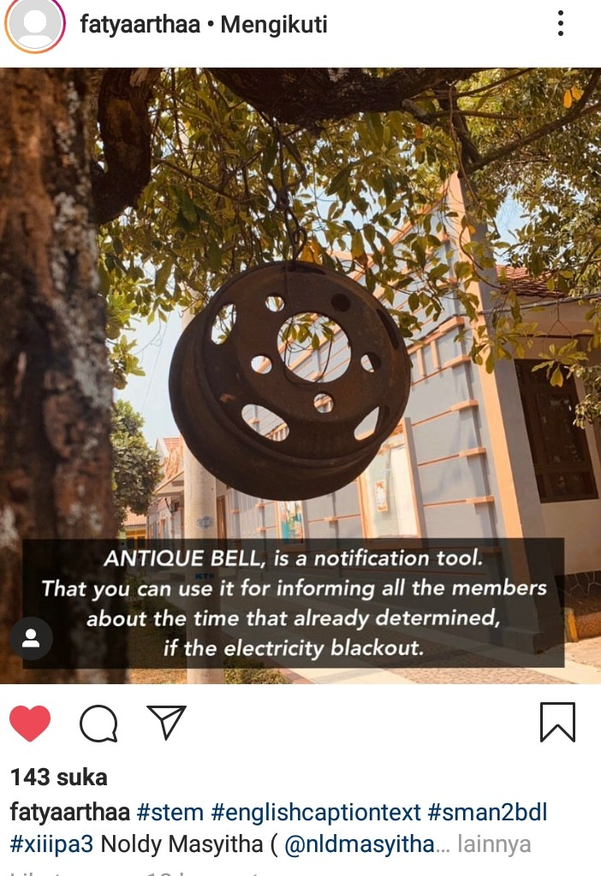

Figure 11. Student’s Caption Text Created that Uploaded on Her IG account

The process of introducing STEM learning approaches to non-STEM teachers has succeeded in changing their perspective about how the teaching profession works effectively. In this view, building and applying teacher's pedagogical reasoning skills to engage students for specific goals in certain teaching and learning environments at certain times becomes important for achieving effective teaching and learning [21, 22, 23]. Figure 11 showed how English teacher succeed to promote student creativity in STEM-Linguistics Class.

- Conclusion
The application of integrated STEM-based learning does not have to be in the context of each dimension of STEM itself, because STEM-based learning can also be applied to social studies (non-STEM majors). Teacher's belief or their self-assessment showed a very good result that they had a high sense of awareness related to STEM learning approach. Teachers who have a well-developed STEM PCK will have a good constructivist paradigm of teaching and learning, and show the ability to use their goals during reflection to help internalize challenges in the context of STEM teaching, so that their students are involved in concept development, inquiry processes, and real-world applications that are more meaningful to their lives in the future.
- Acknowledgement
The authors would like to thank to Teacher Training and Education Faculty, Lampung University for financial support of this study through the Institutional Grants. The authors would like to thank to the experts as reviewers for some comment and suggestion to make the paper better.
- Reference
[1] Gess-Newsome J, Taylor J A, Carlson J, Gardner A L, Wilson C D and Stuhlsatz, M A 2019 Int. J. Sci. Educ 41 7
[2] Powell D 2018 J. Teach Educ. 69 3
[3] Meschede N, Fiebranz A, Möller K, and Steffensky M 2017 Teach. Teach. Educ. 66
[4] Abdurrahman A, Nurulsari N, Maulina H, and Ariyani F 2019 J. Educ. Gifted Young Scientists 7 1
[5] Sheffield R S, Kurisunkal J J, and Koul R 2019 Sci. Educ. India Springer Singapore
[6] Montandon L, Playfoot J, Ghergulescu I, Bratu M, Bogusevschi D, Rybarova R, and El Mawas N 2018 EdMedia+ Innovate Learning Association for the Advancement of Computing in Education (AACE)
[7] Struyf A, De Loof H, Boeve-de Pauw J and Van Petegem P 2019 Int. J. Sci. Educ. 41 10
[8] Abdurrahman, Ariyani F, Achmad A and Nurulsari N 2019 J. Phys. Conf. Ser. 1155 1
[9] Sloan K, Allen A, Bass K M and Milligan-Mattes E 2018 Pedagog. Content Knowl. STEM 157-173
[10] Uzzo S M, Graves S B, Shay E, Harford M and Thompson R 2018 Pedagog. Content Knowl. STEM: Research to Practice. Springer
[11] Townsend A, McKinnon D H, Fitzgerald M T, Morris J and Lummis G 2017 Int. J. Innov. Sci. Math. Educ. 24 4
[12] Allen M, Webb A W and Matthews C E 2016 Theor. Pract. 55 3
[13] Jin G and Bierma T 2013 J. Coll. Sci. Teach. 42 6
[14] Sills S J and Song C 2002 Social Science Computer Review 20
[15] Norman K W, Moore T J, and Kern A L 2010 Montana Mathematics Enthusiast 7
[16] Little A J and de la Barra B A L 2009 European Journalof Engineering Education 34
[17] Cole D and Espinoza A 2008Journal of College Student Development 49
[18] Rose M A 2007 Journal of TechnologyEducation 19
[19] Rahman B, Abdurrahman A, Kadaryanto B and Rusminto 2015 Aust. J. Teach. Educ. 40 11
[20] Loughran J 2010 What expert teachers do: Enhancing professional knowledge for classroom practice. Crows Nest, NSW: Allen & Unwin
[21] Angell C, Ryder J, and Scott P 2005 Proc. Int. Conf. on European Science Education Research Association, Barcelona, Spain
[22] Davis E A, Petish D and Smithey J 2006 Rev. Educ. Res. 76
[23] Loughran J and Hamilton M L 2016 International handbook of teacher education (pp. 3-22). Springer, Singapore

