THEMATIC AND ILLUSTRATIVE DICTIONARY FOR FRENCH LANGUAGE BEGINNERS

¹ Setia Rini

¹ French Language Study Program, Universitas Lampung – Indonesia
¹ setiarini99@yahoo.fr

ABSTRACT. The conducted present study used R&D method because of French Language beginners FPBS UPI, were indicated having difficulties in mastering French language especially in vocabularies. The study aims to investigate : 1) possibilities of the dictionary as the solution solve the lexical difficulties and 2) the strength and weakness of the dictionary. The study analyzed the survey data and gained that almost all the students have difficulties in mastering the vocabularies and they need the independent and innovative media. Thus we built the thematic and illustrative Indonesia language dictionary as their learning media. And from the test result of its dictionary by test and survey evaluation, we gained the conclusion : 1) the dictionary can be the problem solver for the lexical difficulties and 2) the strength of the dictionary is the easy-used of the dictionary and very interesting, and the weakness is the number of vocabulary is less wide.

Keywords: lexical, French language, dictionary, thematic, illustrative

- INTRODUCTION
The difficulty in learning the foreign language like French, is because of various external or internal factors. According to the result of the preliminary study, we gain data that almost all students of French beginner level FPBS UPI 82.4% students have difficulty in mastering vocabularies. Some reasons are the French vocabulary is too much and it is very different between the pronunciation and written. Furthermore, it is because of the minimum number of the Learning Media in French language especially on vocabulary.
Accordingly, we did the needs analysis to collect accurate data on the difficulty of the students and their needs in learning French, especially that relate to the vocabulary of investigation. Moreover, the importance of mastering the vocabulary by learning a foreign language is an undeniable thing. Although the language was not the only factor to be able to master this foreign language, yet learners cannot therefore leave it away. As some examples of previous research connect with vocabulary such as: “La prédiction automatisée de la difficulté lexicale en FLE”, automated prediction of lexical difficulty FLE by Francois in 2016, “Le rôle du vocabulaire actif dans le développement de la compétence lexicale, cas des élèves de 5ème année primaire”, the role of active vocabulary in the development of lexical competence, cases of 5th primary grade students by Bendjeddou in 2014, “L’apprentissage du lexique à l’école : comment élargir et enrichir le lexique des élèves”, the lexical learning in school: how to expand and enrich the vocabulary of students by Chardon in 2014 and “Le rôle de la compétence lexicale dans le processus de lecture et l’interprétation des textes”, the role of lexical competence in the process of reading and interpreting texts by Grossmann in 2012.
These examples showed us that vocabulary has a very important role in learning the foreign language. On the other hand, the use and role of the vocabulary are very wide. In all courses aprris by students specifically, they need to master the vocabulary. More specifically, refers to the four language skills, the role of vocabulary is very important. To listen, read, speak and write, students need vocabulary. Therefore, the mastery of vocabulary is very important especially for the beginner level so that they are able to understand what they listen or what they read, and so they are able to speak or write in French. Further more, sudents also can balance it with mastering the grammar, phonetics and other factors.
Those examples were the reasons why we conducted this research. Through this research, we hoped to contribute good solution to help students solve their problems. Moreover, the problems of this research are:
- Is the thematic and illustrative Indonesian-French dictionary can be one of the solutions to solve the lexical difficulty students FLE beginner?
- What are the advantages and disadvantages of the thematic and illustrative Indonesian-French dictionary by the students of FLE beginner?

To support the estimates and the realization of this research, we used and we respected the theories of masters who are suitable. Moreover, the theory of the importance of mastering vocabulary or lexical competence as one of the parts of language proficiency is explained in details in CECRL. Lexical competence is a skill or ability of a person using the vocabulary in a language. Then, refers to this research, we limit the type of vocabulary that we are discussing, it is only the simple vocabulary (CECRL, 2001, p. 88) that consists of open lexicon (name, verb, adjective, the adverb) and closed lexicon (the names of days, months, quantity and measurement).
Also, in this research, we limited the vocabulary just for the beginner level (A1, A2) which is also explained in CECRL. Therefore, to know what vocabulary that students have beginners mastered, we explain in the following table.

Table 1. Vocabulary Scope
 | Vocabulary Scope
A2 | Possède un vocabulaire suffisant pour mener des transactions quotidiennes courantes dans des situations et sur des sujets familiers. Has sufficient vocabulary to conduct routine daily transactions in situations and on familiar topics.
 | Possède un vocabulaire suffisant pour satisfaire les besoins communicatifs élémentaires. Has a sufficient vocabulary for basic communicative needs.
 | Possède un vocabulaire suffisant pour satisfaire les besoins primordiaux. Memiliki kosakata yang cukup untuk memenuhi kebutuhan dasar.
A1 | Possède un répertoire élémentaire de mots isolés et d’expressions relatifs à des situations concrètes particulières. Has a very basic repertoire of isolated words and phrases related to particular concrete situations.
(CECRL, 2001, p. 88)

Furthermore, to deeper the understand of specification or conditions that must be mastered by novice learners, bellows are the explanations according to CECRL (2001, p. 25-28).

Table 2. Common Skills Levels - Global Scale
Utilisateur élémentaire (débutant)  Basic user (beginner) | A2 | Peut comprendre des phrases isolées et des expressions fréquemment utilisées en relation avec des domaines immédiats de priorité (par exemple, informations personnelles et familiales simples, achats, environnement proche, travail). Peut communiquer lors de tâches simples et habituelles ne demandant qu’un échange d’informations simple et direct sur des sujets familiers et habituels. Peut décrire avec des moyens simples sa formation, son environnement immédiat et évoquer des sujets qui correspondent à des besoins immédiats. Able to understand sentences and frequently used expressions related to immediate priority areas (eg, personal information and simple family, shopping, local geography, employment). Able to communicate in simple and routine tasks requiring a simple and direct exchange of information on familiar and routine matters. Able to describe in simple terms their background, immediate environment and all that matters in areas of immediate needs.
 | A1 | Peut comprendre et utiliser des expressions familières et quotidiennes ainsi que des énoncés très simples qui visent à satisfaire des besoins concrets. Peut se présenter quelqu’un et poser à une personne des questions la concernant – par exemple, sur son lieu d’habitation, ses relations, ce qui lui appatient, etc. – et peut répondre au même type de questions. Peut communiquer de façon simple si l’interlocuteur parle lentement et distinctement et se montre coopératif. Able to understand and use familiar daily expressions and basic phrases aimed to express the satisfaction of concrete needs. Able to introduce someone and ask a person questions about themselves - for example, where they live, relationships, which appatient him, etc. - And able to respond to the same type of questions. Able to communicate in a simple way provided by the other person in slowly and clearly and cooperative.
(CECRL, 2001, p. 25)

In the other side, there are classifications of vocabulary that needs to be mastered by French learners are : 1) personal characterization, 2) house, 3) and home environment, 4) daily, 5) and recreational leave (recreation, hobbies and interests, radio and television, film, theater, concept, etc., museums, exhibitions, etc., intellectual and artistic research, sports, news), 6) trips, 7) relationship other, 8) health and wellness, 9) education, 10) purchases 11) food and drink, 12) services, 13) places, 14) and 15 foreign language) time (weather) (CECRL, 2001, p.45). Accordingly, these themes really facilitate learners in mastering the vocabulary in the easiest and simplest way.
Although in fact, the difficulty in mastering the vocabulary often encountered by learners especially at beginner. In addition, there are many factors that cause this difficulty. Légende (1993, p. 371, in Itma, 2009, p. 4) explained that “La difficulté d’apprentissage est peu précis en raison du manque de critères pour déterminer avec exactitude l’écart entre le potentiel intellectuel et les performances scolaires, en raison également des critères fluctuants qui servent à déterminer un ou des retards scolaires”. Moreover it can be said that the learning difficulty is not very accurate because of the lack of criteria for determining accurately the gap between the intellectual potential and school performance, also because of fluctuating criteria used to determine a school or delays. At the other side, refers to the lexical difficulty, Laniel (2005, p. 80, in Hamel dan Milicevic, p. 26) say that “Les difficultés que rencontrent les apprenants lorsqu’ils ont à faire des choix lexicaux et les fréquentes erreurs qu’ils commettent sont fondamentalement dues à leur méconnaissance du système lexical de la langue cible”. It’s mean that the learners’ difficulties when they have to make choices and frequent lexical mistakes are fundamentally due to their lack of lexical system of the target language. Then, according to the above definitions, we concluded that the difficulty in relating to learning FLE beginners, specifically lexical difficulty in this research, is an obstacle that makes learners difficult to control and enrich the lexicon or vocabulary, because of ignorance lexicon or vocabulary of the target language. Accordingly, depending on the result of the analysis of needs, we offered a solution to solve this difficulty, it is the media and independent learning in the form of Indonesian-French dictionary thematic and illustrative.
Refers to the learning media, Cuq (2003, p. 163) gave his opinion that :
les rapports entre les médias et la didactique des langues sont constants et nombreux : tout d’abord parce que les médias peuvent servir à diffuser des contenus d’apprentissage de langue : méthodes télévisées, méthodes vidéo, cours radiophoniques, cours sur internet; ensuite parce que les satellites de transmission directe on permis de donner accès à des programmes authentiques français dans un grand nombre de pays du monde; enfin parce que les médias (presse, radio, télévision et maintenant e-médias) sont souvent abordés en tant que tels dans des enseignements pour développer chez les apprenants une compétence médiatique. Le dernier rapport est vraiment actualité aujourd’hui. C’est-à-dire dans le processus d’enseignement-d’apprentissage utilise souvent les médias pour supporter ces activités.

We can say that the relationship between the media and language teaching are constant and numerous: first because of the media can be used to disseminate language learning content: TV methods, video methods, radio courses, internet courses; then because the direct transmission satellites is possible to provide access to authentic French programs in many countries of the world. Finally, because the media (press, radio, television and now e-media) are often addressed as such in lessons to develop the learners' media literacy. The final report is very relevant today. That is to say in the teaching-learning process often uses the media to support these activities. That is why, it is very important to use the learning media for learners to achieve their learning goal. The most important, we must develop the interesting and innovative learning media to attract the attention of learners, for example using pictures, colors, themes, etc.
Seguin (1989, in Lesage, 2015, p. 7) said that “La visualisation est un facteur important dans la création d’un manuel, d’un livre, inclut d’un dictionnaire“. It means that the visualization is an important factor in creating a manual, a book, including a dictionary. Furthermore he added that :
l’un des facteurs qui ont contribué le plus à l’évolution du livre scolaire, depuis les dernières décennies, est sans aucun doute l’lutilisation de l’illustration et de la couleur (indépendamment du fait que les techniques de composition et d’impression se sont considérablement améliorées). Les illustrations des manuels ont des objectifs précis. Pour les livres scolaires, elle supposent des apparences, des techniques et des styles variés (photos, dessins, schémas, etc.). de plus les choses concrètes sont mieux représentées par des illustrations. La descriptions physique d’un pays, la présentation d’animaux ou de plantes, de machines ou d’instruments, d’expériences de laboratoire, seront fidèlement et plus rapidement données par une carte, une photo, un dessin, un schéma qui apportent un support visuel aux textes de l’auteur.

It’s mean that one of the factors that contribute most to the evolution of the textbook, in recent decades, is undoubtedly the use of illustration and color (regardless of whether the composition techniques and printing have improved considerably). The illustrations of textbooks have specific goals. For school books, it assumes appearances, techniques and styles (photos, drawings, diagrams, etc.). More concrete things are better represented by illustrations. The physical descriptions of a country, the presentation of animals or plants, machines or instruments, laboratory experiments will faithfully and faster data by a map, a photo, a drawing, a diagram that bring visual support to the author's texts.
Pasha et Kissi (2012, p. 1) also said that “L’image a été toujours considérée comme un instrument privilégié du codage de l’information figurative se plaçant au centre des stratégies cognitives pour optimiser les conditions de réception et de mémorisation de cette information”. The image was always regarded as a privileged instrument of the figurative coding information being placed in the center of cognitive strategies to optimize the conditions for receiving and storing this information. Therefore, images or illustrations really help students to learn and master the vocabulary simply and easily.
Color also has the important role to stimulate the students so they can learn in the fun way. Martin (1982, p. 53 in Soumia, 2009, p. 14) explain that “La couleur peut exercer un rôle figuratif (la scène représentée se rapproche de la vie réelle), esthétique, psychologique et signifiant”, the color can have a representational role (the scene depicted approximates real life), aesthetic, psychological and meaning.
In addition, the elaboration of the learning media by the theme, will facilitate students seeking the vocabulary that they need. So the use of thematic learning media is very important to support the students to master the vocabulary. Rey et al. (2011, p. 712) defined “Thématique est quelque chose qui se relie à un thème”, theme is something that connects to a theme. Furthermore, Fallery and Rodhain (2013, p. 9) explained that “L’approche thématique c’est-à-dire grouper ou classer selon les catégories”, the thematic approach is to say, group or sort by categories.
Unfortunately the Indonesian-French bilingual dictionary, thematic and illustrative, in fact, it is not yet here. There is only the dictionary as general, that is to say, the dictionary offers only words or texts with very little illustration and color. We show some Indonesian-French dictionaries today below.
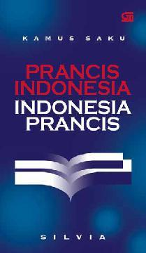
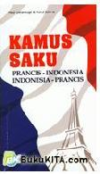
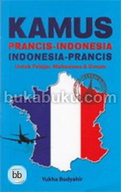
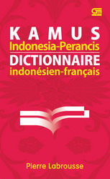
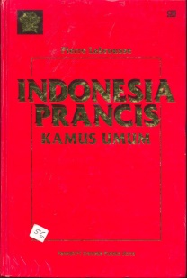
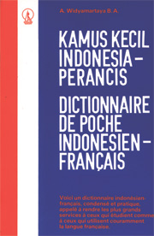

http://www.google.fr/imgres
Image 1. Indonesian-French bilingual dictionary

Namely, to develop the dictionary, mainly there are five important steps to do (Béjoint , 2014, p. 374-381, in FPBS proposals, 2015, p. 8, and UPN Veteran East Java), they are :
- decide the design,
- develop the corpus,
- arrange the vocabulary alphabetically,
- processing of entries,
- complete the meaning or translation.

- METHOD
The sample of this research was 34 students of the first level of French Department of FPBS UPI. This research used a few instruments such as bibliographic study, lexicography, the investigation, testing and grid assessment of the investigational product. While the research method used was the method of Research and Development (R & D). Sugiyono (2011, p. 407) explained the methode R&D :
Metode penelitian yang digunakan untuk menghasilkan produk tertentu, dan menguji keefektifan produk tersebut. Untuk dapat menghasilkan produk tertentu digunakan penelitian yang bersifat analisis kebutuhan (digunakan metode survey atau kualitatif) dan untuk menguji keefektifan produk tersebut dapat berfungsi di masyarakat luas, maka diperlukan penelitian untuk menguji keefektifan produk tersebut.

The research method that is used to produce certain product and to test the effectiveness of its product. To create certain product, need to use the need analysis research based (survey or qualitative) and to test the effectiveness of the product function in the society, it needs research to test the effectiveness of its product. Sugiyono (2011, p. 409-419) added that there are ten steps in this method : 1) find the potential and problems, 2) collect the data, 3) design the product, 4) validiter the design of the product, 5) review the product design, 6) examine the product, 7) review the product, 8) examine the product, 9) revise the product and 10) produce the final product. We also use the descriptive and quantitative methods for analyzing data from this research.

- RESULTS AND DISCUSSION
  - Needs analysis
The first result we gained was the result of the investigation for purposes of analysis or preliminary study. This enquette consisted of 15 about lexical difficulty and needs to solve. And according to the results of research there were 28 students (82.4% / much student) had lexical difficulty. Furthermore, students need independent media that is innovating with images, colors, etc. Similarly, the students gave their very positive opinions refers to the elaboration of the Indonesian-French dictionary and thematic showed.

  - Making of dictionary
According to the research results, we then developed the dictionary as the solution we proposed to solve the problematic of students. Specifically this dictionary was intended for beginners (A1/ A2). Again, this was because 16 students (47.1% / less than half) who wanted the media supplemented by images. Now, we explain the process of elaboration of the dictionary according to the theory.
- Decide the design
Pocket dictionary, Indonesian-French, thematic and illustrative. The dictionary completed by pictures and colors and organized by themes. In addition, the dictionary contains only the vocabulary for the beginner level (A1 / A2). The cover of this dictionary is as follows.

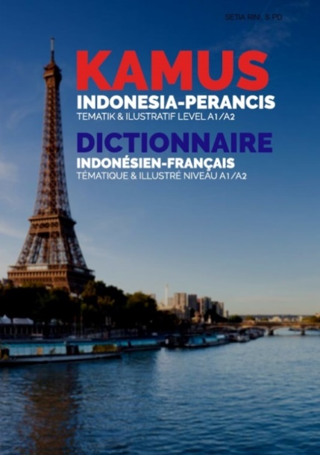

Image 2. The cover of dictionary

- Develop the corpus
The dictionary consists of eight themes principals according CECRL and 52 sub-themes. While the total vocabularies are 1585. The corpus of the dictionary are : 1) personal identity: the figure, the human body, nature, nationality, introduce, 2) family life: family activities, family members, household items, utensils, cooking utensils, the necessary makeup, bath amenities, 3) daily life: leisure activities, daily activities, shopping accessories, fruits, clothes, vegetables, month name, day, season, time, 4) the school life: school activities, the book party, school items, tools in the classroom, school facilities, punctuation, level of education, 5) the hobby: cooking activities, musical instruments, quantity, food, drink, sports, flavor, color, 6) the holidays: spend the holidays, animals, tourism type of vacation needs, beach holiday or sea, places to stay, tourist spots, 7) work: work activities, office, profession et 8) public services: transport, directions and positions, in the streets, places of worship, places of public.

- Organize vocabulary alphabetically
In this step, we organized all the vocabulary alphabetically using the application the computer. We also completed the dictionary with the phonetics for each vocabulary using the site http://www.wordreference.com/fr/French-Pronunciation.aspx. In addition, we also translated the indonesian to french vocabulary by the Indonesian-French dictionary (Labrousse).
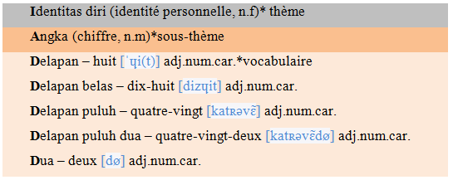

Image 3. Organisation of vocabulary alphabetically
- Processing of entries
We evaluated all entries in the dictionary and we put out the vocabularies that were not appropriate.

- Giving the example sentences, pictures and colors
We completed the dictionary with phrases made by ourselves. As for the images, we used pictures through the internet. So we proposed the presentation of this dictionary.
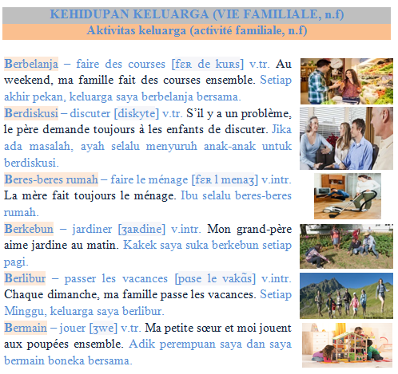

Image 4. The presentation of dictionary

  - Examination of the dictionary
We did twice examination of the product, the original dictionary and the dictionary revised after the first examination. According to the results of all examinations, we then revised the dictionary. Before we showed the difference between the dictionary before and after the revision, we explained that for the firts examination of dictionary, we used the test and investigation. And then, then we reviewed and revised the dictionary according to the results of the first examination. Consequently, we did the second examination by the assessment grid of the dictionary. In the assessment grid, there were grading scale who the students could give their notes to the revised dictionary.
Briefly, 88.2% students said that the dictionary is very easy and convenient to use. In addition, 91.2% students believed that the dictionary is very interesting to use. In addition, almost 100% students felt they are really aids in this dictionary. The contents of the dictionary is suitable for beginners (76.5%). The theme and sub-theme facilitate the students to search the vocabulary (82.4%). Phonetics also facilitate a properly pronounce (52.9%). While data sentences are simple and easy to understand (94.1%). The illustrations facilitate their easy-to-remember (73.5%). Colors easy to use dictionary (73.5%). Then, this dictionary is the solution to solve the lexical difficulty (100%).

While the disadvantage of the dictionary according to the students are: the presentation of the dictionary as typography, spacing, letter size and images. Even the students wanted the conjugation table in this dictionary. And the advantage of the dictionary according to the opinions of students are: the dictionary gives a lot of utility to students, the dictionary is very interesting, easy to use and very simple. And then the average value of the dictionary according to the students is 83.6 out of 100.

  - Revision of dictionnaire
Based on the research results we then revised dictionary. To understand the process of this revision we show below the different between before and after the revision of the dictionary.
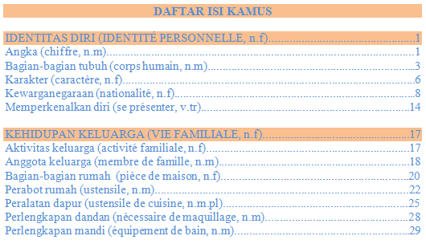  Before | 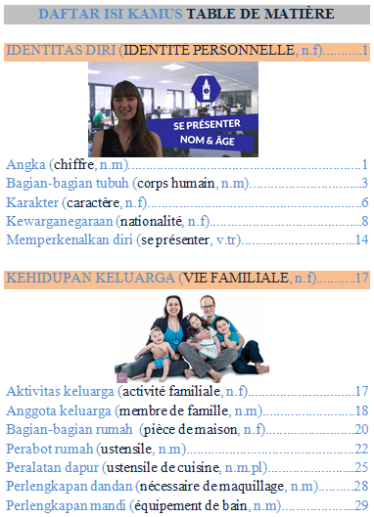  After
Image 5. The revision of table of content

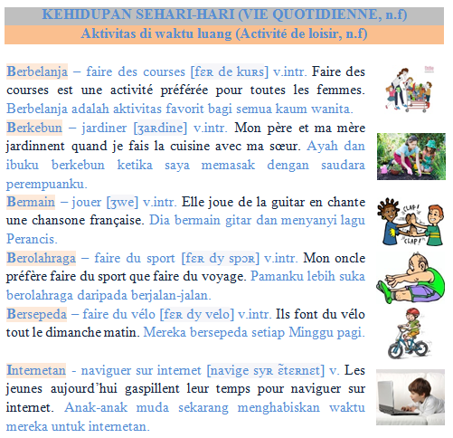  Before | 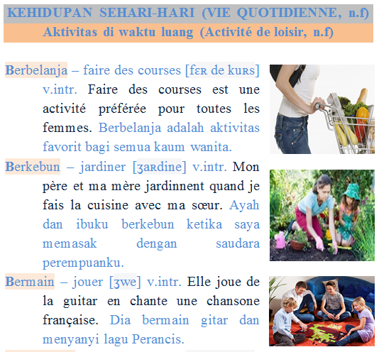  After
Image 6. The revision of content of dictionary

We also completed the dictionary with the table of conjugation table beacause there are many the student want this content.
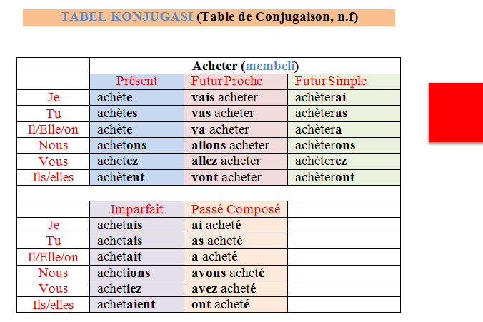

Image 7. The conjugation table

- CONCLUSION
According to the results of research and refers to the research problematic, we can conclude that:
- The Indonesian-French dictionary thematic and illustrative can become the solution to solve the lexical difficulty (94.1%)
- The advantages of dictionary: the dictionary is easy to use and understand, the dictionary is very interesting, applicable, practical and simple and the dictionary is very complete; the disadvantages: the number of vocabulary is less wide.

While the recommendation for the teacher, learners of French, researchers and the public is:
- Teachers can use the dictionary as the learning media to support the teaching-learning process in any way.
- Learners of french especially beginners can use the dictionary to enrich their vocabulary and to solve the lexical difficulty.
- Researchers can also revise and develop all aspects missing in this research.
- The public who want to learn french primarily to enrich the vocabulary can enjoy this dictionary.

REFERENCES
Bendjeddou, A. (2014). Le rôle du vocabulaire actif dans le développement de la compétence lexicale, cas des élèves de 5ème année primaire, ecole Bennouna Derradji, Djamâa, El-Oued. (Thèse). Université Mohamed Khider, Biskra. Retrieved from : http://dspace.univbiskra.dz:8080/jspui/bitstream/123456789/5865/1/BENDJEDDOU%20Asma.pdf. [2 January 2016]
Chardon, L. (2014). L’apprentissage du lexique à l’école : comment élargir et enrichir le lexique des élèves. Journal du Dépôt Universitaire de Mémoire Après Soutenance. Retrieved from : http://dumas.ccsd.cnrs.fr/dumas-00993131/document. [2 January 2016]
Conseil de l’Europe. (2001). Cadre Européen Commun de Référence pour les Langues : Apprendre, Enseigner, Evaluer. Journal de l’Unité des Politiques, Strasbourg. Retrieved from: https://www.coe.int/t/dg4/linguistic/Source/Framework_FR.pdf. [2 January 2016]
Cuq, J.P. (2003). Dictionnaire de didactique du français langue étrangère et seconde. Paris : CLE international.
Fakultas Pendidikan Bahasa dan Seni UPI. (2015). Penguatan kompetensi pengajaran bahasa dengan kamus linguistik terapan multibahasa dalam jaringan. Bandung : FPBS UPI.
Fallery, B. et Rodhain, F. (2013). Quatre approches pour l’analyse de données textuelles: lexicale, linguistique, cognitive, thématique. Journal de HAL, XVIème Conférence de l’Association Internationale de Management Stratégique AIMS, Montréal, Canada, p. 1-16. Retrieved from : https://halshs.archives-ouvertes.fr/hal-00821448/document. [2 January 2016]
François, T. (2016). La prédiction automatisée de la difficulté lexicale en FLE. Séminaire à l’Université de Fukuoka. Retrieved from : http://cental.fltr.ucl.ac.be/team/tfrancois/articles/seminaires/Fukuoka2016.pdf. [2 Januaryr 2016]
Grossmann, F. (2012). Le rôle de la compétence lexicale dans le processus de lecture et l’interprétation des textes. Journal du Forum Lecture. Retrieved from : http://www.forumlecture.ch/myUploadData/files/2012_1_Grossmann.pdf. [2 January 2016]
Hamel, MJ. & Milicevic, J. (-). Analyse d’erreurs lexicales d’apprenants du FLS : démarche empirique pour l’élaboration d’un dictionnaire d’apprentissage. Journal de Canadian Journal of Applied Linguistics et Revue Canadienne de Linguistique Appliquée, 10 (1). Retrieved from : https://journals.lib.unb.ca/index.php/CJAL/article/view/19733/21408. [2 January 2016]
Itma, M. (2009). Quelles difficultés d’apprentissage chez les étudiants de français à l’université An-Najah de Naplouse? [Online]. Retrieved from : http://eprints.aidenlignefrancaisuniversite.auf.org/33/1/pdf_ITMA_Maha_these.pdf. [2 January 2016]
Lesage, V. (2015). Matériel pédagogique: Élaboration des manuels scolaires. [Papers]. Unpublished manuscript, Universitas Pendidikan Indonesia, Bandung, Indonesia.
Pasha, S. & Kisi, A. (2012). L’image (dans les manuels ) hier et aujourd’hui. Journal de Journées Pierre Guibbert, IUFM, Montpellier II et Montpellier III. Retrieved from : http://www.fde.univ-montp2.fr/internet/site/cedrhe/_img_cedrhe/jepg/jepg_id_28.pdf. [2 January 2016]
Rey, A. et al. (2011). Le Robert de Poche Plus 2012. Paris : Sejer.
Soumia, A. (2009). L’enseignement du français par l’image dans le manuel de 3ème année primaire. Mémoire. (Thèse). Retrieved from : http://bu.umc.edu.dz/theses/francais/AMO1276.pdf. [2 January 2016]
Sugiyono. (2011). Metode penelitian pendidikan, pendekatan kuantitatif, kualitatif dan R&D. Bandung : CV. Alfabeta.
UPN Veteran Jatim. (-). Tinjauan pustaka. [Online]. Retrieved from : http://eprints.upnjatim.ac.id/2736/2/file2.pdf. [2 January 2016]
http://www.google.fr/imgres
http://www.wordreference.com/fr/French-Pronunciation.aspx

