Geothermal Potential Assesment of Way Ratai Area Based on Thermal Conductivity Measurement to Measure Thermal Properties of Rocks

Karyanto^{1, 2}, Nandi Haerudin¹,Rahmi Mulyasari¹, Suharno¹,and Posman Manurung³
¹Geophysical Engineering Department, Faculty of Engineering, University of Lampung, Indonesia
²Doctoral Student, Faculty of Mathematics and Natural Science, University of Lampung, Indonesia
Jl. Sumantri Brojonegoro No. 1 Bandar Lampung, Indonesia
³Physics Department, Faculty of Science, University of Lampung, Indonesia
Jl. Sumantri Brojonegoro No. 1 Bandar Lampung, Indonesia
karyanto@eng.unila.ac.id, nandithea@yahoo.com, rahmi.mulyasari@eng.unila.ac.id, suharno.1962@eng.unila.ac.id, reip65@yahoo.com
Corresponding author: Karyanto (karyanto@eng.unila.ac.id)

Abstract
Thermal conductivity measurements have been applied on Way Ratai geothermal prospect area. The thermal conductivity method is used to evaluate the ability of a rock to deliver heat by conduction. In the area, many surface manifestations are scattered in various regions, where hot springs dominate these various manifestations. This thermal conductivity mapping of rocks is carried out around geothermal manifestations by making a hole as deep as 1 meter to insert the stick of conductivity meter. The result of thermal conductivity method measurement is data of k (thermal conductivity), Rt (thermal resistivity), and T (temperature). The measured value of conductivity data in the geothermal field is valued between 0.056-0.664W/mK, thermal resistivity between 1.344-17.527 mK/W, and the temperature between 22.7-52.6°C. The difference value of thermal conductivity rock is influenced by several factors: existing geological structures in the field such as normal faults and lineaments, presence of alteration, and the manifestation zone of hot water or hot vapor that caused by fumaroles.
Keywords: Thermal Conductivity, Temperature, Geothermal, Geology, Way Ratai

- Introduction
Conductivity or thermal conductivity (k) is an intensive amount of material that shows its ability to conduct heat. Thermal conductivity is one of important physical property for predicting heat flow and corresponding subsurface temperatures (Haenel et al., 1988; Rühaak et al., 2015; Rühaak, 2015; Blázquez et al., 2018). Meanwhile, each rock has a different conductivity level depends on the rock structure.
Conductivity, resistivity, and temperature of rocks are important data in a geothermal system. Conductivity is used to deliver heat that passes through rocks from heat source rocks through impermeable rock layers to the surface.Thermal conductivity describes how well the heat is conducted through a material (Gua et al., 2017; Blázquez et al., 2018). While resistivity data is used as a comparison of conductivity data that has been produced. In addition, the temperature is linear with conductivity data when the rock has a high conductivity value which has a consequence that is the high temperature value.
Karyanto (2002) was conducted a study in Way Ratai geothermal area to map the hot springs using the Mise-A-La-Masse method. The result stated that hot water from hot water well A was not connected to hot water well B underneath. This is indicated by isopotential contour between well B and well A that is not connected. However, the contour itself is closer to the center of hot water well A, which indicates that the hot water comes from the well itself.
Then in 2003,Karyanto carried out a subsurface imaging process in Way Ratai geothermal area using a 2-dimensional resistivity method. The results show that hot water wells, which are one of the surface manifestations from an area that geothermally active like Way Ratai, between Hot Springs A and B are not related to each other.
Karyanto, et al. (2008) have determined the conductive zone of Way Ratai Lampung with Resistivity Method. Data that measured from the area mostly taken from surface manifestations. From these data indicate that the distribution pattern of low resistivity anomalies (ρ_{a}≤10 ohm meters) is at the top of the study area and will increase in line with depth increasing. However, this pattern is mostly continuous and not separate.
Haerudin, et al. (2016) has mapped Radon and Thoron to deliniate local faults. The results show that there are three lineament anomalies that pass geothermal manifestations which indicated as local faults, namely F1, F2, and F3. The first fault delineation (F1) that connects the BambuKuning spring and Margodadi from the northwest to the southeast. The second (F2) connects the Padok hot spring and Way Asin from the southwest to the northeast. The third (F3) passed Margodadi hot spring in the same direction with F2.Based on the ratio of Radon to Thoron, F1 and F2 is a fault that extends to depth. Both are indicated as geothermal fluid flow channel
According to Karyanto and Haerudin (2013), heat is the dominant parameter in geothermal active areas.Therefore, a study that discusses this parameter is needed to be applied in Way Ratai geothermal area. Way Ratai geothermal area is located at coordinates 5.12° - 5.84°S and 104.92° - 105.34°E, Padang Cermin Sub-District, Pesawaran District, Lampung Province, Indonesia. This geothermal area has several hot water wells on the surface with a relatively high temperature (80°C - 90°C) (Karyanto, 2003). The wells are surface manifestation of a geothermal system that has not been fully explored by researchers.

Thermal conductivity research method is used to determine the ability of a rock to transfer heat by conduction. The main purpose of this research isspecifically to map the distribution of rock thermal conductivity values, analyze the value of rock thermal conductivity, and determine the factors that affect the rock thermal conductivity value.

- Theory
2.1 Way Ratai Local Geology
Research area is dominated by lithology product of young volcanoes (Qhv), alluvium (Qa), Hulusimpang formation (Tomh), Sabu Formation (Tpos), Kantur Formation (Tmpk), and Menanga Formation (Km). Stratigraphy in this area is composed by rocks of Pre-Tertiary, Tertiary, and Quaternary.
Volcanostratigraphy of Way Ratai and surrounding areas are grouped into: 1) Tertiary rocks (bedrock), 2) Old Pre-Betung-Ratai volcanic rocks, 3) Volcanic rocks resulting from eruptions of Betung and Ratai Volcanic. The complete volcanic structure in the Way Ratai - Lampung Geothermal Field is separated into 40 lithology units, including 3 surface destruction sediment units (debris, lava and alluvium deposits), 1 unit Banjarmeger volcanic eruption rock and 3 volcanic rock units associated with Gebang volcano(Figure 1).

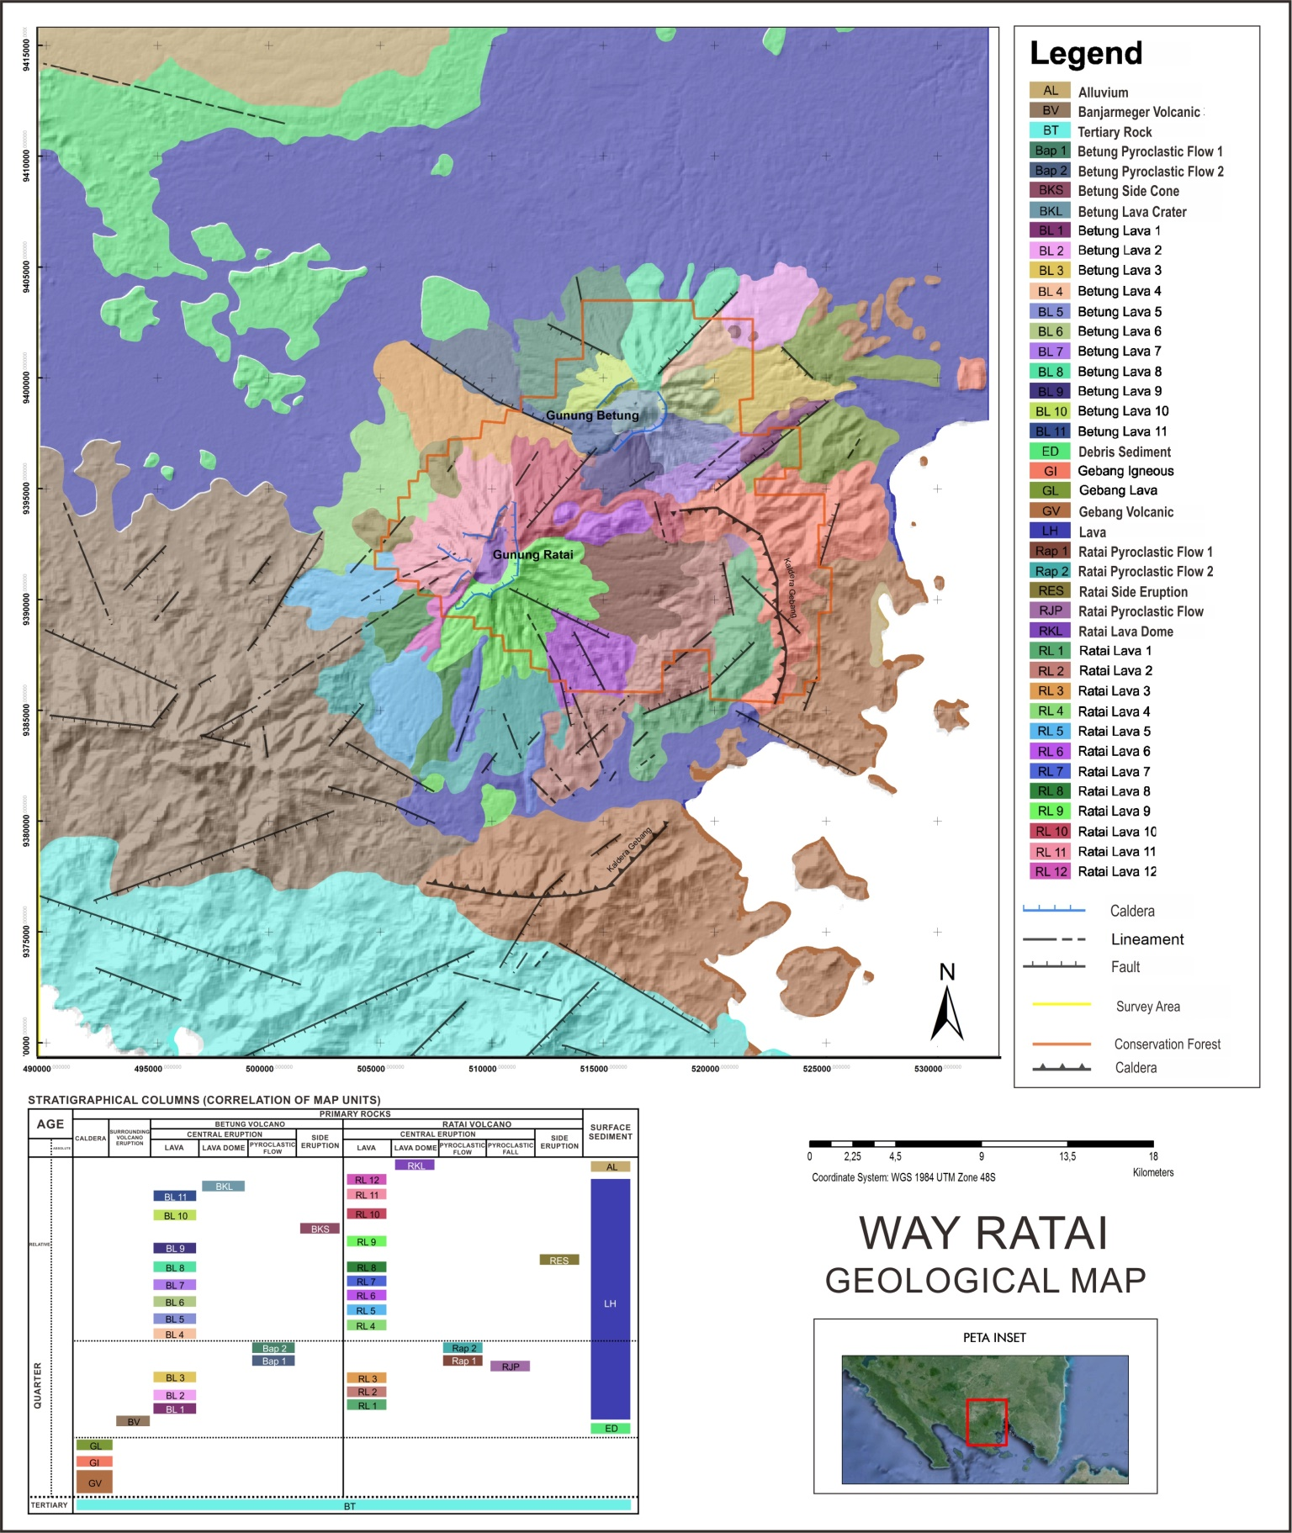

Figure 1.Geological map of the research area (modification from Gafoer et al., 1993).

In the study area there were 3 geological structure groups, namely caldera structure, crater structure and fault. Fault structures in the Way Ratai Geothermal Field and its surroundings are dominated by northwest-southeast and northeast-southwest faults which are suspected as normal faults. The mechanism for the formation of normal faults is caused by tention and tends to cause wide open space. Therefore, its presence is considered important because it can support the high permeability of reservoir rock which is the target zone of the geothermal prospect in Way Ratai.
2.2 Thermal Conductivity
Heat flowing process from a high-temperature part to a lower temperature part in a medium without particle medium or different mediums is called conduction process, for example, the process that occurs when a piece of iron is heated. In conduction process, if the medium is fast in conducting heat, then the temperature increase will run slowly, on the contrary if a medium is slow in conducting heat then the temperature increase occurs rapidly (Isjmiradi, 1989). Furthermore, by plotting the temperature rise in the time function, a straight line will be obtained that corresponds to Equation (1)below (Carslaw and Jaeger, 1959).
$T=\frac{Q}{4πK}\ln\left(t\right)+A$ (1)
where T is temperature (Celcius), Q is the heat that produced by probe per unit length (W / m), K is the material thermal conductivity (W / m C), t is time (second), and A is a constant that states the temperature t = 0 (Celcius).
Based on the second law of thermodynamics, thermal conductivity can be measured if there is heat transfer from a high temperature to low temperature. With this formula, if a material is given certain heat power, heat transfer will occur. The principle is then applied to the Needle Probe method (principle of the tool used), which is one of the practical methods for measuring a thermal conductivity of a material with a working system as follows: a probe that has been flowed with certain heat is inserted into material to be measured, which then causes a difference in heat between the heat on the probe and the material causes heat transfer which will be detected by a sensor inside the probe. The heat energy formed in the Needle Probe comes from electrical energy, by flowing electric current into the heating wire. Electric current in a wire is defined as the amount of charge that passes through the wire each time unit at a certain point. Therefore, the current (I) is defined as:
$I=\frac{q}{t}$ (2)
whereq denotes the amount of charge (C) that passes through the conductor at a location during a certain time interval which expressed by t (seconds) and I states the electric current (A)
If qthat moves past the potential difference (V) is qV, then the power (P), which is the speed of energy shifting is (Fraden, 1996):
$P=\frac{qV}{t}$ (3)
With P, the power (watts) and V represent the potential difference produced (volts). The charge that flows every second is an electric current, with:
$P=VI$ (4)
The heat that produced in a heating coil occurs because there are many collisions between moving electrons and atoms in the wire. At each collision, energy from the electrons is transferred to the atom that collides with them. Which causes the kinetic energy of the atom increase, therefore, the wire’s temperature increase (Fraden, 1996). This increased heat energy can be transferred as heat with conduction properties onto the Needle Probe.
Most of the geothermal reservoirs are found in volcanic rocks with the main flow through fractures. As found in oil fields, the important rock properties that determines the geothermal reservoir rock properties are porosity, permeability and, rock density. Meanwhile, several other important parameters are specific heat and thermal conductivity (Saptadji, 2002).
Thermal conductivity is the thermal property of an object to transfer heat in a unit of time through a certain cross-sectional area driven by a difference in temperature (Jangam and Mujumdar, 2010). The thermal conductivity of rocks indicates how fast heat in a reservoir flows to the surface. The value of thermal conductivity rocks determines the potential of the geothermal reservoir as geothermal energy source (Endovani, 2016). According to Raina (1993), the conductivity value of rocks is around 0.05 W/m° C to 3.0 W/m°C.While thermal resistivity is the thermal property of an object to inhibit the flow of heat in a unit of time through a certain cross-sectional area caused by a temperature difference. The relationship between thermal conductivity and resistivity can be expressed as Equation (5) below:
$k=\frac{1}{R_{t}}$ (5)
Where k is thermal conductivity and R_{t} is thermal resistivity.
3. Data and Methods
Tools and materials used in this study are: 1:500,000 scale Geothermal Working Area map, SRTM DEM map, regional geological map (Gafoer et al., 2003), local geological map (Gafoer et al., 2003), GPS garmin map 78s, CT Drill, Main unit MAE v.A5000T, Probe CTS45, CT measurements & Stationery form, Laptop with Global Mapper v.13, Surfer v.12, ArcMap v.10.0, Map Source v.240, and Microsoft Excel v.2007 software.
Research using rock thermal conductivity method was conducted in Way Ratai geothermal field using primary data with 122 measurement points with seven manifestations of hot water and scattered in eight sub-districts of Way Ratai region. The observation results in this study were conductivity maps that overlaid with local geological maps, conductivity maps with topographic maps, temperature maps, and resistivity maps. This research was conducted to analyze the four maps and find out the factors that influenced rock thermal conductivity value.
This research method consists of several stages: data acquisition, data processing, and data interpretation. In data acquisition, measurements were taken with electrode sensors or probes that were placed 0,5 m under the surface with closed hole conditions.The probe was positioned to make contact with the surface.The probe is inserted carefully into the hole as careful as possible to prevent damage. Data collection was done for 5 minutes. The measurement data wasreceived in the form of Rt (thermal resistivity), k (thermal conductivity), and T (temperature) values.
After data acquisition phase, then data processing was carried out. Method use for gridding data is Kriging Method. Kriging is a geostatistical method that is used to estimate the value of a point or block as a linear combination from sampled values ​​around the point to be estimated. Kriging value is obtained as a result of the minimum estimation variance by expanding the use of semi-variogram. Kriging estimator can be interpreted as a unit of unbiased variable and the sum of the overall weights. This value is used to estimate the value of thickness, height, grade or other variables.Kriging gives more values ​​to samples with close distance compared to samples that have a longer distance. Continuity and anisotropy conditions are important considerations in the kriging process. Data geometric shape, estimated variable characters, and the block size are also estimated. This method is able to produce maps with a good appearance that comes from the smoothing effect. Where the effect is formed directly on the depiction of contour lines.
Data processing produced four maps, which arerock thermal conductivity map with topography (topographic data from DEM SRTM map), rock thermal conductivity map overlaid with local geological conditions, thermal resistivity map, and temperature map of the study area.
The last stage is data interpretation, which was done by examiningthe four data maps. First, a map of the thermal conductivity of rocks overlaid with local geological map. The area that has a high thermal conductivity value is presumed to be in proximity witha manifestation of hot water. The appearance is closely related to geological conditions of faults and lineaments that controlthe area. Second, a map of rock thermal conductivity overlaid with topography map. Topographic contours of a region were generally used to determine on-site conditions by the time of data acquisition. Denser topography contour shows higher inclination. Third, data from temperature maps was needed to confirm the thermal conductivity of the rocks in an area: temperature values and thermal conductivity are linear. Higher conductivity value of a point will be shown through high temperature measured, and vice versa. Fourth, resistivity data was used to compare the thermal conductivity value of rock. In theory, it was explained that the conductivity value is inversely proportional to its resistivity value. If the conductivity value of a point shows a high value, then the resistivity value will be low, and vice versa.
- Results and Discussion
Rock thermal conductivity value in Way Ratai geothermal prospect area wasaffected by several factors: geological structure, the presence of alteration, and hot spring manifestation. In this case, specifically, the existence of alteration affects the value of thermal conductivity, this is because alteration rocks have a good level of conductivity. In alterationrocks contains several types of mineral:alunit, chlorite, hematite, pyrite, magnetite, and silica. These minerals have very good properties and conductivity (Horai, 1971). Then the existence of geothermal manifestations is very influential on the distribution of thermal conductivity values. This was because geothermal manifestations have high temperatures which can affect value rock thermal conductivity value.
4.1 Conductivity - Local Geological Map
Based on Figure 2, it shows us that hotspring appearance in Way Ratai area arerelated to the geological appearance in the field.Normal faults are the control factor on the study area which directed from north-east to south-west and north-west to south-east,also the lineaments which have same main direction as fault structure’s. This study area is composed of lava sedimentary rocks, ratai pyroclastic flow 1, ratai pyroclastic flow 2, ratai lava 1, ratai lava 2, ratai lava 4, ratai lava 5, and ratai lava 7.
Conductivity-local geological mapshows that high conductivity values are scattered on several hot spring manifestations or hot steam discharge from fumaroles. This is due to the water vapour content in the hot area, which increase the conductivity value. In addition, soil or topsoil at this area is a result of rocks weathering that continuously undergoing alteration processes. The existence of alteration affects the value of thermal conductivity, this is because alteration rocks are rocks with good conductivity. In the study area, hot spring manifestation area is dominated by silica sinterwhich has a high influence on its thermal conductivity value.
Furthermore, there is also a high conductivity value in the geological structure such as faults and lineaments. This is caused bythe weak zone on that area that can be passed by hot fluids thus increasing the conductivity value.The conductivity value also increases when the measurement process is carried out close to the swamp or in other aqueous areas as well as on rocks containing water, because of the conductive nature of the water.

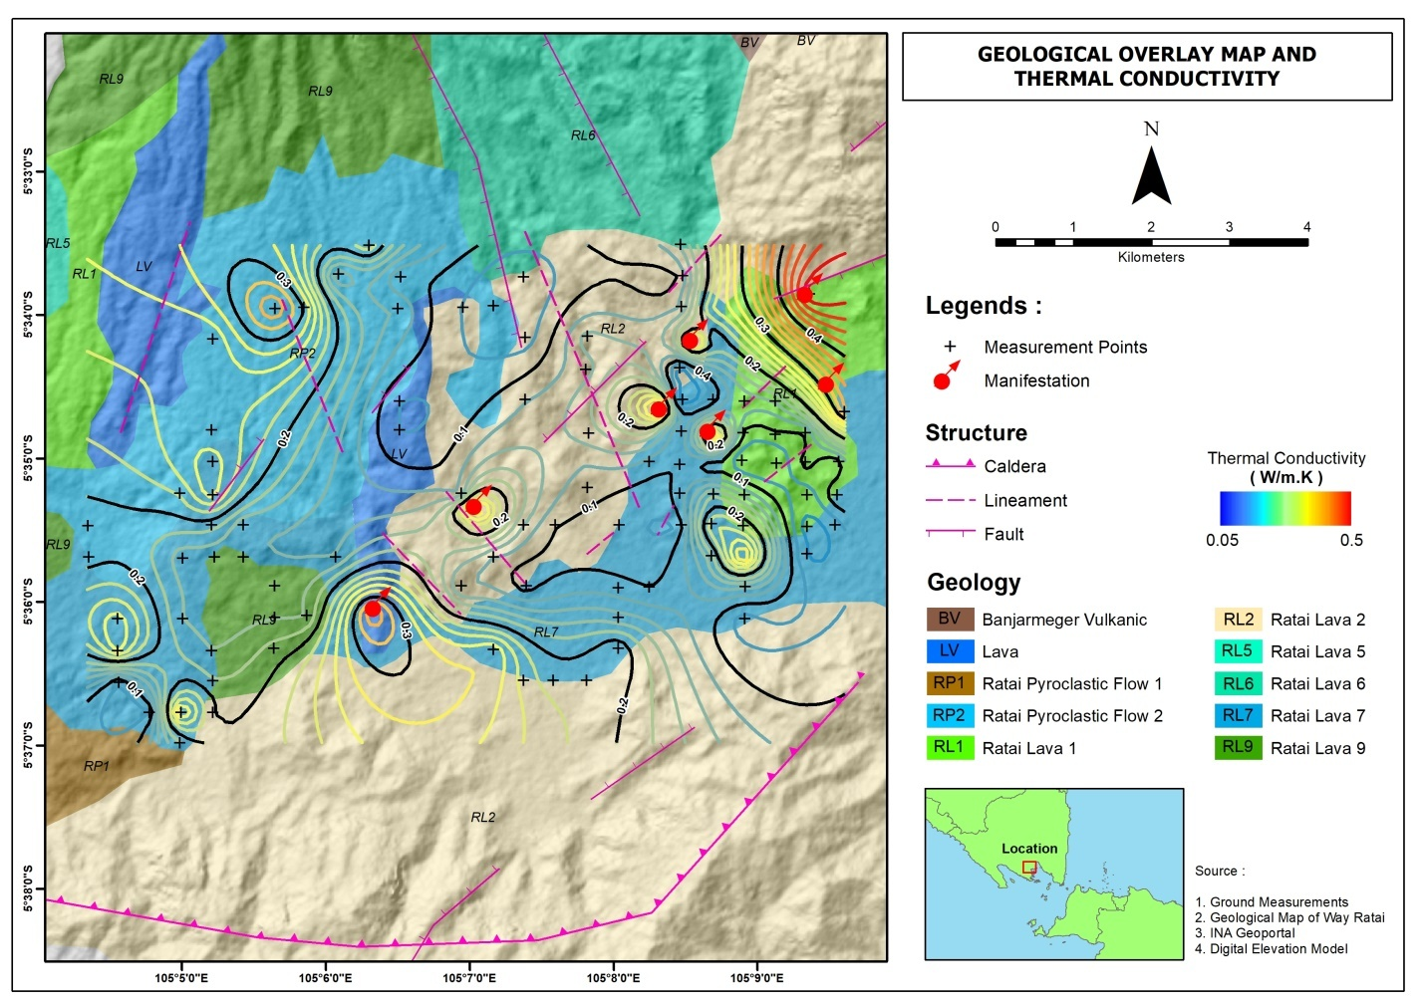
Figure 2.Conductivity – local geological map
Rocks thermal conductivity values distribution that overlaid with the area’s local geological conditions are highlighted withlight blue to dark blue color scales which shows a low value of rock thermal conductivity and its dominantly located at Ratai lithology:ratai lava 1 (RL1), ratai lava 2 (RL2), ratai lava 7 (RL7), and there is a rock insert in the form of ratai pyroclastic flow 1 (Rap1) and lava deposits (LH) which have low thermal conductivity as well. For the yellow to green color scale shows the medium thermal conductivity value and itsdominantly located at rock lithology: ratai lava 4 (RL4), ratai lava 5 (RL5), and there is intercalation rock in the form of 2 pyroclastic flows (Rap2). The orange to dark red color scale is spread over seven manifestations of hot water and the appearance of the existing geological structure.

4.2 Conductivity – topography map
Based on Figure. 3, it shows us that the value of Way Ratai geothermal prospect area rock thermal conductivity measurement is valued between 0.056 to 0.644W/mK. On the topographic contour map, it is explained that the closer distance between topographic contour lines represent steep slopes, otherwise, the farther the distance between topographic contour lines to each other represent gentle slopes. Steep slopes topography dominantly located at north-east and east of the study area and gentle slopes topography dominantly located at south-east and south of the study area. Basically, topographic map is used to view terrain of the study area when data acquisition is carried out.
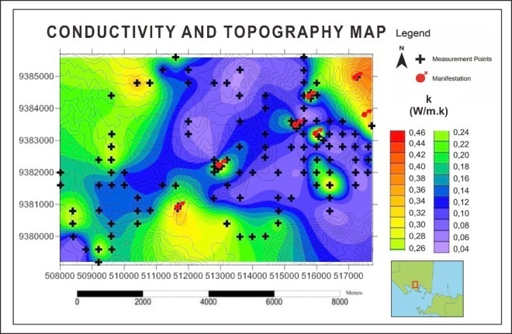
Figure 3.Conductivity-topography map.
4.3 Temperature Map
Figure 4 shows us that the temperature measurement value of Way Ratai geothermal prospect area is valued between 22.68 to 52.59° C. The temperature data was used as supporting data for thermal conductivity values that was measured in the field. Based on existing theory, temperature and conductivity values are linear. From the temperature measured value map, it shown that high-temperature values are scattered in several manifestations of hot spring in the study area.
Distribution of rock temperature values appear with purple, light blue to old scales shows low rock temperature value and is predominantly located in west and northwest direction of study area. For green to yellow scale shows the value of the medium rock temperature and is predominantly located in east, southeast, and south directions of study area. The orange to dark red color shows high rock temperature values in seven manifestations of hot spring. Based on obtained temperature analysis, it can be seen that map of thermal conductivity of rock with its temperature has a relative value that is directly linear to each other.
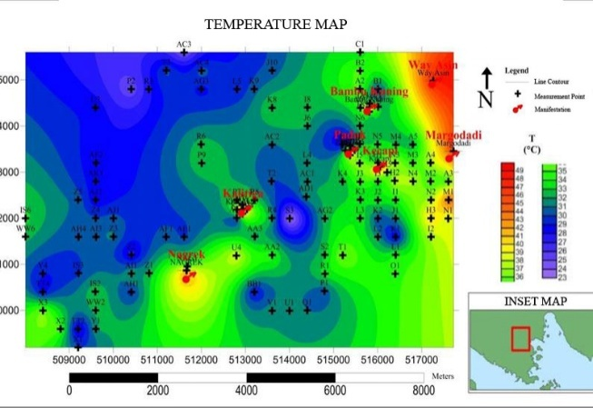
Figure 4. Temperature map
4.4 Thermal Resistivity Map
Based on Figure 5, it shows thatWay Ratai geothermal prospect areathermal resistivity measurements value is valued between 1,344 to 17,527mK/W. The resistivity data was used as a comparative data for thermal conductivity rock value.

Thermal resistivity data has the same function as thermal conductivity data, which is to determine the manifestation area that has been altered. Alterations include the replacement of primary phases and the results caused by rising hot fluidssurface (Suharno et al., 2015). Alteration in Way Ratai geothermal area occurs due to the influence of temperature and high pressure on the mineralogical composition of the rock (in a solid state).Temperature that caused damage to potassium, calcium, and magnesium becomes clay minerals. Therefore, the altered area has a low thermal resistivity value.

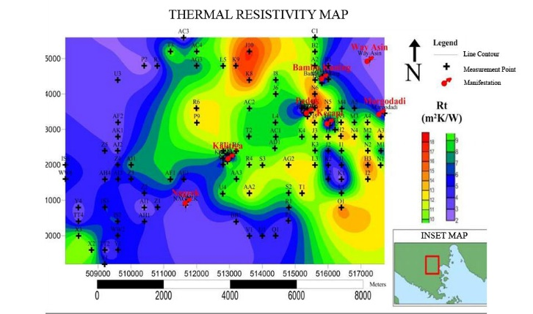
Figure 5. Thermal resistivity map
From the maps produced, an integrated map is made from the results of research based on thermal conductivity, temperature and thermal resistivity as shown in Figure 6.

High thermal conductivity is in the northwestern part of the study area, also in most areas that have manifestations.Likewise, for regions that have low thermal resistivity, most of them intersect with these regions.Whereas high-temperature areas, most are in areas that have manifestations.As shown in Figure 6.
Figure 6 shows that regions that have manifestations tend to be higher in temperature than the surrounding area. Likewise, these areas have lower thermal resistivity and higher thermal conductivity.

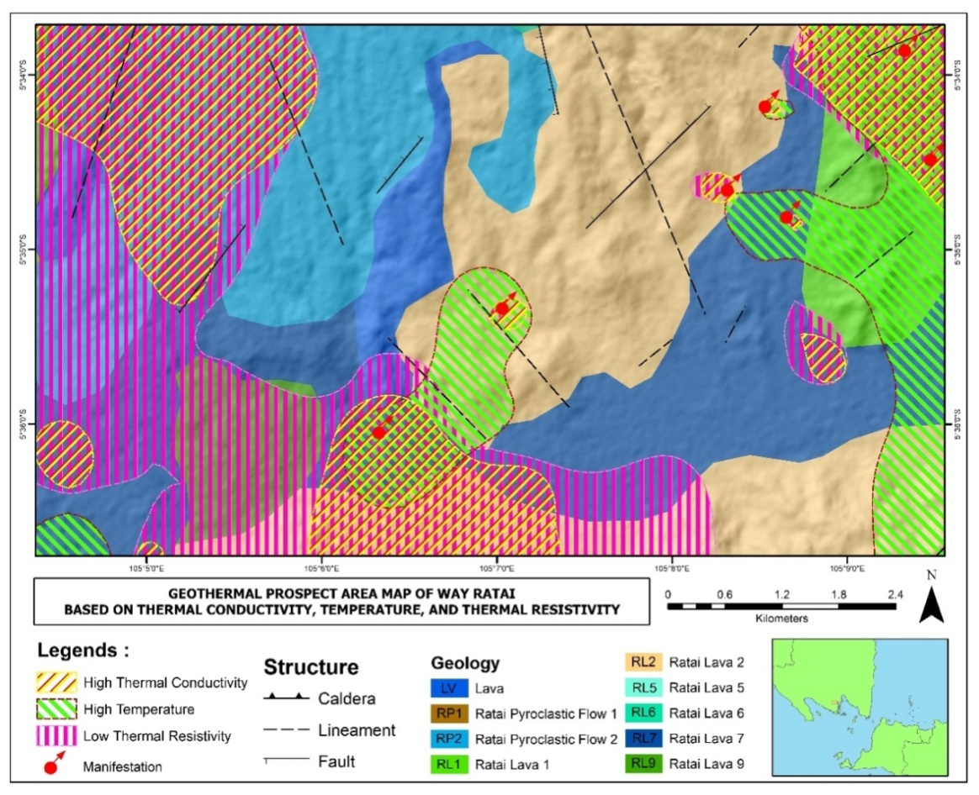
Figure 6. Integrated map of research results

- Conclusions
Thedifference value of thermal conductivity rock is influenced by several factors:existing geological structures in the field such as normal faults and lineaments, the presence of alteration and the manifestation zone of hot water or hot vapor that caused by fumaroles. The existence of geothermal manifestations affecting the distribution of thermal conductivity values.
Acknowledgements
The authors would like to thank Directorate General of Research and Development Strengthening, Ministry of Research, Technology and Higher EducationRepublic of Indonesiathrough The InstitutionNational Strategic Research Scheme.

References
Blázquez, C. S., Martín, A. F., García, P. C. and Aguilera, A.G., 2018, Thermal conductivity characterization of three geological formations by the implementation of geophysical methods, Geothermics, 72, 101–111.
Carslaw, H. S., and Jaeger, J. C., 1959, Conduction of Heat in Solids, Oxford Press, 2nd ed, pp 344-345.
Endovani, R., 2016, Analysis of thermal conductivity and porosity of sintered hot spring silica in SapanMaluluang, AlamPauh Duo District, South Solok Regency, Journal of Physics Unand, 4 (1), 65.
Fraden, J., 1996, Handbook Of Modern Sensors (physics, designs, and applications 2 nd), Sandiego, California, Thermoscan, inc
Gafoer, S., Amirudin., Mangga, A., and Sidarto., 1993, Geological Map of Indonesia Quadrangle, TanjungKarang Sheet, Sumatera, 1: 250.000 scale, Bandung: Geological Research and Development Centre.
Gua, Y., Rühaak, W., Bära, K. and Sassa, I, 2017, Using seismic data to estimate the spatial distribution of rock thermal conductivity at reservoir scale, Geothermics, 66, 61–72.
Haenel, R., Rybach, L., Stegena, L., 1988, Thermal exploration methods, In Haenel, R., Stegena, L., Rybach, L. (Eds.), Handbook of Terrestrial Heat-Flow Density Determination, Chapter 2, Kluwer Academic Publishers, Dordrecht.
Haerudin, N., Karyanto, and Kuntoro, Y. 2016, Radon and Thoron Mapping to delineate the Local Fault in The Way Ratai Geothermal Field Lampung Indonesia, ARPN Journal, Vol.11 No. 7
Horai, K., 1971, Thermal conductivity of rock forming minerals. J Geophys Res, 76, 1278–1308.
Isjmiradi, M., 1989, Thermal Conductivity Measuring Instrument Making Rocks With Needle Probe Method, Physics Departement,University of GadjahMada, Yogyakarta.
Jangam, S.V., and Mujumdar, A.S., 2010, Basic Concepts and Definitions, Drying of Foods, Vegetables, and Fruits: Singapore.
Karyanto, 2002, Distribution Mapping of Hot Springs in the Way Ratai Geothermal Area, Lampung with the Mise-A-La-Masse Method, Jurnal of Science and Technology, Unila, Vol.8 No.2.
Karyanto, 2003, Subsurface Imaging of Way Ratai Geothermal Area Lampung with 2-dimensional resistivity method, Jurnal of Science and Technology, 9 (3), 55.
Karyanto and Haerudin, N., 2013, Qualitative interpretation of surface temperature at Way Ratai Geothermal Potential, Lampung, Proceedings of the Science & Technology National Seminar V, Research Institute University of Lampung, Bandar Lampung.
Karyanto, Sarkowi,M., Rustadi, Haerudin, N. dan Satiati, I., 2008, Determination of Conductive Zones in Way Ratai Geothermal Lampung with Resistivity Method, Proceeding of SATEKS 2 Seminar, University of Lampung, Bandar Lampung.
Raina, V. K., 1993, Concrete for Construction, Facts, and Practic, Tata McGraw-Hill Publishing Company, Ltd., New Delhi.
Rühaak, W., Guadagnini, A., Geiger, S., Bär, K., Gu, Y., Aretz, A., Homuth, S., Sass, I., 2015, Upscaling thermal conductivities of sedimentary formations for geothermal exploration. Geothermics, 58, 49–61.
Rühaak, W., 2015, 3-D interpolation of subsurface temperature data with known measurement error usingKriging, Environment Earth Science, 73 (4), 1893–1900.
Saptadji, N., 2002, Lecture Notes "Geothermal Engineering”, Bandung Institute ofTeknology, Bandung.
Suharno, S., Amukti, R., Hidayatika, A. and Putroi, M. K. 2015, Geothermal Prospect of Padang Cermin Pesawaran Lampung Province, Indonesia, Proceedings World Geothermal Congress 2015, Melbourne, Australia, 19-25 April 2015.

