CONDUCTIVITY ZONE ON AUDIO-MAGNETOTELLURIC DATA (AMT)
IN PARANGTRITIS AREA, BANTUL, YOGYAKARTA
Akroma Hidayatika¹, Suharno², Hesti³
^{1,2,3} Department of Geophysical Engineering, University of Lampung, Jl. Prof. Soemantri Brojonegoro, Bandar Lampung 35145
E-mail correspondence: akr_tika@yahoo.co.id
Abstrak. Parangtritis area has a high attraction for tourists and researchers. This area has high cliffs with steep slopes, large rivers, sand dunes, warm springs to adjacent beaches. Morphologycaly, existence of highly dissected structural mountains to the beach with sand dunes. From geological point of area Parangtritis is contact of Nglanggran Formation, Wonosari Formation, Merapi Volcano and Alluvial Sediment. This study uses the MT geophysical method. The MT electromagnetic geophysical method is capable of measuring rock resistivity and has a high efficiency, one of which is the Audio-Magneto Telluric or AMT method (Berktold, 1983). This method is able to describe subsurface lithology using a resistivity model that has penetration more than 1 km. The result generally consists of five layers; the first layer is a 37 Ohm-m thin resistive layer with a thickness of about 7 m associated with breccias; the second layer is a 9 Ohm-m conductive layer about 100 m thick possibly related to andesite lava that is altered and contaminated with sea water; the third layer is still a conductive layer but with a relatively higher type of resistivity (18 Ohm-m) with a thickness of about 180 m which is probably related to andesite lava changed; the fourth layer is a 9 Ohm-m conductive layer around 700 m thick which is probably still related to the changed andesite lava rock but it is uncertain whether or not it has been contaminated with sea water. Then, conductive zone is located in North-East of the research location.
Kata kunci: Parangtritis, conductive zone, Audio-Magneto Telluric

1. Introduction

Back Ground
Parangtritis has a high attraction for tourists and researchers. This area has high cliffs with steep slopes, large rivers, sand dunes, warm springs to adjacent beaches. Geologically, the Parangtritis area is a meeting of the Nglanggran Formation, Wonosari Formation, Merapi and Alluvial Volcanic Deposits (Rahardjo et al., 1995).
Magnetoteluric (MT) is a geophysical passive method that measures the time variation of electric fields and natural magnetic fields on the surface of the earth (Cagniard, 1953) . This method utilizes the physical properties of rock namely resistivity. The MT method is able to measure rock resistivity and has a high efficiency, one of which is the Audio-Magneto Telluric or AMT method (Berktold, 1983). The AMT method uses natural electromagnetic waves with a frequency of 8 Hz - 20 kHz (Cagniard, 1953). This method is able to provide depth information up to ± 2 km at a certain point (Hoover and Long, 1976). Ardiansyah, (2007) used AMT data to identify basements in parts of Bantul and Yogyakarta filled with young volcanic rock sediments. The conductive zone appears to split the limestone from this basement. The conductive zone is estimated a fracture of the Opak fault activity. Niasari, (2015) using MT data to interprete the faults of geological structure in the Sipoholon geothermal area.
Knowing the three AMT data points of conductivity zone in the Parangtritis will be able to be used later as a baseline to know the depth of aquifer to establish water wells for the community, to determine the contamination of land, to know landslides risk, to find the river under surface that able to develop geo-tourism in Parangtritis.

1.2. Parangtritis Physiography and Geology
The research area is south of the Oyo River and Opak River. Geologically, it is located in the Sewu Mountains zone and the Alluvial Coastal Plain zone (Bemmelen, 1949).

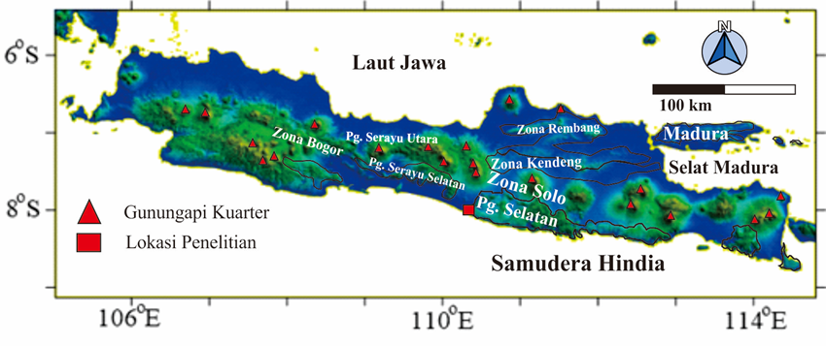
Figure 1. The physiographic map sketch of parts of Java and Madura (physiography from van Bemmelen, 1949; base map from DEM). The research area is in the red box south side of Yogyakarta.

The study area are included in the south-eastern part of Central Java, which includes the Merapi Volcano area, Yogyakarta, Surakarta and the Southern Mountains. Then split back into Solo and Southern Mountains Zone (Bemmelen, 1949) (Figure 1). The Solo Zone is a part of the Central Depression Zone of Java Island. This zone is occupied by the cone of Mount Merapi (± 2,968 m). The southeast foothills of the volcano are the Yogyakarta-Surakarta plain (± 100 m - 150 m) composed of alluvium deposits from Mt. Merapi. South Mountain zone the west, the plains of Yogyakarta constantly until southern coast of Java, which extends from the coast up to the Progo Parangtritis. The main river flows in the west are Kali Progo and Opak River, while there is Dengkeng River in the east which is a tributary of Bengawan Solo River (Bronto and Hartono, 2001).

2. Eksperimental
The research area covers west part of Parangtritis area, precisely in Parangtritis Village, part of Kretek Subdistrict and Pundong Sub-district, Bantul Regency, Special Region of Yogyakarta, Indonesia. The research area is ± 2 km x 2 km. The five-point AMT (Audio Magnetto Telluric) data measurement uses a set of stratagems. 1-dimensional inversion modeling using MTINV software and visualization using Rockwork software.

2.1. Instruments and Software
The instrument in the study was a set of Stratagem version 26716-01 REV.D consists of receiver component and several enhancements to support the conduct of the study. Receiver system components used in this study are 4 stainless steel electrode rods, a grounding system and ground cable system rods, 4 electrode connections with eggic cables, a Analog Front End (AFE) model, 2 coils magnetic field (BF6 model), 2 standard AFE coil/ cable links, a console that processes the stratagem signal, a IBM compatible keyboard, a AFE console communication cable, a console power cable, an operating manual for the stratagem, a 12 volt battery.
The laboratory equipment consists of a set of personal computers complete with software used in geophysical and geological data processing: MT INV is a program used to create models and interpret electromagnetic data. EM data of magnetoteluric method results of measurements using horizontal bedding. We use this tool to model 1-D AMT data to obtain resistivity to depth layers. Rock Work 16 is computer software that is used to model numerical data. This program is able to interpolate spatial data with various choices of interpolation methods. The author uses this program to visualize AMT data in the form of resistivity maps, resistivity cross sections and 3-dimensional building models. Global Mapper 8 is software used to process satellite images in the form of Digital Elevation Model (DEM) data in 3-D views , topographic maps and topographic contours . This tool is used to visualize the topography of the research area in 3-D. Corel Draw 14 is a graphic design program that able to produce vector-based images and perform image editing and sketching functions that already exist. This program helps the writer to visualize diagrams, make sketches, and illustrate the map layout used in research.

2.2. Literature Study
The literature study include the collection of secondary data and the study of literature relating to the geology of the research area and the theoretical basis that supports this research. The geological map covers research areas that have been previously created (regional and local) and seeks information on research that has been carried out in relation to the research area. The measuring points are 3 points. In the study area of 2 x 2 km with a height of between 5 to 100 m above sea level. The boundaries of the research area are UTM 428000 - 9116000 to UTM 424000 - 9112500.

2.2. Field Geological Observation
Geological Observation is done by direct observation in the field after previously known the general condition of the study area and carrying a basic map as a reference and to do plotting. Look directly at surface geology and make AMT measurement strategies.

2.3. AMT Data Acquisition
Retrieval of data using the measuring configuration shown in figure 3.1. The results of data recording during AMT acquisition using stratagem consist of 3 frequency bands, namely Band 1 (10 Hz - 1 kHz) showing a deep target, Band 2 (500 Hz - 3 kHz) shows a target of moderate depth, and Band 3 (750 Hz - 92 kHz) indicates a shallow target. While the data output from the stratagem is the result of calculating the impedance in the X and Y directions in the form of frequency, coherence, apparent resistivity and phase data.
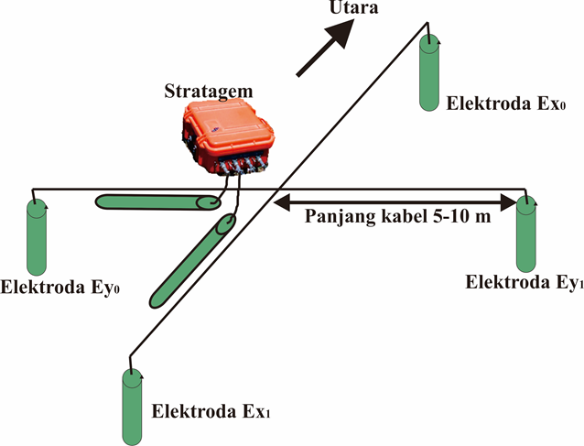
Figure 2. The installation of the stratagem AMT tool as the center by burping the electric electrodes in the north-south direction on the x-axis, and the magnetic coil on the y-axis oriented west-east with a stretch cable of about 5-10 m.

2.4. AMT Data Prossessing
Data processing from AMT signal reception is processed directly by Stratagem. Fourier transform is performed to obtain apparent resistivity, wave phase and depth data from impedance calculations. Then selection the data based on the value of coherence. The coherence used is above 0,5.
Then, data smoothing is done. This process is carried out because the data contains noise which is characterized by the data distribution is not smooth. Then the modeling is done by way of approaching the curve of the model with the data curve as close as possible to produce the value of error is small. A small error value indicates that the model curve and data curve are almost the same. Good data is then inverted using MTINV software to obtain depth and resistivity and coating thickness model curves. Modeling performed on the data at all points of measurement by separating the components Z xy and Z yx . The inversion method is used to obtain model parameters by selecting the most suitable response from the data obtained from the observer's results. In this study, 1-D inversion results of the xy and yx components were compared. The comparison includes several parameters, namely resistivity and depth. After that, the results of the comparison of the two made 2-D reconstruction. After obtaining resistivity values at each layer, the next step is to make a 3-D model using Rock Work software. Finally finishing the map of the conductivity zone using a surfer.

2.5. Interpretation
The interpretation of AMT data is done after the resistivity structure model is formed through inversion 1-D modeling. Based on the model, further interpretation is made to determine the distribution of conductive zones and resistive zones in the study area. The results of 1-D inversion modeling in the form of electrical resistivity describe certain rock properties so that they can be interpreted as certain rock units. The integrated interpretation stages include the combination of the resistivity model and the geological model of the study area and other geophysical anomaly maps from previous researchers.

3. Discussion
Data 3x has an error of 0.19 with an average of 0.1. The first layer with a resistivity of 69.14 Ωm and a thickness of 121.07 m. The second layer has a resistivity of 84.15 141 Ωm as thick as 141.16 m and then the third layer has a resistivity of 298.31 Ωm interpreted continuously to a depth of 1000 m. The result of 1D inversion of layers for the data 5x to 3 consecutive layers has a resistivity of 191, 14 Ωm; 257, 05 and 301, 27 Ωm. Furthermore, the data 7x point has a depth of 12.11 meters for the resistivity of the first layer with a small number of 9.04 Ωm jumping to the second layer reaching a value of 248.05 Ωm to a depth of 179.16 meters below the surface, then the third layer with resistivity 298 Ωm continuously to a depth of 1000 m.

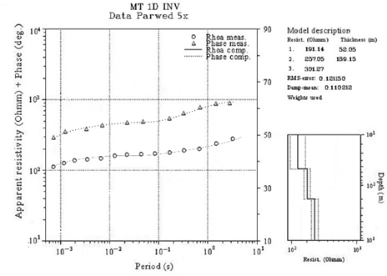
(a) | (b)
Figure 3. The 1-D inversion window uses MTINV from 5x data with the smallest error acquisition with 3 layers (a), 1-D inversion results use MTINV from 3x data which shows the first layer is thicker than in 5x data (b).

BB ’pass through AMT 7, AMT 5 and AMT 3 measuring points with a distance of 2240 m. This track is directed from northwest to northeast. There is a resistivity pattern that protrudes deeper into the northwest from the AMT 5 point. The maximum elevation reaches 260 m above sea level and the minimum elevation is 20 m above sea level. This path is located at UTM coordinates between 425100, 9113400 and 426830, 9114900. Zoning is done based on resistivity values. Zone A has a resistivity range of 0 Ωm - 10 Ωm which can be called a conductive zone. Zone B is a rock layer with resistivity between 50-100 Ωm can be said to be an intermediate zone, while Zone C is a layer with a resistivity value above 170 Ωm (up to 350 Ωm) can be called a resistive zone. The resistivity value of Zone A is only on the side of the surface to a depth of ± 20 m. This section is indicated as a beach sediment and sand dune. Zone C is classified as a resistive zone. This zone is interpreted as Andesite breccia rocks. This zone dominates the two trajectories that come to the surface. Andesite breccia rocks are the oldest rocks in this study area, Early-Middle Miocene (Rahardjo et al., 1995).

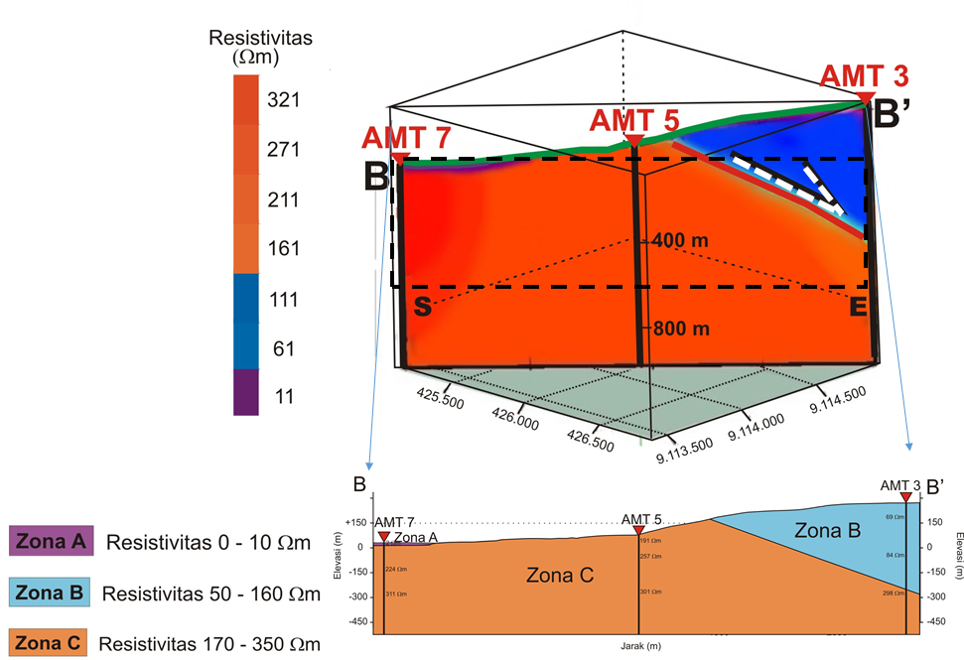
Figure 4. The division of zones into 3, the highly conductive zone is zone A with resistivity 0 to 10 ohmmeter that is located on the southwest side of the study area, while the conductive zone is written zone B with resistivity 50 - 160 ohmmeter on the northeast side of the study area.
Surface geological data is needed in the interpretation of geophysical data in identifying subsurface lithology. Nglanggran andesite breccias are found along the northern to western parts of the study area. The naming of this unit is based on the dominance of the andesite breccia found in the field. The relationship between the andesite breccia unit with the limestone units above is unconformity. The Nglanggran andesite breccia is brownish gray with a size from sand to massive structure, poor sorting and open packaging. This rock is exposed in AMT 5. Wonosari limestone is exposed at AMT 3 measurement point. The precipitate beaches of sand exposed at the measurement point AMT 7, fine sized sand grains to being found in the area near the beach, which is in the southwestern part of the study area. These deposits are blackish gray and the sand material is separated from one another.

4. Conclusion

The result generally consists of five layers; the first layer is a 37 Ohm-m thin resistive layer with a thickness of about 7 m associated with breccias; the second layer is a 9 Ohm-m conductive layer about 100 m thick possibly related to andesite lava that is altered and contaminated with sea water; the third layer is still a conductive layer but with a relatively higher type of resistivity (18 Ohm-m) with a thickness of about 180 m which is probably related to andesite lava changed; the fourth layer is a 9 Ohm-m conductive layer around 700 m thick which is probably still related to the changed andesite lava rock but it is uncertain whether or not it has been contaminated with sea water. Then, conductive zone is located in North-East of the research location.

Acknowledgment
The authors thank all those who helped in the completion of this paper. Thank you very much to Mrs. Niasari Windi, Department of Physics, Gadjah Mada University, who has been willing to assist in data acquisition and processing. Thanks also to the parangtritis village official Bantul DIY who gave author's permission to review the results of this study for the best. Thanks to Unila Beginner Lecturer Research grant Number 2530/UN26.21/PN/2019.

References

Karlina, T. (2014) Zonasi Bahaya Jatuhan Batuan di Sepanjang Jalan Desa Parangtritis - Desa Giricahyo, Provinsi DIY, Master Tesis, M.Eng., Gadjah Mada University, Yogyakarta.
Niasari, S., W. (2015) Magnetotelluric Investigation of The Sipoholon Geothermal Field, Indonesia, Doctoral thesis Dr. Rer. Nat., Freien Universität Berlin.
Rahardjo, W. (2004) Panduan Ekskursi Geologi Regional (EGR) Pegunungan Selatan dan Kendang, Department of Geology Engineering, Faculty of Engineering, Gadjah Mada University, Yogyakarta.
Rahardjo, W., Sukandarrumidi, dan Rosidi, H. M. D. (1995) Peta Geologi Lembar Yogyakarta 1:100.000 edition 2. Directorate of Geology, Director General of General Mining. The Department of Mining, Bandung.
Ranganayaki, R. P. (1984) An Interpretative Analysis of Magnetotelluric Data. Geophysics, 49: 1730–1748.
Santosa, L. W., dan Adji, T. N. (2014) Karakteristik Akuifer dan Potensi Airtanah Graben Bantul. Gadjah Mada University Press. Yogyakarta.
Setijadji, L. D. (2010) Segmented Volcanic Arc and it Association with Geothermal Fields in Java Island, Indonesia. Proceedings World Geothermal Congress, Bali, Indonesia.
Srijono dan S. Untung (1981) Perpetaan Geomorfologi Metode ITC-dengan conto studi daerah Parangtritis, Proceedings PIT X IAGI, Bandung, pp. 64-73.
Sudarno, I. (1997) Kendali Tektonik Terhadap Pembentukan Struktur pada Batuan Paleogen dan Neogen di Pegunungan Selatan, Daerah Istimewa Yogyakarta dan Sekitarnya, Thesis, Masters. Postgraduate Geology Study Program, Bandung Institute of Technology.
Telford, W. M., L. P. Geldart, dan R. E. Sheriff (1990) Applied Geophysics, 2nd ed., Cambridge University Press, Cambridge.
Twiss, R. J. dan Moores, E. M., 1992, Structural Geology, W. H Freeman and Company, New York.
Van Bemmelen, R. W. (1949) The Geology of Indonesia and Adjacent Archipelagoes, General Geology, Vol I A, Government Printing Office, The Hague, pp. 25-28.
Varnes, D. J., (1978) Slope Movement Types and Process, Special Report 176; Landslide; Analysis and Control, Eds: R.L. Schuster dan R. J. Krizek, Transport Research Board, National Research Council, Washington, DC.
Vozoff, K. (1991) The magnetotelluric method, in Electromagnetic methods in applied geophysics, Vol.2 Application, M.N. Nabighian (ed.) SEG Publishing.
Wagner, D. I., Koulakov, W., Rabbel, B. G., Luehr, A., Wittwer, H., Kopp, M., Bohm, G., Asch dan peneliti MERAMEX (2007) Joint Inversion Of Active And Passive Seismic Data In Central Java, Geophys. J. Int. 170, 923–932

