Analysis of gravity anomaly for groundwater basin in Bandar Lampung City based on 2D gravity modeling
A Zaenudin¹*, R Risman¹, I G B Darmawan¹, I B S Yogi¹
*ahmad.zaenudin@eng.unila.ac.id
Abstract.The research aims to delineate the groundwater basin in Bandar Lampung from gravity anomaly. Field data acquisition was carried out at 403 points with a spacing of 2-3 km, covering the Bandar Lampung and surrounding areas. Data processing through gravity data corrections, namely drift, tide, Free Air, Bouguer and Terrain using Geosoft Oasis Montaj 8.3. The Bouguer density used is 2.67 gr/cm3. For the anomaly separation, spectrum analysis and regional and residual anomaly separation were carried out, whereas 2D modeling was carried out by forward modeling. This basin boundary analysis is based on gravity residual anomaly patterns, gravity Second Vertical Derivative (SVD) analysis, and 2D gravity modeling. There are 2 low residual anomaly patterns (-22 to -5 mGal), where the boundaries of the basin can be clearly delineated from SVD analysis. This 2D model shows layers with a density of 2.3 gr/cm3 which are the Young Volcano Formation (Qhv) and the Lampung Formation (QTl) which have depths of up to 1.0 -1.5 km. This Groundwater Basin correlates well with the hydrological pattern with a water discharge of 5 to 100 l/sec.
- Introduction
This research area belongs to Lampung Province, which includes Bandar Lampung and its surroundings. This area is described geologically in the Tanjung Karang Sheet Geological Map. The geological unit of this area consists of the Gunung Kasih Complex (Pzg), which composed of metamorphic rocks. The lithology is thought to be the oldest rock formations formed in the paleozoic era. Moreover, the formation is composed of schist, gneiss, quartzite, and marble. The Lampung Formation (QTl) is a formation that dominates almost the entire region on the Tanjung Karang sheet and consists of Rhyolite-Tufan Rock and Volcanoclastic Tufan. The existence of a layer of young volcanic rocks is closely related to the subduction of the Indian Ocean Plate, which occurs throughout the arcs of Barisan mountains during tertiary which produce Tuff, Lava, and Breccia rocks [1]. According to [2], the coastal land area of ​​Lampung Bay is classified as a narrow and hilly coastal plain, with dominant rocks including alluvium and swamp deposits, reef limestone, and quarter-old young volcanic deposits (Qhv). Furthermore, the sediments in Lampung Bay waters are dominated by silt (75-90%).
Ensuring the availability of the groundwater, the proper management of groundwater usage needs to be done to avoid regret in the future. For this reason, it is necessary to study regional characteristics of groundwater basins. Moreover, data on the nature of the basin is crucial for further investigation. In this study, groundwater basin studies have been carried out utilizing the gravity method to delineate basin boundaries and validate with local hydrogeology data.
This study aims to identify the boundaries of groundwater basins based on regional conditions of subsurface based on gravity data. Where the nature of the gravitational field, capable of mapping regional density distribution, is an appropriate method for investigating the characterization of regional basements and their correlation with groundwater basins in this area.
- Gravity Method for basin deliniation
Some groundwater basins have clear boundaries, can be identified as rock strata in the form of geological deposits and geological structures, where the basin has a contrast of physical properties (density, resistivity, or susceptibility) with the environment. The basins of groundwater may also consist of aquifers at various depths which can be characterized as sub-basins. Groundwater basins in deltas, where rivers end their paths and meet at sea, have complicated problems. Rivers move material from land to sea, so deltas are also the main reservoir of sediment, nutrients, and carbon [3]. The deposition and interaction of shallow groundwater and groundwater in a delta are very dependent on the properties of the delta [4].
Among all geophysical methods, geoelectric methods are commonly used for local groundwater characteristics. However, to study of regional groundwater basins the best choice is still the gravity method [5]. The gravity method can be implemented in groundwater investigation such as a granite environment [6]. In this research, the anomaly data of residual gravity and Second Vertical Derivative (SVD) gravity are applied to delineate and identify potential sub-basins as potential rock layers to be an aquifer.
A gravity investigation had done by the Minnesota Geological Survey to map the potential of groundwater and the thickness particularly in a sedimentary host rock [7]. One of the oldest gravity survey applications was the groundwater exploration in the glacier area [8]. They mapped the basin location and depth of bedrock for the groundwater sources. Whereas, several other studies used a combination of different geophysical methods with gravity methods [9–10]. Therefore, the overall studies have shown the efficiency of gravity methods are for regional groundwater exploration.
Gravity method is sensitive to subsurface variations of mass, and the improvements in gravimeter allow the current investigations to detect small variances caused by lowering water inside unconfined aquifers [11, 12]. Furthermore, research of gravity method in Colorado has detected that groundwater depth changes can be identified. The anomaly differences measured in the same place at two different times, where these positive differences are correlated with the groundwater influx and the negative contrasts with water removal [13]. Continuous of gravity monitoring is possible and shortly might be a common practice [11]. Variations of Bouguer anomalies can reflect lateral variations in density so that high-density features in medium with low density should give rise to positive Bouguer anomalies. While, the low-density features in higher density mediums will produce negative Bouguer anomalies [14].
- Data and Processing
The Gravity data is from a measurement that is conducted by ESDM in Bandar Lampung and its surroundings. Gravity data (gobs) consist of 403 data (round marks on the map) with spaces of 2-3 km and an area of 50 x 60 km. Furthermore,the gravity data is calculated by applying the 1967 International Gravity formula. The data is processed by applying the drift correction and tide correction of the Longman equation. Bouguer and free-air gravity corrections were done using 2.67 g / cm³ as a reduction density and sea level as a datum. Calculation of these corrections, including terrain correction, is done by applying the existing algorithm in the Oasis Montaj 8.3 software. The final result of this process is Complete Bouguer Anomaly (Figure 1a).
Regional-residual anomaly separation is done through the spectrum analysis. The spectral analysis process was made from 12 slices in order to determine the depth and the optimal window width in the filtering. Fourier Transform then transforms the slices, so we get the value of the amplitude and frequency. Until the end of processing, an analysis is performed on the graph between the wave num-
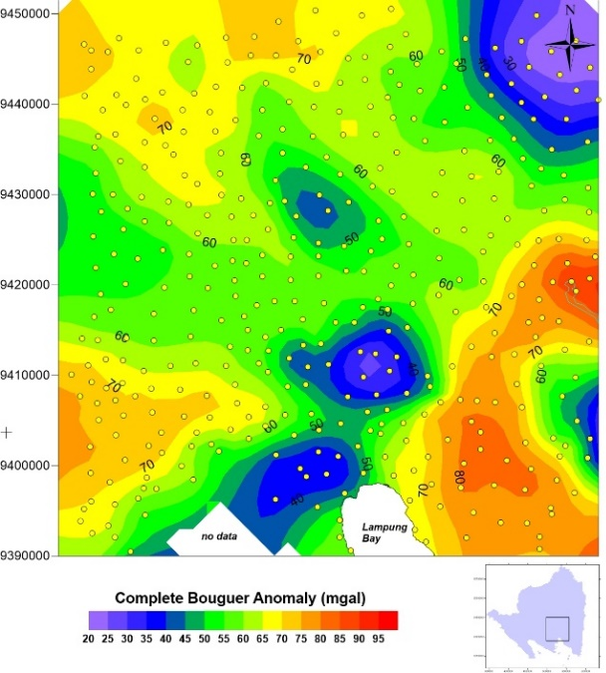  (a) | 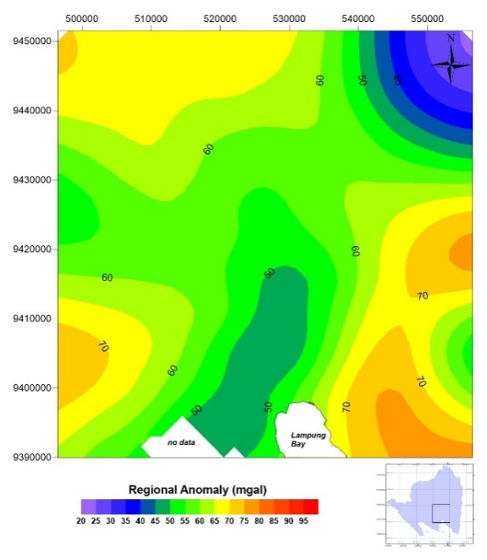  (b)
Figure 1. Gravity Anomaly, (a) Complete Bouguer Anomaly, (b) Regional Bouguer Anomaly

-ber (k) on the x-axis with the natural amplitude logarithm (LnA) on the y-axis. The results of the spectrum analysis of the 12 slices are shown in Table 1.

Table 1. Optimationof windows with spectral analysis
Line | Depth Estimation (m) | k cutoff (1/Hz) | Windows Optimation (1/Hz)
A | 8792 | 0.00037 | 11.32
B | 6828 | 0.00044 | 9.52
C | 6867 | 0.0006 | 6.98
D | 9280 | 0.00041 | 10.21
E | 7475 | 0.00041 | 10.21
F | 7091 | 0.00044 | 9.52
G | 8375 | 0.00041 | 10.10
H | 5066 | 0.00045 | 9.21
I | 7802 | 0.00040 | 10.47
J | 10750 | 0.00029 | 14.60
K | 9320 | 0.00037 | 11.34
L | 6543 | 0.00046 | 9.10
Average | 7849 | 10.21

From Table 1, we get an estimate of regional depth as 7849 m and optimal window width screening of 10, 21 (1 / Hz). Furthermore, for the filtering process, the nearest wave number multiple is used; in this case, 11. Separation of the regional and residualanomaly uses a moving average with windows 11 x 11 in a moving average, with a grid space of 1500 m. The results of this filtering produce regional anomalies (Figure 1b) and residual anomalies (Figure 2a).

- Analysis and Interpretation
Figure 1b shows the Bouguer regional anomaly (20 to 100 mgal), which explains the regional anomalyis influenced by the response of bedrock or deeper layers. And the results of the spectrum analysis (Table 1) show that the bedrock in Bandar Lampung and its surroundings is at a depth of 7800 m.
Whereas, Figure 2 shows the residual anomaly of Bouguer (-20 to -5 mgal). The Bouguer residual anomaly map shows two parts of anomaly that are of low value, which is thought to be an anomaly response from shallow rocks. This shallower rock layer is thought to be a groundwater basin, where the boundaries of this groundwater basin can be delineated firmly from the SVD Map (Figure 2b).
Figure 2b is the result of filtering with SVD on Bouguer residual anomaly, so it produces SVD anomaly map. The sub-basins of the groundwater basin can be well identified by SVD contours equal to zero (Figures 2a and 2b). The zero contours on the SVD Map shows the boundaries of a shallow/local geological feature [14] marked by a dashed red line. Figure 3a shows the correlation of -
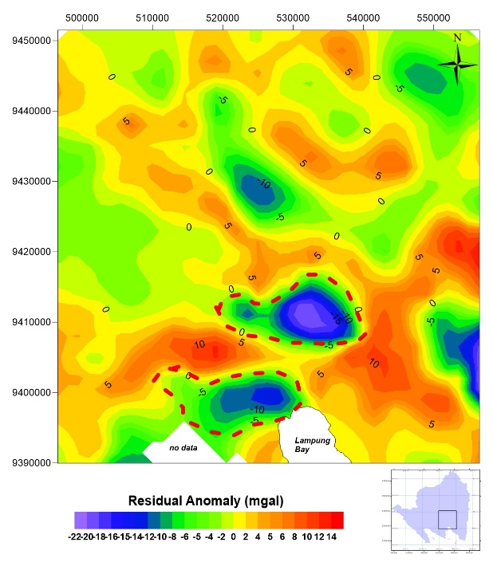  2 (a) | 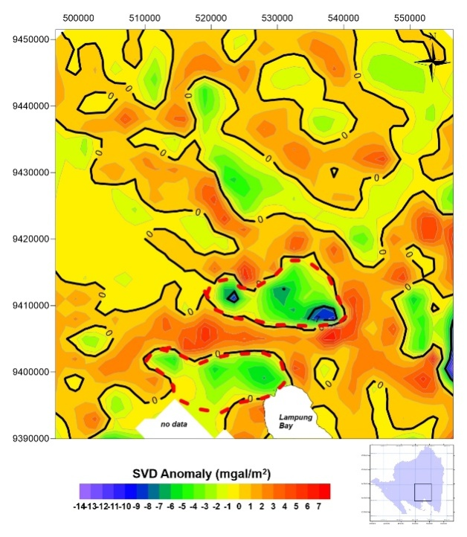  2 (b)
Figure 2. Gravity Anomaly, (a) Residual Bouguer and (b) SVD residual anomaly

aquifers in the groundwater sub-basin of 25 data from the bore well survey results and direct visits in the field through interviews. Table 2 presents data on the location of wells, aquifer depth, elevation, and criteria about productivity and endurance of wells (aquifers) to seasons change. Wells criteria are divided into 3, which are good aquifers, medium aquifers, and poor aquifers.
A good aquifer is an aquifer that is never dry throughout the year, a medium aquifer is an aquifer that is dry if a drought is more than three months, and the poor aquifer is aquifer that is dry if the drought is less than three months. Each of these criteria is plotted on the residual Bouguer anomaly map (Figure 3a) and the Hydrogeology Map (Figure 3b). In Figure 3a, most good aquifers correspond to negative residual Bouguer anomaly (-22 to -5 mgal). Hence, it reinforces the assumption that the negative residual Bouguer anomaly is a groundwater basin.

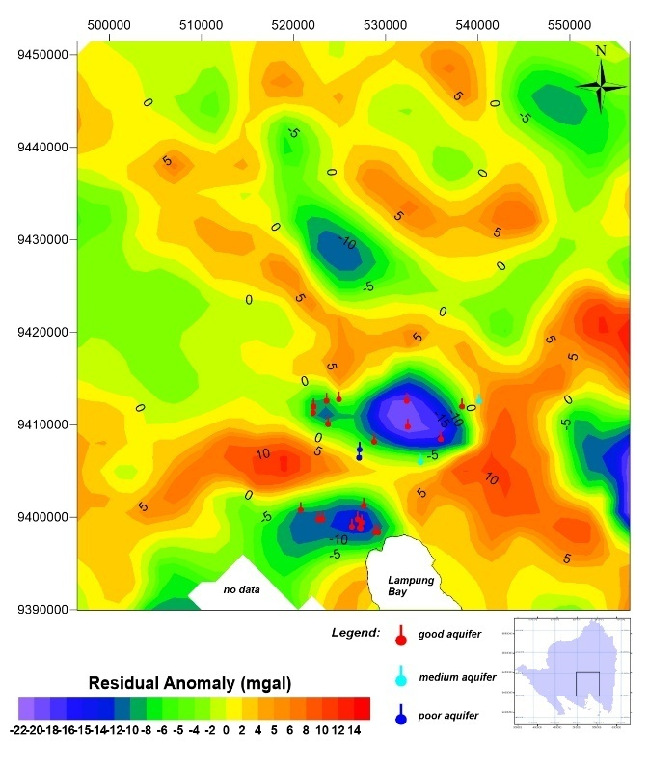  3 (a) | 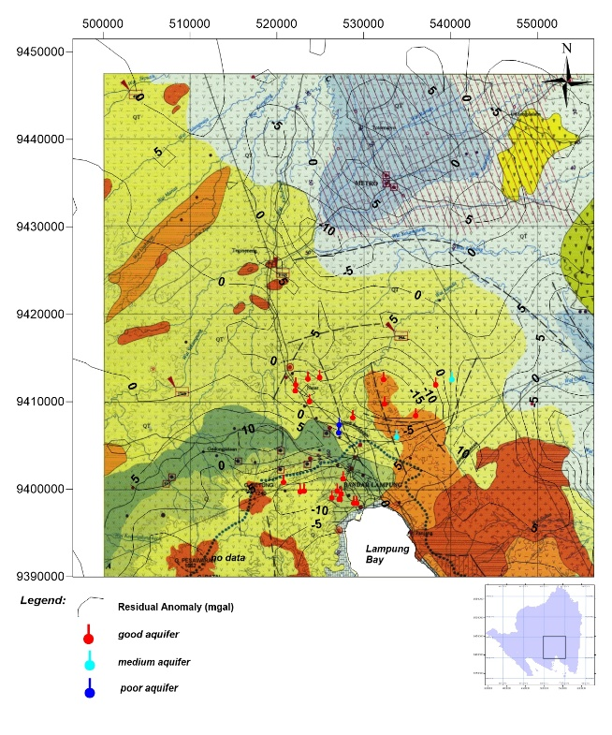  3 (b)
Figure 3. (a) Residual Bouguer Anomaly with production well, (b) Correlation Residual Bouguer Anomaly and production well in hydrogeological map.

Table 2. Bore well data classification from the field measurement.
No | UTM X | UTM Y | Elevation (m) | Depth (m) | Creteria
S-1 | 528745 | 9408152 | 95 | 9 | 1
S-2 | 522130 | 9411259 | 129 | 7 | 1
S-3 | 523568 | 9412582 | 115 | 8 | 1
S-4 | 524952 | 9412747 | 119 | 9 | 1
S-5 | 522200 | 9411940 | 122 | 6 | 1
S-6 | 523727 | 9410037 | 134 | 9 | 1
S-7 | 527191 | 9407329 | 135 | 6 | 3
S-8 | 529173 | 9398352 | 25 | 6 | 1
S-9 | 528858 | 9398352 | 69 | 9 | 1
S-10 | 527628 | 9401190 | 102 | 8 | 1
S-11 | 526949 | 9399776 | 128 | - | 1
Ind-1 | 527377 | 9399440 | 101 | - | 1
Ind-2 | 527266 | 9398811 | 54 | - | 1
Ind-3 | 527180 | 9398839 | 53 | - | 1
Ind-4 | 522668 | 9399732 | 259 | - | 1
S-12 | 526310 | 9398979 | 90 | 6 | 1
S-13 | 523139 | 9399776 | 246 | - | 1
S-14 | 520802 | 9400777 | 390 | - | 1
S-15 | 533823 | 9405946 | 188 | 4 | 2
S-16 | 535972 | 9408411 | 107 | 3 | 1
S-17 | 540144 | 9412514 | 89 | 5 | 2
S-18 | 538320 | 9411933 | 196 | 5 | 1
S-19 | 532303 | 9412547 | 161 | 5 | 1
S-20 | 532412 | 9409752 | 187 | 5 | 1
S-21 | 527140 | 9406424 | 149 | 6 | 3
Figure 3b. shows validation of groundwater sub basins with Hydrogeological maps [15]. The groundwater sub-basin (low/negative anomaly residual Bouguer) correlates with "moderately productive aquifers" and "highly productive aquifers". Where moderately productive aquifers are aquifer of most varying transmissivity, depth to groundwater is generally great, spring discharge is generally low, and wells yield is generally less than 5 l/sec. Moreover, highly productive aquifers are aquifers that are widely varying transmissivity, depth to water table varies in a wide range, spring discharge varies, some of them discharging more than 100 l/sec, well generally yield more than 5 l/sec [15]. Both types of aquifers are extensive, where aquifers in which flow are both through fissures and interstices. A small anomaly residual Bouguer low/negative corresponds to poorly productive aquifers.
From the 2D modeling of the Residual Bouguer Anomaly in the Northwest - Northeast direction, it describes a vertical layering model. Which consists of 3 main layers with a density from top to bottom, respectively 2.0 gr / cm3, 2.3 gr / cm3 and 2.7 gr / cm3. Layers with a density of 2.3 gram / cm3 are associated as groundwater basins from the Young Volcanic Formation (Qhv) and Lampung Formation (Qtl). Moreover, this groundwater basin to a depth of 1.5-2.0 km. Furthermore, the lithology with a density of 2.7 gr / cm3 is the bedrock of the Tarahan Formation (Tpot).
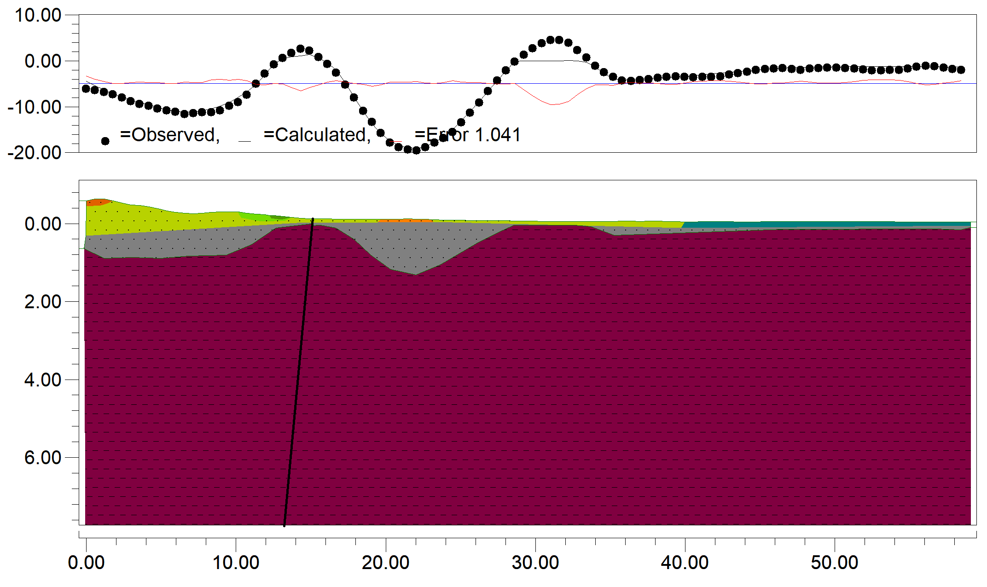
Figure 4. 2D model of Bouguer residual anomaly

The 2D modeling as shown by Figure 4, we can further emphasize the shape and geometry of the groundwater basin in Bandar Lampung.
- Conclusion
- Residual Bouguer Anomaly and SVD of Residual Bouguer can delineate groundwater basins in Bandar Lampung. Where the groundwater basin is shown by residual Bouguer anomaly -22 to -5 mgal and the boundary of the basin is indicated by the zero value contours of SVD residual Bouguer anomaly.
- 2D modeling shows rock layers and geometry of the groundwater basins where groundwater basins are in the Lampung Formation (Qtl) and the Young Volcanic Formation (Qhv). Besides, this groundwater basin is located at a depth of 1.0 - 1.5 km.
- This groundwater basin correlates with aquifer productivity of 5 to 100 l/sec as shown by the Hydrogeological Map.
Acknowledgments
Acknowledgments were delivered to ESDM Bandung for providing data access and to the UNILA Geophysical Engineering students who have helped in data processing and modeling until the completion of this paper.
References
- Mangga S A, Amirudin, Suwarti T, Gapoer S and Sidarto 1993 Geological Map The Tanjungkarang Quadrangle, Sumatera Geological Research and Development Centre
- Wiryawan 1999 Atlas Sumberdaya Wilayah Pesisir Lampung (Coastal Resources Center, University of Rhode Island dan Pusat Kajian Sumberdaya Pesisir dan Lautan, Bandar Lampung, Indonesia)
- Kolker A S, Cable J E, Johannesson K H, Allison M A and Inniss L V 2013 Pathways and
processes associated with the transport of groundwater in deltaic systems J. Hydrol. 498 319–
334
- Sawyer A H, Edmonds D A, Knights D, Kolker A S, Cable J E, Johannesson K H, Allison M A,
Inniss L V, Bethke C M, Johnson T M, Winter T C, Harvey J W, Franke O L, Alley W M,
Fan Y, Article R, Fan Y, Gleeson T, Befus K M, Jasechko S, Luijendijk E, Cardenas M B,
Vandersteen J, Sophocleous M A, Taniguchi M, Alley W M, Allen D M, and Zhou Y 2015
Pathways and processes associated with the transport of groundwater in deltaic systems Nat.
Publ. Gr.3 319–334
- Handayani L, Wardhana D D, Hartanto P, Delinom R, Sudaryanto, BaktiH and Lubis R F 2017 Gravity survey of groundwater characterization at Labuan Basin Global Colloquium on Geosciences and Engineering 2017 IOP Conf. Series: Earth and Environmental Science 118 (2018) 012015
- Murty B V S and Raghavan V K 2002 The gravity method in groundwater exploration in
crystalline rocks : a study in the peninsular granitic region of Hyderabad, India Hydrogeol.
J. 10 307–321
- Chandler V W 1994 Gravity investigation for potential groundwater resources in Rock County,
Minnesota (St. Paul) Report of Investigations 44
- Rubin Y and Hubbard S S 2005 Hydrogeophysics (Netherlands: Springer)
- Selim E S, Abdel-raouf O and Mesalam M 2016 Implementation of magnetic, gravity and
resistivity data in identifying groundwater occurrences in El Qaa Plain area, Southern Sinai,
Egypt J. Asian Earth Sci.128 1–26
- Sultan S A, Mohameden I M and Santos F M 2009 Hydrogeophysical study of the El Qaa Plain,
Sinai, Egypt Bull. Eng. Geol. Environ.68 525–537
- Kennedy J, Ferre T P A, Guntner A, Abe M and Creutsfeldt B 2014 Direct measurement of
subsurface mass change using the variable baseline gravity gradient method Geophys. Res.
Lett., 41 2827–2834
- Gonzales-Quiros A and Fernandez-Alvarez J P 2014 Simultaneous solving of three-dimensional
gravity anomalies caused by pumping tests in unconfined Math Geosci 46 649–664
- Gehman C L, Harry D L, Sanford W E, Stednick J D and Beckman N A 2009 Estimating
specific yield and storage change in an unconfined aquifer using temporal gravity surveys
Water Resour. Res. 45 1–16
- Reynold J M 1997 An introduction to applied and environmental geophysics (England: John Wiley & Sons Ltd)
- Setiadi H and Ruhijat S 1993 Hidrogeological Map of Indonesia Sheet Tanjungkarang (Sumatera) Directorat of Environmental Geology

