Thinned Coal Distribution Modeling Based on Integrated Geological and Geophysical Data: Case Study CBM Resources in Central Palembang Sub-Basin
Rahmat C. Wibowo^{1, a)}, Muh. Sarkowi¹, Bagus S. Mulyatno¹, Ordas Dewanto¹, Ahmad Zaenudin¹, Andri A. Aspari², Hendra Amijaya³
¹Geophysical Engineering Department, Universitas Lampung, Prof. Sumantri Brojonegoro Street, No. 1, Bandar Lampung City, Lampung Province, Indonesia.
²PT. Pertamina Hulu Energi, TB. Simatupang Street, Kav 99, South Jakarta, Indonesia
³Geological Engineering Department, Universitas Gadjah Mada, Yogyakarta Special District, Indonesia.
^{a)}Corresponding author: rahmat.caturwibowo@eng.unila.ac.id
Abstract. The main workable coal measures are concentrated at two horizons sediments within the Miocene Muara Enim Formations (MEF). MEF coals are has a proper coal thickness and favorable depth for Coal Bed Methane (CBM) production, and become the main CBM target. Generally, coals are recognized of thin toward the east as they pinch out against the Sunda landmass. Coal presence and lateral coal distribution are the CBM essential elements. The research aim is to identify thin coal reservoir distribution using well and seismic data integration. Reprocessing seismic data before acoustic impedance (AI) inversion produces better results than non-reprocessing. In situations where the wells are located far away from seismic lines, calibration with logs is problematic, and inversion produces less than maximum results. The multi-attribute approach can optimize the results. Integration of the filtering, AI inversion, and then multi-attribute and neural network methods produce the best output to identify coal seams, their distribution, and continuity. The thickest coal, 6 m of thickness, was identified form 11 wells well data at depth 768 m with a total of 5 layers of coal (seam A, B, C, D, and E) in R5. Based on seismic modeling, the seam target was only seamed A with a total volume respectively 518 million m³.

INTRODUCTION
In South Sumatra Basin, two coal-bearing formations were identified as potentially CBM development prospectively. Oligocene Talang Akar coals are known to be more mature and older than the Miocene Muara Enim coals but are known to be thinner and buried deeper. Muara Enim coals are known to have a proper coal thickness and favorable depth for CBM development, though the coals are typically thin towards the Sunda landmass [1]. Muara Enim coals divided into (from oldest to youngest) Kladi, Merapi, Petai, Suban, Mangus, Benuang, Burung, Enim, and Jelawatan seams [2]. It is estimated that the maximum net coal thickness is about 140 m. Some of the coal seams are thin discontinuous layers, whereas others are thick seams. The economically valuable coal seams are Mangus, Suban, and Petai [3].
To estimate CBM resources is very complex and requires the following information: sweet spot area, coal thickness, and coal density. The deeper coal layers at depths greater than 400 m will be very promising to be a potential CBM reservoir since the coal rank and gas content are much higher [4]. Integration of surface and subsurface geological data are essential to identify sweet spot area, thickness, and density of coal seams. Analysis of coal deposits characteristics related to the CBM content can be done using outcrop and core drillings data [5]. Identifying coal seams distribution from the subsurface, well log data had some characteristics such as low density, low acoustic impedance, and high resistivity value. The consistency of the coal seam characteristic is correlated with the inter availability well [4][6].
Seismic reflection data has been used successfully to evaluate detailed structural and stratigraphic features of coal prospects. When combined with drill hole data, seismic is a cost-effective method of mapping coal seams for exploration and exploitation [7]. Improving the seismic resolution using Continuous Wavelet Transform (CWT) addressed to expand the signal frequencies and to extend the upper of the spectrum that can guide the coal seam distribution [4]. Acoustic Impedance (AI) inversion is considerably the most proper seismic inversion to display coal seam thickness within its wide distribution area [8][9]. When the area has a lack of data, and low S/N ratio, integration between re-processed data [10], multi-attribute, neural network and model-based AI inversion produce the best output to identify coal seams, their distribution, and continuity [11].
Estimating CBM resources is crucial for planning and the design of producing a coal seam. The resource estimation is highly uncertain due to lack of data, especially at the beginning of the CBM production. The uncertainty comes mainly from two sources, namely well log interpretation and predicted the distribution of each parameter [12]. 3D geological modeling, including stratigraphic modeling and property modeling, were used to predict the distribution of coal thickness, coal density, and gas content in 3D. Geostatistical methods, which are optimal when data of the modeled parameters are stationary (mean and variance or covariance do not vary significantly in space). They are typically used to generate the distributions of coal properties and gas content. A combination of stochastic geological modeling and history matching were used in selecting the most probable realizations from geostatistical realization [13].
This paper presents modern modeling and estimates some methodologies that carried out in these sectors with particular focus on coal seams identification based on outcrop sample data, well log data, seismic data, 3D coal seams modeling, and coal seams resources estimation based on geostatistical approach.

MUARA ENIM COALS
The coal-bearing of Muara Enim Formation was deposited during the Late Miocene-Early Pliocene. The age of Muara Enim Formation cannot be determined directly, as reliable “marker fossils” are not yet identified. Claystone and siltstone with several sandstone layers and some coal beds are generally constituent’s compiler of Muara Enim Formation. That formation consists of stacked shallowing upward parasequences with 10-30 m thick, specifically shallow marine at the bottom part, then at the upper part are the shoreline and delta plain facies (sand, silt, clay, coal). [3]. Shell Mijnbouw (1976) [21] divided the Muara Enim Formation into two parts (members), known as the lower MPa (Middle Palembang ‘a’) and the upper MPb (Middle Palembang ‘b’). Both members have been subdivided again into M1-M4 within contain about nine coal seams and estimated that the maximum net coal thickness is approximately 140 m (Figure 1). Some of the coal seams are thin discontinuous layers, whereas others are thick seams. The upper part of MPa (Mangus, Suban, and Petai) are economically valuable coal seams.

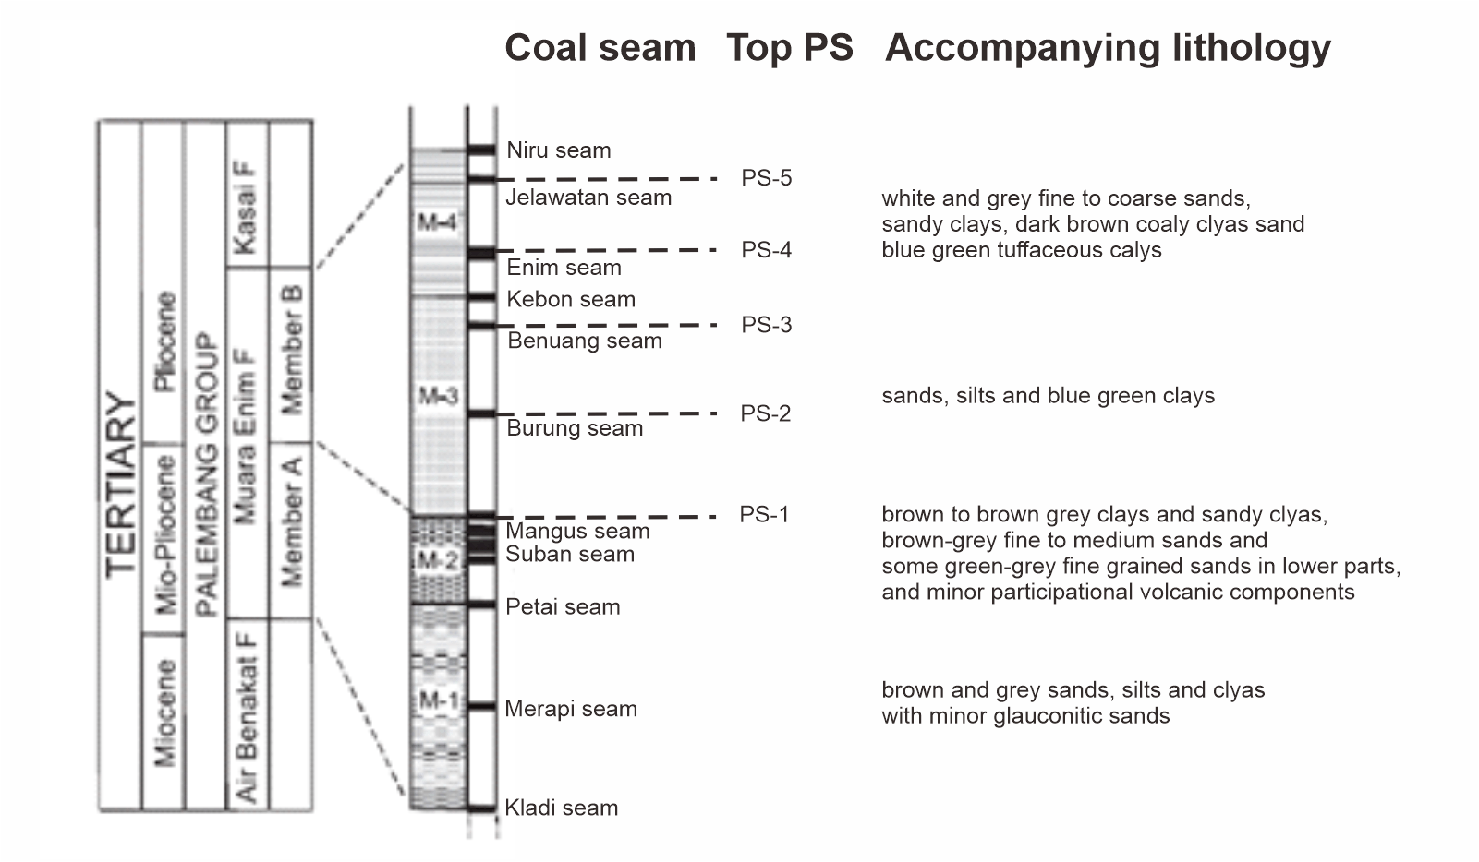
FIGURE 1. General stratigraphy of the study area [3] correlated with Top Parasequence (PS)

COAL SEAMS IDENTIFICATION
Several difficulties arise from lithostratigraphic concept to identify the coal groups, mostly due to chronostratigraphy misinterpretation. Subsurface map ambiguity, misunderstanding geological correlation, and resource calculation are significantly correlated with that concept. Parasequences concept can solve that is problems; it provided more precise markers to describe the characteristic of coal distribution based on depositional process [11].
Coal seams were determined by two analytic techniques (qualitative and quantitative), both showed good results. Nine outcrop sample was collected and analyzed to identifying coal properties, especially density value. Table 1 shows coals in the studied area have 1.4 gr/cc average density value and the value that will be used to determine the cut-off value for lithology identification. Based on well log analysis from 11 depth wells (9 conventional wells and 2 CBM wells) on the studied area (figure 2), five parasequences are identified in Muara Enim Formation. Parasequence 1 (PS-1) with coarsening upward pattern was deposited in wave-dominated delta environment, while Parasequence 2 (PS-2) to Parasequence 5 (PS-5) with fining upward pattern was deposited in tidal dominated delta environment. Coal seam A (equivalent Mangus) in PS-1, coal seam B (equivalent Burung) in PS-2, coal seam C (equivalent Benuang) in PS-3, coal seam D1 (equivalent Kebon) and D2 (equivalent Enim) in PS-4, coal seam E (equivalent Jelawatan) (Figure 1).

TABLE 1. Coal properties of outcrop sample data
Sample Number | Huminite (%) | Liptinite (%) | Inertinite (%) | Mineral (%) | Ro (%) | Ash (Ar) (%) | Density (gr/cc) | Seam
U1-9-4 | 91.7 | 1.4 | 3 | 3.9 | 0.29 | 5.5 | 1.4 | E
U1-2-1 | 92.2 | 2.6 | 1 | 3.3 | 0.15 | 5.5 | 1.4 | E
U3-13-1 | 92.9 | 3.1 | 0.4 | 3.3 | 0.13 | 4.3 | 1.4 | E
U3-14-2 | 94.4 | 1.3 | 1.0 | 3.3 | 0.14 | 3.1 | 1.4 | E
U3-16-5 | 96.1 | 1.8 | 0.7 | 3.3 | 0.15 | 3.9 | 1.4 | E
U3-7-2 | 87.6 | 4.9 | 0.4 | 7.1 | 0.14 | 4.0 | 1.5 | E
T2-27 | 90.7 | 2.9 | 3.2 | 3.2 | 0.17 | 6.1 | 1.5 | D
S3-5-1 | 93.6 | 2.8 | 0.4 | 3.2 | 0.15 | 4.7 | 1.5 | -
S3-3-1 | 94.0 | 2.2 | 1.9 | 1.9 | 0.15 | 6.9 | 1.4 | -

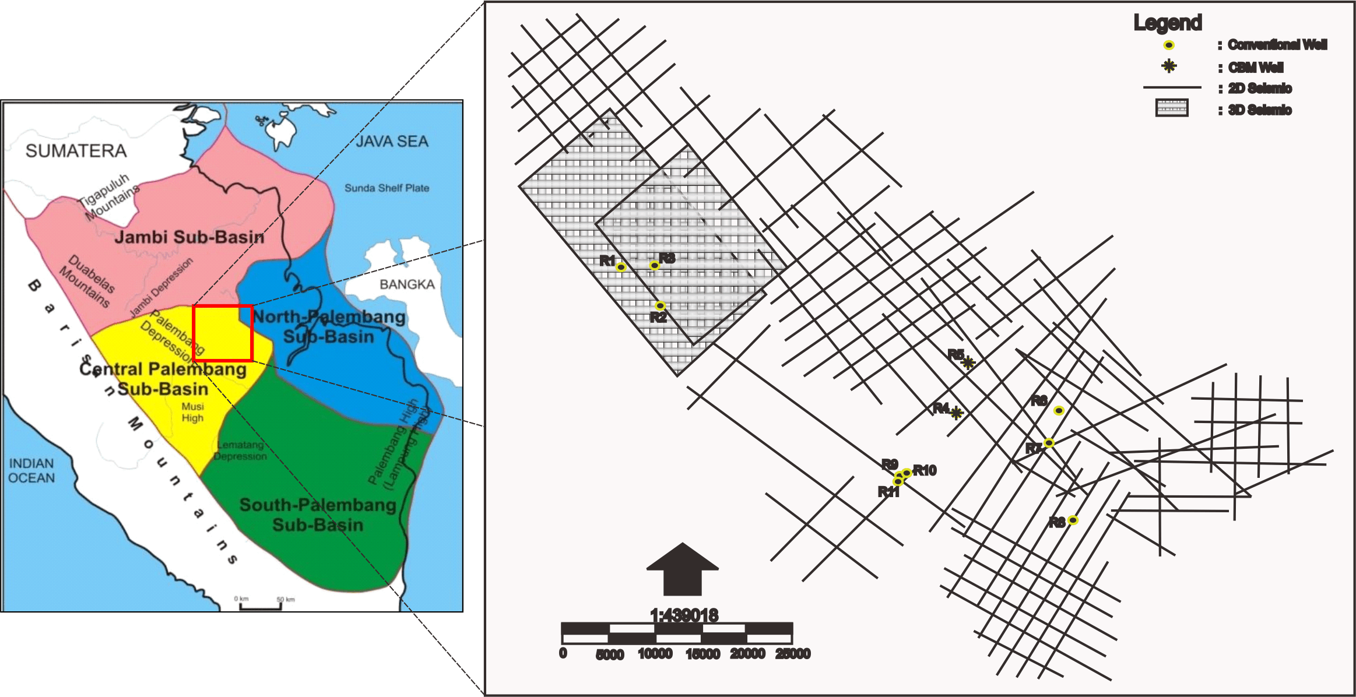
FIGURE 2. All data are used to create a seismic modeled and 3D coal seam modeled in the study area

Based on chronostratigraphic correlation (conventional wells) with NW-SE direction, stratigraphic correlations in northern part at R1, R2, and R3 wells (Figure 3a) show correlations in PS-1 and PS-2. Whereas PS-3 and so on in some wells have been exposed. In PS-1 coal can be found with a constant thickness of about 7 m and continuously within a range of distances of about six kilometers. Whereas in the southern part (Figure 3b), in PS-1 it can be found the presence of coal A in the R4 well, R5, and R6 well, but coal does not exist continuity towards the southwest. This is evidenced by the absence of coal seam A on the R9, R10, and R11 wells. Coal B in PS-2 slides thinly to the northwest-southeast, but its continuity is not found to the southwest. Coal C in PS-3 has continuity towards the northeast southeast and northwest-southeast. Besides, coal D was found in PS-4 based on well data R4 and R5. Whereas in the other wells PS-4 was not found because it had been exposed to the R10 well and Because the taken log data did not reach the parasequence depth on the R6 well. The coal found in R4 well is quite thick with a thickness of about 17 meters. However, further to the northeast, the coal seam D has experienced significant thinning.
Some coal samples have taken from two CBM wells represent the northern part of the work area. For wells R4 data, gas content approximately 12 SCF/Ton (Raw) and 14 SCF/Ton (DAF) on coal seam D. The content of CH₄ approximately 65% and CO₂ ranges from 14 % on coal seam D. In the R5 well, gas content approximately 9.16 SCF/Ton (Raw) and 11.45 SCF/Ton (DAF) on coal seam D. Whereas on coal seam A, gas content approximately 43,44 SCF/Ton (Raw) and 74,6 SCF/Ton (DAF). CH₄ content approximately 90.55% on coal seam D and 93.01% on coal seam A. CO₂ content approximately 2.49% on coal seam D and 5.34% on coal seam A. Coal seam A have some gases, and CH₄ content value is relatively higher and it will be modeled to 3D modeling although relatively thinner than coal seam D.

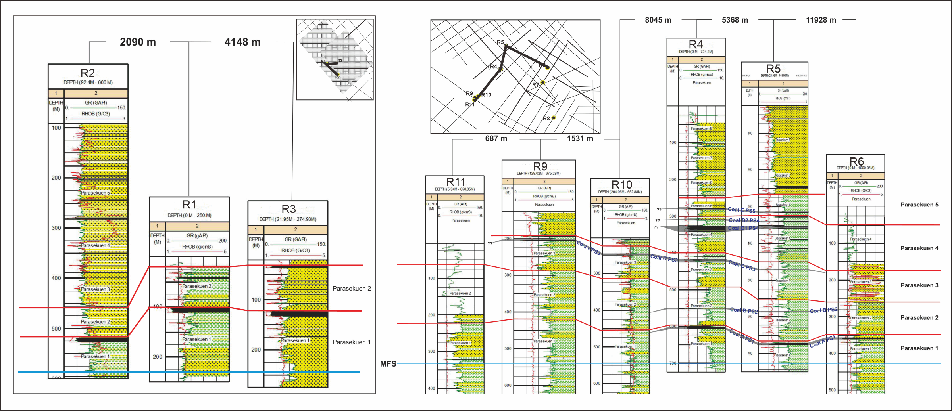
b)
a)

FIGURE 3. Chronostratigraphic correlation in the northern part (a) and the southern part of the study area (b)

SEISMIC MODELING
Seismic surveying has important effect to reduce unpredicted structural “surprises” and provides far greater confidence for underground coal exploration [14]. When interpreting seismic data, it is essential to differentiate two essential concepts: detection and resolution. Detection deals with the recording of a composite reflection from a particular horizon with good S/N ratio, regardless of whether the composite reflection can be resolved into separate wavelets that compose it. Thus, a detectable event may or may not be resolvable. The resolution related to the ability seismic data to separate coal bed with others and primarily associated with a frequency bandwidth deal with the recorded wavefield data. Whereas detection principally correlates with the acquisition technique [15]. One of the critical fields of application of thin-layer theory is in coal exploration where coal seams form notable exceptions to the above acoustic impedance rule [16].
Based on bed tuning thickness analysis (Table 2), no one coal seam is expected to be seen in the seismic. That figure shows that all coal seam is below seismic resolution because the thickness of the coal seam is lower than tuning thickness (< λ/4) [17][18]. That is the additional reasons why to choose the parasequences concept than lithostratigraphy concept. The parasequences can be traced well in seismic, because have higher than the limit of resolution, high acoustic impedance, and disperses across all of the study areas. Top parasequence is identified at seismic reflection trough, precisely located above the bright peak reflector (Figure 4).

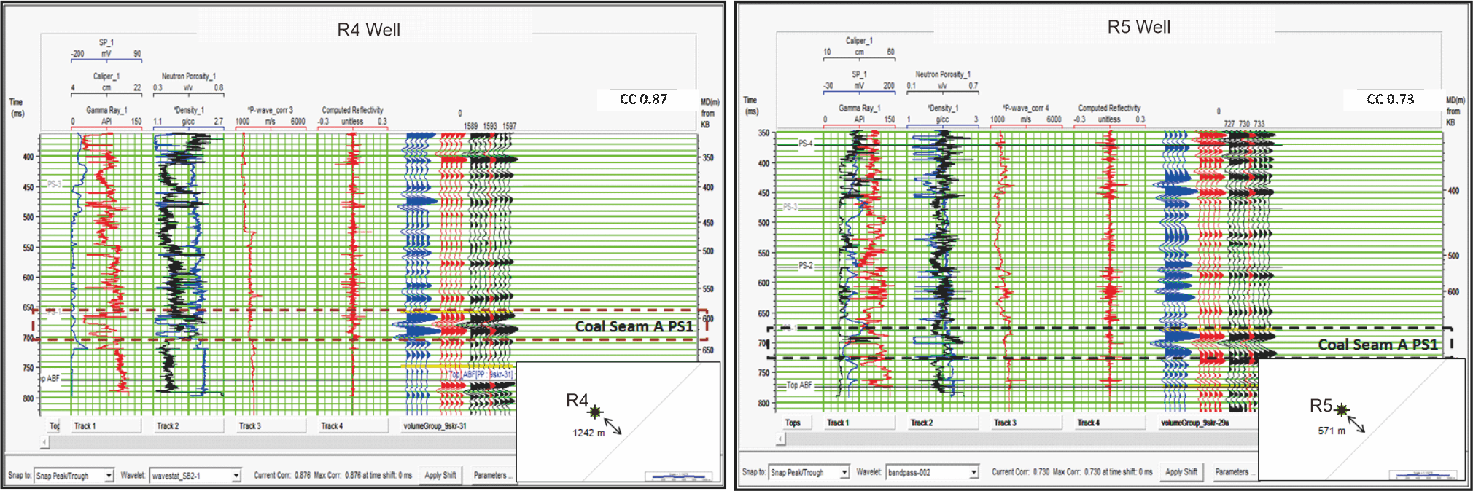
FIGURE 4. The results of the well seismic tie in R4 (left) and R5 (right) well that produced correlation about 0.87 and 0.73 with a red dashed line is the coal seam target.

TABLE 2. Tuning thickness analysis on R4 and R5 wells with window analysis at the bottom to top coal seam target
Well | Interval | Velocity (m/s) | Before filtering |  |  | After filtering |  |  | Coal Thickness (m)
 |  |  | Frequency (Hz) | Lamda (m) | Lamda/4 (m) | Frequency (Hz) | Lamda (m) | Lamda/4 (m)
R4 | PS-1 | 2296 | 25 | 91.8 | 22.9 | 63 | 36.4 | 9.4 | 5.6
R5 | PS-1 | 2433 | 43 | 56.6 | 14.1 | 85 | 28.6 | 7.1 | 6.1

When the targeted layer is not transparent, and it becomes complicated to perform seismic interpretation, field data is carefully analyzed and fit-for-purpose solutions are adopted, such as noise attenuation, and resolution enhancement [10]. The improvement was performed using frequency enhancement to get maximum S/N ratio. The seismic data has a dominant frequency range from 25 Hz to 43 Hz, and this information is also used as a reference in the filtering. To obtain best results, the lower limit of filtering was adjusted to 20 Hz, and the maximum upper limit of filtering was adjusted to 100 Hz. Bandpass filters employed a lowcut 20 Hz, low pass 30 Hz, high pass 80 Hz, and high cut 100 Hz. Filtering process increases the frequency from 43 Hz to 85 Hz. The effect of this analysis can be seen in the increasing frequency of line seismic inversion results (Figure 5). Inline seismic inversion results with frequency 43 Hz, it only shows locally visible coal. Whereas in line seismic with 85 Hz frequency, it shows better coal distribution of coal seam A PS-1. This coal appears consistently and then disappears when it thins below the tuning thickness of seismic.
Seismic inversion is a seismic modeling process which requires well data input to be guidance [8]. When the well location very far from seismic, so the inversion results will be displayed, not actual sub-surface conditions. The results of the inversion analysis show that the correlation value is 0.6 in both wells (R4 and R5) although after enhancement resolution caused the nearest well (have a check-shot data) approximately 571m. These inversion results were used as input in the multi-attribute and neural network processing (as an external attribute) to improve the correlation values (figure 5) from 0.6 to 0.9. The process of multi-attribute and neural network produces good correlation and shows very clear coal seam A continuity on the seismic line.

3D COAL MODELING
In 3D coal modeling, seismic inversion (depends on modeling type) are mostly used than raw seismic data because they are more useful. Three approaches to characterizing the uncertainty associated with coal resource estimate are presented and compared: global estimation variance (GEV), local confidence intervals via the discrete Gaussian model (DGM), and the conditional simulation (CS) [19]. Sequential Gaussian method (SGS) is the methods has the most used application commonly used in the industry caused more flexibility and simplicity among all geostatistical simulation methods. When the effect of smoothing ruins the kriging estimation, this method solves the trouble with producing a variety of realizations and equal probabilities. Kriging with an external drift (KED) is a geostatistical estimation method that more beneficial for surface modelling than the others. External drift in this method using seismic data, and if kriging is not able to estimate a proper result (out of variogram range), the consequences would be the same as secondary data [20].

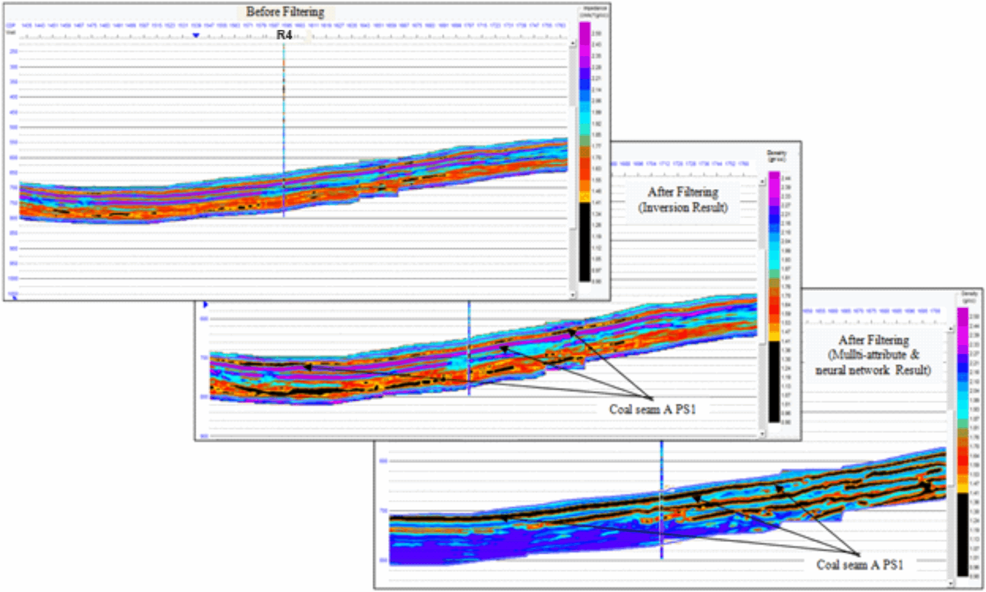
FIGURE 5. Seismic inversion results featuring the coal seam A PS-1 before filtering (above), after filtering (middle), and after a multi-attribute and neural network (below) with cut-off density value of coal (black layer) <1.4 gr/cc.

All available data for modeling PS-1 (coal seam A) consists of 11 wells, 82 lines 2D, and two volume 3D seismic. Two volume of 3D seismic data was not included for modeling, and it was just used for finding the optimum resolution PS-1 bottom & top border from 2D seismic lines. Before the facies distribution modeling step, it is necessary to do clipping on the depth structure map of each of the Top Parasequence that has been obtained previously. The clipping process is carried out by using the ASTER-GDEM Map (Advanced Spaceborne Thermal Emission and Reflection Radiometer-Global Digital Elevation Model), which represents the surface topography of study areas. The purpose of topography clipping is to eliminate zones that have been exposed to the surface. So that when done 3D static modeling, it will be following the actual conditions.
Markers are used as parasequence boundaries, namely Top ABF and Top PS-1, which are the main target zone boundaries. The distribution of coal density obtained from the value of the pseudo-density attribute on each parasequence is based on the input property of multi-attribute density with a cut-off value of 1.4 gr/cc and then spread using the best experimental, and conditioned variogram estimation follow the facies distribution (Figure 6a). In modeling the lateral spread of the coal seam, coal seam A which are the targets, the upscaling process is carried out into a new grid which is only limited by the coal top horizon and coal bottom horizon (Figure 6b).

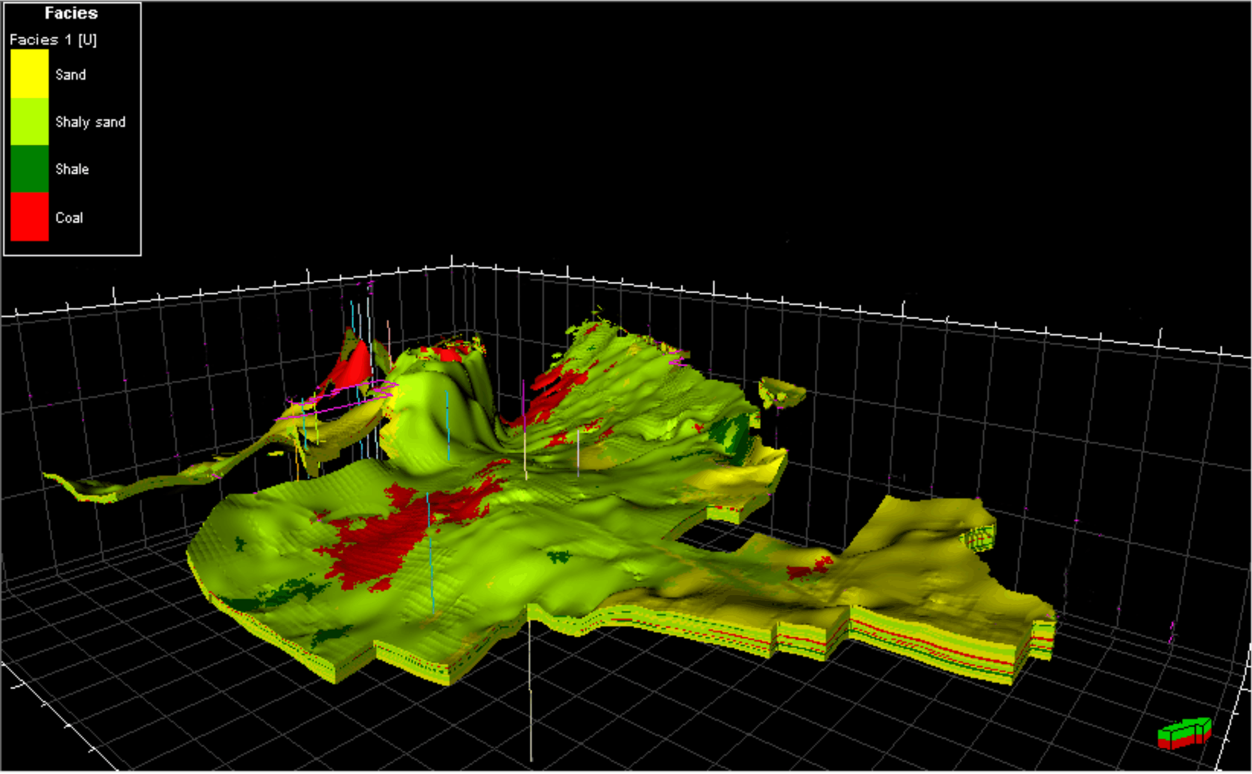
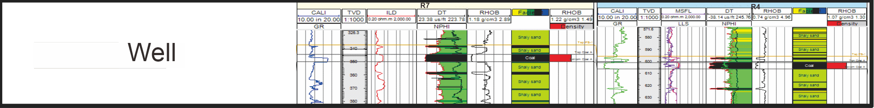
FIGURE 6. Facies modeling which divided into four types, such as coal, shale, shaly sand, and sand (a) and upscaling results for coal seam A in two wells (b)

The relative density grid distribution model obtained is a representation of the value of the coal matrix density. The relative property modeling of the density in the body of coal A is carried out using the Standard Gaussian method by using the RHOB grid property as the trend volume. Grid distribution of relative density coal A is shown in Figure 7. To prove the distribution of coal, it is necessary to do validation based on a seismic trajectory which has a property value of multi-attribute density with an interpretation of the target coal horizon. In Figure 6a, shows that the property of multi-attribute density, which is considered as coal density, is following the results of coal interpretation. As a final validation material, it is also proven through probability facies cross-section in PS-1 in R4 Well, according to the grid cell distribution of coal seam A (Figure 8). Coal seam A has a bulk volume of 518 million m³.

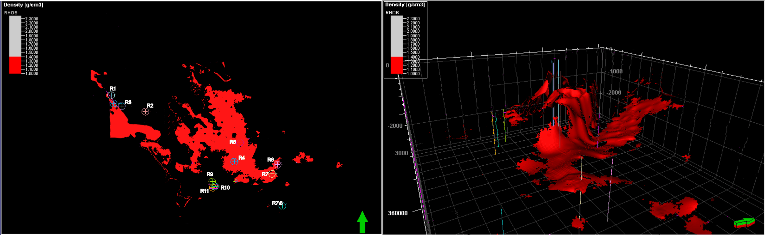
FIGURE 7. Coal seam A distribution from relative density cut-off 1.4 gr/cc
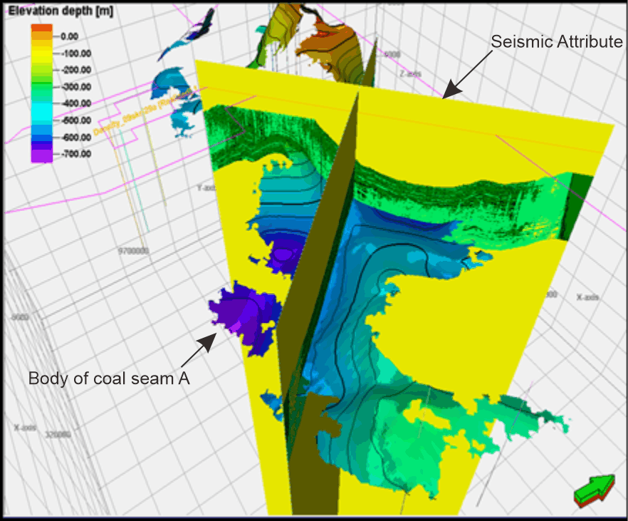

FIGURE 8. Cross-check body of coal seam a with a seismic attribute and to validated 3d modeling coal seam A

CONCLUSIONS

The method of 3D coal seam modeling related to coal seam interval below tuning thickness seismic data has been done. Nine sample outcrops, 11 well logs, 82 2D lines seismic, and 2 volume 3D seismic data were used in coal density, log interpretation, seismic modeling, and stochastic modeling for estimation of CBM resources. Seismic resolution enhancement can detect thin coal seam A with several problems, such as lateral continuity caused frequency variation in seismic data (esp. 2D lines). Seismic modeling method and distributed coal properties (density) have to add to solve this problem and get better results. Continuity of coal seam A is clear in several parts but still spotted and low correlation in inversion analysis results. Far offset between seismic and well data are the main problem for that is a result, so linear and non-linear statistical approach such as multi-attribute and artificial neural network must be made to “ignored” that effect. Increasing correlation from 0.6 to 0.9 linearly will be improve a positive seismic attribute result to input and, or compared 3D coal modeling from a geostatistical approach.
A combination between SGS and KED resulted the best 3D facies and coal seam A model. 3D coal seam A model has a bulk volume of 518 million m³ and spreads into a southern part. Accuracy of geostatistical estimations can be improved by adding well data in the areas of higher uncertainty.

Acknowledgments
Authors are thankful to the Engineering Faculty University of Lampung for providing financial support for this publication. Special acknowledgements to Universitas Gadjah Mada and PT. Pertamina PHE for providing exploration data to conduct of this academic research. Thanks are also for Mr. Imam for sharing the best knowledge in this research.

References
[1] N. Muksin, D. Yusmen, R. Waren, A. Werdaya, and D. Djuhaeni, “Regional Depositional Environment Model of Muara Enim Formation and Its Significant Implication for CBM Prospectivity in South Sumatra Basin , Indonesia *,” AAPG, vol. 80272, p. 9, 2012.
[2] N. Suwarna and Y. Kusumahbrata, “Macroscopic , Microscopic , and Paleo-depositional Features of selected Coals in Arahan , Banjarsari , Subanjeriji , and South Banko Regions , South Sumatra,” J. Geol. Indones., vol. 5, no. 4, pp. 269–290, 2010.
[3] H. Amijaya and R. Littke, “Microfacies and depositional environment of Tertiary Tanjung Enim low rank coal , South Sumatra Basin , Indonesia,” Int. J. Coal Geol., vol. 61, pp. 197–221, 2005.
[4] A. Haris, C. Imam, N. B. Berger, A. Riyanto, G. S. Program, and R. Geophysics, “Coal Bed Methane Properties Modeling Using Improved Seismic Resolution For Estimating Gas Reserves : A Case Study Of East Kalimantan Field ,” Int. J. GEOMATE, vol. 13, no. 40, pp. 81–87, 2017.
[5] N. Suwarna and B. Hermanto, “Coalbed methane potential and coal characteristics in the Lati region , Berau basin , East Kalimantan,” J. Geol. Indones., vol. 1, no. 1, pp. 19–30, 2006.
[6] P. Hatherly, “Overview on the application of geophysics in coal mining,” Int. J. Coal Geol., 2013.
[7] G. Tselentis and P. Paraskevopoulos, “Application of a high-resolution seismic investigation in a Greek coal mine,” GEOPHYSICS, vol. 67, no. 1, pp. 50–59, 2002.
[8] A. Noor, Faris Mohamad; Adipta, “A Comparison between Model Base Hardconstrain , Bandlimited , and Sparse-Spike Seismic Inversion : New Insights for CBM Reservoir Modelling on Muara Enim Formation , South Sumatra A Comparison between Model Base Hardconstrain , Band- limited , and Sparse-,” IOP Conf. Ser. Earth Environ. Sci., vol. 132, no. 41st HAGI Annual Convention and Exhibition, pp. 1–8, 2016.
[9] D. Andriani, E. Wibisono, H. Khanaif, R. J. T. Pratiwi, and W. Atmoko, “Determining Coal Distribution Based on Integrated Geological and Geophysical Study to Estimate Coal Bed Methane Resources In The Tarakan Formation: Case Study Kuncring Area,” in PROCEEDINGS INDONESIAN PETROLEUM ASSOCIATION, 2013, no. May, p. 17.
[10] L. Qiaoling, P. Suping, and Z. Guangui, “High resolution processing of 3D seismic data for thin coal seam in Guqiao coal mine,” J. Appl. Geophys., vol. 115, pp. 32–39, 2015.
[11] M. H. F. Setiawan, M. R. Asy’ari, R. C. Wibowo, D. H. Amijaya, and A. A. Aspari, “Parasequence Concepts, Problems and Solutions In CBM Exploration Using Seismic Data Case Study: Muara Enim Formation, South Sumatra Basin,” in INDONESIAN PETROLEUM ASSOCIATION Thirty-Ninth Annual Convention & Exhibition, 2015, no. May, p. 10.
[12] F. Zhou, G. Allinson, J. Wang, Q. Sun, D. Xiong, and Y. Cinar, “International Journal of Coal Geology Stochastic modelling of coalbed methane resources : A case study in Southeast Qinshui Basin , China,” Int. J. Coal Geol., vol. 99, pp. 16–26, 2012.
[13] F. Zhou, G. Yao, and S. Tyson, “International Journal of Coal Geology Impact of geological modeling processes on spatial coalbed methane resource estimation,” Int. J. Coal Geol., vol. 146, pp. 14–27, 2015.
[14] B. Zhou and P. Hatherly, “Coal seismic depth conversion for mine data integration : A case study from the Sandy Creek 3D seismic survey,” vol. 35, no. 4, pp. 324–330, 2004.
[15] L. M. Gochioco, “Modeling studies of interference reflections in thin- layered media bounded by coal seams,” GEOPHYSICS, vol. 57, no. September 1992, pp. 1209–1216, 1992.
[16] L. M. Gochioco, “Tuning effect and interference reflections from thin beds and coal seams,” GEOPHYSICS, vol. 56, no. 8, pp. 1288–1295, 1991.
[17] S. E. Richardson, R. Meyer, D. C. Lawton, and W. Langenberg, “Seismic modelling of coal bed methane strata , Willow Creek , Alberta,” 2001.
[18] G. Zou, Z. Xu, S. Peng, and F. Fan, “Analysis of coal seam thickness and seismic wave amplitude : A wedge model,” J. Appl. Geophys., vol. 148, pp. 245–255, 2018.
[19] A. Cornah, J. Vann, and I. Driver, “International Journal of Coal Geology Comparison of three geostatistical approaches to quantify the impact of drill spacing on resource con fi dence for a coal seam ( with a case example from Moranbah North ,” Int. J. Coal Geol., vol. 112, pp. 114–124, 2013.
[20] M. Rezvandehy, “Logical depth modeling of a reservoir layer with the minimum available data-integration geostatistical methods and seismic attributes,” J. Unconv. OIL GAS Resour., vol. 7, pp. 11–21, 2014.
[21] N.V. Shell Mijnbouw, " Geological study of the Bukit Asam coal mines, Jakarta, p. 18, (1976). (unpublished).

