The Influence of Geographical Factors on Extreme Rainfalls in Lampung Province
M Welly ^{1,*}
¹Civil Engineering Department Universitas Lampung, Bandar Lampung, Indonesia 35145
*email: margaretta.welly@eng.unila.ac.id
Article Information:  Received:  20 March 2019  Received in revised form:  30 April 2019  Accepted:  3 June 2019  Volume 1, Issue 1, June 2019  pp 33 – 39  © Universitas Lampung  http://dx.doi.org/10.23960/jesr.v1i1.7 | Abstract  Many people in Indonesia calculate design rainfall before calculating the design flood discharge. The design rainfall with a certain return period will eventually be converted into a design flood discharge by combining it with the characteristics of the watershed. However, the lack of a network of rainfall recording stations makes many areas that are not hydrologically measured (ungauged basin), so it is quite difficult to know the characteristics of rain in the area concerned. This study aims to analyze the characteristics of design rainfall in Lampung Province. The focus of the analysis is to investigate whether geographical factors influence the design rainfall that occurs in the particular area. The data used in this study is daily rainfall data from 15 rainfall recording stations spread in Lampung Province. The method of frequency analysis used in this study is the Gumbel method. The research shows that the geographical location of an area does not have significant effect on extreme rainfall events. The effect of rising earth temperatures due to natural exploitation by humans tends to be stronger as a cause of extreme events such as extreme rainfall.  Keywords: Influence, geographical, factors, extreme, rainfall.

Introduction
F
lood is a natural disaster in the form of overflowing river water to the mainland. Floods occur because the capacity of a water body is no longer able to hold off the passing discharge. Floods often occur in many cities in the world, both in developing countries and developed countries. Floods can be a pool of water that sinks an area. Puddles that occur can be receding inundations in a short time or for a long period of time. Floods can be caused by natural factors such as high rainfall, poor watershed conditions, and regional topography. Another factor that causes flooding is the poor drainage system caused by blockages of garbage dumped carelessly by humans. Changes in regional drainage coefficients due to changes in land use are also the most common causes of flooding everywhere. From the point of view of the community, flooding is generally a negative thing that is always materially detrimental. Floods can be classified as natural disasters because the consequences cover a very large area and affect the community in significant amounts. Floods can cause considerable and long-lasting damage. In areas that are densely populated, material losses due to flooding will be very large and the recovery of post-disaster conditions requires considerable time. In Indonesia, flooding occurs almost every year in every major city. For example, the city of Jakarta always experiences disruption due to flooding that comes every year on a different scale. In several cities on Java Island that are located in the Bengawan Solo River Basin, such as Bojonegoro and Madiun, flooding is a disaster that comes every year and incurs significant losses. On other islands such as Sulawesi and Sumatra, flooding began to become a routine annual event due to reduced forest and damage to the landscape due to illegal logging and forest fires. Sudden disasters such as flash floods at night often occur and cause considerable casualties. The most recent flash flood occurred in March in Sentani, Jayapura, and Papua Province. Flash floods accompanied by landslides have killed 58 people and many victims have not yet been found.
Estimates of the magnitude of flood discharge in Indonesia are usually calculated by flood frequency analysis (FFA). FFA analysis in general can be defined as a method for predicting a magnitude of flood discharge by analyzing the distribution of historical flood discharge data. The magnitude of the flood discharge generated by frequency analysis is the design flood discharge for a certain period (Q_{T}). Furthermore, the design flood discharge is defined as the largest flood discharge that statistically occurs at times over a certain period of time. For example, the annual 50 flood (Q₅₀), is the largest flood that statistically occurs once in 50 years. The data needed to calculate the flood design using the FFA method is the annual maximum daily discharge data from the nearest discharge data recording station.
In fact, calculating flood discharge using the FFA method is not always easy to do. This happens because historical flow data is not always available in the field. The flow recording stations in Indonesia are very few in number compared to the area that must be monitored. Therefore, many people calculate the design rainfall before calculating the design flood discharge. In the design rainfall analysis, the method taken remains the frequency analysis method. The data used in the design rainfall analysis, is rainfall data and not flow data. Rainfall data is easier to obtain in Indonesia due to the availability of a network of rainfall recording stations. The results of frequency analysis using rainfall data are design rainfall for a certain return period (R_{T}). This design rainfall with a certain return period will eventually be converted into a design flood discharge by combining it with the characteristics of the watershed.
Even though the number of rainfall recording stations is far more than the flow recording stations, but many regions in Indonesia do not yet have rainfall recording stations. One example is in Lampung Province. Rainfall recording stations in the province are concentrated in several districts in the central part of Lampung Province. Several other districts, such as West Lampung, Way Kanan, Tulang Bawang, Tulang Bawang Barat, and Mesuji, do not have a rain record station that is sufficient in terms of quantity. The lack of a network of rainfall recording stations in Lampung Province makes many areas that are not hydrologically measured (ungauged basin), so it is quite difficult to know the characteristics of rain in the area concerned. This study aims to analyze the characteristics of design rainfall in Lampung Province. The focus of the analysis is to investigate whether geographical factors influence the design rainfall that occurs in the particular area.

Materials and Methods

Data used in the study
The data used in this study is daily rainfall data from 15 rainfall recording stations spread in Lampung Province. The data is obtained from Mesuji – Sekampung Water Management Office (BBWS Mesuji – Sekampung) in Bandar Lampung. The rain station used was chosen based on the length of the rain data series. The position and name of each station are presented in Fig. 1 and the length of rainfall data for each station is given in Table 1.

Table 1. Rainfall data used in the research
No. | Name of the station | District | Data period | Notes
1 | Air Naningan | Tanggamus | 1976 - 2002 | Data completed
2 | Pematang Nebak | Tanggamus | 1974 - 2002 | Data completed
3 | Banyuwangi | Pringsewu | 1972 - 2002 | Data completed
4 | Metro | Metro | 1970 - 2002 | Data missed for 1972 and 1973
5 | Sukadana | Lampung Timur | 1974 - 2002 | Data completed
6 | Sukaraja Tiga | Lampung Timur | 1976 - 2002 | Data completed
7 | Jabung | Lampung Timur | 1975 - 2002 | Data completed
8 | Rumbia | Lampung Tengah | 1981 - 2002 | Data completed
9 | Way Kekah | Lampung Tengah | 1972 - 2002 | Data completed
10 | Negeri Kepayungan | Lampung Tengah | 1974 - 2002 | Data missed for 1985
11 | Kotabumi | Lampung Utara | 1966 - 2000 | Data missed for 1982
12 | Blambangan Umpu | Way Kanan | 1972 - 2001 | Data completed
13 | Bandar Lampung | Bandar Lampung | 1974 - 2002 | Data completed
14 | Tanjung Bintang | Lampung Selatan | 1977 - 2002 | Data completed
15 | Penengahan | Lampung Selatan | 1972 - 2001 | Data completed
(BBWS Mesuji Sekampung, 2019)

Table 2. The statistical characteristics of the data
No. | Name of the station | Number of data (n) | Average of data ($\overline{R}$) | Standard deviation of data (Std)
1 | Air Naningan | 29 | 92.42 | 16.18
2 | Pematang Nebak | 29 | 93.82 | 34.65
3 | Banyuwangi | 31 | 81.47 | 21.41
4 | Metro | 31 | 72.41 | 29.96
5 | Sukadana | 29 | 98.19 | 18.78
6 | Sukaraja Tiga | 27 | 87.35 | 17.15
7 | Jabung | 28 | 96.78 | 25.46
8 | Rumbia | 21 | 79.51 | 20.68
9 | Way Kekah | 25 | 100.61 | 34.13
10 | Negeri Kepayungan | 24 | 60.90 | 30.94
11 | Kotabumi | 23 | 104.40 | 36.13
12 | Blambangan Umpu | 25 | 127.95 | 78.73
13 | Bandar Lampung | 25 | 82.24 | 31.55
14 | Tanjung Bintang | 25 | 80.14 | 20.56
15 | Penengahan | 25 | 103.78 | 50.09

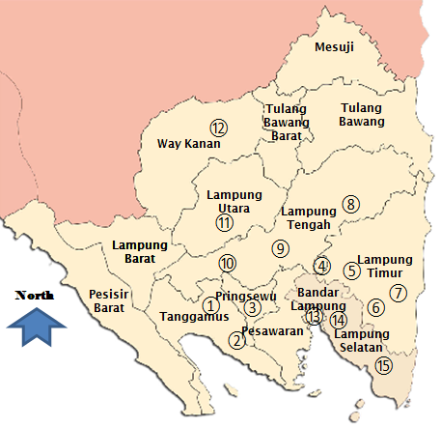
Figure 1. Position and name of stations used in this research

Statistical data analysis
The first step in conducting frequency analysis is to identify the statistical characteristics of the data. The statistical characteristics that must be known from the data are the sum of data, the average value of the data, and the standard deviation value of the data. These values are main parameters used in the calculation of rainfall design using frequency analysis method. The values can be calculated easily by using facility in the Excel software. The results of statistical data analysis are presented in Table 2.

Frequency analysis of data
There are several frequency analysis methods used in Indonesia. They are the Gumbel method, the Log Pearson III method, and the Log Normal method. The method of frequency analysis used in this study is the Gumbel method [1][2][3] with several considerations. The main consideration is because this method is the most commonly used for frequency analysis work in Indonesia. The formula for calculating rain design with the Gumbel method is given as [4]:
$R_{T}=\overline{R}+Std.K$ (1)
were R_{T} is design rainfall with a certain return period, R is the average of the data, Std is the standard deviation of the data, and K is the Gumbel coefficient. The value of K is obtained from the formula:
$K=\frac{Y_{T}-Y_{n}}{S_{n}}$ (2)
where Y_{n} is the value of reduced mean, S_{n} = value of reduced standard deviation, and Y_{T} = value of reduced variate. Y_{n} and S_{n} depend on the amount of data (n), while Y_{T} is calculated based on the formula:
$Y_{T}=-ln⁡(-ln\frac{T-1}{T})$ (3)
where T is the return period. With the formula above, the Y_{T} value for the various return times is as follows:
- Return period of 2 years, Y₂ = 0,3665
- Return period of 5 years, Y₅ = 1,4999
- Return period of 10 years, Y₁₀ = 2,5040
- Return period of 20 years, Y₂₀ = 2,9702
- Return period of 50 years, Y₅₀ = 3,9019
- Return period of 100 years, Y₁₀₀ = 4,6001
The value of Yn and Sn for various number of n and given in Table 3.

Table 3. The value of Yn and Sn for various number of n
n | Yn | Sn |  | n | Yn | Sn |  | n | Yn | Sn
10 | 0,4952 | 0,9496 |  | 19 | 0,5220 | 1,5650 |  | 28 | 0,5343 | 1,1047
11 | 0,4996 | 0,9676 |  | 20 | 0,5236 | 1,6280 |  | 29 | 0,5353 | 1,1080
12 | 0,5035 | 0,9833 |  | 21 | 0,5252 | 1,6960 |  | 30 | 0,5362 | 1,1124
13 | 0,5070 | 0,9971 |  | 22 | 0,5268 | 1,7540 |  | 31 | 0,5371 | 1,1159
14 | 0,5100 | 1,0950 |  | 23 | 0,5283 | 1,8110 |  | 32 | 0,5380 | 1,1193
15 | 0,5128 | 1,2060 |  | 24 | 0,5296 | 1,0864 |  | 33 | 0,5388 | 1,1226
16 | 0,5157 | 1,3160 |  | 25 | 0,5309 | 1,0915 |  | 34 | 0,5396 | 1,1255
17 | 0,5181 | 1,4110 |  | 26 | 0,5320 | 1,0961 |  | 35 | 0,5403 | 1,1285
18 | 0,5202 | 1,4930 |  | 27 | 0,5332 | 1,1004

Results and Discussions
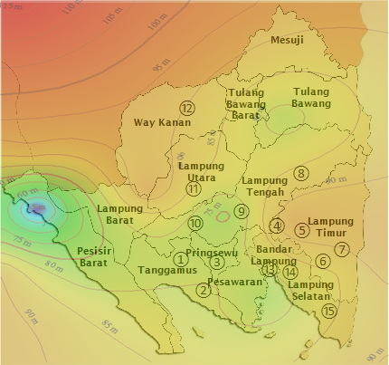
By using the frequency analysis method, design rainfall for each station can be calculated.

The results of analysis are given in Table 4. The isohyets of design rainfall are presented in Fig. 2 to Fig. 8 as follow.
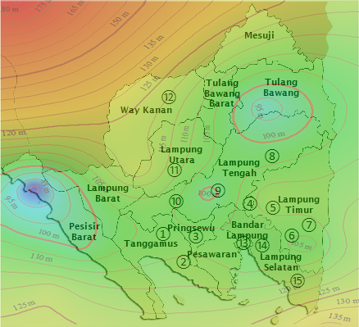

Figure 2. The isohyets of design rainfall of 2 years (R₂)

Figure 3. The isohyets of design rainfall of 5 years (R₅)

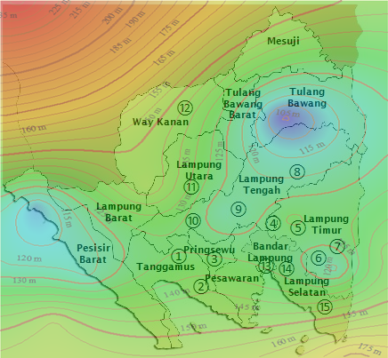

Figure 4. The isohyets of design rainfall of 10 years (R₁₀)

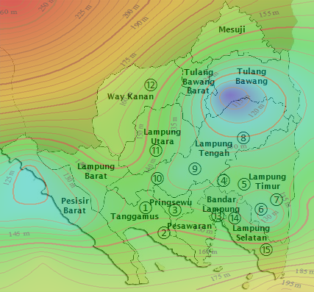

Fig 5. The isohyets of design rainfall of 20 years (R₂₀)

Figure 5. The isohyets of design rainfall of 50 years (R₅₀)

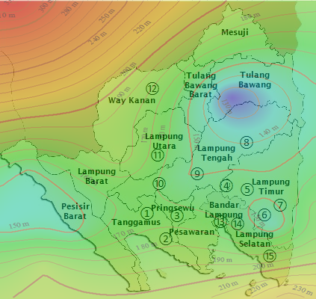

Figure 6. The isohyets of design rainfall of 50 years (R₅₀)

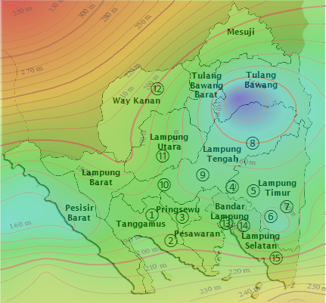

Figure 7. The isohyets of design rainfall of 100 years (R₁₀₀)

Fig. 2 to 6 show the rain contour patterns (isohyets) formed for each return period. The Figures show that for a small return period, for example R₂, the spread of rain is quite even. This means that the design rainfall for the 2-year return period is not much different from one another, except for the West Coast region. This area has smaller design rainfall than other regions.
For rainfall with a large return period, the figures above show that the direction of the rain contour or isohyets moves from the West and East to the middle part of Lampung. From the central area the rainfall continues to rise to the North and South. Rainfall contour valleys occur in the West, parts of Central and East Lampung with design rainfall that is quite low when compared to other parts.
The distribution of design rainfall turns out to have different characteristics with monthly or annual average rainfall. This is because the value of design rainfall is an extreme rainfall value whose characteristics are clearly different from the average rainfall characteristics. In some areas such as in West Lampung Regency, the rainfall that occurs tends to be influenced by local influences due to local topography. This is because this region is right behind the high geographical area, which is in the form of the Bukit Barisan Hills. The influence of the plateau on increasing rainfall is mainly to provide a boost (coercion) of rising air, which will trigger the onset of local atmospheric instability. The drive up by the plateau brings the moist air to the level of condensation. After that the addition of heat from the condensation results in the air becoming unstable and continuing to rise and there is rain called orographic rain [5]. Research turns out to show that the West Lampung area is not an area with high extreme rainfall. Isohyets show that this area does not have a high rainfall distribution design. This fact shows that the high average rainfall in an area does not guarantee that the area has high extreme rainfall. This also proves that extreme rainfall is not affected by the topography of the area.
Other conditions occur in the Right Way and parts of North Lampung. This area is a plateau where land cover has changed from secondary forest to plantation and residential areas. The monthly and annual average rainfall in this area is quite large when compared to other regions. Meanwhile the extreme rain pattern is also greater than the other regions. Extreme weather increases are expected to be in line with global warming because increasing temperatures affect weather parameters in several ways. Changes in the frequency of extreme events coinciding with global warming have been observed, and there is increasing evidence that some of these changes are caused by the impact of human activities on climate such as changes in forests to residential areas or plantations. Changes in sea surface temperature also affect atmospheric conditions and rainfall in Indonesia. Even so, this change does not automatically produce extreme weather events but reinforces the possibility that the event will occur. When linked to global warming, this means that increasing temperatures increase the likelihood of extreme events [6].
When there is burning of fossil fuels, such as oil and coal, carbon dioxide is released into the air. The carbon dioxide accumulates in the atmosphere and triggers an increase in temperature on earth. The heat caused by carbon dioxide is like a blanket covering the earth. This trapped heat disrupts many interconnected systems in the earth's environment. One of the effects of changes in the environmental system on the earth is the increase in extreme rainfall and extreme drought that can have an impact on human health. Warmer temperatures cause more water to evaporate into the air and allow the air to hold more water. This situation will cause rain that is more heavy than usual. At the same time, global heat temperatures affect the temperature and humidity around the planet which triggers drier conditions that will occur in some regions [7].
For the Lampung region, high extreme rainfall can occur due to extreme land use changes such as in North, Central and South Lampung, so that changes in temperature occur suddenly and massive. Another possibility is that extreme rainfall can also occur due to rising sea surface temperatures or symptoms of natural phenomena such as El Nino and La Nina.

Conclusions
Overall, the research shows that the geographical location of an area does not have significant effect on extreme rainfall events. The effect of rising earth temperatures due to natural exploitation by humans tends to be stronger as a cause of extreme events such as extreme rainfall. The results also show that extreme rainfall in Lampung can be caused by land temperature increases due to changes in forests to plantations and settlements. Another possible cause is an increase in sea surface temperatures due to climate anomalies such as El Nino and La Nina. More in-depth research on the influence of climate anomalies on extreme events in Indonesia has not been done by many people. Therefore in the future similar research will be an interesting topic to discuss.

Acknowledgment
The author gratefully acknowledges Head of Department of Civil Engineering Universitas Lampung for his support on this research and completion of the article.

References
[1] Wikipedia. (2019, January 10). Emil Julius Gumbel. Available: https://en.wikipedia.org/wiki/ Emil_Julius_Gumbel
[2] S. Syafalni, O. Setyandito, F. R. Lubis, Y. Wijayanti, (2015). Frequency analysis of design-flood discharge using Gumbel distribution at Katulampa weir, Ciliwung River. Int. J. Appl. Eng. Res., 10(4), pp. 9935-9946
[3] N. Mujere. (2011). Flood frequency analysis using the gumbel distribution. Int. J. Comp. Sci. Eng. (IJCSE), 3(7), pp. 2774-2778.
[4] T. C. Upomo, R. Kusumawardani. (2016). Pemilihan distribusi probabilitas pada analisa hujan dengan metode goodness of fit test. J. Tek. Sip. & Peren. 18(2), pp. 139-148.
[5] E. Nurhayati. (2009, February 26). Analisis Sebaran Hujan di Provinsi Lampung untuk Pewilayahan Tanaman Padi. Available: https://ardidafa78.wordpress.com/2009/02/26/analisis-sebaran-hujan-di-provinsi-lampung-untuk-pewilayahan-tanaman-padi/
[6] Skeptical Science. (2015, 7 July). Is extreme weather caused by global warming? Available:
https://www.skepticalscience.com/extreme-weather-global-warming.htm
[7] U.S Department of Health and Human Services Centers for Disease Control and Prevention (CDC). (2019, March 1). Extreme rainfall and drought, Available: https://www.cdc.gov/climate and health /pubs/ PRECIP-Final_508.pdf.

