SCALE OF TONES OF PISAAN LAMPUNG: A MUSICAL ANALISYS OF LAMPUNG LITERATURE

Riyan Hidayatullah
FKIP Universitas Lampung, Jl. Prof. Dr. Soemantri Brojonegoro No. 1 Bandar Lampung
* e-mail: riyan.1002@fkip.unila.ac.id , Telp: +6281389777661

Received: Accepted: Online Published:

Abstract: Scale Of Tones Of Pisaan Lampung: A Musical Analisys Of Lampung Literature. Scale is an important part in measuring a literary pronunciation. Through the scale of tones, singing and reciting literary works can be taught through methods. Pisaan is one type of literature from Lampung regional literature. In facing the challenges of the times, this literary inheritance is fairly slow and not comprehensive. This is due to the method of learning that is not patterned and has not been disseminated. Therefore, it is necessary to design a good and appropriate teaching method specifically to teach students. The initial step taken to develop an appropriate method is to analyze the analysis using music analysis techniques. The purpose of this study was to find the tone scale patterns found in Lampung pisaan. The pattern is further refined according to the level of student ability and customized teaching techniques. The method used in the study is a method of music analysis using a qualitative approach. Pisaan was recorded using a special recording device and a "condenser" type mic to get clear sound and facilitate the auditive analysis process. After doing a long analysis, the result is the scale (laras) and interval motives that are similar to the pelog tunnels in Java. Furthermore, the results of this study have stages that need to be disseminated to teachers throughout Lampung. This is done so that the Pisaan teaching method is even and even.

Keywords: pisaan, scale, method

Abstrak: Skala Nada Pisaan Lampung: Sebuah Analisis Musik Sastra Lampung. Skala nada merupakan salah satu bagian penting dalam mengukur sebuah pelafalan sastra. Melalui skala nada, bernyanyi hingga melafalkan karya sastra mampu diajarkan melalui metode. Pisaan merupakan salah satu jenis sastra dari kesusastraan daerah Lampung. Dalam menghadapi tantangan zaman, pisaan pewarisan sastra ini terbilang lambat dan tidak komprehensif. Hal ini disebabkan oleh metode pembelajarannya yang tidak terpola dan belum disebarkan. Oleh karena itu, perlu dirancang sebuah metode ajar yang baik dan tepat khusus untuk mengajarkan pisaan. Langkah awal yang dilakukan untuk menyusun sebuah metode pisaan yang tepat adalah dengan menganalisa pisaan tersebut menggunakan teknik analisis musik. Tujuan dari penelitian ini adalah untuk menemukan pola-pola skala nada yang terdapat dalam pisaan Lampung. Pola tersebut selanjutnya disempurnakan sesuai tingkat kemampuan siswa dan teknik ajar yang disesuaikan. Metode yang digunakan dalam penelitian merupakan metode analisis musik menggunakan pendekatan kualitatif. Pisaan direkam menggunakan alat rekam khusus dan mic jenis “condenser” untuk mendapatkan suara yang jernih dan memudahkan proses analisis secara auditif. Setelah melakukan analisa panjang, hasilnya adalah skala nada (laras) dan motif interval yang mirip dengan laras gamelan pelog di Jawa. Selanjutnya, hasil penelitian ini memiliki tahapan yang perlu didiseminasikan kepada guru-guru di seluruh Lampung. Hal ini dilakukan agar metode pengajaran pisaan merata dan sama.
Kata kunci: pisaan, skala nada, metode

INTRODUCTION

According to Effendi Sanusi (Lampung University language and literature academician), Lampung oral literature can encourage understanding, loving, and fostering life well, fostering unity and mutual understanding among people, supporting the development of Lampung language and culture, and supporting the development of Indonesian language and literature ( Karzi, 2013).
Pisaan is a part of Lampung literary form that needs to be preserved. Sudjirnan (1986: 19) suggests that literary works can be used as a means of teaching or moral, religious and ethical guidance. Oral Literature Lampung is a representation of the Lampung community which is preserved. During this time, pisaan is used as a tool to express themselves in a variety of situations and conditions, for example when releasing the departure of a child to get married, the grief left by the parents, lamenting the condition of themselves and others. In some places, Pisaan is used as part of traditional processions and shows. However, this show is very rarely found among the urban community in Lampung.
Another thing that encourages this research is that pisaan needs to be examined not only the preservation of the derni and the description of its value system, but also the importance of the knowledge of Lampung regional literature. As will be explained in the "Relevant Research" section, pisaan as Lampung's cultural wealth has not been widely studied. In other words, as long as the researchers' knowledge to date has never been carried out research that specifically examines penance, whereas research that focuses on study will deepen our knowledge and understanding of the phenomenon itself. If this last thing is achieved, it is expected that our knowledge of the literature of Lampung region as a whole will be more perfect (Fuad et al. 2000: 2).
In the Dian Azmiyati thesis (2018) was concluded that the results of the analysis of the analysis had a complete physical structure and inner structure. Physical structure includes diction, images, advances, verification and typography. While in the inner structure includes the theme, taste, tone and mandate. The physical structure and inner structure above are closely related to the musical aspect in a poetry-poetry presentation. Thompson (2006) writes in an article called "some elements of poetry" that elements of a poem include meters, stanzas or stanzas, rhymes and sounds, and ideas. Each of these ideas is formed with musical polarization, for example rhymes and sounds formed and supported by sound elements.
The problems that arise in reviewing pisaan are about teaching methods that have not been formulated. So far Pisaan has only been taught to a few generations who want to reduce their knowledge. There is no clear text, the stages of making the poem, and the basic tone. This is important as a reference in learning to the next generation. Through a standard and tested method, conservation measures will be easily carried out evenly in Lampung.
Meter is a literary term of rhythm (in music), rhymes are related to articulation and pronunciation and sound is categorized as the term melody. Melodies in musical studies require tones. Tone patterns will be easily imitated through the scale (tone, barrel) tone. This study requires music analysis to determine the form of presentation of Lampung literature in full, seen from the melodic, scale and interval aspects.
Tone scale or scale or tonality is a tiered arrangement of the tone of the main tone of a tone system, starting from one of the basic tones to the octave tone, for example do, re, mi, fa, so, la, si, do (Hidayatullah & Hasyimkan, 2016: 63). Tone scale is a meeting point or pedestal that connects the tones so that it forms a pattern and is easily recognizable auditively. Knowing the scale will make it easier to compose melodies in a song, poem or poem. In addition to providing analysis and fostering literary studies, music provides a new color in the study of society and culture. Ruth Benedict and Margaret Mead, these first-generation ethnomusicologists were the fields of leader who saw music as an important factor for understanding culture (Campbell, 2003: 18)

METHOD
Types of research
This research is a qualitative type using a phenomenological approach to the analysis technique of audio music samples. The context analysis deals with broader problems of understanding the musical phenomenon; it is a low-level perspective of music. In the context of the musical analysis, whole is analyzed with descriptions and according to its uses. Music description, for example, analyzing musical styles, text and textual sources, tonality and modality, melody and harmony, as well as rhythm and features of the sound spectrum. Music can be listened to in order to increase factual knowledge of it (Merriam, 2000). The data used in this study came from the initial sampling to one of the sources residing in the Tiyuh neighborhood of Pesawaran District Life Crisis, taking the data in the form of 'advice'.

Research Time and Research Place
When the research was conducted in April 2018 by bringing in data sources and recording about 5-10 minutes in a closed room. The recording process is done for one day. Recording is done to get electronic data (audio) and other information about pisaan. Research place in Bandarlampung city with consideration of completeness of equipment used for recording.
Research subject
Subjects in this study were Lampung people who were domiciled in Tiyuh Kejungan Kurwah Nyawah in Pesawaran district. Data retrieval techniques are carried out by recording sound and reading the text of the pisaan that was previously prepared.
Procedure
The stages in this study begin by doing audio recording (audio analysis) pisaan and field notes. Recording was carried out using a laptop, recording 2i2 studio focusrite-scarlett equipment. The audio signal is stored on the computer to be analyzed at a later stage. The analysis of sampled audio is becoming common for electroacoustic music and ethnomusicology where there are no scores. Waveforms provides overall amplitude and timbre information, and can be used to calculate data timings through comparison of onset peaks. Many programs (even basic sequencers) display audio waveforms (Brown, 1999: 4, p4)

Data, Instruments and Data Collection Techniques
Data taken in the form of audio data and pisaan (transcript) documents. Documents are taken from the writing script made by the core resource person. Audio data is taken through the recording process using professional recording tools and Cubase 5 software. In addition to recording, interviews are conducted to draw information about the types of pisaan and various types of Lampung pisaan styles.

Data analysis technique
Audio data were analyzed using auditive analysis techniques. The stage starts with mapping the basic tone. Taking audio data through the recording process is not intervened, the basic tone is taken based on the condition of the resource person in natural conditions. Furthermore, the writing of the text is adjusted to the writing that is sung through the recording tool. Then the basic tone and interval obtained are adjusted according to rhymes, stanzas and phrases in pisaan. After knowing the basic tone (tonality), interval, frequency, and synchronization of text with audio, the next step is to write beam notes or tone transcripts. This is done to do visual mapping to make it easier to find tone progression patterns or melodies used. This transcription flow is described as follows.

Diagram 1. The process of transcription of pisaan
After the melody patterns are obtained, the next step is to determine the beginning and end tones at the end of each line and the pisaan temple. This process is carried out to draw conclusions about the melody patterns used. After the audio picture of the pisaan is fully illustrated using not transcription, the next step can be the formation of a system or model of teaching materials that can be used for learning Pisaan. Transcription uses "the staff" which is commonly used in music notation (score). A pattern system using symbols is used to translate perceptions of text and methods. One can symbol transformed into another symbol (Leman, 1993: 126-129, Utriainen, 2005)

RESULT AND DISCUSSION
The results of this study are audio data and recorded text. In the Pisaan text there are three stanzas. Text is used as a tool to match melodies with syllables in text.

Table 1. Text of pisaan
Teks Pisaan | Artinya
Tabikpun nabik tabik  Mahappun ngalimpugha  Terhadap di sai ghamik  Penghwatin sai wat dija  Cutik siji pesan buya  Kuti Ghua kak bekeluarga  Ibadah dang sampai lupa  Piil keluarga gham jaga  Ganta nayah ceghita  Anak lupa di hulun tuha  Cawa tian jaman kak bida  Dusa jadi biasa | Permisi,  Maaf kepada semua yang terhormat  Kepada seluruhnya  Penyimbang adat, tuha raja yang ada di sini  Sedikit pesan orang tua  Kalian berdua sudah berkeluarga  Kerjakan ibadag jangan sampai lupa  Harga diri keluarga dijaga  Sekarang banyak cerita  Anak lupa dengan orang tua  Kata mereka zaman sudah berbeda  Dosa jadi biasa

By using the standard frequency A = 440 Hertz. obtained the following analysis.
Tabel 2.
Analysis Resuts | descriction
Tonality  Scales  Interval | C # (this sound collection is pure without using tunner help, so the sound is pure without the intervention of musical instruments.  Pentatonik  1 2 3 4 5  C# D E G# A
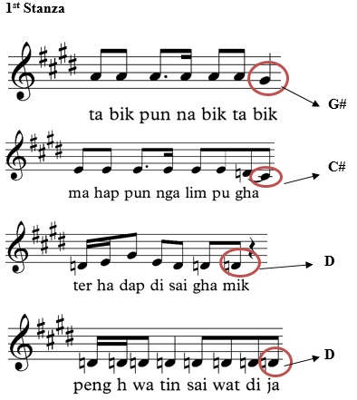

Tones are taken without giving prior auditive perceptions, so the tone that is raised is quite high in tonality. The visualization of the staff is used to give the melody pattern and the endpoint of the tone or each rhyme. In the first stanza the final tone has an arrangement of G # -C # -D-D.

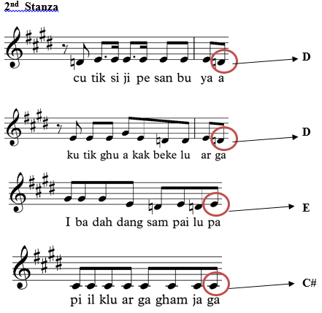

In the 2nd stanza, the endpoint of the tone taken by the singer is the D-D-E-C #.
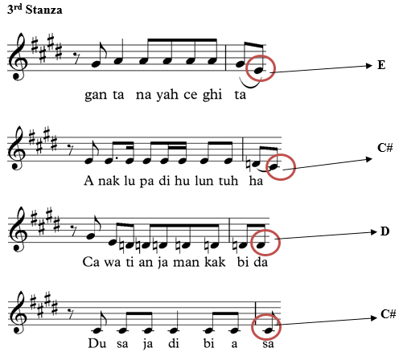
In the 3rd stanza, the endpoint of the tone has an E-C # -D-C # pattern. If you notice, the G # -C # -D-D, D-D-E-C #, and D-D-E-C # patterns are still on a tonality path. So that at this stage we can create a pattern for teaching methods using a pentatonic scale pattern of tonality and alignment (5 tones). At intervals, the distance C # to D is half, D to E = 1, E to G # = 2, G # to A = half.
From this sample, the use of the tone scale in Lampung pisaan actually only uses one type of vocal style and tonality system. This needs to be carried out further studies on other types of clans. Data sources were recorded using Lampung pubian style surname way semah.

CONCLUSION
Based on the results of the analysis of audio data, the most prominent results for the media and teaching methods are using the pentatonic tone system which is almost the same as pelog dissolution in Java. Matters related to ornaments and pronunciation styles need to be done in future research. The next stage of the research is tracing several clans who are still in the Lampung pubian family ties. This needs to be done to find out the character or style of pronunciation.

REFERENCES

Azmiyati, Dian. 2018. Pisaan Pada Masyarakat Sungkai Bunga Mayang Dan Implikasinya Dalam Pembelajaran Sastra Di Sekolah Menengah Pertama. Tesis tidak diterbitkan. Lampung: PPS FKIP Unila
Brown, A. R. 1999. An Introduction to Music Analysis with Computer. XArt Online Journal, 4(1)p 1-7.
Campbell, P. S. (2003). Ethnomusicology and music education: Crossroads for knowing music, education, and culture. Research studies in music education, 21(1), 16-30.

Fuad, Muhammad dkk. 2000. Nilai Didaktis Dalam Pisaan Lampung pubian. Jakarta:
Pusat Bahasa Departemen Pendidikan Nasional

Hidayatullah, Riyan & Hasyimkan. 2016. Dasar-dasar Musik. Yogyakarta: Arttex

Karzi, Udo Z. 2013. Sastra (Berbahasa) Lampung dari Kelisanan ke Keberaksaraan (Online), (http://cybersastra.org/sastra-berbahasa-lampung-dari-kelisanan-ke-keberaksaraan-udo-z-karzi/) diakses 8 Agustus 2018
Merriam, A. 2000. Anthropology of Music (4th printing). Evanston: Northwestern University Press

Sudjiman, Panuti. 1986. Kamus lstilah Sastra. Jakarta: Gramedia

Thompson, M. C. 2006. Some Elements of Poetry (Online) (http://www.rfwp.com/samples/elements-of-poetry.pdf), diakses 8 Agustus 2018

Utriainen, J. 2005. A Gestalt music analysis: philosophical theory, method, and analysis of Iegor Reznikoff's compositions (No. 39). University of Jyväskylä.

