See discussions, stats, and author profiles for this publication at: https://www.researchgate.net/publication/326735822

SPERMS QUALITY OF MICE DECREASED BY SEED EXTRACT OF PAPAYA
(CARICA PAPAYA L.)

Article · August 2018

CITATIONS
0
READS
15

4 authors, including:

Hendri Busman

11 PUBLICATIONS 4 CITATIONS SEE PROFILE

Mohammad Kanedi

Lampung University
55 PUBLICATIONS 21 CITATIONS
Sutyarso Sutyarso
Lampung University

23 PUBLICATIONS 26 CITATIONS SEE PROFILE

SEE PROFILE

Some of the authors of this publication are also working on these related projects:

Trace elements surrounding Krakatau Islands View project
The use of succulent plants for hair growth promotion herbs View project

All content following this page was uploaded by Mohammad Kanedi on 01 August 2018.

The user has requested enhancement of the downloaded file.

ejbps, 2018, Volume 5, Issue 8, 95-98.
Research Article
SJIF Impact Factor 4.918

European Journal of Biomedical | ISSN 2349  Volume | -8870  : 5
AND Pharmaceutical sciences  http://www.ejbps.com | Issue: 8  95-98  Year: 2018

SPERMS QUALITY OF MICE DECREASED BY SEED EXTRACT OF PAPAYA (CARICA PAPAYA L.)

Hendri Busman, Nuning Nurcahyani, Sutyarso, Eka Ratna Susmala Dewi and Mohammad Kanedi*

Department of Biology, Faculty of Mathematics and Sciences, University of Lampung, Bandar Lampung, Indonesia.

*Corresponding Author: Mohammad Kanedi
Department of Biology, Faculty of Mathematics and Sciences, University of Lampung, Bandar Lampung, Indonesia.

Article Received on 07/06/2018 Article Revised on 27/06/2018 Article Accepted on 17/07/2018

ABSTRACT
Objective: To enrich new evidence about the anti-fertility activity of seeds extract of papaya (Carica papaya L.) in
test animals, especially mice. Methodology: Male mice (n=20) were grouped into four. The first group received only distilled water containing 1% CMC as the control. Group 2, 3 and 4 consecutively recei ved papaya seeds extract of 2, 4 and 8 mg/40 g body weight. All treatment administered orally using stomach sonde once daily for
35 days. Study parameters assessed were sperm motility, viability, and normal morphology. Results: In comparison to control group, mice injected with papaya seeds extract at the doses of 4 mg or more significantly decreased motility and normal morphology of spermatozoa. In addition, papaya seeds extract of all doses were significantly decreased percentage of sperm viability. Conclusion: Papaya seeds extract is potential to be used as male anti-fertility agent.

KEYWORDS: Carica papaya, contraceptives, papaya seeds, antifertility, sperm quality.

INTRODUCTION

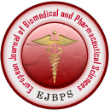

Kanedi et al. European Journal of Biomedical and Pharmaceutical Sciences
The low rate of success of family planning programs in
many parts of the world, especially in developing countries, is the reluctance of men to use contraception. This is because there are still doubts about the potential for male contraception and currently no contraceptive product for male that are fully eligible: effective, safe, convenient, reversible, cheap and acceptable.[1]

Biologically, the effectiveness of male contraceptives should have anti-spermatogenic properties that suppresses sperm production, prevents sperm maturation, and blocks sperm transport along the vas deferen tract. However, there are disadvantages of male hormonal contraceptives. As indicated, long term use of such type contraceptives may cause some side effects. That is why male contraception must meet several conditions i.e. effective, safe, reversible and does not affect libido.[2,3]

There are many medicinal plants that were reported to worth considering to be developed as an eligible contraceptive agents, among oothers is papaya (Carica papaya L.). is one of tropical plants. Seeds extract of papaya revealed to cause tubules of testis shrunken, vacuolation of Sertoli cells and abnormalities of germ cells, and inhibition of steroidogenic function of Leydig cells in Langur monkey.[4] In Wistar rats, seeds extract of this caused hypertrophy of pituitary gonadotrophs, gradual degeneration of germ cells, Sertoli cells and Leidig cells as well as germinal epithelium, progressive
collapse and shrinked villi of seminal vesicles.[5] In mice, treatment of seed extract of papaya for 7 days revealed to cause decrease in sperm concentration, motility and viability.[6]

Papaya contains a broad spectrum of phytochemicals including, polysaccharides, alkaloids, lectins, saponins, flavonoids, and sterols. Papaya seeds, as has been known since 1970, contain saponin as a potent antifertility compound.[7] Additionally, this plant is also contained triterpenoid and saponin that are suspected as the active ingredient that potentially has an antifertility properties.[4] As an effort to enrich new evidence of antifertility activity of chemicals content of papaya in male subjects, a 35-day treatment of papaya seed extract was performed in mice.

MATERIALS AND METHODS
Plant Materials
Seed samples of papaya (Carica papaya) used in the
study were originated from ripen fruit collected from a local papaya farmer in suburb of Bandar Lampung, Indonesia. The seeds were dried using oven at 40o C, milled into powder and then macerated using ethanol. After vacuum evaporation, the viscous extract then suspended in 1% CMC in distilled water in accordance with the prescribed treatment doses.

Animals and Treatment
Twenty male Swiss albino mice, aged 4 months and
weighing 25-30 g from Lampung Veterinary Center, Indonesia, were used and divided into four gorups. The first group received only distilled water containing 1% CMC as the control. Group 2, 3 and 4 consecutively received papaya seeds extract of 2, 4 and 8 mg/40 g body weight. All treatment administered orally using stomach sonde once daily for 35 days. The 35-day treatment was based on the spermatogenic cycle of mice that lasting for 35 days.[8] On day 36 all mice were sacrificed and the epididymal organ is taken. Semen in the epididymis was squeezed and diluted with physiological saline.

Study Parameters
Study parameters assessed were sperm motility, viability,
and normal morphology. Spermatozoa was counted using a Neubauer’s haemocytometer under a light microscope at 400x magnification. Quantitative epididymal sperm motility expressed as an index determined by counting both motile and immotile spermatozoa per unit area. Sperm morphology was assessed from a smear of the
epididymal filtrate prepared on a clean glass slides by addition of a drop of 1% eosin. After the object dried observation done under a light microscope and the abnormalities of either head or tail were noted. Sperm viability was determined by counting the colorless-sperm among 100 sperms observed for each test.

Data Analyses
To detect intergroup differences one-way ANOVA was
performed, followed by Fisher's least significant difference (LSD) test to detect differences between individual groups at the p < 0.05.

RESULT
Bar chart in Fig.1, 2 and 3 consecutively represented
mean percentage ± SD of sperm motility, viability and normal morphology of mice after treatment of papaya seeds extract for 35 days. It is clear from Fig.1 that in comparison to control group, mice injected with extract at the doses of 4 mg or more significantly decreased motility of spermatozoa according to the increase of the dosage (p < 0.05).

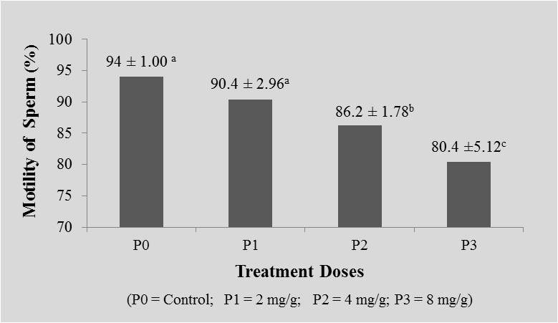
Fig. 1: Sperm motility of mice treated with papaya seeds extract for 35 days. Mean values ± SD followed by the same superscript are not statistically different at p < 0.05.

Fig. 2: Sperms viability of mice treated with papaya seeds extract for 35 days. Mean values ± SD followed by the same superscript are not statistically different at p < 0.05.
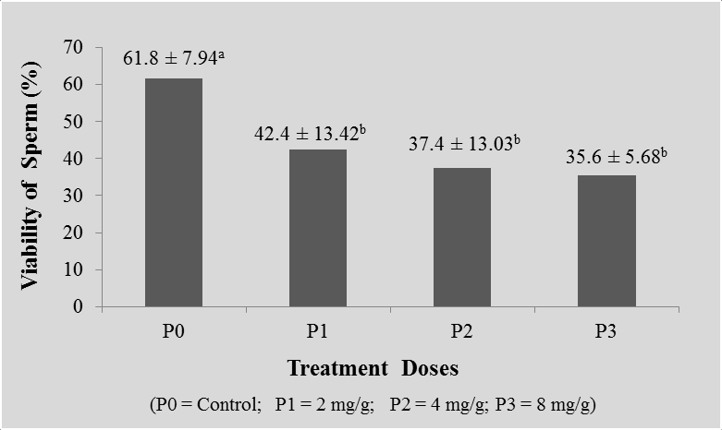

From Fig.2 it is revealed that papaya seeds extract significantly decreased percentage of sperm viability, but there is no significant different between the doses of extract given (p<0.05). Next, the data in Fig.3 further
confirms that the papaya seeds extract has the potential to affect fertility of male mice as it is proven that at the doses of 4 and 8 mg significantly decrease the normal morphology of spermatozoa (p<0.05).

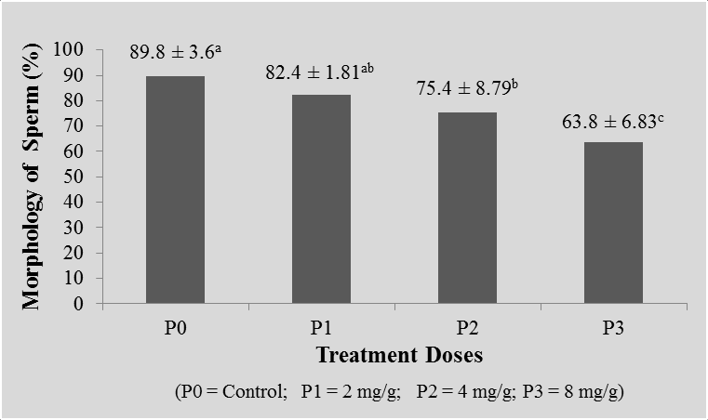
Fig. 3: Normal morphology of sperms of mice treated with papaya seeds extract for 35 days. Mean values ± SD
followed by the same superscript are not statistically different at p < 0.05.

DISCUSSION
The results of this study clearly suggest that papaya
seeds extract is potential to be used as anti-fertility agent in male subjects because it significantly decreases motility, viability and normal morphology of spermatozoa. Regarding sperm motility there are factors, both endogenous and exogenous, that are influential. The availability of energy sources is an important endogenous factor. The energy source used in sperm motility is adenosine tri phosphat (ATP). Active compounds contained in papaya seeds such as alkaloids, tannins, saponins and tritepenoid can interfere with the sperm transport process, which agglomerates sperm to decrease motility and sperm life power, consequently sperm can not reaching the ovum and fertilization can be prevented accordingly.[9]

Other chemical content in papaya seeds whose effect needs to be considered is glucosinolate. Glucosinolate is allegedly inhibit sperm maturation and affect the formation of plasma cement as a medium in sperm transport. Most likely the papaya seed extract affects the sperm transport process, by coagulating the cement so that the motility, morphology, and viability of the sperm decreases. The agglutination mechanism took place at the epididymis level, by interfering with the fluid composition of the epididymis and affecting the enzymes produced by the sperm.[10] Papaya seed extract is also known to contain a polypetide crushing enzyme, called papain, which is a group of protease enzymes that may inhibit sperm motility in semen plasma. This enzyme is similar to the compound semenogelin and polypeptide destroyer which is a motility inhibitor in cement plasma.[9]

Ethanol extract of papaya seeds proved to have the efficacy of contraception by affecting motility and
viability of sperm. The active components present in the methanol and ethanol fractions of papaya seed extract cause vacuolization of the Sertoli cell cytoplasm and the destruction of some organelles in the cytoplasm, thereby reducing their metabolic activity. Furthermore, Sertoli cell abnormalities will inhibit the devopment and maturation of spermatogenic cells, especially spermatids and sperm.[11]

As shown in Fig.2, sperm viability of mice treated with papaya seeds extract decreased compared to control. The decrease in sperm viability is thought to be due to the effect of papaya seed extract given to the test animals has disrupted the function of Sertoli cells in supporting, protecting and regulating nutrients for developing sperm. Disorder of Sertoli cells causes disruption of cell exchange and metabolism that lead to disruption of sperm cells development.[12]

The morphology of sperm found in this study is also decreased compared to control. This is likely due to the ability papain contained in the extract to break the chemical bonds in protein molecules—the raw material synthesis reproduction hormone, so that the protein decomposes into peptides and the reproduction hormone synthesis consequently will decrease. As indicated, papain can damage organelles of Sertoli and spermatogenic cells. The decrease in Sertoli and spermatogenic cells so that the cell components in the semineferus tubule degenerate.[5] It is suspected that the papain compounds contained in the papaya seeds inhibit the androgens, resulting in a disturbance in the spermiogenesis leading to sperm abnormalities.

CONCLUSION
Referring to findings that ethanol extract papaya seeds
significantly decreased sperms motility, viability, and

morphology it is inferred that papaya seeds extract is potential to be used as male anti-fertility agent.

REFERENCES
1. Matthiesson KL, McLachlan RI. Male hormonal
contraception: concept proven, product in sight?
Hum Reprod Update., 2006; 12(4): 463-482.
2. Sharma R.S, Rajalakshmi M. and Jeyaraj D.A. 2001.
Current Status of Fertility Control Method in India. J. Bioscienc, 26(4): 391-405.
3. Kamal, R.; Gupta, R.S. dan Lohiya, N.K., 2003, Plant for Male fertility Regulation, http:/www.3.interscience.wiley.com/cgibin/abstract/
1085655781
4. Lohiya, Manivannan, Mishra, Pathak, Sriram, Bhande, Panerdoss. Chloroform extract of Carica papaya seeds induces long-term reversible azoospermia in Langur monkey. Asian J Androl.,
2002; 4(1): 17-26.
5. Lohiya NK, Manivannan B, Mishra PK, Pathak N, Sriram S, Bhande SS, Panneerdoss S. Chloroform extract of Carica papaya seeds induces long-term reversible azoospermia in Langur monkey. Asian J Androl., 2002; 4(1): 17-26.
6. Wiryawan R.A., I’tishom R. and Purwaningsih S.
Papaya Seed Extract Lowers Sperm Concentrations, Motility and Viability in Male Mice. Folia Medica Indonesiana, 2015; 51(4): 252-256.
7. Udoh, P. 1998. Studies on Anfertility Effect of Pawpaw Seeds (Carica papaya) on the Gonads of Male Albino Rats. Pub. Med. Departement of Biological Sciences. University of Calabar. Nigeria.
8. Rugh, Roberts, 1903- Mouse: its reproduction and development. Minneapolis, Burgess Pub.Co. [1968] (OCoLC) 607645203
9. Lohiya NK, Manivannan B, Goyal S, Ansari AS.
Sperm motility inhibitory effect of the benzene chromatographic fraction of the chloroform extract of the seeds of Carica papaya in langur monkey, Presbytis entellus entellus. Asian J Androl., 2008;
10: 298-306.
10. Marfo EK, Oke OL, Afolabi OA. Chemical composition of papaya (Carica papaya) seeds. Elsevier Science Ltd., 2003; 259-266.
11. Lohiya NK, P.K. Mishra, N. Pathak, B.
Manivannan, S.S Bhande, S. Penerdoss, S. Sriram. Efficay trial of purified compounds of the seeds of Carica papaya for male contraception in albino rat. Reprod Toxicol., 2005; 20n(1): 135-48.
12. Tjokronegoro, A. 2002. Oxidative Stress and Male Infertily: Phatophisiologyb and Clinical Implication. Jurnal Kedokteran Yarsi. Vol.10.No.1. hlm, 50-59.

