ISOLASI DAN APLIKASI FUNGI ENTOMOPATOGEN DARI LARVA Aedes aegypti L.

WURI ARTIKASARI¹ , EMANTIS ROSA², BAMBANG IRAWAN³
¹ Jurusan Bilogi FMIPA Universitas Lampung, Bandar Lampung, artikawuri58@gmail.com
² Jurusan Bilogi FMIPA Universitas Lampung, Bandar Lampung, emantisrosa@gmail.com
³ Jurusan Bilogi FMIPA Universitas Lampung, Bandar Lampung, birawan11@ymail.com
Jl. Soemantri Brojonegoro, No.35, Gedung Meneng, Bandar Lampung, 085766708353, 35145, artikawuri58@gmail.com

Diterima: -Disetujui
©2019 Jurusan Biologi FMIPA Universitas Cenderawasih

ABSTRACT

DHF (Dengue Hemorrhagic Fever) is a serious problem in Indonesia. DHF disease control has been done a lot, one of which is the use of larvacida temephos (abate). Larvasida is a chemical insecticide that has a negative impact on human health and causes resistance. Therefore biological control is carried out by utilizing entomopathogenic fungi. The purpose of this study was to determine the effectiveness of entomopathogenic fungi isolated from larvae Ae. aegypti against the death of Ae mosquito larvae Ae. aegypti with the moist chamber method. This study used a completely randomized design (CRD) with a factorial pattern and performed two repetitions. Factor A is a type of fungi with 3 levels, namely A1: Aspergillus sp. 1, A2: Aspergillus sp. 2, and A3: Syncephalastrum sp. Factor B is a dilution with 7 levels, namely B0: Control, B1: 100 (without dilution), B2: 10-1, B3: 10-2, B4: 10-3, B5: 10-4, B6: 10-5 each the treatment was carried out 2 repetitions. Observations were made 24 hours after treatment for 3 days. Data were analyzed using ANARA and continued with the Smallest Significant Difference Test (LSD) at 5% real level. The results of this study indicate that fungi isolates are the most effective in killing Ae mosquito larvae. aegypti is Aspergillus sp. 1 and Aspergillus sp 2.

Keywords: DHF, Aedes aegypti, Entomopathogenic Fungi

ABSTRAK

Penyakit DBD ( Demam Berdarah Dengue) merupakan masalah serius di Indonesia. Pengendalian penyakit DBD sudah banyak dilakukan, salah satunya adalah penggunaan larvasida jenis temephos (abate). Larvasida merupakan insektisida kimiawi yang memiliki dampak negatif bagi kesehatan manusia dan menyebabkan resistensi. Oleh karena itu dilakukan pengendalian hayati dengan memanfaatkan fungi entomopatogen. Tujuan dari penelitian ini adalah mengetahui efektivitas fungi entomopatogen yang diisolasi dari larva Ae. aegypti terhadap kematian larva nyamuk Ae. aegypti dengan metode moist chamber. Penelitian ini menggunakan Rancangan Acak Lengkap (RAL) dengan pola faktorial dan dilakukan 2 kali pengulangan. Faktor A merupakan jenis fungi dengan 3 taraf yaitu A1: Aspergillus sp. 1, A2: Aspergillus sp. 2, dan A3: Syncephalastrum sp. Faktor B merupakan pengenceran dengan 7 taraf yaitu B0 : Kontrol, B1 : 10⁰ (tanpa pengenceran), B2 : 10⁻¹, B3 : 10-², B4 : 10⁻³, B5 : 10⁻⁴, B6 :10⁻⁵ setiap perlakuan dilakukan 2 pengulangan. Pengamatan dilakukan 24 jam setelah perlakuan selama 3 hari. Data dianalisis menggunakan ANARA dan dilanjutkan dengan Uji Beda Nyata Terkecil (BNT) pada taraf nyata 5%. Hasil penelitian ini menunjukkan bahwa isolat fungi yang paling efektif dalam mematikan larva nyamuk Ae. aegypti adalah Aspergillus sp. 1 dan Aspergillus sp 2.
Keywords: DHF, Aedes aegypti, Fungi Entomopatogen

PENDAHULUAN
Penyakit DBD menjadi salah satu masalah kesehatan masyarakat di negara – negara yang mempunyai iklim tropis, termasuk Indonesia. Hal ini ditandai dengan terjadinya peningkatan kasus setiap tahunnya. Nyamuk Ae. aegypti menjadi salah satu vektor utama penyebaran penyakit Demam Berdarah Dengue (DBD) yang mencakup wilayah baik di desa maupun di kota. Menurut data World Health Organization (WHO), Indonesia tercatat sebagai negara dengan kasus DBD paling tinggi di Asia Tenggara. Sampai saat ini, obat dan vaksin yang secara efektif dapat mengobati penyakit DBD belum ditemukan (Depkes RI, 2016). Salah satu alternatif dalam mengendalikan larva Ae. aegypti adalah dengan penggunaan insektisida hayati seperti golongan fungi entomopatogen.
Tujuan dari penelitian ini adalah untuk mengetahui efektivitas fungi entomopatogen yang diisolasi dari larva nyamuk Ae. aegypti terhadap kematian larva nyamuk Ae. aegypti.
Pengendalian hayati merupakan pengendalian yang memanfaatkan musuh alami sebagai agen biologis. Pengendalian hayati menjadi suatu yang cukup menjanjikan, karena pengendalian hayati akan berdampak positif terhadap faktor ekologi, terutama tentang pengaturan populasi oleh pengendali alami dan keseimbangan ekosistem (Hamid, dkk. 2017).
Fungi entomopatogen adalah fungi yang menyebabkan penyakit atau infeksi pada serangga target. Fungi entomopatogen memiliki sifat spesifik dalam menyerang target tertentu dengan efek samping dan resiko yang sangat rendah terhadap organisme non target atau serangga yang bermanfaat. Dengan karakteristik demikian, penggunaan fungi entomopatogen sebagai musuh alami dalam usaha pemberantasan hama memiliki dampak positif lebih banyak dibandingkan dengan penggunaan insektisida sintetis (Septiana, 2015).

METODE PENELITIAN
Variabel dalam penelitian ini adalah jumlah kematian larva dan perubahan morfologi serta aktifitas larva nyamuk Ae. aegypti.

Penelitian ini dilakukan dengan metode eksperimental menggunakan Rancangan Acak Lengkap (RAL) dengan pola faktorial. Faktor A adalah jenis isolat fungi yang diisolasi dari larva nyamuk Ae. aegypti. Faktor B adalah perlakuan (pengenceran) yang terdiri dari kontrol, 10⁰, 10⁻¹, 10⁻², 10⁻³, 10⁻⁴, 10⁻⁵. Setiap kombinasi perlakuan diulang 2 kali sehingga jumlah satuan percobaan adalah 36.
Pemancingan fungi entomopatogen dilakukan dengan metode moist chamber dengan memanfaatkan larva nyamuk Ae. aegypti yang diletakkan pada wadah cawan petri yang telah diberi lapisan kapas lembab. Lalu dibiarkan selama 1-2 minggu pada suhu ruang sampai larva nyamuk tersebut terdapat fungi.
Fungi yang sudah tumbuh pada tubuh larva nyamuk lalu dilakukan isolasi, kemudian diinokulasi ke dalam cawan petri yang sudah berisi media Potato Dextrose Agar (PDA). Biakkan diinkubasi selama 48 jam kemudian dimurnikan kembali pada media PDA. Fungi entomopatogen yang berasal dari biakan selanjutnya dimurnikan pada media Potato Dextrose Agar (PDA) hingga berumur 14 hari.
Hasil fungi yang telah dimurnikan selama 14 hari kemudian dipanen sporanya dengan cara menuangkan air sejumlah 1 mL pada media, kemudian spora di screap (dikerok) permukaannya menggunakan pinset, setelah itu dimasukkan ke dalam wadah yang berisi 9 mL aquadest, dan dibuat pengenceran berseri mulai dari 10⁰, 10⁻¹ ,10⁻²,10⁻³,10⁻⁴ dan10⁻⁵ per mL. Hasil dari pengenceran fungi tersebut kemudian dihitung kerapatan sporanya dengan haemocytometer dan diamati dengan mikroskop. Kerapatan spora dihitung menggunakan rumus rumus (Gabriel dan Riyanto, 1989)
$$S=\frac{t.d}{(n x 0,25)}$$
Keterangan :
S : Kerapatan spora per mL larutan
t : Jumlah total spora dalam kotak sampel yang diamati
d : Tingkat Pengenceran
n : Jumlah kotak sampel
0,25 : Faktor koreksi penggunaan kotak sampel skala kecil pada haemocytometer

Spora dari fungi yang telah diidentifikasi kemudian disuspensikan kedalam aquades dengan konsentrasi masing-masing 10⁰, 10⁻¹ ,10⁻²,10⁻³,10⁻⁴ dan10⁻⁵ per mL mengikuti Yasmin (2010). Larva stadium 3 diletakkan pada nampan dengan jumlah larva pada setiap nampan sebanyak 10 larva. Kemudian dari konsentrasi pengenceran fungi diinvestasikan pada media larva dengan cara direndam (150 ml). Larva nyamuk dibiarkan beberapa saat dan diamati jumlah larva yang mengalami kematian. Pengamatan dilakukan setelah 24 jam. Banyaknya larva nyamuk yang mati dicatat pada hari ke 1 sampai hari ke 3 setelah perlakuan.

HASIL DAN PEMBAHASAN
- Perolehan Seleksi Fungi Entomopatogen
Berdasarkan hasil isolasi yang telah dilakukan didapatkan lima isolat fungi, kemudian diseleksi tiga isolat dominan dapat dilihat pada tabel 1.
Tabel 1. Isolat Fungi yang diperoleh dari Isolasi Larva Nyamuk Ae. aegypti

No | Kode Isolat | Hasil Pengamatan |  | Literatur |  | Nama Isolat
 |  | Deskripsi | Gambar | Deskripsi | Gambar
1 | IL 1 | -konidiofora menyokong 1 konidia  -konidiofora tegak  - konidiofora panjang berbentuk silinder  - konidia berbentuk bulat  -hifa tak bersepta | 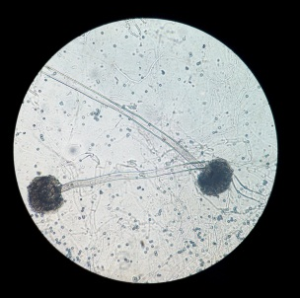 | -konidiofora tegak, sederhana  -konidia berbentuk glubosa  -hifa tak bersepta  Sumber : Barnett & Hunter (1972). | 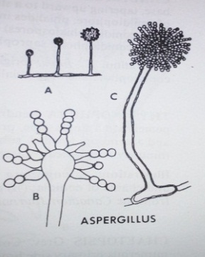  Sumber : Barnett & Hunter (1972). | Aspergillus sp. 1
2 | IL 2 | -hifa tak bersepta  -konidiofora menyokong 1 konidia  - konidia berbentuk bulat  - konidiofoa panjang berbentuk silinder  - vesikula berbentuk glubosa | 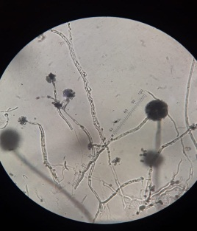 | -hifa tak bersepta  -konidiofora tegak, sederhana  -konidia berbentuk glubosa  Sumber : Barnett & Hunter (1972). | 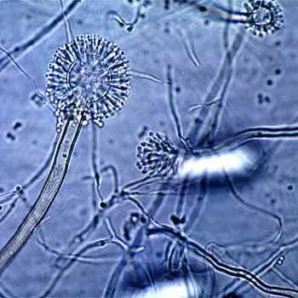  Sumber : Barnett & Hunter (1972). | Aspergillus sp. 2
3 | IL 3 | - hifa bersekat  - vesikula berbentuk glubosa  -miselium tumbuh banyak, bercabang  -konidia berbentuk bulat  -konidiofor tegak |  | -miselium tumbuh cepat, banyak, bercabang  -konidia berbentuk bulat  -konidiofor tegak, bercabang  Sumber : Barnett & Hunter (1972). | 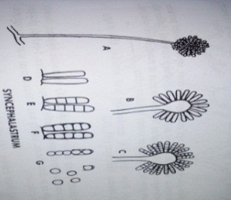  Sumber : Barnett & Hunter (1972). | Syncephalastrum sp.

- Hasil Perhitungan Kerapatan Spora
Perhitungan kerapatan spora dilakukan menggunakan Haemocytometer dan diamati menggunakan mikroskop. Hasil perhitungan dapat dilihat pada tabel 2.
Tabel 2. Kerapatan Spora Aspergillus sp.1
Jenis Isolat | Perlakuan (Pengenceran) | Kerapatan Spora/ml
Aspergillus sp. 1 | Kontrol | 0
 | 10⁰ | 1,806 x 10⁹
 | 10⁻¹ | 1,476x10⁷
 | 10⁻² | 8,56x10⁵
 | 10⁻³ | 2,2x10⁴
 | 10⁻⁴ | 1,06x10³
 | 10⁻⁵ | 460

Isolat 1 (Aspergillus sp. 1) didapatkan hasil perhitungan kerapatan spora yang dapat dilihat pada tabel 2. Kerapatan spora yang paling tinggi adalah pada perlakuan 10 sebesar 1,806 x 10⁹ spora/ml , kemudian pada perlakuan 10⁻¹ sebesar 1,476x10⁷ spora/ml dan kerapatan spora yang paling rendah terletak pada perlakuan 10⁻⁵ yaitu 460 spora/ml.
Tabel 3. Kerapatan Spora Aspergillus sp. 2
Jenis Isolat | Perlakuan  (Pengenceran) | Kerapatan Spora/ml
Aspergillus sp. 2 | Kontrol | 0
 | 10⁰ | 2,354x10⁹
 | 10⁻¹ | 2,2x10⁷
 | 10⁻² | 1,5x10⁶
 | 10⁻³ | 2,6x10⁴
 | 10⁻⁴ | 1,04x10³
 | 10⁻⁵ | 520

Isolat 2 (Aspergillus sp. 2) didapatkan hasil perhitungan kerapatan spora yang dapat dilihat pada tabel 3. Kerapatan spora yang paling tinggi adalah pada perlakuan 10 sebesar 2,354x10⁹ spora/ml, kemudian pada perlakuan 10⁻¹ sebesar 2,2x10⁷ spora/ml dan kerapatan spora yang paling rendah terletak pada perlakuan 10⁻⁵ yaitu 520 spora/ml.
Tabel 4. Kerapatan Spora Syncephalastrum sp.
Jenis Isolat | Perlakuan  (Pengenceran) | Kerapatan Spora/ml
Syncephalastrum sp. | Kontrol | 0
 | 10⁰ | 2 x 10⁸
 | 10⁻¹ | 1,81x10⁷
 | 10⁻² | 1,038x10⁶
 | 10⁻³ | 3,96x10⁴
 | 10⁻⁴ | 2,66x10³
 | 10⁻⁵ | 230

Isolat 3 (Syncephalastrum sp.) didapatkan hasil perhitungan kerapatan spora yang dapat dilihat pada tabel 4. Kerapatan spora yang paling tinggi adalah pada perlakuan 10 sebesar 2 x 10⁸ spora/ml, kemudian pada perlakuan 10⁻¹ sebesar 1,81x10⁷spora/ml dan kerapatan spora yang paling rendah terletak pada perlakuan 10⁻⁵ yaitu 230 spora/ml.
Feron (1981), menyatakan bahwa semakin tinggi kerapatan spora semakin tinggi pula kematian serangga uji. Kepadatan spora yang semakin besar menempel pada tubuh serangga uji, maka semakin besar peluang spora tersebut untuk tumbuh, berkembang, dan merusak serangga sasaran yang selanjutnya dapat mematikan serangga.

- Pengamatan Morfologi dan Perubahan Aktivitas Larva Nyamuk Setelah Infeksi Fungi

Perubahan aktivitas larva setelah perlakuan isolat fungi Aspergillus sp. 1 menunjukkan setelah perlakuan selama 48 jam, terlihat bagian kepala dan tubuh dari larva mengalami kerusakan yang diakibatkan adanya hifa yang masuk dan merusak struktur dan morfologi tubuh larva. Selain itu, warna dari tubuh larva terlihat berubah menjadi kemerahan. Pengamatan 24 jam aktivitas larva mulai mengalami penurunan, sementara itu pada pengamatan 48 jam terlihat larva mulai tidak bergerak ketika disentuh. Sedangkan pada saat pengamatan 72 jam larva mengapung diatas permukaan air. Perubahan morfologi larva nyamuk setelah perlakuan isolat fungi Aspergillus sp. 1 dapat dilihat pada gambar 1.
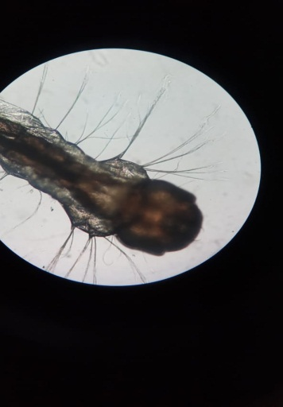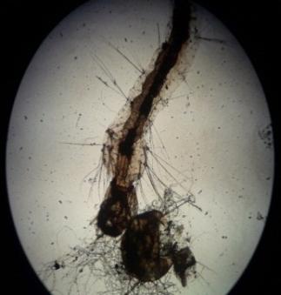
B
A

Gambar 1. Larva Nyamuk Aedes aegypti (A) Normal (B) setelah diberi perlakuan. Tanda panah menunjukkan bagian kepala dan tubuh larva
Hasil pengamatan morfologi setelah infeksi dapat dilihat pada gambar 2. Fungi Aspergillus sp. 2 menunjukkan adanya kerusakan pada tubuh larva uji, kerusakan terjadi setelah pengamatan 72 jam. Larva yang terinfeksi mengalami kerapuhan dan terlihat hifa fungi menembus tubuh larva. Tubuh larva terlihat mengalami pengurangan massa tubuh.
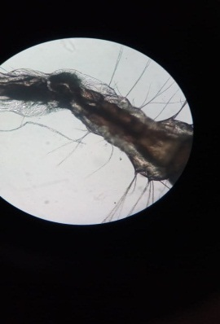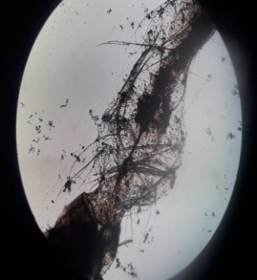
A
B
Gambar 2. Larva Nyamuk Aedes aegypti (A) Normal (B) setelah diberi perlakuan. Tanda panah menunjukkan bagian tubuh larva
Hasil pengamatan morfologi setelah infeksi fungi Syncephalastrum sp. menunjukkan adanya perubahan warna setelah pengamatan 48 jam. Larva yang terinfeksi mengalami perubahan warna dari yang semula lebih gelap menjadi lebih terang. Namun pada 72 jam setelah pengamatan, tidak terjadi perubahan morfologi yang sangat signifikan. Perubahan morfologi larva nyamuk setelah perlakuan isolat fungi Syncephalastrum sp. dapat dilihat pada gambar 3.
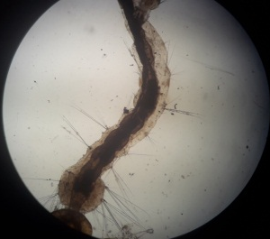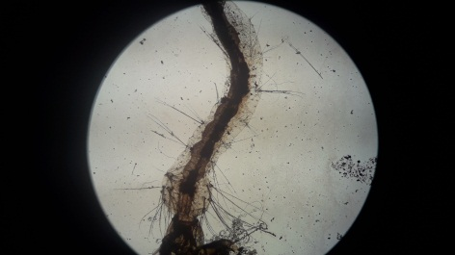
B
A
Gambar 3. Larva Nyamuk Aedes aegypti (A) Normal (B) setelah diberi perlakuan.
Menurut Wahyudi (2002) menyatakan bahwa jamur entomopatogen ini membutuhkan waktu untuk mematikan serangga inangnya, dikarenakan konidia jamur yang menempel pada kutikula harus berkecambah membentuk hifa terlebih dahulu agar dapat menembus kutikula. Kaur et al. (2011) menyatakan bahwa jamur entomopatogen menyebabkan kematian serangga inang dengan menyerap nutrisi dan menyebarkan racun pada hemolymph sehingga dapat mempengaruhi perkembangan dan fisiologis serangga terutama reproduksi. Menurut Freimoser et al. (2003) kutikula serangga yang telah mati akan berubah warna menjadi gelap. Pertumbuhan konidia dalam tubuh larva melalui berbagai tahap seperti inokulasi, invasi, penetrasi dan dekstruksi. Menurut Prayogo (2011) setiap cendawan memiliki patogenitas yang berbeda beda karena toksin yang dimiliki juga berbeda.
- Hasil Analisis Data Kematian Larva Nyamuk Ae. aegypti
Tabel 6. Hasil Analisis Data Kematian Larva Nyamuk Ae. aegypti

Pengenceran | Jenis Fungi
 | Aspergillus sp. 1 | Aspergillus sp. 2 | Syncephalastrum sp.
Kontrol | 0,000 ± 0,000^{d} | 0,000 ± 0,000^{d} | 0,000 ± 0,000^{d}
10⁰ | 3,000 ±1,414ª | 3,000 ± 1,414ª | 0,500 ± 0,707^{cd}
10⁻¹ | 2,500 ± 2,122^{ab} | 2,000 ± 1,414^{abc} | 0,000 ± 0,000^{d}
10⁻² | 1,000± 0,000^{bcd} | 0,500 ± 0,707^{cd} | 0,500 ± 0,707^{cd}
10⁻³ | 0,500 ± 0,707^{cd} | 0,000 ± 0,000^{d} | 0,500 ± 0,707^{cd}
10⁻⁴ | 0,500 ± 0,707^{cd} | 0,000 ± 0,000^{d} | 0,000 ± 0,000^{d}
10⁻⁵ | 0,000 ± 0,000^{d} | 0,000 ± 0,000^{d} | 0,000 ± 0,000^{d}

Keterangan : Angka yang diikuti huruf berbeda pada kolom yang sama menunjukkan beda nyata pada taraf 5 %

Berdasarkan uji ANOVA (Analysis of Varians) menunjukkan bahwa rata-rata kematian larva nyamuk Ae. aegypti yang paling tinggi terdapat pada pengenceran 10⁰, kemudian terdapat perbedaan nyata antara kontrol dengan pengenceran 10⁰ pada Aspergillus sp. 1, sementara itu pada Aspergillus sp. 2 terdapat perbedaan yang signifikan antara kontrol dan pengenceran 10⁰. Perlakuan pada jenis fungi Syncephalastrum sp. dari setiap perlakuan tidak menunjukkan perbedaan nyata.
Dari hasil penelitian yang telah didapat jenis fungi Aspergillus sp.1 dan Aspergillus sp.2 terdapat perbedaan nyata, hal ini menunjukkan bahwa kedua isolat fungi tersebut memiliki kemampuan atau daya bunuh terhadap larva uji. Kemampuan isolat fungi dalam mematikan larva uji karena fungi Aspergillus sp. diketahui dapat menghasilkan senyawa Aspergillin dan memproduksi zat yang dapat menghambat perkembangan fungi patogen (Venkatasubbaiah dan Safeeulla, 1984).

Penelitian Handayani (2015) menunjukkan bahwa fungi Syncephalastrum sp. mempunyai kemampuan yang rendah dalam menghidrolisis selulosa. Fungi ini juga tidak memiliki enzim kitinase, amilase, dan protease sehingga daya bunuh terhadap larva nyamuk uji juga rendah.

KESIMPULAN
Isolat fungi yang memiliki daya bunuh paling besar terhadap larva nyamuk Ae. aegypti adalah isolat fungi Aspergillus sp.1, Aspergillus sp.2, dan Syncephalastrum sp. sehingga dapat dikatakan bahwa isolat fungi yang paling efektif dalam mengendalikan larva nyamuk Ae. aegypti adalah Aspergillus sp.

UCAPAN TERIMAKASIH
Saya mengucapkan terimakasih kepada Program Kreativitas Mahasiswa (PKM Dikti 2018) atas dana hibah penelitian yang telah diberikan.
DAFTAR PUSTAKA
Barnett, H.L., and B.B. Hunter.1998. Illustrated Genera of Imperfect Fungi, 4th Edition. Macmillian Publishing Company, New York.

Depkes RI. 2016. Pencegahan dan Pemberantasan Demam Berdarah Dengue di Indonesia. Depkes RI. Direktorat Jenderal Pengendalian Penyakit dan Penyehatan Lingkungan. Jakarta.
Freimoser, F.M., Jakob, C.A., Aebi, M., dan Tuor., 1999. The MTT [3-(4,5- Dimethylthiazol-2-yl)-2,5-Diphenyltetrazolium Bromide] Assay Is a Fast and Reliable Method for Colorimetric Determination of Fungal Cell Densities. Applied and Environmental Microbiology. 65(8): 3727-3729

Gabriel, B.P., dan Riyanto. 1989. Metarhizium anisopliae Taksonomi, Patologi, Produksi dan Aplikasinya. Proyek Pengembangan Perlindungan Tanaman Perkebunan. Direktorat Perlindungan Tanaman Perkebunan. Departemen Pertanian. Jakarta.

Hadi U.K., Soviana S., dan Gunandini D.D., 2012. Aktivitas Nokturnal Vektor Demam Berdarah Dengue di Beberapa Daerah di Indonesia. Jurnal Entomologi Indonesia. Vol. 9. No. 1: 1-6

Hamid S, Halouane F, Bisaad FZ dan Benzina F. 2013. Study About The Effect of Beauveria bassiana on The Aquatic Stages of Culex pipiens. International Journal of BioTechnology and Research. Vol.3 : 31-42.

Handayani T. dan Purwantisari S. 2015. Isolation and Identification of Mold Contaminants Mushroom Growing Medium (Bag Lag) and Their Cellulolytic Performance Test. Jurnal Sains dan Matematika. Vol. 23.55-58

Kaur SP, Rao R dan Nanda S. 2011. Amoxicillin: a broad spectrum antibiotic. International Journal of Pharmacy and Pharmaceutical Sciences.3(3):30–37

Prayogo, Y. 2011. Sinergisme Cendawan Entomopatogen Lecanicillium lecanii dengan Insektisida Nabati untuk Meningkatkan Efikasi Pengendalian Telur Kepik Coklat Riptortus linearis pada Kedelai. Jurnal HPT Tropika. ISSN 1411-7525. Vol. 11. No. 2 : 166-177.
Ratledge, C. 1994. Biochemistry of Microbial Degradation. Kluwer Academic Publishers, London.

Schuster, E., N. Dunn-Coleman, J. Frisvad, and P. Van Dijck. 2002. On the safety of Aspergillus niger - A review. Appl. Microbiol. Biotechnol. 59: 426-435. http://doi.org/10.1007/s00253-002-1032-6.

Septiana, Eris. 2015. Jamur Entomopatogen: potensi Dan Tantangan Sebagai Insektisida Alami Terhadap Serangga Perusak Tanaman Dan Vektor Penyakit Manusia. Biotrends 1 (1).

Setyowati, E.A. 2013. Biologi Nyamuk Aedes aegypti Sebagai Vektor Demam Berdarah Dengue. Universitas Jenderal Soedirman.

Sudarma IM & DN Suprapta. 2011. Potensi Jamur Antagonis yang Berasal dari Habitat Tanaman Pisang dengan dan tanpa Gejala Layu Fusarium untuk Mengendalikan Fusarium oxysporum f.sp. cubense Secara In Vitro. Skripsi. Fakultas Pertanian Universitas Udayana. Bali.

Venkatasubbaiah, P. & Safeeulla, K. M. 1984. Aspergillus niger for biological control of Rhizoctonia solani on coffee seedling. Trop. Pest Management 30(4) : 401-406.

ISOLATION AND APPLICATION OF ENTOMOPATHOGENIC FUNGI FROM Aedes aegypti L. LARVAE
Wuri Artikasari¹ , Emantis Rosa², Bambang Irawan², Yulianty²
¹ Department of Biology, Faculty of Mathematics and Natural Science
Email: artikawuri58@gmail.com

Abstract

DHF (Dengue Hemorrhagic Fever) is a serious problem in Indonesia. Indonesia is the country with the highest DHF cases in Southeast Asia. Ae. aegypti mosquitoes are one of the main vectors of the spread of the disease. DHF disease control has been done a lot, one of which is the use of larvacida temephos (abate). Larvasida is a chemical insecticide that has a negative impact on human health and causes resistance. Therefore biological control is carried out by utilizing entomopathogenic fungi. The purpose of this study was to determine the effectiveness of entomopathogenic fungi isolated from Ae. aegypti larvae against the death of Ae. aegypti mosquito larvae. This study was conducted at the Microbiology Laboratory, Department of Biology, Faculty of Mathematics and Natural Sciences, University of Lampung, in November 2018. Research this was done in a factorial experiment 2. Factor A is a type of fungi isolate. Factor B is a treatment (dilution) consisting of 10⁰, 10⁻¹, 10⁻², 10⁻³, 10⁻⁴, 10⁻⁵. Each treatment combination was repeated twice so that the number of experimental units was 36. The research variables were the number of mosquito larvae deaths and morphological changes and larvae activity of Ae. aegypti mosquitoes. Data analysis was performed by ANOVA test, if there were significant differences, the LSD (the Smallest Significant Difference) test was done at the 5% level. The results showed that there was an effect of fungi isolates obtained in killing mosquito larvae. that the isolates that have the best killing power against Ae. aegypti mosquito larvae are isolates 2 (Aspergillus sp.), for the treatment of the most effective is 10⁰, while for the most efficient treatment is 10⁻²

Keywords: Dengue Hemorrhagic Fever, Aedes aegypti, Entomopathogenic Fungi, Biological control, Larvasida

INTRODUCTION

Indonesia is listed as the country with the highest DHF cases in Southeast Asia. DHF cases in Indonesia, first discovered in the city of Surabaya in 1968, as many as 58 people were infected and 24 people died. Since then, this disease has spread throughout Indonesia. Until now, drugs and vaccines that can effectively treat dengue disease have not been found (Ministry of Health, 2016). One alternative in controlling Ae. aegypti larvae is the use of biological insecticides such as entomopathogenic fungi.

The purpose of this study was to determine the effectiveness of entomopathogenic fungi isolated from A.aegypti mosquito larvae against the death of A.aegypti mosquito larvae.

Ae. aegypti mosquitoes have the habit of biting several people in a short period of time (Multiple bitters), so that it has the potential to transmit the virus to several people in a short time (Sulistyorini, 2016). This disease transmitted by Ae. aegypti mosquitoes has not yet found a cure / vaccine. One way to prevent it is to break the chain of transmission by eradicating the vector (Hadi, 2012).

Biological control is a control that utilizes natural enemies as biological agents. Biological control is a promising one, because biological control will have a positive impact on ecological factors, especially regarding population regulation by natural control and ecosystem balance (Hamid et al. 2017).

Entomopathogenic fungi are fungi that cause disease or infection in target insects. Entomopathogenic fungi have specific properties in attacking certain targets with side effects and a very low risk of non-target organisms or beneficial insects. With such characteristics, the use of entomopathogenic fungi as natural enemies in efforts to eradicate pests has a more positive impact than the use of synthetic insecticides (Eris, 2015).

METHOD

The variables in this study were the number of larvae deaths and morphological changes and larvae activity of Ae. aegypti mosquitoes.

This research was carried out using an experimental method using a Completely Randomized Design (CRD) with a factorial pattern. Factor A is a type of fungi isolate isolated from Ae. aegypti larvae. Factor B is treatment (dilution) which consists of controls, 10⁰, 10-1, 10-2, 10-3, 10-4, 10-5. Each treatment combination is repeated twice so that the number of experimental units is 36.

The entomopathogenic fungus is carried out using the moist chamber method by utilizing Ae. aegypti mosquito larvae which are placed in a petri dish container which has been given a layer of moist cotton. Then left for 1-2 weeks at room temperature until the mosquito larvae have fungi.

Entomopathogenic fungi originating from culture are then purified in Potato Dextrose Agar (PDA) media until they are 14 days old. The results of the purified fungi for 14 days were then harvested spores by pouring 1 mL of water on the media, then the spores in screap (scraped) using tweezers, then put in a container containing 9 mL aquadest, and serial dilution from 100, 10-1, 10-2.10-3.10-4 and 10-5 per mL. The results of the fungus dilution were then calculated for spore density with a haemocytometer and observed with a microscope. The density of spores is calculated using the formula formula (Gabriel and Riyanto, 1989)

$$S=\frac{t.d}{(n x 0,25)}$$
The spores of the identified fungi were then suspended into aquades with concentrations of 10⁰, 10⁻¹, 10⁻², 10⁻³,10⁻⁴ and 10⁻⁵ per mL following Yasmin (2010). Stage 3 larvae were placed on trays with 10 larvae in each tray. Then from the concentration of dilution fungi were invested in the larval media by soaking (150 ml). The mosquito larvae were left for a while and observed the number of larvae that had died. Observations are made after 24 hours. The number of dead mosquito larvae is recorded on day 1 to day 3 after treatment.

Observations carried out include changes in activity and morphology of mosquito larvae after treatment with entomopathogenic fungi. Then the data obtained is further analyzed.

RESULT AND DISCUSSION

1. Acquisition of Entomopathogenic Fungi
Based on the results of isolation that has been done, five fungi isolates were obtained, then three dominant isolates were selected and can be seen in table 1.

Table 1. Fungi Isolates obtained from Isolation of Ae. aegypti Mosquito Larvae

No | Isolate Code | Observation Result |  | Literature |  | Name of isolate
 |  | Description | Image | Description | Image
1 | IL 1 | - conidia is round  - hyphae without septa |  | -Conidiofora upright, simple  - hyphae without septa | 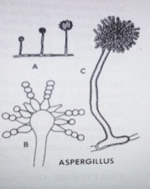 | Aspergillus sp. 1
2 | IL 2 | - hyphae without septa  -konidiofora supports 1 conidia |  | - hyphae without septa  -Conidiofora upright, simple | 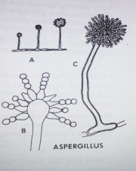 | Aspergillus sp. 2
3 | IL 3 | -hyphae have septa  - Mycelium grows a lot, branching out |  | - Mycelium grows fast, many, branching  -conidia is round  -conidiophore upright, branched | 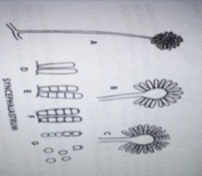 | Syncephalastrum sp.

2. Results of Calculation of Spore Density

Calculation of spore density was carried out using Haemocytometer and observed using a microscope. The calculation results can be seen in table 2.

Table 2. Density of Aspergillus sp.1 Spores

Type of Isolate | Treatment  (Dilution) | Density of Spores / ml
Aspergillus sp. 1 | Control | 0
 | 10⁰ | 1,806 x 10⁹
 | 10⁻¹ | 1,476x10⁷
 | 10⁻² | 8,56x10⁵
 | 10⁻³ | 2,2x10⁴
 | 10⁻⁴ | 1,06x10³
 | 10⁻⁵ | 460

Isolate 1 (Aspergillus sp. 1) obtained the calculation of spore density which can be seen in table 2. The highest spore density was in treatment 10 of 1.806 x 109 spores / ml, then in treatment 10-1 was 1.476x107 spores / ml and the lowest spore density was in the 10-5 treatment of 460 spores / ml.

Table 3. Density of spores of Aspergillus sp. 2

Type of Isolate | Treatment  (Dilution) | Density of Spores / ml
Aspergillus sp. 2 | Control | 0
 | 10⁰ | 2,354x10⁹
 | 10⁻¹ | 2,2x10⁷
 | 10⁻² | 1,5x10⁶
 | 10⁻³ | 2,6x10⁴
 | 10⁻⁴ | 1,04x10³
 | 10⁻⁵ | 520

Isolate 2 (Aspergillus sp. 2) obtained the calculation of spore density which can be seen in table 3. The highest spore density was in treatment 10 of 2.354x109 spores / ml, then in treatment 10-1 was 2.2x107 spores / ml and the lowest spore density is in the treatment of 10-5 ie 520 spores / ml.

Table 4. Density of Spores of Syncephalastrum sp.

Type of Isolate | Treatment  (Dilution) | Density of Spores / ml
Syncephalastrum sp. | Control | 0
 | 10⁰ | 2 x 10⁸
 | 10⁻¹ | 1,81x10⁷
 | 10⁻² | 1,038x10⁶
 | 10⁻³ | 3,96x10⁴
 | 10⁻⁴ | 2,66x10³
 | 10⁻⁵ | 230

Isolate 3 (Syncephalastrum sp.) Obtained the results of the calculation of spore density which can be seen in table 4. The highest spore density was at treatment 10 of 2 x 108 spores / ml, then in treatment 10-1 was 1.81 x 107 export / ml and density the lowest spores were in the 10-5 treatment of 230 spores / ml.

Feron (1981) stated that the higher the spore density the higher the death of the test insect. The greater the density of the spores attached to the body of the test insect, the greater the chance of these spores to grow, develop, and damage the target insects which can then kill the insects.

3. Morphological Observations and Changes in Mosquito Larvae Activity After Fungi Infection

Changes in larval activity after treatment of Aspergillus sp. Larvae at the time of observation 72 hours the larvae floated above the water surface. Changes in mosquito larvae morphology after the treatment of Aspergillus sp. Fungi isolates. 1 can be seen in figure 1.
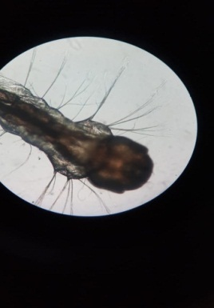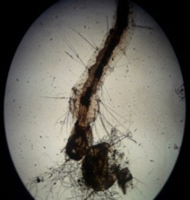
A
B

Figure 1. Aedes aegypti (A) Normal (B) Mosquito Larvae after being treated. Arrows indicate the head and body of the larvae
Morphological observations after infection can be seen in Figure 2. Fungi Aspergillus sp. 2 showed damage to the body of the test larvae, damage occurred after 72 hours of observation. The infected larvae are fragile and visible fungal hyphae penetrate the larval body. The body of the larva is seen to experience a reduction in body mass.

A
B
Figure 2. Aedes aegypti (A) Normal (B) Mosquito Larvae after being treated. Arrows indicate the body parts of the larvae

Morphological observations after infection with Syncephalastrum sp. indicates a change in color after 48 hours of observation. Infected larvae change color from darker to lighter. But at 72 hours after observation, there was no significant morphological change.

B
A
Figure 3. Aedes aegypti (A) Normal (B) Mosquito Larvae after being treated.

From the results of observations that have been done, it indicates that the entomopathogenic fungus requires time to infect and kill the larvae, because the conidia fungus that attaches to the larvae cuticle germinates to form hyphae to penetrate the cuticle. According to Wahyudi (2002) states that this entomopathogenic fungus requires time to turn off its host insect, because the fungus conidia attached to the cuticle must germinate to form hyphae in order to penetrate the cuticle.

4. Fungi Isolate Test Results Against Mosquito Larvae

The test results of each different isolate in the same dilution can be seen in the following figure.

Figure 4. The average yield of mortality of mosquito larvae to the treatment of isolates 1,2 and 3 in dilution 10⁰.

Figure 5. Average results of Mosquito Larva Death Amounts against Treatment of Isolates 1,2 and 3 at 10⁻¹ dilutions

Figure 6. The average yield of mortality of mosquito larvae against the treatment of isolates 1,2 and 3 at 10⁻² dilutions

Figure 7. The results of the number of mosquito larvae deaths against the treatment of isolates 1,2 and 3 at 10⁻³ dilutions

Figure 8. The average yield of mortality of mosquito larvae against the treatment of 1,2 and 3 isolates at 10⁻⁴ dilutions

The average mortality of mosquito larvae to the treatment of Isolates 1, 2, and 3 at 10-4 dilutions can be seen in Figure 8. The highest average number of deaths was in isolates 1 (Aspergillus sp.). While for isolates 2 (Aspergillus sp.2) and 3 (Syncephalastrum sp.) Did not show any larval death.
5. Results of Data Analysis of Ae. aegypti Larva Death
Table 6. Results of Data Analysis of Ae. aegypti Larva Death
Pengenceran | Jenis Fungi
 | Aspergillus sp. 1 | Aspergillus sp. 2 | Syncephalastrum sp.
Kontrol | 0,000 ± 0,000^{d} | 0,000 ± 0,000^{d} | 0,000 ± 0,000^{d}
10⁰ | 3,000 ±1,414ª | 3,000 ± 1,414ª | 0,500 ± 0,707^{cd}
10⁻¹ | 2,500 ± 2,122^{ab} | 2,000 ± 1,414^{abc} | 0,000 ± 0,000^{d}
10⁻² | 1,000± 0,000^{bcd} | 0,500 ± 0,707^{cd} | 0,500 ± 0,707^{cd}
10⁻³ | 0,500 ± 0,707^{cd} | 0,000 ± 0,000^{d} | 0,500 ± 0,707^{cd}
10⁻⁴ | 0,500 ± 0,707^{cd} | 0,000 ± 0,000^{d} | 0,000 ± 0,000^{d}
10⁻⁵ | 0,000 ± 0,000^{d} | 0,000 ± 0,000^{d} | 0,000 ± 0,000^{d}

Note: Numbers followed by different letters in the same column show a significant difference at the level of 5%
Based on the ANOVA (Analysis of Variance) test, the highest mortality of
Ae. aegypti mosquito larvae was found in 10⁰ dilutions, then there was a significant difference between the control and 10⁰ dilutions in Aspergillus sp. 1, meanwhile in Aspergillus sp. 2 there is a significant difference between control and dilution 10⁰. Treatment of the type of fungi Syncephalastrum sp. from each treatment did not show significant differences.

From the results of the research that has been found that Aspergillus sp.1 and Aspergillus sp.2 fungi have significant differences, this indicates that the two fungi isolates have the ability or ability to kill the test larvae. The ability of fungi isolates to kill test larvae because of Aspergillus sp. known to produce Aspergillin compounds and produce substances that can inhibit the development of pathogenic fungi (Venkatasubbaiah and Safeeulla, 1984).Handayani's study (2015) showed that the Syncephalastrum sp. has a low ability to hydrolyze cellulose. This fungi also has no chitinase, amylase and protease enzymes so the killing power of the test mosquito larvae is also low.
CONCLUSION
The isolate that has the best killing power against Ae. aegypti mosquito larvae is isolate 2 (Aspergillus sp.), For the treatment of the most effective is 10⁰.
ACKNOWLEDGE
I thanks to the student activity program (PKM DIKTI 2018) for research grant.
REFERENCES
Barnett, H.L., and B.B. Hunter.1998. Illustrated Genera of Imperfect Fungi, 4th Edition. Macmillian Publishing Company, New York.

Depkes RI. 2016. Pencegahan dan Pemberantasan Demam Berdarah Dengue di Indonesia. Depkes RI. Direktorat Jenderal Pengendalian Penyakit dan Penyehatan Lingkungan. Jakarta.
Freimoser, F.M., Jakob, C.A., Aebi, M., dan Tuor., 1999, The MTT [3-(4,5- Dimethylthiazol-2-yl)-2,5-Diphenyltetrazolium Bromide] Assay Is a Fast and Reliable Method for Colorimetric Determination of Fungal Cell Densities, Applied and Environmental Microbiology, 65(8): 3727-3729

Gabriel, B.P. and Riyanto. 1989. Metarhizium anisopliae Taksonomi, Patologi, Produksi dan Aplikasinya. Proyek Pengembangan Perlindungan Tanaman Perkebunan. Direktorat Perlindungan Tanaman Perkebunan. Departemen Pertanian. Jakarta.

.Gubler, J.D. 2014. Dengue and Dengue Hemmorhagic Fever. Second Edition. USA. CPI Group Ltd, Croydon.

Hadi U.K., Soviana S., Gunandini D.D., 2012. Aktivitas Nokturnal Vektor Demam Berdarah Dengue di Beberapa Daerah di Indonesia. Jurnal Entomologi Indonesia. Vol. 9. No. 1: 1-6

Hamid S, Halouane F, Bissaad FZ, and Benzina F. 2013. Study About The Effect of Bauverria bassiana ( Vuillemin in 1992) On The Aquatic Stages Of Culex pipiens (Linneaus, 1758). 3 (3): 31-42

Handayani T. and Purwantisari S. 2015. Isolation and Identification of Mold Contaminants Mushroom Growing Medium (Bag Lag) and Their Cellulolytic Performance Test. Jurnal Sains dan Matematika. Vol. 23.55-58

Kaur SP, Rao R and Nanda S. 2011. Amoxicillin: a broad spectrum antibiotic. International Journal of Pharmacy and Pharmaceutical Sciences.3(3):30–37

Prayogo, Y. 2011. Sinergisme Cendawan Entomopatogen Lecanicillium lecanii dengan Insektisida Nabati untuk Meningkatkan Efikasi Pengendalian Telur Kepik Coklat Riptortus linearis pada Kedelai. Jurnal HPT Tropika. ISSN 1411-7525. Vol. 11. No. 2 : 166-177.
Ratledge, C. 1994. Biochemistry of Microbial Degradation. Kluwer Academic Publishers, London.

Schuster, E., N. Dunn-Coleman, J. Frisvad, and P. Van Dijck. 2002. On the safety of Aspergillus niger - A review. Appl. Microbiol. Biotechnol. 59: 426-435.

Septiana, Eris. 2015. Jamur Entomopatogen: potensi Dan Tantangan Sebagai Insektisida Alami Terhadap Serangga Perusak Tanaman Dan Vektor Penyakit Manusia. Biotrends 1 (1).

Setyowati, E.A. 2013. Biologi Nyamuk Aedes aegypti Sebagai Vektor Demam Berdarah Dengue. Universitas Jenderal Soedirman.

Sudarma IM and DN Suprapta. 2011. Potensi Jamur Antagonis yang Berasal dari Habitat Tanaman Pisang dengan dan tanpa Gejala Layu Fusarium untuk Mengendalikan Fusarium oxysporum f.sp. cubense Secara In Vitro. Skripsi. Fakultas Pertanian Universitas Udayana. Bali.

Venkatasubbaiah, P. and Safeeulla, K. M. 1984. Aspergillus niger for biological control of Rhizoctonia solani on coffee seedling. Trop. Pest Management 30(4) : 401-406.

