Designing an Inquiry-based STEM Learning strategy as a Powerful Alternative Solution to Enhance Students’ 21st Century Skills: A Preliminary Research
Abdurrahman¹, Farida Ariyani², Arwin Achmad³, and Novinta Nurulsari⁴
^{1,4}Physics Education Department of Lampung University
²Language Education Department of Lampung University
³Biology Education Department of Lampung University
Jl. Sumantri Brojonegoro No. 01 Gedong Meneng, Rajabasa Kota Bandar Lampung, 35141, INDONESIA

E-mail: ¹ abdurrahman.1968@fkip.unila.ac.id, ²dulifarida@gmail.com, ³arwin.achmad@fkip.unila.ac.id, ⁴novinta.nurulsari@fkip.unila.ac.id
Abstract. In response to pedagogical challenges in 21st century education, embedded STEM across the primary-secondary school transition had been widely investigated. However, integrated-STEM implementation had not shown practical packaging and could not reach all the skills needed in the 21st century. We proposed an inquiry-based STEM learning strategy to fostering student inquiry skills through investigation. The purpose of this study was to design a hypothetical model of an inquiry-basedSTEM learning strategy design that could systematically guide instructors or designers in creating an appropriate learning activities oriented to 21st century skills. Before conducting the strategy design, we do need assessment survey teacher in Lampung Indonesia to describe teachers’ perceptions about STEM education and career as a starting point for designing a strategy that could follow up the 21st century learning framework. We conduct a cross-sectional non-experimental descriptive survey approach using quetionnaire to 75 teachers in Lampung, Indonesia. Based on data analysis, it indicated that all of the teachers realized about the importance of STEM in education and career dimension and they should take a part in overcoming the 21st century challenging.
- Introduction

Students need “21st-century skills” to be successful today. All studets had been already called to learn 21st century skill. In response, hundreds of solutions had been suggested, especially optimization in curriculum studies of the education field. However, there was no single set of methods and approach that could explore a whole of “21st-Century Skills”. Lack of clarity about the nature of 21st century skill could be a reason of that problem [1]. Many lists include life skills, workforce skills, applied skills, personal skills (curiosity, imagination, critical thinking, and problem solving), interpersonal skills (cooperation and teamwork), and noncognitive skills required 21st century-learning [2]. Regardless of the skills included or the terms used to describe them, all 21st-century skills defi nitions are relevant to aspects of contemporary life in a complex world. Most focus on similar types of complex thinking, learning, and communication skills, and all are more demanding to teach and learn than rote skills.These abilities are alsocommonly referred to as higher-order thinking skills, deeper learning outcomes, and complex thinking and communication skills.
The broad call for “deeper learning” and “21st century skills” reflects a long-standing issue in education and training – the difficult task of equipping individuals with transferable knowledge and skills. Associated with this is the challenge of creating learning environments that support development of the cognitive, interpersonal and intrapersonal competencies that enable learners to transfer what they have learned to new situations and new problems. These competencies include both knowledge in a domain and the understanding of how, why and when to apply this knowledge to answer more complex questions and solve problems [3].

Enggaging STEM across the primary-secondary school transition had been widely investigated to overcome the 21st century challenging through problem solving processes of real world situations . Problems related to real world context can be overcome with design-based solutions [4]. Student learning, their lives, and the global economy could be developed through STEM education [5]. Improving performance in science and mathematics [6], increasing STEM literacy [7], and improving technological literacy [8] were objectives of STEM education. Students' motivation to learn and enhance specific discipline content learning could be improved by the integration of STEM dimensions in the classroom [9]. The integrated STEM approach was an effort to combine science, technology, engineering, and mathematics into a class based on the relationship between learning material and real-world problems. However, in general, integrated STEM education can involve many classes and teachers and does not necessarily involve all four STEM disciplines. So, in each phase of learning, it can contain one or more STEM disciplines or even the entire STEM discipline. Technical discipline could provide students with great problem-solving opportunities to learn about mathematics, science, and technology while working through the engineering design process [10]. STEM was inherently interdisciplinary [11]. Addressing the integration of 21st century skills and content through science, technology, engineering, and mathematics (STEM) education was a best venue to be implemented . If STEM was seen as a potential practical solution for the development of the quality of future learning especially in 21st century era, then the effort to combine STEM-based strategies into the learning process needs to be considered.

- Method
The design of this study was a cross-sectional non-experimental descriptive survey approach using quetionnaire. To provide a “theme” for the questionnaire, a familiar STEM dimension of general interest to most potential respondents was required. We used web-based surveys [12] with a multidimensional scale [22] to desribe teacher and practitioner perceptions about STEM education and careers dimension [13][14][15][16]. The survey instrument consisted of 22 statements with the type of response that were strongly agree, agree, disagree, and disagree. The survey respondents were 75 professional teachers in Lampung, Indonesia with S-1 and S-2 educational backgrounds from different science disciplines.

- Result and Discussion
As we are all aware the 21st century learner was a self directed learner, globally aware, a communicator, an innovator, financially and economically literate, civically engaged, a problem solver, a collaborator, information and media literate and a critical thinker. That was a lot that the learner of today needs to achieve. To create such learners we need to take the teaching and learning above and beyond the basics of knowledge. It challenges us to take a part in this problem by giving an alternative powerful solution in education field by designing Inquiry-Based STEM Learning Strategy. But, before validating and conducting this model, we made a survey analysis about teacher’s perception of STEM in terms of education and career dimension.

  - Teacher’s perception of STEM Education and Career
The development of inquiry-based STEM learning strategy began with an analysis of the results of a survey of teachers 'and practitioners' perceptions of STEM education and STEM career to investigate views and describe the the urgency of STEM-based inquiry learning. The questionnaire used included favorable and unfavorable items [17]. The survey results were analyzed by making a percentage of responses from each item submitted. Respondents' answers were then classified into the types of positive and negative responses. The survey results were analyzed by making a percentage of responses from each item submitted. The percentage of respondents' answers was then classified into the types of positive and negative responses. The positive responses percentage of favorable items were identified from the percentage of agree and strongly agree responses. Meanwhile, the negative responses percentage of favorable items were identified from the percentage of disagree and strongly disagree responses. Based on the survey results, it can be indicated teachers have a good perception of STEM education and careers, because the average percentage of respondents' responses on some favorable items were more than 50%.

Positive responses = 96.10% ; negative responses = 3.90%
Figure 1. Teacher awareness that STEM was an important field
Based on figure 1, the teacher already had a good awareness that STEM Education had an important role in modern education. Based on authors’ records during the survey, according to most teachers, national education should be based on STEM [18]. This concept was expected to improve national excellence and competitiveness [19]. According to them, STEM approach was important because it would discipline thinking patterns to be logical, structured, and planned [20]. STEM-based education processes potentially coul create different generations. Students would appreciate the process, not easy to take shortcuts, and want to work hard. Teachers stated that they were really enjoy working in STEM field like in figure 2.
Positive responses = 93.50% ; negative responses = 6.50%
Figure 2. Teacher satisfaction working in the STEM field
Figure 2 described that most of teachers were satisfied working in the STEM field which was shown by high percentage. It means that the teachers liked their work oriented at STEM. That is, if the teacher feels happy and enjoy, the teacher would find it easier to develop and implement STEM content in the learning process [21].

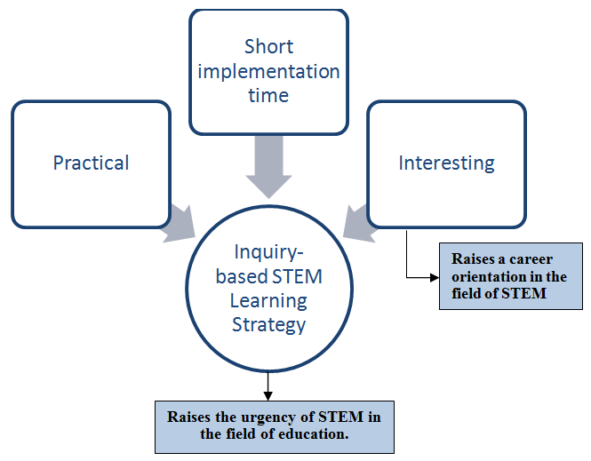
Figure 3. Description of inquiry-based STEM learning strategy which should be compiled based on survey data

In this case, the researcher saw the excellent potential on the application of STEM, because the teacher's perception leads to the conclusion that STEM must be applied and developed in the dimensions of education and career. However, it still seems that there were some respondents' perceptions that lead to negative responses, respondents assumed that STEM education did not need to be applied because of minimal urgency, wasting time in its application, and disinterest.It turned out that negative responses related to the education dimension also appeared in the careers dimension. The respondent's perception leads to a perception that STEM had no potential to serve as a career orientation. Based on these two contradictory results, the researcher tries to draw a red thread from some of the findings that appear that researchers must develop a model of STEM implementation in the field of education that is practical and contains the urgency of STEM in its application (see figure 3).
  - The hypothetical model of alternative solution
The hypothetical model of inquiry-based STEM learning strategy was design from the synthesis of inquiry learning approach and STEM learning strategy. Design suggestion from survey results and literature study were embedded in the design and development step. Design step refered to determining learning approach, designing strategy framework, and mapping sequential srategy based on theoretical rationality. Theoretical rationality through literature study was conducted to obtain sequential mapping of learning activities derivatives that still refer to the empirical results of survey data. Finally we proposed an alternative strategy namely GUIDANCE (Generating motivation and interest in science, Upraising curiosity, In depth Discussion, Analyzing, arraNging, and Constructing idEas) like in figure 4.

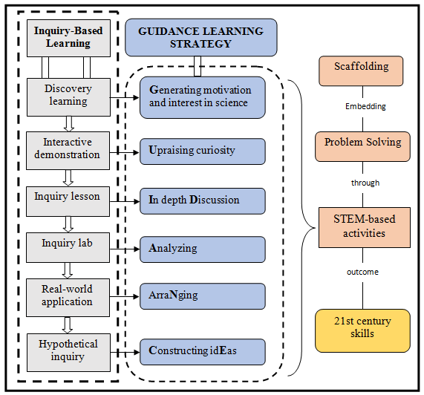
Figure 4. The hypothetical model of inquiry-based STEM learning strategy

- Conclusion

Based on the results and discussions, it could be concluded that all of the teachers realize the urgency of STEM disciplines implementation in education. The hypothetical model of inquiry-based STEM learning strategy “GUIDANCE” (Generating motivation and interest in science, Upraising curiosity, In depth Discussion, Analyzing, arraNging, and Constructing idEas) could be a powerful alternative solution to serve all the skills needed in the 21st century. The hypothetical model proposed should be implemented in the future research.

Reference
[1] Dede C 2010 Comparing frameworks for 21st century skills. 21st century skills: Rethinking how students learn, 20, 51-76.
[2] Saavedra A R and Opfer V D 2012 Phi Delta Kappan 94 2
[3] Pellegrino J W 2017 Teaching, learning and assessing 21st century skills. Pedagogical knowledge and the changing nature of the teaching profession (OECD)
[4] Williams J 2011 Design and Technology Education: An International Journal16 1
[5] Roberts A dan Cantu D 2012 PATT 26 Conference; Technology Education in the 21st Century; Stockholm; Sweden; 26-30 June; 2012 (No. 073, pp. 111-118). Linköping University Electronic Press
[6] Norton S 2008International Journal ofTechnology and Design Education18 1
[7] DeCoito Iand Richardson T 2016 Using Technology to Enhance Science Literacy, Mathematics Literacy, or Technology Literacy: Focusing on Integrated STEM Concepts in a Digital Game. In Improving K-12 STEM Education Outcomes through Technological Integration (IGI Global)
[8] Rogers G 2005Journal ofIndustrial Teacher Education413
[9] Riskowski J L, Todd C D, Wee B, Dark M, and Harbor J 2009 International journal of engineering education 251
[10] Stohlmann M, Moore T J, and Roehrig G H 2012 Journal of Pre-College Engineering Education Research (J-PEER) 21
[11] Asghar A, Ellington R, Rice E, Johnson F, and Prime, G M 2012Interdisciplinary Journal of Problem-Based Learning 6 2
[12] Sills S J and Song C 2002 Social Science Computer Review201
[13] Norman K W, Moore T J, and Kern A L 2010 Montana Mathematics Enthusiast7
[14] Little A J and de la Barra B A L 2009 European Journalof Engineering Education34
[15] Cole D and Espinoza A 2008Journal of College Student Development49
[16] Rose M A 2007 Journal of TechnologyEducation19
[17] Peysakhovich A and Karmarkar U R 2015 Management Science 62 8
[18] Minichiello A, Hood J R, and Harkness D S 2018 Journal for STEM Education Research, 1-27.
[19] Chiu A, Price C A, and Ovrahim E 2015 NARST 2015 Annual Conference.
[20] Henriksen D 2014 The STEAM journal 1 2
[21] Nuangchalerm P 2018 Education 27 2

