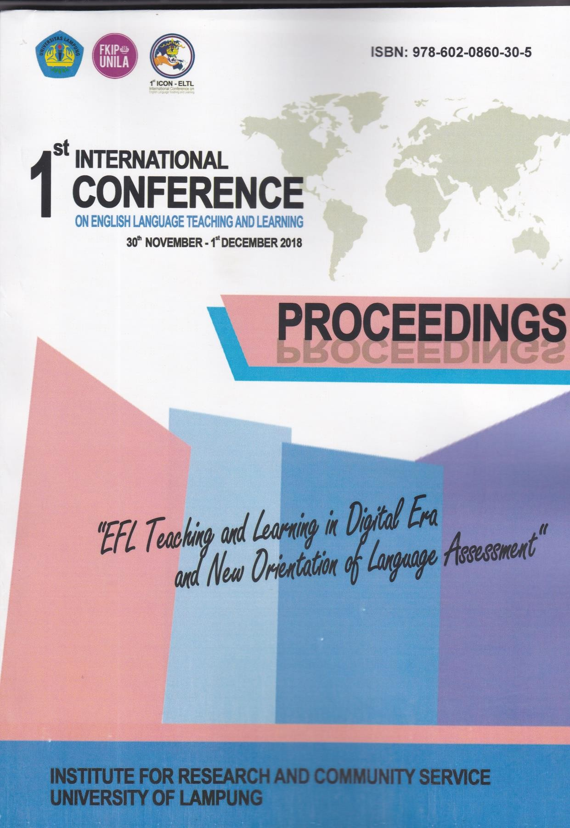

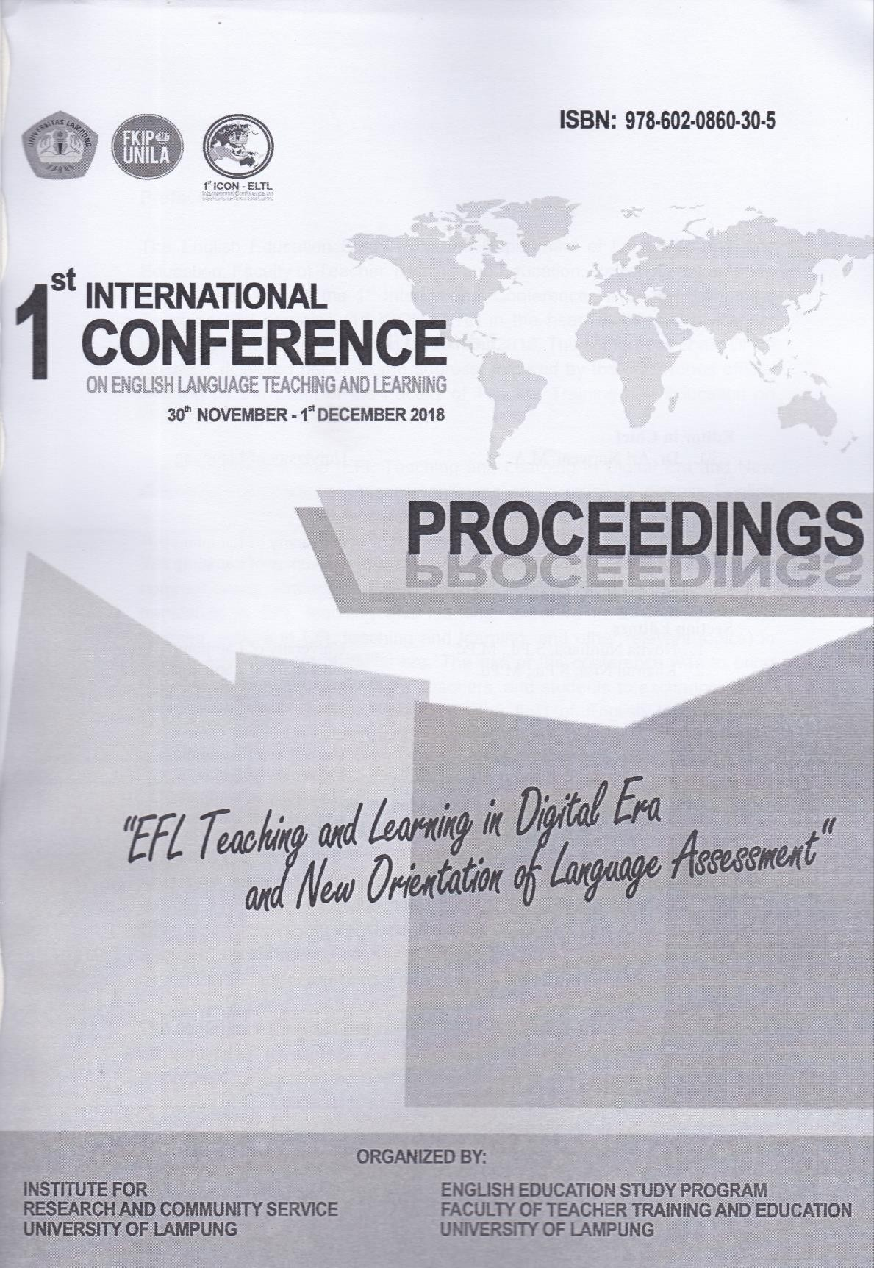

Editorial Team

Editor in Chief
1. Dr. Ari Nurweni, M.A. University of Lampung

Editors
- Gede Eka Putrawan, S.S., M.Hum. University of Lampung
- Rafista Deviyanti, S.Pd., M.Pd. University of Lampung

Section Editors
- Novita Nurdiana, S.Pd., M.Pd. University of Lampung
- Khairun Nisa, S.Pd., M.Pd. University of Lampung

Reviewers
- Prof. Dr. Patuan Raja, M.Pd. University of Lampung
- Prof. Dr. Ag. Bambang Setiyadi, M.A. University of Lampung
- Prof. Dr. Cucu Sutarsyah, M.A. University of Lampung
- Mahpul, PhD. University of Lampung

Preface

The English Education Study Program, Department of Language and Arts Education, Faculty of Teacher Training and Education, University of Lampung was honored to host the 1st International Conference on English Language Teaching and Learning (1st ICON-ELTL) in the heart of the city of Bandar Lampung from 30 November – 1 December 2018. The conference chair, Dr Ari Nurweni, delivered her welcome address, followed by the conference official opening by the Dean of the Faculty of Teacher Training and Education on Friday morning 30 November 2018.

The conference theme “EFL Teaching and Learning in Digital Era and New Orientation of Language Assessment” was an invitation to discuss English language teaching and learning-related issues (including blended learning, communicative competence in EFL context, ICT in EFL teaching and learning, TBLT, English curriculum and material development, teaching methodology, communication strategies of EFL learners, learning style, learning strategy, translation in EFL teaching and learning, literature in EFL teaching and learning, culture in EFL teaching and learning, and other relevant topics) in today’s advancement of digital era. The aim of the conference was to bring together academics, researchers, teachers, and students to exchange ideas, experiences, and research findings in the field of English language and assessment to make better, more efficient and impactful teaching and learning.

The conference was attended by 162 participants and 31 presenters from all over Indonesia. Two invited keynote papers were delivered on the first day of the conference, the first was presented by Eric L. Campbell (Director of CONNECT, USA) in the morning and the second was presented by Dr Vahid Aryadoust (National Institute of Education, Singapore) in the afternoon. On the second day, other two invited keynote papers were also presented by Prof. John Read (University of Auckland, New Zealand) and Prof. Patuan Raja (University of Lampung, Indonesia). In addition, 31 papers were also presented by registered presenters in the parallel sessions of the conference.

The conference program represents the efforts of many individuals. Therefore, we would like to express our gratitude to the members of the organizing committee for putting much effort into ensuring the success of day-to-day operation of the conference and the reviewers for their hard work in reviewing submissions. We also thank the four invited keynote speakers for sharing their

insights with us. Finally, the conference would not be possible without the excellent papers contributed by authors. We thank all authors for their contributions and participation in the 1st ICON-ELTL 2018.

We hope that this conference will further stimulate research on English language teaching and learning in today’s advancement of digital era and provide academics, researchers, teachers, and students with better understanding, knowledge, and ideas for further research. We feel honored to serve the best recent scientific knowledge and development in the field of English language teaching and learning. In addition, we also hope that these proceedings will furnish scholars from all over the world with an excellent reference book.

Realizing that there were still some weaknesses during the conference, we do have an apology to make to everyone and we hope we will be able to hold better international conferences in the future. Finally, it was with great pleasure that we had the opportunity to host such a conference. Thank you.

Ari Nurweni
Conference Chair
Gede Eka Putrawan
Conference Co-Chair

CONFERENCE SCHEDULE AT-A-GLANCE
THE 1ST INTERNATIONAL CONFERENCE ON ENGLISH LANGUAGE TEACHING AND LEARNING UNIVERSITY OF LAMPUNG
Fri – Sat, 30 November – 1 December 2018, Bandar Lampung, Indonesia

Time | Activity | Speaker/PIC | Location
Friday, 30 November 2018
08.00 – 08.50 | Conference Registration | Dr. Feni Munifatullah, M.Hum. | Lobby, Hall K, 2nd Floor
09.00 – 09.05 | Opening | MC | Hall K, 2nd Floor
09.05 – 09.15 | National anthem of Indonesia | Amiswari and PSPBI Choir
09.15 – 09.25 | Welcome dance | PSPBI Dancers
09.25 – 09.35 | Chair’s report | Dr. Ari Nurweni, M.A.
09.35 – 09.50 | Welcome remarks from Rector of the University of Lampung and  opening | Prof. Dr. Ir. Hasriadi Mat Akin, M.P.
09.50 – 10.00 | Prayers | Hendi Nur Pratama
10.00 – 10.30 | Coffee and refreshment break | Khairun Nisa, S.Pd., M.Pd.
10.30 – 11.30 | Keynote Speaker 1: Eric L. Campbell  The LESYNSO Three-Dimensional Model  for Spoken Language Assessment | PIC: Dr. Flora, M.Pd.
11.30 – 13.00 | Networking luncheon | Khairun Nisa, S.Pd., M.Pd. | Hall K, 2nd Floor
13.00 – 15.00 | Parallel Sessions | Moderators | K1-5, 1st Floor
15.00 – 15.30 | Coffee and refreshment break | Khairun Nisa, S.Pd., M.Pd. | Hall K, 2nd Floor
15.30 – 16.30 | Keynote Speaker 2: Dr Vahid Aryadoust  Language Assessment Research by Employing Neuro-imaging and Eye-  tracking Method | PIC: Prof. Bambang Setiyadi, M.A. | Hall K, 2nd Floor
Saturday, 1 December 2018
08.15 – 09.15 | Keynote Speaker 3: Prof. John Read  Vocabulary Assessment in the Digital  Era | PIC: Hery Yufrizal, PhD | Hall K, 2nd Floor
09.15 – 09.45 | Coffee and refreshment break | Khairun Nisa, S.Pd., M.Pd. | Hall K, 2nd Floor
09.45 – 10. 45 | Parallel Sessions | Moderators | K1-5, 1st Floor
10.45 – 11.45 | Keynote Speaker 4: Prof. Dr. Patuan Raja  Writing Assessment | PIC: Mahpul, PhD | Hall K, 2nd Floor
11.45 – 12.00 | Wrapping Up and Closing | Dean of Teacher Training and Education Faculty,  Prof. Dr. Patuan Raja, M.Pd. | Hall K, 2nd Floor
12.00 – 13.00 | Networking luncheon | Khairun Nisa, S.Pd., M.Pd. | Hall K, 2nd  Floor

CONFERENCE SCHEDULE
THE 1ST INTERNATIONAL CONFERENCE ON
ENGLISH LANGUAGE TEACHING AND LEARNING (1st ICON-ELTL 2018) UNIVERSITY OF LAMPUNG
Fri – Sat, 30 November – 1 December 2018, Bandar Lampung, Indonesia

No. | Time | Activity | Speaker/PIC | Location
 | Friday, 30 November 2018
1 | 08.00 – 08.50 | Conference Registration | Dr. Feni Munifatullah, M.Hum. | Lobby
2 | 09.00 – 09.05 | Opening | MC | Hall K, 2nd Floor
3 | 09.05 – 09.15 | National anthem of Indonesia | Amiswari and PSPBI Choir
4 | 09.15 – 09.25 | Welcome dance | PSPBI Dancers
5 | 09.25 – 09.35 | Chair’s report | Dr. Ari Nurweni, M.A.
6 | 09.35 – 09.50 | Welcome remarks from Rector of the University of Lampung  and opening | Prof. Dr. Ir. Hasriadi Mat Akin, M.P.
7 | 09.50 – 10.00 | Prayers | Hendi Nur Pratama
8 | 10.00 – 10.30 | Coffee and refreshment break | Khairun Nisa, S.Pd., M.Pd.
9 | 10.30 – 11.30 | Keynote Speaker 1: Eric L. Campbell  The LESYNSO Three-Dimensional Model for Spoken Language  Assessment | PIC: Dr. Flora, M.Pd.
10 | 11.30 – 13.00 | Networking luncheon | Khairun Nisa, S.Pd., M.Pd.
Parallel Sessions
No. | Time | Title | Presenter | Location
Panel 1 ICT in EFL Teaching and Learning  Moderator: Annely Prima Santoso |  |  |  | Room K1, 1st Floor
1 | 13.00 – 13.40 | Canvas: A Digital Tool in ELT | Ratu Sarah Pujasari  Siliwangi University
2 |  | The Influence of Blog  Wordpress Towards Students’  Writing Ability on Recount Text | Fitri Nur Asy-Syifa, Yudi Juniardi  University of Sultan Ageng  Tirtayasa
Panel 2 English Language Teaching and Learning, Curriculum, and Material Development
Moderator: Annely Prima Santoso
3 | 13.40 – 15.00 | TINKERBEL: The Bloom- Anderson-Krathwohl’s Cognitive Levels and K 13 Text Based English Teaching in  Vocational Schools | Nina Fatriana  SMKN 2 Kalianda
4 |  | Students’ Difficulties in  Describing Something | Dewi Sri Kuning  STKIP Muh. Kotabumi
5 |  | Error Analysis in Subject-Verb Agreement of English Department Graduate  Student’s Thesis as EFL Learners  based on Surface Strategy  Taxonomy | Khairun Nisa  University of Lampung

No. | Time | Activity | Speaker/PIC | Location
6 |  | Altruism in English Language Teaching and Learning  Documents in Indonesia | Ratna Dewanti  UNJ
Panel 3 English Language Teaching and Learning, Curriculum, and Material Development  Moderator: Hendi Nur Pratama |  |  |  | Room K2, 1st Floor
1 | 13.00 – 14.00 | The influence of using realia to  improve students’Vocabulary | Alanda Liantara  UM Metro
2 |  | An English Teaching Model for Non-English Students in One of State Universities: Indonesian  Context | Ujang Suparman  University of Lampung
3 |  | An analysis of negotiation of meaning at the first year  students of SMAN 4 Bandar Lampung | Novita Nurdiana  University of Lampung
4 | 14.00 – 15.00 | Error made by Fourth semester students of English study program in Pronoucing  English Voiced and Unvoiced  Fricative Dental | Hengki  Universitas Negeri Papua
5 |  | Implementing Content Language Integrated Learning (CLIL) at a Higher Education  Institution in Indonesia | Huzairin  University of Lampung
6 |  | Students’ Difficulties of Writing  an Essay | Rulik Setiani  STKIP Kotabumi
Panel 4 English Language Teaching and Learning, Curriculum, and Material Development  Moderator: Eka Riski |  |  |  | Room K3, 1st Floor
1 | 13.00 – 14.20 | The Concept of Meaning | Cucu Sutarsyah  University of Lampung
2 |  | Hypno-teaching in English Language Classroom: Theoretical Issues and Practical  Guides | Ruslan  Siliwangi University
3 |  | Enhancing Speaking Fluency through 4/3/2 Technique of EFL Students in Indonesia | Hery Yufrizal  University of Lampung
4 |  | Teachers’ perception toward English teaching in full day school in Yogyakarta in the  academic year of 2017/2018 | Bambang Widi Pratolo  University of Ahmad Dahlan
Panel 5 Language Assessment
Moderator: Eka Riski
5 | 14.20 – 15.00 | Employing Self-Assessment Technique to Promote  Student’s Writing Ability in Composing Cause-Effect Essay at Universitas Muhammadiyah  Gorontalo | Indah Wardaty Saud  Muh. University of Gorontalo

No. | Time | Activity | Speaker/PIC | Location
6 |  | Challenges in Assessing Young Language Learners in The  Indonesian Context | Nury Supriyanti  Yogyakarta State University
Panel 6 Learning Styles, Strategies, and Interaction  Moderator: Desi Setia N. |  |  |  | Room K4, 1st Floor
1 | 13.00 – 14.00 | Gender Differences in Written Discourse Competence | Dian Agustina Purwanto Wakerkwa  Universitas Sebelas Maret
2 |  | How successful language learners use strategies in  learning speaking | Umi Rokhyati  University of Ahmad Dahlan
3 |  | (Re)Constructing Students’  Identity in EFL Classroom Interactions | Meinarni Susilowati  UIN Maulana Malik Ibrahim, Malang
Panel 7 Translation, Literature, and Culture in EFL Teaching and Learning
Moderator: Desi Setia N.
4 | 14.00 – 15.00 | Translation as a learning strategy by EFL learners in a public university in Indonesia | Gede Eka Putrawan  University of Lampung
5 |  | Analyzing Cultural Transfer in ELT Class of Senior High School  Teachers | M. Sukirlan  University of Lampung
6 |  | The use of long functional texts with Lampung local wisdom in  English language teaching | Agatha Nila Sukma M.  SMPN 20 Bandar Lampung
7 |  | An Analysis of Theme and Rheme in Advertisement in English of Forbes Magazine Indonesia Edition Volume 8 Issue 11 Page 78 on November  2017 | Yanuarius Yanu Dharmawan  UBL
8 |  | Gender and Cultural Familiarity in Reading Material | Elis Susanti  STKIP Muh. Kotabumi
9 | 15.00 – 15.30 | Coffee and refreshment break | Khairun Nisa, S.Pd., M.Pd. | Hall K, 2nd  Floor
10 | 15.30 – 16.30 | Keynote Speaker 2: Dr Vahid Aryadoust  Language Assessment Research by Employing Neuro-imaging and Eye-  tracking Method | PIC: Prof. Bambang Setiyadi, M.A. | Hall K, 2nd Floor
 | Saturday, 1 December 2018
1 | 08.15 – 09.15 | Keynote Speaker 3: Prof. John Read  Vocabulary Assessment in the  Digital Era | PIC: Hery Yufrizal, PhD | Hall K, 2nd Floor
2 | 09.15 – 09.45 | Coffee and refreshment break | Khairun Nisa, S.Pd., M.Pd. | Hall K, 2nd Floor
Parallel Sessions
Panel 8 Blended Learning

No. | Time | Activity | Speaker/PIC | Location
Moderator: Resti Rahmawati |  |  |  | Room K1, 1st Floor
1 | 09.45 – 10.45 | Collaborative Blended Learning Activities to Improve Extrovert and Introvert Students’ Argumentative Essay Writing  Ability and Their Perception | Ani Novitasari  University of Lampung
2 |  | The Effect of Blended Learning Activity in Improving the  Students’ English-Speaking Skill in the Context of English as a  Foreign Language | Rachma Vivien Belinda  University of Lampung
3 |  | Mobile Learning: The Impact of WhatsApp Usage in English  Language Learning | Berlinda Mandasari  Universitas Teknokrat  Indonesia
Panel 9 Blended Learning  Moderator: Dias Fatmasari |  |  |  | Room K2, 1st Floor
1 | 09.45 – 10.45 | The Effect of Instagram on the  Students’ Writing Ability at  Undergraduate Level | Achmad Yudi Wahyudin  Universitas Teknokrat  Indonesia
2 |  | Undergraduate Students’ Attitudes to the Implementation of WhatsApp Group As Their Learning Media  in the EFL Classroom | Fatimah Mulya Sari Universitas Teknokrat Indonesia
3 |  | Cartoon Films and Its Correlation of Students  Vocabulary Mastery | Dedy Subandowo Meilani Ambariyani  UM Metro
Panel 10 ICT in EFL Teaching and Learning  Moderator: Desi Setia N. |  |  |  | Room K3, 1st Floor
1 | 09.45 – 10.45 | Enhancing Students’ Reading Skills in the Digital Era through Problem Solving Based-Reading | Ari Nurweni  University of Lampung
2 |  | The Urgency of Digital Learning  to Create Global Citizens | Hermi Yanzi  University of Lampung
3 |  | Ethnic Snake Game: A Study on the Use of Multimedia in Speaking Class for Electrical  Engineering Students | Lulud Oktaviani Universitas Teknokrat Indonesia
4 | 10.45 – 11.45 | Keynote Speaker 4: Prof. Dr. Patuan Raja  Writing Assessment | PIC: Mahpul, PhD | Hall K, 2nd Floor
5 | 11.45 – 12.00 | Wrapping Up and Closing | Dean of Teacher Training and Education Faculty, Prof. Dr.  Patuan Raja, M.Pd. | Hall K, 2nd Floor
6 | 12.00 – 13.00 | Networking luncheon | Khairun Nisa, S.Pd., M.Pd. | Hall K, 2nd  Floor
THANK YOU

TABLE OF CONTENTS

A PRACTITIONER’S MODEL FOR ORAL LANGUAGE

ASSESSMENT IN THE EFL CLASSRROM 1
Eric L. Campbell, CONNECT, USA

VOCABULARY ASSESSMENT IN THE DIGITAL ERA 2 – 13
John Read, The University of Auckland

USING EYE TRACKING AND NEUROIMAGING IN LISTENING ASSESSMENT: UNDERSTANDING THE ROLE OF
TEST METHODS 14 – 19
Vahid Aryadoust, Nanyang Technological University, Singapore

THE INFLUENCE OF BLOG WORDPRESS TOWARDS

STUDENTS’ WRITING ABILITY ON RECOUNT TEXT 20 – 27
Fitri Nur Asy-Syifa, Yudi Juniardi, John Pahamzah, & Delsa Miranty, University of Sultan Ageng Tirtayasa

TINKERBEL: THE BLOOM-ANDERSON-KRATHWOHL’S COGNITIVE LEVELS AND K 13 TEXT BASED ENGLISH

TEACHING IN VOCATIONAL SCHOOLS 28 – 38
Nina Fatriana, SMKN 2 Kalianda South Lampung

STUDENTS’ DIFFICULTIES IN DESCRIBING SOMETHING 39 – 47
Dewi Sri Kuning, STKIP Muhammadiyah Kotabumi

ERROR ANALYSIS IN SUBJECT-VERB AGREEMENT OF ENGLISH DEPARTMENT GRADUATE STUDENT’S THESIS AS EFL LEARNERS

BASED ON SURFACE STRATEGY TAXONOMY 48 – 55
Khairun Nisa, University of Lampung

THE INFLUENCE OF USING REALIA TO IMPROVE STUDENTS’ VOCABULARY AT SMP N 2 NATAR

IN THE ACADEMIC YEAR OF 2017/2018 56 – 63
Eva Faliyanti & Alanda Liantara, Muhammadiyah University of Metro

IMPLEMENTING CONTENT LANGUAGE INTEGRATED

LEARNING (CLIL) AT A HIGHER EDUCATION INSTITUTION 64 – 71
Huzairin, Basturi Hasan, & Sudirman, University of Lampung

STUDENTS’ DIFFICULTIES OF WRITING AN ESSAY 72 – 79
Rulik Setiani & Dewi Sri Kuning, STKIP Muhammadiyah Kotabumi

THE CONCEPT OF MEANING 80 – 92
Cucu Sutarsyah, University of Lampung

ENHANCING SPEAKING FLUENCY THROUGH
4/3/2 TECHNIQUE OF EFL STUDENTS 93 – 100
Hery Yufrizal, University of Lampung

EMPLOYING SELF-ASSESSMENT TECHNIQUE TO PROMOTE STUDENT’S WRITING ABILITY IN COMPOSING CAUSE-EFFECT
ESSAY AT UNIVERSITAS MUHAMMADIYAH GORONTALO 101 – 106
Indah Wardaty Saud, Yulan Puluhulawa, & Dahlia Husain Universitas Muhammadiyah Gorontalo

TRANSLATION AS A LEARNING STRATEGY BY EFL
LEARNERS IN A PUBLIC UNIVERSITY IN INDONESIA 107 – 119
Gede Eka Putrawan, University of Lampung

ANALYZING CULTURAL TRANSFER IN ELT CLASS
OF SENIOR HIGH SCHOOL TEACHERS 120 – 136
Muhammad Sukirlan, University of Lampung

THE USE OF LONG FUNCTIONAL TEXTS WITH LAMPUNG
LOCAL WISDOM IN ENGLISH LANGUAGE TEACHING 137 – 143
Agatha Nila Sukma M., SMP Negeri 20 Bandar Lampung

AN ANALYSIS OF THEME AND RHEME
IN AN ADVERTISEMENT 144 – 150
Yanuarius Yanu Dharmawan, Universitas Bandar Lampung

GENDER AND CULTURAL FAMILIARITY
IN READING MATERIAL 151 – 160
Elis Susanti, Rini Susilowati, & Asep Hardiyanto, STKIP Muhammadiyah Kotabumi

COLLABORATIVE BLENDED LEARNING ACTIVITIES
TO IMPROVE EXTROVERT AND INTROVERT STUDENTS’ ARGUMENTTATIVE ESSAY WRITING ABILITY AND
THEIR PERCEPTION 161 – 176
Ani Novitasari, Patuan Raja, & Flora, University of Lampung

MOBILE LEARNING: THE IMPACT OF WHATSAPP USAGE
IN ENGLISH LANGUAGE LEARNING 177 – 188
Berlinda Mandasari & Shafa Tiara P. Agusty, Universitas Teknokrat Indonesia

UNDERGRADUATE STUDENTS’ ATTITUDES TO THE IMPLEMENTATION OF WHATSAPP GROUP AS THEIR

LEARNING MEDIA IN THE EFL CLASSROOM 189 – 196
Fatimah Mulya Sari, Universitas Teknokrat Indonesia

CARTOON FILMS AN ITS CORRELATION TO STUDENTS VOCABULARY MASTERY 197 – 203
Dedy Subandowo & Meilani Ambariyani, Muhammadiyah University of Metro

PROMOTING DIGITAL LEARNING TO ENHANCE STUDENT COMPETENCIES AS GLOBAL CITIZENS 204 – 214
Hermi Yanzi & Obby Taufik Hidayat, University of Lampung

ETHNIC SNAKE GAME: A STUDY ON THE USE OF MULTIMEDIA IN SPEAKING CLASS FOR
ELECTRICAL ENGINEERING STUDENTS 215 – 225
Lulud Oktaviani, Universitas Teknokrat Indonesia

THE EFFECT OF INSTAGRAM ON THE STUDENTS’ WRITING
ABILITY AT UNDERGRADUATE LEVEL 226 – 234
Achmad Yudi Wahyudin & Fatimah Mulya Sari, Universitas Teknokrat Indonesia

THE EFFECT OF BLENDED LEARNING ACTIVITY IN IMPROVING THE STUDENTS’ ENGLISH SPEAKING SKILL IN THE CONTEXT
OF ENGLISH AS A FOREIGN LANGUAGE 235 – 240
Rachma Vivien Belinda, Patuan Raja, & Ari Nurweni, University of Lampung

The 1st International Conference on English Language Teaching and Learning (1st ICON-ELTL 2018)

IMPLEMENTING CONTENT LANGUAGE INTEGRATED LEARNING (CLIL) AT A HIGHER EDUCATION INSTITUTION
Huzairin1, Basturi Hasan2, Sudirman3 University of Lampung1,2,3 huzairin1958@gmail.com1

ABSTRACT
This study tries to explore project based content language integrated learning (CLIL) executed at a higher education insitution in Lampung Indonesi. The research was proposed based on a mixture of the principle of language integrated learning (CLIL) and the principle of project based learning. The design was implemented for the teaching of English as a compulsory subject at Istitute of Technology Sumatera. Quantitative data was obtained from the teaching before and after CLIL model application. While the qualitative data was obtained from the output of language produced by students during the learning process took place. The results showed thatproject based CLIL English language course atthe Istitute of Technology Sumatera could work effectively.

Keywords: content language integrated learning (CLIL), project based, biology, history and economic study programs

INTRODUCTION
In general, the aims of English teaching are to give students additional skills to communcate in the language so that the students can use it to communicate both orally and written. The topics of analysis were focused on language skilles: listening, speaking, reading and writing. they include analysis on vocabulary, diction, and structure in relation to the use in the community.
As stated in the previous studies (Huzairin, 2017, 2018) that the needs to master English in the future has become a big challenge for higher educationaj institutions as an institution to produce workers. If we wish to win global competition, higher educarion institutions must equip its graduates with the ability to communicating in English adequately.
Furthermore, for students having the ability in English will be helpfull to assist them in accomplishing their study tasks particularly in reading books written in English. Therefore, in order to answer all challenges above, there need to be upgrading in the teaching of English for non-English department students by using the most approriate planning of teaching approach. One of the ways is by placing the needs to learn as a central issue in the lesson plan. This is in accordance with English for Specific Purposes ESP in which the learners and their needs become the main consideration in determining the most effective and efficient learning direction (Hutchinson & Waters, 1987; Robinson, 1991). The main target of such an approach is to assist the learners in order to

30 November – 1 December 2018, Bandar Lampung, Indonesia 64

The 1st International Conference on English Language Teaching and Learning (1st ICON-ELTL 2018)

master English in a short time with high appropriacy in accordance with field of respected study
The problems arise were the limitation of time for classroom face to face in class meeting in the classroom causes the class meeting become less effetive for the class with different English ability. In higher education system whch require active learning, the English instructors often find difficulties to deal with students whose English competence below the average among peers. In fact, English lecturers ofen find difficulties in assisting students with below average capabilies. In fact the target for teaching English at university level is high enough, i.e to enable students to possess adequate capabilities to master English so that they are able to to write in academic Engish as an international language.
One of the attempts to fulfill students’ learning needs is by optimizing all potensials available. For instance, by making use of internet to gather learning material based on the field of studies.
One o the steps taken was to develop Content Language Integrated Learning (CLIL) learning model i.e by integrating lerarning different subjects with the ability to communicate in English. CLIL is the development of Englsh for Specific Purposes (ESP), which facuses on the learning of English for specific objectives, for instance, for working (vocation) or for academic Purposes.

THEORETICAL FRAMEWORK Project Based Learning
Project based learning is a model of learning organisation in the form of project. Project is a complex learning task which is based on challenging questions or problems which involve learners in desiging problem solving, decision making or other investigating tasks, involving learners study individually for a limited time in order to produce realistic products (Jones, Rasmussen, & Moffitt, 1997; Thomas, Mergendoller, & Michaelson,1999).Stoller (2006) defined learning in project bases as the learning, which has the process and product target. Giving learners the right to owning some projects, lasted in quite longer time (for several weeks or months, to integrate skills, to develop students’ comprehensibilty toward a topic through the integration of language with other learning subjects, collaborating with other students or self work, assigning new roles for students or lecturers, making the students produced high quality products.
Project based learning is a learning method using problems as the first step in collecting and integrating new knowledge based on experiences in real activities. Procect based learning is designed for the use in complex problems needed by students for investigation and comprehensibility.

Project base learning has the following characteristics:

30 November – 1 December 2018, Bandar Lampung, Indonesia 65

The 1st International Conference on English Language Teaching and Learning (1st ICON-ELTL 2018)

- Students make a dacision on a freme work;
- There should be problem or challenges directed to the students;
- Students design a process to determine a decision on the problm or challenge;
- Students are responsible collaboratively to access and manage information in order to solve problems;
- Evaluation process is done continuously;
- Students make reflection contnuously;
- The end product of leraning activities will be evaluated qualitatively;
- Learning situation is full tolerated toward mistakes and changes.
In its application, project base learning model have syntax (steps) specific that disinguish it from other learning models such as discovery learning model) and (problem based learning model). The steps are: (1) determining basic question, (2) desiging the project; (3) Arranging schedule; (4) momitoring the progree of the project; (5) Evaluating results; (6) Evaluating experiences.
Project base learning model always starts by finding the basic question, which later will be used as the basis for assigning students the project they should accomplieh. Of course the topic used should relate to the teal job. The next step is by the aids from the lecturers, groups of students are desiging activities that will be done in teheir respected teams. The bigger the students’ involvement in contributing their ideas, the bigger stedents’ sense of belonging toward the project. Next, students and lecturers determne the time limit to accomplieh the project.

METHODS
This research implemented Developmental Research. The research was oriented toward product development in which the developmental process was described in detail and the products are finally evaluated. In the teaching of English the developmental research is applied over and over from the design and examination toward learng material products. (Gravemeijer, 1999). The output of the research is high quality products theoreticaaly, methologica procedures and empirically.
Research and development is a strategy to develop effective educational products . The educational research and development is an industrty with model developmental in which researh inventions are used to develop new productcs and procedures which is systematically tried out, evaluated, and revised untill effective criteria or quality reach particular standard (Gall, Gall and Borg, 2003). The steps and processes of development refers to research and development which consist of studying research inventions related to products being developed, developing products based on scientifiic findings, try out of designs, revising the products to improve the weaknesses on try out phase. This is because, according to Borg (1979), the intention of research and development is to bridge the gaps that are often found between educational research and educational practice.

30 November – 1 December 2018, Bandar Lampung, Indonesia 66

The 1st International Conference on English Language Teaching and Learning (1st ICON-ELTL 2018)

RESULTS AND DISCUSSIONS

Content Language Integrated Learning (CLIL) is implemened in several study programs at Institut Teknologi Sumatera as the realisation of 2 credit subject. The subject aims at providing students with the ability to master English with subskills of listening, speaking, reading and writing in English. These skills are expected to able to equip students develop their academic potentials. Formally, English as subject, is taught in 100 minute of learning face to face, structured learnig activities, and self study for 100 minutes. The number of meeting time is 16 meetings in one semester.
For the English subject given for the odd semester 2017/2018, the implementation was devided in to two term: before the mid semester term consists of 8 meetings. Another 8 meetings were implemented for the second term of the session.
In each term, content language integrated learning on project base is organised with different emphasis. To evaluate the students were given tasks related to language skills: listening, reading, speaking, and writing, to complete the langage instruction by the lecturer.
The following table illustrates the descriptive statistcs of the learning results of four lerning results: lab work tasks, speaking task, writing task, and language analysis tasks
Tabel 1 Descriptive statistics of learning results

 | N | Minimum | Maximum | Mean | Std. Deviation
Labwork |  | 128 43,00 | 80,00 | 67,9063 | 8,21306
Writing |  | 128 52,00 | 85,00 | 71,3646 | 8,28965
Speak |  | 128 41,67 | 78,67 | 66,4489 | 8,26424
Grammar |  | 128 41,00 | 80,00 | 65,7396 | 8,82967
Valid N (listwise) |  | 128

Table 1 shows that for lab work tasks the lowest point was 43, the highest point was 80, and the average score was 67,90 sd = 8,21. For writing task, the lowesr score was 52, the hughest score was 85, the mean score was 71,36, sd = 8,28. For speaking task, the lowest point was 41,67, the highest point was 78,76, znd the average score was 66,44 sd = 8,26. For grammar task the lowesr score was 41, the highest score was 80, the maen score 65,73 sd = 8,83.

30 November – 1 December 2018, Bandar Lampung, Indonesia 67

The 1st International Conference on English Language Teaching and Learning (1st ICON-ELTL 2018)

Analysis of speaking tasks.

In order to answer the question is there any inflence of categorizing students into categories toward stedents’ achievement of speaking, Mutivariate Analysis of Variance (MANOVA) was applied. The following table shows descriptive statistics of speaking task into four types af learning achievement.

Table 2. Deskriptive statistics os students’ speaking achievement

 | N |  | Mean | Std. Deviation | Std. Error | Minimum | Maximum
1,00 |  | 28 | 67,7778 | 8,76679 | 1,78951 | 48,67 | 78,00
2,00 |  | 28 | 67,1389 | 9,73113 | 1,98636 | 41,67 | 78,67
3,00 |  | 28 | 66,2681 | 6,40604 | 1,30763 | 51,67 | 76,00
4,00 |  | 28 | 64,6110 | 7,97569 | 1,62803 | 44,33 | 77,33
Total  128 |  |  | 66,4489 | 8,26424 | ,84347 | 41,67 | 78,67

Note: 1 = upper class 1 2 = upper class 2
3 = lower class 1 4 = lower

Analysis of writing task

In order to answer research question is there any significant influence of learning categories toward the achievement of writing at Institut Teknologi Sumatera, statistical testing Analysis of Variance was undertaken. The result of the calculation is presented in table 3
Tabel 3 ANOVA on qualification on writing task

 | N | Mean | Std. Deviation | Std. Error | Minimum | Maximum
1,00 |  | 28 71,5833 | 9,30599 | 1,89958 | 53,00 | 85,00
2,00 |  | 28 75,3750 | 5,80714 | 1,18538 | 62,00 | 85,00
3,00 |  | 28 70,5417 | 7,66686 | 1,56499 | 52,00 | 85,00
4,00 |  | 28 67,9583 | 8,66517 | 1,76877 | 52,00 | 80,00
Total |  | 128 71,3646 | 8,28965 | ,84606 | 52,00 | 85,00

30 November – 1 December 2018, Bandar Lampung, Indonesia 68

The 1st International Conference on English Language Teaching and Learning (1st ICON-ELTL 2018)

Analysis learnig tasks on grammar analysis

In order to answer the question is there any infuence of categorization of learning task on of English grammar analysis at the Institute of Technology Sumatera, Statistical tesing Analysis of Variance was conducted with the following resuls
From a series of statistical analysis, it can be concluded that there is no significant inflence of different learning tasks toward the quantity and quality of speaking when involved in the interactions.This can be seen from the F count in statistical analysis in students’ amount of speaking (length of time of speaking, number of turns, and C-unit) and also the F count for quality of speaking which cannot be categorized significant because the F value is not >0,05. However, even though there is no significant influence of different learning tasks on the quanirty and quality of students’ speaking, there are still students’ speaking ability designed by the researcher with the characteristics of students’ achievement.
This funding supports previous study by Brown 1994 who stated that if teachers could give students a kind of assignment suitable to their capability the performance will better. If the students’ learning style is suitable with insructional style, morivation, their performance and achievement will increase.
There are some important findings from the research. Among others are: procect base CLIL on English subject at Institut Teknologi Sumatera could run well. This is proven from the overall application of programs from the establishment of of study groups, students work in groups to accomplieh the project well. Group presentation, personal presentatation, and presonal responses activities were done in English.
From a series of statistical analysis, it can be concluded that there is no significant inflence of different learning tasks toward the quantity and quality of speaking when involved in the interactions.This can be seen from the F count in statistical analysis in students’ amount of speaking (length of time of speaking, number of turns, and C-unit) and also the F count for quality of speaking which cannot be categorized significant because the F value is not >0,05. However, even though there is no significant influence of different learning tasks on the quanirty and quality of students’ speaking, there are still students’ speaking ability designed by the researcher with the characteristics of students’ achievement.
This funding supports previous study by Brown 1994 who stated that if teachers could give students a kind of assignment suitable to their capability the performance will better. If the students’ learning style is suitable with insructional style, morivation, their performance and achievement will increase.

There are some important findings from the research. Among others are: procect base CLIL on English subject at Institut Teknologi Sumatera could run well. This is proven from the overall application of programs from the establishment of of study groups,

30 November – 1 December 2018, Bandar Lampung, Indonesia 69

The 1st International Conference on English Language Teaching and Learning (1st ICON-ELTL 2018)

students work in groups to accomplieh the project well. Group presentation, personal presentatation, and presonal responses activities were done in English.

1V. CONLUSION AND SUGGESTION
From the description of the results of research and the analysis, it can be concluded that:
a) There a significant influence of Project based Integrated Language Learning toward the fluency and accuracy of English by students at the Institute of Technology Sumatera. This was proofed by significant difference difference between students’ ability before and after the application of Project based Integrated Language Learning. b). Students’ responses toward the teaching of English through Project based Integrated Language Learning were positive. This is evidenced from the studets’ responses through questuinnaire answers before and after the application of the language program.

Based on the results of the research, some suggestions are proposed: Teaching English at higher education level are suggested to accommodate students’ needs toward better quality of English teaching at higher education institution. Teaching and learning activities proposed should be able to accommodate students’ need of learning English at hegher aducation institutons.

REFERENCES
Anderson, L. W., & Krathwohl, D.R. (Eds). (2001). A taxonomy for learning, teaching,and assessing: A revision of Bloom’s taxonomy of educational objectives. New York: Longman.
Bentley, K. (2010). The TKT course CLIL module. Cambridge: Cambridge University Press.
Coyle, D. (2007). Content and language integrated learning: Towards a connected research agenda for CLIL pedagogies. The International Journal of Bilingual Education and Bilingualism, 10, 543-562.
Coyle, D., Hood, P., & Marsh, D. (2010). CLIL: Content and language integrated learning. Cambridge: Cambridge University Press.
Johnson, D. W., Johnson, R. T., & Holubec, E. J. (1994). The new circles of learning:cooperation in the classroom and school. Alexandria: Association for Supervision and Curriculum.
Kagan, S. (1992). Cooperative learning. San Juan Capistrano, California: Kagan Cooperative Learning.
Lorenzo, F., Casal, S. and Moore, P. (2010). The effects of content and language integrated learning in European education: Key Findings from the Andalusian Bilingual Section. Evaluation Project. Applied Linguistics, 31, 418-442.
Lasagabaster, D. (2008). Foreign language competence in content and language integrated courses. The Open Applied Linguistics Journal, 1, 31-42.
Lasagabaster, D. (2011). English achievement and student motivation in CLIL and EFL settings. Innovation in Language Learning and Teaching 5(1), 3-18.
Jones, B. F., Rasmussen, C. M., & Moffitt, M. C. (1997). Real-life problem solving.: Acollaborative approach to interdisciplinary learning. Washington, DC: American Psychological Association.

30 November – 1 December 2018, Bandar Lampung, Indonesia 70

The 1st International Conference on English Language Teaching and Learning (1st ICON-ELTL 2018)

Miller, P. C. 2006. Integrating second language into project-based instruction. In project- based learning in second and foreign languageeducation: Past, present, and future, ed. G.H. Beckett and P.C. Miller, 225–40. Greenwich, CT: Information Age
Stoller, F. 2006. Establishing a theoretical foundation for projectbased learning in second and foreign language contexts. In Projectbased second and foreign language education: Past, present, and future, ed. G.H. Beckett and P.C. Miller, 19–40. Greenwich, CT: Information Age
Thomas, J. W. & Mergendoller, J. R. (2000). Managing project-based learning: Principles from the field. Paper presented at the Annual Meeting of the American Educational Research Association, New Orleans.
Thomas, J. W., Mergendoller, J. R., and Michaelson, A. (1999). Project-based learning: A handbook for middle and high school teachers. Novato, CA: The Buck Institute for Education.
Hadley, A. O. (2001). Teaching Language in Context Third Edition. Boston, MA: Heinle and Heinle Thomson Learning
Huzairin, et al 2017. Pengembangan Model Pembelajaran Bahasa Inggris Content And Language Integrated Learning (Clil) Berbasis Project Mata Kuliah Bahasa Inggris Di Perguruan Tinggi. Laporan Penelitian. Universitas Lampung.
Joyce, B., Weil, M. & Calhoun, E. (2000). Models of Teaching Sixth Edition. Boston: Allyn and Bacon.
Krashen, S. D. (1981). Second language acquisition and second language learning. New York: Pergamon.
Krashen, S. D. (1982). Principles and Practices in Second Language Acquisition. Oxford: Pergamon.
Kumaradivelu, B. (2001). Toward a Postmethod Pedagogy. TESOL Quarterly, 28, 27-48.
Robinson, R. D., McKenna, M. C., dan Wedman, J. M. (Eds.) (2000). Issues and Trends in Literacy Education Second Edition. Needham Heights, MA: Allyn and Bacon.

30 November – 1 December 2018, Bandar Lampung, Indonesia 71

